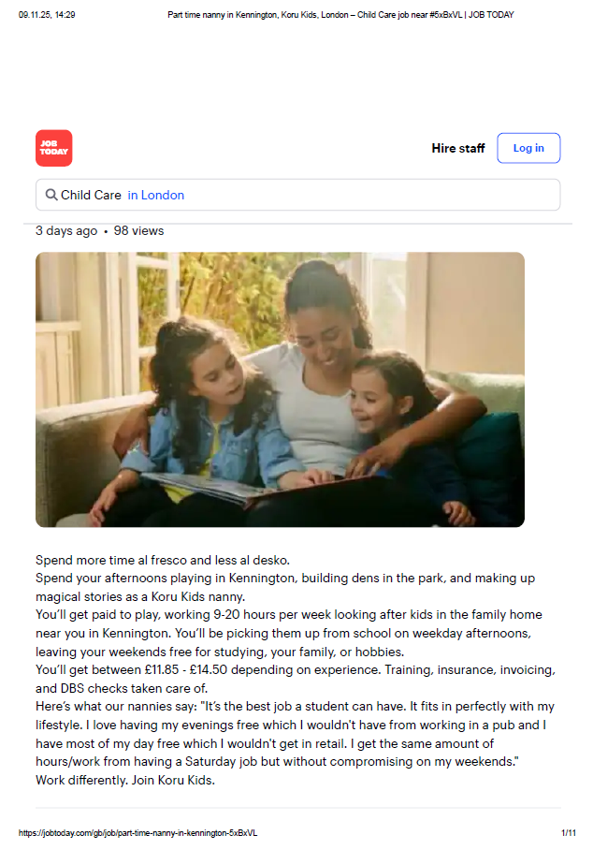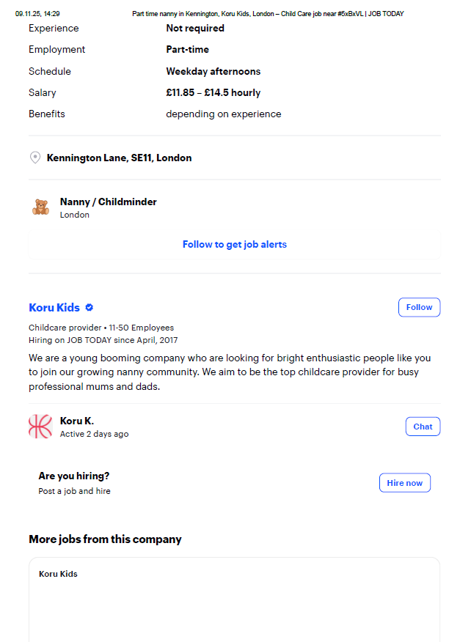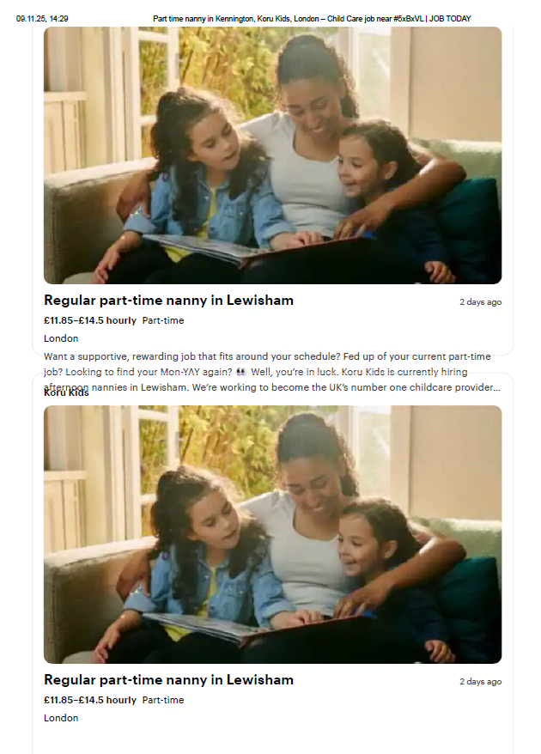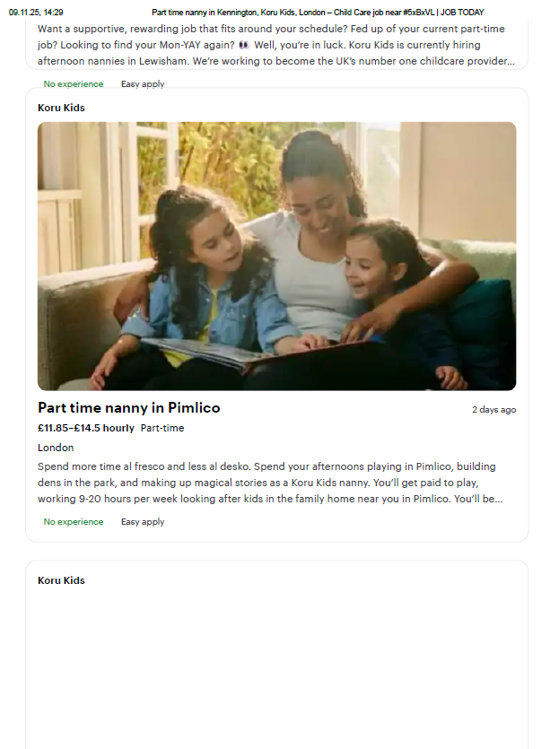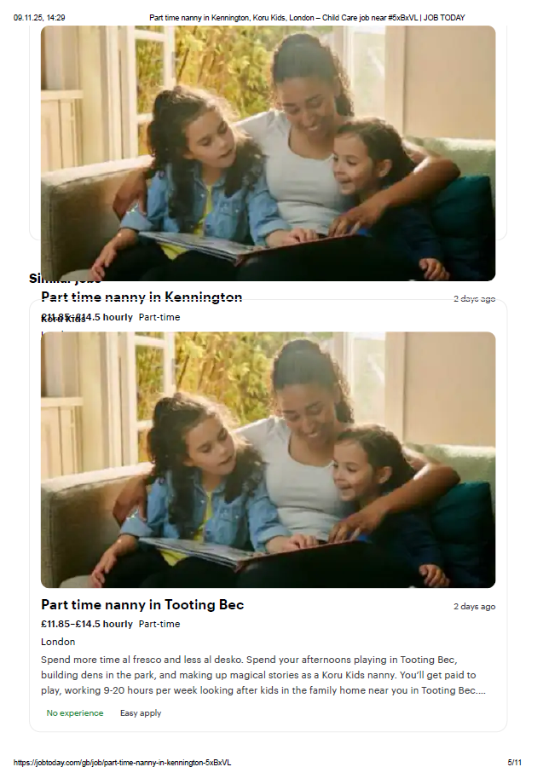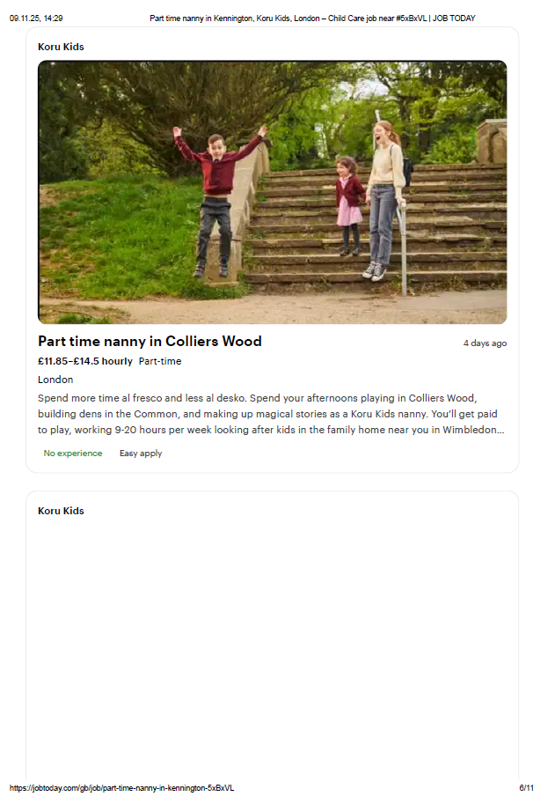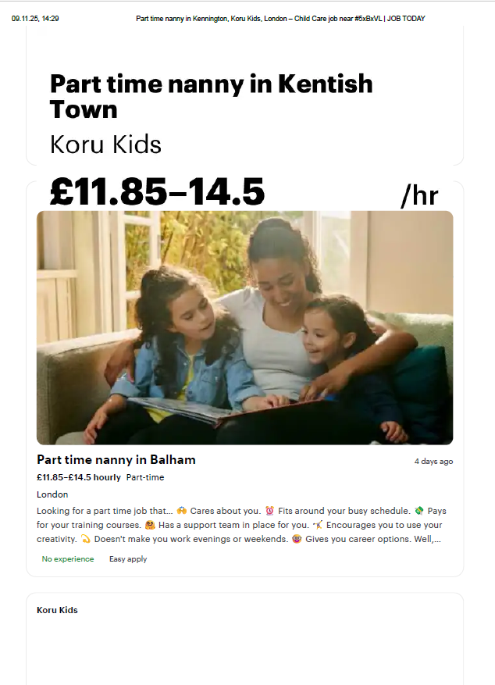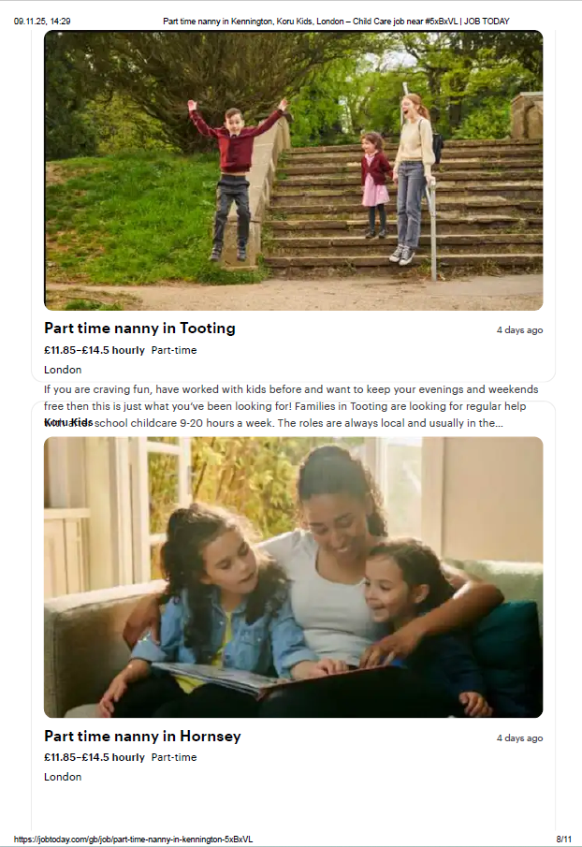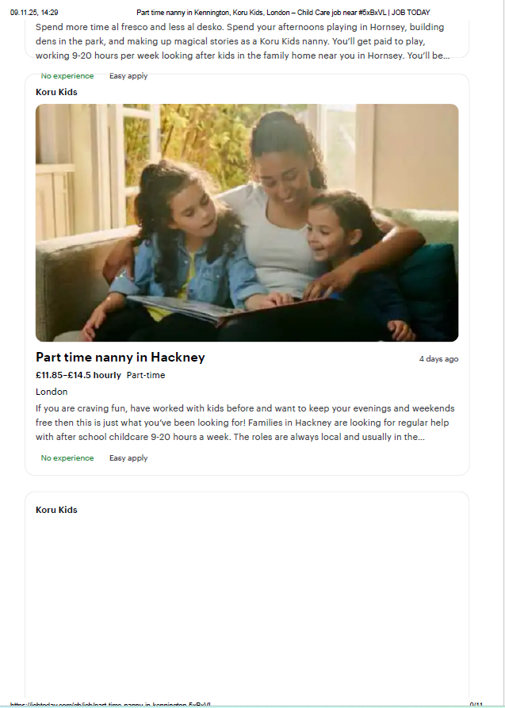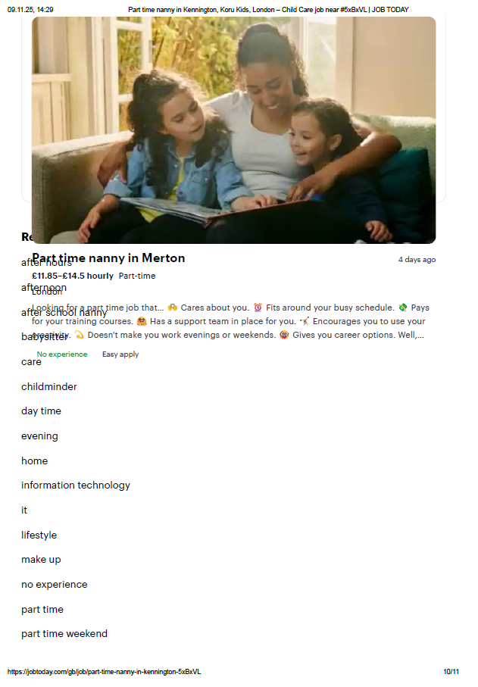

Cover letter
Anna Dark
96, [Your Street Name], London
[Your Postcode]
08/11/2025

Hiring Manager
Confidential or DEF Ltd
London

Dear Sir/Madam,

I wish to apply for the role of Nanny, currently being advertised.
Please find enclosed my CV for your consideration.

As you can see from my attached CV, I have over 15 years of experience working with children in the education and childcare field. I believe my experience and skills developed during this time make me a strong candidate for this role.
In my previous work as a teacher and art instructor, I have been responsible for supporting children’s learning, creativity, and emotional development. I also worked in a charity organisation and a private art studio, where I organised creative classes and educational activities.
Additionally, during my first two years in the UK, I cared for my three nieces and nephews, which gave me valuable hands-on experience within a family environment and a good understanding of the British lifestyle.
All of this, combined with my enthusiasm, patience, and strong sense of responsibility, has helped me create a warm and nurturing environment where children can thrive.
I am confident that I can bring the same level of care, reliability, and creativity to your household and contribute positively to your family.
Thank you for considering my application. I look forward to the opportunity to discuss how I can support your childcare needs.
Yours sincerely,
Anna Dark

CV
Anna Dark

London, UK
📞 [Phone Number]
📧 [Email Address]
📍 96, [Street Name], London, [Postcode]
Right to work in the UK: Yes

Personal Profile

Warm, reliable, and organised Nanny with over 15 years of experience supporting children in both educational settings and family homes. Former teacher and art instructor with a strong focus on creativity, emotional wellbeing, and structured routines.
Experienced with toddlers and school-aged children. Calm, patient, and confident in creating a safe, nurturing, and stimulating environment.

Core Skills

Childcare & supervision

Emotional and behavioural support

Creative & educational activities

Early years understanding

Routine planning (meals, homework, bedtime)

Strong communication with parents

Safety awareness

Patience, calmness, empathy

Organisational skills

Professional Experience
Nanny – Family Household

London, UK | 2022–2024

Daily care for three children (nieces/nephews), supporting routines and emotional needs.

Assisted with schoolwork, reading, and structured play.

Prepared meals, managed bedtime routines, and encouraged healthy habits.

Organised creative activities, art lessons, and outdoor play.

Art Teacher / Instructor

Private Art Studio, Ukraine | 2015–2020

Delivered creative classes for children aged 4–14.

Encouraged imagination, confidence, and fine motor skills.

Planned workshops, exhibitions, and group projects.

Ensured a positive and safe environment.

School Teacher

Secondary School, Ukraine | 2005–2015

Taught children aged 6–15, providing academic and emotional support.

Managed classroom behaviour, planned lessons, assessed progress.

Worked closely with parents and staff.

Built strong communication and leadership skills.

Volunteer – Children’s Charity

Ukraine | 2017–2019

Led educational and creative activities for children.

Supported learning, wellbeing, and social skills.

Assisted with programmes and events.

Education

Bachelor’s Degree in Teaching / Education
University in Ukraine

Additional Information

Languages: English (fluent), Ukrainian (native), Russian (fluent)

DBS: Available/Can be obtained

First Aid: Can be completed if required

Creative background as an artist and designer

Non-smoker

Strong understanding of British family lifestyle

