Assignment Title-
Business report: Comparison of two hospitality organizations.-Shangri La & Premier Inn.

Name: Syed Maksum Zabid (ID: 2245066)
Module: BMIH5007
Tutor- Tristan Hawkins

ACKNOWLEDGEMENT (Use of AI):
I confirm that I have not used any AI tools in the research and creation of this assignment. I confirm that I have not presented any AI generated materials as my own work. I confirm I have copies of my drafts, notes, and other resources I used, which I may be asked to provide in evidence.

Table of Contents
Introduction: 2
Total Revenue: 3
Shangri-La Hotel: 3
Premier Inn Hotel: 3
Sectors of Revenue: 4
Shangri-La Hotel: 5
Premier Inn Hotel: 5
Factors Influencing Growth & Decline in Revenue 6
Shangri-La Hotel: 7
Increase in Revenue: 7
Decrease in Revenue: 7
Premier Inn Hotel: 7
Increase in Revenue: 7
Decrease in Revenue: 7
Market Positioning: 8
Shangri-La Hotel: Sustainable Practices 8
Premier Inn Hotel: 9
Growth Potential: 9
Shangri-La Hotel: 10
Premier Inn Hotel: 10
Expansion Strategies: 10
Shangri-La Hotels 10
Premier Inn: 10
Potential Barriers: 11
Shangri-La Hotels 11
Premier Inn Hotel: 11
Corporate Social Responsibility (CSR): 11
Shangri-La Hotels 11
Premier Inn Hotel: 12
Conclusion: 12
Recommendation: 12
References 13

Introduction:
The report looks at two of the major hospitality industry groups that are Shangri-La Hotels and Premier Inn Hotels. The paper gives comprehensive data on how each brand has positioned itself in its market discussing its revenue, market opportunities and operational cost. The paper will also discuss other strategies for being successful in the market like extension, and strategic management of finances to guarantee sustainable prosperity (Mucharreira, et al., 2019). The paper will also focus on premium service and luxurious stay at Shangri-La, and the no-frills, cost-effective approach at Premier Inn. This report's goal is to talk about the financial management and performance over the past years and in present. Both brands will be analysed according to their total revenues, growth potential, market position, and CSR efforts (Chauhan, et al., 2011).

Total Revenue:

Shangri-La Hotel:
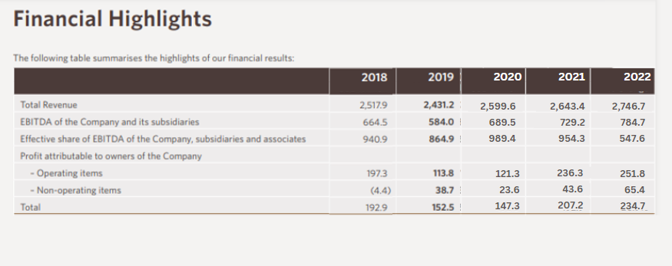
Figure 1: Total Revenue 2018-2022 (Shangri-La, 2023)
In 2018, 2019, and 2020, revenues of Shangri-La stood at around £1.89 billion, £1.87 billion, and £2.03 billion, respectively. Despite growing competition and market change at Shangri-La, the group was stable in its financial position until COVID-19 hit. COVID-19 changed the financial performance of Shangri-La from 2020 to 2022. The revenue of the hotel chain went from £2.03 billion in 2020 and escalated to £2.22 billion in 2022 (Shangri-La, 2023).

Premier Inn Hotel:
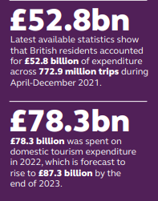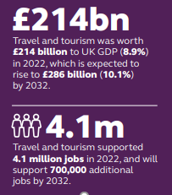
Figure 2: Revenue Record of Premier Inn Hotel (Whitbread, 2023)
Overseas visits in the UK were estimated at 6.4 million, with overnight stays of 93.5 million and overseas tourism spending of £5.6 billion in 2021. According to the market, domestic tourism expenditure is projected to hit £87.3 billion by 2023 at a growth rate of 11.5% from the benchmark of 2022 set at £78.3 billion. The contribution to the economy was estimated at £214 billion, accounting for 8.9% of GDP by the close of 2022. It is predicted to rise by £286 billion by 2032, equivalent to 10.1% of the economy and generating nearly 700,000 new jobs over the period (Whitbread, 2023).

Sectors of Revenue:

Shangri-La Hotel:
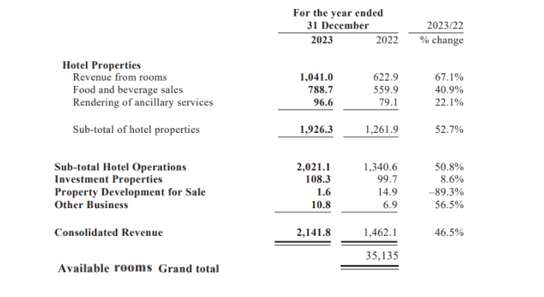
Figure 3: Sources of Revenue (Shangri-la, 2024)
Hotel properties are a huge source of revenue, with rooms revenue standing at £1,041.0 million; followed by food and beverage services, with £788.7 million revenue; ancillary services bring in £96.6 million from 2022. Hotel operations saw a rebound of tourists from China, which brought improved consolidated revenue during a peak of £2,021.1 million for the year 2023 (Shangri-la, 2024).
In 2023, the Group had an equity interest in showing an inventory of 35,135 rooms (2022: 35,144) across Asia Pacific, Europe, and Africa. For operating costs, the hotel group took cost-cut measures during the pandemic and that enhanced efficiency. By doing so, their EBITDA margin remarkably stood at 31.5%, the highest in the last decade. Group weighted average room occupancy was 62% for the year ended 31 December 2023. This was 42% for the year ended 31 December 2022, an improvement of 20 percentage points.

Premier Inn Hotel:
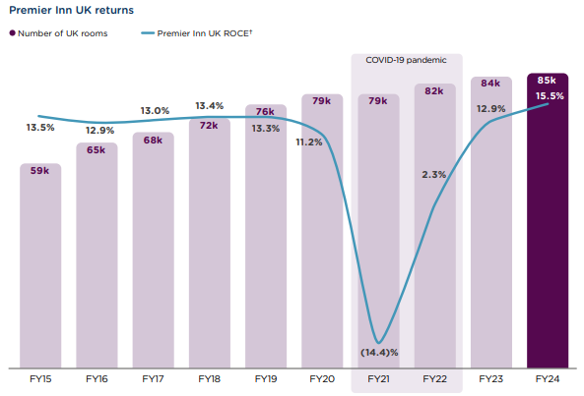
Figure 4: Sources of Revenue (Whitbread, 2024)
Premier Inn has seen significant expansion since 2019/20, with over 7,000 rooms added in the UK and Ireland, while the return on capital employed (ROCE) growth has also been secured. The UK Premier Inn estate reached over 85,000 rooms by 2023/24, with an ROCE standing at 15.5%. Although only in the development stage, Premier Inn's operation in Germany is recording excellent growth and good prospects for the long term. Charges this year include reclassifications totalling £109 million, of which £107 million are non-cash items, including impairment charges on seven properties in Germany and £27 million relating to the Group's IT strategic programmes. Sales in UK accommodation were 12% higher, with London increasing by 17% and the Regions increasing by 10%, which was well-supported by strong, constantly high occupancy levels, along with higher average room rates.

Factors Influencing Growth & Decline in Revenue

Shangri-La Hotel:

Increase in Revenue:
Shangri-La Hotel's revenue gain can primarily be attributed to digital engagement initiatives, as the hotel built on strides taken to drive the Shangri-La Circle loyalty program, thereby improving customer retention and direct bookings. Revenue for the year ending 31 December 2023 grew by 187.4% to £50 million from £17.4 million recorded in 2022. The lockdown brought by COVID-19 previously negatively impacted revenue taken as loans from banks. Its net borrowings decreased to £4,717.6 million by 2023 from £4,846.4 million by the end of the year 2022, partly contributed by the better operating cash flows since the recovery of the hotel business began (Journal, 2024).

Decrease in Revenue:
The main reason for the revenue decrease was bank loans. The COVID-19 lockdown affected hotel revenue, forcing the hotel to borrow the loan payment by 2022. The net borrowings of subsidiaries based on a percentage of equity interests were £4,152.3 million in 2023, a decrease of £255.6 million, compared to £4,407.9 million in 2022. The decrease was mainly driven by the growing cash inflow from hotel operations due to the recovery of the hotel business.

Premier Inn Hotel:

Increase in Revenue:
The gradual respite in COVID-19 restrictions around the world and increasing vaccination levels across many countries supported demand in travel and hospitality, which have been the two major group contributors (Chaffey, 2019). Revenue increased by 13%, reflecting the inherent operating leverage of the model. Also, the further enhancement of the demand-based event enabled the hotel to quickly respond to spikes in demand and maximise revenue (Christoph & Madeleine, 2019).

Decrease in Revenue:
For Premier Inn, the relaxation of COVID-19 restrictions and rising vaccination rates across the world had already caused a surge in demand in travel and hospitality (Whitbread, 2024). Statutory revenues were up 13% to £2,960 million, while adjusted operating profit was up 24% to £674 million. Mechanisms related to event triggers make it easier to respond with speed to increases in demand. On the downside, Premier Inn faced challenges in its defined benefit pension scheme, which now amounts to a mere £165 million compared to what it was back in 2022/23 at £325 million, largely influenced by an asset growth and discount rate mismatch. Labour shortages have been generally experienced since Brexit especially in London for housekeepers, affecting its turnaround to decrease by 30% year-on-year (Whitbread, 2024).

Market Positioning:

Shangri-La Hotel: Sustainable Practices
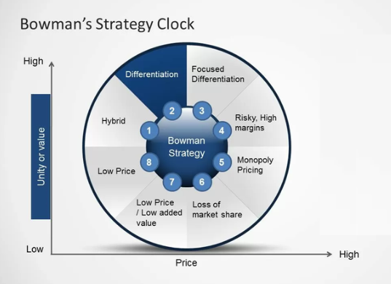
Figure 5: Bowman’s Strategy Clock for Shangri-La Hotel
In Shangri-La, sustainability is offered with the luxury stay that puts it on Bowman's Clock on Differentiation Strategy. It focuses on distinctive, high-value experiences through the execution of such green initiatives, energy efficiency, and locally sourced products. It attracts the niche segment of environmentally conscious luxurious travellers willing to pay a premium for a valid experience with some heightened sensitivity about ethics in hospitality (Avelini, et al., 1995). Differentiation creates worth beyond accommodation, reinforcing Shangri-La's reputation for combining luxury with corporate responsibility.

Premier Inn Hotel:
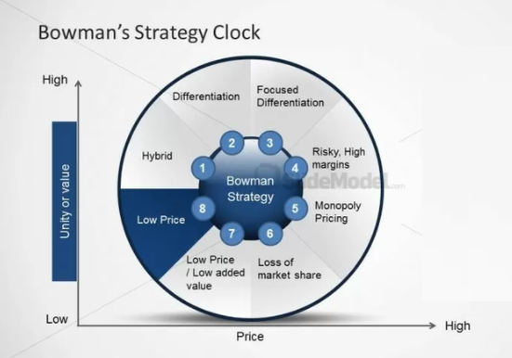
Figure 6: Bowman’s Strategy Clock for Premier Inn Hotel
Being affordable and friendly to families, Premier Inn falls under the category of Low Price. Premier Inn targets budget-conscious families through family rooms and special packages, while providing services that enhance their travel experience (Bharwani & David, 2016). This sort of strategy balances cost and added value, positioning Premier Inn as a more appealing option for families seeking affordable and comfortable accommodations.

Growth Potential:

Shangri-La Hotel:
Shangri-La's digital upgrade has improved their booking process and further deepened guest relations, which is growing in repeat business. With international travel picking up to pre-pandemic levels and Chinese domestic travel rebounding, Shangri-La is confident of the return of outbound Chinese tourists with the policies designed and implemented by countries such as Singapore, Malaysia, and Thailand that offer visa-free travel (HMG, 2016).

Premier Inn Hotel:
As the operations continue to grow, Premier Inn's business will support the Tourism Recovery Plan developed by the UK Government, which promotes private-sector investment to support the hospitality industry in recovery. Premier Inn is one of the largest branded hotel chains in the UK, with a 12% market share, and therefore growth would be expected to feed into economic recovery by contributing extra room capacity to ultimately stimulate overall tourism sector growth (Gregg, 2022).

Expansion Strategies:

Shangri-La Hotels
One of the most important trends nowadays is people's plans to travel across borders. This trend in Asia is huge, and as such, presents an excellent opportunity for Shangri-La Hotels to attract foreign tourists and increase its customer base (Wang, et al., 2023). Placing five-star and four-star hotels strategically through their unique Asian architectural designs as well as ocean or lake views has given Shangri-La Hotels customers an unforgettable experience while using its services (Cadotte & Turgeon, 1988). The luxury hotel sector is pretty dynamic and is experiencing novel trends and strategies, which keep on arising. The luxury hotel sector is likely to reach an astounding figure of around £117,000 billion by 2033, and therefore, has a large scope for businesses such as Shangri-La.

Premier Inn:
The Premier Inn hotel has the potential to open up to 125,000 rooms and 93 hotels in the market. Premier Inn hotels anticipate that the UK hotel supply will not return to 2019 levels until at least 2028 due to the pandemic's impact on supply. In addition to providing the hotel with a strong position and a large number of guests to take advantage of this lucrative market opportunity, Premier Inn hotels' in-house precuring team, extensive freehold portfolio, and flexible approach to property ownership also give them the flexibility to add rooms through new sites and extensions. (Onofre, et al., 2013).

Potential Barriers:

Shangri-La Hotels
Shangri-La has operations in various regions. Thus, geopolitical tensions or economic decline, especially in Asia and the Middle East, would impact travel demand. Their business was heavily affected during the COVID-19 lockdown due to travel restrictions and economic instability. The potential barriers also include labour, energy, and maintenance costs (Shangri-La, 2021).

Premier Inn Hotel:
Due to a vast number of players in the budget hotel sector, Premier Inn has to constantly innovate and improve service for competitive viability, which means constant investment in technology and infrastructure​. As regulatory standards move upward, there will be increased costs in terms of energy efficiency, waste management, and overall reduction of environmental impact that can limit the growth potential of the hotel.

Corporate Social Responsibility (CSR):

Shangri-La Hotels
Shangri-La's CSR is under three themes: community engagement, environment & biodiversity, and health & safety (Public, 2022). The hotel remains committed to supporting and uplifting the surrounding community, always focused on making a real impact on the lives of those it interacts with. The hotel is very concerned about environmental sustainability and thus seeks to contribute actively to the fight against global warming by incorporating some green practices in its operations. A recent initiative includes requiring their partners to have reusable water bottles. This reflects their commitment to the effort to eliminate plastic waste and conserve natural resources.

Premier Inn Hotel:
The company has concentrated on expanding its goals. Whitbread set a target to reduce carbon emissions intensity by 84% by 2040. With the reduction already at nearly 40%, Whitbread is well on its way to reaching the first target. However, this year the company took it a notch higher by revising its target for carbon, as it now plans to have net-zero carbon emissions by 2040.
Some of the basic barriers for Shangri-La and Premier Inn include cost burdens brought about by adopting green technologies, the requirement of constant staff training, and giving up financial returns for sustainability (Buzatu, et al., 2019). At the same time, regulatory constraints can restrain how far these businesses can go, especially in regions that are not aligned with full government policies on sustainability practices.

Conclusion:
Shangri-La and Premier Inn stand on two different ends of the hospitality spectrum. Shangri-La focuses on luxury, premium service, and sustainability, thus attracting upper-class guests willing to pay for exclusivity. Premier Inn has a no-frills approach at a low cost for budget-sensitive travellers, families, and others. Both companies have shown resilience; that is, Shangri-La's case bounces back because of sustainable luxury, while in the case of Premier Inn, they provide an affordable and luxury environment at the best prices (Cadotte & Turgeon, 1988). Opposites are attracted to the products within the contrasting strategies that target two different markets, but the bottom line is how flexibility, creativity, and sustainability can fuel financial growth and facilitate future growth.

Recommendation:
Shangri-La should further expand on sustainable luxury offers by providing more eco-friendly initiatives, such as carbon-neutral packages, to attract an environment-conscious luxury traveller.
Premier Inn would still have to pay investment for the enlargement of business travel facilities, such as conference rooms, to attract a larger share of corporate customers without losing its model for affordable accommodation (Gentile, et al., 2007).

References
Avelini, H., Ivanka & Milena, P., (1995) Incorporation of Croatian hotel trade in the standard system of monitoring business results in the world hotel industry. Tourism and hospitality management 1, p. 239–51.
Bharwani, S. & David, M., (2016) Customer service innovations in the Indian hospitality industry. Worldwide Hospitality and Tourism Themes 8, p. 416–31.
Buzatu, A., Pleșea, D., Iulian, C. & Valentin, W., (2019) Managing organizations for sustainable business development: Interaction between VRIO framework and Mckinsey 7s framework. New trends in sustainable business and consumption, pp. 243-251.
Cadotte, E. & Turgeon, N., (1988) Key factors in guest satisfaction. Cornell Hotel and Restaurant Administration Quarterly, p. 45–51.
Chaffey, D., (2019) Digital Business and E-Commerce Management,. 7th ed. Harlow: Pearson.
Chauhan, A., Sharma, S. K. & Tyagi, T., (2011) Role of HRIS in improving modern HR operations. Review of Management, p. 58–70.
Christoph, B. & Madeleine, B., (2019) Cross-cultural management research: Topics, paradigms, and methods—A journal-based longitudinal analysis between 2001 and 2018. International Journal of Cross-Cultural Management.
Chung, K. & D’Annunzio-Green, N., (2018) Talent management practices in small and medium-sized enterprises in the hospitality sector: An entrepreneurial owner-manager perspective. Worldwide Hospitality and Tourism Themes, pp. 101-116.
D’Annunzio-Green, N., (2018) Cornerstones of talent management as a strategic priority in the hospitality. Worldwide Hospitality and Tourism Themes, pp. 5-13.
Gentile, C., Spiller, N. & Noci, G., (2007) How to sustain the customer experience: an overview of experience components that co-create value with the customer. European Management Journal, p. 395–410.
Gregg, R., (2022) How Three Global Hospitality Companies Led With a Clear Vision. [Online]
Available at: https://www.bu.edu/bhr/2022/04/27/the-importance-of-leading-with-clear-vision-a-case-study-of-three-global-hospitality-companies/
[Accessed: 7 October 2024].
HMG, H. T., (2016) Hotel Growth Strategies. [Online]
Available at: https://hmghospitality.com/hotel-growth-strategies/
[Accessed: 4 October 2024].
Journal, d., (2024) SHANGRI-LA GROUP RELEASES 2024 INTERIM RESULTS. [Online]
Available at: www.journaldespalaces.com
[Accessed: 5 October 2024].
Mucharreira, et al., (2019) The relevance of tourism in the financial sustainability of hotels. European Research on Management and Business Economics, pp. 165-174.
Onofre, M.-C., Anna, M., Antoni, S. & Forteza, C. M., (2013) The growth strategies in the hospitality industry from the perspective of the forgotten effects. Computational and Mathematical Organization Theory, p. 195–210.
Public, (2022) Sustainability Report 2022. [Online]
Available at: https://ebs.publicnow.com/view/9700BFD61CEA9787BDFED7BC9A683614DBA04654
[Accessed: 2 October 2024].
Shangri-La, (2021) Shangri-La Group Releases 2020 Full Year Results. [Online]
Available at: https://www.shangri-la.com/group/media/media_post?post=Mar26_2020FY_Results2
[Accessed: 9 October 2024].
Shangri-La, (2023) Shangri-La Asia Ltd 2022 Annual Results. [Online]
Available at: https://sitecore-cd.shangri-la.com/-/media/Project/Shangri-La-Group/Investor/Files/Public-Disclosures/Latest-Top-Publications/2022_final-results_presentation.pdf
[Accessed: 12 October 2024].
Shangri-la, (2024) FINAL RESULTS ANNOUNCEMENT - Shangri-La Hotels and Resorts. [Online]
Available at: sitecore-cd.shangri-la.com
[Accessed: 2 October 2024].
Wang, Zhisheng, Xiang, L. & Huiying, L., (2023) Impact of reputation on hospitality profitability: impact of service failure online exposure on revenue performance–evidence from the hotel industry in China. Tourism Review , pp. 1387-1413.
Whitbread, (2023) Annual Report. [Online]
Available at: https://www.whitbread.co.uk/investors/annual-report/
[Accessed: 7 October 2024].
Whitbread, (2024) Operational highlights. [Online]
Available at: https://www.whitbread.co.uk/investors/annual-report/#operational-highlights
[Accessed: 5 October 2024].
Whitbread, (2024) Opportunity. [Online]
Available at: https://www.whitbread.co.uk/investors/annual-report/#opportunity
[Accessed: 11 October 2024].

