
By Bruno Rosado

Student name: Bruno Rosado
Student ID number: 1907896
Module: Problem Solving and Decision Making (Final report)
Module code: BMSW 4004
Module Coordinator: Chijioke Uba
Programme: Certificate of Higher Education in Skills for the Workplace


Introduction………………………………………………………………….…1
Examples……………………………………………………………………….2
Identify the problem…………………………………………………………...3
Fishbone……………………………………………………………………….4
Alternative solution……………………………………………………………5
PMI and Pestel analyses……………………………………………………..6
Solution planning………………………………………………………………7
Conclusion……………………………………………………………………..8
References…………………………………………………………………….9



The industrial and technological development of recent years has brought a new way of thinking and managing organizations. In this way, companies intensify their collections. They suffocate, pressure and overload them in the performance of activities, so that the result is achieved faster and with better quality. Organizations are intensifying the competition among themselves for customers and markets, also starting to compete for the most important resource: human talent. Given this scenario, new skills and abilities have been required of workers, in addition to of different ways of producing and relating to the work, associating the important value for health. aspects are directly related to the quality of life of the human being and their motivations, which directly and indirectly reflect on individual and global levels of productivity. A survey carried out identified that 34.26% of respondents indicate that they perceive their stress level to be extreme (scores 8-10 on the 10-point scale). Given this context, the research problem of this study arises which are the main causes of stress in the environment organizational? The general objective was to identify, through bibliographical material, which variables contribute to the increase in stress at work. Among the specific objectives, the following were addressed historical and evolutionary context of stress causes and consequences of this disease for individuals. With this intense competition, studies related to quality of life, and, above all, stress have received, in recent years, greater attention by organizations around the world. (https://www.cipd.co.uk/knowledge/culture/well-being/health-well-being-work?)


1-Task overload When we think about what causes stress at work, the main factor that often comes to mind is work overload. Assigning too many tasks and obligations to a single employee can make the employee feel very overwhelmed. Therefore, try to know the productive limits of each employee and do not exceed them. Give the professional the number of tasks he will be able to perform. Otherwise, the stress caused by the heavy workload could jeopardize the final quality. But if you are in a subordinate position, learn to say “no” and avoid taking on responsibilities greater than your ability to honour them.
2 -Excessive competitiveness encouraging in the work environment can be good for encouraging employees to seek better results. However, when things get out of hand, excessive determination becomes a major cause of stress. Employees wanting to prove themselves better than others always contribute to a toxic and unhealthy environment. So set an acceptable competitive threshold and always remind employees that everyone is in the same boat.
3 - Unattainable goals Setting unattainable goals and objectives does nothing to reduce stress at work. In fact, this reprehensible practice only encourages employees' emotional exhaustion. When faced with a goal that is clearly not possible to be achieved, professionals become discouraged and less engaged in showing results.
4 - Inappropriate distribution of responsibilities another factor that encourages stress at work is the inappropriate distribution of responsibilities and tasks. Few things are as stressful for a professional as being delegated a role that has nothing to do with their education or experience. Imagine, for example, putting an experienced accountant to work at the reception or serving coffee. In addition to being counterproductive, this contributes to this professional feeling stressed for being in a role that does not suit him. In this sense, seek to know and understand the skills of each employee and allocate the available labour without losing sight of it.
5 -Compensation incompatible with functions Professionals who work a lot and are paid disproportionately tend to be more stressed. Not having your effort properly recognized in the salary increases stress and reduces motivation.
6 - Lack of flexibility Every employee has a life outside the company. When the company is very rigid and inflexible in relation to the workload and presence of the employee, it becomes more difficult for him to reconcile his professional and personal life. This contributes to the increase in the stress level, as the professional starts to live practically because of their work, which is not healthy at all. In this way, try to offer employees the possibility of making their hours more flexible. Or even working from home (home office) for a few specific days. That way, he will be happier and more satisfied. This post may interest you: Check out 4 cases of innovative actions in the workplace and find out how they can help your company achieve better results
7 - Problematic infrastructure a company that does not offer good infrastructure conditions for its employees to perform their duties is contributing to a more stressful work environment. Lack of adequate material, worn furniture, old machinery, defective equipment, poor lighting, small and poorly ventilated space, and even poor sanitation in bathrooms are examples of problematic infrastructure that helps accentuate work stress.
8 - Lack of a career plan the lack of perspective for professional growth is also what causes stress at work. When the professional is in a company that does not offer a career plan, he tends to feel more unmotivated and stressed with the work routine. (https://www.siteware.com.br/gestao-de-equipe/o-que-causa-estresse-trabalho/)


The causes of stress also depend on our perception of it. Something that is stressful for one person may not be stressful for another. It is very common to say, “I am stressed” or “my colleague was stressed”, but what is stress? Stress is defined as a set of physical, chemical, and mental reactions in response to some factor that is triggering the body's imbalance. It is the sum of organic and psychological disturbances caused by aggressive agents, such as fatigue and conflicting situations, for example, that generates stress, which, in turn, can cause anxiety and anguish and depression. Environmental causes involve external and contextual factors, which can induce stress at work. Lack of tranquillity at work, job/job insecurity, high workload, intense work pace, the number and nature of customers are part of the environmental causes. Personal causes involve a variety of individual characteristics that will predispose to stress. There are people who deal with stress better than others, this has to do with their individuality. Lack of patience, low self-esteem, poor health, sedentary lifestyle, and sleep deprivation are factors that lead people to react negatively to stress, whether it comes from work or personal. (https://rockcontent.com/br/blog/estresse-no-trabalho)

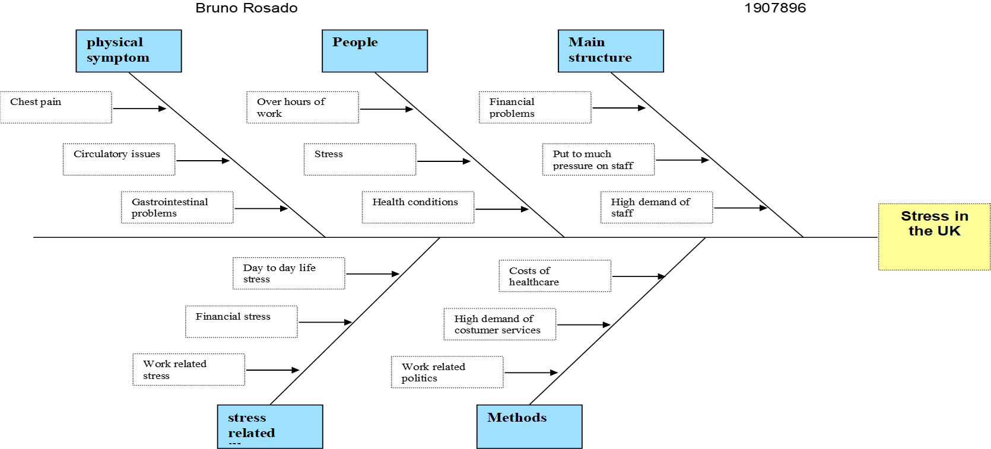
During business hours, various issues can occur. Some of them are recurrent, while others appear unexpectedly. In any case, it is necessary to analyse them and identify their cause. For this, the fishbone helps a lot. the diagram provides a more systemic view and allows for analysis of the “root cause” of problems. That is, for what really contributed to the negative results. Thus, the manager can act with greater precision. Imagine, for example, that daily conflicts have grown, and employees argue with the recurrence. At first glance, it appears that an employee doesn't "fit in" well on the team. By doing an internal analysis, you will see that the real problem is lack of communication. Well, the diagram makes it easier to look even closer. It also ensures that the manager has a more complete picture. Daily life at work is unpredictable. Problems can arise from all sides. For example, delivery delays, new conflicts, accidents, and outdated projects. It is no use simply ignoring these problems, it is necessary to identify their causes. Likewise, impressive effects can arise even outside the curve. Goals that were surpassed in record time, highly satisfied customers, highly engaged teams, and so on. In this case, it is also interesting to identify the causes of success. The Diagram, therefore, aims to help the team to find the real causes of problems that affect a company's organizational processes. That is, its objective is to discover the factors that result in an unwanted situation in the organization. One of the most common mistakes companies make is allowing their processes to be interfered with by small problems and failures, without investigating their causes or neutralizing them. With that, it ends up deteriorating its routine, which causes losses and leaves the company less and less productive. Therefore, as one of the most important quality management tools, the use of fishbone helps to keep these activities in constant improvement and facilitates the solution of your problems, from the simplest to the most complex.


The company can invest in colours and decoration to bring a happier air to the environment this method is widely used by large companies, such as Google, for example, and it brings great results to improve the organizational climate and reduce turnover, that is, staff turnover. When employees find a pleasant environment to spend the day and interact with their co-workers, their journey becomes less stressful and more enjoyable. As a manager stay on top of the activities performed by your employees and make sure they are being carried out in a balanced way. On the other hand, it is important that employees always plan their daily tasks to keep track of activities rather than stressing out by running out of time. What differentiates the cause of stress from one person to another is the way they work around problems, the frequency with which these difficulties appear, and the way conflicts from the work environment are carried into personal life. Therefore, seek a balance between your personal and professional life, that is, establish a limit for each one and do not take problems from your personal life to work and above all, avoid taking work home – leave your professional problems at the company. Carrying out activities together with other co-workers brings pleasant experiences and encourages healthy relationships between team members. This is one of the most important actions to generate a healthy organizational climate. The unity of the team provided by the interaction between employees also results in an increase in learning, creativity, and performance in general. Poor communication discourages employees a lot and can cause various conflicts within the organization, such as gossip, resentment, and speculation. So, find the best way to talk to each employee profile, have individual roles and responsibilities well defined, and communicate through feedback that allows the employee to analyse their performance and have more job security. (https://www.rhportal.com.br/artigos-rh/estresse-no-trabalho-2)

Plus | Minus | Interesting
Good communication from managers +5 | Poor motivation -4 | Create quiet time +3
Improve employee satisfaction +5 | Low morale -5 | Prepare for the future +4
Find and retain talent +4 | Increase health issues  -4 | Be comfortable at wor+4
+14 | -13 | +11



Stress injects adrenaline into your body as a way to prepare you to face or escape the perceived threat. But because the causes of stress at work usually don't require you to fight danger or flee a predator, this stress hormone builds up in your system with nowhere to go, bringing restlessness and irritability. This is also known as adrenaline rush. And what is the way to put out the fire after the stress sets in? Exercise! During exercise, your brain produces endorphins, which make you feel good and help ward off stress. In addition, a University of Chicago study showed that people who don't exercise have a greater drop in positive emotions after a stressful task than people who exercise regularly. The result suggests that regular exercise can protect people from the "negative emotional consequences of stress." The US Department of Health and Human Services currently recommends that adults do at least 150 minutes of moderate-intensity aerobic activity, or 75 minutes of high-intensity per week. No matter where you live, take time each week to perspire and release all that stress. stress injects adrenaline into your body as a way to prepare you to face or escape the perceived threat. But because the causes of stress at work usually don't require you to fight danger or flee a predator, this stress hormone builds up in your system with nowhere to go, bringing restlessness and irritability. This is also known as adrenaline rush. And what is the way to put out the fire after the stress sets in? Exercise! During exercise, your brain produces endorphins, which make you feel good and help ward off stress. In addition, a University of Chicago study showed that people who don't exercise have a greater drop in positive emotions after a stressful task than people who exercise regularly. The result suggests that regular exercise can protect people from the "negative emotional consequences of stress." The US Department of Health and Human Services currently recommends that adults do at least 150 minutes of moderate-intensity aerobic activity, or 75 minutes of high-intensity per week. No matter where you live, take time each week to perspire and release all that stress. Right now, be aware of your jaw. Is she tense? Shake your shoulders for 2 seconds and then relax. You probably didn't even realize how much tension you were building until you brought your attention to those parts of your body, did you? When you're under stress, your muscles contract to prepare you for confrontation or flight. Often, while you're in front of your computer solving work problems, you can build up tension without even realizing it. To combat this, you can practice progressive muscle relaxation to become aware of your muscles tensing and relaxing them. (https://www.researchgate.net/publication/339870732)


The present study allowed us to conclude that variables such as work demands for time and perceived group cohesion have a huge impact in terms of perceived professional stress and psychological well-being of individuals in the workplace. This situation is of extreme importance for company directors, as well as for their human resource managers, as it reinforces the notion that the experiences and demands of individuals at work, they will affect them as working agents, with repercussions (also) at the organizational level. As is well known, the consequences of occupational stress phenomena extend to damage to the individual's personal, family, and social life, but also to countless costs for organizations. The worker's well-being must be an ever-present concern, whether because of the natural ethics towards a human being, but also because the organization does not survive with “sick” employees, either physically or psychologically. According to Katz & Kanh (1978) individuals' illnesses and their psychological well-being are not analysed as organizational results. In fact, the success of an organization should also be guided by its ability to obtain good results, through healthy workers. According to Caetano &Silva (2010), organizations are expected to be able to combine their sustainability and productivity with the promotion of quality of life for their workers. (Conclusão - Stress no meio ambiente do trabalhohttps://livros-e-revistas.vlex.com.br)


- FRANÇA, ANA CRISTINA LIMOGNI; RODRIGUES, AVELINO LUIZ. Stress e trabalho: uma abordagem psicossomática. 4ª ed. São Paulo: Atlas, 2011, p.29- 55, 159-177.
- PEREIRA, LUCIANO S. Motivação de indivíduos e grupos de trabalho. Maringá: Cesumar, 2012, p.28-35, 105-134.
- FIORELLI, JOSÉ OSMIR. Psicologia para administradores: integrando teoria e prática. 3ª Ed. São Paulo: Atlas, 2003, p. 240-255.
- MICHEL, OSWALDO. Acidentes do trabalho e doenças ocupacionais. 3ª Ed. São Paulo: LTR, 2008.
- LIPP, Marilda Emmanuel Novaes e MALAGRIS, Lucia Novaes. O Stress Emocional e seu Tratamento. In Bernard Range (Org). São Paulo: Artes Medicas, 2001.
- PEREIRA, Ana Maria T. Benevides. Burnout: Quando o trabalho ameaça o bem-estar trabalhador. São Paulo: Casa do Psicólogo, 2002.
- LVA, Marco Aurélio Dias Da, DE MARCHI, Ricardo. Saúde e Qualidade de Vida no Trabalho. São Paulo: Editora Best Seller, 1997.
- SITE MIGALHAS.COM.BR. Stress no ambiente de trabalho. Rio de Janeiro, dez.2006. Disponível em: http://www.migalhas.com.br/dePeso/16,MI33425,41046- Stress+no+ambiente+de+trabalho
- SITE ESTRESSE.COM.BR. Globalização e Mudanças: o Stresse do Novo Milênio. São Paulo, jun.2016. Disponível em: http://www.estresse.com.br/orientacoes/os-21-passos-do-manejo-do-stress/

