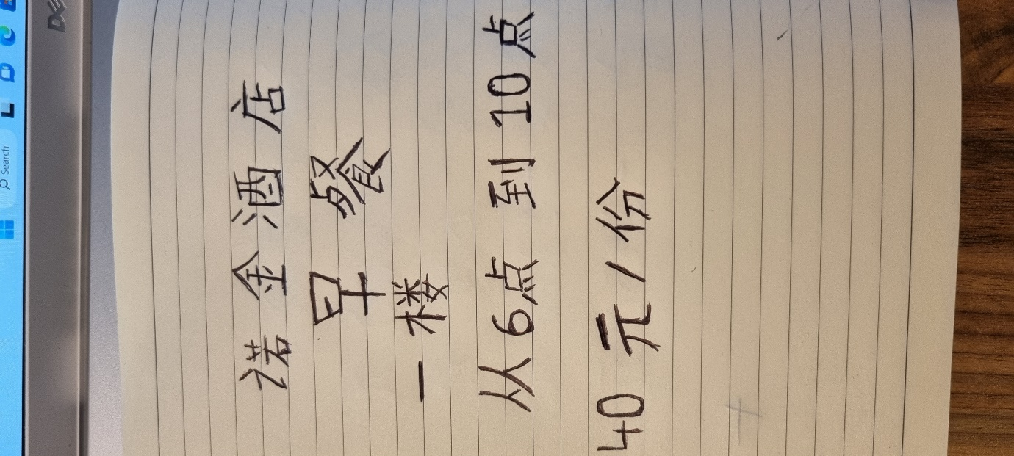

Mandarin breakfast card for final assessment . hope is all okay , thank you
Alex Radu 2166633 / / / / /

