Research proposal
An exploration into the social impacts on events held in a local community and its stakeholders- Case study of MUUK-Adventures

Rebecca Reynolds (1701301)

Table of Contents
1. Introduction 3
1.1 MUUK Adventures 3
1.2 Background and Rationale 3
2 Aims and objectives 4
3. Research design 4
3.1 Methodology 4
Figure 3.1- The research onion 5
3.2 Philosophy 5
3.3. Sample 5
4. Data analysis and collection 6
4.1 Strategies 6
4.2 Collection method and analysis 6
5.Limitations 7
6. Resources 7
6.1 Gantt chart 8
7.Ethics and risks 8
8. References 9

1. Introduction
The purpose of this dissertation is to explore the social impacts on events held in local communities and to see if it benefits the community and stakeholders. The case study that will be investigated is MUUK Adventures and the local community of St. Davids in Pembrokeshire. There has been previous research from Getz (2007) on the social impacts. Events can have both positive and negative consequences on local communities and therefore this dissertation will explore the issues surrounding the social impacts.

1.1 MUUK Adventures
MUUK Adventures provides outdoor endurance events. The organisation works closely with its partners and hires people with expertise in their fields (MUUK, 2018). The company is situated in St.Davids Pembrokeshire and the two biggest events they hold there is Ras Dewi Sant (full/half & 10k runs) and tour de Shane which is a charity cycle event. Over 5000 people have taken part in their events and over 20,000 has been raised for charities and organisations (MUUK-Adventures,2019).

1.2 Background and Rationale

The events industry is increasingly expanding and is becoming increasingly important for the social aspects according to Bowdin et al (2011). From past academic theories, many highlight the positives but avoid the negatives or lack the social impacts (Getz 2007). Richards et al (2013) states that the social impacts from events can include social capital, community development, social cohesion and inclusion or exclusion. According to Maslow (1943) these are needed social needs. Bladen (2012) highlights that the motivational factors such as the social needs can be caused by events. Events in the community can bring people together and motivate them to take part in social interaction and increase social capital. Yuruk (2017) states events provide a sense of community, community pride, and spirit within a destination which can contribute to improving the quality of life of those who live there. However, Getz (2007) quotes event impacts on a community ranges from noise, congestion, crime and other disruption to everyday lives. Residents can be affected in their homes, from their daily routines from events being staged in a community.
The research for this dissertation needs to be done as events can have significant impacts on individuals, groups and community as a whole (Getz,2007). Attendance in communities for small- scale events are significantly low than major events. The rationale underpinning this proposal research is developed from current academic theories and from this the social impacts can be explored in detail on how benefits and effects small communities and its stakeholders. The main focus is how small-scale sport endurance events can impact the community socially and is it actually beneficial for the community.

2 Aims and objectives

The overall aim of this dissertation is to explore the social impacts of events in the local community by seeing if it can benefit those who are involved and the community’s stakeholders. A case study of an outdoor events organisation MUUK Adventures will be used for research to come up with conclusions. In order to complete this aim, through extensive research, the dissertation will explore the following objectives:
• To critically evaluate the social impacts from MUUK Adventures
in the community and its stakeholders.
•To analyse if the events can increase social capital of the community
• To see if the community itself can contribute to making events more sustainable.
•To provide MUUK Adventures with recommendations in regard to holding events to get the community involved.

3. Research design

3.1 Methodology

Research can be defined as ‘something that people undertake to find out things in a systematic way, thereby increasing knowledge’, (Saunders et al., 2009, p.5). It therefore makes something that is unknown known by increasing a person’s knowledge (Veal,2011). The researcher of this proposal will use the ‘research onion’, in figure 3.1 which is developed by Saunders (2009). By following the layers of the onion right through to the centre, Saunders (2007) highlights that this can be used as a of effective research achievement.

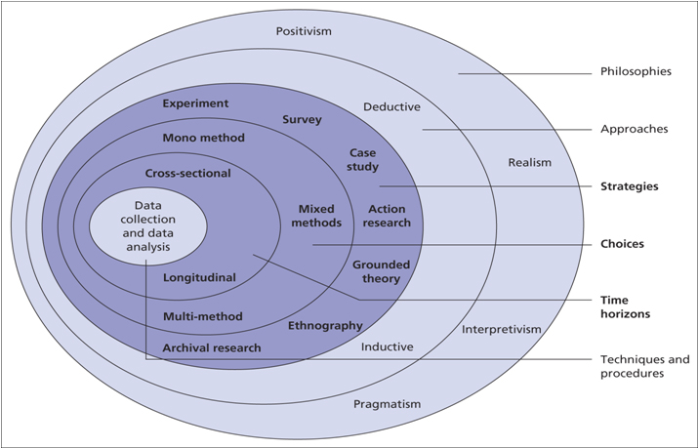

Figure 3.1- The research onion

3.2 Philosophy

Research philosophy Is defined by Dudoyskiy (2018) as the credence of how information occurrence should be obtained and further analysed. A framework of research of philosophy is positivism. For this dissertation, the main philosophy taken is positivism as a quantitative method is being used in order to meet the objectives set out for this research. According to veal (2011), the positivism approach links with data gathered by the research using theories and models. This is seen as the most relevant paradigm to the researcher chosen methods of research and the overall topic. Additionally, a qualitative will also be used collected which is an interpretivist paradigm. According to Veal (2011) interpretivist contradicts that reality can be known through individual interpretations.

3.3. Sample
For the purpose of this study, sampling will be used to collect data. Sampling can be defined by Etikan (2015) as nonprobability sampling is using judgement from the researchers to select people based on the subject of the research. Sampling is needed in order actively select participants that are involved in the area of St. David’s and the organisation MUUK Adventures. The sample size will be made up of hundred participants as the larger the size, the more it will represent the social impacts of a community. According to Collins and Hussey (2009), one hundred participants is seen as feasible and time consuming. For the interviews that will be conducted for research, a number of five participants will be used. The samples being used will all be over the age of 18.

4. Data analysis and collection

4.1 Strategies
For the purpose of this research, a deductive approach has been used. Gabriel (2013) states a deductive research approach is more appropriate for quantitative research by developing theory that is already known. Quantitative date is data that is in numerical structure and has a link between theory and research (Collins and Hussey, 2009) and is used in the positivist approach due to it being precise. Qualitative data is used to generate words rather than numbers (McCuskar, K & Gunaydin, S, 2014) and can also been seen as imprecise and not straightforward. A deductive approach is theory that is tested by empiric observations (Collins & Hussey, 2004). Both approaches are often used to support each other to look at the research objective from different angles in order to get a conclusion (Veal, 2011).

4.2 Collection method and analysis
The research will conduct an online questionnaire using google documents and an interview by selecting a random sample. The questionnaire will be distributed to MUUK Adventure consumers as well as the community of S.Davids with the help of the organisation by using email and social media platforms. This is appropriate for the research as it is seen as getting a large number of data which is useful for getting a conclusion (Saunders, 2009). The interview will be done by face-to- face or over the phone. The questionnaire and interview questions will be piloted with peers to ensure its suitable. The methods being used will be useful in gaining the social benefits of events in the community and the possible negatives. Once both methods have been conducted, the researcher will transcribe them and analyse the data that has been conducted in order to be more effective (Saunders,2012). With the questionnaire, once data has been collected, the researcher will create graphs, bar chats and pie charts in order to effectively be able to analyse the date that has been stored.

5.Limitations
For this study, limitations exist due to a limited timeframe for the collection of primary research. The sample taken may not serve for the wider people but can be seen as suitable for the given timeframe of the study. A Gannt chart has been created to improve time management and to mitigate limitations, see in 6.1.

6. Resources
Various of resources will be used for this study in order to meet the aims and objectives. Secondary data including academic sources which will be used to gain an understanding on the subject which will be used in the literature review. This can be accessed through the university’s online library resources and physical books. Additionally, primary research will be collected by questionnaires and interviews and IT systems will be needed for this and the software to be able to analyse them

6.1 Gantt chart
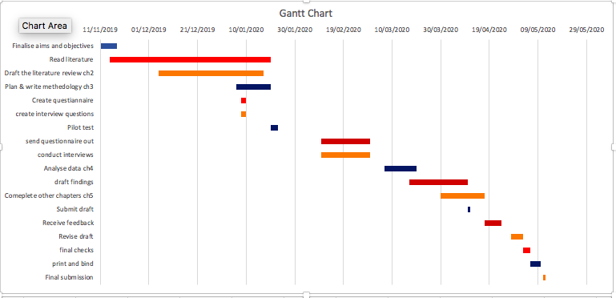

7.Ethics and risks
The research project is low risk as the chosen topic for this study will not offend anyone who takes part in the research or to the researcher or the university. Saunders (2016) states that people should feel the right to have privacy and if they feel uncomfortable then they should not partake. For the interviews, the participant will need to give consent to the researcher in order to conduct the interview. No one will be named either in participating. Equally to the questionnaire, they do not have to participate they do not feel comfortable with the questions. One problem that can occur if there is a non-response due to the connections with MUUK-Adventures although this risk is minimal. Additional time has been made in the Gantt chart should adaptions for this research needs to be carried out.

8. References

Bladen, C., (2012). Events management an introduction 1st ed., London ; New York: Routledge.
Bowdin, G., Allen, J., Harris, R., McDonnell, I., & O'Toole, W. (2011). Events management (3rd ed)., Oxford: Elsevier Butterworth-Heinemann.
Bryman, A. & Bell, E., (2007). Business Research Methods (2nd ed). Oxford: Oxford University Press.
Collins, J & Hussey, R. (2003)., Business research a practical guide for undergraduate and postgraduate students. (2nd ed) Palgrave Macmillan Higher Educaton, Hampshire.
Dudovskiy, J., (2018)., Research Methodology. [online]. Available: https://research-methodology.net/research-philosophy/ (accessed: 17, November, 2019).
Etikan, I, Abubaka, S-M, Alkassim, R-S (2015)., Comparison of Convenience Sampling and Purposive Sampling. American Journal of Theoretical and Applied Statistics. Vol. 5, No. 1, 2016, pp. 1-4.
Gabriel, D., (2013)., Inductive and Deductive approaches [online].
Getz, D., (2007)., Event studies: Theory, research and policy for planned events (1st ed)., Amsterdam ; London: Elsevier Butterworth-Heinemann.
Maslow, A. H., (1943)., A Theory of Human Motivation, Psychological review. Journal Psychological Review., 50. (4), pp. 370-396.
McCuskar, K & Gunaydin, S., (2014)., Research using qualitative, quantitative or mixed methods and choice based on research. Perfusion, 30(7), 537–542.
MUUK-Adventures (2019)., ‘MUUK-Adventures [online]. Available at: www.muuk-adventures.com (Accessed: 1, November, 2019).
Richards et al (2013)., Exploring the social impacts of events. London: Routledge.
Saunders, M., Lewis, P. & Thornhill, A., (2012)., Research methods for business students 6th ed., Harlow: Pearson.
Saunders, M.,Lewis P & Thornhill, A., (2009)., Research Methods for Business Students. (5th ed). Essex: Pearson Education Limitied.
Saunders, M. Lewis, P, & Thornhill, A., (2007)., Understanding Your Research. (4th ed), Research Methods of Business Students. Harlow: Person Education Limited.

Veal, A.J., (2011)., Research methods for leisure and tourism : a practical guide 4th ed., Harlow: Financial Times Prentice Hall.
Yürük, P., Akyol, A. & Şimşek, G.G., (2017)., Analyzing the effects of social impacts of events on satisfaction and loyalty. Tourism Management, 60, pp.367–378.

