Design Testing and Evaluation

Testing was the most important part of this project. It was going to give an insight into whether or not I had designed my prototypes in such a way that they were easy to use and appropriate for people with finger limiting disabilities. Although most of my testers didn't have finger limiting disabilities their input was still as valid as those with finger limiting disabilities.

Phase 1: Initial testing

After my initial research I was given a product by a friend (Research name Spartan) to improve, it was something I could look at to compare and contrast my own prototypes with. This benchmark was useful to have with me throughout the design stages as well as the testing stages.
Spartan and I evaluated the product she had bought. I wanted to compare what we thought of it and why we liked or disliked it. I knew that Spartan didn't like the product from the start but I didn't know to what extent she didn't like it.
With the list of issues she had being so long I had to test it myself to see if there were more issues that Spartan had missed. She had given up on using the product very quickly because it wasn't fit for purpose. I had to perform empathy testing to see how unfit for use the product was.
Empathy testing was something I was dubious about before I tried it myself for this project. However, after the fact it was one of the most useful methods of testing that I used during this project. My own testing of the product showed that Spartan had not been exaggerating about how bad it was. The testing was what gave me the criteria and specification for my own product. I now knew what to add, remove and improve upon. Empathy resting become the most important thing I did during this project. It changed the whole way I thought about the design and it genuinely gave me a new appreciation for how not testing a product sufficiently can lead to a product that should never be sold.

Phase 2: Prototype Testing

After having a criteria for my own product I was able to produce prototypes. What I wanted to create were prototypes that fit with the need of Spartan, since she is a target user. She was going to provide the most useful data in regards to the products suitability but the other members of my testing group would also be able to provide information and feedback based on the suitability for themselves. I had hoped before testing my own prototypes that the results I would collect from the other testers would provide information that backed up my theory that the prototypes were less useful for those who had better finger dexterity and grip.
I tested the prototypes by giving the testers one at a time and a potato to peel. They would have the choice of whatever tool they wished to peel with, standard potato peeler, vegetable peeler or a knife. They were told to peel the potato in its entirety, using the board without my guidance but they may ask questions if they needed to. Thankfully no one needed to ask questions about the use of the board.
The prototypes are shown below and will be referred to by the labels given below them. They were tested in order Prototype 1, Prototype 2 and last Prototype 3.
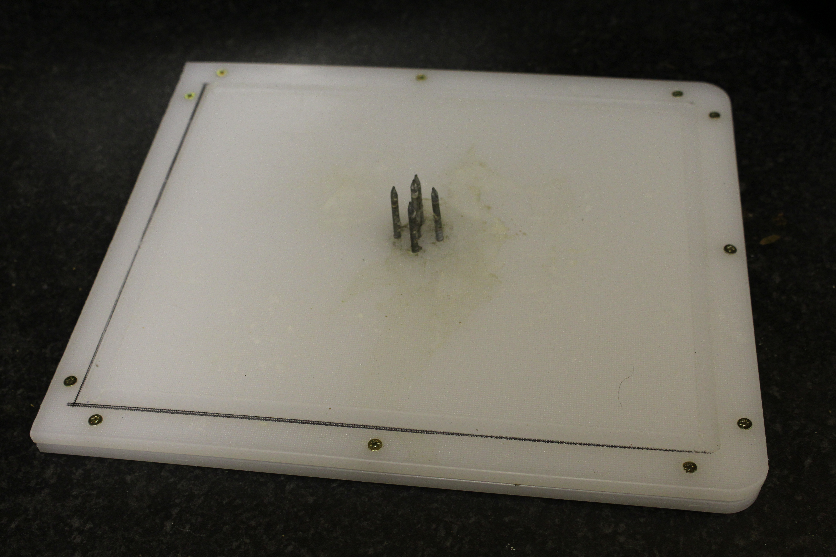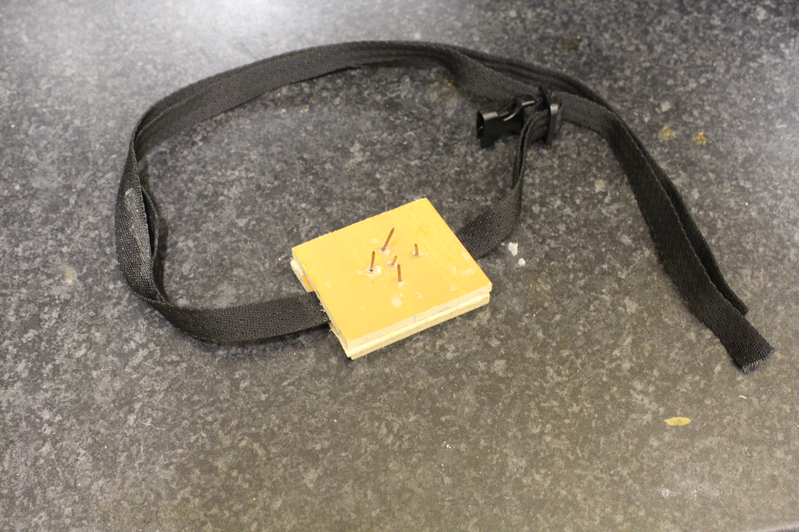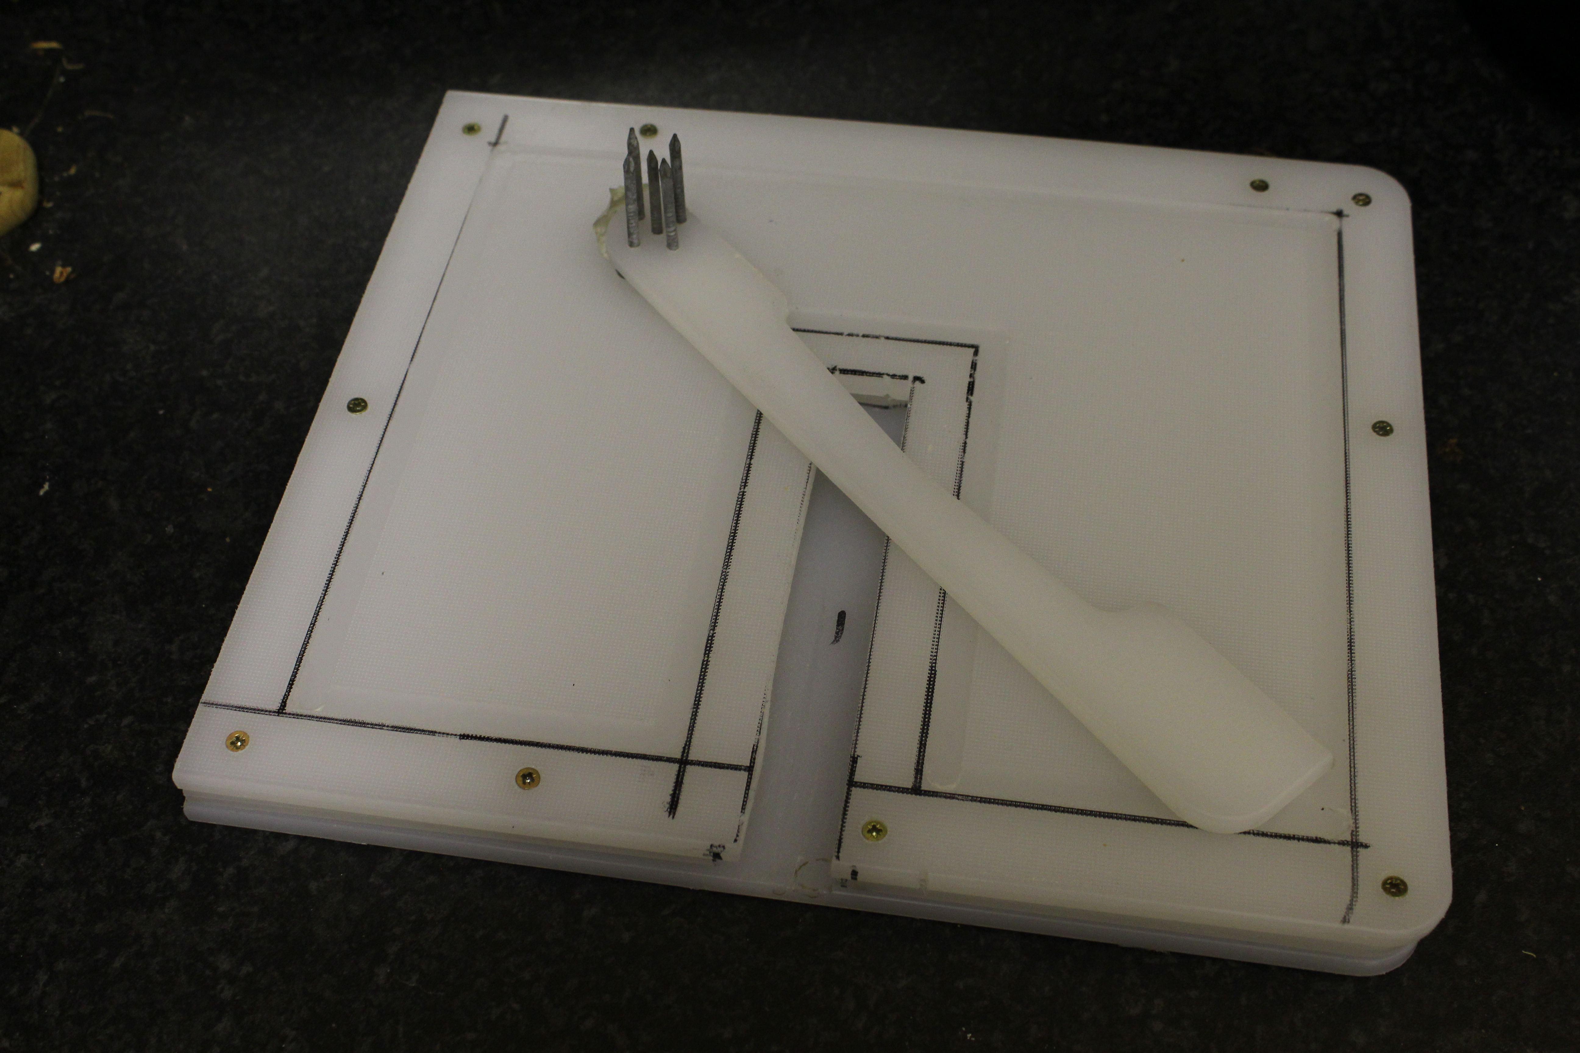

Prototype 3
Prototype 2
Prototype 1

Spartan

I started by giving Spartan Prototype 1 and not revealing the other prototypes to her. Prototype 1 was the prototype where I only addressed the issues she and I had with the original product. It was important to see her reaction and evaluate the fact that I had only fixed the issues she had.
Her initial reaction was overwhelmingly positive. She was happy to see that all her problems had been addressed and that the board wasn't too heavy either. She found that the board was easy to use and that all of what should have been on the one she had purchased was there. It worked as intended and she was happy with the prototype.
Prototype 2 worked almost the exact same as Prototype 1. Spartan found that the removable section fit into the board without hassle but didn't move about. The weight was a bit of an issue for her since the prototype was so thick.
The third prototype was a complete surprise to her. She had not thought that a solution to her problems could be addressed by such a small product. Spartan voiced concern before she used it about it moving about on her chopping board despite being tightly strapped down. However, as soon as she started to peel a potato she could see that she had no need to worry. The prototype stayed secured tight to the chopping board she had attached it to. The potato was peeled in no time and she was amazed by it saying that it was her favorite of the three.
To measure up the three against each other I had prepared a small evaluation for my testers to fill out. She was asked to rate out of 5 (1 being very negative and 5 being not very positive) the prototypes separately in different categories I personally deemed important. the results are shown below.
 | Prototype 1 | Prototype 2 | Prototype 3
Size when in use | 5 | 5 | 5
Size for storage | 4 | 4 | 5
Ease of use | 5 | 5 | 5
Safety when in use | 4 | 4 | 4
Safety when stored | 3 | 4 | 4
Suitability for yourself. | 5 | 5 | 5

Spartan's results proved that I had thought through what I had needed to in the design phase. Prototype 2 and Prototype 3 were built off of Prototype 1 and although Prototype 2 wasn't as successful with Spartan as prototype 3 I was happy with the results that I had received from her.

Monarch
Monarch was chosen as a hopeful intermediary to Spartan and my other test subjects. She has arthritis developing in her fingers, so her dexterity is not what it used to be and she does have some minor pain when holding items. Monarch was having some pain with her fingers that day, so it was a perfect time to test. Her results are shown below.
 | Prototype 1 | Prototype 2 | Prototype 3
Size when in use | 5 | 5 | 4
Size for storage | 4 | 4 | 5
Ease of use | 5 | 5 | 4
Safety when in use | 5 | 5 | 5
Safety when stored | 4 | 5 | 5
Suitability for yourself. | 3 | 3 | 3

Monarch didn't like the look of Prototype 3 before she tried it and admitted that her prejudice against it had made her like it less while she was using it but did think that it was as good as the rest and that it would suit other people well. Monarch also admitted that she would like to have one of the prototypes in the future if her fingers got worse.

Prometheus
 | Prototype 1 | Prototype 2 | Prototype 3
Size when in use | 4 | 4 | 4
Size for storage | 3 | 3 | 4
Ease of use | 4 | 4 | 4
Safety when in use | 4 | 4 | 4
Safety when stored | 2 | 3 | 4
Suitability for yourself. | 1 | 2 | 2
Prometheus is young and doesn't have any issues gripping or holding small items. She was not part of my target audience but her input allowed me to show that people without disabilities linked to the hand would most likely not need to buy or use my product. She also has a nervous disposition so she was worried about injuring herself on the spikes.

Prometheus was initially nervous about using the boards because of the open spikes. She was concerned that she could injure herself on them when placing the potato on. However, after the testing she felt more comfortable with them and didn't mind them as much as before she used them. She agreed that the product didn't suit her.
Olympus
Olympus has a very busy life. She has family who are constantly at her house and she often cooks for her grandson as well as her husband. Sometimes with her grandson, her daughter's dog visits too, so safety was the primary concern of Olympus. She left her normal chopping board out on the counter when it was not is use so she would want to do the same with my boards too.
 | Prototype 1 | Prototype 2 | Prototype 3
Size when in use | 3 | 3 | 5
Size for storage | 4 | 4 | 5
Ease of use | 4 | 4 | 5
Safety when in use | 4 | 4 | 4
Safety when stored | 1 | 5 | 5
Suitability for yourself. | 1 | 1 | 1

She liked how Prototype 2 and Prototype 3 could be stored in such a way that the spiked parts of the product were out of harm's way of children and animals. Prototype 3 was her favourite by far because she felt that she could store it in such a way that it could be out of reach her grandson. She was very enthusiastic about the prototypes, particularly Prototype 3 which she liked because it raised the potato off the board enough that she only had to rotate the potato once to peel all of it.

Bismarck
Bismarck is a student who has lived with many different house mates. His prime concern was, in his position, that other housemates may be searching through his draws to borrow a kitchen utensil and injure themselves on the products. As well as this, limited space was a factor.
 | Prototype 1 | Prototype 2 | Prototype 3
Size when in use | 4 | 4 | 5
Size for storage | 3 | 3 | 5
Ease of use | 5 | 5 | 5
Safety when in use | 5 | 5 | 5
Safety when stored | 3 | 4 | 4
Suitability for yourself. | 1 | 1 | 1

Bismarck liked the prototypes but commented that without a cap to cover the spikes there was the possibility of a house mate not knowing about the board and injuring themselves on it. He has also had issues with housemates using items they shouldn't and reaching into draws that don't contain their stuff so was worried about the safety of the boards when stored.

Odin
 | Prototype 1 | Prototype 2 | Prototype 3
Size when in use | 3 | 3 | 4
Size for storage | 2 | 4 | 4
Ease of use | 4 | 3 | 4
Safety when in use | 3 | 4 | 3
Safety when stored | 4 | 4 | 4
Suitability for yourself. | 1 | 1 | 1
Odin is also a student but cooks far less frequently than Bismarck does, he also doesn't have any finger limiting disabilities. He had some worries about the storage of the boards, which is understandable, considering that he had limited storage space too.

Odin voiced the same concerns as Bismarck about housemates injuring themselves on the boards.

All of my test subjects liked the boards and agreed that they would be appropriate for people with issues gripping and holding objects, most could name at least one person they knew who could benefit from my prototypes. However, as I had expected, all those without issues holding and gripping found that the boards were not appropriate for themselves. The third board was the favourite of all apart from Monarch.
However, there were a couple of issues with my research that I wish I had addressed. I wish I had been able to have a second person with the relevant disabilities to test my prototypes so that I could have more data to back up what I had done. I also wish I had been more thorough with writing down the comments of the testers. One thing that they all brought up, which I agreed with, was the possibility of a cap for the spikes, this could be taken as further development of my prototypes. More of these comments should have been recorded for later review.
I also wish that I could have spent more time with my testing group but they were unavailable to me a lot of the time. I was unable to spend as much time as I would have wanted to with them and know that I would have much more accurate data if I had had the time I wanted. But even though what feedback did collect from them was sufficient for my purposes, I should have strived for more.
In conclusion the research fulfilled its purpose but should have been undertaken in a much more thorough manner. I should have noted more of the comments from the testers so that if I revisited or continued this project I would have more copious notes to look over. From the results I got I had clearly designed prototypes that were appropriate for the end users. Overall, I was happy with my results and found them insightful and interesting. My test group provided me with all that I needed to prove that the prototypes I made were fit for purpose.

