University of Wales Trinity Saint David
Wales Institute of Science & Art



Undertaking a Green Belt Project

Six Sigma Green Belt (ACMA5005)

Word count (5084)

Parry Phillips
2011664
May 2026

Table of Contents
Table of Figures 2
Introduction 3
Define 4
Problem Statement 4
Process Mapping 5
Voice of the Customer and Critical to Quality Tree 7
Project Charter 9
Measure 10
Data Collection 10
Pareto Analysis 12
Analyse 13
Fishbone Analysis 13
Five Why’s Analysis 14
Improve 18
Brainstorming and Pay Off Matrix 18
Pugh Matrix 20
Cost Base Analysis 21
FMEA Improved Plan 23
Future State Process Map 24
Pilot Proposals 25
Control 26
Control Plan Framework 26
Exception Report 27
Updates to be rolled out in workplace 28
Conclusion 29
Bibliography 0

Table of Figures
Figure 1. Current LO / LC Register on Desktop Excel Spreadsheet 5
Figure 2. Current Process Map 6
Figure 3. VoC Displayed in Table 7
Figure 4. Project Charter 9
Figure 5. Data Collection Plan 11
Figure 6. Recorded Data from documentation. 11
Figure 7. Pareto Analysis 12
Figure 8. Fishbone Analysis 14
Figure 9. Five Why's Analysis 15
Figure 10. FMEA Analysis 16
Figure 11. Brainstorming and Pay-Off Matrix 19
Figure 12. Pugh Matrix 20
Figure 13. Cost Base Analysis for automatic sensor system 21
Figure 14. Cost base analysis for tablet system 22
Figure 15. FMEA Improve Plan 23
Figure 16. Future Process map 24
Figure 17. Control Plan 26
Figure 18. Exception report tied to register, highlights clear errors. 27

Introduction
Dragon LNG operates within the energy sector, managing the transfer, storage and processing of liquified natural gas at the UK based terminal (Dragon LNG, 2024). Such facilities form a critical part of national energy infrastructure, handling large quantities of LNG under tightly controlled conditions. Due to the nature and scale of operations, the site is classified as an upper-tier COMAH (Control of Major Accident Hazards) site, requiring strict compliance with the COMAH (2015) regulations (Dragon LNG, 2024). These regulations enforced by the Health and Safety Executive, mandate that the terminal must implement all necessary measures to prevent major accidents and limit their consequences to people and the environment (HSE, 2025). A fundamental requirement of COMAH compliance is the demonstration of robust safety management systems, safe procedures, and full traceability of safety-critical operations (HSE, 2025). Within this context, valves designated as Locked Open (LO) or Locked Closed (LC) play a vital role in maintaining safe plant configurations. These valves are often integral to isolation boundaries, safeguarding maintenance activities, and ensuring that process systems operate within defined safety parameters. Consequently, maintaining an accurate and up-to-date LO/LC register is essential for both operational integrity and regulatory compliance.

At present, the LO/LC valve register is maintained via a desktop-based document, requiring operators to manually update valve positions following field activities. This process introduces a reliance on delayed data entry and operator memory, occasionally during periods of high operational demand. As a result, updates are not completed in real time and, in some instances, are omitted entirely. This creates discrepancies between the physical state of the plant and the recorded system status, undermining the reliability of the register as a safety-critical control measure and potentially compromising compliance with regulatory expectations. In parallel, Six Sigma principles emphasise the importance of reducing variation and eliminating defects within processes (Abualsauod, 2025). The aim of this project is to improve the accuracy of the LO/LC valve register by reducing missed updates and minimising delays in data entry. This will be achieved through the application of the Six Sigma DMAIC (Define, Measure, Analyse, Improve, Control) methodology to identify root causes of process failure, quantify current performance, and implement a robust, error-resistant solution (Ilin and Bohlen, 2023).

Define

The design phase is the first step within a Six-Sigma project, Monday (2022) and Mittal et al (2023) suggest that the design phase ultimately consists of three major steps which are identification of the problem, understand the projects objectives and identify the customer requirements. These elements are essential in translating operational issues into measurable improvable goals and ensure that the project delivers value.

The following sections will therefore define the problem in measurable terms, map the current process to identify the problems, translate project requirements into Critical to Quality (CTQ) characteristics, and establish a clear project scope and charter.

A strong problem statement is critical to ensure buy in by those that are backing the change. The statement should utilise information such as where the problem occurred, when did the problem happen, what process did the problem involve, how is the problem measured and how much is the problem costing. These questions should be answerable by the person reading the problem statement (The Council for Six Sigma Certification, 2018).

Problem Statement
The Six Sigma project problem statement is as follows. “The current Locked Open / Locked Closed (LO/LC) valve register is a register that is cross-referenced against the piping and instrumentation diagrams (P&ID) of the plant during the design phase, where valves have been identified as safety critical and the current valve position needs to be recorded for safe operation and regulatory compliance. The register is currently maintained via a desktop based excel spreadsheet, requiring manual updates following alterations to valve positions by the process operator. The current process introduces significant delays between valve position changes and the valve register being updated and, in some cases, results in the updates being completely omitted. Due to reliance on the operator to update the register on a desktop which could be a significant amount of time till the operator has downtime to access a desktop which leads to late updates or even missed updates”.

Figure 1. depicts the current locked open locked closed register used by the process operator.

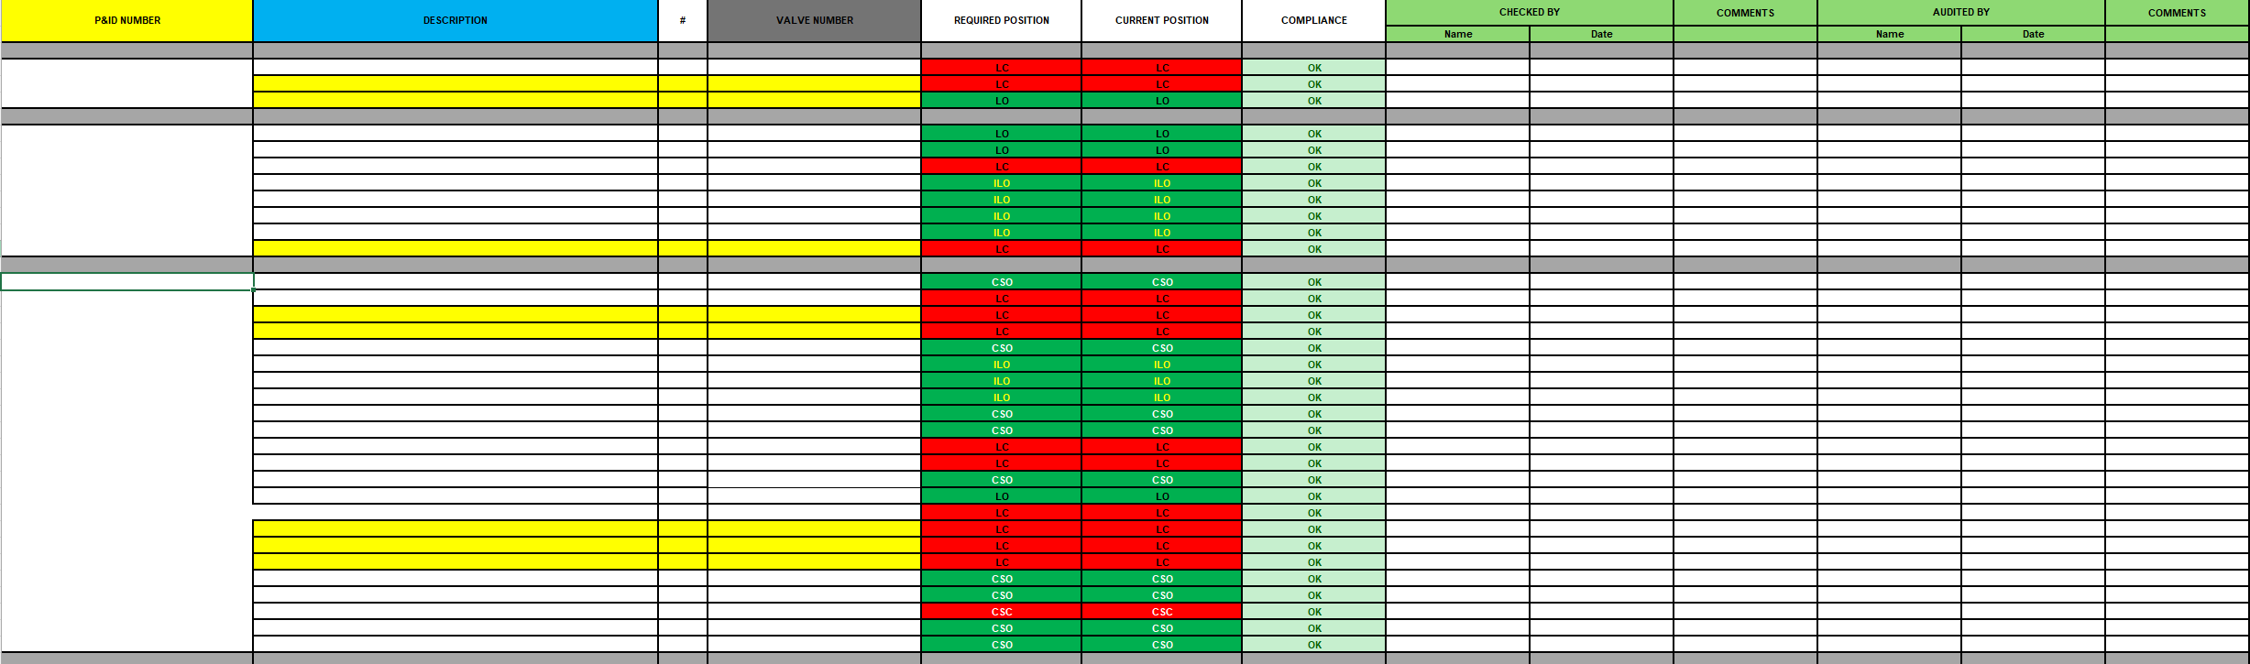
Figure 1. Current LO / LC Register on Desktop Excel Spreadsheet

Process Mapping

The process map identified in figure two highlights the current operating standard used by the process operator. The process map identified in Figure 2 highlights the current operating standard used by the process operator. The function of a process map is to identify the start of the process, the key process steps, decision points, handoffs and the end point of the process. Damelio (2011) explains that process mapping helps organisations understand how the work flows in the field, rather than how it is assumed to flow. This is particularly important in improvement projects because process maps can reveal delays, decision points and failure pathways that may not be obvious from procedures alone. Six Sigma utilises standardised symbols which represent an action (Van Den Berg, 2021) which can be identified by the user of the map.
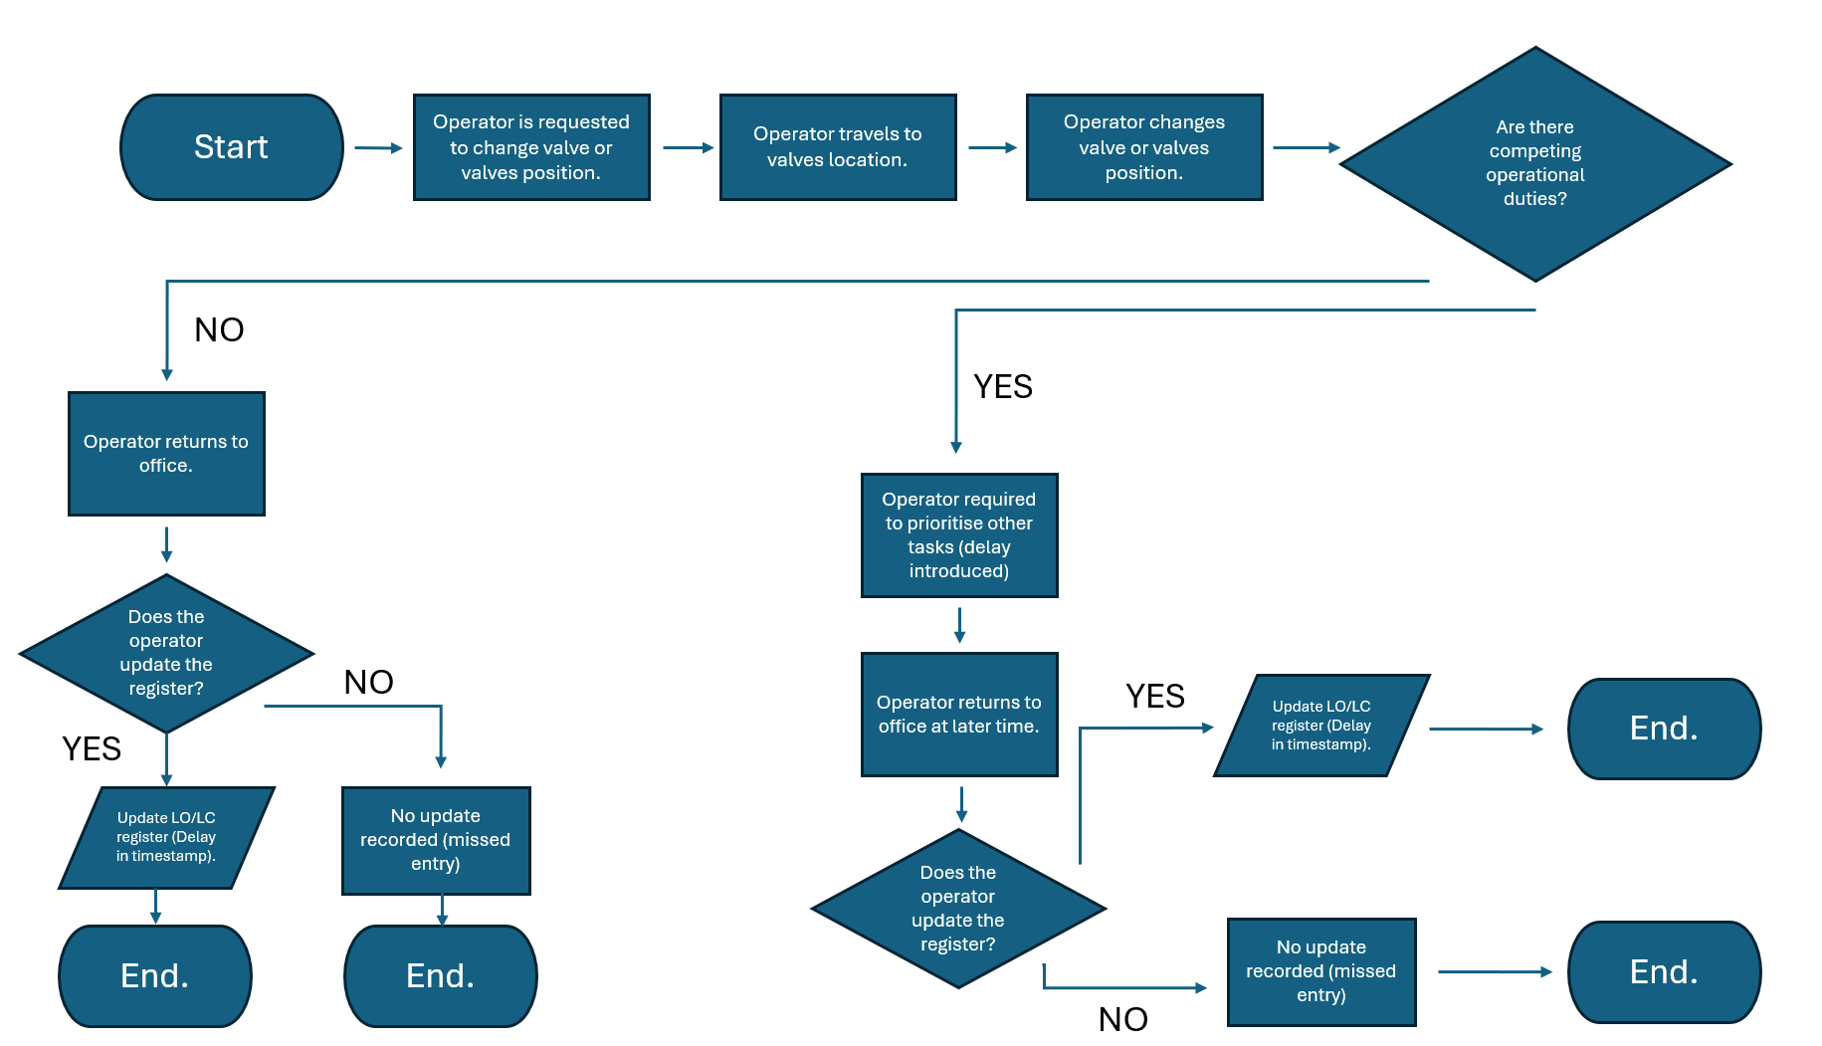
Figure 2. Current Process Map

The takeaway from the process map indicates that the current LO/LC register system is characterised by the following:

- High dependency on human memory and initiative with no prompt.
- Variable delays driven by competing operational priorities.
- Lack of enforced workflow or mandatory completion steps.
- Absence of real-time data capture.
- No error detection or feedback mechanisms.

Reason (2002) suggests the causes of inaccuracy are likely to be embedded within the process design rather than being solely attributable to individual operator performance.

Voice of the Customer and Critical to Quality Tree
The Voice of the Customer (VoC) is a methodology for capturing the requirements of all affected by a process. The VoC data is translated into measurable Critical to Quality (CTQ) markers. Found and Harrison (2012) emphasise that CTQ characteristics must be expressed as measurable specifications rather than qualitative preferences, to enable objective assessment of whether the process is meeting customer requirements.
For this project, VoC inputs were gathered from four key stakeholder groups through questioning each individual or team. Their requirements were translated into CTQ specifications as presented in figure 3.
Figure 3. VoC Displayed in Table
The Shift Supervisor’s requirement for register accuracy and timeliness directly supports the Operations Manager’s requirement for process compliance, which in turn provides the evidence for the HSE team requirement for a complete and timestamped audit trail.
This hierarchical structure confirms that the CTQ requirements are mutually reinforcing because a process that achieves real-time update within five minutes will simultaneously satisfy all three groups.
Critically, the fourth CTQ row captures the Voice of the Customer from the perspective of the user of the current system. Their request was a fast, simple update mechanism accessible at the point of valve activity in the field.
The CTQ requirements identified in this phase provide the basis for the Measure phase, where update compliance, delay, missed entries and traceability will be quantified.
Project Scope
Khan (2006) states that defining a clear and agreed scope boundary is essential in preventing scope creep and ensuring that project resources are focused on improvement of the system .The scope for this project is defined as follows.
In scope:
- The LO/LC valve register update process, from the point of a valve activity being completed in the field through to the recording of that activity within the register.
- All methods, tools, and operator behaviours associated with making, verifying, and auditing register entries.
- All shifts and all operator grades involved in LO/LC valve activities.
- All 624 LO/LC designated valves on site.

Out of scope:
- The physical condition, specification, or maintenance of LO/LC valves.
- Associated documentation.
- The quarterly outside operator audit and the shift supervisor’s 25% verification process.

Project Charter
Mckeever (2006) establishes the project charter as the formal document that authorises the project, defines its objectives and boundaries, and establishes accountability for delivery. The project charter serves as the primary reference document for all subsequent phases of the DMAIC cycle and provides the basis against which improvement success is measured (Mckeever, 2006). Figure presents the project charter for this Green Belt project. It utilises some data established from each phase to help identify what the project needs to achieve and how this success can be measured against the data.
Figure 4. Project Charter

Measure

The purpose of the Measure phase is to establish the current performance of the LO/LC valve register process before any improvement is implemented. Pyzdek (2003) explains that the Measure phase provides the factual and data driven baseline required to understand process capability, quantify defects and support later comparison after improvement. The key focus was to measure whether valve activities were recorded accurately, whether updates were completed within the required timeframe, and whether any valve movements were missed.

Data Collection
A data collection plan was developed to ensure that the measurement approach was consistent and repeatable. The effectiveness of data collection requires clear operational definitions, identified data sources and a consistent method of recording, otherwise measurement variation can distort the understanding of process performance (Phillips and Stawarski, 2018). The data was collected by the project lead and E Shift supervisor Stefan Ashby who champions the register. Relevant documentation such as the LO/LC register was cross-referenced against mechanical process isolation certificates, maintenance procedures, and operator logs to identify what valves had been operated and at what time as the operator signs for movement of valve. This approach allowed valve activities to be compared against register entries to determine whether the process met the required Critical to Quality (CTQ) standard.

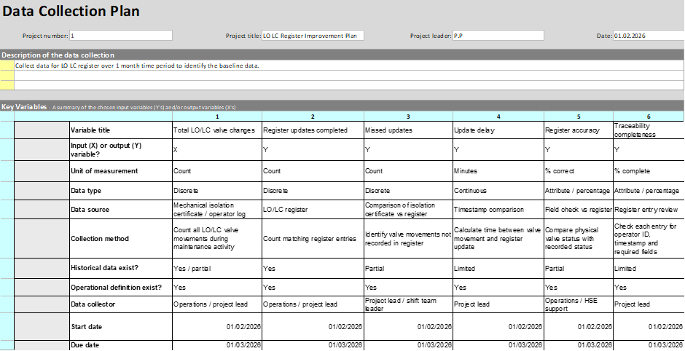
Figure 5. Data Collection Plan

The data collection plan includes discrete data being the number of compliant updates, delayed updates and missed updates. It also includes continuous data, such as the time delay measured in minutes between the valve being operated and the register being updated. The discrete data shows how often the process failed, while the continuous data shows how much the delay varied between activities.

The following data was extracted from the relevant documentation and recorded in figure 6 .
Figure 6. Recorded Data from documentation.

A one-month observational study based off the data collection plan recorded 124 valve activities and revealed that 84.7% failed to meet the Critical to Quality (CTQ) threshold of the register being updated correctly within 30 minutes of valve being operated. Seventeen operated valves (13.7%) had no register entry, sixteen involved valves confirmed to be in the correct physical position. Finally, one valve was in the wrong position and had no timestamp or signature associated to the valve’s movement. The relevant calculations were then completed to determine the sigma value and Defects Per Million Opportunities (DPMO). DPMO is a standard Six Sigma measure used to compare process defect performance by normalising defects against one million opportunities (DeLadurantey, 2023).

Pareto Analysis
To further interpret the baseline data, a Pareto chart was produced using the three defect categories. Powell and Sammut-Bonnici (2014) explain that Pareto analysis helps identify the vital few contributors that account for the majority of process problems, allowing improvement effort to be focused where it will have the greatest effect. The Pareto analysis confirmed that delayed updates were the dominant contributor to poor process performance, accounting for most defects. However, after a discussion with shift supervisor Stefan Ashby (2026), the missed update categories, while lower in frequency, were considered higher in risk because they resulted in a complete absence of traceability. This distinction is important because improvement actions must address both the frequency issue of delayed updates and the significance issue of missed entries.
Figure 7. Pareto Analysis

Analyse

The purpose of the Analyse phase is to identify the underlying causes of delayed and missed updates within the Locked Open / Locked Closed (LO/LC) valve register process. The Measure phase established that the current process is affected by variation in update timing, incomplete data entry, and reduced compliance. The Analyse phase therefore focuses on determining why these defects occur and which factors contribute most significantly to poor process performance (Pyzdek, 2003).

Within Six Sigma, the Analyse phase is used to move beyond symptoms and identify root causes of process failure. Pyzdek, (2003) argues that effective Six Sigma improvement depends on understanding variation and identifying the process conditions that allow defects to occur. In this project, a defect is defined as either a valve position change that is not recorded in the LO/LC register, or a valve position change that is recorded after an unacceptable delay.

The current process map demonstrates that the LO/LC register update is separated from the physical valve operation. The operator changes the valve position in the field, but the register can only be updated when the operator returns to the office or control room. This separation creates a time gap between the physical action and the administrative record. Where the operator has no competing duties, the delay may be relatively short. However, where other operational priorities exist, the update may be significantly delayed or missed entirely. This reflects Reason’s (2000) system approach to human error, which argues that errors are often created by the conditions in which people work rather than by individual carelessness alone.

Fishbone Analysis
Root cause analysis was carried out using a fishbone approach depicted in figure 8. Ishikawa (1986) introduced the cause-and-effect diagram as a method for organising potential causes of a problem into structured categories, helping teams explore how different factors contribute to process failure. For this project, the key cause categories are people, process, technology, environment, measurement, and management.
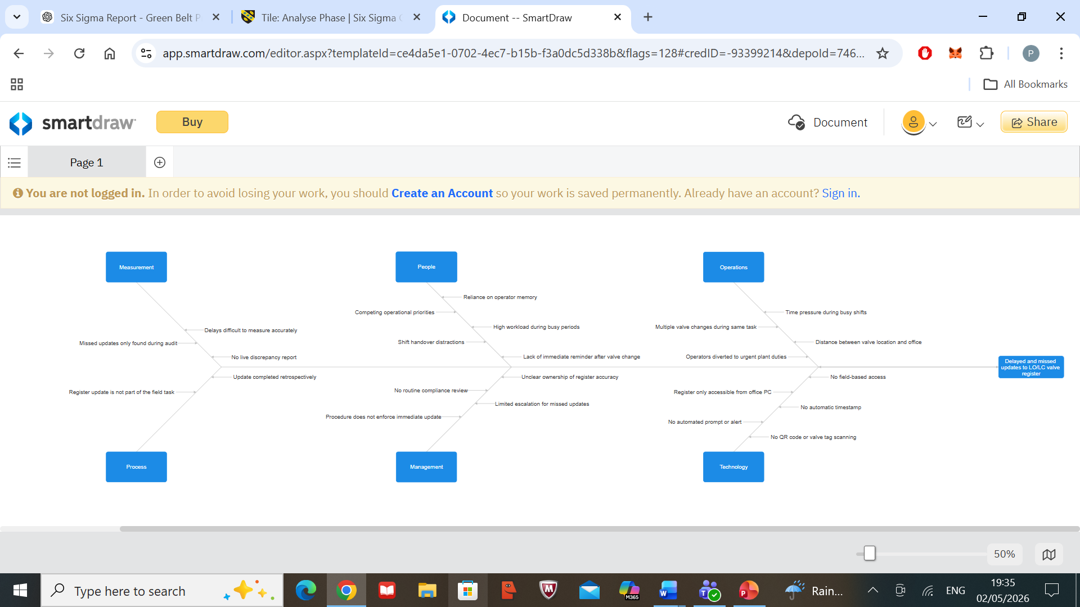
Figure 8. Fishbone Analysis

The analysis suggests that the main causes are not isolated to one category but are spread across the system and fails on multiple fronts.

The fishbone analysis therefore supports the view that delayed and missed updates are systemic rather than behavioural. Although the immediate symptom may appear to be an operator failing to update the register, the wider causes are rooted in process design and lack of control. The current process does not provide a prompt, warning, or enforced workflow to ensure the register is updated. This means the process can reach an end point even when the critical data entry step has not been completed.

Five Why’s Analysis
A Five Whys analysis was also used to examine the issue of missed updates in greater depth. Ohno (1988) describes repeated “why” questioning as a method for moving beyond surface symptoms and identifying the underlying cause of a process problem (Lean Enterprise Institute, 2025). The first question asks why LO/LC register updates are missed. The immediate answer is that operators do not always update the desktop register after changing valve positions. The next level of questioning shows that this occurs because operators may be required to complete other duties before returning to the office. This then leads to the question of why competing duties result in missed updates. The answer is that the process relies on the operator remembering to complete the update later. The deeper root cause is therefore that the register is not available at the point of work and there is no mandatory workflow control requiring the update to be completed before the task is closed.
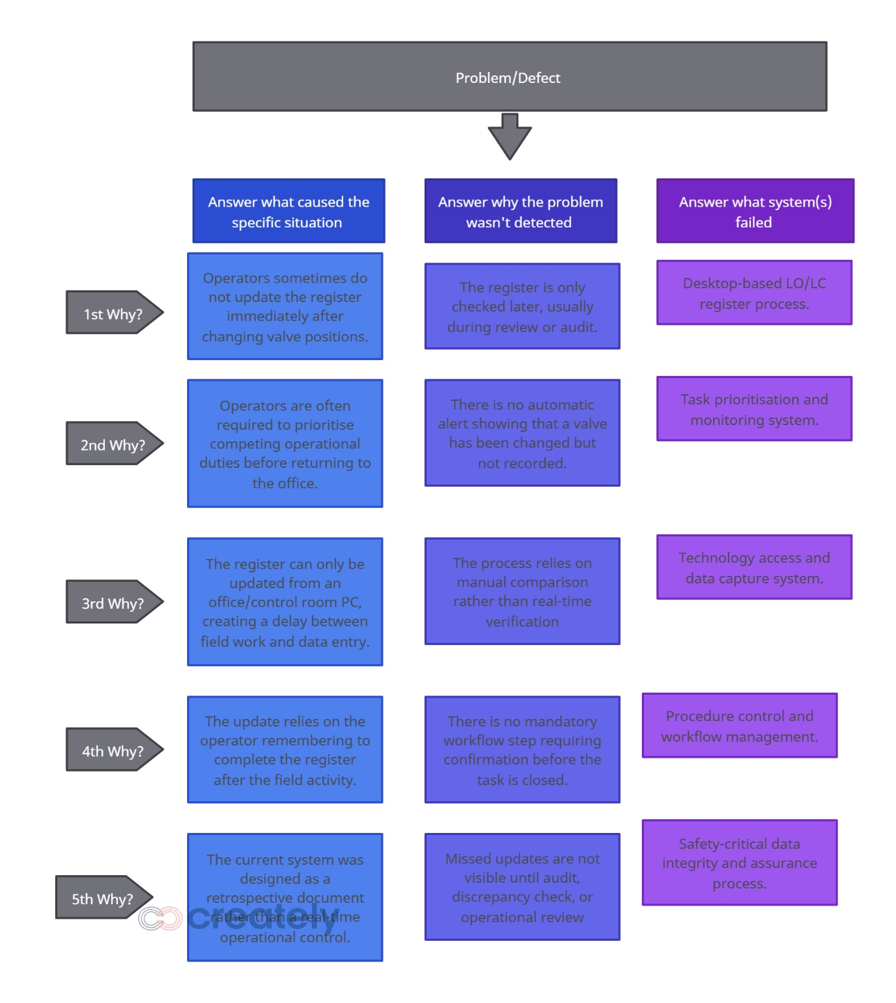
Figure 9. Five Why's Analysis

FMEA Analysis
Following the Fishbone Diagram and 5 Whys analysis, a Failure Mode and Effects Analysis (FMEA) was completed to prioritise the risks identified at each step of the process. The Fishbone Diagram provided a broad overview of potential causes, while the 5 Whys helped identify the underlying root cause of the process failure. However, these tools do not quantify the relative risk of each failure mode. The FMEA was therefore used to assess each failure mode in terms of severity, occurrence and detection. This enabled the project to prioritise the most significant risks and ensure that improvement actions were focused on the failure modes with the highest potential impact on safety, compliance and process reliability (El-Awady, 2023)
Figure 10. FMEA Analysis
.

The FMEA demonstrated in figure 10. that the highest-risk failure mode was a completely missed register update, with an RPN of 432. This was driven by the high severity of inaccurate valve status information due to the likelihood of omission during busy operational periods, and weak detection controls within the current process. Delayed updates also scored highly, with an RPN of 336, confirming that update timeliness is a major source of process risk. Overall, the FMEA showed that the current controls are largely procedural and dependent on operator memory, with limited immediate detection of missed or incorrect entries. This supports the conclusion that the process requires redesign rather than further reliance on training or retrospective audits.

Improve

The Improve phase focuses on generating, selecting and testing solutions that address the verified root causes of poor process performance (Pyzdek, 2003). This phase began with a structured brainstorming exercise involving the project lead and shift supervisor Stefan Ashby (2026) who champions the LO / LC register. The aim was to think of improvement ideas that addressed the root causes identified during the analyse phase (delayed register updates, missed entries, reliance on operator memory, weak traceability and poor detection of errors). Tague (2004) identifies brainstorming as a useful quality improvement tool for generating a broad range of ideas before narrowing them through structured selection methods, it allowed the team to consider several practical and technical options before deciding which solution should be developed further. This was important because the issue was not caused by one single failure, but by a combination of process and people weaknesses.

Brainstorming and Pay Off Matrix
The brainstorming output is shown in Figure 11. These ideas were reviewed using a pay-off matrix, which ranked each option by likely impact and implementation effort. This helped separate quick wins from higher cost engineering solutions which is tool commonly used in Six Sigma projects (Peterka, 2024).

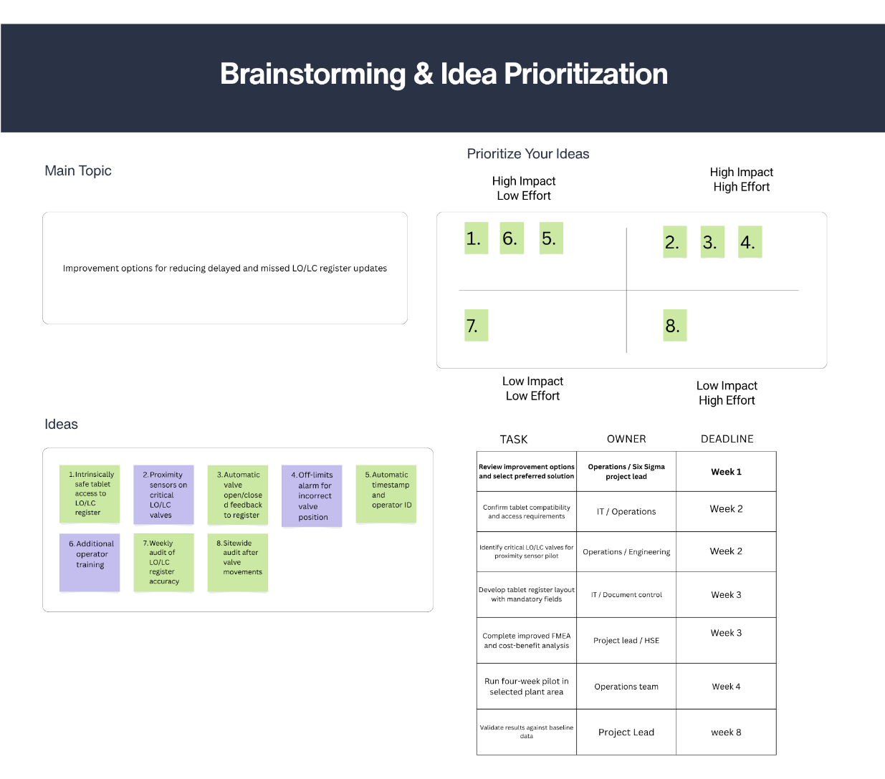
Figure 11. Brainstorming and Pay-Off Matrix

The payoff matrix showed that many individual ideas could be combined into two main improvement routes. The first route was a tablet-based register accessed from an intrinsically safe device at the job site. This option could include mandatory fields, named operator identification, and automatic timestamps. The second route was an automatic valve sensor system, where valve position feedback would be transmitted to the register. This option could include open/closed status feedback and off-limits alarms if a valve was detected outside its permitted position.

The team agreed that these two options were the most relevant because they both addressed several causes identified during the Analyse phase. Both options would reduce reliance on the operator returning to an office PC, improve traceability and reduce the risk of missing updates. However, the team also recognised that they represented very different levels of cost, complexity and implementation risk. The tablet option mainly changes how the register is accessed and completed, while the sensor option requires physical instrumentation, installation, testing and integration with site systems.

Pugh Matrix
To support objective decision-making, a Pugh Matrix was completed, shown in Figure 12 . Pugh (1991) developed the decision matrix approach to compare alternative design concepts against agreed criteria, supporting structured and transparent solution selection.
Figure 12. Pugh Matrix

The baseline was the current desktop-based LO/LC register. The two alternatives were then compared against criteria. The Pugh Matrix showed that both options were better than the current process in terms of reducing delays and improving traceability. However, the tablet-based register scored higher because it was easier to implement, more cost effective, quicker to pilot and more suitable for the Green Belt scope.

The automatic valve sensor system scored positively for technical performance because it would provide direct valve position feedback and further reduce human input. However, it scored poorly against cost effectiveness, process area complexity, maintenance and speed of implementation. This was because installing sensors on LO/LC valves would require new infrastructure, commissioning, proof testing and ongoing maintenance. These requirements make the option more complex than a tablet-based register.

Cost Base Analysis
A cost-benefit analysis was then used to support the decision. Cost-benefit analysis supports decision-making by comparing the expected costs of an intervention against the financial and non-financial value it is expected to deliver (Hessing, 2014). As shown in Figure 13. the estimated non-recurring cost for the sensor option was approximately £217,980. This confirmed that, although technically strong, the sensor system was disproportionate for the initial improvement phase. It would be more suitable as a future capital project for the most safety-critical valves rather than as a Green Belt improvement project.
Figure 13. Cost Base Analysis for automatic sensor system

The cost-benefit analysis shown in figure 14. for the tablet-based option further supports the outcome of the Pugh Matrix. The estimated non-recurring implementation cost is relatively low. The projected cost savings are mainly through providing the operations team to dedicate workload elsewhere as the register updates can average up to three hours workload when updating the desktop document. Although the project does not generate direct revenue, the analysis demonstrates that the tablet-based register provides a positive financial case while also delivering important non-financial benefits, including improved traceability, stronger audit results, and reduced exposure to compliance risk. This confirms that the tablet option is a practical improvement when compared with the significantly higher-cost automatic sensor system.
Figure 14. Cost base analysis for tablet system

Overall, the brainstorming exercise, pay-off matrix, Pugh Matrix and cost-benefit analysis provided a clear decision-making route. They demonstrated that the tablet-based solution offers the best combination of impact, practicality and cost effectiveness, while the automatic sensor system should be retained as a potential long-term enhancement.

FMEA Improved Plan
Following selection of the tablet-based LO/LC register, the FMEA was reviewed to assess how the proposed improvement would reduce process risk. The purpose of the improved FMEA was to demonstrate how the selected controls would address the failure modes identified during the Analyse phase.
Figure 15. FMEA Improve Plan

The revised FMEA in figure 15. shows that the tablet-based process reduces risk mainly by lowering occurrence and improving detection. Field-based access reduces the likelihood of missed or delayed updates because the register can be completed at the point of work. Mandatory fields, automatic timestamps and named user identification improve traceability and prevent incomplete submissions.

Severity remains largely unchanged because the consequence of an inaccurate LO/LC register would still be significant in a safety-critical environment. However, the improved controls make the process more robust by reducing reliance on operator memory and retrospective desktop entry. Overall, the improved FMEA supports the tablet-based register as the preferred solution because it directly addresses the highest-risk failure modes identified in the original analysis.

Future State Process Map
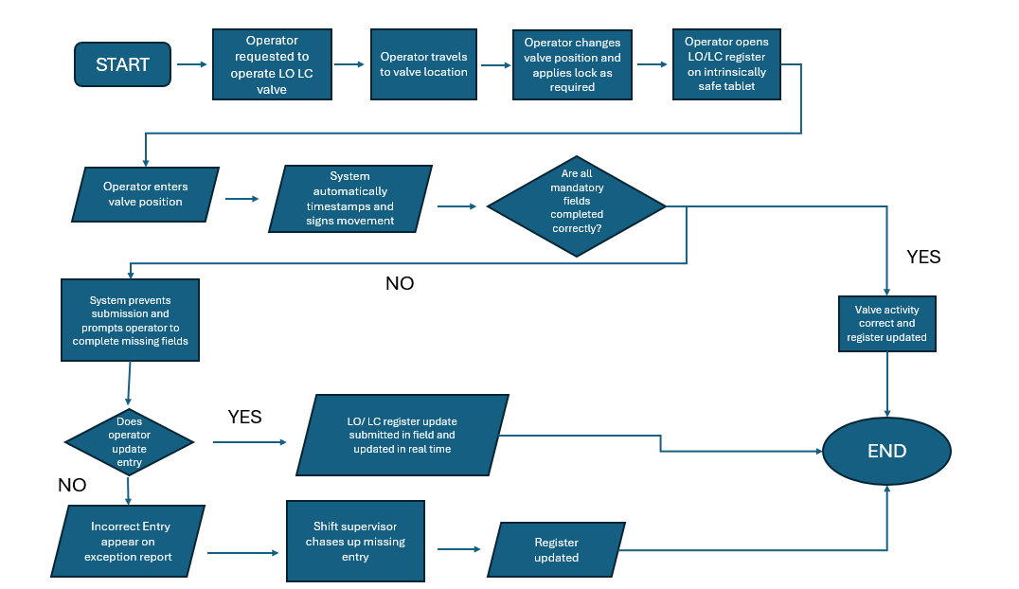
Figure 16. Future Process map

Following the improved FMEA, a future-state process map was developed to represent the improved process and show how proposed changes remove waste, reduce variation and improve control (Damelio, 2011). Figure 16 shows the main change is that the LO/LC register update would be completed at the point of work using an intrinsically safe tablet, rather than retrospectively from an office-based desktop document. The new process removes the key failure point identified in the current-state map, the delay between operating the valve and updating the register. Once the operator has changed the valve position and applied the required lock, the register is opened immediately on the tablet. The operator then enters the valve position, while the system automatically records the timestamp and user identification. This improves traceability and reduces reliance on operator memory.
The map also introduces a mandatory completion check. If all required fields are not completed correctly, the system prevents submission and prompts the operator to correct the missing information. This acts as a control mechanism to reduce incomplete or unclear entries. If the operator still fails to update the entry, the error appears on the exception report, allowing the shift supervisor to chase and correct the missing update.

Pilot Proposals
Following the identification of the how the software will work and be developed by the IT team, a proposed pilot was formulised to test the system in the field. Piloting allows proposed improvements to be tested on a limited scale before wider implementation, reducing implementation risk and allowing the solution to be refined using evidence from real process conditions (SixSigma.us, 2024).

It was decided by the team that a dummy register consisting of 10 valves would be tested. The test would consist of two operators which would be tasked with operating the tablet altering the position on the register to match the dummy register while completing 9 correctly and one incorrectly to test the full function of the system. Following the pilot the operators will be asked to provide feedback on the app to smooth the app before launch with IT team.
Following this, a field pilot will be completed selecting five maintenance tasks. The LO/LC valves linked to isolation will be reviewed by the shift supervisor once they issue the isolation certificate to the process operator to operate the valves. This will test the tablet-based register under realistic operational conditions and allow results to be compared with the Measure phase baseline.
The improvement will be validated by comparing pilot results against the Measure phase baseline. The same measures will be used, update compliance, missed updates, update delay, traceability completeness and register discrepancies. The pilot will be considered successful if all valve activities are recorded, average update delay is reduced to less than five minutes, missed updates reduce to zero, and all entries include operator identification and timestamp. Operator feedback will also be reviewed to confirm that the tablet system is practical for field use. This validation approach ensures that the improvement is assessed using measurable evidence rather than assumption.

Control

The Control phase will ensure that the improved LO/LC register process is sustained once the tablet-based system has been introduced. Pyzdek (2003) states that the Control phase is used to standardise improved processes, monitor performance, and prevent regression after improvements have been implemented. Its purpose will be to prevent the process from drifting back to the previous desktop-based method, where updates were delayed or missed due to reliance on operator memory. In DMAIC, the Control phase is used to standardise improvements, monitor performance and maintain gains over time.

Control Plan Framework
The first control will be the control plan, shown in figure 17. This table will define the key process measures, including update compliance, update delay, traceability completeness and register accuracy. It will also identify the measurement method, review frequency, process owner and corrective action required if performance falls below target. This will make ownership clear and ensure that the improved process is actively managed rather than simply implemented and left uncontrolled.

Figure 17. Control Plan

Exception Report
The second control will be the exception report, shown in figure 18. This report will be attached to the current register on a separate tab which will highlight only entries that fall outside the required standard. This will allow supervisors to focus on non-compliant activities quickly without reviewing every register entry manually. The exception report will also provide useful evidence for trend review and escalation as it will highlight the errors in the register.

Figure 18. Exception report tied to register, highlights clear errors.

Updates to be rolled out in workplace
The third control will be the register being tied to company KPI tracker. The audit output will be linked to the existing KPI system so that LO/LC register performance is visible through normal business reporting routes. Measures such as percentage of updates completed within the required timeframe, number of missed updates and number of discrepancies will be reviewed regularly. If performance drops below the agreed target, escalation will be required through operations supervision and HSE support. KPI contributes to wider company performance measures, it will provide additional visibility and accountability.

The maintenance procedures will also be updated to make the tablet-based register the formal method for recording LO/LC valve changes as well as being stated in the work tools needed to complete the job. The procedure will state that the register must be updated at the point of work immediately after the valve has been operated.

Training and competency checks will be completed before rollout. Operators and supervisors will be briefed on how to use the tablet register, complete mandatory fields, respond to exceptions and understand their responsibilities. Training will support the new process, but it will not be relied upon as the only control. Reason (2000) argues that reliable systems should reduce dependence on memory and individual behaviour, which supports the use of system-based controls.

Periodic audit checks carried out by the process operator for their designated area will continue each quarter to verify that physical valve status and register entries remain aligned. The shift supervisor will also still verify twenty five percent of that quarterly check.

Overall, the Control phase will combine the control plan, exception reporting, KPI tracking, procedure updates, training and audits to ensure the tablet-based LO/LC register remains effective long-term.

Conclusion

This Green Belt project has applied the DMAIC methodology to investigate and improve the Locked Open / Locked Closed (LO/LC) valve register process. The project was selected because the existing register was maintained as a desktop-based document, meaning operators were required to update valve positions after returning from the field. During a busy shift, this created opportunities for delayed updates, missed entries and loss of traceability. As the site operates within stringent health and safety and COMAH regulations, accurate plant status information is essential for safe operation, isolation assurance, audit readiness and regulatory compliance.

The Define phase established that the issue was not simply an administrative weakness, but a process design problem. The current-state process map showed that the physical valve movement and register update were separated, creating reliance on operator memory and task prioritisation. The Voice of the Customer and Critical to Quality requirements confirmed that the key measures were update compliance, timeliness, accuracy and traceability. This provided a clear project scope and ensured that the improvement work remained focused on these variables.

The Measure phase quantified the scale of the problem which was formalised after a data collection plan was established by the team on how to extract the data from relevant documentation. The Pareto analysis showed that delayed updates were the dominant defect category, while missed updates created the greatest traceability and compliance concern. This evidence confirmed that the existing process was not capable of consistently meeting the required standard.

The Analyse phase identified the main root causes. The Fishbone Diagram and 5 Whys analysis showed that delayed and missed updates were driven by desktop-only access, competing operational duties, retrospective data entry and reliance on memory. The FMEA then prioritised the risks and confirmed that a completely missed register update had the highest RPN. This demonstrated that the main weakness was not individual operator behaviour, but a system that allowed critical updates to be delayed or omitted.

The Improve phase compared two main options. A tablet-based register and automatic valve sensor feedback. Improvement techniques such as brainstorming, pay-off matrix, Pugh Matrix and cost-benefit analysis showed that the tablet-based register offered the best balance of impact, practicality, speed and cost. The sensor option offered technical benefits but was disproportionate for the Green Belt scope due to high installation and integration costs.

The Control phase proposed a control plan, exception reporting, KPI tracking, procedure updates, training and audits to sustain the improvement.

Overall, the project demonstrates that a practical digital field-based register can significantly strengthen the LO/LC process by reducing delay, improving traceability and supporting safer, more reliable plant configuration control.

Bibliography
Abualsauod, E.H. (2025). Integrating Six Sigma and Lean Management for Enhanced Quality Management in Industrial Applications. Journal of Engineering Research. [online] doi:https://doi.org/10.1016/j.jer.2025.09.007.

Adobe (2023). Control plan (Six Sigma) — definition and example. [online] Adobe.com. Available at: https://business.adobe.com/uk/blog/basics/control-plan.

Damelio, R. (2011). The Basics of process mapping. New York: Crc/Productivity Press.

DeLadurantey, C. (2023). Understanding Defects per Million Opportunities (DPMO).

[online] Six Sigma Online. Available at: https://www.sixsigmaonline.org/defects-per-million-opportunities-dpmo-six-sigma/ [Accessed 2 Apr. 2026].

Dragon LNG (2024). Home - Dragon LNG. [online] Dragon LNG. Available at: https://www.dragonlng.co.uk/.

El-Awady, S.M.M. (2023). Overview of failure mode and effects analysis (FMEA): A patient safety tool. Global Journal on Quality and Safety in Healthcare, 6(1), pp.24–26. doi:https://doi.org/10.36401/jqsh-23-x2.

Found, P. and Harrison, R. (2012). Understanding the lean voice of the customer. International Journal of Lean Six Sigma, 3(3), pp.251–267. doi:https://doi.org/10.1108/20401461211282736.

Hessing, T. (2014). Cost Benefit Analysis. [online] Six Sigma Study Guide. Available at: https://sixsigmastudyguide.com/cost-benefit-analysis/ [Accessed 15 Apr. 2026].

HSE (2025). Control of Major Accident Hazards Regulations 2015 (COMAH) - HSE. [online] Hse.gov.uk. Available at: https://www.hse.gov.uk/comah/comah15.htm#background [Accessed 20 Mar. 2026].
Ilin, M. and Bohlen, J. (2023). Six Sigma Method. [online] PubMed. Available at: https://www.ncbi.nlm.nih.gov/books/NBK589666/.

Ishikawa, K. (1986). Guide to Quality Control. New York: Unipub/Quality Resources.

Khan, A. (2006). Project Scope Management. [online] pp.1–6. Available at:
https://brainmass.com/business/human-resources-management/business-management-271591
[Accessed 21 Feb. 2026].

Lean Enterprise Institute (2025). 5 Whys - What is it? [online] Lean Enterprise Institute. Available at: https://www.lean.org/lexicon-terms/5-whys/.

Mckeever, C. (2006). The Project Charter -Blueprint for Success. [online] CROSSTALK the Journal of Defense. Available at: https://web.archive.org/web/20180426115327id_/http://static1.1.sqspcdn.com/static/f/702523/9272274/1288904488857/200601-McKeever.pdf?token=H8isIMMyyWTrEDwFtm5pQmyr24Q%3D [Accessed 4 Mar. 2026].

Mittal, A., Gupta, P., Kumar, V., Owad, A.A., Mahlawat, S. and Singh, S. (2023). The performance improvement analysis using Six Sigma DMAIC methodology: A case study on Indian manufacturing company. Heliyon, [online] 9(3). doi:https://doi.org/10.1016/j.heliyon.2023.e14625.

Monday, L. (2022). Define, measure, analyze, improve, Control (DMAIC) Methodology as a Roadmap in Quality Improvement. Global Journal on Quality and Safety in Healthcare, [online] 5(2), pp.44–46. doi:https://doi.org/10.36401/jqsh-22-x2.

Peterka, P. (2024). COVID-19 Situation: Six Sigma Ongoing Training Announcements.

[online] SixSigma.us. Available at: https://www.6sigma.us/process-improvement/payoff-matrix/ [Accessed 13 Mar. 2026].

Phillips, P.P. and Stawarski, C.A. (2018). Data collection: planning for and collecting all types of data. San Francisco: Pfeiffer.
Powell, T. and Sammut-Bonnici, T. (2014). Pareto Analysis. [online] Available at: https://www.um.edu.mt/library/oar/bitstream/123456789/21815/1/sammut-bonnici%20pareto%20analysis.pdf.

Pugh, S. (1991). Total Design. Prentice Hall.

Pyzdek, T. (2003). The Six Sigma Handbook, Revised and Expanded. McGraw-Hill Companies.

Reason, J. (2000). Human Error: Models and Management. British Medical Journal, 320(7237), pp.768–770. doi:https://doi.org/10.1136/bmj.320.7237.768.

SixSigma.us (2024). Pilot Run in Six Sigma. A Complete Guide (2024). [online] SixSigma.us. Available at: https://www.6sigma.us/six-sigma-in-focus/pilot-run-six-sigma/.

Stefan Ashby (2026) Dragon LNG – Shift Supervisor

Tague, N. (2004). The Quality Toolbox. Quality Press.

The Council for Six Sigma Certification (2018). Six Sigma : a Complete step-by-step Guide : a Complete Training & Reference Guide for White belts, Yellow belts, Green belts, and Black belts. Buffalo, Wy: Council for Six Sigma Certification/Harmony Living.

Van Den Berg, W. (2021). What Is a Six Sigma Process Map? - LSS Online - Purdue. [online] Lean Six Sigma Online Certification & Training at Purdue University. Available at: https://www.purdue.edu/leansixsigmaonline/blog/six-sigma-process-map/.

