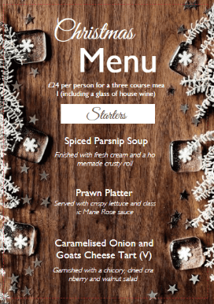
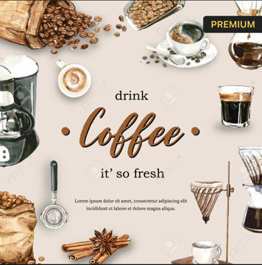
Menu

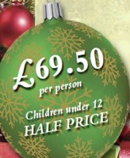
Christmas party Drinks
Save water and wine special for Christmas we proudly serve new menu of wine from luna Rossa
WE DISTINCTIVE RED WINE and WHITE WINE
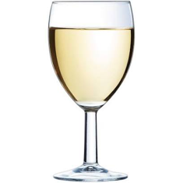
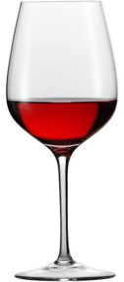
With affordable prices :Luna rossa sweet riesling
£13, £25, £40, £50
We also offer domestic &import beer , New Mexico Beers, Port and Vino. We offer discount for all of our products.

Our location
Hotel trinity Coulsdon minor is one of the luxury hotel 4 star near Coulsdon town, the hotel operating 24/7 with parkland and an 18- hole golf course, conference facilities and leisure club *free wifi, *Free parking, *Paid breakfast * Accessibility

Other Options

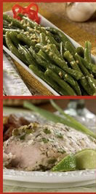
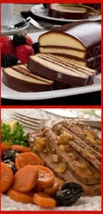
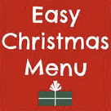
We offer *Meat and Fish, Turkey, Additional fish and meat. Party food selection .
*Vegetable and Fruits : potatoes, Sprouts, Carrots, Apples , Peas, Beetroot so on
*Condiments &Sauces& Seasonal
Gravy, Honey, Goose fat ,horse radish…
*Deserts: Fresh Cream, Jelly, Ice cream,
Yule log, Mince Pies , Gâteau
*Sweet and Treats : Nuts ,Ginger Biers, popcorn, Roses, Candy canes Chocolate
*Our food prices is starting from £5 to £100.

References : Wine Folly (2020) Wine Basics - A Beginner's Guide to Drinking Wine. [online] Wine Folly. Available at: https://winefolly.com/wine-basics-beginners-guide/ [Accessed: 18 February 2021].Wine & Spirit Education Trust (2005), Wines and Spirits – Looking behind the label: London. Wine & Spirit Education Trust ,Wine & Spirit Education Trust (2011), Wines and Spirits – Understanding Style and Quality: London. Wine & Spirit Education Trust

