

Postgraduate/Distance Learning
Assignment coversheet & feedback form

THIS SHEET MUST BE THE FIRST PAGE OF THE ASSIGNMENT YOU ARE SUBMITTING (DO NOT SEND AS A SEPARATE FILE)

For completion by the student:
Student Name: Heather McVey

Student University Email: 2307454@student.uwtsd.ac.uk
Module code: HPCA7015  Module title: Foundations in Cultural Astronomy and Astrology | Student ID number:  2307454 |  |  | Educational support needs:  No
Assignment title: A Critical Comparison of Two JSTOR Papers

Assignment due date: 06/11/2023
This assignment is for the 1st 2nd 3rd 4th 5th 6th module of the degree
I confirm that this is my original work and that I have adhered to the University policy on plagiarism.
Signed ……………………………………………………………
Email submission: if you are submitting this form via email, please tick this box □
(as a substitute for your signature) to confirm that you agree to the above declaration.
Assignment Mark
1st Marker’s Provisional mark
2nd Marker’s/Moderator’s provisional mark
External Examiner’s mark (if relevant)
Final Mark

NB. All marks are provisional until confirmed by the Final Examination Board.

For completion by Marker 1 :
Comments:

Marker’s signature: |  |  | Date:
For completion by Marker 2/Moderator:

Comments:

Marker’s Signature: |  | Date:
External Examiner’s comments (if relevant)

External Examiner’s Signature: |  | Date:

Essay Based on a Sky Journal
Introduction
This essay discusses my experience of keeping a Sky Journal, in which I documented daily observations of Sunsets from October 27th - November 30th, 2023, from Cambridgeshire, England. Equipped with my Pixel smartphone to take photographs and notebook and pen to record observations, thoughts, and feelings, qualitative and reflexive methodologies facilitated a free-flowing unencumbered approach to documenting everchanging skyscapes and experience. Across the course of my observations, two main themes emerged: Sunset as a journey to the light, and Sunsets as epic sky stories. These themes are presented within the academic framework of Vincent Van- Gogh’s quote “Be clearly aware of the stars and infinity on high. Then life seems almost enchanted after all.”
Defining Terms
In this essay, the use of the word enchantment, unless otherwise defined, is used in the sense of Ronald W. Hepburn’s definition of ‘existential wonder’.
Observing Sunset
I chose to make my Sunsets observations from a grassy field close to my home, situated just beyond the farthest trees as seen from my south-westerly facing living room (See Figure 1.). The field has an open southwest border and facilitates excellent access to open sky, enhancing the perception of depth with its classically flat Fenland terrain. Recognising that my initial observations from home, and my short journey to the field were part of my broader engagement with the Sunset, I conducted my research to include these preliminary observations.
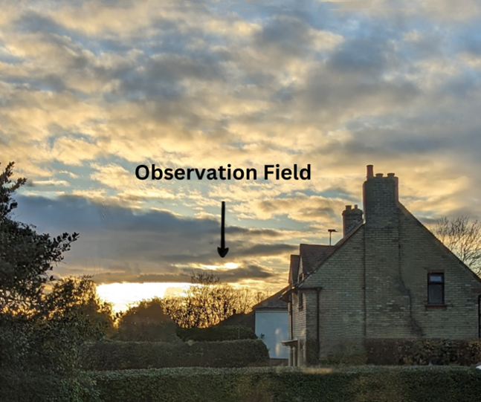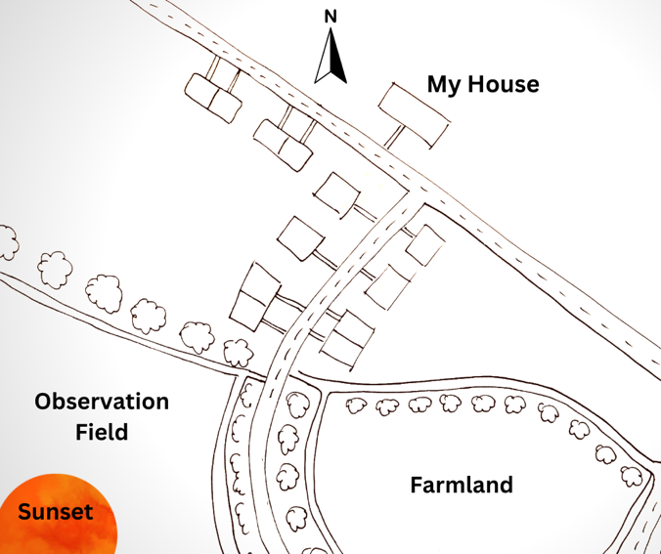
Figure 1. (left): Sunset from my southwest facing living room window on 30th October, 2023, 15:15. Photo: Heather McVey. Figure 2. (right): Drawn map (not to scale) illustrating the location of the field, relative to my house. Drawing: Heather McVey.
Sunset as a Journey to the Centre
On days where the sun was at least partially visible, the act of observing the sunset from my window, built excitement and anticipation, but also a sometimes deep sense of journey that repeatedly felt intrinsic to bursts of enchantment. In fact, these moments of enrapture could occur whilst looking at a preview of the sunset from my window, and just by the idea of soon emerging from these more obscured views and into the sun-drenched field and open skies. My sky journal on 30th October reads ‘Arriving in such beauty already feels like a pilgrimage, and so it should. How could a sunset this radiant and giving, not be divine? Looking at the sun, one feels the same glow within
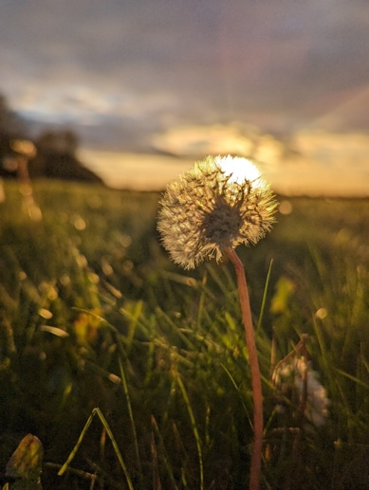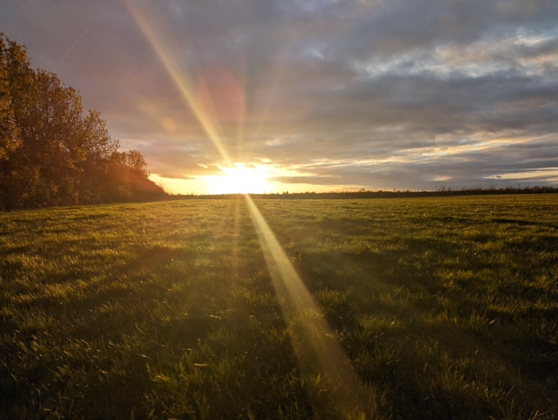
Figure 2. A dandelion aglow at sunset in the observation field (left) 30th October, 2023, 15:21. Photo: Heather McVey. Figure 3. A divine sunset of golden light, dramatized by dark surrounding clouds to illustrate the contrast (right) 30th October, 2023, 15:29. Photo: Heather McVey.
This radiant giving aspect of the sun brought to mind the first verse of Philip Larkin’s poem Solar, in which he beautifully illustrates the self-generating, giving nature of the Sun:
Suspended lion face Spilling at the centre Of an unfurnished sky How still you stand And how unaided Single stalkless flower You pour unrecompensed.
Larkin’s expression of the sun resonates with my own sense of the sun as a radiating, giving other, causing me to explore this dynamic of self and other when engaging with the sun. In a published talk for the Sophia Centre, Patrick Curry sheds light on the subject of relationality and difference in instances of enchantment, stating ‘wonder is always wonder-at: an encounter, a meeting, across a gap of difference, with an other.’ Elsewhere in a separate paper on the same topic, Curry clarifies that the other party, the enchanter, need not be another person, and that it can in fact be many things, from a plant, to an animal, or to a smell, sight, or place.
Whilst Larkin’s poem and Curry’s paper quash remaining traces of anxiety around my deep inner understanding of what modernity might insist is an inanimate object, as an other, I reflected on insights gained from Curry’s thoughts on relationality and enchantment. In further contemplating the giving nature of sun, I remembered a particularly fond memory of simple joy when eight years old, where I was perhaps, at least in part, the giving party. I recalled serenading the sun, setting within a stunning pink and red sky, with a love-song from my bedroom window. I sang into a hairbrush to mimic a microphone, whilst passionately performing to a cassette tape playing on my stereo. Blinking beams of light were interpreted by me as the approval of the recipient of my admiration - the sun, whilst simultaneously appreciating Sun’s skills as lighting manager to my stage performance. Whilst it is likely unwise to perform to the sun with a hairbrush in the public village field at forty-three, I am reminded of the joy in letting go, and allowing the skies to simultaneously be what they are, whilst also allowing them to be whatever I receive them to be, and indulging in the relationship therein.
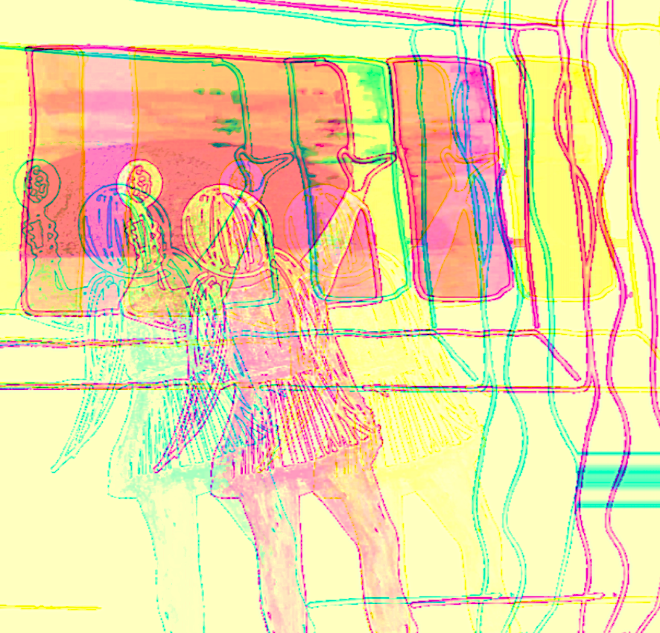
Figure 7. A digitally adapted drawing of my eight-year-old self, serenading the sunset. Image: Heather McVey

Arriving at the Centre
On November 12th 2023, upon walking through the cut-through in the hedgerow and into the field, I was caught completely off guard. I photographed the cut-through before entering to add context to my sky journal. I was feeling the usual peak sense of excitement in being seconds away from my immersion in sunlight and beauty, and in going over the bridge and through the short path and just before stepping into the open field and bright light, I became overwhelmed by instantaneous full body tingling. As I emerged into the beams of a breath-taking sunset I spontaneously burst into tears.
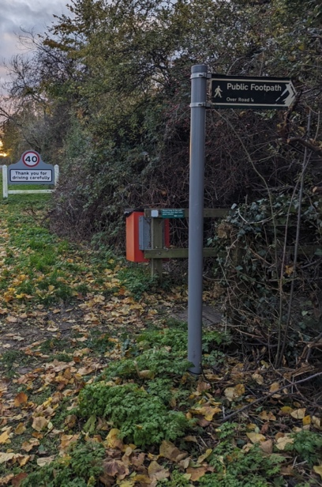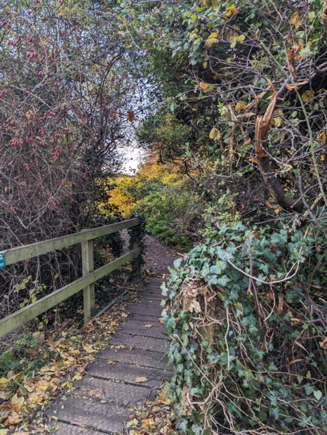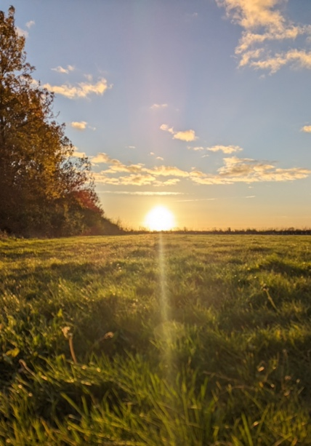
Figure 5. Roadside entrance to the cut-through to the field, (left) 12th November 2023, 15:29. Photo: Heather McVey Figure 6. Small wooden bridge leading into the field, (middle) 12th November 2023, 15:29. Photo: Heather McVey. Figure 7. Sun-drenched grass during a beautiful golden sunset (right), 12th November 2023, 15: 40. Photo: Heather McVey
This remarkable moment lasted for less than 15 seconds, yet seemed not only just stretched out in time, but in physical distance too – I experienced the path as longer and more tunnel-like. I believe that not only was this moment of sheer existential wonder due to the impending emergence into light and beauty, but that it was also facilitated by a moment in which the liminality of travelling across a boundary that bridged dark and light, challenge and ease, mediocrity and sublimity, limitation to freedom, burst in potency.
In my sky journal later that evening on 12th November, I summarised my experience to have been a:
…moment and quality of time, colliding with self, place and meaning, erupting in nerve tingling juxtapositions and the paradox of walking into the light of the sun, with the simultaneous and quite overwhelming experience of walking into myself.
So much of the moment had an unfathomable depth and contradiction and slipped away like a grasped at dream, but I was as alive as the sun. Somehow though, the liminal hedgerow passage that leads me to the sun, had become my wardrobe to Narnia and my gate to the Secret Garden, taking me in an instant, from occupying my edges - living on the periphery of myself, into my blazing core. Sunset as a journey to centre of the Sun, was also a journey to the centre of myself.
Later reflecting upon my experience of recognising myself in the sun, I viewed Vincent Van-Gogh’s famous painting The Sower in which he paints the sun, highlighting its centrality and sheer aliveness, radiant with yellow hues. In another painting also entitled The Sower, he places the sower with his head in front of the sun, perhaps depicting a relationship between sun and self, whilst also inferring the sun as a halo, thus indicating divinity. I contemplated the possibility that whilst sitting in the sun painting his landscapes, Van-Gogh too, may have experienced a relational enchantment with the sun.
Conjecture aside, in viewing Van-Gogh’s The Sower, as seen in Figure 8. I find Van-Gogh’s sun as alive as the sun in the sky, whilst feeling the resonant glow in my core.
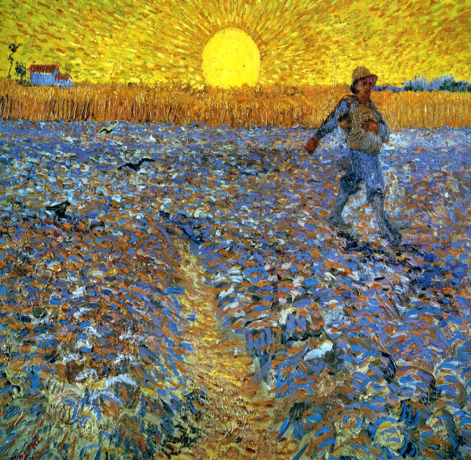 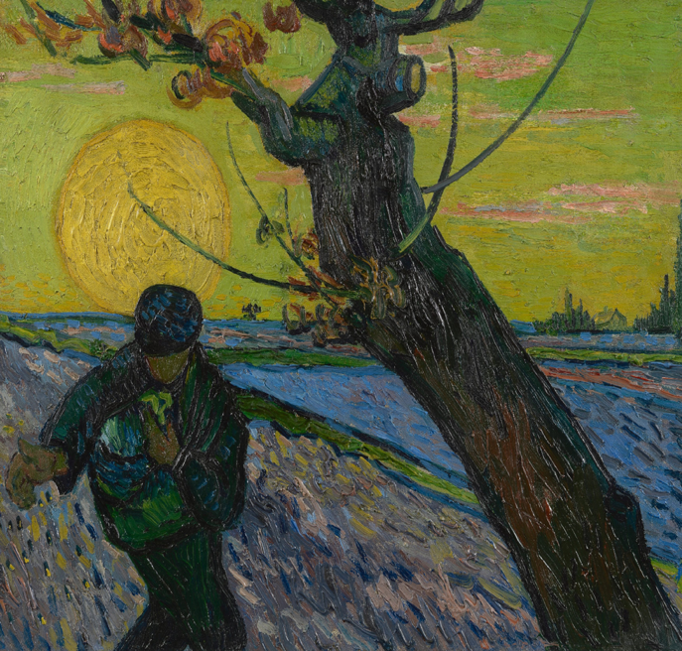Figure 8. Vincent Van Gogh’s The Sower 1888 Figure 9. Vincent Van Gogh’s The Sower, November 1888 (right)
Sunset and Sky as Epic Sky Stories
Though I was not observing the stars as might be suggested in Van-Gogh’s quote, I found wonder in the daytime sky not only via. Sacred connection with the sun, but in a more mythical story based expression, noting the sky on October 31st 2023, as ‘living, moving sky stories.’
This sense of the sky as a storyboard, with heroes and villains, was a recurring theme throughout my observations, particularly on days, where clouds dominated, creating such diversity of shape, tone and animation so readily.

Registering that it was Halloween, I settled into what I noted as a ‘weighty, tense atmosphere, suspiciously still’. I was struck by how I had so quickly interpreted ‘the smothering miserly clouds hold the Sun hostage, portraying the landscape beneath to be more monotonous in tone that I know to be true”.
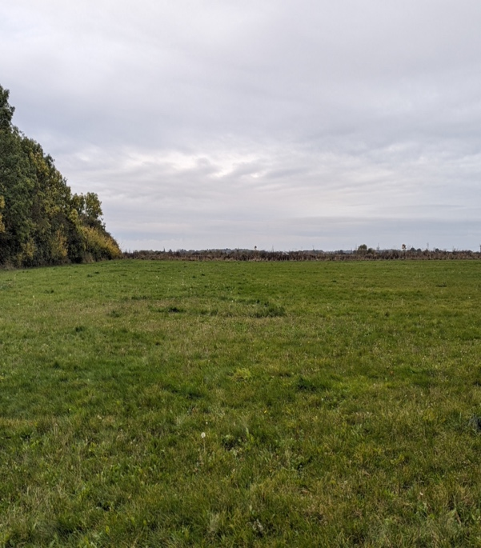
Figure 10. Overcast miserly clouds, holding the sun hostage. 31st October 2023. Photo: Heather McVey
I felt cheated out of a communion with a picture postcard sunset but had forgotten just how quickly even the most stubborn looking of skies can change. The wind picked up and a giant, dark grey sky-crab cloud rolled in from the south, headed straight for a confrontation with the sun. I was transported in an instant to a front row seat at the theatre of the epic sky.

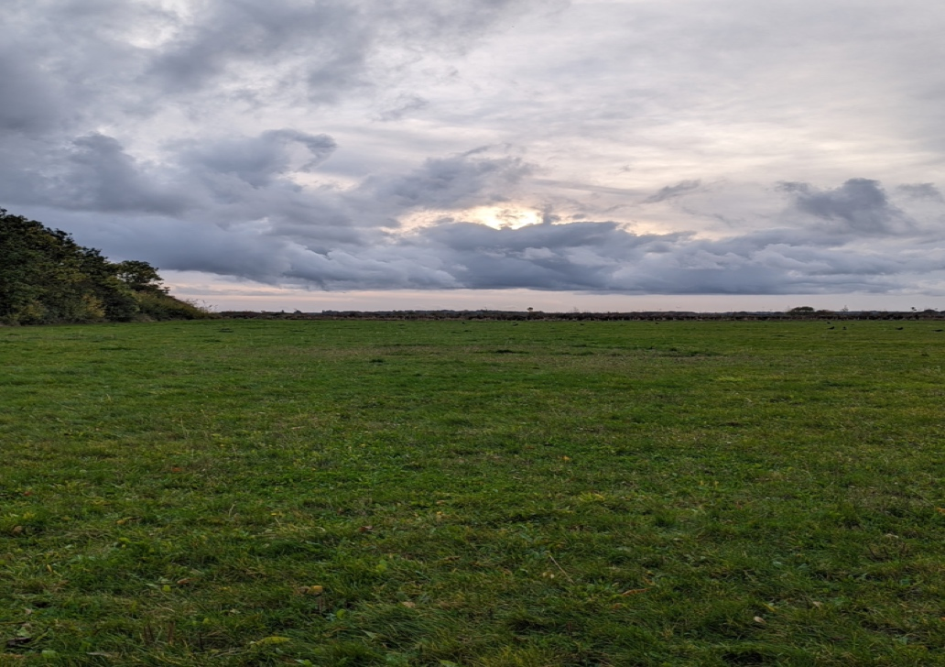
Figure 10. Giant Sky-Crab cloud in an epic confrontation with the sun. 14th November 2023 15:20. Photo: Heather McVey.
Sensing the increased participation of surrounding grass - now waving, the circling cawing crows, I noted ‘the musical sough of the crisp autumn leaves through the swaying trees play orchestra to the battle’ It seemed as though every being in the environment, whether a blade of grass, crow or tree, were equally invested in the unfolding drama above. Utterly swept away I had enjoyed a moment of wonder, in the face of something so epic and huge.
In an article in the New York Times, author Katherine May, advocates suggests that enchantment can be encouraged by letting yourself get past any doubts of futility or silliness, and allow yourself to engage with the sacred, and ‘the feeling of being able to commune with something that’s bigger than you are.’ This process has been crucial to me and my sky observations, and in Katherine May’s advice, is something similar in Van-Gogh’s quote, in that both tell us that once in while it’s to suspend disbelief and engage in non-rational.
Conclusion
As we have seen, my Sky Journal observations were not simply a process of rational, scientific observation, but an embracing and immersion in the non-rational. As Kimmler states, ‘Enchantment is a matter of both heart and mind. Reason and imagination collapse into a shared logic of sensibility’, The insights of Kimmel, Curry, Larkin, and May, not only resonate and add depth to my with my own profound and deeply enriching experience of observing Sunsets, but furthermore offer a lens through which we can gain insight into Van-Gogh’s quote, and the importance of being willing to immerse yourself in the impossible, suspending disbelief in the face of something more powerful or larger than yourself, and that arising from such engagement, profoundly meaningful enchantment can arise.

Bibliography
Campion, Nicholas, Enchantment and the Awe of Heavens, Astronomical Society of the Pacific, Vol. 441, pp. 415 -422

Caron, Christie, How to Find more Joy in You Daily Life, The New York Times, 27 February, 2023,
<https://www.nytimes.com/2023/02/27/well/mind/katherine-may-enchantment.html>

Curry, Patrick, Enchantment, Place and Space, A talk for the Sophia Centre, University of Wales, Trinity St. David, Lampeter, 22nd
September 2020.

Curry, Patrick, The Experience of Enchantment and the Sense of Wonder, Green Letters, 25:2, (2021) pp. 115 – 129, (p. 119.)
<DOI: 10.1080/14688417.2021.1928530>.

Levy-Bruhl, The Law of Participation, How Natives Think, George Allen and Unwin, 1956. Pp. 69 -104

Kimmel, Lawrence The Aesthetics of Enchantment. (The Yearbook of Phenomenological Research, 2000) Trinity University, (2000)

Watts, Alan, Out of Your Mind, Souvenir Press, 2019 pp. 100 -140

Gogh, Vincent van, and Ronald de Leeuw. The Letters of Vincent Van Gogh. London: Penguin Books, 1997, p.392
Ronald W. Hepburn, The Inaugural Address: Wonder (Proceedings of The Aristotelian Society, 1980) Volume 54, p. 10.
Heather McVey, Sky Journal, (2023), p. 4.
Philip Larkin, High Windows, Faber and Faber (1974), p. 33.
Patrick Curry, Enchantment, Place and Space, A talk for the Sophia Centre, University of Wales, Trinity St. David, Lampeter, 22nd September 2020. p. 1. Available at http://www.patrickcurry.co.uk/papers/Enchantment,%20Place%20and%20Space.pdf [accessed 18 November 2023].
Patrick Curry, The Experience of Enchantment and the Sense of Wonder, Green Letters, 25:2, (2021) pp. 115 – 129, (p. 119.) <DOI: 10.1080/14688417.2021.1928530>.
Heather McVey, Sky Journal, 2023, p. 15
McVey, Sky Journal, p. 14
Vincent Van-Gogh, The Sower, (1888) [Oil on canvas] https://www.vangoghmuseum.nl/en [accessed 12th November 2023].
Van-Gogh, The Sower, (November 1888) [Oil on Canvas] https://www.vangoghmuseum.nl/en [accessed 12th November 2023].
McVey, Sky Journal, p. 5
McVey, Sky Journal, p. 5
McVey, Sky Journal, p. 5
McVey, Sky Journal, p. 6
Christina Caron, How to Find more Joy in You Daily Life, The New York Times, 27 February, 2023, <https://www.nytimes.com/2023/02/27/well/mind/katherine-may-enchantment.html> [accessed 16 November 2023]
Lawrence Kimmel, The Aesthetics of Enchantment. (The Yearbook of Phenomenological Research, 2000) Trinity University, (2000) p. 197.

