
Control System Design
word count 2589
Joshua Ede (2023302)
Contents
Abstract 3
1. Introduction 4
1.1 Control systems: A brief overview 4
1.2 Control systems: Transfer Functions 6
1.3 Control systems: Controllers 7
1.4 Control system for the CIWS 9
2. Methodology 9
3. Results and analysis 12
3.1 Scope Results 12
3.2 Stability analysis 12
4. Discussion 17
5. Conclusion 18
References 19
Annex A 20

Figure 1: A block diagram for a simple control system [4]. 3
Figure 2: A block diagram of a closed loop control system. 3
Figure 3: A block diagram of top (a) an open loop system and bottom (b) a closed loop system. 4
Figure 4: A block diagram of a toaster. 4
Figure 5: A block diagram of cruise control set at 70 mph. 5
Figure 6: Top (a) Block diagram of the input paths into the controller. Bottom (b) The corresponding Laplace transforms for the different input paths [9]. 7
Figure 7: A CIWS control system for rotation relating the controller and process transfer functions in a block diagram. Gc(s) here is labelled as controlled input showing its relationship to the process. 8
Figure 8: Layout of the system in simulink, with the constants shown in the process. 9
Figure 9: Graph showing the tuned output (solid blue line) against the original (dashed blue line) 9
Figure 10:Original system against one represented as a single transfer function to check error. 10
Figure 11: Showing that the design parameters had been met by the tuning within Simulink. 11
Figure 12: Graphs from the scope showing the input against time. Top is input, beneath is the error, third is the PID control input and the bottom graph shows the desired output. 12
Figure 13: Plot showing the difference between the outputs from the PID to Process system and the transfer function, blue line indicates no difference, cropped at six seconds for ease of viewing. 12
Figure 14: Plot Zero of the closed loop transfer function, stability is shown by the position of the poles (x) on the left-hand side of the diagram 13
Figure 15: Bode Diagram for CIWS control system. 14
Figure 16: Nyquist plot of the CIWS control system showing the unit circle. 14
Figure 17: Top (a) Nyquist diagram showing the crossover point at -1, bottom (b) diagram showing the time delay at zero. 15
Figure 18: Nyquist plot zoomed in showing the point where the input crosses the unit circle, bottom has caption for ease of comparison to Bode. 16
Figure 19: Tank control system taken from [10, p. 23]. 17
Figure 20: Block diagram of control system for a heavy machine gun for naval use taken from [11, p. 32] 17

Abstract

This report examines a control system as may be employed in closed-loop feedback mechanisms. The object of study for the report is a close-in weapon system (CIWS), an example of which is the phalanx system, which has a long service history in the Royal Navy and is still being upgraded and supported for future use [1] [2]. The report presents a block diagram and mathematical model for the rotational controls of such a system using Simulink within Matlab. Furthermore, the model was then tuned using a PID controller to ensure its compliance with design requirements of having an overshoot of less than five percent and to control the process within two seconds. These criteria were achieved, and the resulting signal was then investigated using pole-zero, Nyquist and Bode plots to demonstrate overall system stability.

Introduction

Control systems: A brief overview

A control system is a way of demonstrating a cause-and-effect relationship between a stimulus and a response [3]. Many elements of modern life are regulated via control systems, such as household heating or the ball float of a flushing toilet, the latter being a modern use of one of the earliest control systems originally devised in ancient Greece [4] [5]. Control systems can be represented as mathematical descriptions and block diagrams allowing engineers to design systems according to desirable criteria [4].
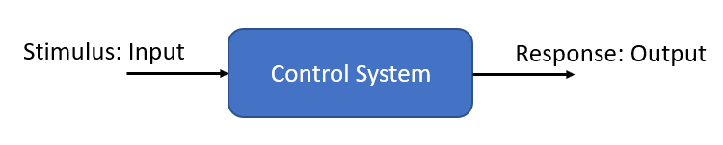
Figure 1: A block diagram for a simple control system [4].
In many cases however, the stimulus, hereon called the input, may not provide the exact response wanted [3]. The response, hereon called the output, might be affected by a range of factors so there is a difference between it and the desired output [4]. Control systems are therefore designed to account for these disturbances [4]. The block diagram shown in Figure 1. represents an open loop system, where an input goes directly through the system and provides a response. A slightly more complex control system may sense a combined disturbance input value and then measure it against the original input in order to produce an output closer to the one desired [3] [4]. This mechanism is called feedback and systems that use it as a method of altering the original input are called closed loop [3] [4].
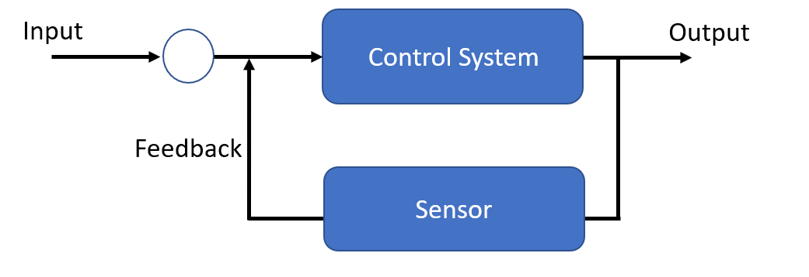
Figure 2: A block diagram of a closed loop control system.
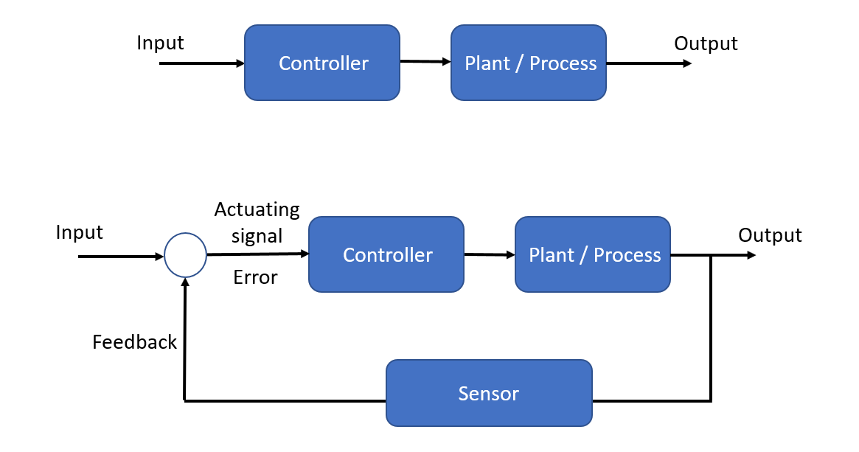
Figure 3: A block diagram of top (a) an open loop system and bottom (b) a closed loop system.
In Fig. 3 (a) the system is open so that an input variable directly produces an output. A toaster, Fig 4., is a good example of an open loop system, the controller may be a numbered dial indicating time and the process is for how long the bread will be heated [3].
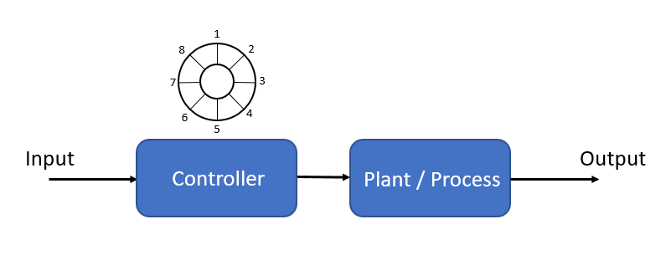
Figure 4: A block diagram of a toaster.
For ease, if the values of the dial relate directly to minutes then increasing the dial from two to four will double the duration the input signal is supplied.
A close loop system, such as that illustrated in Fig. 3 (b), may be better illustrated by cruise control in a car [3]. The input is the desired velocity setting. In this example the controller now uses the feedback from the engine to adjust the velocity producing the desired output, based on the input.

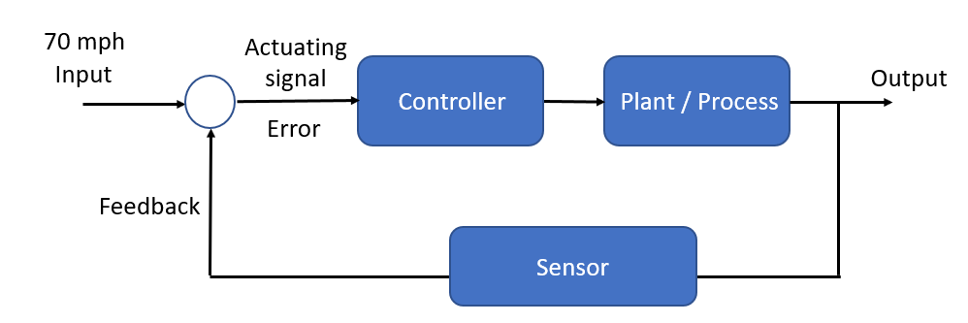
Figure 5: A block diagram of cruise control set at 70 mph.
In order to make the adjustments to the desired output, the system must subtract the actual output from the input, via the feedback [3] [5]. Input may be considered a reference and the output unaltered by feedback may be described as the actual output [3]. Subtracting the actual output, from the reference input thereby gives the error [3], for cruise control a this may be a loss of velocity caused by the mechanics of the engine itself. However, by introducing feedback the input may be altered so that the controller drives the desired output from the system and a constant velocity may be maintained [3] [4].
Two further important concepts to introduce are the transient and the steady-state responses [3] [4]. The transient response can be thought of as the speed of the response to the actuating signal and how close this is to the desired output [3]. In the cruise control example, a rapid change in the transient response could sharply increase or decrease the velocity of the car, which could cause discomfort to the driver, furthermore if there were large enough discrepancies there might be vehicle damage as the engine tried to compensate to produce the desired output [3]. The steady-state response is the longer-term response that should resemble the input once the transients have reached zero, or in other words once the system has settled [4]. To better describe the steady-state response three final terms should be introduced, the total response, natural response and forced response [3]. The relationship between these three is illustrated below.
Total response = Natural response + Forced response
[3, p. 10]
The steady-state of a useful control system should be equal to the total response, with the natural response approaching zero or oscillating. If the natural response grows and does not settle around zero then the system is described as unstable and it has no steady state response [3]. When thinking about a system over time, the transient response should be equal to the natural response, with it approaching zero as time increases to infinity [3].

Control systems: Transfer Functions

The above section illustrated dynamic control systems through block diagrams and examples. The following section will briefly introduce the mathematical formula used to describe the system that will be looked at throughout the rest of this report.
The design brief for the close-in weapon system (CIWS) notes that the rotation of the system is defined by:

$$G\left(s\right)=\frac{1}{as^{2}+bs+c}$$

This is the transfer function for a second order system with the phase and damping simplified and given as constants, the unmodified transfer is given below:
$$G_{\left(s\right)}=\frac{ω_{0}^{2}}{s^{2}+\sin{ζ}+ω_{0}^{2}}$$
[6]
Where G is the input $ω$ is phase and $ζ$ is damping [6]. The transfer function mathematically illustrates the relationship between the input and the output of a system and therefore is a useful design tool [6]. Utilising this along with the block diagrams in the previous section allows an engineer to layout a system and make predictions on its behaviour under certain conditions. As a number of the variables for the system involve solving differential equations these are converted to an easier form through the use of the Laplace transform [5]. This is also why in the above transfer functions the domain is given as s, which is a way converting the inputs, from time, to frequency domains [5]. Changes therefore can be analysed changes to the magnitude and phase across the signal this is important when examining the results in the later section [5].
This brief section has highlighted the use of transfer functions for understanding how a system can be analysed during its design. The CIWS transfer function was given by a design brief and this has been related to a general second order transfer function. The final element for the design of the CIWS that needs to be examined is the controller.

Control systems: Controllers

The controller is an important component of the design allowing a system to alter the input to produce a more desirable output based on feedback [4] [6]. The most popular controller for this purpose is a proportional-integral-derivative (PID) controller [7] [8]. By passing the input through a PID controller, via feedback, several disturbances can be adjusted for so that the desired output remains the same. The figure below shows path of the input broken into the three paths contained within the controller.

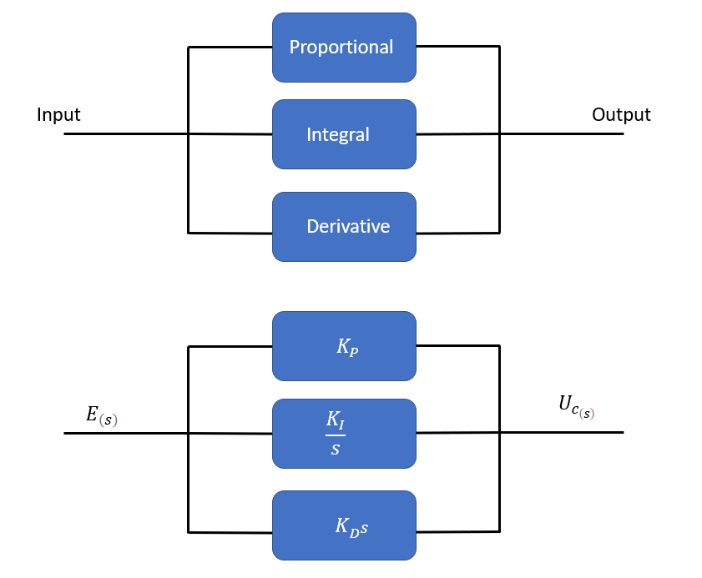
Figure 6: Top (a) Block diagram of the input paths into the controller. Bottom (b) The corresponding Laplace transforms for the different input paths [9].
The proportional path of the controller can be said to reduce the present error between the input and desired output, however you cannot reduce this completely to zero due to steady state error which is defined as the difference between the desired output and the actual output [3]. To reduce the steady state error to zero the input needs to consider the past error, which it does through the integral [9] [3]. Finally the derivative path accounts for the future error, which may be thought of as accounting for the rate of change of the error, this effectively reduces the amount the inputs may cause a system to go beyond, or overshoot, the desired output [3] [9]. The amount that an input needs to be altered according to any one of these paths is called tuning, the constant to be applied to the path is called gain and denoted by K [3].
Table 1: Table showing the notation for the PID paths and gain.
Path | PID gain
Proportional | $$K_{P}$$
Integral | $$K_{I}$$
Derivative | $$K_{D}$$

In block diagrams a PID is shown as the controller as in the example in Fig 5. The transfer function for the PID is:
$$G_{C\left(s\right)}=K_{P}+\frac{K_{I}}{s}+K_{D^{S}}$$
[3]
$G_{C\left(s\right)}$ being the output from the controller in the frequency domain.
In the time domain the equation is;
$$u_{\left(t\right)}=K_{P^{e}}\left(t\right)+K_{I}∫e\left(t\right)ⅆt+K_{D}\frac{dⅇ\left(t\right)}{ⅆt}$$
[5]
$u_{\left(t\right)}$ being the output in the time domain.
This section has looked at the PID controller as a block diagram and as a transfer function, whilst briefly outlining the effect of tuning on desired output. The following section relates the previous three sections to the CIWS design.

Control system for the CIWS

The design of the CIWS is shown in the following diagram, utilising the block diagram and illustrating the applicable transfer functions.
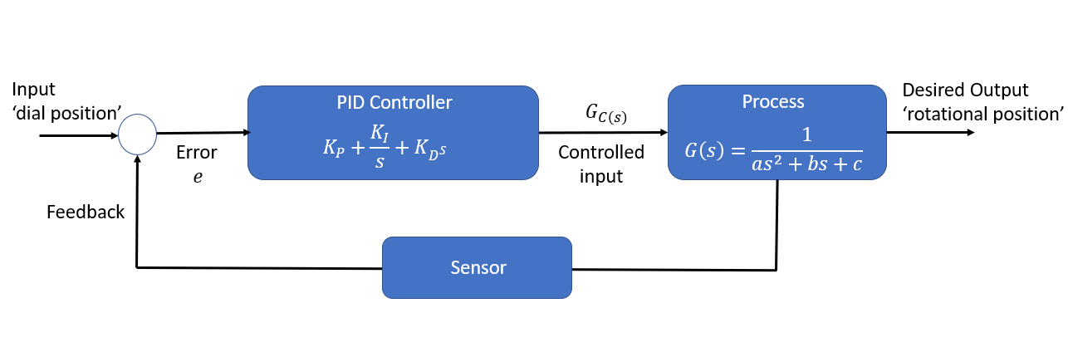
Figure 7: A CIWS control system for rotation relating the controller and process transfer functions in a block diagram. Gc(s) here is labelled as controlled input showing its relationship to the process.
To simulate and analyse the applicability of this control system for the design brief it was created within MatLab Simulink.

Methodology

To check the suitability of the control system it was simulated using the MatLab Simulink software and was arranged according to Fig 8. The addition of the scope provided a means of graphically checking the input and output variables and shall be discussed in the results section.

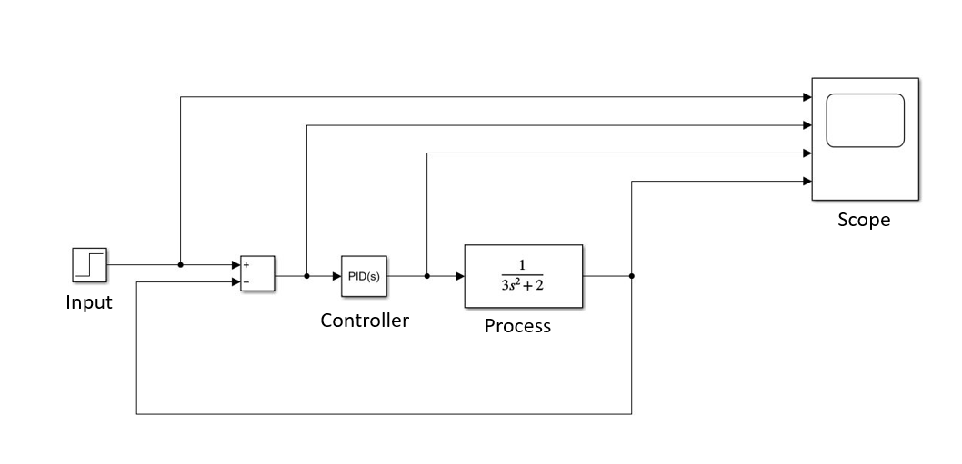
Figure 8: Layout of the system in simulink, with the constants shown in the process.
The system PID controller was then adjusted so that design parameters could be met, namely that the system had less than 5% overshoot and reached its steady state response within two seconds. This was done by adjusting the response and transient bars, which in turn alter $K_{P}$, $K_{I}$, $K_{D}$ values for the controller.
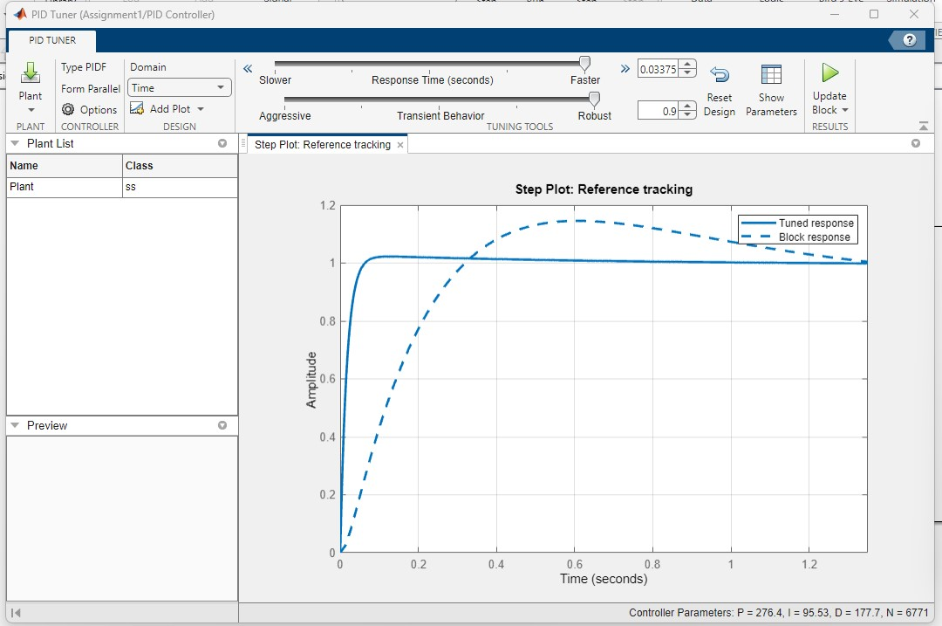
Figure 9: Graph showing the tuned output (solid blue line) against the original (dashed blue line)

Table 2: Table showing the tuning values used in the PID controller.
Parameters | Value
$$K_{P}$$ | 276.3769
$$K_{I}$$ | 95.339
$$K_{D}$$ | 177.6507
$$N$$ | 6771.3521

To analyse the results Nyquist, Bode and pole-zero diagrams were also generated and finally, to verify the results the system was rerun with a single transfer function to check error within MatLab. The setup of that system is illustrated below, but all the results from these will be discussed in the following section.
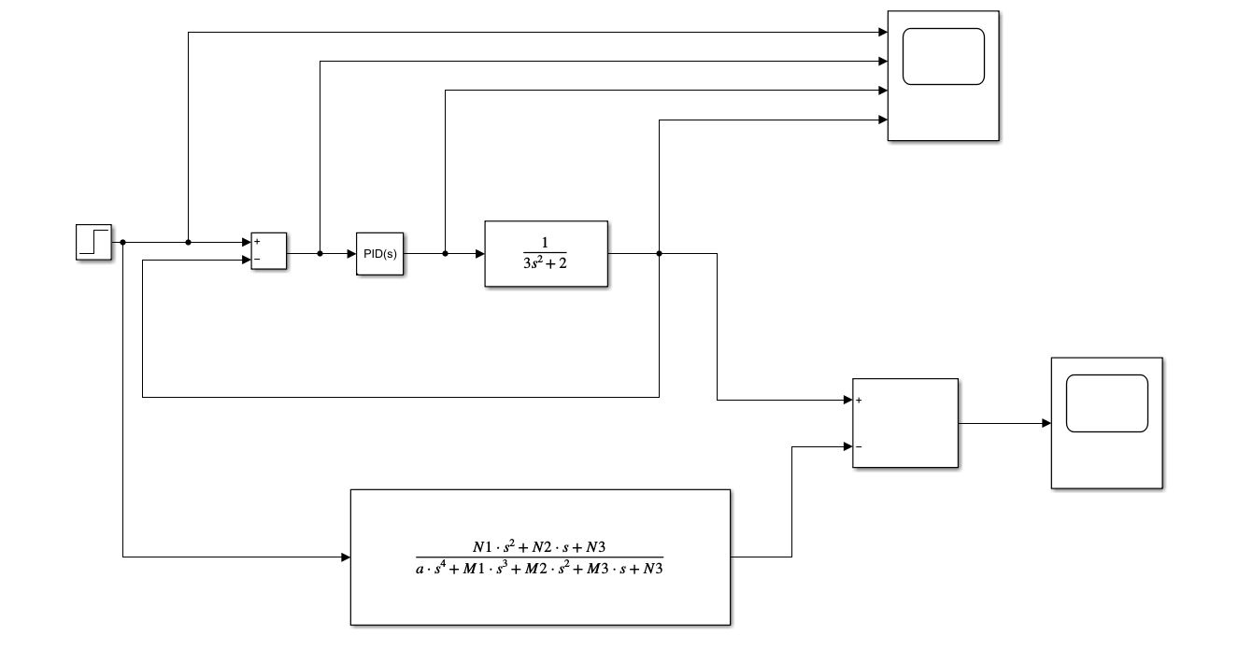
Figure 10:Original system against one represented as a single transfer function to check error.

Results and analysis

Once the system had been tuned, the design brief parameters were met, as shown in Fig 11. The following sections will show different ways of displaying these results as well as analysing them for an understanding of the system overall.
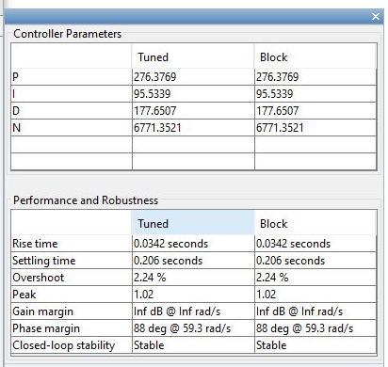
Figure 11: Showing that the design parameters had been met by the tuning within Simulink.

3.1 Scope Results

The results were displayed graphically using a scope within MatLab. The top graph shown in Fig 12., shows the input into the system over time. The second plot shows the error. Subtracting plot 2 from plot 1 is equal to the output, which is shown in plot 4. The third plot is of the PID response, which recognises that the inputted error is not zero and therefore generates an output to compensate for this. Due to the speed of the response time required for the system this number needs to be large enough to reduce the error quickly so that the desired output is reached within two seconds.
The system was then checked to ensure that there were no large mathematical errors being generated within MatLab itself, this was done by combining the process and the PID into a single transfer function and checking the output against the original. Fig 13., shows the difference between the outputs of the original and verification system. The flat blue line indicates little to no difference between them.
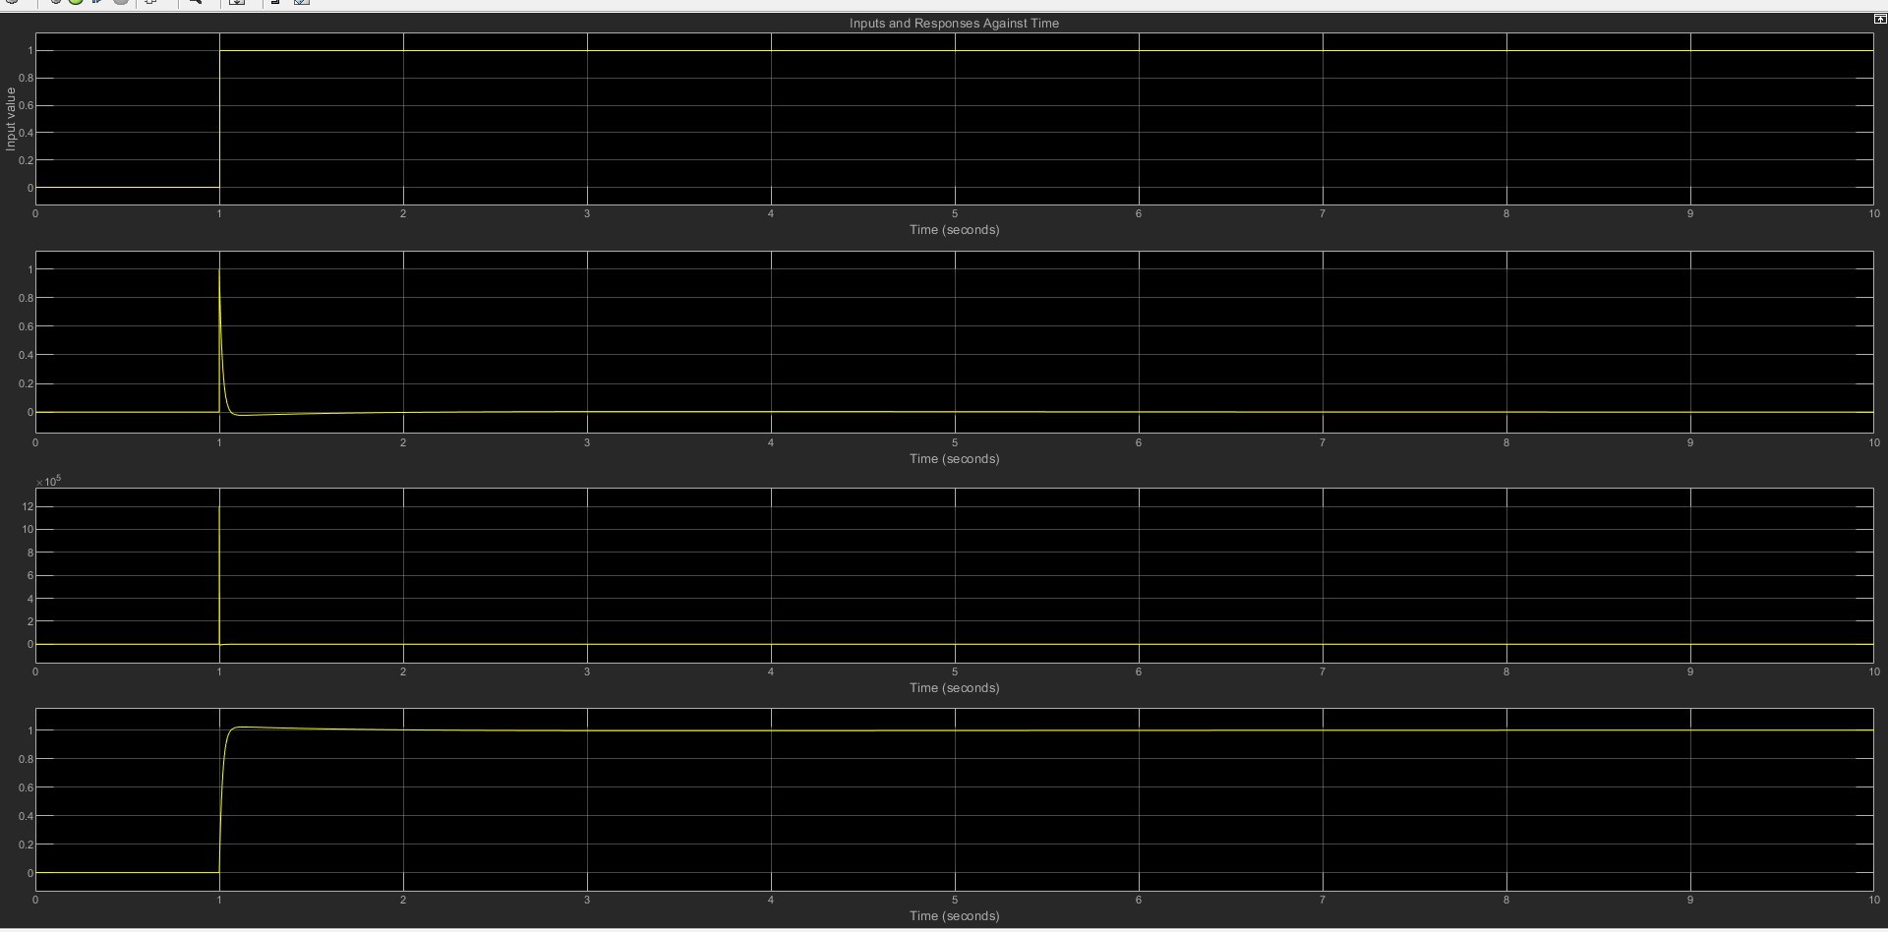
Figure 12: Graphs from the scope showing the input against time. Top is input, beneath is the error, third is the PID control input and the bottom graph shows the desired output.

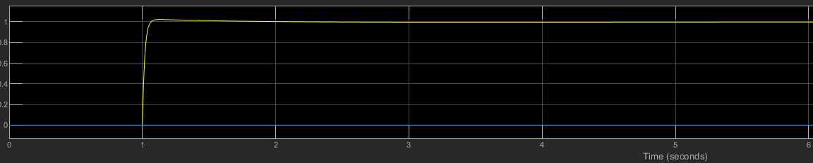
The transfer function for both the PID and Process is derived from multiplying the two transfer functions together and then simplifying.
Figure 13: Plot showing the difference between the outputs from the PID to Process system and the transfer function, blue line indicates no difference, cropped at six seconds for ease of viewing.
PID transfer function:
$K_{P}+\frac{K_{I}}{s}+K_{D}\frac{s}{\frac{s}{N}+1}$
(1)
Process transfer function:
$$\frac{1}{as^{2}+bs+c}$$
(2)
Multiplied and simplified:
$$\frac{\left(K_{P}+KⅆN\right)s^{2}+\left(Nk_{p}+k_{I}\right)s+K_{I}N}{as^{4}+\left(b+Na\right)s^{3}+\left(C+N_{b}+K_{P}+K_{D}N\right)s^{2}+\left(CN+Nk_{P}+K_{I}\right)s+K_{I}N}$$
(3)
Taking the values obtained from the results this simplifies to:
1203000s² + 187200s + 646900
3s⁴ + 20310 s³ + 2s² + 13540s
(4)
A complete derivation is contained within Annex A.

3.2 Stability analysis

The next way of analysing the results is to check their stability. The stability of the system is a measure of how it responds to different inputs, if the output remains bounded to the input response it is said to be stable [3]. To check the stability of the signal several graphs can be generated, these are the pole-zero, Nyquist and Bode diagrams.
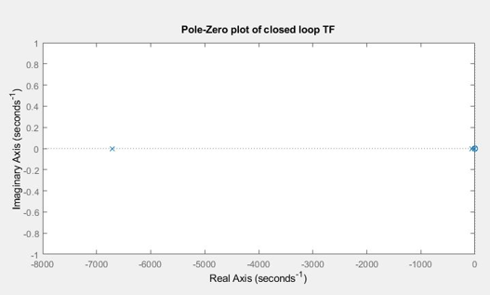
Figure 14: Plot Zero of the closed loop transfer function, stability is shown by the position of the poles (x) on the left-hand side of the diagram
The pole-zero plot uses the transfer function for the process and defines poles as the roots of the denominator polynomial and indicated by an x, the zeros are indicated by a 0 and are the roots of the numerator polynomial [5]. According to the equation, the pole for the system is the root of
3s⁴ + 20310 s³ + 2s² + 13540s = 0
(5)
Which gives:
s= 0, s = -6770 in the real plane
(6)
The pole is therefore on the left-hand side of the diagram, and as this means the system response is reducing the disturbance inputs it is said to be stable [3]. The distance from the origin also suggests a very rapid settling time, which again indicates the stability of the control [3]. The next plots to examine are the Bode and Nyquist diagrams which are different representations of the same information [4].
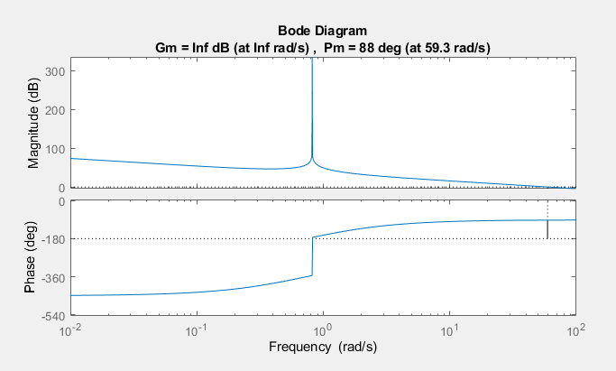
Figure 15: Bode Diagram for CIWS control system.
The Bode diagram is a measure of stability in the frequency domain, the top diagram shows the gain margin and the bottom shows the phase [6]. The gain margin for this system is infinity, meaning that the system will remain stable no matter the magnitude of the signal inputted. The phase margin is at 88º, which implies that so long as the phase change is beneath this value the system will remain stable [3]. A second way of viewing this data is by looking at the Nyquist plot.
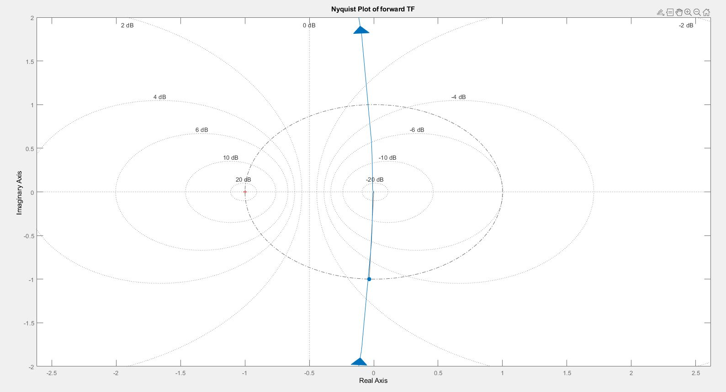
Figure 16: Nyquist plot of the CIWS control system showing the unit circle.
The Nyquist plot is harder to read than the Bode plot, however it shows the same data [3]. To illustrate this, it is worth zooming in on the plot.
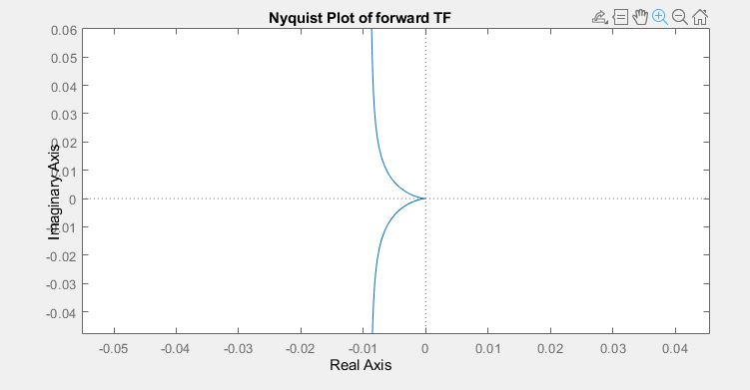
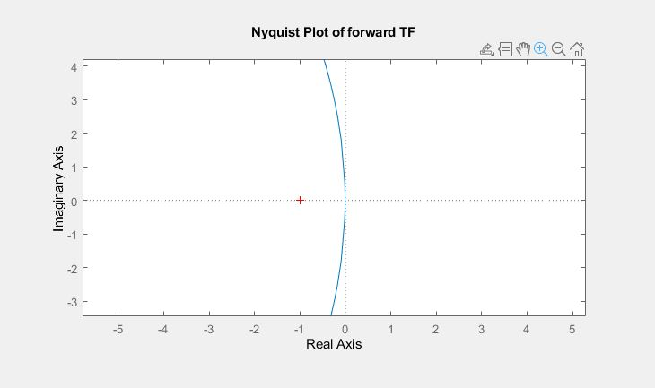

Figure 17: Top (a) Nyquist diagram showing the crossover point at -1, bottom (b) diagram showing the time delay at zero.

The gain margin here is given by the relationship between the two plots, the crossover point illustrated by the cross on Fig. 17 (a) and where the point forms on Fig. 17 (b). This indicates the relationship is -1/0, which is infinity, as corroborated by the Bode diagram. The phase margin is the angle between input and the unit circle [5].

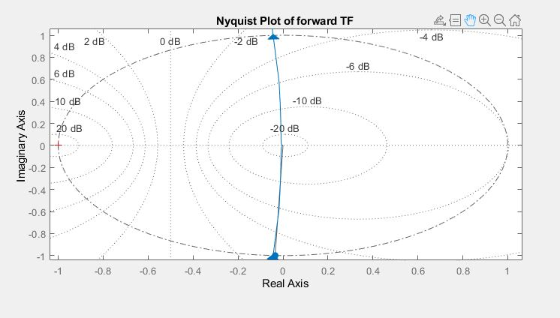
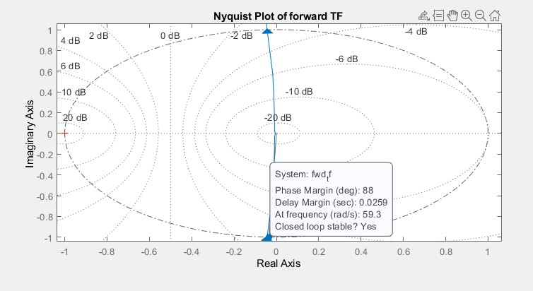
Figure 18: Nyquist plot zoomed in showing the point where the input crosses the unit circle, bottom has caption for ease of comparison to Bode.

Figure 18. shows that the Nyquist plot compares well to the Bode, similarly indicating that the system is stable for any change in phase less than 88º.
Overall the results show that the system is very stable, this is good as a systems stability can be reduced by the response time required and as noted previously the CIWS requires a very fast response time [3]. However, in the simulation it appears that despite the sharp rise, as indicated by the steep slope on the fourth plot in Fig 12., the system overall remains stable and able to fulfil the design criteria.

Discussion

The system outlined here was run as a simulation therefore there is a discussion to be had about its relationship to real world systems. In the previous section this report outlined the results of the CIWS model and suggested that due to its stability and meeting the design criteria that it was appropriate. To further corroborate this it is useful to look at other studies that have used a similar approach. During the author’s research two thesis were found where control systems for military use were explicitly laid out. The first examined the applicability of simulations for modelling a main battle tank turret and although the object of the study was centred on different controllers there is considerable overlap with the layout of the system and the object of this report [10].
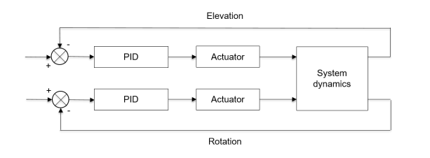
Figure 19: Tank control system taken from [10, p. 23].
The second study examines the control system for a CIWS to be used by the American navy [11]. This detailed study also describes the control system very similarly to the approach taken.
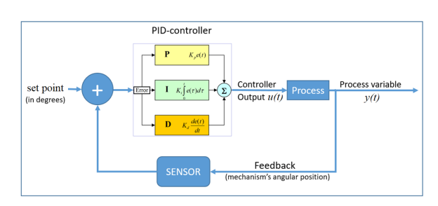
Figure 20: Block diagram of control system for a heavy machine gun for naval use taken from [11, p. 32]
Therefore, the system simulated has a degree of correlation with other researchers tentatively suggesting it is appropriate starting point for modelling real world systems. This combined with the results and analysis for the system suggests that this report offers a useful understanding of a CIWS control system in the real world.

Conclusion

This report examined the rotational control for a close-in weapon system (CIWS). It successfully followed the design brief creating a system that met the requirements and was stable. The report verified these findings by examining several different plots of the input response within MatLab and then commented overall on the applicability of a simulation to real world scenarios. Overall, the findings of the report demonstrate that it is possible to successfully model a CIWS within Simulink.

References

[1] | Navy Lookout, 10 08 2020. [Online]. Available: https://www.navylookout.com/last-ditch-defence-the-phalanx-close-in-weapon-system-in-focus/. [Accessed 24 04 2023].
[2] | G. Allison, “Uk Defence Journal,” Uk Defence Journal, 19 11 2021. [Online]. Available: https://ukdefencejournal.org.uk/uk-awards-40m-contract-for-phalanx-ciws-support/. [Accessed 23 04 2023].
[3] | R. C. Dorf and R. H. Bishop, Modern Control Systems, 14th ed., Harlow: Pearson Education Limited, 2022.
[4] | N. S. Nise, Control systems Engineering, 8th ed., Hoboken: Wiley, 2019.
[5] | G. F. Franklin, J. D. Powell and A. Emami-Naeini, Feedback Control of Dynamic Systems, 7th ed., Harlow: Pearson, 2014.
[6] | K. J. Astrom and R. N. Murray, Feedback Systems: An Introduction for Scientists and Engineers, Oxford: Princeton University Press, 2008.
[7] | H. Wu, W. Su and Z. Liu, “PID Controllers: design and tuning methods,” in IEEE 9th Conference on Industrial Electronics and Applications (ICIEA), Hangzhou, 2014.
[8] | D. P. Atherton and S. Mahji, “Limitations of PID controllers,” in Proceedings of the American Control Conference, San Diego, 1999.
[9] | M. Johnson, “PID Control Technology,” in PID Control, M. Johnson and M. Moradi, Eds., London, Springer, 2005, pp. 1-46.
[10] | M. Lyth, Modeling and Evaluation of Turret Control Systems for Main Battle Tanks, Stokholm: Unpublished, 2021.
[11] | E. Serris, Design and prototyping of a portable naval weapon control system for heavy machine guns, Monterrey: Naval Postgraduate School, 2018.

Annex A

$$\left(K_{P}+\frac{k_{I}}{s}+K_{D}\frac{s}{\frac{s}{N}+1}\right)\left(\frac{1}{as^{2}+bs+c}\right)$$
(1)

$$\left(K_{P}+ \frac{k_{I}}{s}+ \frac{K_{D}Ns}{N+s}\right)\frac{1}{as^{2}+bs+c}$$
(2)

$$\frac{\left(K_{P}+ \frac{k_{I}}{s}+ \frac{K_{D}Ns}{N+s}\right).1}{as^{2}+bs+c}$$
(3)

$$\frac{K_{Ps^{2}}+ K_{P}Ns+K_{I}+K_{I}N+ K_{D}Ns^{2}}{\frac{s(s+N)}{as^{2}+bs+c}}$$
(4)

$$\frac{{(K}_{P}+K_{D})s^{2}+\left(K_{P}N+K_{I}\right)s+K_{I}N}{as^{4}+\left(b+Na\right)s^{3}+\left(c+Nb+K_{P}+K_{D}N\right)s^{2}+\left(cN+NK_{P }+K_{I}\right)s+K_{I}N}$$
(5)

