

Project Proposal:

The effectiveness of online learning tools in developing interactive learning experiences

Name: Greg Rees
Student number: 1905774
Programme: MSc Applied Computing
Module: Research Methods and Professional Development
Date submitted: 31st March 2020
Contents

1. Introduction 1
2. Background to the proposed research 1
3. Aims & Objectives 5
4. Research Methods 6
4.1 Philosophy 7
4.2 Strategy 8
4.3 Approaches 9
4.4 Risks & Limitations 10
4.5 Data Evaluation 11
5. Development Methods 13
5.1 Waterfall Model Methodology 13
5.2 Agile Model 15
6. Resources & Planning 16
6.1 Resources Required 16
6.2 Gantt Chart 16
References 18

List of Figures
Figure 1: The research onion, Saunders et al [14] 6
Figure 2: The SDLC Waterfall Model [20] 14
Figure 3: Comparison of Waterfall and Agile methodologies [23] 15
Figure 4: Gantt Chart Task View 16
Figure 5: Gantt Chart Calendar Views 17

List of Tables
Table 1: The advantages and disadvantages of online learning [13] 4
Table 2: Characteristics of research philosophies, Collis and Hussey [15] 7
Table 3: Differences between deductive and inductive approaches to research, Saunders et al [14] 9

1. Introduction
This research proposal will outline the background of the topic chosen as the basis for further research. This will be supported by a summary of the literature and current issues identified in the area. The aim of the project, as well as a set of related objectives, will be identified in order to give the project clear direction and measurable outcomes. The research philosophy, strategy and approaches will also be discussed as well as any methodologies that fit with the development of the expected outcome upon completion of the project.

2. Background to the proposed research
The topic chosen for this project will involve the research and exploration of a variety of online learning tools available to educators in the delivery of their content to learners. Upon completion of the project the expected outcome, or deliverable, will be a framework for the evaluation of such tools to be used by educators and to help them select the best tools for their specific needs in the future.
The current working title for this research project is: “The effectiveness of online learning tools in developing interactive learning experiences”.
Recent years have seen an acceleration in the growth of online learning tools and platforms. The continuing growth of the Internet and developments in technology such as connectivity and network bandwidth have provided a solid foundation and backbone to enable this growth [1].
In addition to this, the Department for Education [1] identify that enhancements in the availability and capability of personal digital devices such as smart phones, laptops, tablets have enabled more users to access these online learning tools in a variety of different settings.
This has created opportunities for educators across a variety of different settings, disciplines and age ranges, to engage their learners in their online learning programs in a number of different ways. A variety of engaging resources can be created and can provide different types of experiences for learners [2].
For example, distance learning has become an established method of course delivery in university settings. According to Midgley [3], in 2020 there are currently 270,000 undergraduate and 108,000 postgraduate students undertaking their studies on an entirely distance learning basis.
Universities UK [4] state that the number of higher education institutions in the UK offering some sort of distance learning provision has increased from 102 in 2010-11 to 117 in 2016-17.
Distance learning can be used as a tool by universities to offer 100% fully online qualifications. One such example is The Open University, which is a widely established online university which currently makes up 65% of all online learning in higher education, whilst other institutions make up the remaining 35% [5].
Haughey [6] explains that distance learning mainly refers to education settings where the educator and learner are separated and where the learner can study at a place, pace and time of their choosing. Haughey [6] goes on to explain that distance learning comprises some forms of communications technology to link the instructor to the learners either synchronously (at the same time for all) such as via live video link, or asynchronously (in their own time) through online methods such as blogs, wikis and email or downloadable materials such as guided video tutorials.
Traxler [7] identifies that the term distance learning in a university setting can be thought of as learning away from a campus. However, there are many other terms that are used interchangeably with distance learning such as online learning, digital learning, e-learning and virtual learning. Traxler [7] goes on to point out that the term blended learning may be a better definition as it suggests a combination of digital learning along with other traditional methods.
Almarashdeh [8] acknowledges that the use of distance learning and technology for education purposes has become much more prevalent. However, Almarashdeh [8] also acknowledges that the success of such methods is heavily based on the satisfaction level of the educator using such tools. It is suggested that an educator that is satisfied with the online learning tools they are using will promote greater utilisation of these methods by their learners.
Whilst a university setting has been used as an example here, the uptake and deployment of online learning tools in a school-based environment seems to be more sporadic and piecemeal. This research project will aim to address the reasons for this in order to gain a better understanding of the barriers that educators face in school settings and ways in which these can be mitigated with the assistance of a new framework.
There are several proprietary and open source tools already in existence and the choice of which tool to use is very much down to the priorities and needs of the educator.
Although not an exhaustive list, Antsey and Watson [9] identify some factors that need to be considered by educators when choosing online learning tools including:
- Features available – such as learner tracking, gamification of learning, reporting on learner progress
- Scale – how easy is it to scale up the materials that are created. The tools chosen for a school setting may need to be suitable for a number age ranges, phases and subjects
- Ease of use – the move towards creating and delivering online content will be a big shift for educators. It is essential that the transition process is made as simple as possible
- Collaboration – they may be a requirement for tools to be included that enable communication between learners. Many courses nowadays have an emphasis on working in teams and online learning tools will need to consider this
- Cognitive engagement – it is essential that all learners are taking something from using the tools available and engaging in the content that is provided. It is vital that the online learning tools assist in moving learning forward
- Integration with an existing system – many schools use management information systems already e.g. SIMS to store and organise the vast amounts of data and information they are required to keep. Any new system that is introduced may need to have a link to an existing management information system

In addition to these factors, there some additional factors that are applicable to all web applications and must be taken into account:
- Accessibility – the W3C [10] explain that website accessibility helps to ensure that there are no barriers to using the online learning tools by anybody who may have physical disabilities and also those who may face social inclusion issues e.g. those in rural areas or developing countries
- Security – any tools that are chosen must be protected from various threats such as malware, viruses, spam and DDoS attacks [11]. If educators are to invest their time and efforts in learning and migrating to an online system, they will want to be assured that security issues have been addressed.
- Privacy – there is likely to be a requirement for any online learning tools that are chosen to store data about its users. This could include personal information. In the UK, this process is governed by the Data Protection Act 2018, which is the UK’s implementation of the General Data Protection Regulations (GDPR) [12]. There are six principles which must be followed to comply with the Act.

Arkorful and Abaidoo [13] explain some of the advantages and disadvantages of online learning, as seen in Table 1:

Table 1: The advantages and disadvantages of online learning [13]

Advantages | Disadvantages
Increasing student interest and focus | Feelings of remoteness, isolation and the lack of interaction with others
Learners can study in the time and place that suits them, promotes autonomy | The lack of clarification, explanation and interpretation of the material
Provides opportunities for relations between learners via forums, blogs, wikis | Difficulties in assessing learner progress through regulation of online tests or exams
Cost effective as learners do not need to travel and courses can be offered without needing to accommodate learners in a building | Issues such as piracy, plagiarism, cheating can be evident
Learners can engage in the ways that suit them best e.g. little and often, self-pacing | Not all disciplines are suitable for online learning. For example, scientific experiments are practical skills that may be better suited to a laboratory

3. Aims & Objectives
The primary aim for this project is to research a variety of online learning tools in order to define a framework for the evaluation of such tools.
To achieve this aim, a number of SMART objectives have been identified:
- To investigate the development and current state of online learning tools for developing interactive learning experiences
- To investigate the current state of teacher engagement with and adoption of tools for online learning
- To create a framework for online learning tools based on the findings
- To evaluate the current tools available using the framework and using input from actual users in an education setting

Upon completion of the project, it is expected that a framework will have been created that will assist educators in deciding which online tools are best suited for their distance learning needs. This will require input from school educators, across a number of subjects and phases, who have used the framework and feedback will be gathered using interviews and questionnaires.
This feedback will allow for an evaluation of the framework to take place to assess its effectiveness and suitability for the purpose intended.

4. Research Methods
A research methodology can be thought of as an operational framework in which to structure and organise the research process. There are many different elements which make up an effective research process and it is important to address each one.
Saunders et al [14] introduce the concept of the ‘research onion’ to aid the research process, as shown in Figure 1:

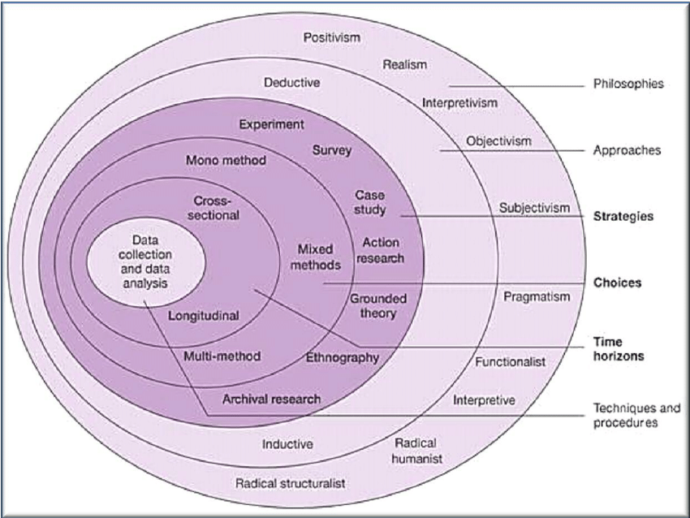
Figure 1: The research onion, Saunders et al [14]

The use of the onion to illustrate the process is an example of a cognitive metaphor. The idea is that a researcher starts at the outer layer and addresses each issue or ‘layer’ in turn, effectively ‘peeling’ away layers until they arrive at the core. The individual layers cover aspects such as research philosophies, approaches, strategies, choices, time frames and data collection methods. This approach helps to ensure the process is methodical and systematic without missing out any vital component.

4.1 Philosophy
Beginning at the outer most layers, the researcher needs to address the research philosophy that is most appropriate. The research philosophies are usually approached in two main ways, either by positivism or phenomenology.
Collis and Hussey [15] explain that positivists believe that any knowledge we may acquire is normally based on the observation or experience of real phenomena in an objective and real world and that there are logical answers to questions. Collis and Hussey [15] go on to add that logical reasoning is applied to the research in order to ensure that precision and disciplined reasoning is established instead of being subject to human experiences or perceptions. There are other terms which can be used to describe positivism, including quantitative, scientific, objectivist and experimentalist.
Phenomenologist’s, on the other hand, are primarily concerned with understanding human behaviour. Rather than establishing the measurement of social phenomena, as dictated by positivism, phenomenology is concerned with the meaning of the data. This is supported by Saunders et al [14] who suggest that phenomenology is a way in which humans try to make sense of the world around us. Essentially, we each have a perspective on subjects through our experiences with them. Other similar terms which are sometimes used to describe phenomenology include qualitative, subjectivist, humanistic and interpretivist [15].
Collis and Hussey [15] have identified a number of characteristics pertaining to both types of philosophy, as shown in Table 2:

Table 2: Characteristics of research philosophies, Collis and Hussey [15]
Positivism | Phenomenology
Lends itself towards quantitative data | Lends itself to qualitative data
Usually involves large samples | Usually involves small samples
Concerned with testing theories (deductive approach) | Concerned with generating theories (inductive approach)
Data is highly specific and precise | Data is rich and subjective
Uses artificial location | Uses natural location
High reliability, can be replicated | Low reliability, cannot be replicated easily
Low validity, not a good representation | High validity, give a good representation
Generalises from sample to population | Generalises from one setting to another

It is anticipated that the research philosophy more suited to this research project would be phenomenology. The main reasons for this approach include:
- It is likely that the research will generate a significant amount of qualitative data. This will come from sources including the teaching staff asked to use the tools suggested. The data generated will mainly consist of thoughts and opinions.
- The sample, or group, that is needed to conduct this research is relatively small.
- Unlike a quantitative methodology, where measurements form a critical part of the research process, the phenomenological methodology is concerned with data which is of quality and depth regarding the specific problem. The data can also be classed as rich, due to the fact it will be detailed.
- As already mentioned, the data being collected is going to be qualitative. As this cannot be measured statistically, it may be considered to have low reliability.
- On the other hand, the data collected can be regarded as highly valid in the sense that it is an accurate representation of what exactly is happening in the research environment, meaning it should address all the required questions by means of its in-depth knowledge nature.
- Finally, the research will be rather generalised to one specific sector. As such, the characteristics and findings are unlikely to be relative to a wider population.

4.2 Strategy
Saunders et al [14] explain that there are four main strategies of conducting research, namely:
- Action research – where an analysis is made of the situation before the introduction of the change, followed by further analysis and an evaluation following the implementation.
- Experiments – where experiments are conducted that involve repeating a set of actions with a different set of variables, in order to collect data to test a hypothesis or to develop theories.
- Surveys – which involve gathering and analysing large amounts of data from a sizeable number of respondents, using appropriate questionnaires or through conducting interviews.
- Case studies – which aim to understand certain phenomena within a particular context, for example in one organisation. This involves gathering detailed information and extracting in-depth knowledge through a number of methods including interviews and questionnaires.

After considering the application of each technique to this project, it was concluded that the case study approach would be most suitable. Yin [16] identifies that there are certain characteristics of the case study approach. Firstly, the approach is a phenomenological method aiming to understand certain phenomena within a particular context. This fits with the phenomenology research philosophy selected earlier in this section.
Secondly, Yin [40] outlines that the research does not commence with a set of questions or concerns about the limits within which the research will take place as the boundaries between the phenomenon being studied and the context within which it is being studied are clearly evident.
Finally, this approach involves gathering a significant amount of detailed data regarding how the current methods work and establishing the requirements of the new framework from the end users. The process used to gather this data will come from a variety of qualitative methods. In particular interviews and questionnaires will be implemented.

4.3 Approaches
A research approach needs to be chosen that compliments the research philosophy that will be used. The two approaches to consider are inductive and deductive. Saunders et al [14] have identifies the differences between the two approaches, as seen in Table 3:

Table 3: Differences between deductive and inductive approaches to research, Saunders et al [14]
Deductive | Inductive
Collection of quantitative data | Collection of qualitative data
Based on scientific principles | Gaining an understanding of the meaning’s humans attach to events
The need to explain causal relationships between variables | A close understanding of the research context
A highly structured approach | A more flexible structure to permit changes of research emphasis as the research progresses
Researcher independent of topic being research | Researcher is part of the research process
Samples must be of a sufficient size to be able to generalise conclusions | Not as much need to generalise conclusions

It is believed that the approach most suitable for this project is the inductive approach. This has been chosen because:
- There is no specific hypothesis that has been identified from the outset
- The research will aim to detect patterns and regularities
- These patterns and regularities will then lead to the formulation of tentative hypotheses that can be explored further
- There will be an emphasis on the collection of quantitative data from users
- The data produced could result in a shift in the focus of the research as the project progresses
- The conclusions drawn from the research are likely to be more generalised [17]

4.4 Risks & Limitations
There are a number of risks and limitations that have been identified that could jeopardise the success of this project. These include:
- Users having sufficient time to experiment with the tools – individuals within education will already have their own work to do and may struggle to find the time to assist with this project. It will be important to communicate the timescales to them in advance and give them sufficient time for any tasks they need to undertake
- Access to end users – as the researcher is not working directly with those users asked to take part in the project, it will be important that adequate communication is maintained e.g. via email
- Limited only to open source/free solutions – the scope of this project does not enable paid-for solutions to be used which could limit the tools and features that are available for research
- Poor time management – it will be important to constantly monitor the progress of the project and adjust timescales as appropriate if any issues arise. Project management software is being used and a Gantt chart has been created to assist with this

4.5 Data Evaluation
The methods of data collection over the duration of this project are anticipated to be:
- Questionnaires - will be distributed to educators prior to the framework being created . Questionnaires will also be issued to educators after the implementation of the framework to gather feedback. The design of the questionnaires will need to be carefully considered. It is likely that the questions asked will use a combination of open and closed questions as well as the Likert scale, where respondents are asked to rate statements on a scale from strong agreement to strong disagreement. Questionnaires are a suitable method because they reduce the risk of interviewer bias and are relatively cheap to produce and administer.
- Interviews - with end users/educators. The main purpose of the interviews will be to understand the current issues and to gauge the expectations of the new framework. The use of interviews will be suitable because it will allow interviewees to express their views in their own words, which will allow the interviewer to probe for further information. A rapport can also be built with the interviewee to gain their trust and commitment. However, interviews can potentially be expensive and very time consuming.

In order to analyse the results of the research findings, a number of techniques will need to be applied. Similar to the methods of data collection, it is likely that the data analysis techniques may be a combination of positivistic and phenomenological methods.
It has been suggested by Robson and McCartan [18] that unlike quantitative methods, there are no clear and accepted set of conventions for the analysis of qualitative data.
Further to this Collis and Hussey [15] outline that due to the possible large volume of data which may have been collected, it is important to apply methods that reduce the data, give it some structure and try to use alternative forms of representation other than extended text. In order to do this, it might be necessary to apply techniques to convert qualitative data into quantitative data. Whilst not universally accepted, Collis and Hussey [15] acknowledge that this method is quite commonplace.
One such way of applying this technique would be to conduct a content analysis. Collis and Hussey [15] describe content analysis as a way of systematically converting text to numerical value for statistical data analysis. This could be done by analysing the findings from the user observations and interviews to identify themes which could be represented statistically. Another statistical method that could be applied is the use of cross tabulation of findings from user questionnaires. Cross tabulations are relatively simple to produce and easy to understand.
Non-statistical methods which can be applied include the collation and analysing of user interviews. These will require a more general analytical method.

In order to analyse the results of this project a number of methods will be used:
- Comparison with initial aims and objectives – this will involve comparing and contrasting what was initially required from the framework to what has actually been developed. The result of the project should fulfil the aim and the objectives outlined earlier in this report.
- Evaluation of the framework – the new framework will be used by educators to assist them in selecting a tool that is the best fit for their needs. An evaluation of this process will need to be conducted to gauge the success of the framework and to identify any areas that require improvements.

5. Development Methods
Avison and Fitzgerald [19] outline that a general development methodology consists of a number of key components. This is commonly referred to as the Software Development Life Cycle (SDLC).
Firstly, it is necessary to specify how a project is to be broken down into stages and identify what tasks are to be carried out at each stage. These stages should also have a pre-determined output to signify completion and give a clear idea of the people involved and any input required from them. Any constraints that need to be applied to these stages and outputs should also be identified. It is also necessary to classify what support tools and resources may be needed throughout the process as well as producing a plan of how the project will be managed and controlled. Finally, there should be a clear philosophy that shapes the further development of the methodology.
Whilst every system development project is unique, it is recognised that a structured, systematic approach is a necessity to ensure its success. Avison and Fitzgerald [19] go on to identify some of the reasons a developer may wish to adopt a development methodology. Firstly, the use of a development methodology provides an overall systematic method of development and allows progress to be planned and maintained. Having this framework in place should ideally provide a system that is developed within an appropriate time frame and delivered at a cost acceptable to the organisation.
The methodology should allow for the system requirements to be accurately captured, therefore providing a deliverable that is usable by the people who are directly affected by its implementation.
Lastly, as the development progresses, changes may need to be made and having a framework in place should allow these changes to be identified and reacted to in good time.
The two methodologies identified as potentially suitable for this project include the Waterfall Model and the Agile Model.

5.1 Waterfall Model Methodology
The waterfall model is classed as a general approach to systems development and typically consists of a number of generic stages including a feasibility study, system investigation, systems analysis and design, implementation, as well as a review and maintenance phase post implementation.
Although the terminology for each phase may change depending on which source is used, they all tend to follow the same general pattern. A basic outline of this methodology is illustrated in Figure 2:

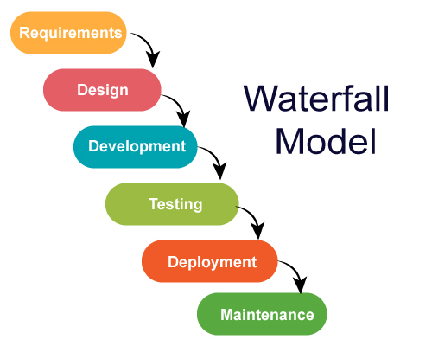
Figure 2: The SDLC Waterfall Model [20]

Kramer [21] outlines the main advantage of adopting a traditional waterfall model approach as being able to provide some structure for organising and controlling a project.
However, there are some limitations to the model including:
- Accurate user requirements must be specified in advance
- No iteration and feedback between stages
- The model is very structured and rigid
- The inability to handle change well or cost-effectively
- Lack of prototyping can result in lengthy delivery of the final outcome

It should be noted that there is no software or system being developed as part of this research project, which may make the Waterfall Model a less suitable candidate to use. Another approach to development would be the Agile Model, which uses a similar structured approach but is far more flexible and less rigid.

5.2 Agile Model
CPrime [22] explain that Agile development methods are based on the concept of iterative development and that requirements and the associated outcomes can evolve throughout the project through collaboration between stakeholders. There is a strong emphasis on the model having the ability to respond effectively to change.
As the development of the new framework will require input and feedback from test users, it is highly likely that there will be many iterations of the framework as the project progresses. The Agile development methodology will facilitate this and enable incremental progress.
An illustration of the key differences between the Waterfall and Agile methodologies can be seen in Figure 3:

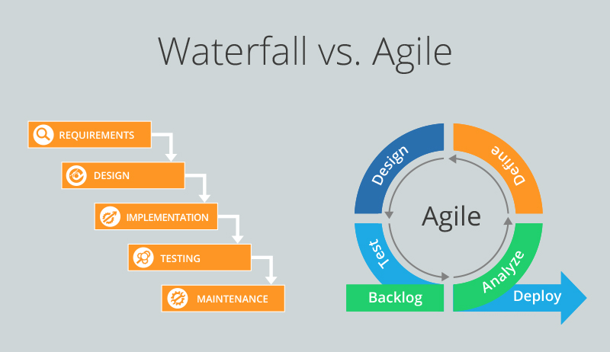
Figure 3: Comparison of Waterfall and Agile methodologies [23]

It is expected that elements of the Agile Model can be used and adapted to suit the needs of this project.

6. Resources & Planning

6.1 Resources Required
In order to complete this project successfully, it is anticipated that the following resources will be required at various different stages:
- A desktop/laptop computer system with the Windows 10 operating system
- Microsoft Office Suite – Word, Excel, Access, PowerPoint
- Project Management software – to track and monitor progress of the project
- Internet access
- Reference materials on the topic
- End users for feedback and testing of the framework

6.2 Gantt Chart
In order for this project to be successful, the main project will need to be broken down into smaller sub-tasks. These sub-tasks will need to be assigned timescales and given deadlines.
A Gantt chart has been constructed that outlines the sub-tasks identified, as seen in Figure 4, whilst Figure 5 shows the tasks plotted in calendar view:

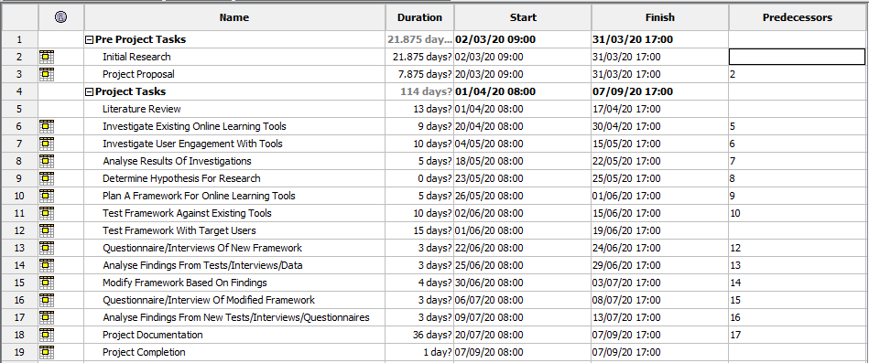
Figure 4: Gantt Chart Task View



Figure 5: Gantt Chart Calendar Views

References

[1] | Department for Education, "Realising the potential of technology in education," London, 2019.
[2] | Markova.T, Glazkova.I and Zaborova.E, "Quality Issues of Online Distance Learning," Science Direct, vol. 237, pp. 685-691, 2017.
[3] | Midgley.S, What is Distance Learning?, 2020. [Online]. Available: https://www.thecompleteuniversityguide.co.uk/distance-learning/what-is-distance-learning. [Accessed 20 Mar 2020].
[4] | Universities UK, "Flexible Learning: The current state of play in UK Higher Education," Oct 2018. [Online]. Available: https://www.universitiesuk.ac.uk/policy-and-analysis/reports/Documents/2018/flexible-learning-the-current-state-of-play-in-higher-education.pdf. [Accessed 20 Mar 2020].
[5] | The Open University, "Annual Report 2018/19," 2019. [Online]. Available: http://www2.open.ac.uk/about/annual-report-2018-19/. [Accessed 21 Mar 2020].
[6] | Haughey.M, Distance Learning, Canadian Encyclopedia, Toronto, 2019.
[7] | Traxler.J, "Distance Learning—Predictions and Possibilities," Education Sciences, vol. 8, no. 35, pp. 1-13, 2018.
[8] | Almarashdeh.I, "Sharing instructors experience of learning management system: A technology perspective of user satisfaction in distance learning course," Computers in Human Behaviour, vol. 63, pp. 249-255, 2016.
[9] | Antsey.L and Watson.G, "A Rubric for Evaluating E-Learning Tools in Higher Education," 10 Sep 2018. [Online]. Available: https://er.educause.edu/articles/2018/9/a-rubric-for-evaluating-e-learning-tools-in-higher-education. [Accessed 19 Mar 2020].
[10] | W3C, "Introduction to Web Accessibility," 2020. [Online]. Available: https://www.w3.org/WAI/fundamentals/accessibility-intro/#context. [Accessed 19 Mar 2020].
[11] | CyberExperts, "Top 10 Website Security Practices for 2020," 2020. [Online]. Available: https://cyberexperts.com/website-security-practices/. [Accessed 21 Mar 2020].
[12] | UK Government, "Data protection," 2020. [Online]. Available: https://www.gov.uk/data-protection. [Accessed 22 Mar 2020].
[13] | Arkorful.V and Abaidoo.N, "The role of e-learning, advantages and disadvantages of its adoption in higher education," Internation Journal of Instructional Technology & Distance Learning, vol. 12, no. 1, pp. 29-42, 2015.
[14] | Saunders.M, Lewis.P and Thornhill.A, Research Methods for Business Students, 4th ed., Essex: Pearson Education, 2015.
[15] | Collis.J and Hussey.R, Business Research: A practical guide for undergraduate and postgraduate students, 4th Ed ed., Hampshire: Palgrave Macmillan, 2017.
[16] | Yin.R, Applications of Case Study Research, 6th Ed ed., London: Sage Publications Ltd., 2017.
[17] | T. Prof, "Deduction & Induction," 22 Jan 2020. [Online]. Available: https://socialresearchmethods.net/kb/deduction-and-induction/. [Accessed 18 Mar 2020].
[18] | Robson.C and McCartan.K, Real World Reasearch, 4th Ed ed., Oxford: John Wiley & Sons, 2015.
[19] | Avison.D and Fitzgerald.D, Information Systems Development: Methodologies, Techniques and Tools, 4th Ed ed., Berkshire: McGraw-Hill Education, 2006.
[20] | JavaTPoint, "Waterfall Model," 2020. [Online]. Available: https://www.javatpoint.com/jira-waterfall-model. [Accessed 21 Mar 2020].
[21] | Kramer.M, "Best practices in Systems Development Lifecycle: An analysis based on the Waterfall Model," Review of Business & Finance Studies, vol. 9, no. 1, pp. 77-84, 2018.
[22] | CPrime, "What is Agile? What is SCRUM?," 2020. [Online]. Available: https://www.cprime.com/resources/what-is-agile-what-is-scrum/. [Accessed 21 Mar 2020].
[23] | Digite, "Moving from Waterfall to Agile," 8 Apr 2019. [Online]. Available: https://www.digite.com/blog/waterfall-to-agile-with-kanban/. [Accessed 21 Mar 2020].

