Name : Corina Iordan
Student id: 2021277
Module: Sustainable Hospitality & Tourism Management BMHI5006
Lecturer : Huw Thomas

SUSTAINABLE HOSPITALITY & TOURISM MANAGEMENT

Introduction
Sustainability can be referred to as the ability to meet or support the requirements of the present generation from the co-existing resources of the planet however without taking over the ability of the future generation to meet their own. Sustainability is a broad concept that holds not only the environmental prospects however it also highlights the social benefits that organizations across the world can contribute. The following study highlights the discussion on sustainability and its interrelation with the hospitality sector along with reflecting the growing concern across this industry worldwide.
Main Body
Definition of sustainability, its pillars, and its interconnection with the hospitality industry will be discussed in this paragraph. Taking consideration of the concepts of sustaibility, as articulated by Ruggerio, (2021), the conceptualizations of sustainability and sustainable development have received great relevance from the concepts of science and research regarding “environmental issues, policies linked to environmental management, and industrial and agricultural production, among others”. In this context, sustainability refers to meeting the needs and requirements of the present day without compromising the future generations’ requirements and their ability to meet them. However, the competitiveness and the outcomes that result from sustainability and the innovations that are relevant to it can be divided for the business organizations in terms of having “increased value creation, reduced costs, and nonfinancial assets” (Hermundsdottir and Aspelund, 2021). In addition, it can be stated that the relationship between tenability innovations and firm competitiveness is interconnected as in the modern days' the emergence of sustainability policies within the legal aspect of businesses across various industries has led to the organizations gaining a competitive edge in the business environment. As per the statement of Scoones, (2020) the imperatives of sustainability have further called for an ambitious societal transformation through “environmental sustainability, poverty alleviation, and social justice”. With the emergence of sustainability across every other industry the term implies a principle or fundamental change that further leads to new patterns of interconnections and results through “structural, functional, relational, and cognitive aspects of socio-technical-ecological systems” (Scoones et al. 2020).
As articulated by Purvis et al. (2019) the three pillars of sustainability and its conception include prospects of social, economic, and environmental. These three prospects commonly represent or are represented by three intersecting circles with the overall sustainability term origin being at the center. With the definition and concept of the prevalent term, sustainability employs three interconnected pillars that encompass goals in factors that are economically, socially, and environmentally relatable. Though the three prospects are interconnected, and they are not always represented in three intersecting forms. With the emergence of covid-19, the baseline of sustainability has systematically taken a shift over and the results have serious effects on the social economy and environment (Ranjbari et al. 2021). On the contrary, it can be stated that the sustainability post-covid situations have also offered opportunities and transitions that are directed toward healthier and better sustainable development goals (Ranjbari et al. 2021). Since sustainability deals with three integrated proformas that require balance in social, environmental, and economic aspects of human lives therefore the future generations as well as the current generations should be benefited without cropping out challenging bottom lines that can be massively devastating. In this regard, the employment of the three pillars of sustainability from a microeconomic perspective is essentially significant as the government and the private sectors across the world have initiated SDGs that require support and achievement (Ranjbari et al. 2021).
Interconnection with the hospitality industry will be discussed further. As proclaimed by Scavarda et al. (2019), the global environment of the business in alignment with sustainability in the industrial area 4.0 allows the establishment of a ground that interconnects corporate responsibility towards society. In this respect terms such as human resource and corporate social responsibility are interconnected when it comes to sustainability being conceptualized in the industrial plethora. As articulated by Pateli et al. (2020), the hospitality sector and its interconnection with sustainability in the prevailing period has not only enriched the digital strategies of the organizations’ adoptions, however, has also improved the customer experience and theoretical concepts that are diffused with environmental impacts being lessened up. As stated by Úbeda-García, (2021), in the prevailing period organizations, especially in the hospitality sector are striving to achieve CSR and green Human Resource Management goals that connect the organization and its future attainments thereon having a positive impact on the variables on the environmental and financial outcomes of the firms.
A critical evaluation of the business concerns such as increased action of the competitors and pressure of the government that motivates hoteliers for embracing sustainability while making it an integral part will be discussed further. As articulated by Rezapouraghdam et al. (2019), organizations in the prevailing period are under pressure to find and identify competitive as well as new sustainable practices and agendas that would help the organizations to deal with the devastation and deterioration of “biodiversity, widening social inequality, and unsustainable use of scarce resources”. Besides the most challenging and pressurizing part for organizations is to identify and strategies ways to engage employees across the organization in alignment with the sustainability procedures that are considered vital for achieving organizational sustainability as a collective approach (Rezapouraghdam et al 2019). In this regard the respective issue is more concerning, especially in the tourism and hospitality sector which is highly dependent on natural resources however on the contrary is also a labor-intensive sector employing a massive number of employees across the world. Further, as per the statement of Rezapouraghdam et al (2019), hospitality organizations are believed to have the ability to “cultivate workplace spirituality along with creating moral Bedrock” within the organizational space thereby having positive outcomes through the procedure that uplifts the commitment of the employees towards “sustainable practices, organizations’ prosperity, and environmental values”.
In the post-Covid situation, the detrimental effects on the global hospitality sector have significantly offered a transition from the social, and economic perspective that further is being imposed on the outcomes of the environmental performance of the hospitality sector (Filimonau, 2021). With the implications of various social and environmental development aspects organizations have undertaken potential strategies that help in efficiently and effectively managing waste across the hospitality sector globally. This particular initiation has further contributed to addressing the issue regarding food waste across the hospitality sector and thus it is considered that the integration of alternative food networks and short food supply chains would be helpful to further achieve and support the policies of sustained development (Filimonau, 2021). As proclaimed by Jones and Comfort, (2020) sustainability strategies and programs have been increasing and its considered high profile for leading companies to have sustainability programs integrated within their company policies. Besides majority of the companies across the world are becoming committed to sustainable development through schemes that are relevant in developing societies through charitable donations, campaigns, and offering a helping hand. Apart from this organizations are also often for in wearing mental concerns being reduced through business approaches in terms of reducing energy consumption and zero carbon emission (Jones and Comfort, 2020). However, from a contradictory point of view covid-19 has imposed major challenges that might further reduce the ability of organizations to come towards sustainable development plans. However in continuation with the argument that sustainability plans are considered vital in maintaining relationships and interconnections between service industries with the natural and social capital that are highly dependent on each other (Jones and Comfort, 2020).
With the initiative towards environmental and social programs sustainability has become an essential part of the business that offers long-term business growth. Besides these initiatives not only help in striving the business to create corporate transparency, however, also aligns the business strategies with the best options for the planet and people thereby driving brand values and customer trust (Forbes, 2022). Businesses in the prevailing industrial Era do not consider sustainability as the steps that should be integrated to have prosperity and growth however it is considered as this course strategy that offers a competitive advantage for organizations. Corporate social responsibility is also considered an intrinsic part of sustainability as government agencies pressurize organizations on offering special help and relief to various segments of society and to the environment through regulatory responsibilities that emerge as empowerment with proof (Forbes, 2022).
A discussion on circular economy and its relationship with CSR while demonstrating CSR strategies, policies and examples will be done further. As articulated by Meester and Dewulf, (2019), the circular economy in the current period is a growing topic that encourages and promotes responsible as well as cyclical utilization of resources which also possibly contributes to sustainable development plans. The circular economy is a broad concept that “includes lowering material input and minimizing waste generation to decouple economic growth from natural resource use”. Different nations across the world are adopting CE on a diversified manual that helps in monitoring macro scale prospects (Meester and Dewulf, 2019). As per the statement of Moraga e al. (2019) circular economy as a concept has emerged with potential solutions that further help in making better effective and efficient use of resources. Moreover, it can be positioned as a technology-based conceptualization that helps in generating economic games while deviating from pressures on the environment (Velenturf and Purnell, 2021). In addition, the circular economy can also be demonstrated as a positive concept by organizations that increasingly are focusing on adopting highly acclaimed sustainable plans across the public, private, and civics sectors (Morseletto, 2020). However, that transformation into a circular economy requires regulations actions, and policies that govern instruments for making the economy more circular and unlimited to a few discrete cases. Circular economy strategies on allowing the identification and systemization of new targets that further reflect the multifaceted reality (Morseletto, 2020). As proclaimed by Esken et al. (2018), there are different perspectives and perceptions of CSR however the incorporation of the circular economy helps in offering a stakeholder value perspective that is strategic and interconnected with the organizational goals and CE. As stated by Esken et al. (2020), the dynamic capabilities of CSR indicate a positive relation between CE and environmental as well as societal accountable practices. These further have the capability to influence the performance of organizations on a positive note. Besides the pillars of CSR commonly cover the elements of safety trust and innovation which are profoundly some of the parts of a circular economy from a sustainable point of view.
The corporate social responsibility examples or Trends that can be considered include authenticity being the first and foremost while meeting up social issues. In addition, communication can also be considered as a primary component as it would help in engaging employees towards the CSR goals of an organization who are the frontline servers and the strongest brand ambassadors of CSR initiatives. Moreover, diversity or diversified strategies also has a positive impact on businesses that offers leading in challenging inclusion to the businesses integrity thereby adding up non-profit contributions to the society. Volunteering against the social challenges by various companies would also offer solving issues that can help in developing diversified markets across the world, especially where specific companies are commonly based. At last, measuring is also considered one of the most important persons as corporate social responsibility in the alignment of business units has to be measured that would further help the business in achieving measurable goals increasing brand value and bracing innovation increasing employee engagement, and effectively meeting the customer requirements.

Conclusion
Based on the overall study it can be concluded that the above discussion offers an overview of sustainability and the conception it holds apart from highlighting the initiatives that the businesses are undertaking to have sustainable development in the current Industrial era of 4.0. The above discussion also reflects the actions of the competitive firms and the pressures that the government has been imposing on organizations across the world to uplift sustainability as a part and integral segment of every organization. Apart from this the study exceptionally highlights and sheds light on sustainability having a direct relationship with the hospitality sector apart from highlighting circular economy and CSR activities.

References
Esken, B., Franco-García, M.L. and Fisscher, O.A., (2018). CSR perception as a signpost for circular economy. Management research review.
Filimonau, V., (2021). The prospects of waste management in the hospitality sector post COVID-19. Resources, Conservation and Recycling, 168, p.105272.
Fores, (2022).How ESG Can Foster Business Growth And Brand Affinity.[Online]Available at:<https://www.forbes.com/sites/forbescommunicationscouncil/2022/05/05/how-esg-can-foster-business-growth-and-brand-affinity/?sh=17d48bd45610>[Accessed on: 8th October 2022]
Hermundsdottir, F. and Aspelund, A., (2021). Sustainability innovations and firm competitiveness: A review. Journal of Cleaner Production, 280, p.124715.
Jones, P. and Comfort, D., 2020. A commentary on the COVID‐19 crisis, sustainability and the service industries. Journal of Public Affairs, 20(4), p.e2164.
Moraga, G., Huysveld, S., Mathieux, F., Blengini, G.A., Alaerts, L., Van Acker, K., De Meester, S. and Dewulf, J., (2019). Circular economy indicators: What do they measure?. Resources, Conservation and Recycling, 146, pp.452-461.
Morseletto, P., (2020). Targets for a circular economy. Resources, Conservation and Recycling, 153, p.104553.
Pateli, A., Mylonas, N. and Spyrou, A., (2020). Organizational adoption of social media in the hospitality industry: An integrated approach based on DIT and TOE frameworks. Sustainability, 12(17), p.7132.
Purvis, B., Mao, Y., and Robinson, D., (2019). Three pillars of sustainability: in search of conceptual origins. Sustainability science, 14(3), pp.681-695.
Ranjbari, M., Esfandabadi, Z.S., Zanetti, M.C., Scagnelli, S.D., Siebers, P.O., Aghbashlo, M., Peng, W., Quatraro, F. and Tabatabaei, M., (2021). Three pillars of sustainability in the wake of COVID-19: A systematic review and future research agenda for sustainable development. Journal of Cleaner Production, 297, p.126660.
Rezapouraghdam, H., Alipour, H. and Arasli, H., (2019). Workplace spirituality and organization sustainability: A theoretical perspective on hospitality employees’ sustainable behavior. Environment, Development and Sustainability, 21(4), pp.1583-1601.
Ruggerio, C.A., (2021). Sustainability and sustainable development: A review of principles and definitions. Science of the Total Environment, 786, p.147481.
Scarpellini, S., Marín-Vinuesa, L.M., Aranda-Usón, A. and Portillo-Tarragona, P., (2020). Dynamic capabilities and environmental accounting for the circular economy in businesses. Sustainability Accounting, Management and Policy Journal, 11(7), pp.1129-1158.
Scavarda, A., Daú, G., Scavarda, L.F. and Goyannes Gusmão Caiado, R., (2019). An analysis of corporate social responsibility and the Industry 4.0 with focus on the youth generation: A sustainable human resource management framework. Sustainability, 11(18), p.5130.
Scoones, I., Stirling, A., Abrol, D., Atela, J., Charli-Joseph, L., Eakin, H., Ely, A., Olsson, P., Pereira, L., Priya, R. and van Zwanenberg, P., (2020). Transformations to sustainability: combining structural, systemic and enabling approaches. Current Opinion in Environmental Sustainability, 42, pp.65-75.
Úbeda-García, M., Claver-Cortés, E., Marco-Lajara, B. and Zaragoza-Sáez, P., (2021). Corporate social responsibility and firm performance in the hotel industry. The mediating role of green human resource management and environmental outcomes. Journal of Business Research, 123, pp.57-69.
Velenturf, A.P. and Purnell, P., (2021). Principles for a sustainable circular economy. Sustainable Production and Consumption, 27, pp.1437-1457.

Appendix
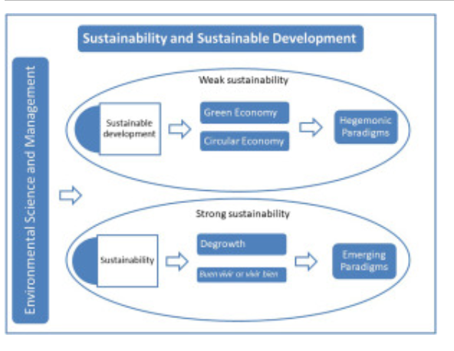
Figure 1: Understanding sustainability and sustainable development
Source: (Scoones et al. 2020)
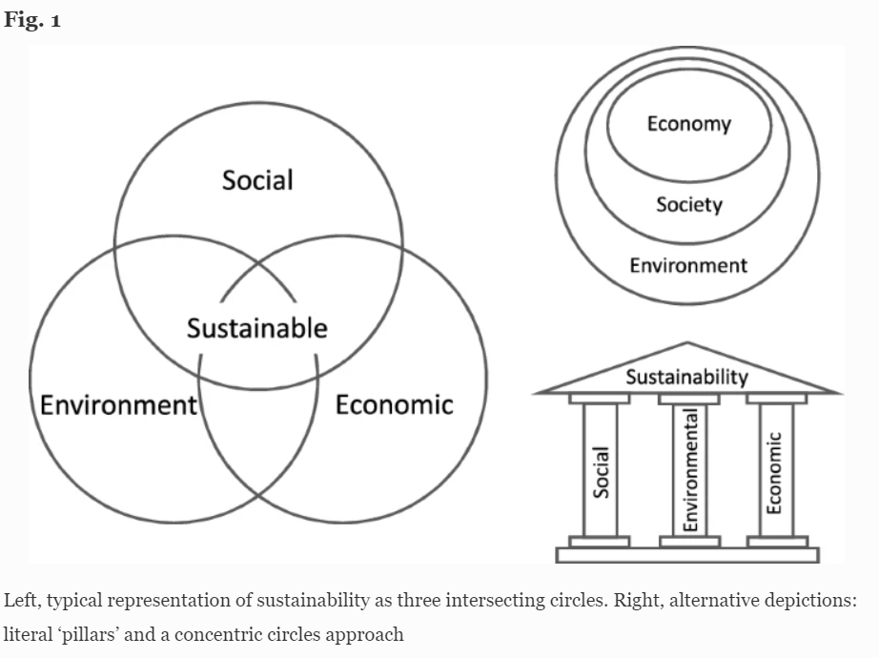
Figure 2: Three pillars of sustainability
Source: (Purvis et al. 2019)

