

Unit Title | Personal Career Development
Unit Number | BMSK4005
Unit level | Level 4
Student’s Name | Isac Ndejeya
Student’s ID | 1712481

Table of Contents
Introduction 3
Self-evaluation review: 4
VAK Learning Styles Self-Assessment Questionnaire 6
Personal development planning: 12
SWOT Analysis: 12
Smart objectives: 13
Johari Window: 15
Review of understanding and expectations of the world of employment: 16
Career ambitions and aspirations: 17
Personal development plan: 18
Development plan 18
Conclusion: 20
References: 20

Introduction
In this report, I am going to talk about my personal development plan along with self-evaluation review, understanding the employment expectations in this era, career goals along with career aspirations and personal development plan. This contents will help me to develop my future ambitions. I believe that by developing those contents in the report, I will be able to improve my skills and knowledge’s. SWOT analysis will help me to identify my different strong zone and weakness zone. Also, it will teach me how to overcome threat zone by taking best possible opportunities in different aspects of life.
Personal development plan is basically a process which helps an individual to gain future aims, helps to fulfill long, short and midterm goals in the sector of career. This plan also assess current realities of an individual by recognizing skills and knowledge. (Morgan, 2017).
My name is Isac and I am from Uganda. I am bus driver and I am doing this job for 13 years in London. This is basically my current position in the professional job field. My previous job experience was in the army field in Uganda and that lasts for about 12 years. I left my professional life when I was a captain. At that sector I actually worked for division intelligence officer for 3 years prior to leaving. I have already set up a future ambition in my life which is I want to complete my degree in the education field. Because I want to start an own security company. I know that I can make effective communication with other people. But there are some lacks in me like my education status. If I want to start an own security company I need to complete my education with proper degree. Furthermore, I want to state that there is a barrier towards my dream carrier which is Finance. I think I should start collecting money from different sources. First of all, I have to fulfil my short term goals like I should continue my education life. I should learn different important sectors on security business. I should do several courses on security company sector. I need some financial support if I want to continue my education along with some extra courses like SIA course. For this, I can take some loan from friends or family. My midterm goal timeline is within the 2years. In that timeframe I will complete my education with a good degree. Then, I will start planning on opening the own security business. After that, my I will start focusing on the long term goal and the timeframe should be within 3-5 years. In that timeframe, I will start my own security company business and also will start doing MBA. Moreover, in this timeframe I will start searching for suitable investors so that I can grow my business by proper planning along with proper decision making process. I will start hiring other employees as well. Because potential employees will assist me to develop the overall structure of the business. Without potential employees, it is quite impossible to develop the overall business infrastructure. I will done this by proper recruitment and selection process.

Self-evaluation review:
Self-evaluation review helps to plan the path of career in an efficient way. First of all, I should determine my strong points so that I can utilize them properly in times of building future careers. This will also help me to develop other sides as well. Various drivers and influencers also help me to develop my skills to achieve those future objectives.
Personal value basically works as a drive which reflect our personal needs and wishes in our life. Values also work as a decision making tool which helps to make proper decision throughout our life. Personal values assist an individual in such a way by providing guidelines in different situations. Personal value actually helps a person to stay true to himself.
The Self-Motivation Quiz:
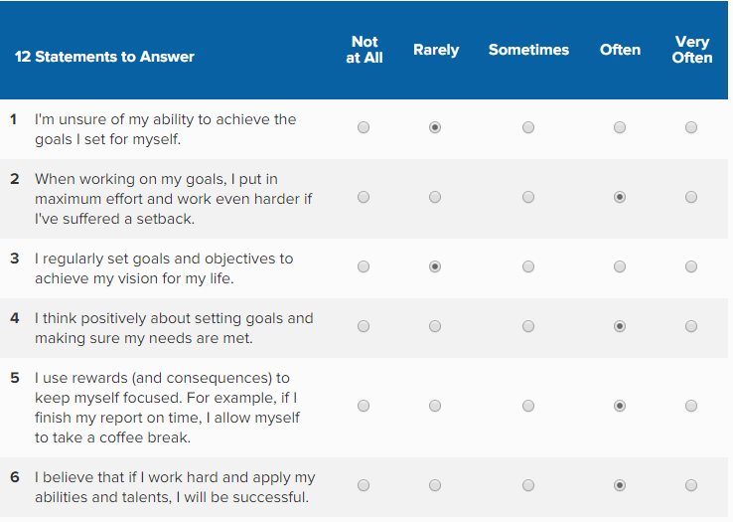
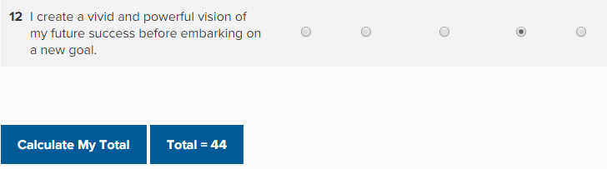
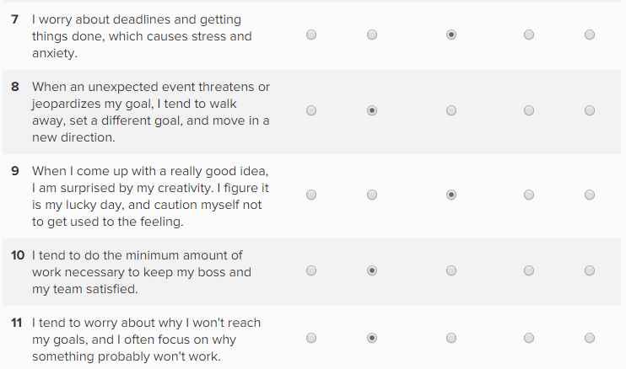
From the self-motivation quiz, I got 44 score. And this score basically interprets that I am basically a person who always like to work hard towards future goal. A person who likes to get the things done in time by staying self-motivated along with the efficient time management. I also like to inspirer other people so that they also can be motivated by me. Some of the factors which can strength my self-motivation has discussed in below:
Self-confidence is factor which will help me to set challenge for myself. Self-confidence also creates self-belief and it assists to gain goals for ourselves. This factor will help to see difficult tasks related future goals in a challenging way. By developing self-confidence will help me to create a strong belief in myself that I will be able to achieve success. (Mindtools.com, 2019).
Thinking in a positive way is also similar to the term self-confidence. It basically works as a motivational feature. When things basically don’t go as planned, one should see those things in a positive way. In that time, one should work towards that task. I think I should identify fail points and then I must work with a vivid success picture so that I can achieve success.

Some of the personal of my life which I have currently possesses described in below:
Passion: I always try to recognize those specific fields where I find passion to do something. Because passion in a particular area helps to give me extra encouragement to do the task.
Creativity: Creativity is a thing which helps an individual to come up with a new idea or thing. I also like to introduce new ideas or new things and it also enhances the process of my career path as well.
Leadership: I already made a plan to engage myself in a leadership training program so that I can develop my leadership skills. I believe in myself that I can lead people and group in the right track.

VAK Learning Styles Self-Assessment Questionnaire

The VARK learning model consists of visual, auditory learning, reading and also kinesthetic learning. The visual learning means when an individual learns through observing other people visuals, notes, spatial arguments with the help of using colors, charts, diagrams and so on.
In the auditory learning style, a learner learns through listening other people speeches, lectures, discussions and so on. In this field, a learner uses different writing tools to note down what they hear from others. They take notes and also rewrite the explanation so that they can collect most important information’s. On the other hand, the kinesthetic learner learns through practical experience. They learn by doing tasks. They use most of the senses like smell, touch and so on. (Mindtools.com, 2019).
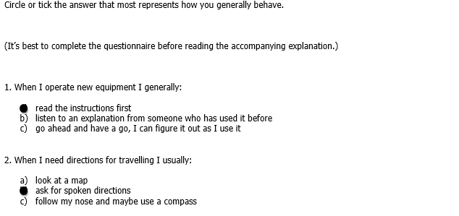
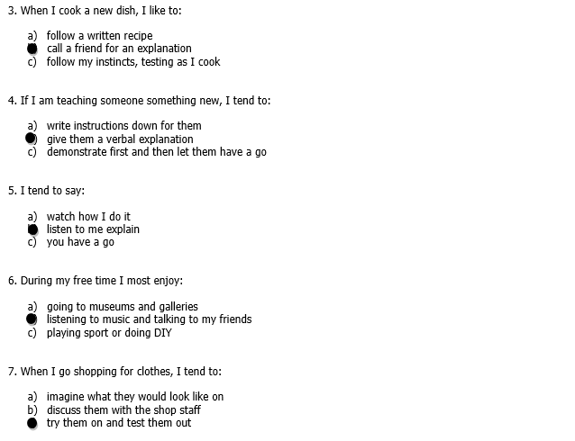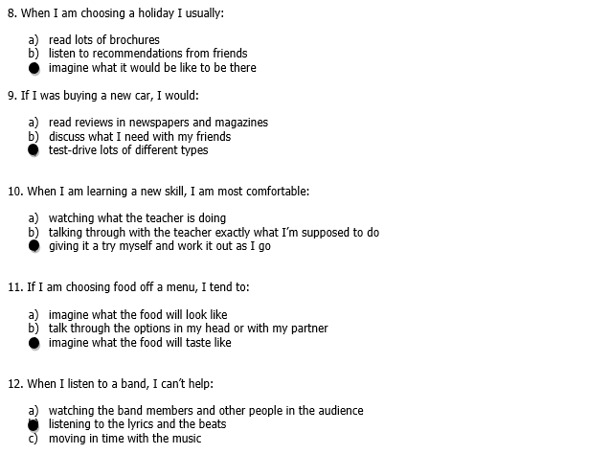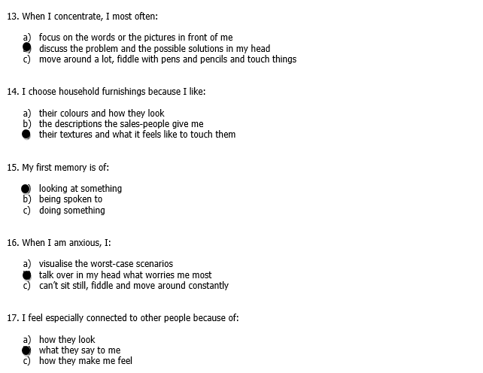
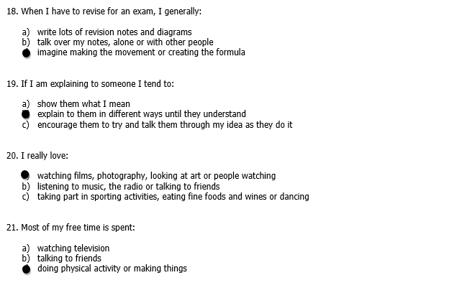
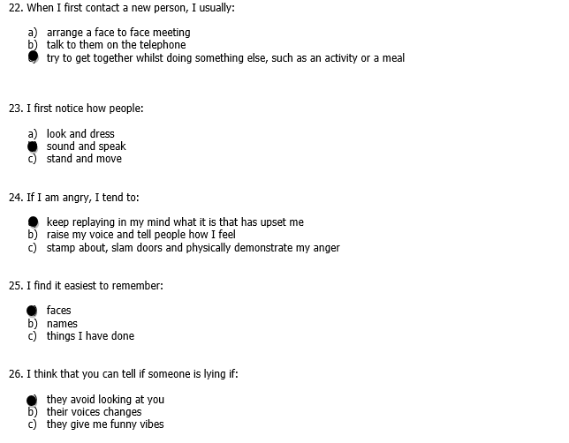
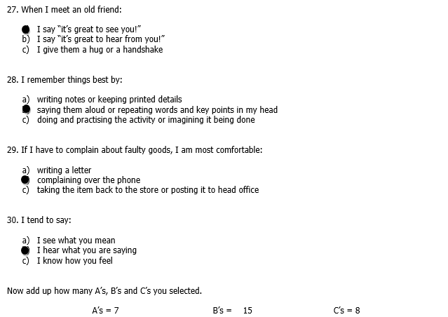
The most chosen from me is B which shows that I have an auditory learning style. This type of learning style shows that I am basically like to listen to other people words, sounds and noises. Basically, I actually like to perform a new task after getting a proper instruction from an expert individual. Auditory learning style reflects that a person learn through the listening process. This kind of learner needs to learn what is being said by other people. I believe that this type of learner are good listeners because they grab other people sending information in efficient way.
Characteristics of auditory learning style: Auditory learners have the ability to capture other people’s word when they listen to audible signals from other. Moreover, I would like to add that as an auditory learner I have the ability to write responses in an efficient way. Some researchers also added that this kind of people are good in the field of oral exams or in oral sessions as well.

Worksheet: Reflecting on my learning style
 | Visual | Auditory | Kinesthetic | Other | Reflections
Leadership |  | Listeting from an expert instructor
Ethics |  | Listening to ethcial topics |  |  | I think that ethics can be build up from my family field
Team Building |  |  | Team should be build from other points of view
Conflict Resolver |  | An expert or proper instructor can solve the problem
Numerical Skills |  |  | I have to engage myslelf in different practical expereince fields |  | I believe that I can develop myself by practicing the same things again and again. I have to practice those things twice in a week. It will assist me to build strong confidence in various sectors
Time Management | Observe other people who manage time properly
Communication |  | Listen other people propelry | Make effective communicaton with various individual
Motivator |  | Listen motivational speeches |  |  | Should understand my staffs psychological matters
Negotiator |  |  |  | I will make effective communication with expert negotiators so that I can learn something
Written Skills | Read articles, magazines

Personal development planning:

SWOT Analysis:
According to McMillan and Weyers (2007), they stated that the SWOT analysis will assist me to determine my personal strength, weakness, opportunities and threats as well. And this will help me to achieve the highest numbers of success by developing those weak points. Opportunities will help me to take better opportunities. Threats will teach me how to overcome those barriers. In below, I have developed a SWOT analysis of my personal life:
Strengths:  - I am good at creativity sector and a good communicator  - I have driving experience  - I think people will see passion as my strengths | Weaknesses  - I need to improve my education status  - I have fewer resources in qualification and contacts. Like I have no educational qualification and no references.  - I think people will see that I have no resources as my weaknesses
Opportunities  - I have opportunities to find out potential investors  - My strength can be turned into opportunities by proper planning and decision making. | Threats  - Financial situation can damage my ambitions and career prospects  - May lose own competitive edge  - May lose own pace with the trends

Strengths: Strengths are some skills which will help me to overcome my weaknesses. I believe that my effective communication skill will help me to find out different potential investors for my future own security business. Moreover, I would be able to manage my employees in an efficient way when I will start my own business. I know how to manage people by providing them proper training.
Weaknesses: By identifying weaknesses I will be able to fill up those gaps and I want to overcome those weak points. Now I am working as a bus driver in London and I have no education status. If I want to open a security business at first I need to learn many things regarding this topic. Without education status I won’t be to build a better security business.
Opportunities: Opportunities are basically favorable situations to me because it shows me better options. I have the opportunity to find better suitable investors for my security business so that I can grow the business in future. Moreover, I can develop my strengths by proper planning and decision making.
Threats: Threats are something which is basically unsolicited liable event. I always have to be prepared for any kind of threats. Because without any pre-mental preparation I won’t be able to overcome those barriers and it can lead me to the failure zone.
These are some of the crucial things which I have identified by doing SWOT analysis. I believe that strengths will help me to develop my current possess. On the other hand, by identifying weaknesses I will be able to overcome those and it will help me to develop my personal skills. Opportunities are basically open field favorable circumstances and I think those better opportunities should be taken by me to develop my career. (Management, Innovation and Analysis, 2019).

Smart objectives:
Skill or ability area | specific task (what is the  task or objective? attach details if appropriate) | measures  (standards and parameters) | agreed  (is it?) | realistic  (is it?) | timings  (start/finish dates) | comments/actions (follow  up notes - attach details if  appropriate)
Soft Skills | Started doing SIA courses | I will complete different sub SIA courses | yes | yes | MAY 2019-JULY 2019 (short term) | In each month, I will take feedback from the course instructor about my improvement
Take security training and develop leadership skills & business knowledge | Take proper security training from expert trainers so that I can set up my own business my developing accurate process | At least 3 months training I will take and also will complete several courses under the training session | Yes | Yes | Aug.2019-Aug 2020 (Medium-term goals) | If I failed to take proper trainng, I will change the training center
Open business, start MBA and find suitable investors | I will start finding suitable investors for my business and also will start MBA | Will build partnership with different organizations | Yes | Good | Sep 2020-Sep 2024 | Will develop the process according to the customer needs

Johari Window:
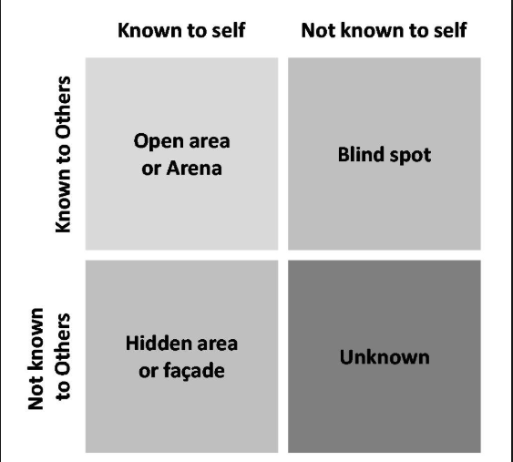
Joseph Luft and Harry Ingham created the Johari Window model (Mindtools, 2019). In times of developing self-awareness, effective communication, team work development this model works efficiently. In below I have reflected myself in this model:
The first quadrant of Johari Window model is the open arena. In this field it basically helps to know my motivation, behavior, self-awareness along with the strength and weakness fields of mine.
The second quadrant of Johari Window model is the blind spot arena. In this field it informs my behavioral activities along with motivations. And this is known by other individuals but not by myself. From this sector I can easily get feedback from other person which will help me to develop my gaps in different sectors. The feedback has to be constructive.
The third quadrant of Johari Window model is the hidden area. Here it refers that only I know the information but other people don’t know. Self-disclosure works properly in this kind of situation.
The fourth and the last quadrant of Johari Window model is the unknown area. Here it refers that neither other nor I have the information of my behaviors along with the motivations. Self-discovery can be the way to solve this problem in this sector. (Businessballs.com, 2019).

Review of understanding and expectations of the world of employment:
The employers of an organization hire employees by following the organization mission or objectives. A review has been made based on the expectation of the world of employment which has discussed in below:
Organizational rules: The organizational employer hire employees by following the organizational rules and regulations. It helps them to hire the most potential employees from different options.
Examine person’s skill: The employer of an organization always examine an individual’s skill and other knowledge’s to see whether they are capable to fit in for that specific role or not.
Person value: The employer of an organization always eager to know about that persons value to see whether they are capable to fit within the organizational culture or not.
Abilities: The employer always eager to determine different skills and other capabilities from that specific individual to see whether they can fulfill the organization goal and future objectives properly or not.
In this era, recruiters follow different methods so that they can fulfill their organization objectives properly. Some organization recruiter follow individual job fit and some other follow person value fit in times of recruitment. It totally depends on the organizational goals and missions. Within the organization, the recruiter basically done the selection process by proper screening method and it starts from advertisement. The recruiter can organize a verbal exam or written exam. Then they can also arrange interview process so that they can assess employee’s skill. (Cottrell, 2015).
Person Specification Purposes:
Person specification is a vital factor in the employee procurement. It basically helps to design a proper job advertisement according to the needs of the organization. Moreover, it helps to evaluate potential employees without any bias. Also, it plays a crucial role in times of comparison between applicants. Because it assists to select potential employees with accurate proof. (Soas.ac.uk, 2019).
Job description purposes:
Job description main goal is to identify roles of a candidate which has been attached in the job description. It plays a vital part in the recruitment system along with the right information’s. Job description helps a candidate to identify whether their skills are applicable for the job or not. If their skills match with the job description they can apply for that specific position. The organization developed a well-structured job description so that they can recruit potential employees for that specific requirements. It assists the human resource department to complete the entire recruitment process. (Maund, 2017).

Career ambitions and aspirations:
Career ambition means when a person desires to move from present place to another place. Ambitious people develop future goals with proper decision making along with right research. My vital career ambitions and aspirations are open an own security company business after completing graduation. And also I will do MBA besides running this business.
Now I am working in the field of bus driving. I want to move from this driving position to an own business position. At first I have to complete my graduation. Because I have no proper education status. Without education status I won’t be able to run a business. Furthermore, I would like to do SIA course and other courses related to security business while continuing my education. I have no security badge or any idea related to my future business. That’s why it is crucial to complete my education on this sector. I also have no finance or suitable investors. Finances should collect from friends, family or bank loan. Security training must needed if I want to run this business in an efficient way. Knowledge will help to run the business efficiently. I believe that an ambitious person learn how to take himself to a specific position by developing skills and experiences. I also would like to work on a security company after completing my education so that I can gain experiences while working for another company. This will help me to increase my business knowledge’s and ideas as well. I must have the ambition to craft a suitable business plan along with the proper financing from different sources.
I will develop my professional knowledge level along with proper training so that I can run my business properly. I will find suitable investors so that my business can be grow in future. SIA courses will be done before completing the graduation. There are also some common career goals like participate in different workshops, getting a certification and so on. Moreover, it can be stated that, I will try to gain new experiences like volunteering in the community or join professional association so that I can develop my communication skills. (Cottrell, 2010).

Personal development plan:
According to Cottrell (2010), he stated that personal development plan helps to identify different weak sectors along with weak skills so that I can overcome those weak points. Persona development plan is basically a process which is designed to establish plan, personal and academic development. PDP is also referred as developing the action plan in the field of awareness, values and so on. Cottrell (2010), also said this kind of framework assists an individual to assess his or her skills, qualities along with future objectives. This plan is crucial for a planner because it helps to achieve future goals without any types of misleading. If anyone wants to become better in his or her career, that individual should use PDP. Because PDP helps an individual to know more and it also assists that individual to manage their weak zone by utilizing strong points accurately. A person can easily develop personal growth by using this PDP along with evaluation of their life cycle improvement.

Development plan

NAME: | Isac Ndejeya | Student NUMBER: | 1712481
COVERING THE PERIOD FROM: | 2019 | TO: | 2024

What do I want/need to learn? | What will I do to achieve this? | What resources or support will I need? | What will my success criteria be? | Target dates for review and completion
Training for Security  Need to gain business knowledge  Education status should be built.  Finally, I will open my own security business. Besides this I will do MBA and will try to find suitable investors. | I have to admit myself in security training centre.  Joining business festival, watching Dragon Den and The apprentice  I want to complete my BA leadership and management in time.  For this I have to increase leadership skills along with business knowledge’s.  For this I have to find suitable investors and also need to find different financing sources. | Proper training  Extra time and flexibility  University and Student Finance England.  Financing support | Obtaining SIA badge  The evidence of the success  Adequate knowledge to be self employed  Getting the qualification  Identifying high performing and low performing investments over time | MAY 2019-JULY 2019  Aug.2019-Aug 2020  july.2019-June 2021  Sep 2021-Sep 2024

Conclusion:
Before developing a personal development plan, a proper analysis should be made. SWOT analysis, Johari Window, learning styles, self- motivation, and SMART objectives has helped me a lot to identify my weak points so that I can overcome those weak sectors. I am also able to find out my strengths so that I can use them properly to make the best use of opportunities. By using the lifeline exercise, I was able to draw a picture of my past occurrences which will help me to take proper decisions in later life. The self-review assessment is beneficial for me to identify my different strength zones, drivers, and motivational factors and so on. I also have made several analysis like personal value, self-motivation, which helps me to develop decision making process. By using the Johari Window model I was able to develop my trust zones along with the development of information process. I used VARK learning style which assists me to understand the importance of learning in different aspects of life. Also, it assists me to reflect my other sectors of my life’s learning style as well. Moreover, it can be stated that by doing SWOT analysis I was able to find out which zones of my life should be developed and also which opportunities I should take in later life. I also discussed some other topics like SMART objectives, career ambitions, personal development plan and all those topics assists me to develop my future career planning process along with the improvement of skills and knowledge’s.

References:
Cottrell, S. (2015). Study skills for success. London: Palgrave.
Cottrell, S. (2010). Skills for success. Basingstoke: Palgrave Macmillan.
Maund, A. (2017). Certificate in higher education.
McMillan, K. and Weyers, J. (2007). The smarter student. Harlow: Prentice Hall.
Morgan, P. (2017). Business student's guide to study and employability. Los Angeles: SAGE.
Businessballs.com. (2019). Johari Window: Model and Free Diagrams - BusinessBalls.com. [online] Available at: https://www.businessballs.com/self-awareness/johari-window-model-and-free-diagrams/ [Accessed 30 Apr. 2019].
Soas.ac.uk. (2019). Human Resources Department at SOAS: Person specifications. [online] Available at: https://www.soas.ac.uk/hr/procedures/recruitment/bestpractice/personalaspecs/ [Accessed 30 Apr. 2019].
Mindtools.com. (2019). Building Self-ConfidencePrepare Yourself for Success. [online] Available at: https://www.mindtools.com/selfconf.html [Accessed 5 May 2019].
Management, O., Innovation, S. and Analysis, S. (2019). SWOT Analysis: Strengths, Weaknesses, Opportunities, Threats - BusinessBalls.com. [online] Businessballs.com. Available at: https://www.businessballs.com/strategy-innovation/swot-analysis/ [Accessed 5 May 2019].
Mindtools.com. (2019). VAK Learning StylesUnderstanding How Team Members Learn. [online] Available at: https://www.mindtools.com/pages/article/vak-learning-styles.htm [Accessed 5 May 2019].

