Strategic Human Capital Renewal at Helios Urban Mobility
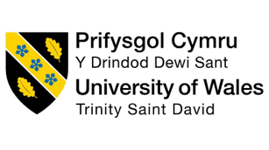
Programme: Masters in business management
Module: Human Capital Management (LCMB7023)
Report Title: Strategic Human Capital Renewal at Helios Urban Mobility
Student Name – Nabeel Ahmed
Student ID - 2504402
Lecturer Name - Eno Maycock (Birmingham)
Word Count – Approx 2500

Table of Contents
Executive Summary 3
1. Introduction 5
1.1 Company Background 5
1.2 Current Human Capital Challenges 5
1.3 Purpose of the Report 5
2. Task A: Socialisation, Identity and Business Activism 5
2.1 Critical Evaluation of Traditional Onboarding vs Strategic Organisational Socialisation 5
2.2 Proposed Socialisation Framework for Helios 6
2.3 Developing Organisational Identification and Business Activism 7
3. Task B: Innovative Job Design Strategy 8
3.1 Need for Job Redesign at Helios 8
3.2 Application of Job Characteristics Model 9
3.3 Job Crafting Theory 10
3.4 Skills-Based Architecture and Internal Talent Marketplace 10
3.5 How the Proposed Design Enhances Motivation and Innovation 11
4. Task C: Reflective Report 11
4.1 Responsible Use of AI as a Decision-Support Tool 11
4.2 Personal Capability Development Plan 12
SMART Development Plan 12
5. Conclusion 13
References 14

Executive Summary
Helios Urban Mobility is an innovative firm at the forefront of AI supported electric mobility systems, smart infrastructure analytics products. The company has good technological capabilities but has main human capital issues such as low level of engagement (54%), long (8 months) employee ramp-up period and high graduate attrition. This report suggests a strategic human capital renewal programmed for increasing organizational socialization, redefining roles in terms of higher motivation and innovation as well as strengthening the ability of the workforce. The key suggestions are creating a defined socialization plan, establishing a framework of skills to be employed in the jobs, and an ongoing capability development. The programmed would be expected to enhance the job satisfaction of the staff, their productivity, their retention in the organization, innovation and the overall performances of the organization.

1. Introduction

1.1 Company Background
Helios Urban Mobility is a technology company in the increasingly vibrant realm of electric mobility. Spear specialists are providing AI-enabled electric mobility solutions and smart infrastructure analytics that are lucrative for enhancing the efficiency, sustainability, and connectivity of urban mobility (AbouBakr and ElSerafi, 2023). Helios strives to create the smartest transport ecosystem based on the strength of advanced data analytics, mobility solutions and Artificial Intelligence (AI) technologies that will solve future urban problems. It boasts a team of engineers, data scientists, software developers, and business professionals all collaborating to provide innovative solutions.

1.2 Current Human Capital Challenges
Helios has acquired numerous technological improvements, but also encountered numerous problems regarding human resources. Lacking effective integration processes, new employees take about 8 months to get up to speed (Cotter et al., 2026). Lack of employee engagement (54%) and increasing numbers of graduates leaving the company are causing talent scarcity and instability in organizations.

1.3 Purpose of the Report
The actions recommended in this report offer suggestions on strategic directions to help with human capital renewal and recommendations to help improve organizational performance, engagement and retention in addition to innovation.

2. Task A: Socialization, Identity and Business Activism

2.1 Critical Evaluation of Traditional Onboarding vs Strategic Organizational Socialization
The old-fashioned orientation is a short period where they introduce the new employees to the organization's policies, procedures, duties and administration. The main goal is the greatest possible level of operational efficiency of employees. Often, orientation, and compliance training sessions are emphasized during onboarding, as well as paperwork related and introductions. This approach does give transparency around the job and the rules and procedures of the organization but often a focus is given to immediate operational needs instead of longer-term integration (Danfulani and Gülseven, 2024). Strategic organizational socialization, on the other hand, is a process of ongoing learning of values, norms, behaviors and cultural expectations of the organization by the employees. Strategic socialization emphasizes the administrative change process rather than the maintenance of commitment, organizations' identification and engagement over a longer period of time within the organization's context. These methods include the integration of employees as a developmental process which is enacted beyond introducing and orienting them in the first weeks of their employment.
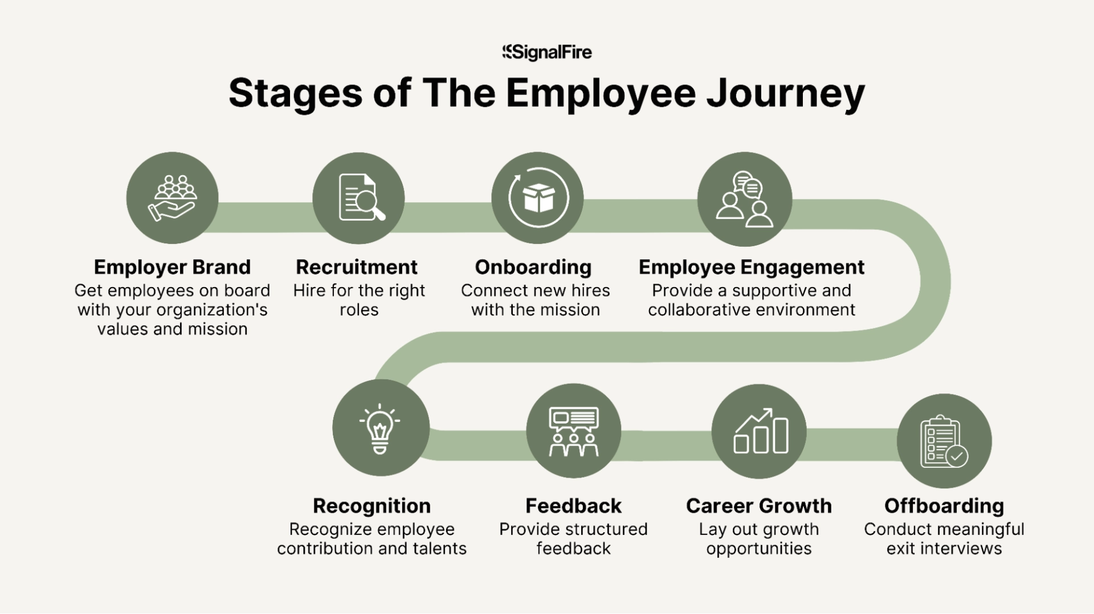
Figure: Employee onboarding process journey
(Source: Danfulani and Gülseven, 2024)

The difference between the above approaches can be explained with the help of socialization theories. Institutionalized socialization activities offer the employee structured learning activities, helping to minimize uncertainty and ease into work. In addition, psychological contract theory implies that employees have expectations regarding job pathways and support they can receive in an organization. Wishing these objectives to be attained, his commitment and trust increases. There is also a focus on the role of support; in order to fill the gap between values and goals, this role is also highlighted in the construction of the identities. Hiring can't seem to be enough for Helios Urban Mobility, as new hires go through long join-ups and don't get engaged with the organization. The organization needs to have a more holistic view which fosters a sense of belonging, purpose and commitment.

2.2 Proposed Socialization Framework for Helios
Employees should be able to avail of a proper socialization process, from their recruitment right up until they have been on the job for a year. Time spent before the plane leaves for the airport should go towards the first phase. Upon starting, each employee must be able to access a digital welcome system which is transparent in its values, strategic vision, product culture and company culture. Culture immersion videos familiarize an employee of the company with the norms of leadership and how the company operates (Halbert, 2025). Some staff members should also be a "buddy" for every member of staff to which he is given to provide orientation and answer questions before he comes in on his first day of work. The second phase will take 90 days to complete. A structured, systematic learning process encompassing the knowledge of the organization, technical training and work experience for this period of time will be implemented by staff. Professional development can focus on learning gained from mentoring and cross functional exposure can build up understanding of the contribution made by other areas to the organization’s objectives. Frequency of feedback points are recommended so that a person should be able to know if there are any concerns and effectiveness of adjustment.
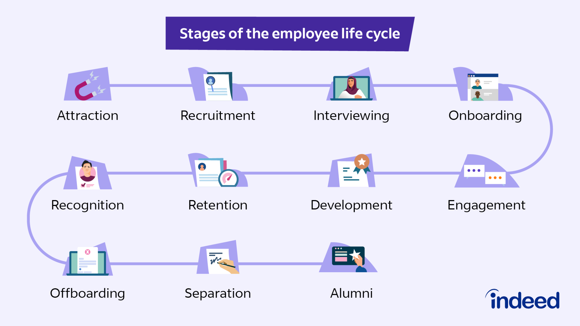
Figure: Employee lifecycle management
(Source: Halbert, 2025)
The third phase will be for a period of one year during the initial year of his/her assignment. Accessibility to employee’s development and leadership opportunities and projects aimed at new ways of doing business. Opportunities for participation in organizational communities and development of knowledge sharing opportunities should be provided as well. These can be helpful in developing a greater connection and sustainability. This framework provides solutions to some issues that Helios is having. Building relationships early on decreases uncertainty, productive learning is accelerated through a structured learning approach and ongoing development means employees are more committed.

2.3 Developing Organizational Identification and Business Activism
Organizational identification is the way in which an employee shows he has a sense of belonging to an organization. Outlook and attitudes that are very similar to the values and attitudes of the organization are predictive of affiliation with the organization, interaction and discretionary effort of the individuals’ relatives. Helios' organizational identification needs to be increased, as engagement is still quite low despite it being a relatively new industry. An Identification that is enhanced by a purpose-driven culture. Staff should be aware of the role and potential of technological advances in mobility systems that involve prominent AI application in connection with environmental protection, smart cities and improved quality of life (Jayme et al., 2023). Set clear messages of purpose will support staff to make the social outcomes relevant to their everyday work. Leadership and employee story telling efforts can help further build 'other' identification, as it will allow others to share their stories and successes as well as individual contributions to the organization’s success.
Ethical professional standards should also build up as norms, as being central to the organizational culture. With the use of Artificial Intelligence and mobility technologies there are major ethical responsibilities for employees. Other topics, such as responsible artificial intelligence, responsible data management, responsible sustainability or responsible occupation of the world of professionals can also be reinforced with training programmed to foster ethics and strengthen organizational values. Helios should learn to develop a business activist mentality besides the identification (Kapsalis, 2022). Members of staff to be able to make suggestions on organizational, social and environmental issues. Formal ways of involving employees in the strategic discussion are possible by the creation of innovation councils. Collaborative work can reinforce/organize and promote sustainability challenges and social impacts projects. An internal activism forum can be a good way to have a discussion about improvement opportunities and issues in the workplace, in a safe space.

3. Task B: Innovative Job Design Strategy

3.1 Need for Job Redesign at Helios
The industry Helios is in is highly dynamic with rapid changes and technological innovations, and even greater competition. The endless need to be motivated and flexible, to be life-long learners will be crucial to success for employees. But, engagement issues, longer ramp-up periods for productivity and graduate attrition are all challenges that the organization is currently facing. Current situations regarding the job structure bring up issues of further sufficient support to motivate and develop employees. The traditional approach of job design schemes tends to be narrower, job specialization, operational efficiency-oriented. Although these methods are effective in routine jobs, these can have the unwanted side effect of lowering flexibility, creativity and employee ownership (Pushkar, 2026). They want to be treated differently in the workplace and prefer to be working for innovative companies with opportunities, development and more trust and autonomy. If these are expectations that are violated it can result in disenfranchisement and demoralization. Therefore, it is important to redesign the jobs in order to provide more motivating and developmental work experiences. Helios can improve employee engagement, increase learning opportunities for employees, and enhance collaboration, providing greater employee commitment and inspiring innovation.
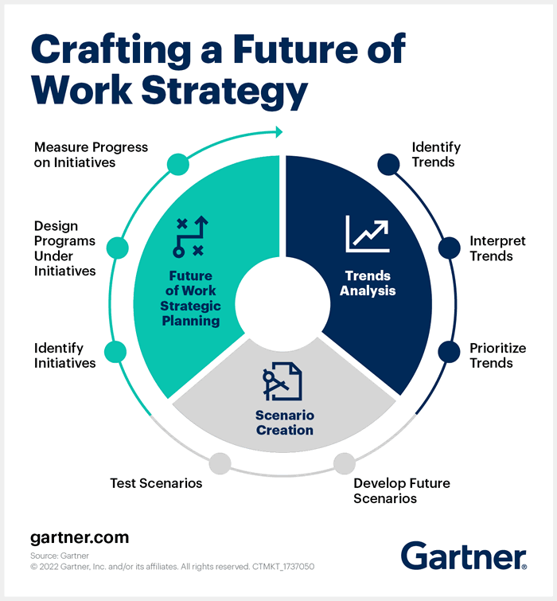
Figure: Future of work job redesign digital workplace employee’s technology
(Source: Pushkar, 2026)

3.2 Application of Job Characteristics Model
The Job Characteristics Model provides an easily concluded model which can be used to enhance employee motivation as a way of job design. The model suggests that these 5 dimensions can have an influence on job satisfaction and job performance. Skill variety can be enhanced by providing employees opportunities to do cross-functional projects, which call on a variety of skills. Task identity may be bolstered by providing workers the chance to work with how they see all aspects of a project, not just parts of it (Queiroz Júnior et al., 2025). The importance of the tasks should be highlighted with the use of examples showing how the individual contribution enhances mobility systems and sustainable urban development.
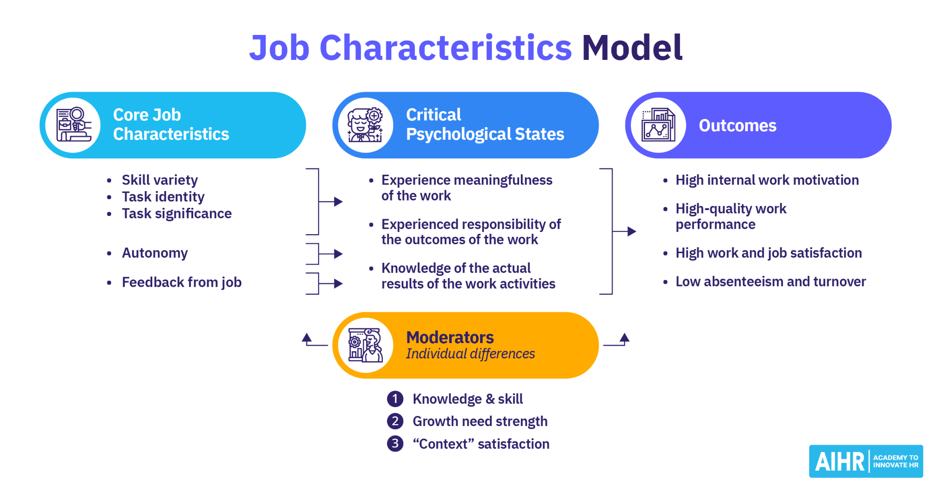
Figure: Job Characteristics Model Hackman Oldham skill variety autonomy
(Source: Queiroz Júnior et al., 2025)
This is particularly important in "Innovative Environments". Responsibility for flexible ways of working, problem-solving and for offering suggestions must be harnessed in the workplace. There should be opportunities to enhance feedback mechanisms further on regular basis through coaching conversation, performance review and project evaluation. The model has its advantages in that it provides an eclectic sample of work experiences and is an intrinsically motivator model. But may not be comprehensive for individual differences or changing expectations of the workforce/complexity of organizations.

3.3 Job Crafting Theory
Job crafting refers to changes that employees initiate and make to fit their personal strengths, interests and duties on the job. Job crafting is an empowerment way for workers to influence their jobs, in contrast to the conventional bottom-up job design approach. Task modification involves changing tasks in order to maximize behaviors for strengths, motivation. Relational crafting involves building effective work relationships, and increasing collaboration (Rubio et al., 2025). Cognitive crafting can be done through employees reconnecting their perception of their work, increasing the relationship between employees and their work, as well as between employees and an organization’s purpose.
Job crafting and employee job ownership can help engage employees in the job with Helios. The staff inputs are able to identify process-related potential improvements, innovations, and cooperations that managers might not be aware of. This can boost the motivation and promote organizational adaptability. There are some difficulties with Job Crafting though. Too many changes in roles could lead to inconsistencies or coordination problems, and to unclear roles. Hence, proper organizational boundaries and supportive measures for management is required.

3.4 Skills-Based Architecture and Internal Talent Marketplace
A skills-based architecture changes an organization's emphasis from job titles to employee skills. Organizations call up skills, build them up and make them available for use according to business need, not because of their location. Helios needs to have an in-house talent marketplace based on an extensive skills catalog. Staff will be able to review current staff profiles that will contain the technical specialities, project experience, understanding of certifications and interests (Sethu, 2025). Artificial Intelligence could then match the employees to the appropriate opportunities throughout the organization.
In projects of this kind, for example, the marketplace should be included: the short-term projects, innovation projects, and the cross-social projects. Individuals might bring skills beyond their core competences, and have the opportunity to develop in those areas. This approach promotes learning, sharing of knowledge and flexibility in the organization. In the long term, an internal talent marketplace can help businesses become more agile in their workforce and reduce the need to hire external talent. Less staff turnover and attrition—more opportunities for growth. Concurrently, managers are also exposed to a variety of talent pools that can help them overcome the business challenge at present.

3.5 How the Proposed Design Enhances Motivation and Innovation
The proposed job design strategy advocated is an integrated solution of structured job enrichment, employee empowerment and skill building. All of these programs offer autonomy, competence and meaningfulness to build intrinsic motivation. Staffs have greater input into the work, have developed new skills and are able to make a positive contribution to the mission of the organization. But, in a purpose-driven company such as Helios, offering purpose is even more crucial (Tran, 2025). Committed staff members are more likely to be creative, and to show commitment, if they know of the social impact of sustainable mobility solutions. More autonomy also fosters experimentation, innovation and problem solving in an anticipatory manner.
The benefits of innovation are gained through increased interaction and knowledge-sharing, cross-functional innovation learning. Expanding the scope of employees' experience with various projects and points of view allows them to be more creative in solving problems and finding opportunities for improvement. It's not like that, either, though with the addition of internal talent mobility expediting organizational learning and adaptability. There may be implementation challenges including the factors “Resistance to change”, “Managerial control of the process”, “Technology transfer challenges”. Reducing the risk can be achieved through employee training, the gradual adoption of the change, effective communication related to the change, and leadership support related to the change.

4. Task C: Reflective Report

4.1 Responsible Use of AI as a Decision-Support Tool
With AI's flourishing in the HR space, the possibilities for better decision-making in an organization are plentiful. AI systems need to be able to sift through the mountains of information regarding staff to derive patterns and determine how staff might look like in the future, thereby helping businesses to plan ahead accordingly. These applications such as rate of employee happiness, forecast of labor deficits, recruitment of fresh employees, and monitoring of employee productivity/metrics may help make work more efficient and also provide valuable information which might not have been as readily noticeable in the more traditional employment practices. There are, however, large caveats associated with getting AI solutions (Zawieska et al., 2025). If it is based on an incomplete or unrepresentative dataset, then an algorithm could be also reinforcing the same biases. Over-reliance on the automated recommendations can reduce critical thinking and working judgement of managers. Furthermore, using AI can result in a feeling of being de-personalized or “unknown” for employees. I believe that AI should be utilized as a tool to help rather than replace decisions-making.

4.2 Personal Capability Development Plan
Professionalizing learning, throughout the career, is essential to success in a fast-changing, global, digital workplace. The list below details areas where I want to be even more effective with populations of people, and to do more with capacity development. First and foremost, data literacy is the key to it. As more and more organizations are turning to workforce analytics, HR professionals must have access to analysis tools to get the information out of the data for them to make decisions. Improving analytical skills will positively impact upon Evidence driven Decision Making and Strategic contribution. The second being, skills in their augmentation by Artificial Intelligence (AbouBakr and ElSerafi, 2023). Knowledge of the use of AI in recruitment, workforce planning, performance and employee engagement will be a growing necessity. In addition to technical skills, it is essential to understand ethical considerations and best practices for AI usage to promote fairness and accountability.
Next is the ability to create ‘strategic influencing'. This requires HR to come in contact with leaders/managers and employees regularly to initiator the change in the organization. Improved communication, business negotiation and stakeholder management are going to increase my ability to be more strategic in my influence and decision-making capabilities. The last development area is ‘mindfulness about travelling worldwide. There has been a trend for an increasing number of organizations working across a variety of cultures and geographical locations.

SMART Development Plan
Capability | Current Level | Development Activity | Timeline
Data Literacy | Medium | Complete HR Analytics Course and apply learning through practical projects | 6 Months
AI Skills | Beginner | Complete AI in HR Certification and study responsible AI practices | 6 Months
Strategic Influencing | Medium | Participate in leadership and communication development programmed | 12 Months
Global Mobility Awareness | Beginner | Conduct international HR research and complete cross-cultural learning activities | 12 Months

5. Conclusion
Helios Urban Mobility faces a challenge regarding human resources and calls for a strategy in human capital renewal that deals with lack of engagement, lengthy time to adapt and turnover rate among employees. The recommendations in this report included ideas for a strategic socialization plan, an intensive organizational identification program, business activation work and innovative job design practices, to be supported by skills-based talent management. These initiatives can help foster greater engagement and retention, quicker ability growth, and an atmosphere for innovation for employees. Helios can link employee experiences and purpose to the future workforce requirements of the organization that could lead to a more engaged, adaptable and effective worker workforce that could support the organization's long-term success and competitive positioning.

References
AbouBakr, D. and ElSerafi, T., 2023. City Growth Challenges as a Dilemma between Urban Mobility and Livability: A Case Study of Heliopolis. Civ. Eng. Archit, 11(4), pp.1795-1813. https://www.researchgate.net/profile/Tamer-Elserafi/publication/371979970_City_Growth_Challenges_as_a_Dilemma_between_Urban_Mobility_and_Livability_A_Case_Study_of_Heliopolis/links/64a3e0bc95bbbe0c6e0f12ce/City-Growth-Challenges-as-a-Dilemma-between-Urban-Mobility-and-Livability-A-Case-Study-of-Heliopolis.pdf?origin=journalDetail&_tp=eyJwYWdlIjoiam91cm5hbERldGFpbCJ9
Rubio, R.M., Suárez-Rojas, G., Albarrán-Godínez, A., De León-Rodríguez, S.G., Aguilar-Flores, C., Fonseca-Montaño, M., Téllez-Sütterlin, M., de Los Santos-Carmona, S.V., Guzmán-Barrenechea, K., Candanedo-González, F. and Soto-Perez-de-Celis, E., 2025. The transcription factor Helios restrains the anti-tumor capacity of CD8+ T cells. Cell Reports, 44(12). https://www.cell.com/cell-reports/fulltext/S2211-1247(25)01452-4
Sethu, S.S., 2025. SCADA-Based EMS Simulation for Minimising Grid Export and Maximising PV Self-Consumption for the HelioS Energy Hub. https://www.diva-portal.org/smash/record.jsf?pid=diva2:1998551
Kapsalis, A., 2022. Mobility and employment of refugee populations in the Greek region. International Organization for Migration. https://greece. iom. int/sites/g/files/tmzbdl1086/files/documents/MOBILITY% 20AND% 20EMPLOYMENT_EN_online. pdf. https://greece.iom.int/sites/g/files/tmzbdl1086/files/MOBILITY%20AND%20EMPLOYMENT_HARD_COPY.pdf
Tran, N.P.T., 2025. Strategic Recommendations for Enhancing the Development of Unique Tourism Products in Da Nang, Vietnam. https://elib.vku.udn.vn/handle/123456789/5879
Halbert, Y., 2025. Recapturing Houston for People. VAS-Visionary Architecture Studies, 1(1), pp.70-77. https://www.journals.wisethorough.com/index.php/VAS/article/view/1165
Jayme, A., Usta, B., Hamad, N., Tahlyan, D., Johnson, B.L., Mahmassani, H., Al-Qadi, I.L. and Quandt, J., 2023. Smart Mobility Blueprint for Illinois.https://rosap.ntl.bts.gov/view/dot/67595
Danfulani, W.A. and Gülseven, E., 2024. Economic Community of West African States (ECOWAS) public–private partnership (PPP) strategy to development. Social Sciences, 13(10), p.531.https://www.mdpi.com/2076-0760/13/10/531
Cotter, T., Moreno, J.F., Peliska, J., Tilidetzke, J. and Van Dyk, A., 2026. Building the passage to success: West Pierce Street strategic plan.https://minds.wisconsin.edu/bitstream/handle/1793/97016/132173.pdf?sequence=1
ZAWIESKA, J., LODI, C., CHEIMARIOTIS, I., PIAZZA, F., RATAJ, M., STEPNIAK, M., GROSSO, M. and MAROTTA, A., 2025. Research and innovation in Smart Mobility in Europe. https://publications.jrc.ec.europa.eu/repository/handle/JRC143360
Queiroz Júnior, H.D.S., Celestino, M.A.D.S., Falcão, V.A., da Silva, F.G.F., Andrade, M.D.O. and Brasileiro, A., 2025. Analysis of the Influence of Transportation Infrastructure on Socio-Environmental Efficiency: Countries Case Studies. Transportation Research Record, 2679(3), pp.899-917. https://journals.sagepub.com/doi/abs/10.1177/03611981241284625
Pushkar, S., 2026. LEED-EB V4-Certified Projects and the Built Environment in the USA. Journal of Green Building, 21(2), pp.81-110.https://jgb.kglmeridian.com/view/journals/jgrb/21/2/article-p81.xml
Boura, S., The EU’s democracy and human rights promotion in the Southern Mediterranean and the role of Greece’s state. https://www.lse.ac.uk/Hellenic-Observatory/Assets/Documents/HO-PhD-Symposia/The-10th-HO-PhD-Symposium/Symposium-Papers/3.6.pdf

