Resourcing and Talent Management (BMHR7015)


Report and recommendations for Talent Management Strategy at Neath Port Talbot Council
Laura Parry CIPD Associate 2240424

1st October 2025

Word Count: 3850

Executive summary

NPTC is a local authority based in South Wales, serving over 140,000 residents. Its Future of Work Strategy 2022–2027 aims to ensure the organisation has the workforce capacity and skills to meet current and future service demands.

This report examines the internal and external factors influencing NPTC’s resourcing and talent management and evaluates the effectiveness of its current approach. Externally, NPTC operates in a challenging labour market. Although the UK labour market is loosening after a period of extreme tightness, recruitment pressures remain, especially in the public sector. Economic uncertainty, slow growth and strong competition for skilled candidates continue to limit attraction. There are skills shortages both nationally and locally, with Neath Port Talbot displaying lower qualification levels than the UK average. Demographic shifts in relation to an ageing workforce and less younger employees entering the workplace, place additional strain on resourcing. Older employees provide valuable experience but face higher risks of ill-health and caring responsibilities, and their retirement threatens the loss of critical knowledge.

Internally, NPTC faces weaknesses in succession planning and talent pipelines due to historically reactive recruitment and under-recruitment of younger workers. Competition with pay compared to private organisations further challenges the attraction of skilled talent. However, NPTC has made positive steps in establishing a Talent Management Team, enhancing learning and development, and working with the CIPD’s People Development Programme.

NPTC’s employer brand is a significant strength, with strong organisational values, social purpose and flexible working supporting attraction and retention. However, limited managerial buy-in for early-career recruitment and reliance on experience-based recruitment restrict future workforce sustainability. A shift toward skills-based recruitment is essential and internal career development is essential.

Recommendations include, promotion of apprenticeships and early-career pathways, development of clearer career progression routes and promotion of existing development opportunities and enhance employer brand visibility through positive ‘good-news’ stories.

Table of contents
- Introduction  - Introduction of NPTC  - Aim of the report  - What is resourcing?  - What is talent management?  - External and internal factors affecting NPTC’s resourcing and talent management including critical analysis  - How to assess external and internal factors  - External Factors  - Economic Factor – current labour market  - Social Factor – Skills shortages  - Social Factor – Demographics  - Internal Factors  - Threat – Pipeline and succession planning  - Strength – Employer brand  - Weakness – Managers buy in for recruiting and developing early talent  - Conclusion  - Recommendations  - Encourage take up of apprenticeships across the authority through an email infographic to be sent to managers to attract a younger demographic  - Develop and promote career pathways to internal talent  - Create and distribute videos of good news stories about employees/teams making a positive difference to the community  - References | Page  4  4  4  4  4  5  5  5  6  7  8  8  10  12  12  13  13  14  14  15

- Introduction

1.1. Introduction of NPTC

NPTC is a local authority based in South Wales serving a population of approximately 140,000 people and 6,600 employees (NPTC, 2024). NPTC’s resourcing and talent management strategy is set out in its Future of Work Strategy 2022-2027, which was designed to ensure that the Council has “the right number of people, with the right skills and attitudes, in the right place, at the right time” to deliver high-quality services to the community (NPTC, 2022).

1.2. Aim of the report

To evaluate internal and external factors affecting resourcing and talent management strategies in NPTC and undertake a critical evaluation of their current resourcing and talent management strategy to identify key findings, which will be used as the basis to form recommendations for improvement.

1.3. What is resourcing?

Resourcing encapsulates a large part of the people professional’s role and includes functions such as human capital, organisational performance, administration, change management, employer brand/reputation and employee wellbeing (Taylor, 2024). Muller-Heyndyk (2018) states that resourcing is pro-active looking at the long-term organisational needs whereas recruitment is reactive only focusing on the short-term. When developing a resourcing strategy, it is essential to focus on the organisational strategy, direction and aims considering the business needs, behaviour and skills required to achieve them (Kapur, 2020).

1.4. What is talent management?

Talent management refers to the coordinated practices of recruiting, identifying, developing, engaging, retaining, and deploying individuals capable of positive impact on organisational performance, whether through their current impact or their future potential (Quilliam, 2024). Roper (2015) questions what can be considered as talent? Is it the best or prospective best or is the workforce, seeing the value in every employee? Talent can be viewed as exclusive with Devine and Syrett (2014) arguing that talent is a rare and valuable trait only found in a limited number of employees or potential employees, senior managers and those who may succeed them and individuals with valued skills and technical abilities, which are in short supply. Alternatively, talent can be viewed inclusively with Lawler (2017) stating that, except for poor performers, everyone in an organisation has the potential to contribute to its success albeit in different measures.

Taylor (2025) highlights how talent management can be viewed broadly encompassing all areas of people management or narrowly concerned only with ensuring the organisation can meet its future skills and workforce needs. The CIPD (Quilliam, 2023) define talent as ‘individuals who can make a significant difference to organisational performance, either through their immediate contribution or by reaching their potential’ and encourage people professionals to take a blended approach when looking at talent management.

- External and internal factors affecting NPTC’s resourcing and talent management including critical analysis

2.1. How to assess external and internal factors

To assess the external factors affecting an organisation Taylor and Woodhams (2023) suggest a PESTLE analysis as a useful framework to apply, which considers the following 6 external factors:
- Political
- Economic
- Social
- Technological
- Legal
- Environmental

Organisations can further use a SWOT analysis to identify internal factors such as strengths, weaknesses, opportunities and threats, although simplistic, it is a good starting point prior to the use of supporting frameworks (Taylor and Woodhams, 2023)

Michels (2025) states that external perspective is important for organisations to build resilience and adapt to external factors and change with Cakmak (2020) adding that organisational agility is essential to its success in the current ever-changing environment.

2.2. External Factors

2.2.1. Economic Factor – current labour market

Francis-Devine and Powell (2025) highlight that 2022 and 2023 saw a tight labour market with low employment rates and high levels of vacancies, but data now shows it loosening. The ratio between unemployed and vacancies was 1.1 in 2022 when the labour market was at its tightest and the ONS report that the ratio is 2.5 from July 2025 (ONS, 2025). Part of this loosening is due to interest rate rises aimed at slowing inflation (Bank of England, 2025) alongside weak economic growth and low business confidence which continues to impact labour demand (Office for Budget Responsibility, 2025). Manpower Group (2025) report that economic uncertainty is the main reason employers anticipate staff reductions. Although the market is loosening, NPTC will still suffer the effects of the tight labour market as competition remains high for suitable candidates. Cockett (2025) highlights ongoing recruitment pressures in the public sector with 67% expecting problems with recruiting in the coming 6 months.

Cockett (2025) noted the likely impact of the upcoming 2025 Budget on 26th November stating that a rise in taxes looks likely which would be detrimental to those entering the workforce. A tax rise would be counterintuitive to the Labour Party’s target of achieving an 80% employment rate in Britain (Labour, 2024). Private sector organisations could be heavily impacted by tax increases, however, public bodies such as NPTC who benefit from tax exemptions remain unaffected and therefore will continue to recruit potentially gaining a competitive advantage (Stewart, 2025).

2.2.2. Social Factor – Skills shortages

Globally, employers report struggles with resourcing with 46% struggling to attract qualified candidates and 29% struggling to fill complex technical roles (Manpower Group, 2025). Hogarth and McCartney (2024) confirm this trend with 69% of respondents reporting that competition for well-qualified talent has increased with 64% struggling to attract candidates. 43% of people professionals rate finding candidates with the right skills as one of their biggest challenges (Soliman, 2024b.).

NPTC are affected by skills shortages in the workforce with 10.7% of its population aged 16 to 64 with no qualifications compared to 6.6% for the national figure (ONS, 2024). Gill (2022) states that only around 28% of people of working age in the Neath Port Talbot district were qualified to NVQ4+, compared with 43% in the UK. In response, organisations are increasingly investing in their internal talent and upskilling and reskilling their current workforce to fill skills gaps along with entry-level or career returner programs (Hogarth and McCartney, 2024). NPTC has developed partnership with local education providers and have a dedicated learning and development department, which facilitates external training/learning and delivers internal training and development opportunities. NPTC provides a mentoring scheme where more senior employees mentor new or ambitious employees sharing their experience, insights and knowledge whilst providing motivation and support to develop their careers.

Boys (2022b) states that where competition for talent is high the employer brand and employee value proposition is essential to attract and retain talent. The CIPD (2023) highlights that a good employer brand enables organisations to attract, recruit, engage and retain talent giving it a competitive edge on others. Further, the brand should encapsulate the organisations values, policies and people strategy whilst promoting its culture, ethical standards and corporate social responsibility.

2.2.3. Social Factor – Demographics

There has been changes to the demographic, with an aging population because of developments and improvements in health care and low birth rates due to cost of living pressures and social/cultural changes (Barton, Sturge and Harker, 2024; Hall and Carrell, 2025; Walker and Roxby, 2024; Ely, 2024; Welsh Government, 2025).

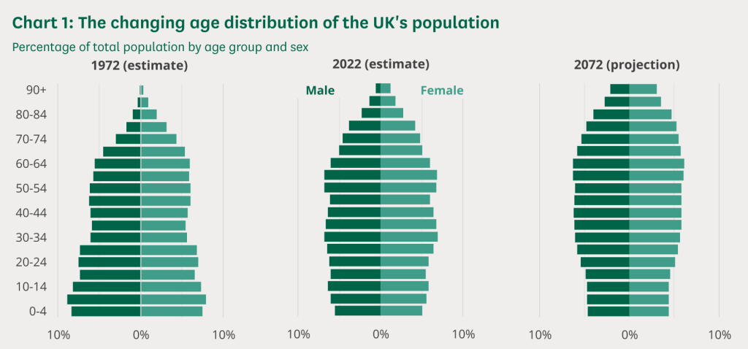
Figure 1. (Barton, Sturge and Harker, 2024; Hall and Carrell, 2025).

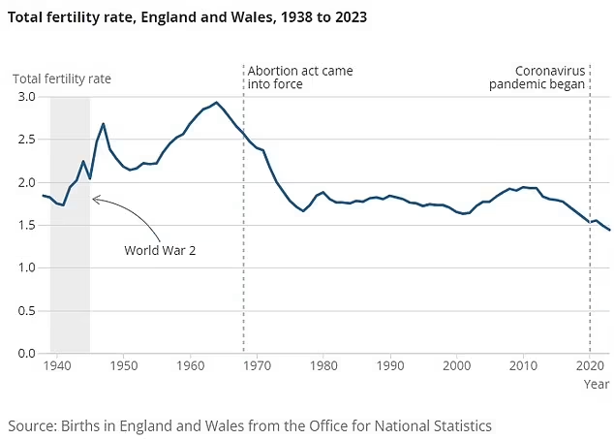
Figure 2. (Ely, 2024).

The Older People’s Commissioner for Wales (2024) notes that the population of adults over 60 is steadily rising. By 2026, 30% of the population will be over 60, with a further increase of 1% anticipated by 2031. As the state pension age is set to rise to between 66 and 67 from 2026 to 2028, more employees will remain in the workforce for longer (Department for Work and Pensions, 2023). Findings from a CIPD (2017b) survey shows that 49% of those aged 55 and over expect to continue working beyond age 65, with many anticipating working until around age 70. Although a higher pension age may increase pressure to prolong employment for financial reasons, only 8% of respondents expecting to work past 65 reported doing so due to financial obligations such as mortgages or loans (CIPD, 2017b).

However, remaining in work for the older generation can be problematic with declining health the main factor driving early workforce exit. In the UK, approximately 42% of people aged 50 to 64 are economically inactive because of long-term illness, representing around 1.4 million individuals (Department of Work and Pensions, 2024). Boys (2022a) highlights that older workers are more likely to be carers to others, which means that employees need to consider how they attract and retain them with flexible working being highly desirable along with increased health and wellbeing support.

NPTC is facing long serving employees reaching retirement age, which is putting pressure on succession planning and retention of institutional knowledge. 28% of NPTC’s workforce is aged between 51 and 60 years old with only 12% are 30 years old or younger (NPTC, 2022) highlighting the need to retain the older generation whilst attracting the younger generation. In the face of a global talent shortage, Ohm states that organisations that can retain the older generation will benefit from their skills, knowledge and ability to mentor younger less experienced employees providing intangible and tangible value to an organisation (CIPD, 2017a). In 2025, NPTC committed to the Age Friendly Pledge through the Centre for Aging Better recognising the value of older workers and committing to actions that support those aged 50 plus to thrive (NPTC, 2025a).

2.3. Internal Factors

2.3.1. Threat – Pipeline and succession planning

NPTC has dealt with recruitment in a reactive manner, without considering future potential skill gaps or succession planning. NPTC has good retention rates of older employees and low recruitment rates of younger employees, which is clearly not sustainable long term. This is in line with other local authorities who report that under 25’s are representing 4.6% of the local government workforce in England and Wales, compared with 66.9% aged 40-64 (County Councils Network (CCN), 2024). As a result, there is a serious risk that the knowledge and skills held by the older generation will be lost on retirement with no suitable replacements. This is exacerbated by the tight labour market and competition for in demand skilled workers, who NPTC struggle to attract and retain against higher paying private organisations. When looking at retention, research from the CCN (2024) suggests that the most important incentive for staying in a local authority would be improved pay. However, exit interview from NPTC report only 12% of leavers give higher pay as the reason, suggesting that this may not be the case. The report also stated that 18–34-year-olds ranked career pathways as the second highest factor to encourage them to stay.

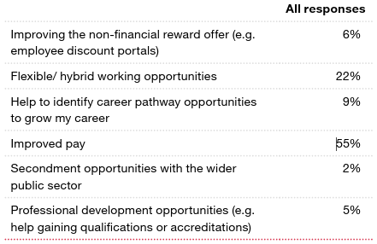
Figure 3. What could be improved about your employment offer to motivate you to continue a career in local government? (CCN, 2024)

In line with Hogarth and McCartney (2024), who state that there is a higher focus on developing skills in house, NPTC should ensure that focus is put on succession planning and developing internal talent whilst creating a psychological contract, which could increase retention of talent further down the line (Tambay, 2024; Keswin, 2022). Succession planning and clear career pathways further supports the retention of talented employees by making internal career progression opportunities visible (George, 2024).

In 2021, NPTC partnered with the CIPD through their People Development Partner (PDP) scheme, which recognises organisations demonstrating a commitment to better work and better working lives (CIPD, n.d.). In 2022, using their people impact tool, NPTC were rated below public sector benchmarking for talent management and reward. It was further identified that the people management team had the lowest impact on ensuring the organisation has people resources, capabilities and skills needed. NPTC used this information to develop the future of work plan 2022-2027, which included the introduction of a specialist talent management team (TMT) in 2024. The TMT was tasked with the delivery of the talent management work programme to support services with recruitment, succession planning and career development. February to March 2025, NPTC completed their second people impact survey, which showed an over 20% improvement in talent management and reward.

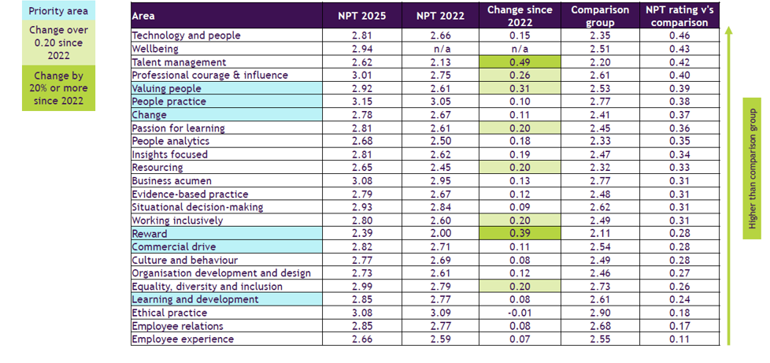
Figure 4. CIPD PDP scheme benchmarking of NPTC comparative data 2022/2025 (NPTC, n.d.).

NPTC, like many local authorities, has encountered significant challenges arising from sustained periods of austerity, resulting in the need to make complex and often difficult decisions. In addition, recent global and national developments have intensified these pressures and further stretched the council’s resources. Paired with the substantial reduction in revenue funding from Welsh Government in recent years, NPTC struggles meet the pay expectations of sought after skilled talent and are unable to compete with salaries offered by the private sector. The use of market pay supplements is being increasingly used to compete with the private sector, but this remains a reactive and unsustainable long-term solution (Hopkins, 2025).

2.3.2. Strength – Employer brand

The CIPD resourcing and talent planning report 2024 highlight the importance of employer brand when competing to attract and retain talent with 81% of organisations saying they have looked to improve their employer brand over the last 12 months (Hogarth and McCartney, 2024; McCartney and Noble, 2025). The CCN (2024) report that public scrutiny and changing perceptions are affecting the publics views of local government organisations with 32.4% of people saying they did not trust their local authority, which is having a negative impact on local authorities’ ability to attract and retain talent. To tackle this, NPTC promote transparency across the organisation whilst clearly communicating their organisational purpose, visions, values and in the corporate strategy (NPTC, 2024). NPTC’s TMT have promoted the employee value proposition through the NPTC website and jobs page where members of the public and potential candidates are able to clearly access the flexible working offerings alongside their benefits and reward packages (NPTC, 2025b; CIPD, 2023).

Hogarth and McCartney (2024) highlight that flexible working as a benefit is one of the most adopted steps to improve attraction and employee brand and that 45% of employers have reported increased retention as a result. NPTC offers hybrid working across the organisation, where appropriate alongside a selection of flexible working options (NPTC, 2025b; NPTC, n.d.). The TMT has further promoted the employer offer for potential talent through attending recruitment events, local education providers i.e. schools, colleges and several other organisations. To address retention, the TMT have promoted the employer offer to current employees organising events to promote and explain what benefits, support and rewards are available to them (CIPD, 2023).

Beyond financial incentives, motivating factors for the workforce are changing with the new generation, Gen Z, seeking roles for ‘mission-led’ organisations (Institute of Student Employers, 2024). Communicate the organisation’s wider social or environmental purpose to help potential employees align their own values with the role, boosting intrinsic motivation. Employees want to feel that their work has meaning with Microsoft’s CHRO Kathleen Hogan created ‘the five Ps of employee fulfilment’ which includes, Purpose (Jacobs, 2021). Offering meaningful, purpose-driven work is central to being seen as an employer of choice. High-performing talent now considers competitive rewards as a baseline requirement, however, insights from Maslow’s Hierarchy of Needs (McLeod, 2025) and Herzberg’s Two-Factor Theory of Motivation-Hygiene (Nickerson, 2025) suggests, they are looking beyond pay for a greater sense of meaning and want clarity on how their work supports a broader purpose.
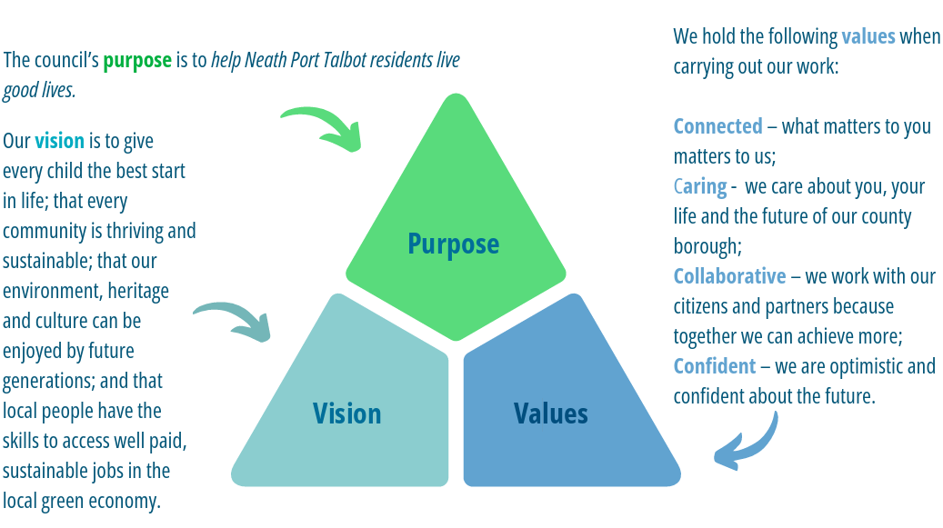
Figure 5. NPTC’s purpose, visions and values (NPTC, 2024)

With NPTC’s organisational strategy focused around serving the community, promotion of such should increase attraction and retention. 77% of employees said they felt their job was fulfilling with a further 86% saying the felt their job was important in the recent NPTC’s employee survey 2024-2025 (NPTC, 2025). Key points raised by employees when asked what they liked about their jobs were “rewarding and meaningful work”, “making a difference in people’s lives/the community” and “helping others”, which shows that NPTC are clearly motivated by intrinsic rewards (NPTC, 2025).

2.3.3. Weakness – Managers buy in for recruiting and developing early talent

NPTC are currently suffering with an experience and skills gap in the workforce with older generation employees looking to retire and a lack of skilled experienced younger generation employees able to fill the void. Cappelli (2024) states that “everybody wants to hire somebody with three years’ experience, and nobody wants to give them three years’ experience”, which highlights the need for organisations to focus on succession planning and providing entry level roles with the aim to develop and train talent to fill future skills gaps. Isherwood (2025) points out that the changes to demographics and the increased use of AI to complete automated tasks, the demand for low skilled jobs is decreasing with growth reserved for higher skilled roles.

There is increased call for organisations to take a skills-based approach to recruitment over experience based with too many organisations focusing on time-served experience rather than the skills required for the role (Hancock et al., n.d.; Lewis, 2023). Lancaster (2024) highlights that those entering the workforce often require upskilling and the opportunity to develop their on-job experience, which is only possible once given the opportunity to do so. Age UK (2024) state that to avoid age discrimination, organisations need to avoid recruiting based on time-served experience, with Pong (2024) arguing that, in the future, skills are set to becoming more valuable than degrees. Isherwood (2025) states that taking a skills-based approach helps organisations adapt to demographic and technological shifts, ensuring they build the talent needed for future success.

To address this, NPTC need to focus on early career focused recruitment with the aim to develop and upskill recruits to fill future skills gaps. Managers in NPTC focus on short term recruitment needs but need to change their mindset to look at a more long-term strategy, with Ronan (2018) warning that ‘short-termism’ is a huge risk to people planning with 67% of managers prioritising short-term pressures over long-term solutions.

- Conclusion

Although recent data suggests that the UK labour market is loosening, the lingering effects of the previously tight conditions continue to create significant competition for talent, particularly within the public sector. Skills shortages remain a critical challenge both nationally and locally, with lower qualification levels in Neath Port Talbot placing additional pressure on the council’s ability to recruit and retain suitably skilled employees. Demographic trends further compound these challenges. An ageing workforce, rising economic inactivity linked to long-term health conditions, and low levels of younger workers entering the workforce increase the urgency of strengthening succession planning and developing internal talent pipelines.

Despite these pressures, NPTC has tried to enhance its resilience through increased learning and development, partnerships with education providers, and an increased focus on employer branding. Evidence indicates that employees value the organisation’s purpose-driven work, strong values and commitment to community impact, offering a competitive advantage beyond pay alone. To sustain this, NPTC must continue shifting towards longer-term, skills-based workforce planning, ensuring managers fully support the development of early-career talent. This strategic focus will be essential to secure the future skills, capacity and organisational sustainability NPTC needs.

- Recommendations

4.1. Encourage take up of apprenticeships across the authority through an email infographic to be sent to managers to attract a younger demographic

Mallon, Cantrell and Forsythe (2025) argue that organisations need to reconsider apprenticeships to fill skills gaps, whilst building on long term relationships between an employer and the apprentice. With 55% of under-25s and 72% of over-25s wanting long-term employment and progression within one organisation apprenticeships appear to be a good option (Glassdoor, n.d.). This is supported by research carried out by the CIPD who noted that out of the 56% of organisations who are developing talent inhouse, 51% are doing so via apprenticeships (Hogarth and McCartney, 2024). The NHS (2022) have worked alongside universities to develop a pathway to becoming a doctor via an apprenticeship rather than the traditional route to education. There's clear belief within organisations that running apprenticeships offers an evidenced pathway for growth and businesses gain a customised stream of skilled talent that helps reduce recruitment costs and enhances their competitive edge, in turn, this mutually advantageous model fosters growth, improves productivity, and supports sustained success for all parties (Barclay, 2025).

Although NPTC can offer apprenticeships and already have strong partnerships with the local educational institutes, so far in 2025 only 6 apprenticeships were offered, which is a decrease from the 10 offered in 2024 and the 11 offered in 2023 (NPTC, 2025).

Essential to the uptake in NPTC’s offers of apprenticeships in buy in from recruiting managers (Frith, 2017). To encourage buy in, NPTC should produce and distribute an email infographic to all managers providing information about apprenticeships, positive statistics and a success story from within the organisation (Bourne, 2025).

Costs

Time for Talent Management Specialist to design and distribute infographic – 14 hours x £20.48 = £286.72

4.2. Develop and promote career pathways to internal talent

For NPTC to increase and promote internal progression it is important that talent understand the routes to progression within the organisation (McCartney, 2016). Exit interview data shows that 12% give their reason for leaving due to better career opportunities elsewhere with only 35% saying the felt there was sufficient opportunities for career progression/promotion in the organisation. An ADP report indicates that employees frequently perceive a lack of advancement opportunities, directly contributing to their choice to leave an organisation citing career development as the foremost reason for staying with an organisation, outranking flexible work arrangements and financial incentives (ADP, 2025, Soliman, 2024a).

Costs

Time for Heads of service (15) to create career pathway documents for their service areas – (37.5 hours x £30.11 = £1,129.16) x 15 = £16,937.40

Time for L&D Officer to assist in development of career pathways/available training for progression – (37.5 hours x £21.13 = £792.38) x 15 = £11,885.70

Time for Content creator to promote via internal communications – 3 hours x £19.32 = £77.28

Total cost: £28,900.38

4.3. Create and distribute videos of good news stories about employees/teams making a positive difference to the community

With the new generation projected to account for 30% of the workforce by 2030, employers are shifting from traditional recruitment practices to more innovative, technology-driven strategies (Institute of Student Employers, 2024) alongside research showing that candidates place the most trust in first-hand accounts from existing employees (Connectr Talent Technologies, 2025). The use of short visual platforms such as videos promoted through websites and social media with accounts from current employees are increasingly successful in reaching potential talent alongside current employees increasing retention (Institute of Student Employers, 2024).

Ward (PMInsight, n.d.) refers to the digital candidate journey whereby candidates are researching potential employers with candidates being influenced by the pictures, messages and culture being promoted via social media and websites. Although NPTC do post attraction videos on their website these videos are not promoted via their social media such as Facebook and Linked in, which appears to be a missed opportunity in the current climate (Wübbelt and Tirrel,2022). With candidates being 200% more likely to be attracted to the culture, mission and ethics of a company, than salary and benefits, NPTC should create a weekly video promoting the positive impact their employees have on the local community distribute through their website and social media channels (Connectr Talent Technologies, 2025).

Weekly costs

Time for Corporate social media Officer to create and distribute video – 22.5 hours x £17.46 = £392.85

- References

ADP (2025) People at Work: A Global Workforce View ADP UK. Available at: https://uk.adp.com/resources/insights/people-at-work.aspx#tab-da735c93-065c-4a44-aae8-cb120c2e1889-5 (Accessed: 29 November 2025).
Age UK (2024) Ageism in the workplace: Advice and Guidance Age UK. Available at: https://www.ageuk.org.uk/information-advice/work-learning/discrimination-rights/ageism/ageism-at-work/ (Accessed: 30 November 2025).
Bank of England (2025) Monetary Policy Report - November 2025. Available at: https://www.bankofengland.co.uk/monetary-policy-report/2025/november-2025 (Accessed: 22 November 2025).
Barclay, S. (2025) How apprenticeships can help close the skills gap. Available at: https://www.acas.org.uk/how-apprenticeships-can-help-close-the-skills-gap (Accessed: 29 November 2025).
Barton, C., Sturge, G. and Harker, R. (2024) The UK’s changing population. Available at: https://commonslibrary.parliament.uk/the-uks-changing-population/ (Accessed: 23 November 2025).
Bourne, J. (2025) What supervisors really think about apprenticeships. Available at: https://feweek.co.uk/beyond-numbers-what-supervisors-really-think-about-apprenticeships/ (Accessed: 29 November 2025).
Boys, J. (2022a) Analysis and recommendations to support longer and more fulfilling working lives. Available at: https://www.cipd.org/globalassets/media/knowledge/knowledge-hub/reports/understanding-older-workers-report_tcm18-107672.pdf (Accessed: 23 November 2025).
Boys, J. (2022b) CIPD Raising your employees value proposition. Available at: https://www.cipd.org/uk/knowledge/webinars/value-proposition/ (Accessed: 23 November 2025).
Cakmak, Z. (2020) ‘Florya Chronicles of Political Economy’, Florya chronicles of political economy, 9(1), pp. 42–53. Available at: https://doi.org/10.17932/iau.fcpe.2015.010.
Cappelli, P. (2024) Podcast - Managing the Future of Work - Harvard Business School. Available at: https://www.hbs.edu/managing-the-future-of-work/podcast/Pages/podcast-details.aspx?episode=2101851700 (Accessed: 29 November 2025).
CIPD (2017a) CIPD Analysis: How can Asia tackle its ageing talent tsunami? Available at: https://www.cipd.org/uk/about/news-archive/tackling-ageing-talent/ (Accessed: 23 November 2025).
CIPD (2017b) Outlook Focus Employee - Employee attitudes to pay and pensions. Available at: https://www.cipd.org/globalassets/media/knowledge/employee-outlook_2017-focus-on-employee-attitudes-to-pay-and-pensions-2016-17_tcm18-18488.pdf (Accessed: 23 November 2025).
CIPD (2023) CIPD Employer Brand Factsheets. Available at: https://www.cipd.org/uk/knowledge/factsheets/recruitment-brand-factsheet/#what-is-employer-brand (Accessed: 23 November 2025).
CIPD (n.d.) CIPD People Development Partner. Available at: https://www.cipd.org/uk/organisations/people-development-partners/ (Accessed: 1 December 2025).
Cockett, J. (2025) Labour Market. Available at: https://www.cipd.org/globalassets/media/knowledge/knowledge-hub/reports/2025-pdfs/9024-lmo-autumn-2025-report-web.pdf (Accessed: 22 November 2025).
Connectr Talent Technologies (2025) State of Candidate Experience Annual Report About this report. Available at: https://cdn.prod.website-files.com/676566d9a1762ef0b8359c47/67c5c621c1282385cf9735ea_State%20of%20Candidate%20Experience%202025%20-%20Full%20Version%20-%20Public%20-%20Released.pdf (Accessed: 29 November 2025).
County Councils Network (2024) Workforce of the Future Industry in Focus. Available at: https://www.countycouncilsnetwork.org.uk/wp-content/uploads/County-Councils-Network-Workforce-of-the-Future_final.pdf (Accessed: 26 November 2025).
Department for Works and Pensions (2023) Economic labour market status of individuals aged 50 and over, trends over time: September 2023. Available at: https://www.gov.uk/government/statistics/economic-labour-market-status-of-individuals-aged-50-and-over-trends-over-time-september-2023/economic-labour-market-status-of-individuals-aged-50-and-over-trends-over-time-september-2023#economic-inactivity (Accessed: 23 November 2025).
Department for Works and Pensions (2024) Economic labour market status of individuals aged 50 and over, trends over time: September 2024. Available at: https://www.gov.uk/government/statistics/economic-labour-market-status-of-individuals-aged-50-and-over-trends-over-time-september-2024/economic-labour-market-status-of-individuals-aged-50-and-over-trends-over-time-september-2024#economicinactivity (Accessed: 23 November 2025).
Devine, M. and Syrett, M. (2014) The economist: managing talent: recruiting, retaining and getting the most from talented people. London: Public Affairs.
Ely, J. (2024) UK fertility timebomb: Crisis as birth rates drop to all time low with some areas becoming ‘baby deserts' as so few are having children. Available at: https://www.dailymail.co.uk/health/article-14010305/UK-fertility-crisis-birth-rates-lowest-records-began.html (Accessed: 23 November 2025).
Francis-Devine, B. and Powell, A. (2025) UK Labour Market Statistics. Available at: https://researchbriefings.files.parliament.uk/documents/CBP-9366/CBP-9366.pdf (Accessed: 22 November 2025).
Frith, B. (2017) Apprentices lacking support from line managers - HR Magazine. Available at: https://www.hrmagazine.co.uk/content/news/apprentices-lacking-support-from-line-managers (Accessed: 29 November 2025).
George, S. (2024) Succession Planning. Available at: https://www.cipd.org/uk/knowledge/factsheets/succession-planning-factsheet/ (Accessed: 26 November 2025).
Gill, R. (2022) Neath Port Talbot Economic Recovery Plan Final draft -DRAFT -Version 4.1. Available at: https://democracy.npt.gov.uk/documents/s77298/App%203%20-%20Economic%20Recovery%20Plans.pdf (Accessed: 22 November 2025).
Glassdoor (n.d.) Gen Z: A Guide for Recruiters - UK Glassdoor for Employers. Available at: https://www.glassdoor.co.uk/employers/resources/gen-z-a-guide-for-recruiters/ (Accessed: 29 November 2025).
Hall, R. and Carrell, S. (2025) Fertility rate hits record low in England, Scotland and Wales. The Guardian. Available at: https://www.theguardian.com/uk-news/2025/aug/27/england-and-wales-fertility-rate-falls-for-third-consecutive-year (Accessed: 23 November 2025).
Hancock, B., Patel, N., Higgins, C., Law, J., Olson, S. and Van Dusen, K. (n.d.) Taking a skills-based approach to building the future workforce. Available at: https://www.mckinsey.com/capabilities/people-and-organizational-performance/our-insights/taking-a-skills-based-approach-to-building-the-future-workforce#/ (Accessed: 30 November 2025).
Hogarth, A. and McCartney, C. (2024) Resourcing and talent planning report 2024. Available at: https://www.cipd.org/globalassets/media/knowledge/knowledge-hub/reports/2024-pdfs/8662-resource-and-talent-planning-2024-report-web.pdf (Accessed: 23 November 2025).
Hopkins, D. (2025) Teams meeting with Laura Parry, 3 November.
Institute of Student Employers (2024) What will engage early talent in 2025? Available at: https://ise.org.uk/knowledge/insights/303/what_will_engage_early_talent_in_2025/ (Accessed: 29 November 2025).
Isherwood, S. (2025) Why you should consider an ‘emerging talent’ strategy rather than an ‘early careers’ one. Available at: https://www.peoplemanagement.co.uk/article/1912078/why-consider-emerging-talent-strategy-rather-early-careers-one (Accessed: 30 November 2025).
Jacobs, K. (2021) How to be an employer of choice. Available at: https://www.peoplemanagement.co.uk/article/1742249/how-be-employer-choice-talent-attraction-retention (Accessed: 23 November 2025).
Kapur, R. (2020) Strategic Resourcing as Key aspect of Strategic Human Resource Management. Available at: https://www.researchgate.net/publication/339041958_Strategic_Resourcing_as_Key_aspect_of_Strategic_Human_Resource_Management (Accessed: 22 November 2025).
Keswin, E. (2022) 3 Ways to Boost Retention Through Professional Development. Available at: https://hbr.org/2022/04/3-ways-to-boost-retention-through-professional-development (Accessed: 26 November 2025).
Labour (2024) Labour’s plan to get Britain working: How we’ll boost employment, deliver better training and secure higher wages. Available at: https://labour.org.uk/updates/stories/labours-plan-to-get-britain-working/ (Accessed: 22 November 2025).
Lancaster, A. (2024) CIPD How L&D can create value: Focusing on skills development. Available at: https://www.cipd.org/uk/views-and-insights/thought-leadership/insight/learning-value-skills-development/#References (Accessed: 30 November 2025).
Lawler, E.E. (2017) Reinventing Talent Management: principles and practices for the new world of work. Oakland: Berrett-Koehler Publishers.
Lewis, G. (2023) Is skills-based hiring the key to plugging talent gaps? Available at: https://www.peoplemanagement.co.uk/article/1830082/skills-based-hiring-key-plugging-talent-gaps (Accessed: 30 November 2025).
Mallon, D., Cantrell, S. and Forsythe, J. (2025) 2025 Global Human Capital Trends, Deloitte Insights. Available at: https://www.deloitte.com/us/en/insights/topics/talent/human-capital-trends.html#closing-the-experience-gap (Accessed: 29 November 2025).
Manpower Group (2025) ManpowerGroup Employment Outlook Survey. Available at: https://go.manpowergroup.com/hubfs/MEOS%20Q4%202025/MPG-MEOS-Q4-2025-Global-Report-2.pdf (Accessed: 22 November 2025).
McCartney, C. (2016) CIPD Career Pathways Podcasts. Available at: https://www.cipd.org/uk/knowledge/podcasts/career-pathing/ (Accessed: 29 November 2025).
McCartney, C. and Noble, K. (2025) CIPD Analysis Activating your employer brand to recruit and retain in a challenging climate. Available at: https://www.cipd.org/uk/views-and-insights/thought-leadership/insight/activating-employer-brand/ (Accessed: 26 November 2025).
McLeod, S. (2025) Maslow’s hierarchy of needs. Available at: https://www.simplypsychology.org/maslow.html (Accessed: 26 November 2025).
Michels, D. (2025) Using External Perspective To Build Resilience And Drive Change. Available at: https://www.forbes.com/sites/davidmichels/2025/03/27/using-external-perspective-to-build-resilience-and-drive-change/ (Accessed: 22 November 2025).
Muller-Heyndyk, R. (2018) HR Magazine - Organisations should focus on ‘resourcing’ rather than recruitment. Available at: https://www.hrmagazine.co.uk/content/news/organisations-should-focus-on-resourcing-rather-than-recruitment (Accessed: 22 November 2025).
NHS (2022) Medical Doctor Degree Apprenticeship. Available at: https://www.hee.nhs.uk/our-work/talent-care-widening-participation/apprenticeships/medical-doctor-degree-apprenticeship (Accessed: 29 November 2025).
Nickerson, C. (2025) Herzberg’s two-factor theory of motivation-hygiene. Available at: https://www.simplypsychology.org/herzbergs-two-factor-theory.html (Accessed: 26 November 2025).
NPTC (2024) Corporate Strategy 2025-2028 - Neath Port Talbot Council. Available at: https://www.npt.gov.uk/council/strategies-plans-and-policies/priorities-and-performance/corporate-strategy-2025-2028/ (Accessed: 26 November 2025).
NPTC (2022) The Future of Work Strategy Strategic Workforce Plan. Available at: https://www.npt.gov.uk/media/cpal4upr/fow_strategy_final.pdf?mediaredirect=false&v=20240430081844 (Accessed: 23 November 2025).
NPTC (2025a) Age Friendly Pledge. Neath Port Talbot Council. Unpublished.
NPTC (2025b) What we offer - NPT Council. Available at: https://www.npt.gov.uk/jobs/working-at-npt/what-we-offer/ (Accessed: 26 November 2025).
NPTC (n.d.) Flexible Working Arrangements - NPT Council. Available at: https://www.npt.gov.uk/jobs/application-forms-and-guidance/flexible-working-arrangements/ (Accessed: 26 November 2025).
NPTC (2025) CIPD PDP scheme benchmarking of NPTC comparative data 2022/202. Neath Port Talbot Council. Unpublished.
Office for Budget Responsibility (2025) Economic and fiscal outlook – March 2025 - Office for Budget Responsibility. Available at: https://obr.uk/efo/economic-and-fiscal-outlook-march-2025/ (Accessed: 22 November 2025).
ONS (2024) No qualifications – ONS. Available at: https://www.ons.gov.uk/explore-local-statistics/indicators/aged-16-to-64-years-with-no-qualifications-great-britain (Accessed: 22 November 2025).
ONS (2025) Vacancies and jobs in the UK, Ons.gov.uk. Available at: https://www.ons.gov.uk/employmentandlabourmarket/peopleinwork/employmentandemployeetypes/bulletins/jobsandvacanciesintheuk/november2025 (Accessed: 22 November 2025).
PMInsight (n.d.) How to use technology to attract and retain top talent. Available at: https://pminsight.cipd.co.uk/how-to-use-technology-to-attract-and-retain-top-talent? (Accessed: 29 November 2025).
Pong, C. (2024) 7 Workplace Trends That Will Define Success In 2025. Available at: https://www.forbes.com/sites/cynthiapong/2024/12/15/7-workplace-trends-that-will-define-success-in-2025/ (Accessed: 30 November 2025).
Quilliam, G.G. (2024) Talent Management. Available at: https://www.cipd.org/uk/knowledge/factsheets/talent-factsheet/ (Accessed: 20 November 2025).
Ronan, S. (2018) Short-termism a risk to people planning - HR Magazine. Available at: https://www.hrmagazine.co.uk/content/news/short-termism-a-risk-to-people-planning (Accessed: 30 November 2025).
Roper, J. (2015) HR Magazine - What do we mean when we talk about talent? Available at: https://www.hrmagazine.co.uk/content/features/what-do-we-mean-when-we-talk-about-talent (Accessed: 22 November 2025).
Soliman, I. (2024a) Career progression concerns driving job dissatisfaction as UK tackles skills gaps, study finds, Peoplemanagement.co.uk. Available at: https://www.peoplemanagement.co.uk/article/1892256/career-progression-concerns-driving-job-dissatisfaction-uk-tackles-skills-gaps-study-finds (Accessed: 29 November 2025).
Soliman, I. (2024b) HR leaders face growing challenge in finding skilled candidates, study finds, Peoplemanagement.co.uk. Available at: https://www.peoplemanagement.co.uk/article/1891767/hr-leaders-face-growing-challenge-finding-skilled-candidates-study-finds?utm_source=chatgpt.com (Accessed: 23 November 2025).
Stewart, H. (2025) Little sign that tax rise for employers will mean mass job losses, data shows, the Guardian. Available at: https://www.theguardian.com/business/2025/apr/15/little-sign-that-tax-rise-for-employers-will-mean-mass-job-losses-data-shows (Accessed: 22 November 2025).
Tambay, G. (2024) Why L&D is critical to driving employee retention in 2024. Available at: https://www.peoplemanagement.co.uk/article/1856529/why-l-d-critical-driving-employee-retention-2024 (Accessed: 26 November 2025).
Taylor, S. (2025) Resourcing and Talent Management. 9th Edn. London: Kogan Page Publishers.
Taylor, S. and Woodhams, C. (2022) Studying Human Resource Management: a Guide to the study, Context and Practice of hr. 3rd edn. London: Kogan Page.
The Older People’s Commissioner for Wales (2024) Understanding Wales’ Ageing Population: Key Statistics. Available at: https://olderpeople.wales/wp-content/uploads/2024/09/Understanding-Wales-ageing-population-September-24 (Accessed: 26 November 2025).
Walker, A. and Roxby, P. (2024) Fertility Rate in England and Wales Drops to New Low. Available at: https://www.bbc.co.uk/news/articles/cnvj3j27nmro (Accessed: 23 November 2025).
Welsh Government (2025) Labour market statistics (Annual Population Survey): April 2024 to March 2025. Available at: https://www.gov.wales/labour-market-statistics-annual-population-survey-april-2024-march-2025-html#176079 (Accessed: 22 November 2025).
Wübbelt, A. and Tirrel, H. (2022) ‘Attracting members of Generation Z to companies via social media recruiting in Germany’, Human Technology, 18(3), pp. 213–233. Available at: https://doi.org/10.14254/1795-6889.2022.18-3.2.

