Richard Jones - 1809132
rojones@gmail.com & 1809132@student.uwtsd.ac.uk
Network Operating Systems and Services
ACCA5023 – Nitheesh Murugan Kaliyamurthy

Abstract
The Author was tasked with documenting and demonstrating a number of tasks including an observational and research element within 2 parts of the following document.
The first part of the document required the author to carry out two tasks which included the following. Task 1 included observational tasks to carry out and document the understanding on NTFS and Share permissions. Task two required the author to utilise Group policy management to configure multiple policies to better facilitate the management of network and client devices within an enterprise network.
The second part of the document included three observational and research tasks. These tasks included task one to explain the difference between local and file share permissions. Task two explaining the role in which Group Policy Object management plays within a network environment. And task three which asked the author to document and research examples of sound password principles in a modern network environment.

Table of Contents
Abstract 1
Table of Contents 2
Introduction 1
1. Part 1 – Practical Work 2
1.1 Worksheet 3 Task 1 – Understanding NTFS and Share Permissions 2
1.1.1 Share Permissions 6
1.1.2 Accessing the file share/server over the network 8
1.2 Worksheet 3 Task 2 – Utilising Group Policy Management Console to better facilitate network object management. 9
1.2.1 GPO 1: Moderating Access to the Control Panel 10
1.2.2 GPO 2: Removing Access to the Command Prompt 11
1.2.3 GPO 3: Restricting Access to Removable Media Drives 12
1.2.4 GPO 4: Restricting Software Installs 13
1.2.5 GPO 5: Enforcing Password Policy in the ‘nwtraders.msft’ domain 15
2 Part 2 – Observational Tasks/Work. 16
1.1 Explain the main differences between local permissions and file shares 16
1.1.1 Local / NTFS permissions 16
1.1.2 Share Permissions 17
1.2 Describe the role of Group Policy Management in the Network Environment 17
1.3 Give some examples of sound password principles in the modern environment. 17
3 References 18

Introduction
The Author was tasked with conducting a two part document with a number of tasks within each part in the following paper. Part one consisted of two tasks which were split in to smaller sub tasks to details and document/evidence the work undertaken.
These two tasks consisted of, task one which was the configuration and demonstration of utilising NTFS and File Share Permissions. Within this task the author would configure a file share within the network server environment, with the selected file share a number of NTFS local permissions would be set and then client connectivity from a windows client device would be used to demonstrate the behaviour. Further upon this the author would then set File Share permissions and again demonstrate the behaviour and evidence the outcomes
Task two required the author to deploy and configure a number of group policy objects within the network and then evidence the behaviour of the set policies using the user/computer that these policies applied to via the windows client devices to confirm expected outcome. Firstly the author set a GPO to moderate the access to the control panel applet within the windows OS. Secondly the author then created a GPO to remove access to the command prompt for a select user base within the network environment.
The third GPO to be created was to restrict access to a number of removable media types for a select user base within the network. The fourth GPO created was to restrict the ability to install software packages for a select device base within the network. And lastly fifth the author was tasked with creating, configuring and enforcing a password policy under the default domain policy to require certain met criteria for password enforcement.
The author then moved on to Part 2 which consisted of three observational and research tasks. The first task required the author to explain the differences between the local NFTS permission sets and how they would apply and be utilised within a file access/share setup. Along with explaining the roles of Network share permissions with the same environment. The author document the overall uses and expected behaviour of these two permission restrictions and explained how they are used in conjunction within a network file share environment.
The second task required the user to document and describe the role of Group policy management within the network. The Author explained how GPO’s were not only created, but how they were deployed and utilised in an enterprise network to facilitate the ease of admin and automation for network administrators. The third and final task asked the administrator to document and provide example of sound network password principles. The author documented and detailed a number of considerations when looking to administer sound network password principles including but not limited to the evidence use of multi factor authentication and password policy practises.

Part 1 – Practical Work
In Part 1, the practical work set in worksheet three has been documented by the author. The author had been tasked with completing and documenting two main tasks with a number of sub tasks within each. The two tasks are as listed below.
- Understanding NTFS and Share permissions
- Utilising Group Policy Management Console to better facilitate network object management.
In task one the author will demonstrate and apply local and NTFS permissions, utilising a created text file within a folder structure. The author will then set two different access levels of permissions to two different user accounts. One of the two accounts will have permissions that represent an administrative level of access including but not limited to full read/write/delete permissions. The second account will have restricted permissions that only allow for read access to the file.
In task two the author will demonstrate and apply group policy objects utilising the group policy management console tool which is part of the Microsoft operating system. The author will create 5 different group policy object entries that will restrict either the user accounts that log on the end controlled device, or they will be targeted at the devices specifically regardless of the user who is logging in.
An example of the user restriction but not limited to, will be to create an Organisational Unit for Admin and Non Admin users and assign more restrictive policies to the non admin users, such as access to removable drives. An Example of the device restriction but not limited to, will be to create an Organisational Unit for Client devices and restrict software install privileges for those client devices.

Worksheet 3 Task 1 – Understanding NTFS and Share Permissions
For the first task the author is tasked with logging in to a Windows 10 Client device with an account that is a member of the administrators group in the nwtraders.msft domain. Once the author has logged in with the account he is then tasked with creating a new folder called Dept_Important_Docs. Once the folder has been created the author then creates a new text file and renamed it to Important_File as shown in Figure 1. Both the folder and file were renamed by right clicking the items and selecting the rename option.
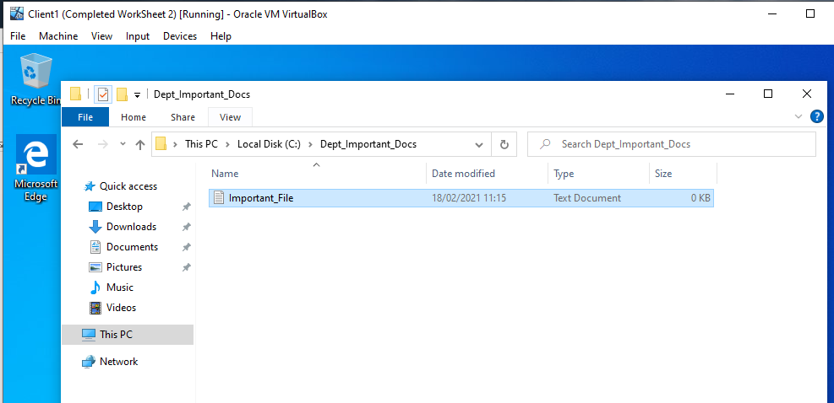
Figure 1. Newly created folder “Dept_Important_Docs” and file “Important_file”.
The author is now tasked with setting the NTFS (local) permissions on the folder and file structure, limiting the access so that a specified user has full access and another user has limited read only access.
Firstly the author right clicks and selects the properties of the folder and selects the Security tab, from here the user needs to tighten the security that is already in place by removing the authenticated users from the permission set. As shown in Figure 2. When you attempt to remove the authenticated user from the security tab a prompt is shown relaying information in relation to inherited permissions.
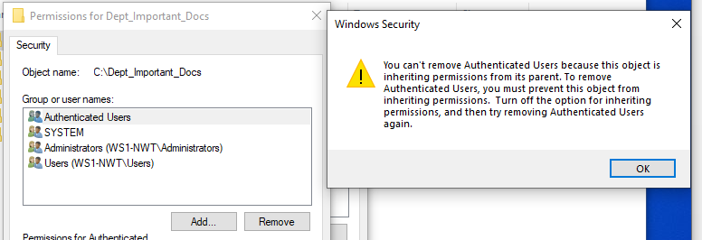
Figure 2. Prompt displayed when removing inherited permissions from the security tab.
The author as per the message needs to navigated to the “advanced” section and disable the in inheritance on this folder which will allow for permissions on this folder level on downwards to be amended accordingly as shown in Figure 3. Once this option has been selected the prompt to remove all existing inherited permission will display and this is selected.
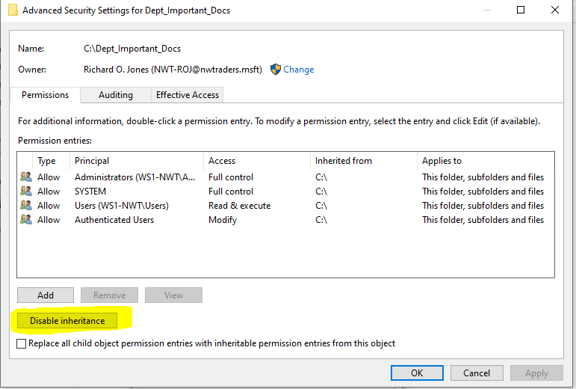
Figure 3. Disable Inheritance option within the advanced security tab.
The author has now removed the inherited permissions that allowed a level of access that was not desired in this scenario. Now that this has been completed the author is then tasked with adding two specific user account with different permission sets.
Firstly the author will add a user account with full permissions over the folder and file structure. In the example shown in Figure 4. The author has added an account named NWT-ROJ@nwtraders.msft via the “edit” permission option, and then selected allow for full control on the folder structure. As shown in Figure 5. The author has confirmed the inherited permissions on the text file has also applied.
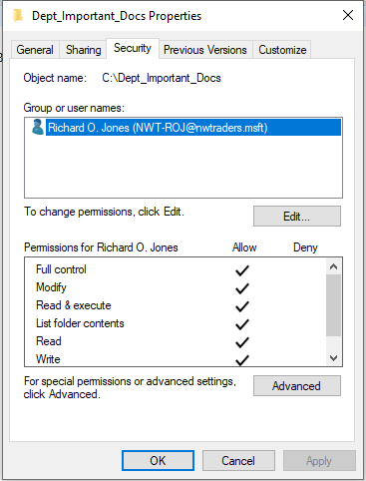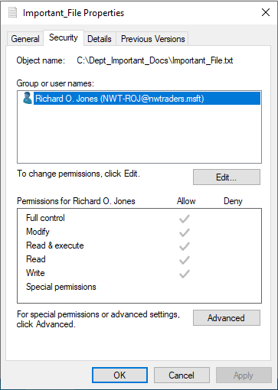
Figure 4. Folder Permissions Full Figure 5. Subsequent File Permissions Full.
The author now adds the second user with a limited read & execute permission set without the ability to modify. As shown in Figure 6. NWT-WJB@nwtraders.msft in the user account selected to add for read only permissions, and is added in the same method by selecting the “edit” button and searching for the user account. While being added the permission sets is amended to only allow the permission including and below Read & Execute.
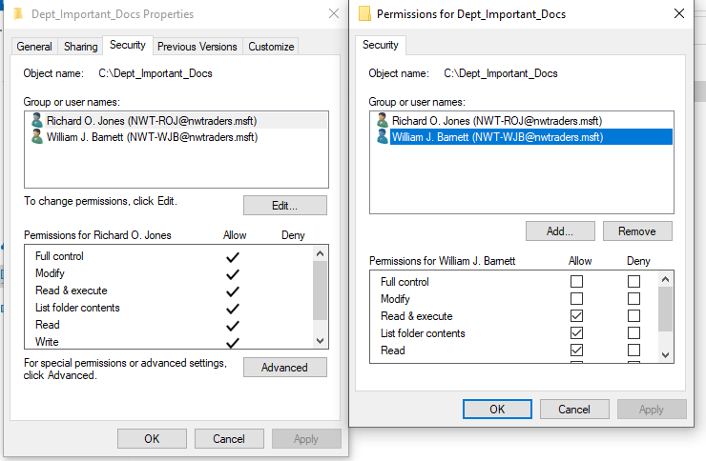
Figure 6. Folder permission demonstrating full access user and read & execute user.
To confirm that when opening the “important_file” as the user with full permissions NWT-ROJ@nwtrader.msft allows for the user to edit and save the file, the user account it used to log in to the Windows 10 client device and the file is edited and saved as shown in Figure 7.
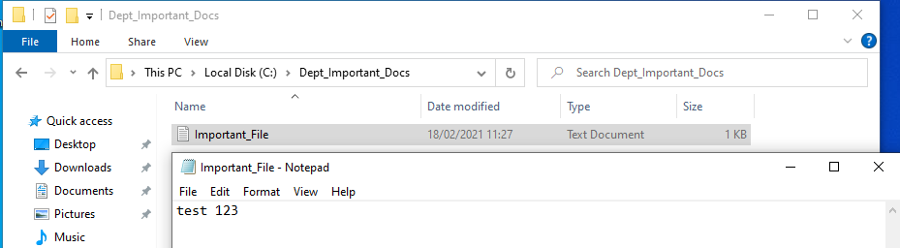
Figure 7. Amending text file and saving successfully with full permission account
The author now logs in to the Windows 10 Client with the non-full permissions account NWT-WJB@nwtraders.msft and attempts to open and edit the text file then saving it. The user is able to do this because the permission allow for writ as shown in Figure 8.
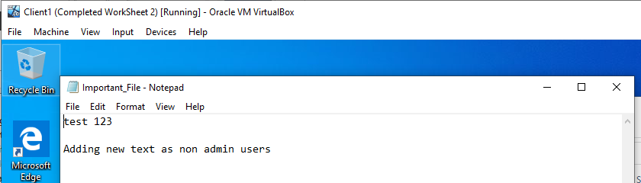
Figure 8. Editing and saving file as non-full permissions user.
When the same user attempts to either rename or delete the file the user account does not have the modify permission set and is therefore unable to carry out this action, and a prompt is displayed as shown in Figure 9 to confirm this.
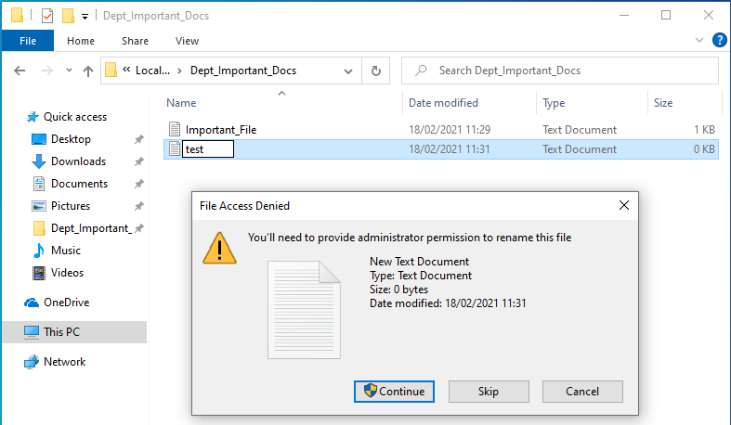
Figure 9. Attempting to rename file blocked due to lack of modify permissions.

Share Permissions

With the completion and demonstration of NTFS (local) permissions, the author is now tasked with demonstrating the setup, enablement and configuration of share and share permissions.
To demonstrate the configuration of a network share setup, the author firstly has to configure the share on the server in question. In this example the author is connected to server 1 virtual machine which is a 2019 windows server operating system. From the Server Manager the author selects the File and Storage Services and then selects the Shares>Tasks>New share option.
As shown in Figure 10. The Author is then presented with an array of option in relation to the type of share that is required. In this example the author will be tasked with creating an SMB Share Quick, which is a basic general file share aimed at Windows Operating systems for general file sharing.
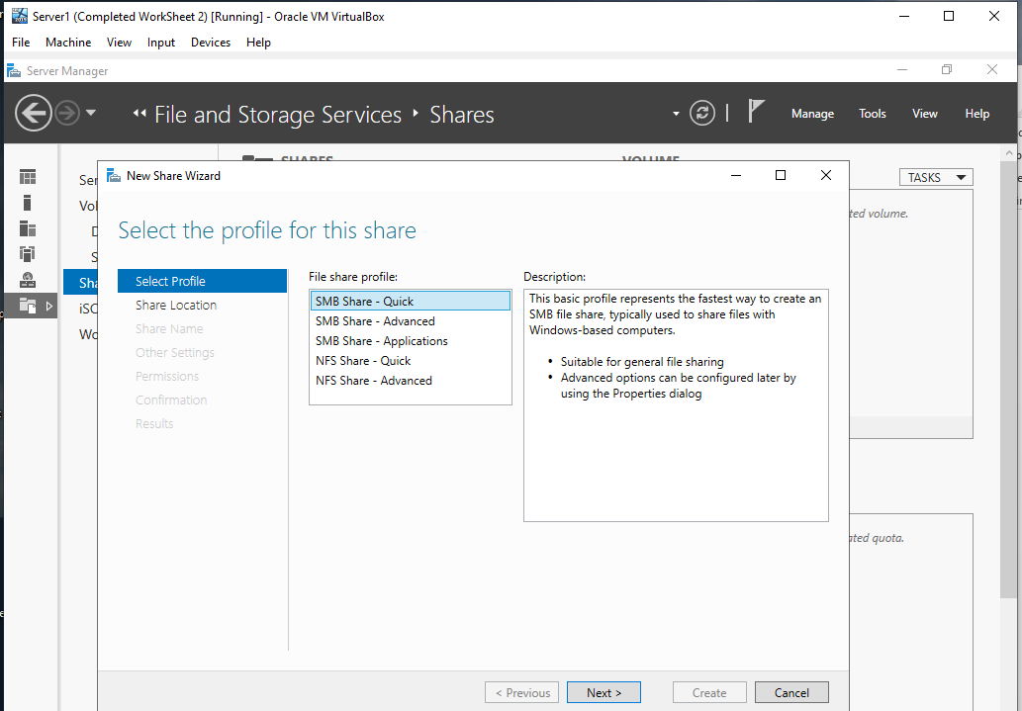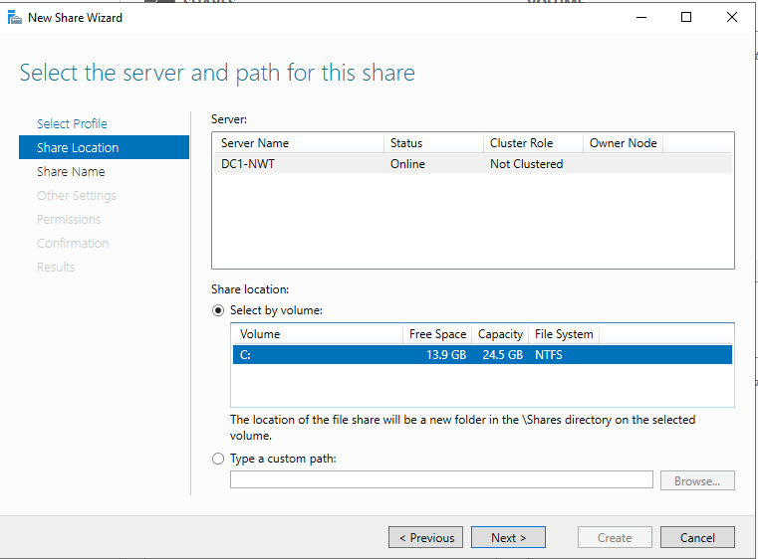
Figure 10. Share Wizard, Share types. Figure 11. Server Selection and Path
Once the author has selected the SMB Share – Quick option, the author is then presented with selecting the server that is hosting the share and the share path on that server. As shown in Figure 11. The author has selected the Server 1 virtual machine which has a host name of DC1-NWT and selected the volume of C:\ on that server.
Once the author has selected the server and path, the author is then presented with specifying the share name for the newly created share. This share name will create the folder on the local path along with providing the same name for the remote path in relation to the hosting server as shown in Figure 12. Adding the $ at the end of the share name means the share will be hidden by default when looking up the server name in file explorer for example.
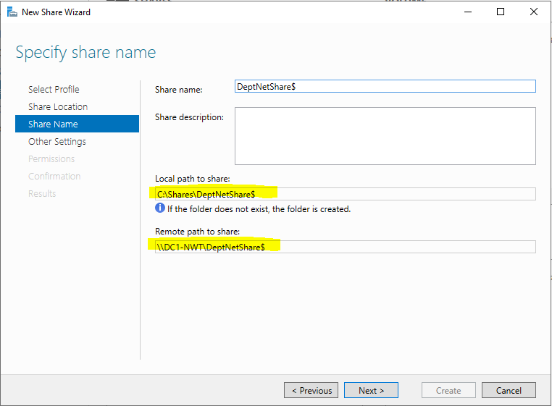
Figure 12. Share Name and associated local and remote paths as highlighted.
The Author now moves on to the next screen in the Wizard which comprises of three tick box options. These three tick box options are (1) Enable Access-Based enumeration, which essentially allows the windows share to hide the files or folders to a use who doesn’t have read permissions to the content (2) Allow caching of share, which as suggested allows for the user to offline cache the shared content on their devices (3) Encrypt data access, which encrypts the file access and transfer of data between the server and the host. For this exercise the author will be selecting the Access-Base Enumeration and Allow Caching of share options as shown in Figure 13.
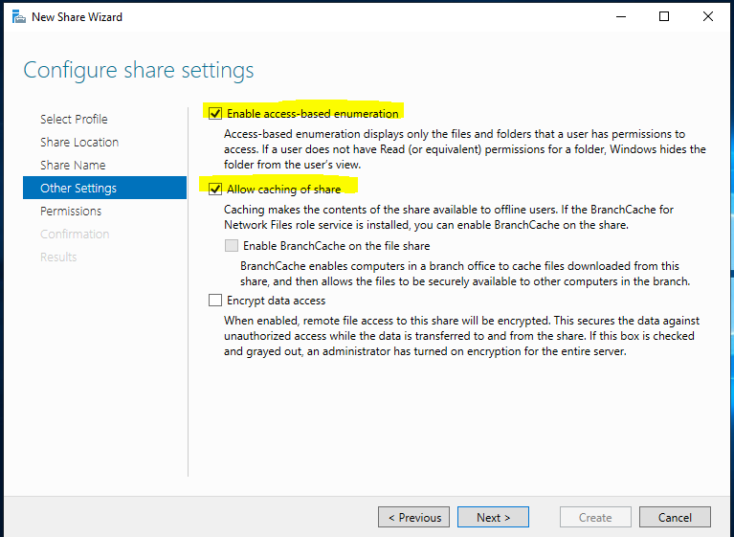
Figure 13. Share Wizard Configure Share Settings screen.
The author next selects the permissions that are required on the share. In this task the author has added two user accounts NWT-ROJ@nwtraders.msft and NWT-WJN@nwtraders.msft with both users having Read and Execute permissions as shown in Figure 14.
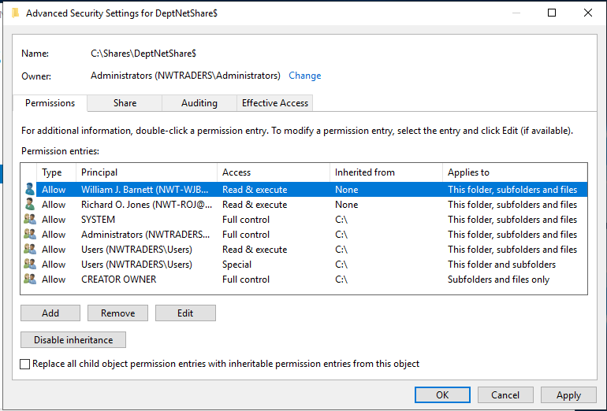
Figure 14. Share Permissions screen within share Setup Wizard.
Once the author has completed the permission configuration, the author then selects next to the confirm settings screen, this screen confirms the configuration selected up to this point in the wizard as show in Figure 15. Then the author selects create followed by close which then completes the setup process.
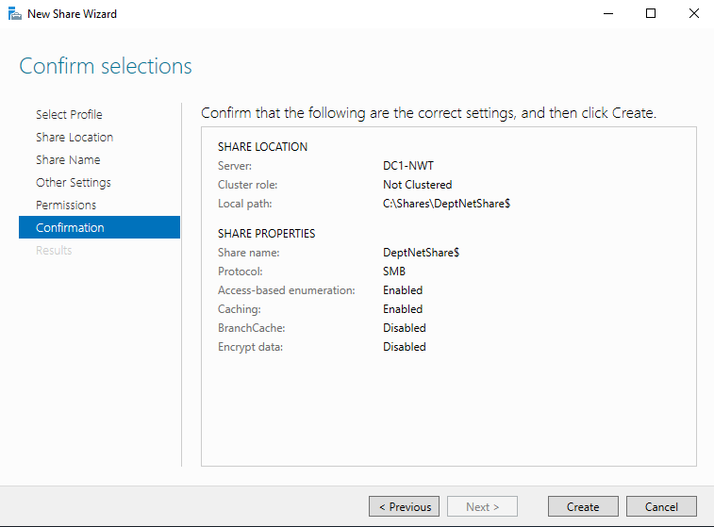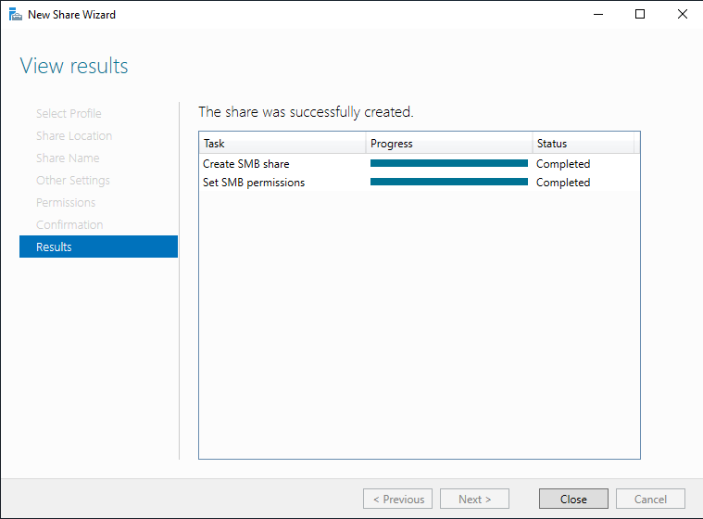
Figure 15. Confirmation and Completion of Share Setup Wizard.

Accessing the file share/server over the network

To confirm that the configuration ran in step 1.1.1 is working as expected, the author will now create a mapped shared drive on one of the windows 10 client devices and test the connectivity to confirm the behaviour is as expected.
To create a shared drive mapping on the Windows 10 client device the author selects my computer from the Windows File explorer and navigates to the menu bar selecting the “Map Network Drive” option. At this point the author can select a drive letter to represent the share on the local device, which is currently being left as the default Z: in this instance. Then the share location is required. In our instance the author enters the server path and share path as shown in Figure 12. Earlier \\DC1-NWT\DeptNetShare$ and completes the creation wizard.
As long as the logged on user to the Windows 10 Client device has read permissions to the share the drive will now be mapped on the device and the share will be visible and accessible as shown in Figure 16.
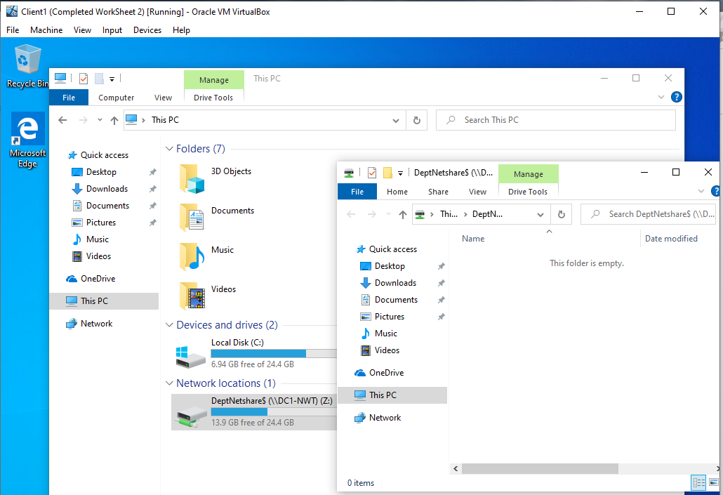
Figure 16. Mapped drive and navigation to shared location on Windows 10 Client.

Worksheet 3 Task 2 – Utilising Group Policy Management Console to better facilitate network object management.
For the second task within the practical element of worksheet 3, the author is tasked with creating and testing the behaviour of 5 Group Policy Objects. The group policies created by the author will restrict access and behaviour of multiple elements on the test Windows 10 client devices. They policies that will be created and tested include access to control panel, access to command prompt, access to removable media drives, software installs restrictions and lastly enforcing a password policy for a user base on the nwtraders.msft domain.
Group policy objects are created and configured within the Group Policy Object snap in for the MMC (Microsoft Management Console). There are primarily 3 types of Group policy objects local, Site and Domain which the author will expand upon in Part 2 later. In the examples below the domain level policies will be utilised.
Before the Group Policy objects are created and configured the Author has created a new OU (Organisational Unit) utilising the Active Directory Users and Computers console. This OU is named “Non Admin Users” and contains three newly created user accounts as shown in Figure 17. These accounts will later use to test the GPO’s that are created under this OU Structure.
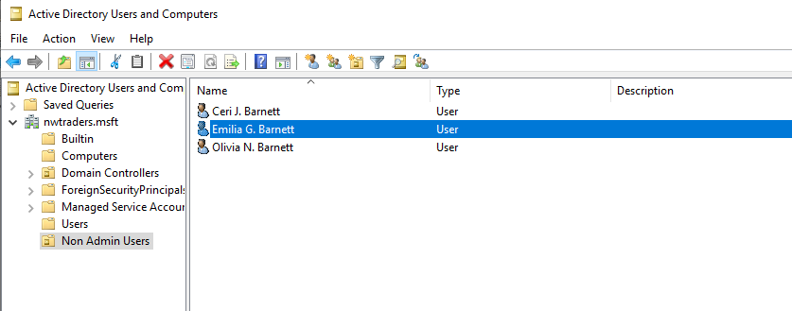
Figure 17. “Non Admin Users” OU created with three user accounts in AD Users & Computers Console.

GPO 1: Moderating Access to the Control Panel

The author will create a GPO to restrict the access of the control panel to the users who are located in the non admin users OU. The author first starts by creates a new GPO named “NoCtrlPanelAccess” under the “non admin users” OU within the Group Policy Management Console as shown in Figure 18.
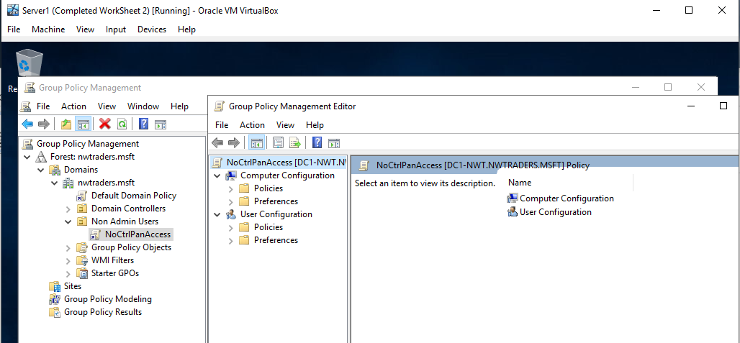
Figure 18. Creation of NoCtrlPanelAccess GPO
Once the GPO is created the author then right clicks and edits the GPO. This presents the author with a list in a tree format of Computer and User settings that can be configured to modify behaviour of the Windows Client. In this instance the author searches under User Configuration Policies Administrative Templates Control Panel and locates the “Prohibit access to control panel and PC settings” option.
By Double clicking on this the author is presented with a configuration setting that can be set as required as shown in Figure 19. To create the behaviour the author is tasked with in this example, the policy setting is set to enabled, which will restrict access to the Control Panel for all users that this GPO applies to.
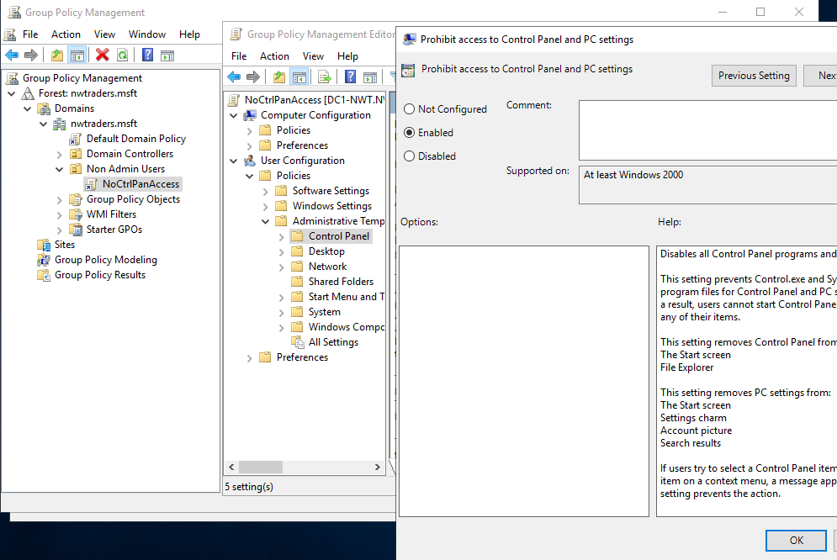
Figure 19. Group Policy Object and Setting for Control panel restrictions.

To confirm that the setting now configured is working as expected. One of the user accounts created and shown in Figure 17. Are used to log in to the Windows 10 Client. Once logged in the author then attempts to load the control panel from the start menu and is presented with the prompt as shown in Figure 20. This is the behaviour the author would expect with a successful GPO implementation for the user in question.
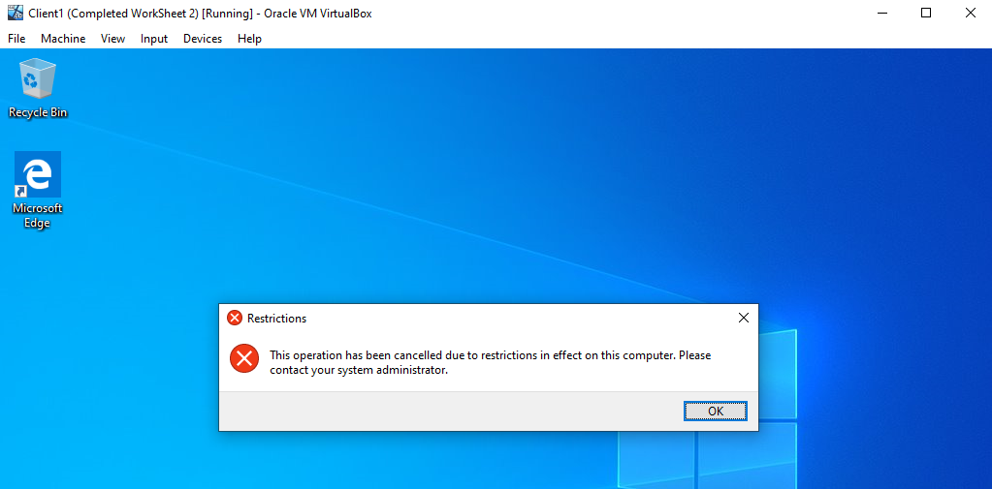
Figure 20. Author using test account NWT-CJB@nwtraders.msft to open control panel.

GPO 2: Removing Access to the Command Prompt

The author will now move on to create a GPO to restrict the access of the command prompt to the same users who are located in the non admin users OU. The author first starts by creates a new GPO named “NoCmdPrmptAccess” under the “non admin users” OU within the Group Policy Management Console as shown in Figure 21.
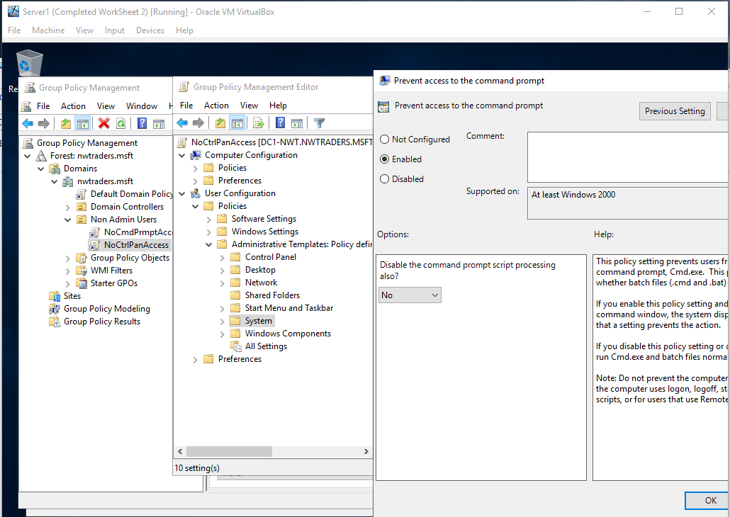
Figure 21. Group Policy Object and Setting for Command Prompt Access.
As shown in Figure 21. The author has navigated to the area containing the Command Prompt GPO setting User Configuration Policies Administrative Templates System and amended the “Prevent access to the command prompt” policy by enabling the policy.
To confirm that the desired behaviour is working as expected. The author uses one of the non admin accounts NWT-CJW@nwtraders.msft to log in to the Windows 10 Client device and attempts to load the command prompt from the start menu icon. As shown in Figure 22. The Command Prompt windows loads by displays a message informing the user that the application is disabled and press any key to continue.
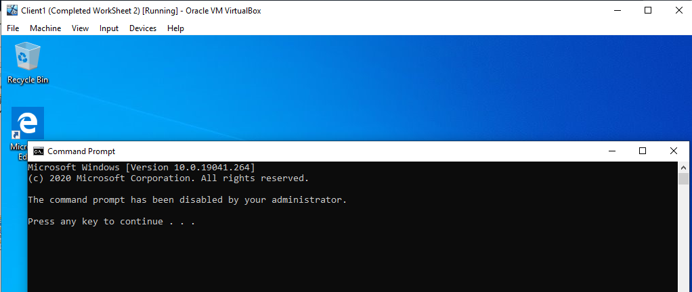
Figure 22. Author using test account NWT-CJB@nwtraders.msft to open command prompt.

1.2.3 GPO 3: Restricting Access to Removable Media Drives

The author now creates the third GPO as tasked to restrict the access of removable media drives to the users who are located in the non admin users OU. The author first starts by creates a new GPO named “NoRemDriveAccess” under the “non admin users” OU within the Group Policy Management Console as shown in Figure 23.
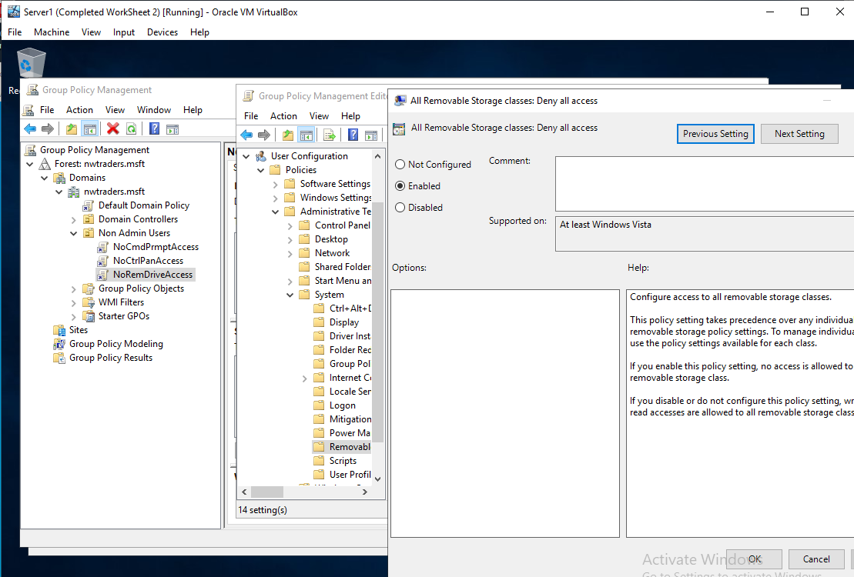
Figure 23. Group Policy Object and Setting for restricting Removable drive access.
As shown in Figure 23. The author has navigated to the area containing the Command Prompt GPO setting User Configuration Policies Administrative Templates System Removable Storage Access and amended the “All Removable Storage Classes: Deny All Access” policy by enabling the policy.
To confirm that the desired behaviour is working as expected. The author uses one of the non admin accounts NWT-CJW@nwtraders.msft to log in to the Windows 10 Client device and attempts to open a removable drive (CD Drive in this example) from the File Explorer Window, the author is presented with a message stating the drive is not accessible and access is denied. As shown in Figure 24.
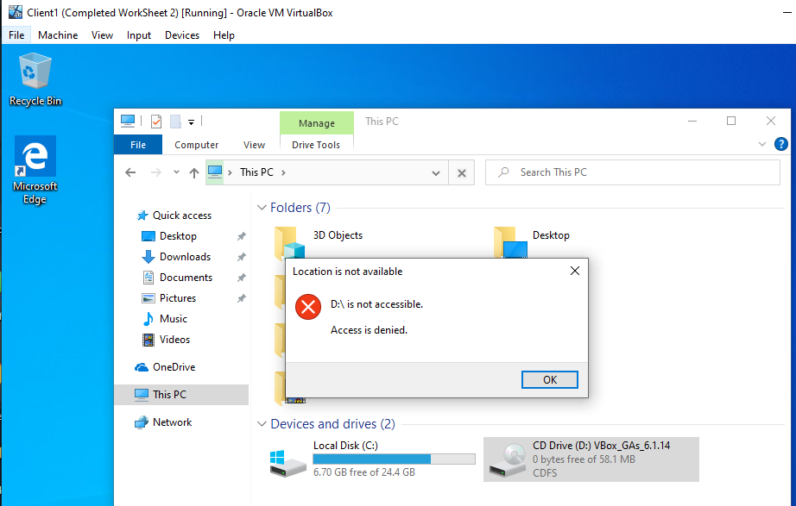
Figure 24. Author using test account NWT-CJB@nwtraders.msft to open the Removable media drive (CD Drive).

GPO 4: Restricting Software Installs

The author will create a fourth GPO to restrict the ability to install software on specified groupings of devices. As this policy is aimed at device objects and not user objects, the author will first create an OU called “NWClient Computers” and move the Windows 10 Client object that is being used for testing in to the OU as shown in Figure 25.
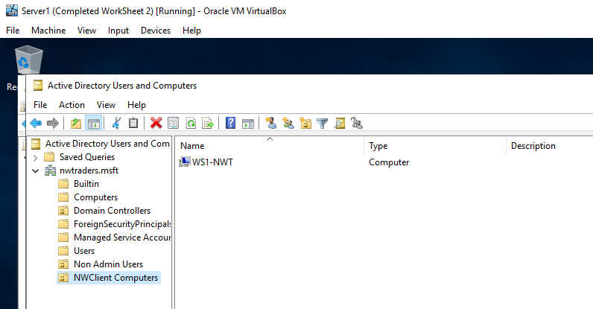
Figure 25. Computer Device Object OU NWClient Computers with a device object located under the OU for testing GPO’s
Once the author has created the NWClient Computers OU, the author then creates a GPO under this OU structure called “NounauthSoftInstalls” and navigates to the following tree structure Computer Configuration Administrative Templates Windows Components Windows Installer and amended the “Prohibit user Installs” policy by enabling the policy as shown in Figure 26.
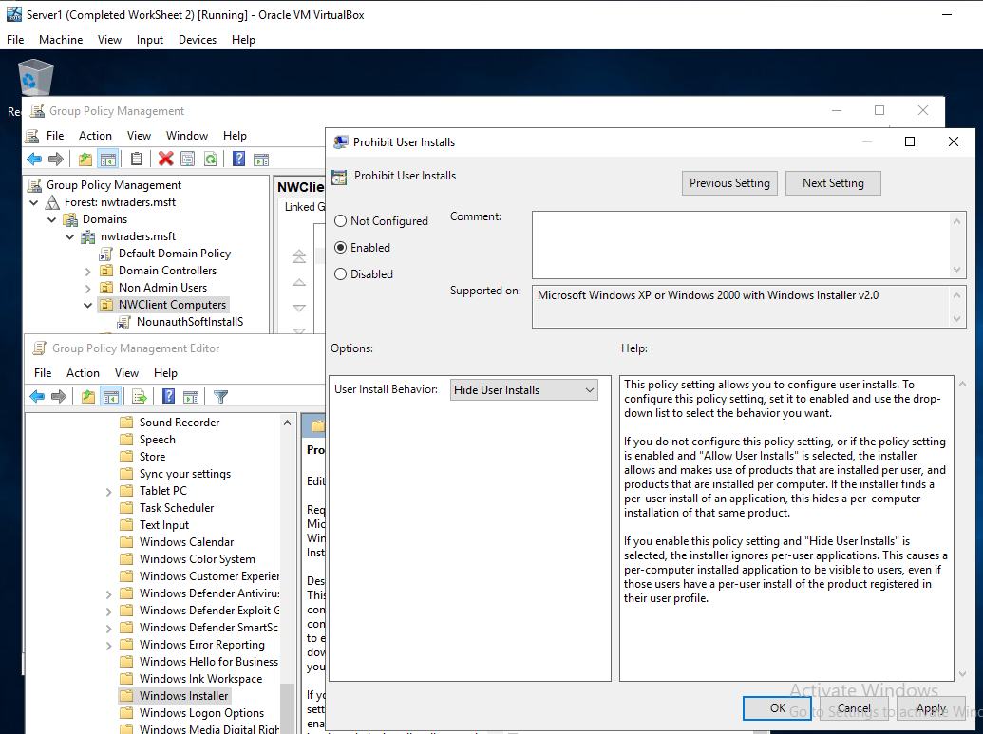
Figure 26. Group Policy Object and Setting for restricting software installs.
The Author then logs in to the test Windows 10 client that was shown in figure 25. And attempts to run a software install package as shown in Figure 27. The software install is blocked and a prompt is displayed informing the user of this.
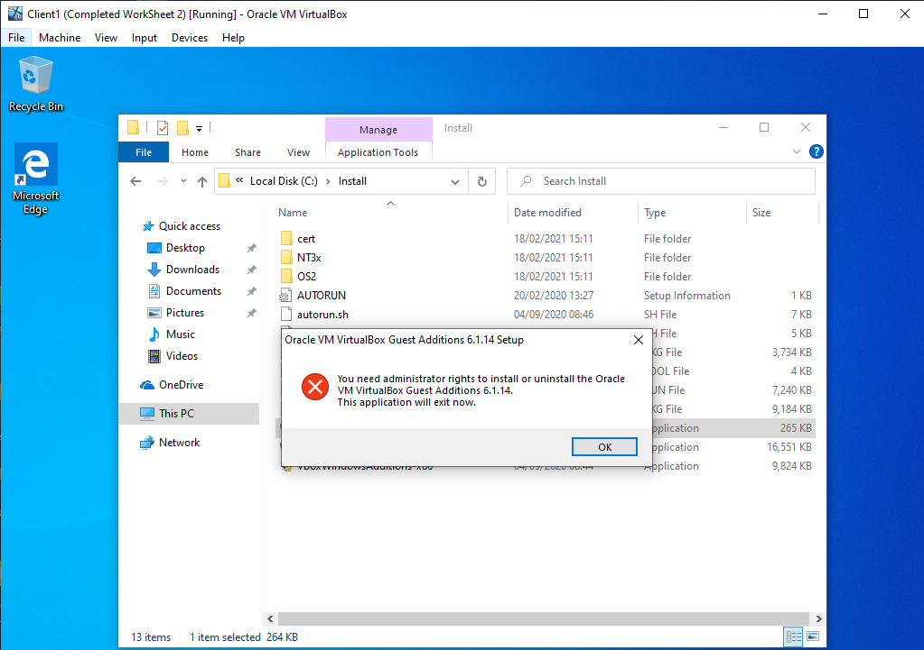
Figure 27. Author logging in to client WS1-NWT and attempting to install a software package.

GPO 5: Enforcing Password Policy in the ‘nwtraders.msft’ domain

Lastly the author will create a fifth GPO to enforce a defined set of requirements for a password policy for users on the nwtraders.msft domain. The author utilises the default domain policy that is already available within the Group Policy Management console tree, as the policy will be enacted on all users within the domain as shown in Figure 28.
As shown in Figure 28. The author navigated to Computer Configuration Windows Components Windows Settings Security Settings Password Policy and amended a number of policy items to require a predefined set of policies.
These included:
- Enforce Password History: 8 Passwords
- Maximum Password Age: 31 Days
- Minimum Password Age: 1 Day
- Minimum Password Length: 10 Characters
- Password must meet complexity requirements: Enabled
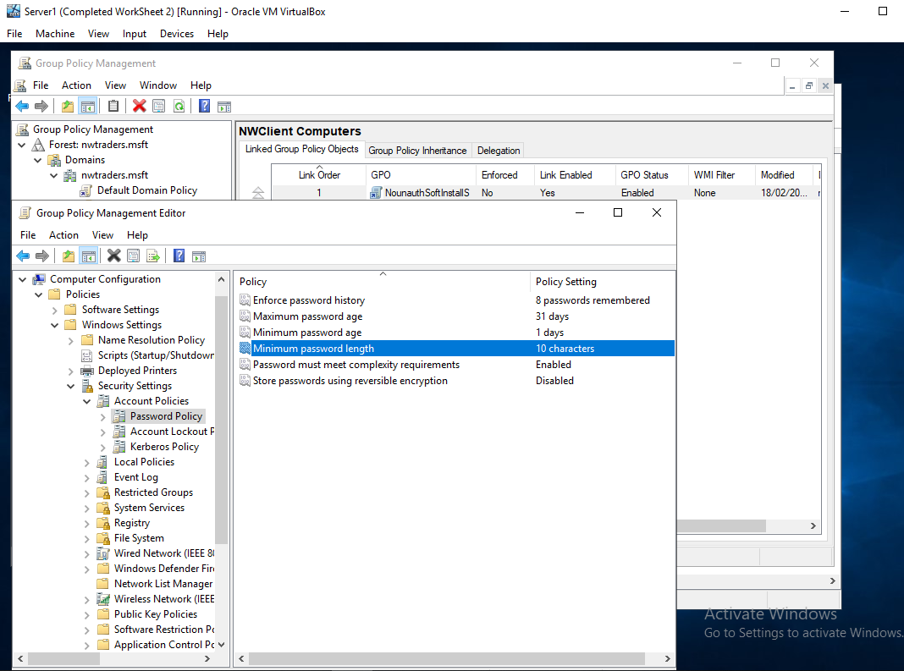
Figure 28. Default Domain Policy. Enablement of Password Policy Requirements.
The author then created a new user account and attempted to create a password for the user that did not meet the defined criteria stated in Figure 28. As shown in Figure 29. If the password did not meet the criteria, the password would not be allowed and a prompt detailing the possible reasons as to why the password was not acceptable.
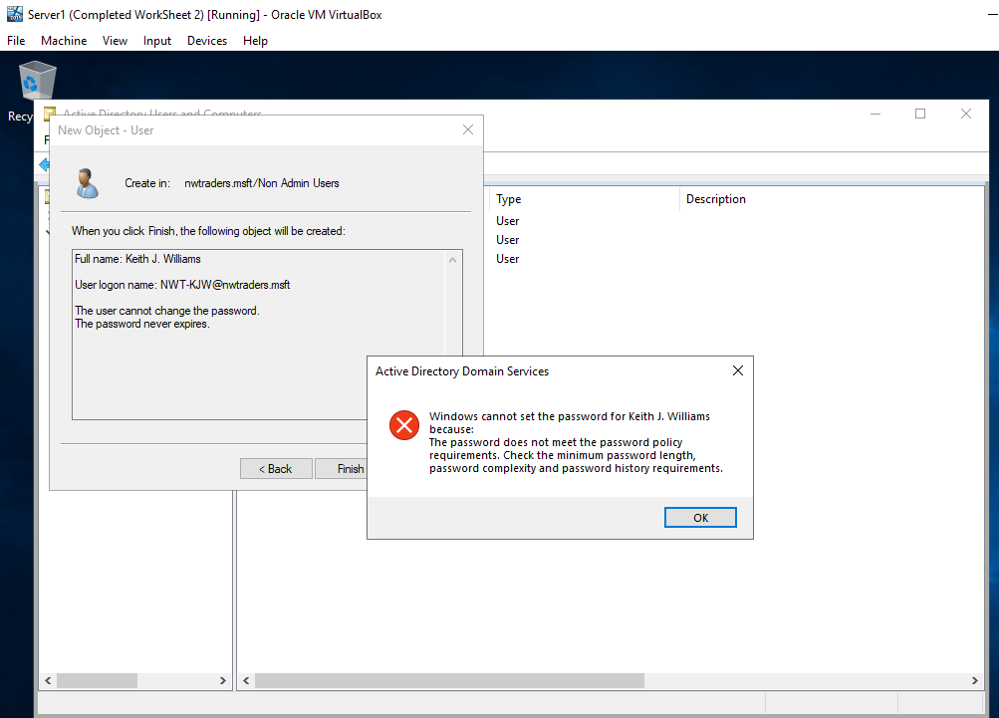
Figure 29. User account creation and Password not being allowed due to GPO Password Policy enforcement.

Part 2 – Observational Tasks/Work.

Explain the main differences between local permissions and file shares
There are two types of common file permission within a window operating system, the author will attempt to explain and list the main difference between them. The two types of permissions are often referred to as (1) local or NTFS permissions and (2) Share Permission.

1.1.1 Local / NTFS permissions
Local permission as stated often referred to as NTFS permissions which stands for New Technology Files System, is a form of file level access control which was first introduced by Microsoft in Windows NT in 1993[1]. The NTFS permissions are sets of “grant” or “deny” permission sets split in to numerous categories[2]. These permission sets are then applied to data that is stored within NTFS file systems including folder and file levels.
The permission sets include but not limited to the following types Figure 30:
- Full Control: As the title suggests this role when enabled allows the user to add, change, move and delete files and directories to which they have this role assigned to. But as well as these abilities the Full Control allows for the user to be able to assign, remove and modify additional permissions to the file/folders[3].

- Modify: Modify is a cut down version of the Full control. While the user with modify permissions is still able to view, modify and delete files and their associated properties. But they are unable to amend additional permission for example[3].

- Read and Execute: As suggested in the title Read and Execute allows the user to read file and folders to which this permission set is applied to them, as well as being able to execute executable file types including scripts. But they user is unable to modify or delete files/folders and their properties[3].

- Read: Read simply allows the user to be able to view the files and folder, including their contents and properties. But the user is unable to execute, modify or delete any files or folders[3].

- Write: Lastly the Write permission set allows for the user to write to a file or folder structure, for example to modify a text file or add a file to a specific directory to which this permission set is applicable to[3].

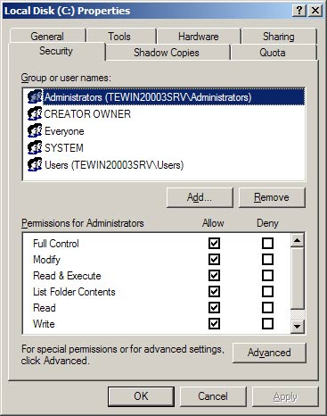
Figure 30. Example of NTFS permissions and the Allow/Deny structure.

To summarise the NTFS or Local permissions that a user or group of user has applied to a specific file or file structure is set to determine what action those users are able to undertaken[4] on a given file or file structure within local and network share scenarios[5].

1.1.2 Share Permissions
Share permissions as the name suggests is a set of permissions which is applied to a designated shared area or subset of areas. Shared permissions for example do not apply to a logged in local user[6] as this permissions set would be handled by the local NTFS permissions that are applied.
Shared permissions are more of a cut down version of NTFS local permissions as they are mainly in place to handle who has the ability to access the assigned shared area and not what the user can specifically do on that shared area[7]. Although this is not always the case depending on the subset of what local permissions are in place and types of file systems as to which the shared permissions are set on[8].
Shared permissions as stated are cut down in to three areas Figure 31, much like NTFS or local permissions shared permissions again have an “allow or “deny” setting when applying to a file/folder area.
- Read: As has already been explained in the NTFS local permissions, read allows for the user to be able to view, read and run some programs.

- Change: Change builds upon Read, by incorporating all of the feature of Read and then adding the ability to change and delete data within the file/folder structure along with the ability to add new files and folders to a specified area.

- Full Control: Much as was the case with NTFS local permissions. Full control allows the user to do all of the pre mentioned Read and Change functions which adding the ability to amend the share permissions for the file and folder structure. By default all administrators are granted full control.

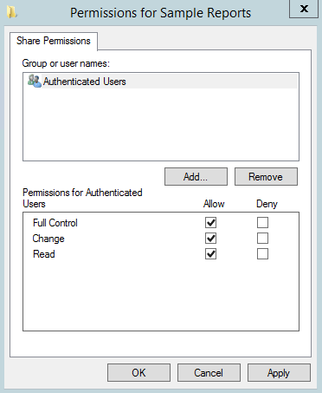
Figure 31. Example of Share Permissions and the Allow/Deny Structure.
To Summarise Share permissions unlike NTFS local permissions are more of a higher level simplified versions of NTFS[9] and only apply to the shared area and not local logged in users Figure 32. NTFS permissions allow for a far granular ability to manage permissions. Often both are used in conjunction and when a permission set between NTFS local and Share collide the most restrictive permission set will take precedence[9].

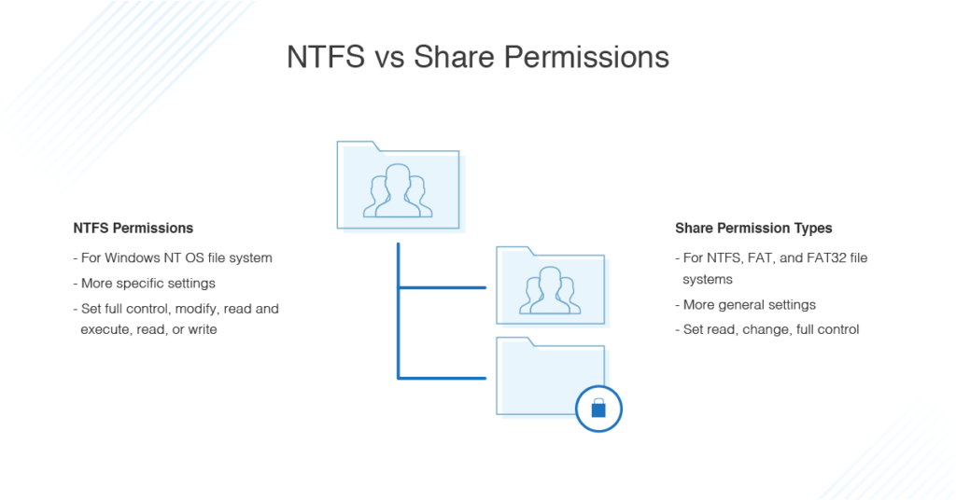
Figure 32. NTFS vs. Share permission high level overview[10].

Describe the role of Group Policy Management in the Network Environment
In this section the Author will expand on the explanation of Group Policy Management, along with explaining how it fits in a modern network environment. The author will detail and explain some examples of GPO deployment within a network and how it can be utilised for management of endpoints and automation of endpoint management.
Group Policy Management within a network on a high level is simply a method for network administrators to configure computer and user settings on end user or corporate devices within an active directory environment[11] Figure 33.
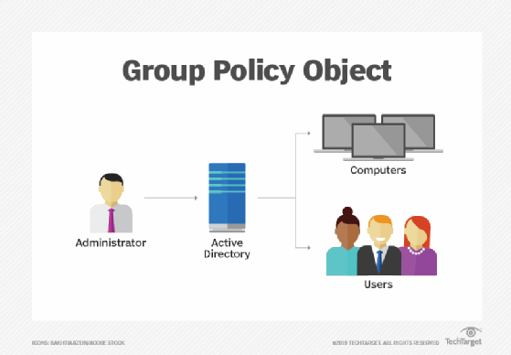
Figure 33. High level overview of GPO Admin.
Group Policy Management utilises Group Policy Objects. These objects are created within and active directory environment, once create they are assigned to a User or Computer Organisational Unit[12]. Within the Group Policy objects are a list of entries that can be amended to force a specific setting or behaviour on the targeted user or Computer. These entries are GUI driven interfaces that essentially amend registry entries on the target device to amend the behaviour as required[13].

Example of Group Policy Management Objects.
Group Policy objects you have a large array of polices/settings that can be controlled for the user or computer target. Underneath both areas are Policy sections and a Preferences Sections.
As the titles may suggest policies are a forced configuration on the target that cannot be amended by the user, whereas a preference is a configured setting on the target device that can be amended by the end user if they chose to. How they can be amended depends on the type of preference that is being deployed[14].
Examples of group policy objects Policy and Preference settings include but are not limited to the following:
- Drive Mappings: Drive mapping can be controlled utilising the Preferences aspect of a GPO. As shown in Figure 34. An administrator is able to define an array of configurations in relation to the shared drive including but not limited to Location of share drive, Drive letter mapping and the action of the shared mapping from either replacing, updating or removing an existing entry[15].

In a network environment the drive mapping can be configured to only apply to specific Active Directory User/Computer groups, this allows for the mass deployment of shared drives to be configured, deployed and managed from a single location.

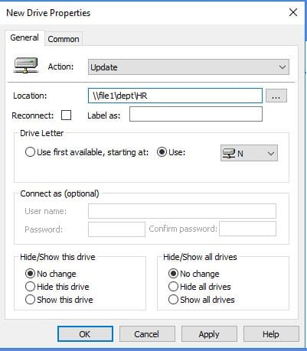
Figure 34. Example of GPO Drive Mapping Preference settings.

- Folder Redirection: Folder Re-Direction utilises the Policy aspect of GPO’s. Therefore this is not a setting the target user/device is able to amend as it is forced upon them. For example as shown in Figure 35. The Administrator is about to configure existing Folder locations for the target and then amend to where those folders are re-directed[16].

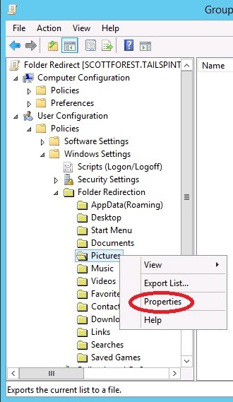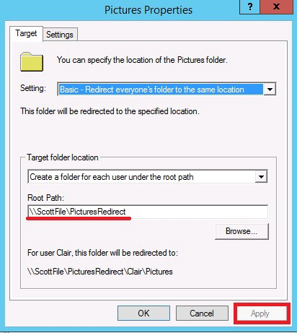
Figure 35. Example of Folder Re-Direction GPO.

A common use of this functionality within a network environment is to re-direct the target users “My Documents” folders to a network file server. The reason for this is that the user “My Document Area” is then hosted and saved on a Network Storage Server which would likely have backup and recovery procedures in place. This allows for a manageable DR scenario for user file management.

- Application/Menu Interface Restrictions: There are many common application or interface restrictions that are used via GPO’s within a network environment. These include but are not limited to the restriction of Command Prompt, PowerShell and Control Panel or specific applets to name a few[17]. As shown in Figure 36.

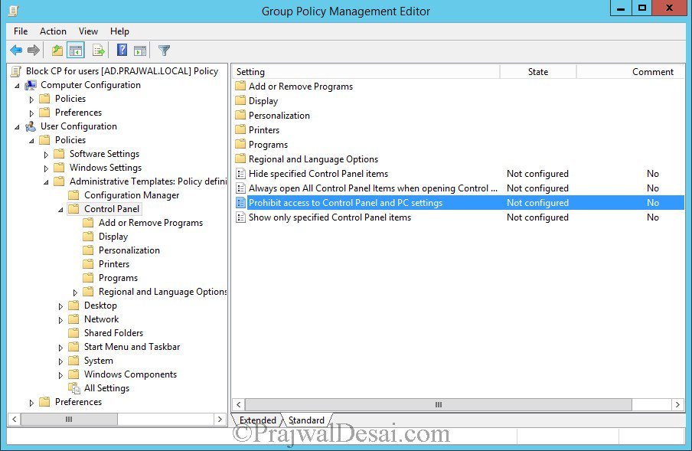
Figure 36. Example of GPO Policy to configure control panel access.
An administrator would configure end users access to prevent user from being able to run harmful application or amend corporate branding and interface options for example.

- Printer Deployment: Much like drive mapping, printer deployment utilises the GPO preferences aspect and therefore the user is able to amend the printers once deployed to their client device. But depending on how the preference is deployed the settings can refresh and replace back to desired configuration on subsequent GPO refreshes (Reboots for example)[18]. As shown in Figure 37. The GPO Preference provides a number of setting including but not limited to the action of the printer deployment, shared path of the printer deployment and permissions as to what groups of devices or users the printer is deployed to.

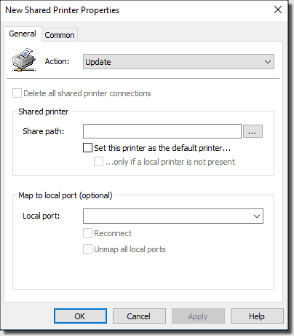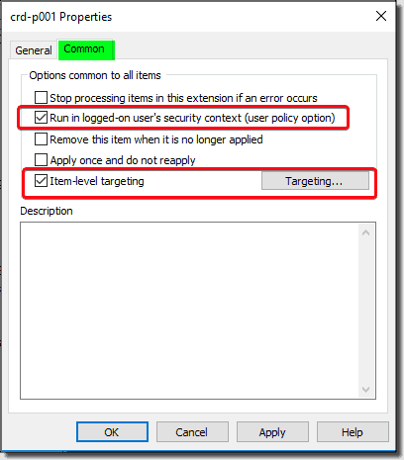
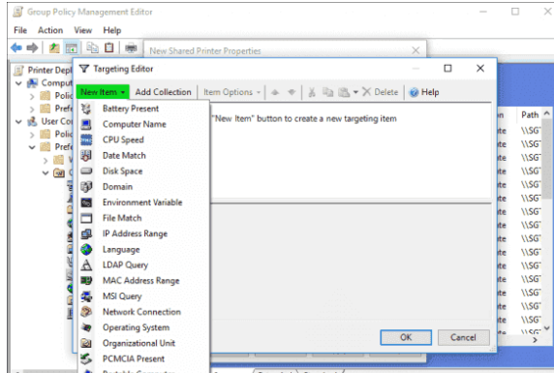
Figure 37. Example of GPO Preference Printer Deployment options.

- Windows Update Behaviour: Group Policy objects can also be used to manage aspects of software deployment via policy settings. Once of the more common software deployment managements within GPO is the ability to manage the Windows Updates. As shown in Figure 38.

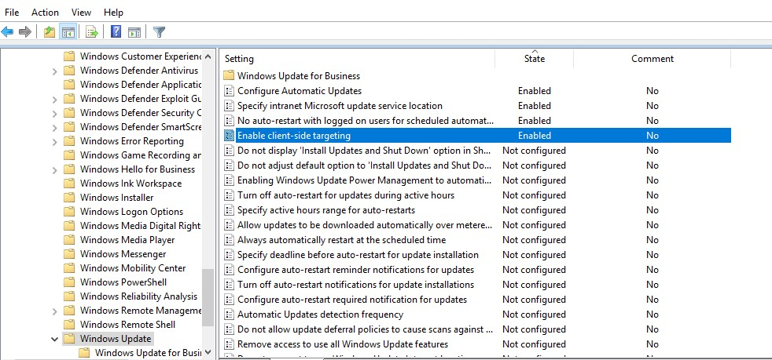
Figure 38. Example of Windows Update GPO configurable settings.

Administrators are able to configure the array of Windows update options to enable automation of deployment of windows updates. Administrators are able to configure multiple options including but not limited to Update Source locations, Scheduling of Updates, Reboot behaviour post install as well as being able to integrate with WSUS (Windows Server Update Services) deployment to enable endpoint targeting[19]. This means that multiple Windows update GPO’s can be tailored and created and then different deployment behaviour applicable to different groups of users and/or devices.

- Password Policies: Password Policies can be configure within GPO’s, commonly they are applied at the default domain level policy to apply to all end users. But it is possible to create additional GPO’s and apply specific tailored password policy behaviour for sub sets of users[20].

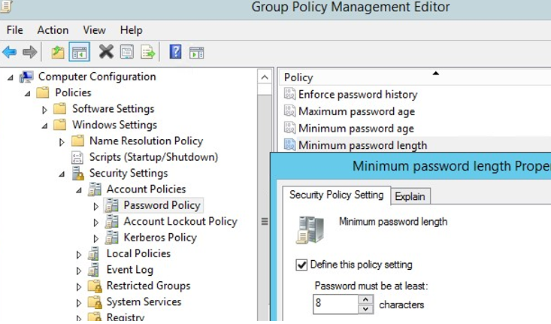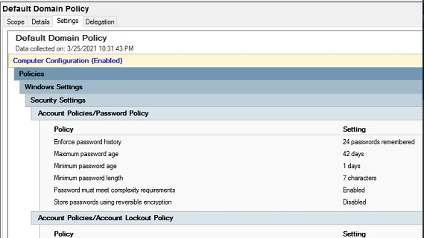
Figure 39. Example of GPO password Policy settings.

As shown in Figure 39. An array of password options including but not limited to password history, minimum and maximum password age and length and meeting password complexity rules.

GPO Summarised.
To Summarise. The benefits of Group Policy objects within a network environment are that they allow for Administrators to be able to configure and customise end users and devices with the provision of ease of administration on a large scale[21]. As well as being able to add security preferences and functions in to the environment to help secure the network infrastructure. Some of the drawbacks of GPO’s is that they are often limited in terms of the configurable triggers within the policies along with some of the flexibility that can be required in large environments, as well as requiring a level of organisation around their deployment as they can often get out of control and conflict in large active directory structures.

1.3 Give some examples of sound password principles in the modern environment.
Modern network environments require users to set and potentially remember a number of passwords. While traditionally it has been common practise to include a few key requirements such as:
- Password Complexity and Length: Many organisations have up until recently encouraged their user base to set passwords to include a combination of but not limited to special characters, minimum password length, combination of upper and lower case sensitive characters and numbers[22]. But these complexity requirements often make it difficult for users to remember password initially.
- Password Age: Previous guidelines from the NIST (National Institute of Standard and Technology) had also recommended having regular password change period enforced. Common timescales included 90 days[23]. However it is believed that having such regular password change enforcement coupled with the complexity rules meant not only did user struggle to remember password, but they also reused old password with slight changes in them (patterns) which lead to the overall security being poor.
Recent recommendations from institutions such as NIST (National Institute of Standard and Technology) and NCSC (National Cyber Security Centre) has suggested that due to the above mentioned implementations, passwords has become more predictable and less secure due the complexity and regular force changes[24]. As users found clever ways to minimize the changes to their hard to remember password, it has become clearer that other approaches to password security are not only more desirable for the end user but also more desirable for the overall security[25]. These include but are not limited to:
- Reducing Reliance on Passwords: Introducing password systems that utilise MFA (Multi Factor Authentication)[26]. MFA allows for a second layer of authentication that is only accessible traditionally to the account holder via methods such as Text codes or MFA apps shown in Figure 40. Such as Microsoft Authenticator or Google Authenticator. Also utilising SSO (Single Sign On) systems for an array of business logins/applications allows for the users reliance and creating and remember a number of secure created passwords.
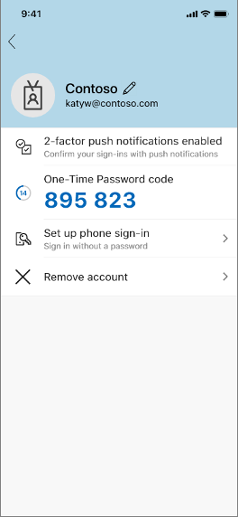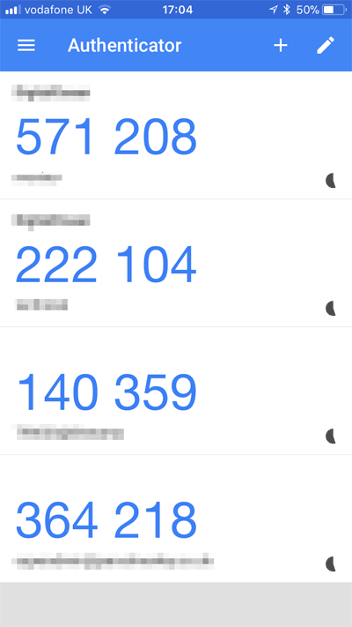
Figure 40. Example of Microsoft and Google Authenticator Apps

- Security Monitoring: Introducing Systems that monitor the user account logins and looks for unusual patterns of behaviour, including but not limited to login attempt failures, brute force attacks and logins from unexpected geographical locations means that active monitoring of password usage can identify potential security intrusions in real time and lock/disable access to highlighted accounts at source of detection. Systems such as SafetState[27] as shown in Figure 41. Are an example of such software solutions currently available.

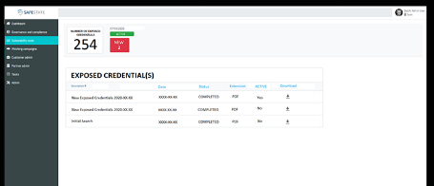
Figure 41. Example of Password Monitoring system Safe State.

- Password Deny Lists: Introducing password deny lists for common words/passphrases allows for basic easily crackable password to be blocked in the first instance and steering the end user to create a more suitable password for the long term. An example of password protection via deny lists are available in many software vendors products, one such example is the provision within Microsoft Azure[28] as shown in figure 42.

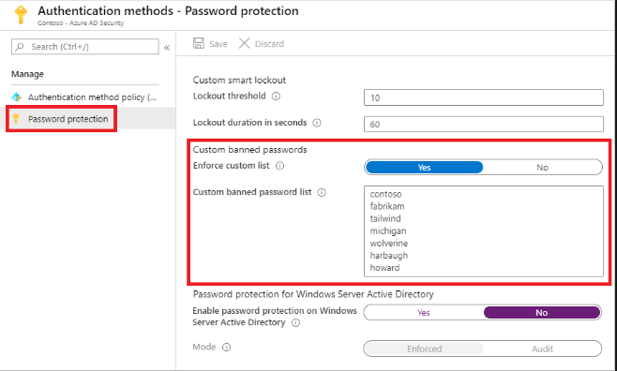
Figure 42. Example of Password Protection in Microsoft Azure.

- Reducing Password Expiry: This to many will seem like the complete opposite to what was recommended up until recently, and that would be true. But it’s been identified by bodies such as NIST and NCSC[29] that regular password expiry policies have become counterproductive and simply encourage the user to develop a regular password that utilises minor changes to cover the password expiry events.

- Password Events: Rather than having the aforementioned regular password expiry, an alternative alongside password monitoring systems is to force password changes on known or suspected password compromising events[30]. This encourages the end user to create a password that is significantly different to the one they have had previously.

- Password Length: It has been known that a more effective approach to passwords is to create longer passwords rather than complexity in the password. It is recommended that password are a longer even when only using one set of conditions and not utilising special characters etc[31]. are more effective than shorter passwords with complex character as shown in figure 43.

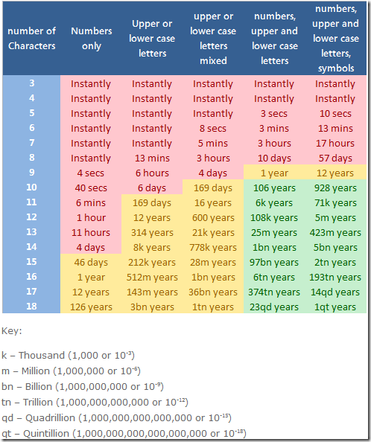
Figure 43. Example of password cracking times in given scenarios.

References
[1] “NTFS Permissions vs Share: Everything You Need to Know.” https://www.varonis.com/blog/ntfs-permissions-vs-share/ (accessed Apr. 22, 2021).
[2] “Permission Precedence - NTFS.com.” http://ntfs.com/ntfs-permissions-precedence.htm (accessed Apr. 22, 2021).
[3] “An Introduction to NTFS Permissions - basic and advanced.” https://www.2brightsparks.com/resources/articles/a-basic-introduction-to-ntfs-permissions.html (accessed Apr. 22, 2021).
[4] “File and Folder Basic NTFS Permissions - NTFS.com.” https://www.ntfs.com/ntfs-permissions-file-folder.htm (accessed Apr. 22, 2021).
[5] “Differences Between Share and NTFS Permissions.” https://blog.netwrix.com/2018/05/03/differences-between-share-and-ntfs-permissions/ (accessed Apr. 22, 2021).
[6] “NTFS vs. Share Permissions: What’s the Difference? - DNSstuff.” https://www.dnsstuff.com/ntfs-vs-share-permissions (accessed Apr. 11, 2021).
[7] “What’s the Difference Between Share and NTFS Permissions?” https://www.lepide.com/blog/whats-the-difference-between-share-and-ntfs-permissions/ (accessed Apr. 22, 2021).
[8] “Learn the basic differences between share and NTFS permissions - TechRepublic.” https://www.techrepublic.com/article/learn-the-basic-differences-between-share-and-ntfs-permissions/ (accessed Apr. 22, 2021).
[9] “A Simple Guide to NTFS Permissions vs. Share Permissions.” https://blog.foldersecurityviewer.com/ntfs-permissions-vs-share-permissions/ (accessed Apr. 22, 2021).
[10] “NTFS vs. Share Permissions: What’s the Difference? - DNSstuff.” https://www.dnsstuff.com/ntfs-vs-share-permissions (accessed Apr. 22, 2021).
[11] “What is Group Policy Object (GPO) and Why is it Important?” https://searchwindowsserver.techtarget.com/definition/Group-Policy-Object (accessed Apr. 22, 2021).
[12] “What are Group Policy and Group Policy Objects?” https://blog.netwrix.com/2017/02/17/group-policy/ (accessed Apr. 22, 2021).
[13] “Group Policy: What Is It and How Do GPOs Work - Microsoft Platform Management - Blogs - Quest Community.” https://www.quest.com/community/blogs/b/microsoft-platform-management/posts/group-policy-what-is-it-and-how-do-gpos-work (accessed Apr. 22, 2021).
[14] “Group Policy Preferences | Microsoft Docs.” https://docs.microsoft.com/en-us/previous-versions/windows/it-pro/windows-server-2012-r2-and-2012/dn581922(v=ws.11) (accessed Apr. 22, 2021).
[15] “Mapping drives using Group Policy preferences - ManageEngine Blog.” https://blogs.manageengine.com/active-directory/active-directory-academy/2019/11/18/mapping-drives-using-group-policy-preferences.html (accessed Apr. 22, 2021).
[16] “Using Folder Redirection in Group Policy | Microsoft Docs.” https://docs.microsoft.com/en-us/previous-versions/windows/it-pro/windows-server-2012-r2-and-2012/dn789199(v=ws.11) (accessed Apr. 22, 2021).
[17] “6 Group Policy Settings You Need to Get Right.” https://blog.netwrix.com/2019/05/07/6-group-policy-settings-you-need-to-get-right/ (accessed Apr. 22, 2021).
[18] “Deploying printers using Group Policy | 4sysops.” https://4sysops.com/archives/deploying-printers-using-group-policy/ (accessed Apr. 22, 2021).
[19] “Configure Windows Update for Business via Group Policy (Windows 10) - Windows Deployment | Microsoft Docs.” https://docs.microsoft.com/en-us/windows/deployment/update/waas-wufb-group-policy (accessed Apr. 22, 2021).
[20] “How To Configure a Domain Password Policy.” https://activedirectorypro.com/how-to-configure-a-domain-password-policy/ (accessed Apr. 22, 2021).
[21] “What is a GPO (Group Policy Objects) | Easy365Manager.” https://www.easy365manager.com/gpo-group-policy-objects/ (accessed Apr. 22, 2021).
[22] “Password must meet complexity requirements (Windows 10) - Windows security | Microsoft Docs.” https://docs.microsoft.com/en-us/windows/security/threat-protection/security-policy-settings/password-must-meet-complexity-requirements (accessed Apr. 22, 2021).
[23] “Minimum password age (Windows 10) - Windows security | Microsoft Docs.” https://docs.microsoft.com/en-us/windows/security/threat-protection/security-policy-settings/minimum-password-age (accessed Apr. 22, 2021).
[24] “NIST Password Guidelines: What You Need to Know - Infosecurity Magazine.” https://www.infosecurity-magazine.com/blogs/nist-password-guidelines/ (accessed Apr. 22, 2021).
[25] “Password policy: updating your approach - NCSC.GOV.UK.” https://www.ncsc.gov.uk/collection/passwords/updating-your-approach (accessed Apr. 22, 2021).
[26] “Reduced reliance on passwords – Print IT Reseller Magazine.” https://www.pitr.uk/reduced-reliance-on-passwords/ (accessed Apr. 22, 2021).
[27] “Password Monitoring - Safestate.” https://www.safestate.com/our-platform/password-monitoring/?lang=en (accessed Apr. 22, 2021).
[28] “Password protection in Azure Active Directory | Microsoft Docs.” https://docs.microsoft.com/en-us/azure/active-directory/authentication/concept-password-ban-bad (accessed Apr. 22, 2021).
[29] “The problems with forcing regular password expiry - NCSC.GOV.UK.” https://www.ncsc.gov.uk/blog-post/problems-forcing-regular-password-expiry (accessed Apr. 22, 2021).
[30] “Guidelines for Password Management - Information Security Office - Computing Services - Carnegie Mellon University.” https://www.cmu.edu/iso/governance/guidelines/password-management.html (accessed Apr. 22, 2021).
[31] “7 Password Experts on How to Lock Down Your Online Security | WIRED.” https://www.wired.com/2016/05/password-tips-experts/ (accessed Apr. 22, 2021).

