Handout 15 - The jamovi Quickstart Guide

Jonas Rafi 2020-06-03

The aim of this website is to provide short, non-technical tutorials on how to do common procedures in jamovi. However, it is not a resource on statistics. If you require an introduction to statistics, there are plenty of other resources, e.g., the free e-book Learning statistics with jamovi by Navarro and Foxcroft.

- Opening data in jamovi
To open a file in jamovi, click the menu icon and select Open file -> Browse.
Excel (.xlsx) and LibreOffice (.odt) files are supported in version 1.2.0. For earlier versions of jamovi, it is common to use data files with “comma-separated values” (.csv or .txt). Other supported file formats are JASP files (.jasp), R files (.RData, .RDS), SAS files (.xpt, .sas7bdat), SPSS files (.sav, .zsav, .por) and Stata files (.dta). Got data in Excel and don’t know how to get it into jamovi? Continue reading about comma delimited data below to find out.

Comma delimited files
A comma-separated values (csv) file is a text file that uses comma to separate values. The file stores data in plain text, where each line of the file is a record. Despite the name comma-separated, other characters such as semi-colon are sometimes used. See figure 1 below for an example of a .csv-file with semi-colon used.
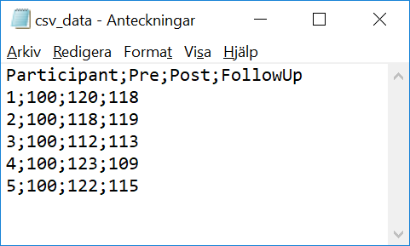
Figure 1: A .csv-file opened in a texteditor.
If you have your data in a spreadsheet program (e.g. Excel), you can create a csv copy of your data by selecting File -> Save as... and choose Comma delimited in the drop-down menu close to the Save as-button. Thereafter, you may open the .csv-file in jamovi.
- Setting the scale of measurement
Before conducting analyses in jamovi, you usually need to set the scale of measurement for each variable included in the analysis. When you load data into jamovi, it is common for variables to get the lowest level (nominal). This means that, for example, if you are conducting a two sample t-test you typically need to change both variables from nominal to continuous.

How to set the scale of measurement for a variable
- Double click the variable you want to edit.
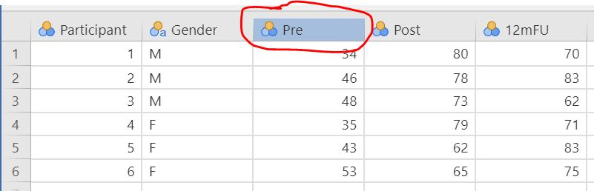

- In the data variable pane, select the desired level: ID, Nominal, Ordinal or Continuous.
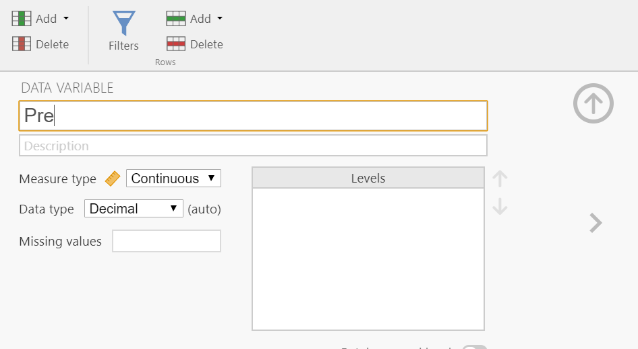
- Lastly, press the up arrow to hide the data variable pane, or the left or right arrows to edit another variable.
3. Descriptive analyses

How to perform descriptive analyses and create graphs in jamovi:
- Select Analyses -> Exploration -> Descriptives.
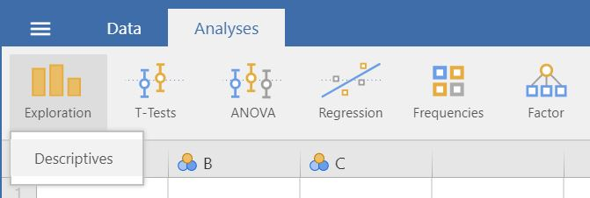
- Drag and drop the variables you want descriptive analyses for to Variables.
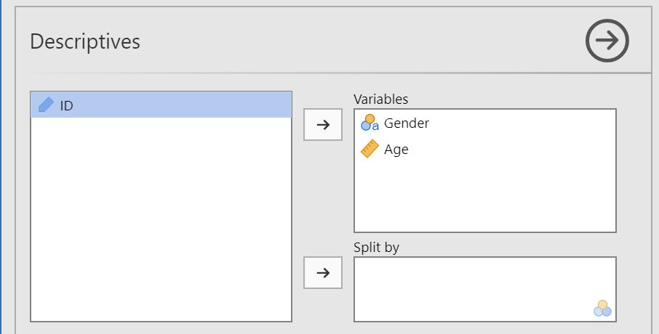
- The result is shown in the right panel. Right click the output to save or copy it.
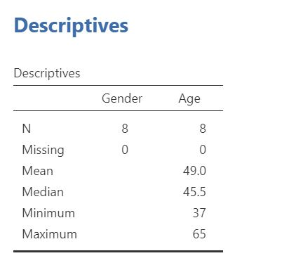
- To split your descriptive analyses on a categorical variable (e.g. to separate by gender), move that variable to Split by.
- Click the Statistics tab to see more alternatives.
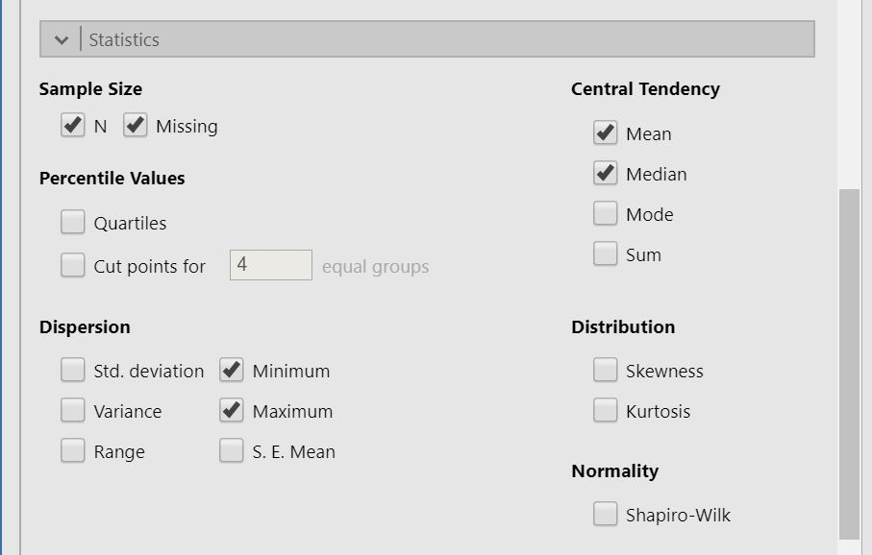

- To create a plot based on the above choices, click the Plots tab and tick the box of your desired plot.
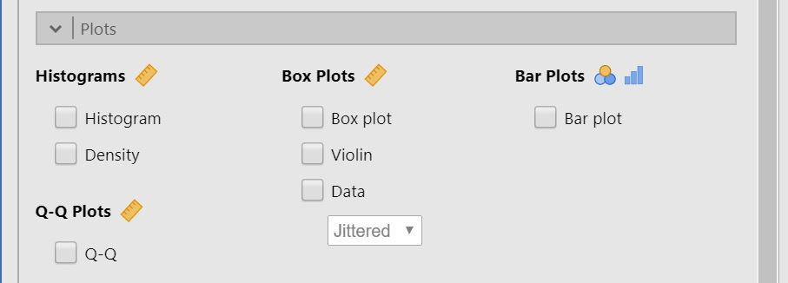

4. T-Test: Independent samples

How to perform an independent samples t-test in jamovi:
- You need one grouping variable with two levels (e.g. treatment/control) and one continuous outcome variable. Make sure that the measurement levels are set so that the grouping variable is marked with  and the continuous variable is marked with .
A correct setup should look similar to this:
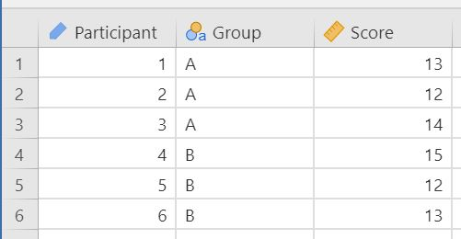
- Select Analyses -> T-Tests -> Independent Samples T-Test.
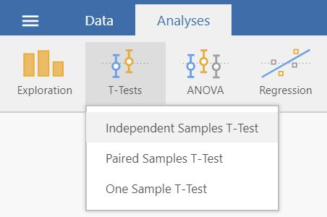
- Drag and drop your outcome variable to Dependent Variables and your grouping variable to Grouping Variable.
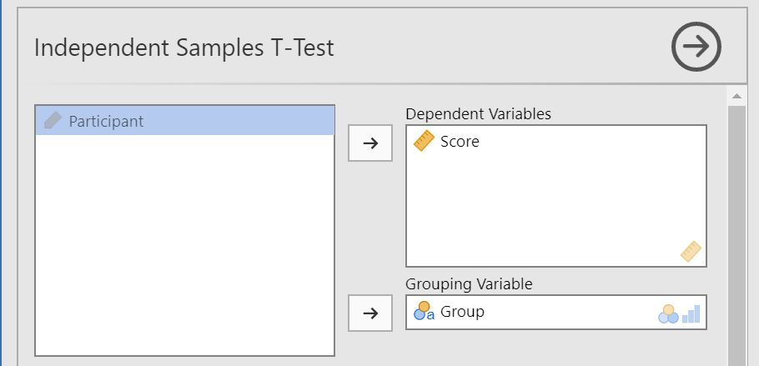
- The result is shown in the right panel

5. Linear Regression

How to perform a linear regression in jamovi:
- You need one predictor variable and one continuous outcome variable. Make sure that the measurement levels are set.
A correct setup should look similar to this:
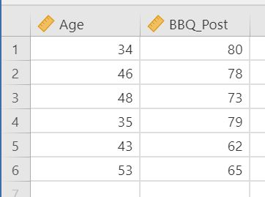
- Select Analyses -> Regression -> Linear Regression.
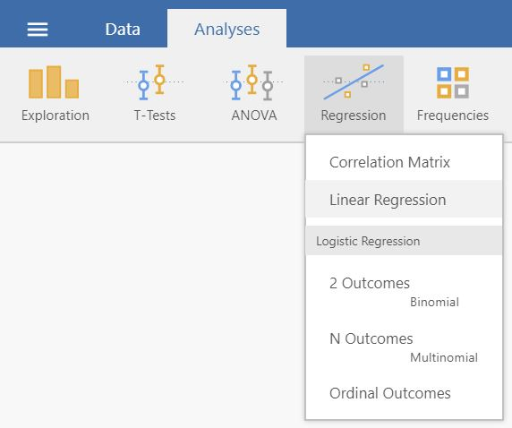

- Drag and drop your outcome variable to Dependent Variable and your predictor variable to Covariates if it is continuous or to Factors if it is categorical.
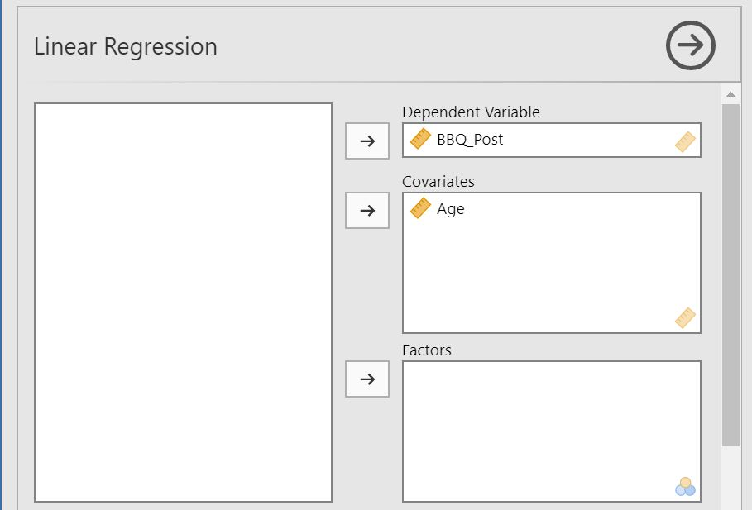
- The result is shown in the right pa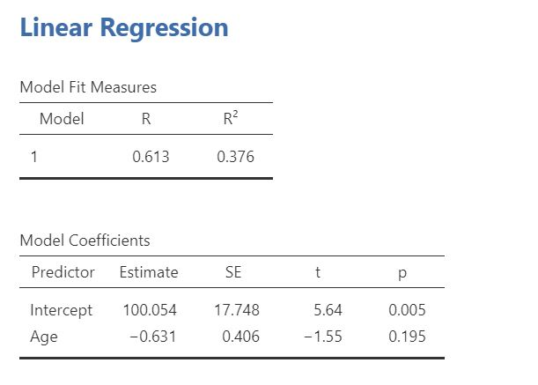
https://www.jamoviguide.com/index.html

Instructions for analysing the “Relational Benefit” survey
By Andrew Chan

- Exploratory factor analysis (Principal component or Principal axis) is used to identify the underlying dimensions of a construct.
- Cronbach's alphas are computed for each of the dimensions
- Summated scores are calculated for all dimensions which are used in the subsequent data analysis.
- Multiple regression analysis is used to examine the relative impact of individual dimensions on the dependent variable.

Open the data set “Relational benefits”
- Principal Component Analysis
- Select Analyses and click Factor > Principal Component Analysis
- Drag and drop q1 to q11 to the Variables box
- Click the Component summary button beneath the Additional output option
Component Loadings
 |  | Component
 |  | 1 |  | 2 |  | Uniqueness |  | Communalities  (1-uniqueness)
q1 |  |  |  | 0.800 |  | 0.360 |  | 0.64
q2 |  |  |  | 0.885 |  | 0.217 |  | 0.783
q3 |  |  |  | 0.902 |  | 0.182 |  | 0.818
q4 |  |  |  | 0.771 |  | 0.401 |  | 0.599
q5 |  |  |  | 0.518 |  | 0.730 |  | 0.27
q6 |  |  |  | 0.611 |  | 0.595 |  | 0.405
q7 |  | 0.870 |  |  |  | 0.235 |  | 0.765
q8 |  | 0.858 |  |  |  | 0.264 |  | 0.736
q9 |  | 0.921 |  |  |  | 0.145 |  | 0.855
q10 |  | 0.931 |  |  |  | 0.131 |  | 0.869
q11 |  | 0.900 |  |  |  | 0.186 |  | 0.814
Note. 'varimax' rotation was used
Communality refers to the amount of variance in an item that is accounted for by the factors together.

Component summary
Component |  |  | SS Loadings |  |  | % of Variance |  | Cumulative %
1 |  |  | 4.06 |  |  | 36.9 |  | 36.9
2 |  |  | 3.49 |  |  | 31.8 |  | 68.7
- Reliability Analysis
- Select Analyses and click Factor > Reliability
- Drag and drop q7 to q11 to the Variables box
Scale Reliability Statistics
 |  | Cronbach's α
scale |  | 0.938
- Click Factor > Reliability
- Drag and drop q1 to q6 to the Variables box
Scale Reliability Statistics
 |  | Cronbach's α
scale |  | 0.846
- Compute summated scores
- Select Data
- Scroll to the end of the data column and move the cursor to the first empty column
- Click Setup and click New computed variable
- Type the name of the new variable (the variable name you will assign to the scale score) in the Computed variable box (e.g. Factor 1).
- In the Function box click the (f_{x}) button. Scroll down under Statistics and double click MEAN. It should read, = MEAN( ) in the function box
- From the Variables box select the variables that are included in the scale by double clicking each variable to move it into the parentheses.
- Add a comma between each variable in the parentheses. Once you have confirmed this, press enter and you are finished. It should read, MEAN(q7,q8,q9,q10,q11) in the function box.

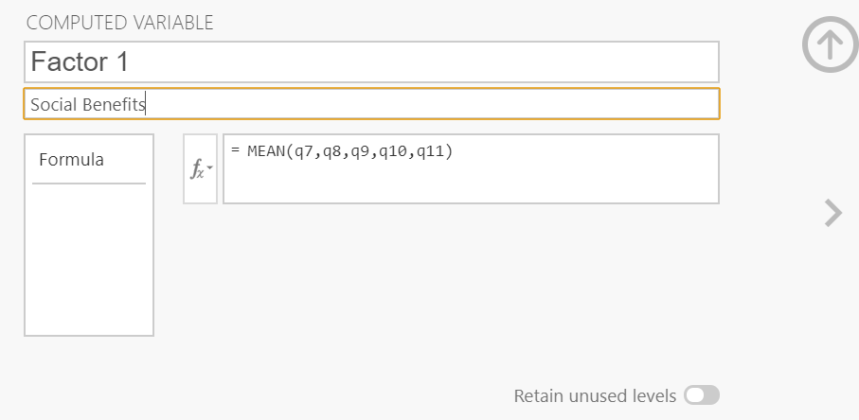
- Linger Regression

Equation: Social benefits + Confidence benefits sat

- Select Analyses and click Regression > Linear Regression
- Drag and drop sat to the Independent variables box
- Drag and drop Social Benefits and Confidence Benefits to the covariates box
- Click the Model fit submen and click the F test button beneath the Model fit option
- Click the Model coefficients submenu and click the Standardized estimate button beneath the Standardized estimate option
Model Fit Measures
 |  |  |  |  |  |  |  | Overall Model Test
Model |  | R |  | R² |  |  |  | F |  |  |  | df1 |  | df2 |  |  |  | p
1 |  | 0.305 |  | 0.0932 |  |  |  | 5.14 |  |  |  | 2 |  | 100 |  |  |  | 0.007
Model Coefficients - sat
Predictor |  |  |  |  |  | Estimate |  |  |  |  | SE |  |  |  |  | t |  |  |  | p |  |  |  | Stand. Estimate
Intercept |  |  |  |  |  | 3.3875 |  |  |  |  | 0.6332 |  |  |  |  | 5.350 |  |  |  | < .001
Social_Benefits |  |  |  |  |  | 0.0515 |  |  |  |  | 0.0859 |  |  |  |  | 0.600 |  |  |  | 0.550 |  |  |  | -0.0575
Confidence_Benefits |  |  |  |  |  | 0.4035 |  |  |  |  | 0.1261 |  |  |  |  | 3.200 |  |  |  | 0.002 |  |  |  | 0.3071

Equation: Social benefits + Confidence benefits beh

- Select Analyses and click Regression > Linear Regression
- Drag and drop sat to the Independent variables box
- Drag and drop Social Benefits and Confidence Benefits to the covariates box
- Click the Model fit submen and click the F test button beneath the Model fit option
- Click the Model coefficients submenu and click the Standardized estimate button beneath the Standardized estimate option
Model Fit Measures
 |  |  |  |  |  | Overall Model Test
Model |  | R |  | R² |  | F |  | df1 |  | df2 |  | p
1 |  | 0.363 |  | 0.132 |  | 7.59 |  | 2 |  | 100 |  | < .001

Model Coefficients - Beh
Predictor |  | Estimate |  | SE |  | t |  | p |  | Stand. Estimate
Intercept |  | 2.295 |  | 0.5640 |  | 4.07 |  | < .001
Social_Benefits |  | 0.152 |  | 0.0765 |  | 1.98 |  | 0.050 |  | 0.186
Confidence_Benefits |  | 0.346 |  | 0.1123 |  | 3.08 |  | 0.003 |  | 0.289

- Confirmatory Factor Analysis
- Select Analyses and click Factor > Confirmatory factor analysis
- Drag and drop q7 to q11 to the Factor 1 box; rename Factor 1 as “Social Benefits”
- Click the + Add new factor box
- Drag and drop q1 to q6 to the Factor 2 box; rename Factor 2 as “Confidence Benefits”
- Click the Estimates submenu and click the standardized estimate button beneath the Statistics option
Factor Loadings
Factor |  | Indicator |  | Estimate |  | SE |  | Z |  | p |  | Stand. Estimate
Social Benefits |  | q7 |  | 1.097 |  | 0.1123 |  | 9.77 |  | < .001 |  | 0.805
 |  | q8 |  | 1.046 |  | 0.1123 |  | 9.31 |  | < .001 |  | 0.779
 |  | q9 |  | 1.285 |  | 0.1048 |  | 12.27 |  | < .001 |  | 0.925
 |  | q10 |  | 1.073 |  | 0.0853 |  | 12.58 |  | < .001 |  | 0.938
 |  | q11 |  | 1.231 |  | 0.1059 |  | 11.63 |  | < .001 |  | 0.896
Confidence Benefits |  | q1 |  | 0.912 |  | 0.1058 |  | 8.61 |  | < .001 |  | 0.749
 |  | q2 |  | 0.962 |  | 0.0844 |  | 11.39 |  | < .001 |  | 0.900
 |  | q3 |  | 0.904 |  | 0.0773 |  | 11.68 |  | < .001 |  | 0.914
 |  | q4 |  | 0.747 |  | 0.0985 |  | 7.58 |  | < .001 |  | 0.679
 |  | q5 |  | 0.346 |  | 0.0926 |  | 3.73 |  | < .001 |  | 0.371
 |  | q6 |  | 0.608 |  | 0.1066 |  | 5.70 |  | < .001 |  | 0.538
Model fit
Test for Exact Fit
χ² |  |  | df |  |  | p
68.4 |  |  | 43 |  |  | 0.008
Fit Measures
 |  |  |  |  |  |  |  |  |  |  |  |  |  | RMSEA 90% CI
CFI |  |  |  | TLI |  |  |  | SRMR |  |  |  | RMSEA |  | Lower |  | Upper
0.967 |  |  |  | 0.958 |  |  |  | 0.0538 |  |  |  | 0.0758 |  | 0.0391 |  | 0.108

Factor Covariances
 |  |  |  | Estimate |  | SE |  | Z |  | p |  | Stand. Estimate
Social Benefits |  | Social Benefits |  | 1.000 | ᵃ
 |  | Confidence Benefits |  | 0.115 |  | 0.104 |  | 1.11 |  | 0.268 |  | 0.115
Confidence Benefits |  | Confidence Benefits |  | 1.000 | ᵃ
ᵃ fixed parameter
Additional resources:
Quick start: https://www.jamoviguide.com/index.html
Advanced topics: https://lsj.readthedocs.io/en/latest/lsj/Introduction.html
Watch "Confirmatory factor analysis- jamovi" on YouTube https://youtu.be/2LzoRo3sziU

