The legacy of an automated and connected
lathe

Contents
- Introduction
1.1 What is industry 4.0?
- Presentation and operation of the proposed model

2.1 Way of operation

3. Industry 4.0 review
3.1 The first industrial revolution
3.2 The second industrial revolution
3.3 The third industrial revolution
3.4 The fourth industrial revolution
4.. The Internet of Things (IoT)
5. Big Data & Analytics
6. Conclusions

- Introduction

The chosen theme has the basic desire to automate a lathe with numerical control to facilitate the work of operators, to reduce labor costs and material handling, but also to significantly increase productivity. Selected solutions can be used on other machine tools, if they have flat, vertical and magnetic clamping tables. Another condition would be that the machine tools be equipped with numerical control equipment. The introduction of the lathe in so called "Industry 4.0" will leave a long-lasting legacy.

1.1What is industry 4.0?
Industry 4.0 refers to a new phase of the Industrial Revolution, which focuses largely on interconnectivity, automation, machine learning and real-time data. Industry 4.0, also called IIoT or intelligent production, interconnects production and physical operations with intelligent digital technology, machine learning and real data producing a strongly interconnected holistic ecosystem to which companies and organizations of the third millennium begin to migrate. This phenomenon is due to the need to connect and access real-time information about processes, partners, products and people, thus necessitating any form of social organization.[1] (Epicor, n.d.)
The term Industry 4.0 also called intelligent production, or the fourth industrial revolution. It refers to the digital interconnection of all entities involved in a system, creating an autonomous, intelligent system, whose participants operate individually, and which are connected to the network. System components can be programmed, or can receive commands, even wirelessly, from a control center. Industry 4.0 provides, among other things, the computerization of production equipment and logistics for real-time communication between machines, but also with people, with the help of several devices that are connected to the Internet. Technologies such as "Internet of Things" or "Cloud Computing" have been introduced in industry 4.0 to facilitate machine communication. Industry 4.0 is therefore a high-tech modernization strategy of the industry. The vertical lathe must therefore be extremely high-performance, in order to meet the 4.0 industrial requirements. It must operate autonomously, and the human operator must intervene only if necessary, such as when a fault occurs, or when he must change toolkits. For the lathe to meet the requirements of the future many sensors and an Internet connection are needed.
2. Presentation and operation of the proposed model

The automatic lathe aims to process medium-sized parts, whose outer diameter does not exceed diameters greater than 500mm and their mass does not exceed 50 kg. The lathe is equipped with a rotating magnetic plate, two revolver heads on which different tools can be mounted, several conveyor mechanisms for feeding and evacuation of semi-finished products and a portal-type robotic structure for automatic tool change or tool storage in the tool magazine, after they have been partially or completely changed. The control panel has been removed because the lathe will be controlled wirelessly by various devices, such as: tablets, mobile phones (smartphones), laptops, or maybe controlled and monitored from a control center inside the factory.

2.1. Way of operation
The semi-finished product to be processed is brought onto the turntable magnetic with the help of the supply / discharge system that is on the conveyor belt. The semi-finished product which has been processed is discharged into identical to a supply / exhaust system, which is also mounted on a conveyor with tape. It is transported to the next machine tool or to another workstation, where it will be further processed. After the semi-finished product has been processed, it is automatically transferred to the next one workstation, which can be for example a grinding machine. This factory also includes areas such as: heat treatment, quality control, assembly, storage and a dispatch from where they are to be sold or delivered to the customer. the whole route can be done with conveyor belts and moved with robots. See below an example of a smart factory (Figure 1.) (www.istockphoto.com, n.d.)
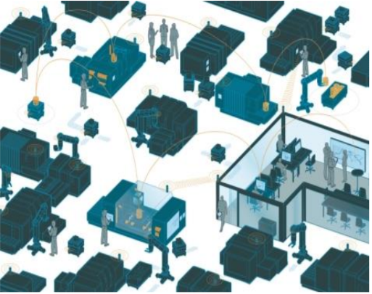 Figure 1 Example of a Smart Factory

3.Industry 4.0 review
All this would not be possible without the existence of what is today "Industry 4.0".
3.1 The first industrial revolution began in the 18th century with the use of steam power and production mechanisms. Their use for industrial purposes was the greatest discovery that increased people's productivity. Instead of weaving workshop driven by human brute force, steam engines could be used to drive. Other advances, such as the steamship or (approx. 100 years later) the steam locomotive, brought massive changes because people and goods could travel long distances in fewer hours. The beginning of the steam traction is made by the company "Watt and Boulton" from Soho (near Birmingham), the largest steam engine factory of the time and which inaugurates, in 1775, the first steam locomotive in the world for narrow gauge railway, the locomotive known as the 'Tram Engine', which was built by James Watt, William Murdoch and Richard Trcvithich. The further development of rail transport is also a synthesis of discoveries and improvements in the manufacture of steel and steam engine.
3.2The second industrial revolution began in the 19th century with the discovery of electricity and the implementation of production on the assembly line. Henry Ford (1863–1947) took up the idea of ​​mass production from a slaughterhouse in Chicago: Pigs were suspended from conveyor belts, and each butcher made only a certain part of the animal's slaughter process. Henry Ford took these principles and implemented them in car production, making drastic changes in this regard. While in the past a station assembled an entire vehicle, now the vehicles were produced in partial stages on the conveyor belt - much faster and at lower costs.
3.3The third industrial revolution began in the 1970s, with partial automation, the use of controls and programmable memory computers. Since the introduction of these technologies, we can now automate an entire production process - without human assistance. Well-known examples of this include robots that perform programmed sequences without human intervention.
3.4The fourth industrial revolution is currently being implemented. It is characterized by the application of information and communication technology at the industrial level and is also called "Industry 4.0". It develops based on the progress brought about by the third industrial revolution. Production systems that already use information technology are expanded through a network connection and, in other words, have a digital duplication on the Internet. They allow communications with other units and the generation of information about them. This is the next step in automating production. The interconnection of all systems leads to "physical cyber production systems" and therefore we benefit from such intelligent factories, where production systems, components and people communicate through a network and production is almost autonomous.
The fourth industrial revolution - or Industry 4.0 - is transforming the economies, jobs and even society in which we live today. Technologies of all kinds, especially digital ones, combine to use data analysis, artificial intelligence, cognitive technologies and the Internet of Things (IoT) to create digital enterprises that are not only interconnected, but perfectly capable of making informed decisions. In short, this revolution incorporates intelligent, interconnected technologies, transcending organizations and interfering with our daily lives.[3] (Wikipedia, n.d.)
4.The Internet of Things (IoT) refers to the billions of devices around the world that are connected to the Internet, collecting and exchanging data. From toothbrushes to machines, commercial and industrial devices are equipped with chips through which they collect and communicate various information.
From a commercial point of view, many of these objects aim to improve what is known as Quality of Life (QoL), easing people's daily responsibilities. However, they include various less useful devices such as: Egg Minder (a tray that tells you how many eggs you have and how fresh they are) or Shuttereaze (a device that pulls curtains or blinds automatically).
On the other hand, at the industrial level, the interconnection of machinery and apparatus is revolutionizing the market. According to a Gartner (Gartner, 2016) report, more than 50% of new businesses will incorporate elements of the Internet of Things.
The combination of device connectivity with systems automation allows the collection of information, its analysis and, implicitly, deciding based on it. IoT can help a person accomplish a task. Moreover, IoT offers devices the opportunity to communicate not only in a private network, but also between different types of networking, thus creating an interconnected world.
A study also conducted by the Gartner Institute shows that in 2017, 8.4 billion devices belonging to the Internet of Things were used. This represents an increase of 31% compared to 2016, the study also showing that by 2021, their number will reach 20.4 billion. Of the 8.4 billion, more than half are products such as smart TVs and smart audio systems. According to the same study, the most widely used devices in the industry are smart electric scales and security cameras. (iot-analytics, 2020)[4]

IoT devices 1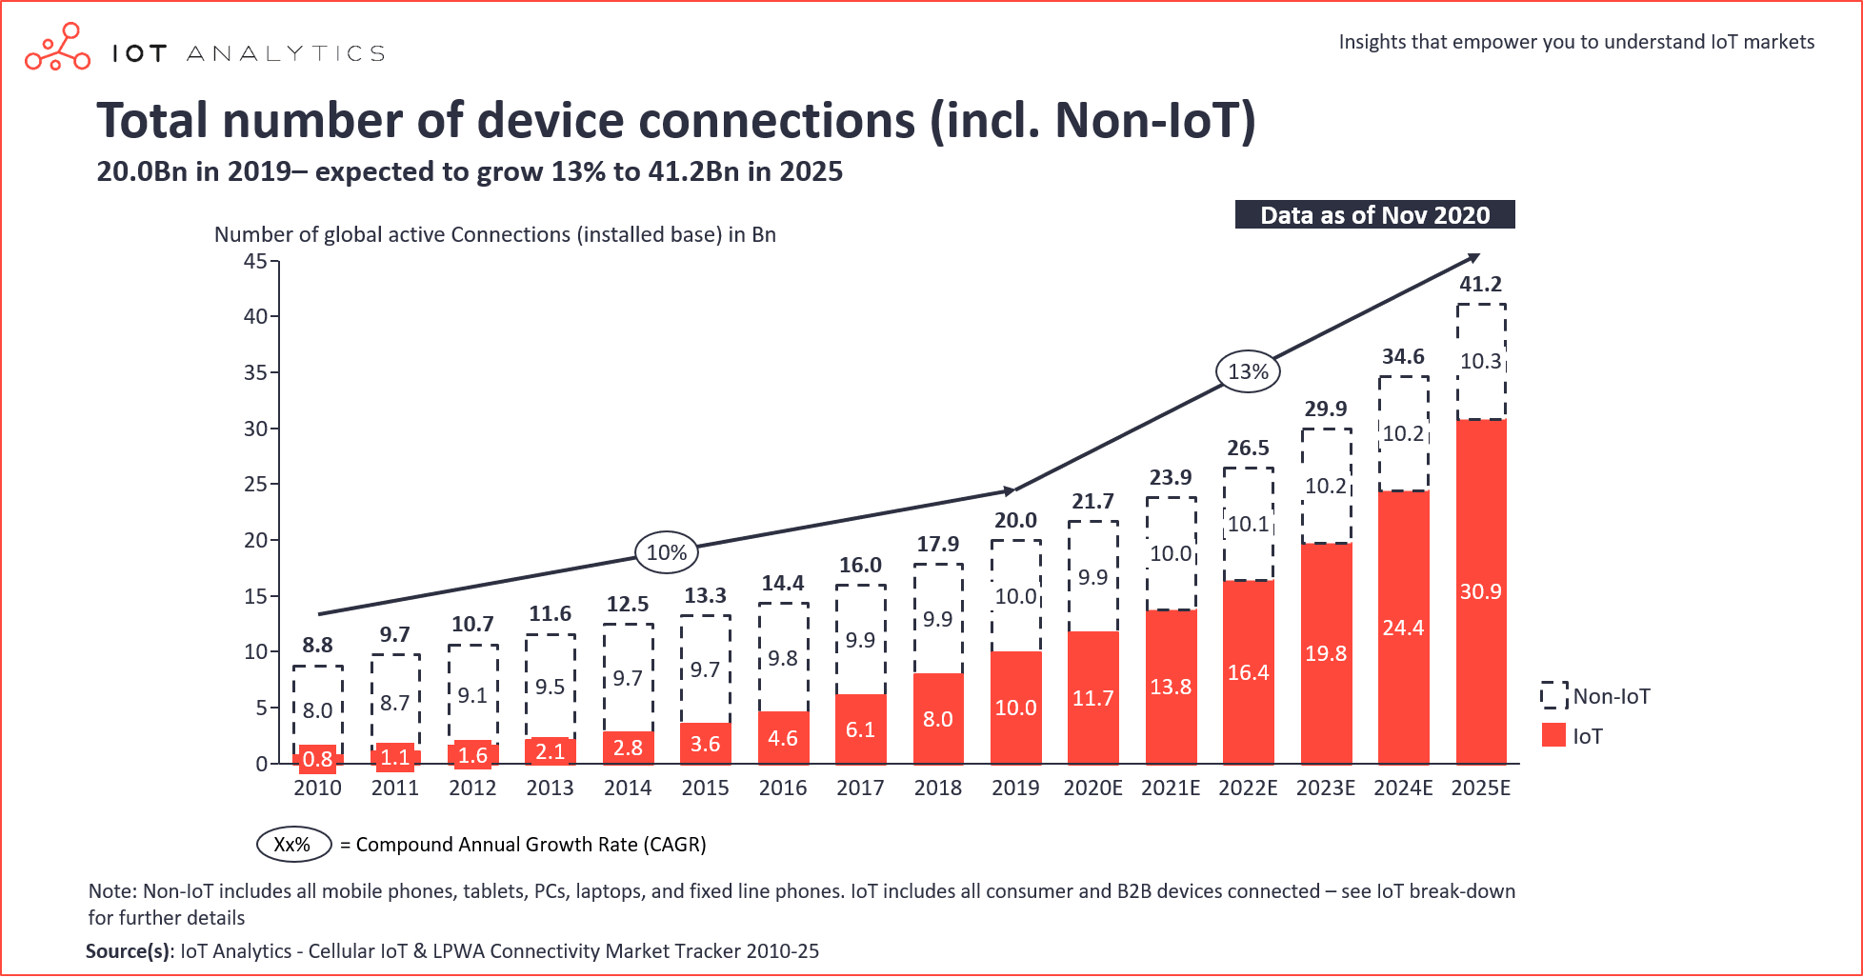
Figure 2 (iot-analytics, 2020)

5. Big Data & Analytics

Big Data has become the spearhead in terms of innovation and competitiveness, providing challenges but also opportunities in the global IT landscape. Collecting, processing and analysing large volumes of data can significantly help business decision making and create competitive advantages for those who choose the right Big Data solutions. The technologies used in Big Data have experienced an accelerated development due to the increasing demand of applications that generate and process large volumes of data. Cloud Computing and IoT are also the main drivers for developing solutions for business organizations that support Business Intelligence.
The research (Oussous, 2018) presents one of the latest development studies for Big Data, in order to help select and adopt the right combination of different Big Data technologies according to their technological needs and requirements. specific applications. They offer not only an overview of the main Big Data technologies, but also comparisons according to the different levels of the system, such as the level of data storage, the level of data processing, the level of data query, the level of data access and management, where the classification and characteristics of the main technologies, advantages, limitations and uses are presented. The end of the last decade finds us at a time when technological evolution, the Internet, interconnected networks have become an integral part of our lives. The impact of digitalization and the importance of cyberspace has grown exponentially in recent years. A very large percentage of the world's population, companies and countries around the world have connected in this space and are increasingly dependent on increasingly complex information and communication technology systems. The flow of information knows no borders, and the volume of data and information has grown very fast. The business environment, state institutions, transport, public safety, health, communications, banking financial system, emergency services, utilities, national defence, components of modern society, depend on the proper functioning of information technologies, the operation of critical information structures, the availability, integrity and confidentiality of information.
6.Conclusions

Regardless of the production sector we are talking about, technological innovation is essential for the future of any successful business. Industry 4.0 represents the new wave in the technological evolution of production, pushing more and more companies to meet the new standards set by a constantly changing market, by transforming production units into "smart factories". This aspect involves the use of software that allows the integration of CNC (Computer Numerical Control), the use of IoT technologies, Big Data & Analytics and the interconnection of systems used in factories.
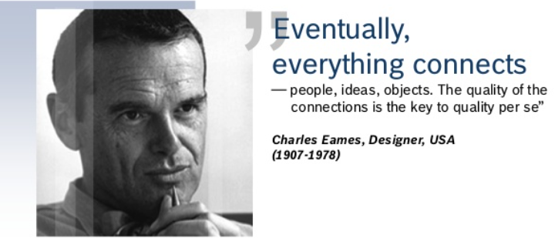[Online] (www.slideshare.net, n.d.)

It is human nature to improve and simplify things as much as possible. With all the technology available today, nothing seems to be impossible anymore. Industry 4.0 is booming, bringing many questions, not only of a technical or economic nature, but also related to social life. Where will it end up if all processes are automated? Who will do the work if the cars do everything? The list of questions continues, implying the that smart factories will first and foremost have a very strong social impact.

References
Epicor, n.d. http://www.epicor.com/en-us/resource-center/articles/what-is-industry-4-0/. [Online].
Gartner, 2016. https://www.gartner.com/en/newsroom/press-releases/2016-01-14-gartner-says-by-2020-more-than-half-of-major-new-business-processes-and-systems-will-incorporate-some-element-of-the-internet-of-things. [Online].
iot-analytics, 2020. https://iot-analytics.com/wp/wp-content/uploads/2020/11/IoT-connections-total-number-of-device-connections-min.png. [Online].
Oussous, A., 2018. https://fardapaper.ir/mohavaha/uploads/2018/12/Fardapaper-Big-Data-technologies-A-survey.pdf. [Online].
Wikipedia, n.d. https://en.wikipedia.org/wiki/Fourth_Industrial_Revolution. [Online].
www.istockphoto.com, n.d. https://www.istockphoto.com/search/2/image?phrase=smart+manufacturing. [Online].
www.slideshare.net, n.d. https://www.slideshare.net/stefferber/business-ecosystems-in-the-factory-of-the-future. [Online].

