Francois Riches (2318399)

Research, Build, & Deploy a
Virtualised Enterprise Network

Module: Network Operating Systems and Services
Module Code: ACCA5023
Bachelor of Science: Computing (Software Engineering)
Contents
Research Report 2
Hypervisors 2
Hypervisors Type1 & Type 2 2
Choice of Hypervisor 2
IP Addressing 3
IPv4 Addressing 3
IPv6 Addressing 4
Internet Scalability 4
Routing 4
Network Services 5
Dynamic Host Configuration Protocol 5
Active Directory Domain Services 5
Certificate Authority 5
Virtual Private Networks 5
Network Implementation 6
Network Plan 6
Hypervisor 6
Downloading 7
Setup Devices 9
Configure IP Addressing 12
Ping Testing 13
Trouble Shooting the Firewall 19
Reflecting on the assignment 21
Technical Reflection 21
Personal Reflection 21
References 22

Research Report

Hypervisors
Hypervisors are the management and monitoring tool for virtual machines (VM). They distribute resources and manage I/O between the VM and the hardware (or host Operating System ‘OS’). This functionality helps prevent multiple VMs trying to access the exact same hardware resources at the same time [1, pp. 18-33] [2, pp. 595-597] [3, pp. 165-168].

Hypervisors Type1 & Type 2
Type 1 hypervisors are layered directly onto the hardware (see figure 1). This allows for them to allocate resources faster, respond to I/O requests more efficiently, and improves security and stability by removing the additional OS layer. If one VM crashes or is corrupted the other VMs on the type 1 hypervisor will continue to work [1, pp. 18-33] [2, pp. 595-597] [3, pp. 165-168].
Type 2 hypervisors are layered onto the OS (see figure 2). The type 2 hypervisor is required to communicate resource or I/O requests through the OS which in turn requests it from the hardware. If the host OS crashes or is corrupted, all the VMs running on the type 2 hypervisor will also fail [1, pp. 18-33] [2, pp. 595-597] [3, pp. 165-168].
Figure 1: Type 1 Hypervisor [1, p. 22] Figure 2: Type 2 Hypervisor [1, p. 23]
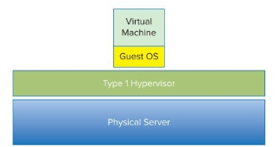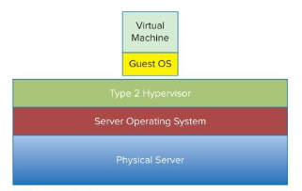
Choice of Hypervisor
For the lab work topology, the type 2 hypervisor will be the better choice. Taking into consideration the facilities available in the lab, it is preferred to use the type 2 since it functions on top of the OS layer, much like any other application. The benefits of the Type 1 (which I would recommend for the NOSS2026 corporation, to secure and stabilise their network services in isolation) will not be of much benefit in the lab.

IP Addressing
A simplified explanation of Internet Protocol (IP) addresses is that they uniquely identify both a host device and the network to which it is connected, often compared to the address written on an envelope when sending mail (See figure 3). The IP addresses of both the sender and recipient are included in the header of a data packet ready for routing [4, pp. 3-7].
Figure 3: The postal service comparison [4, pp. 4-5]
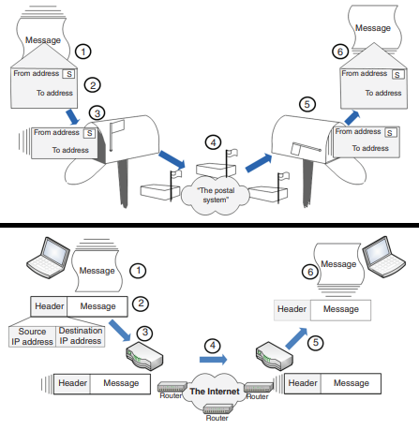

IPv4 Addressing
IPv4 addresses are 32-bit numbers divided into four octets (0–255), split into a network portion identifying the network and a host portion identifying devices. A subnet mask defines these portions, for example, 192.168.0.1 with 255.255.255.0 (/24) assigns 192.168.0 to the network and .1 to the host, allowing 254 devices. Subnetting can further divide the host portion into smaller networks for easier internal management.[4, pp. 3-50].
Figure 4: Splitting of the IPv4 Address [4, p. 36]
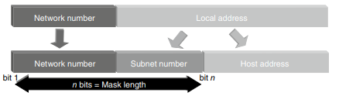

IPv6 Addressing
IPv6 uses 128-bit addresses, written as eight groups of four hexadecimal digits separated by colons. It provides a vastly larger address space, supports virtually unlimited subnets, simplifies routing, and enables long-term Internet scalability [4, pp. 3-50].

Internet Scalability
At 4.3 billion addresses it was assumed that IPv4 was sufficient. Yet with more home computers, business servers, phones, and the internet of things (IoT) the number of devices has vastly increased.
Solutions:
- Classless Inter-Domain Routing (CIDR)
Enables flexible, classless allocation of addresses and reduces routing table size.
- Network Address Translation
Allows multiple private devices to share a single public IPv4 address, extending the usable address space.
- IPv6
Utilises 128-bit addresses, eliminating IPv4 limitations, providing virtually unlimited devices and subnets, and simplifying routing.
[4, pp. 3-50] [5, p. Chapter 1]

Routing
Data transmitted over a network is segmented into packets and assigned source and destination IP addresses. When a device sends traffic outside its local area network (LAN), the packet is forwarded to the default gateway, which is typically a router or a device acting as one. Routers enable communication between different networks. They examine the destination IP address of each packet and use a routing (forwarding) table to determine the next hop. The packet is then passed between routers until it reaches the router connected to the destination network, which forwards it to the target device [5, p. Chapter 1] [6].
Routing can be configured using either static or dynamic methods. Static routing involves manually defining routes in a routing table, making it simple and predictable but less adaptable to change. Dynamic routing uses routing protocols such as OSPF or RIP, allowing routers to automatically discover networks and update routes [6].

In this topology, which consists of two internal subnets connected via a Debian server and a Windows server, static routing is appropriate. The network is small and stable, and manually configured routes are sufficient to support communication and DHCP relay functionality.

Network Services

Dynamic Host Configuration Protocol
Dynamic Host Configuration Protocol (DHCP) automatically assigns IP addresses and other network settings, such as the default gateway and domain name system (DNS) server, to client devices [2, pp. 82-83] [4, p. 25].

Active Directory Domain Services
Active Directory Domain Services (AD DS) creates domains that act as a centralised container for organisational resources, including user accounts and devices. Within a domain, administrators can manage authentication, access permissions, and security policies. This allows consistent configuration and simplified management across multiple systems [2, pp. 171-173] [3, pp. 105-107] [7].

Certificate Authority
A Certificate Authority (CA) issues digital certificates that enable secure communication and authentication. Makes use of public key infrastructure (PKI) [2, p. 80] [3, p. 137].

Virtual Private Networks
A Virtual Private Network (VPN) allows users to securely access a private network over the internet by creating a virtual point-to-point connection between two devices. It uses tunnelling protocols and encryption algorithms to protect data while it is transmitted across public networks [3, pp. 141-142].

Network Implementation

Network Plan
Figure 5: Topology Plan for network.
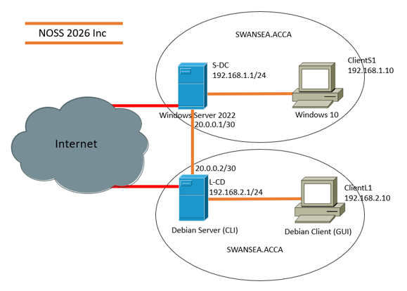
The plan includes two local networks, each consisting of a server connected to a client. The servers in each network are also connected to each other directly using a point-to-point connection, identified by the use of the /30 subnet mask.
Below is a table of the adjusted IP addresses and subnet masks used. This was done to improve on the original plan and will be explained throughout the document.
IP Configuration Plan
Connection | Device | IP Address | Subnet Mask | Default Gateway
IntSwa | S-DC | 192.168.1.1 | 255.255.255.192 | N/A
IntSwa | ClientS1 | 192.168.1.2 | 255.255.255.192 | 192.168.1.1
IntLdn | L-CD | 192.168.2.1 | 255.255.255.192 | N/A
IntLdn | ClientL1 | 192.168.2.2 | 255.255.255.192 | 192.168.2.1
External | S-CD | 20.0.0.1 | 255.255.255.252 | N/A
External | L-CD | 20.0.0.2 | 255.255.255.252 | N/A

Hypervisor
The Oracle VirtualBox [4] type 2 hypervisor was chosen for the task of creating this network due to its function in the lab environment. The VirtualBox acts as a piece of software on the lab computers enabling other applications to function alongside it. The additional benefits of a type 1 hypervisor such as stability/security through segmentation and direct utilising of hardware resources were not a necessity.

Downloading
The network was created in two parts, one using Windows operating systems (OS), and the other using Debian OS. For these required installations, Oracle VirtualBox (pre-installed on the lab devices), Windows Server 2022 (ISO), Windows 11 enterprise (ISO), and Debian (ISO), were all downloaded from the sites listed below.
Downloads
Oracle VirtualBox [4] | www.virtualbox.org
Windows Server 2022 (ISO) [5] | www.microsoft.com/en-us/evalcenter/evaluate-windows-server-2022
Windows 11enterprise (ISO)  [6] | www.microsoft.com/en-us/evalcenter/evaluate-windows-11-enterprise
Debian (ISO) [7] | www.debian.org/distrib

Timestamps: The images for the download sites below have the timestamps for the date of the 26th. However, the original downloads were done on the 5th with additional downloads done on the 19th for the Debian network.
Figure 6: VirtualBox download page [4] (Timestamp Included)
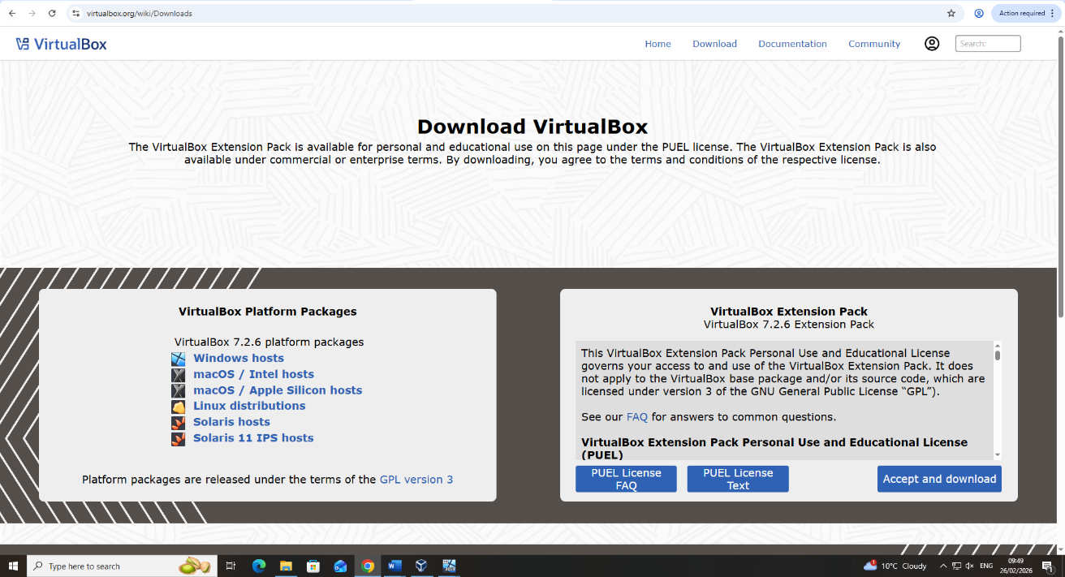
Figure 7: Windows Server 2022 download page [5] (Timestamp Included)
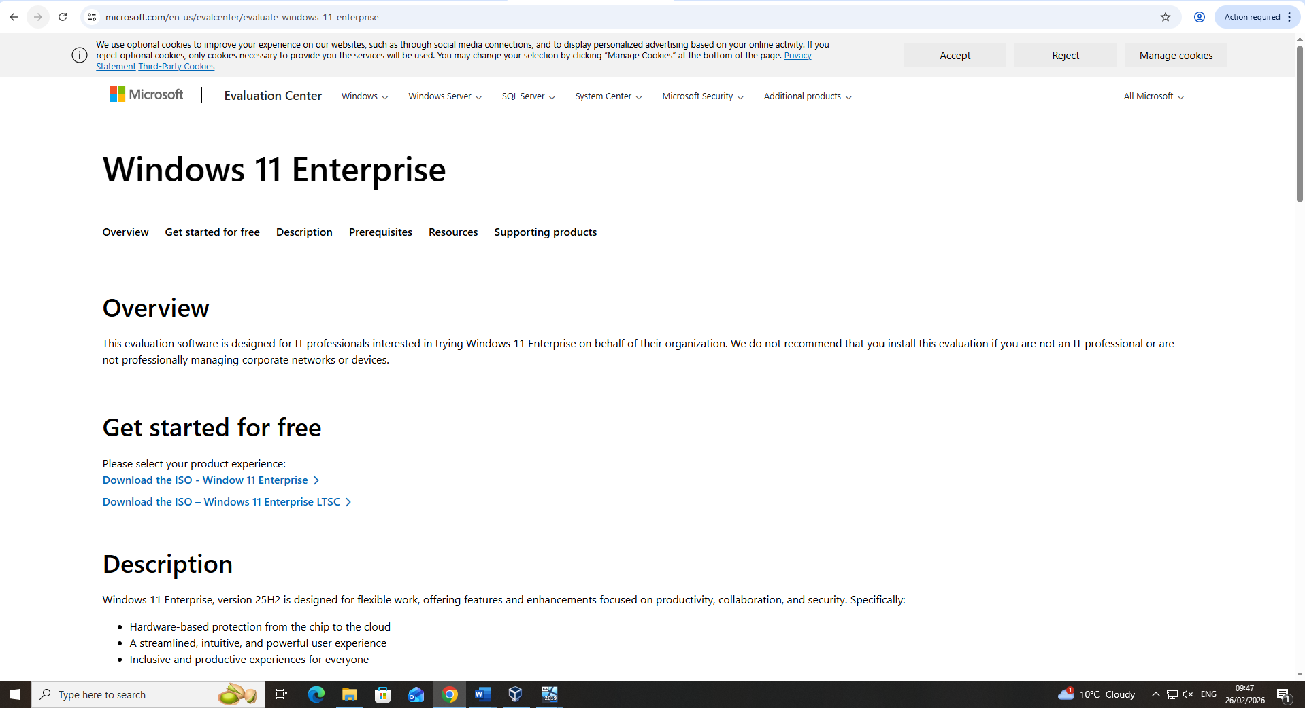

Figure 8: Windows 11 Enterprise download page [6] (Timestamp Included)
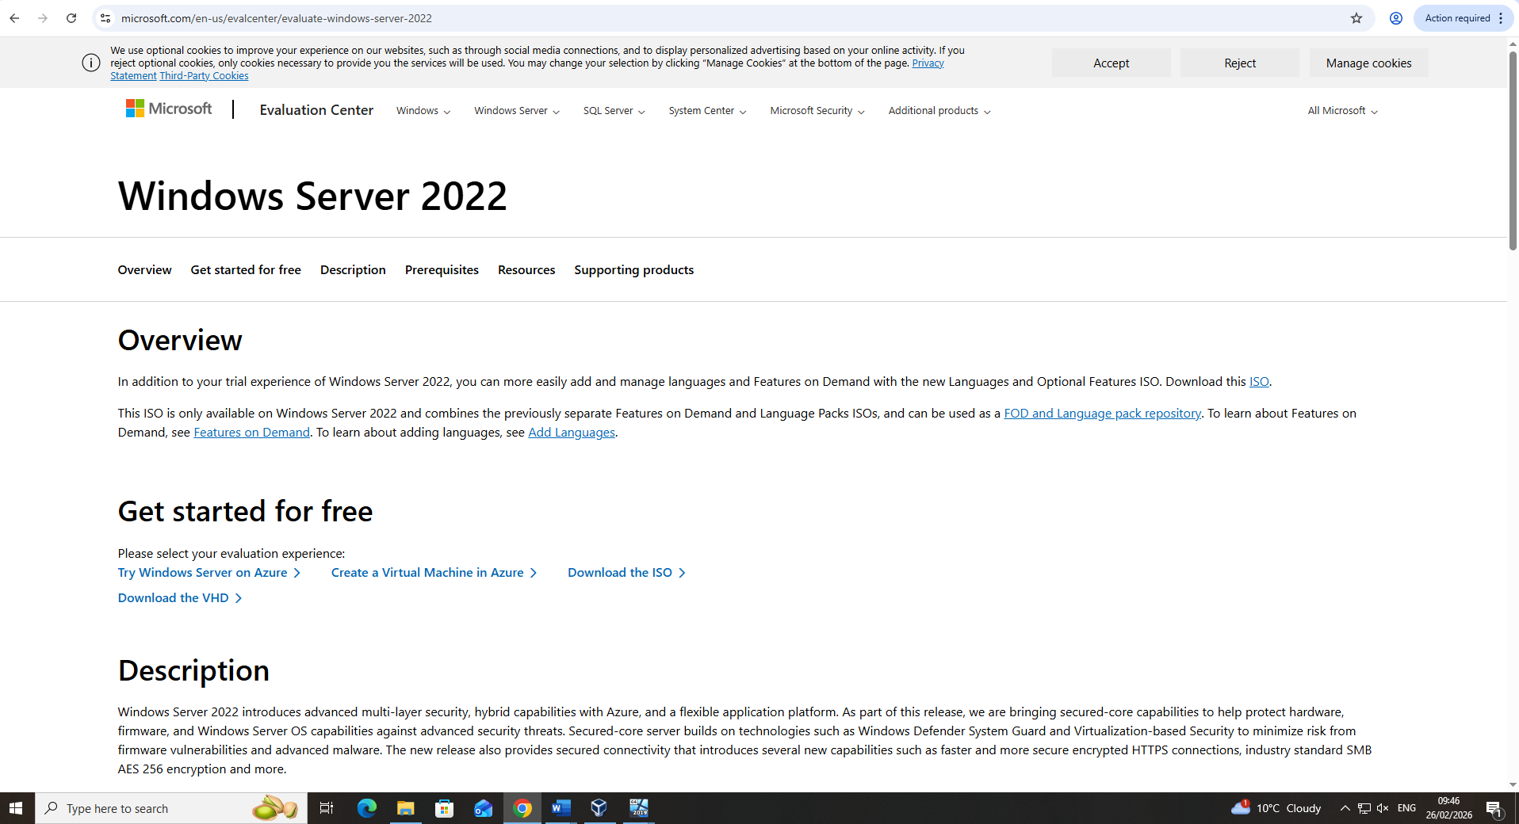
Figure 9: Debian download page [7] (Timestamp Included)
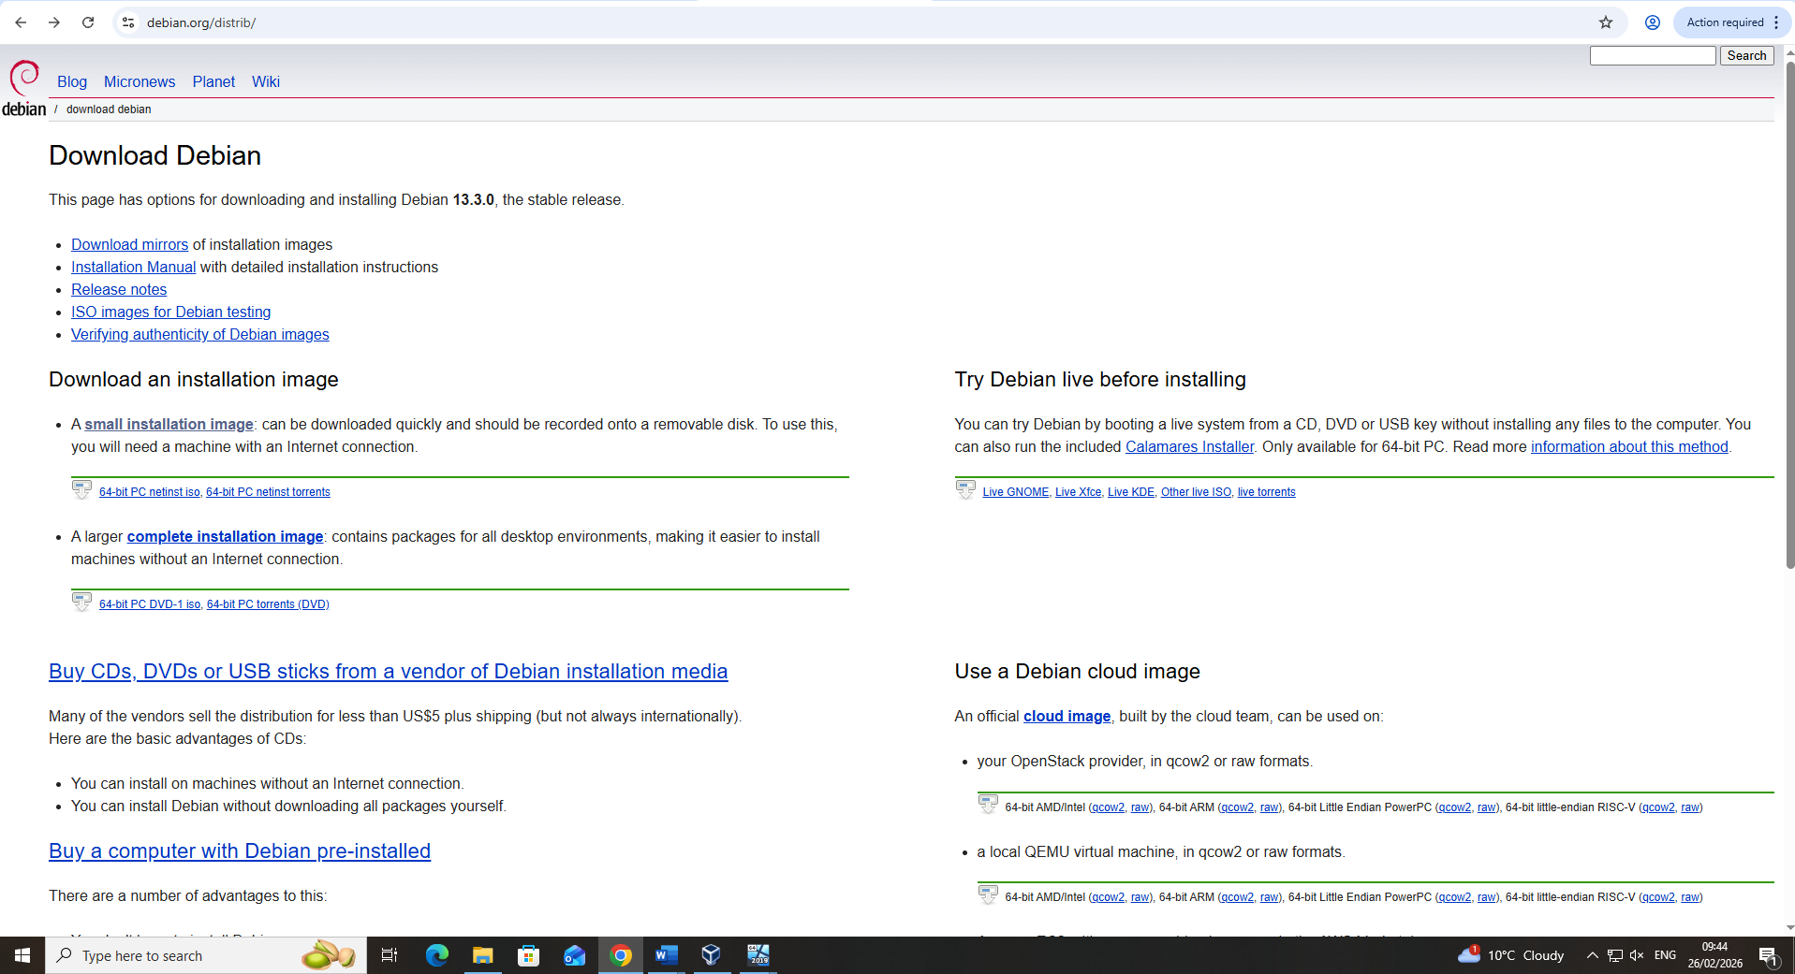

Setup Devices
Virtual machines are set up as per requirements, the amount of network adapters, naming conventions, and hardware allocation can all be seen in the table and images below.
VM Setup and Statistics
Device Name /OS | Network Adapters | RAM | Storage | Processing Cores
S-DC  Win. server  2022 | 1: NAT  2: IntSwa  3: External | 8192MB | 80GB | 4
ClientS1  Win. 11 | 1: NAT  2: IntSwa | 4096MB | 40GB | 2
L-CD  Debian ‘server’ | 1: NAT  2: IntLon  3: External | 2048MB | 20GB | 2
ClientL1  Debian  ‘GUI’ | 1: NAT  2: IntLon | 2048MB | 20GB | 2

Figure 10: Changing the name of the Windows Server. Installed RAM and disk space can be seen. (Timestamp included)
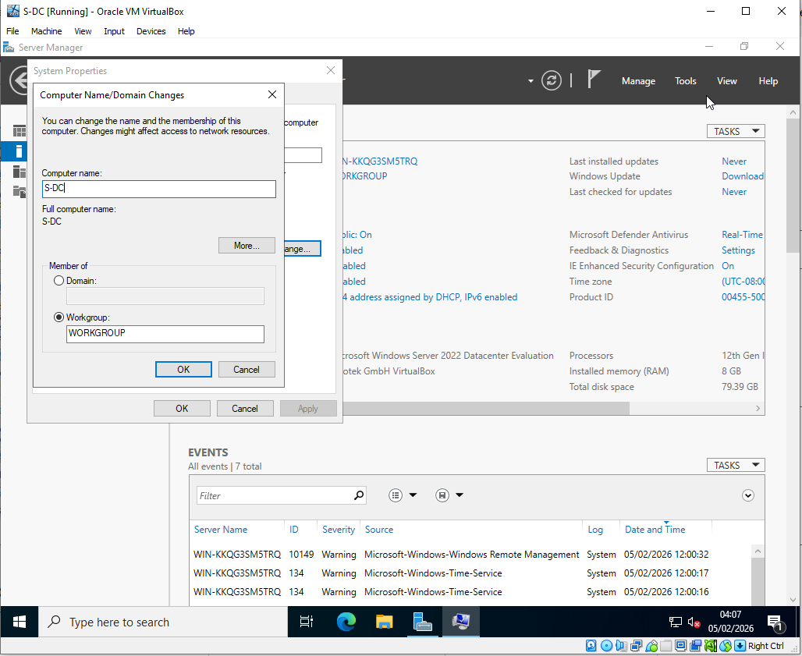
Figure 11: Creation of the Windows 11 Enterprise VM. Device name, RAM, processors, and disk space can be seen.
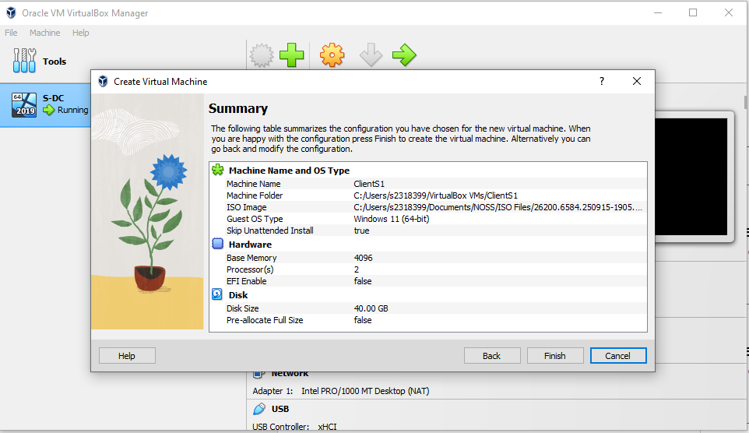

Figure 12: Debian client GUI settings: Changing the device name ‘ClientL1’ (Timestamp Included)
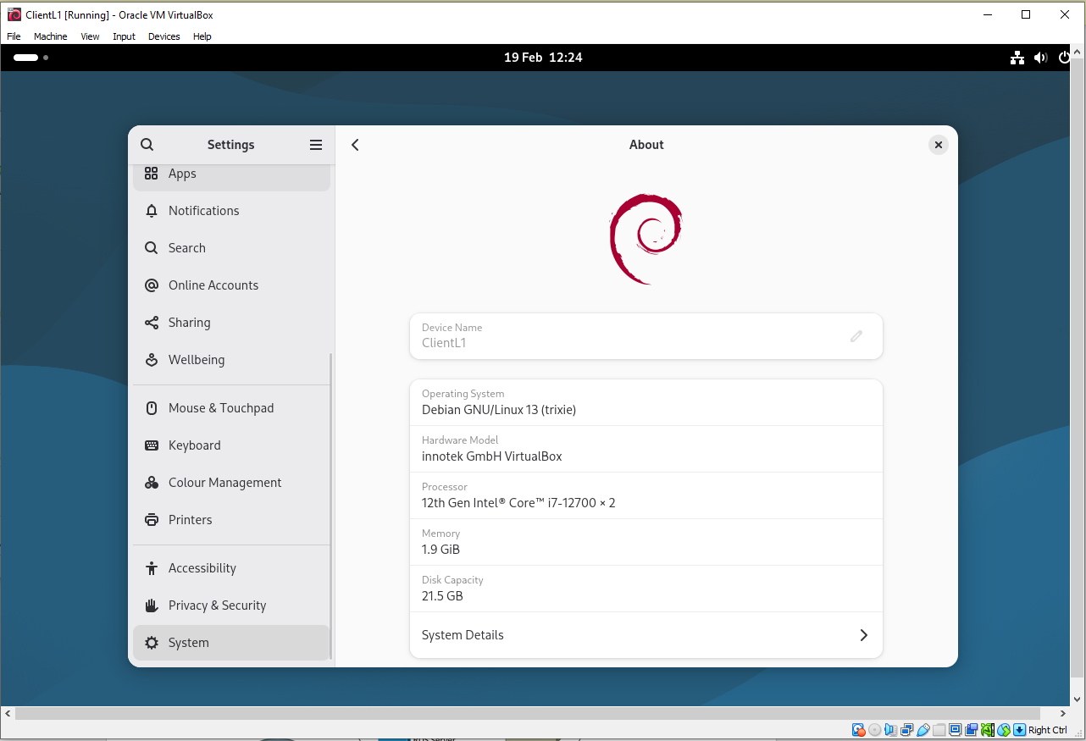

Configure IP Addressing
The configuration of IP addresses follows the ‘IP Configuration Plan’ table included in the Network Plan. Images below show the configuration of IP addresses, subnet masks, and default gateways.
Figure 13: S-DC Windows Server IP configuration. Naming of networks. (Timestamp Included)
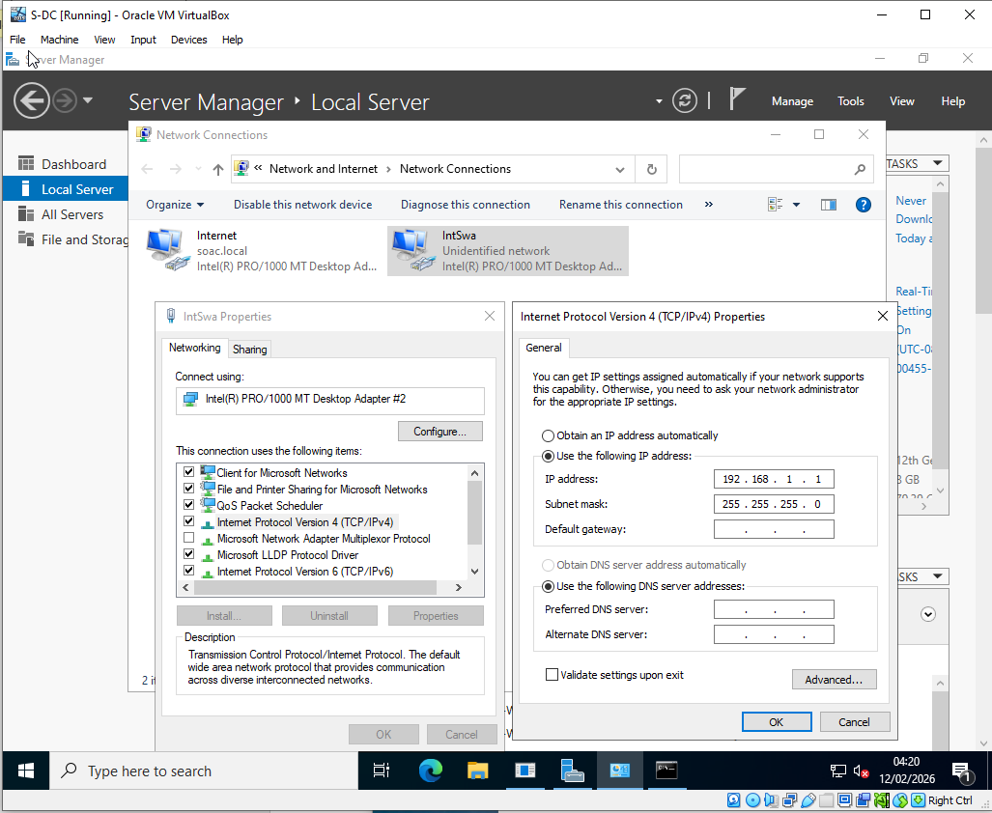
Figure 14: Network Configuration for the Windows 11 ‘ClientL1’ complete with default gateway.
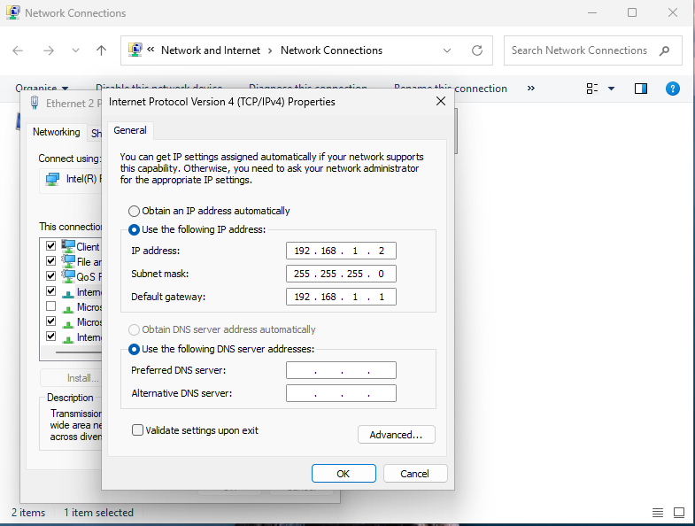

Ping Testing
After IP configuration the ping was tested to ensure that the devices were correctly connected. First pinging between the two Debian devices, then the windows devices and finally connecting and ping testing the servers to each other.

Debian Devices
Figure 15: IP configuration and successful ping testing from the Debian client to the Debian server.
Name ‘ClientL1’ can be seen. (Timestamp Included)
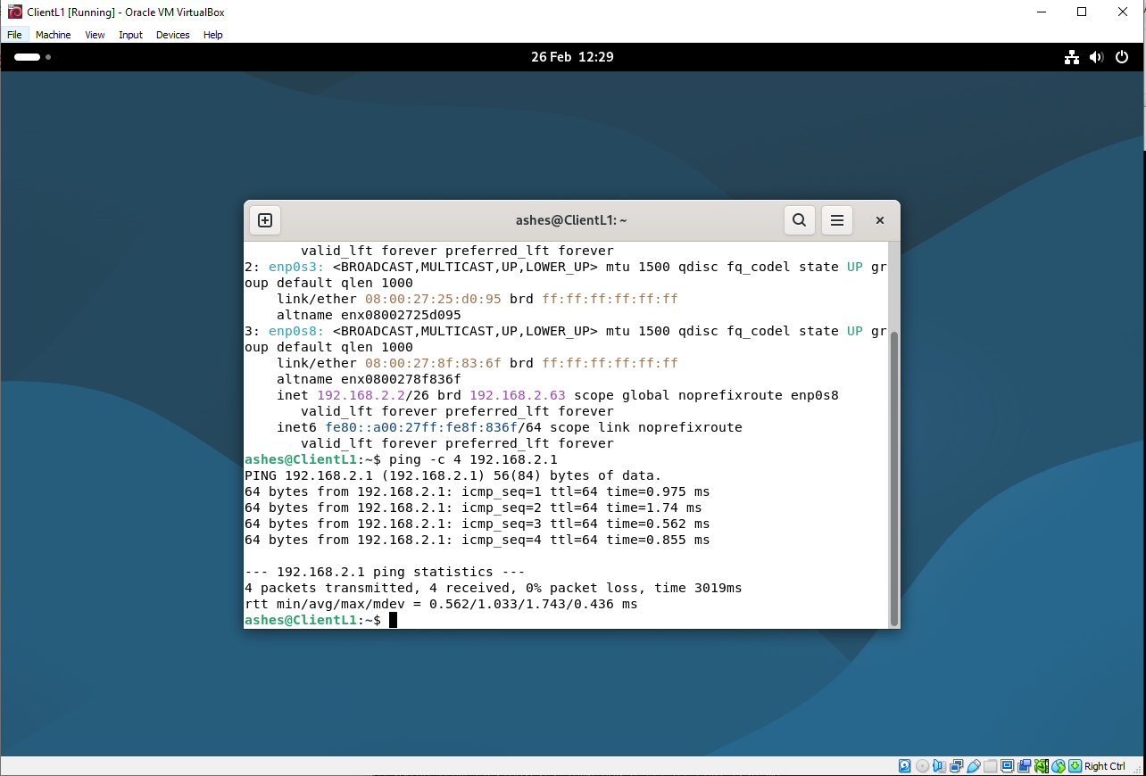

Figure 16: IP configuration and successful ping testing from the Debian server to the Debian client.
Name ‘LCD’ can be seen. (Timestamp Included)
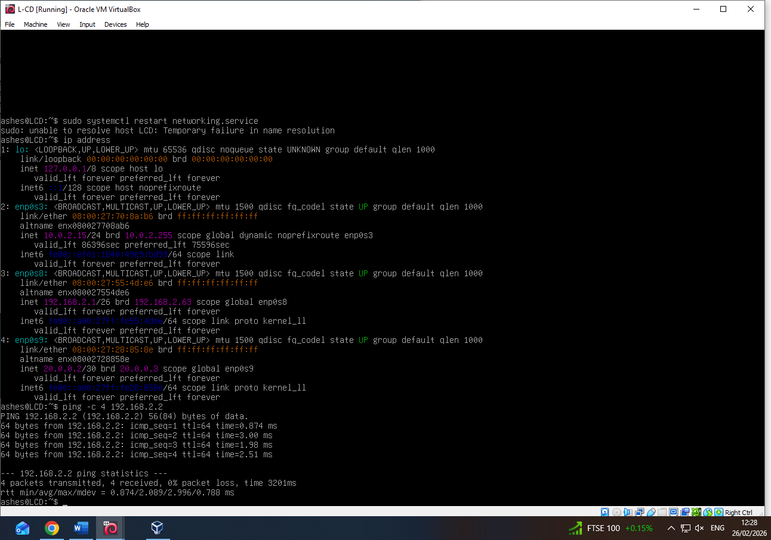

Windows Devices
Figure 17: IP configuration and successful ping testing from the Windows client to the Windows server.
(Timestamp Included)
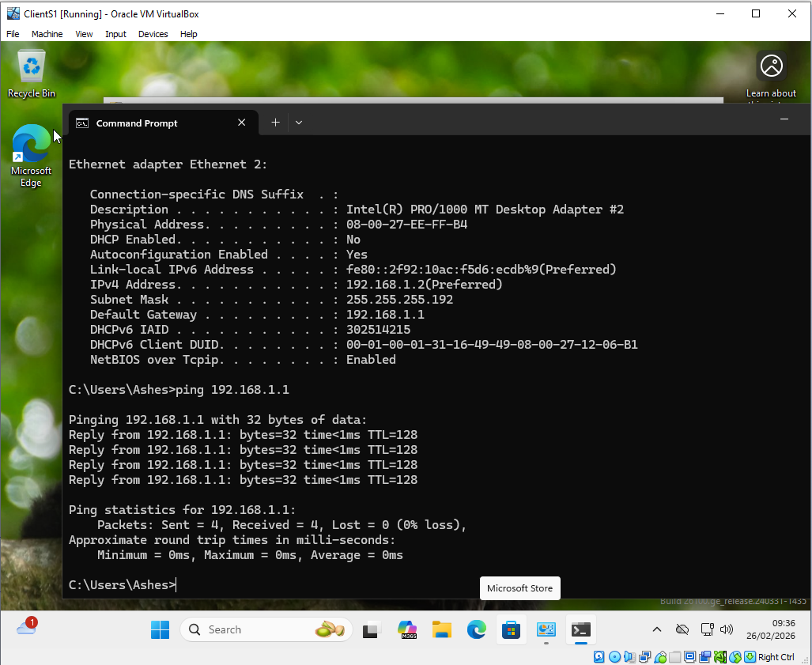
Figure 18: Successful ping testing from the Windows server to the Windows client.
(Timestamp Included)
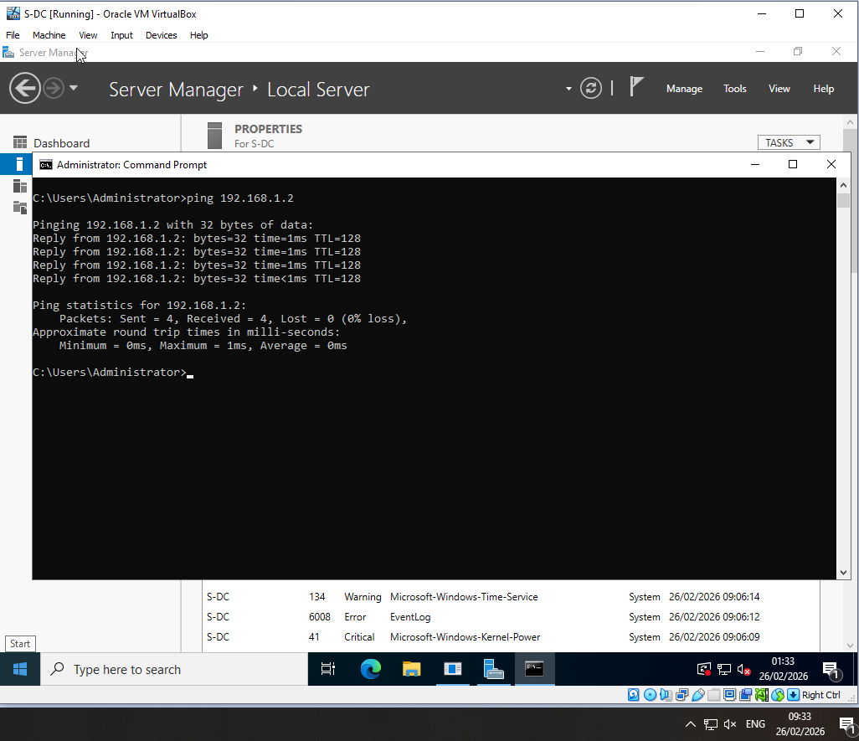

Ping Between Servers
Figure 19: IP Configurations and successful ping from Debian server to the Windows Server. (Timestamp Included)
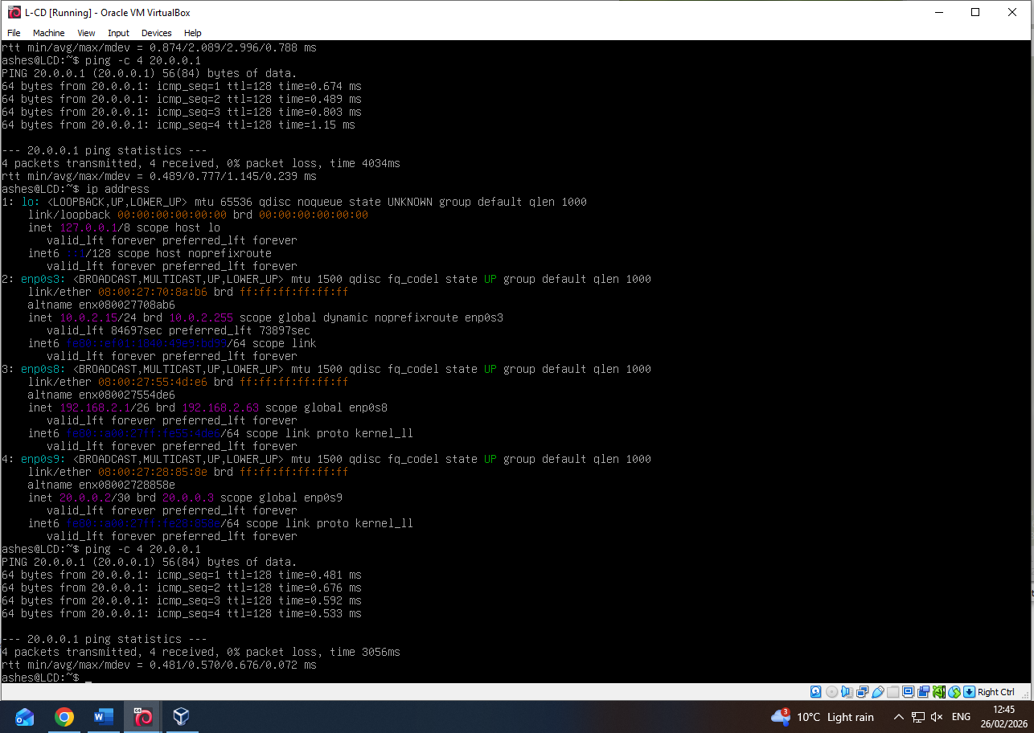

Figure 20: Successful ping from Windows server to the Debian Server. (Timestamp Included)
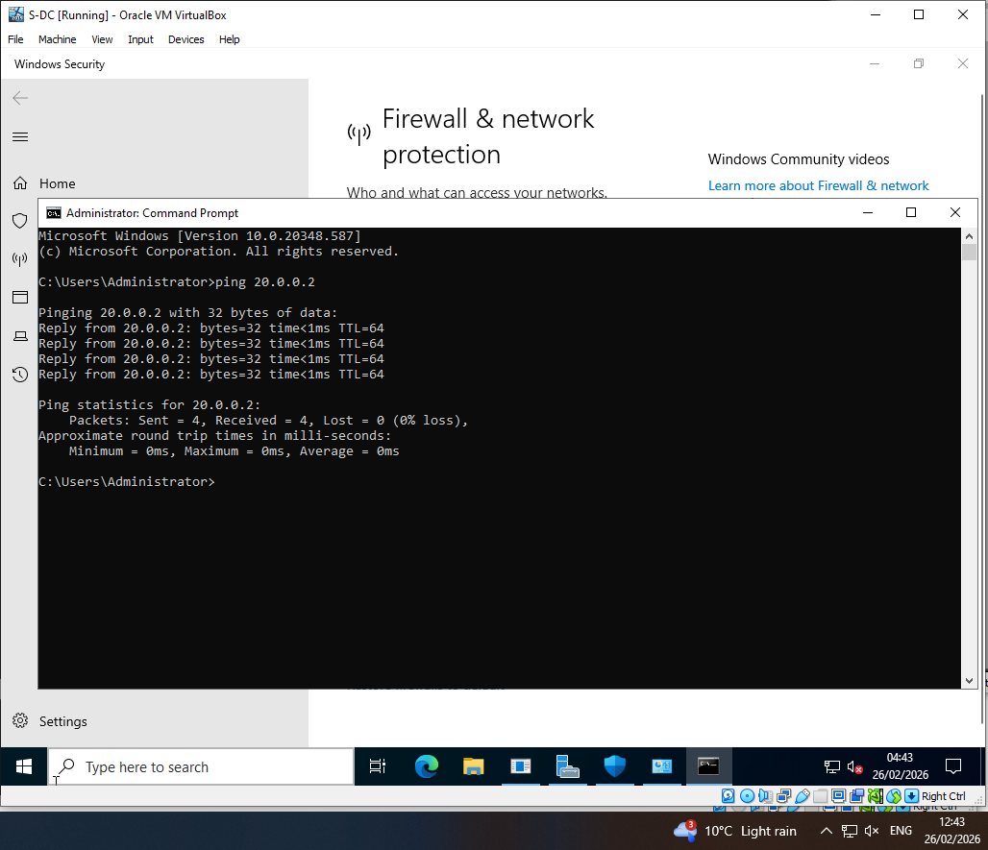

Trouble Shooting the Firewall
Initial ping tests failed due to Windows Firewall restrictions on ICMP traffic. Rather than permanently disabling the firewall, the issue was investigated and resolved by modifying the inbound firewall rules. Specifically, the rule “Core Networking Diagnostics – ICMP Echo Request (ICMPv4-In)” was enabled within the Advanced Firewall settings. This allowed ICMP echo requests to be processed while maintaining overall firewall protection.
Figure 21: Changing the inbound rule for Core Networking diagnostics – ICMP Echo Request (ICMPv4 – In)
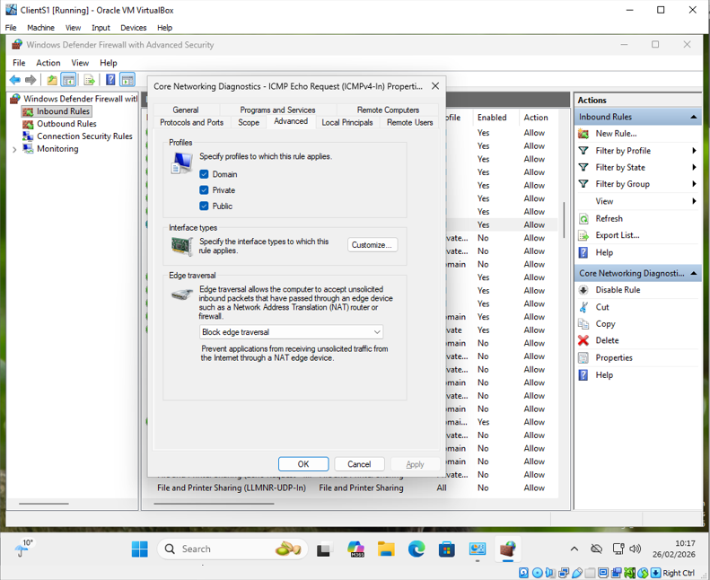
Figure 22: Windows server ping testing the Windows client with the Firewall turned on. (Timestamp Included)
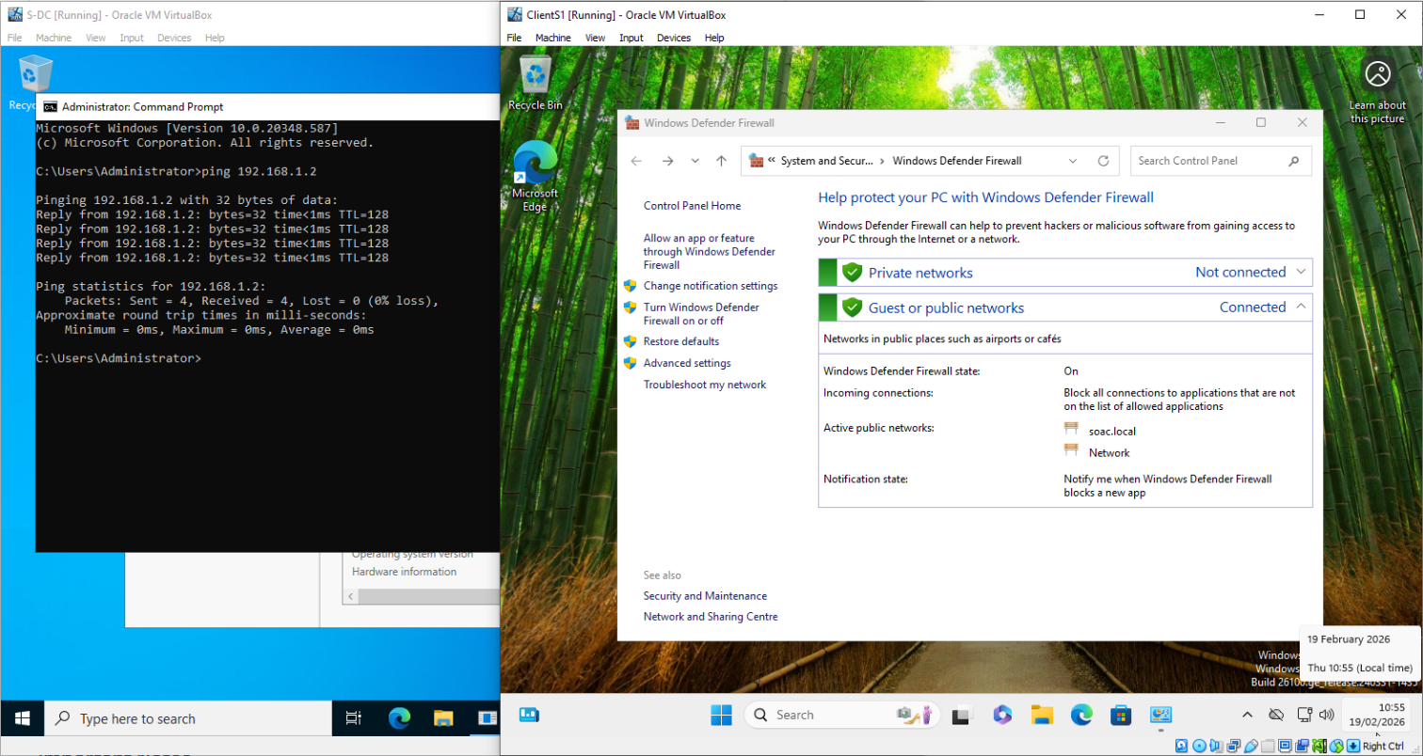

Reflecting on the assignment

Technical Reflection
During the network deployment, several configuration issues were encountered, mainly relating to connectivity and firewall settings. Initial ping tests between the Windows Server and the client were unsuccessful, suggesting a communication problem. Further investigation showed that Windows Firewall was blocking ICMP echo requests. Instead of leaving the firewall disabled, the inbound rules were adjusted to allow ICMPv4 traffic. This resolved the issue while keeping the firewall enabled.
IP configuration on the Debian server was completed using the command-line interface. Some troubleshooting was required when updates did not apply as expected.

Personal Reflection
As a software engineering student networking concepts were initially unfamiliar, yet the opportunity to apply practical skills was very rewarding. Overall, the project improved both technical understanding and practical confidence in configuring and testing networked environments.

References

[1] | M. Portnoy, Virtualization Essentials, 1st ed., John Wiley & Sons, Inc, 2012.
[2] | S. Perrott, Windows Server 2022 & Powershell All-in-One For Dummies, 1st ed., For Dummies, 2022.
[3] | D. D. Bekim, Windows Server 2022 Administration Fundamentals: A Beginner's Guide to Managing and Administering Windows Server Environments, 3rd ed., Packt Publishing, 2022.
[4] | M. Dooley and T. Rooney, IP Address Management, 2nd ed., Wiley, 2021.
[5] | P. L. Dordal, “An Introduction to Computer Networks,” [Online]. Available: https://intronetworks.cs.luc.edu/current2/html/index.html. [Accessed 28 February 2026].
[6] | Cloudflare, “what is routing?,” [Online]. Available: https://www.cloudflare.com/en-gb/learning/network-layer/what-is-routing/. [Accessed 28 February 2026].
[7] | Microsoft, “Active Directory Domain Services overview,” [Online]. Available: https://learn.microsoft.com/en-us/windows-server/identity/ad-ds/get-started/virtual-dc/active-directory-domain-services-overview. [Accessed 28 February 2026].
[8] | Oracle, “Virtualbox,” Oracle, [Online]. Available: https://www.virtualbox.org/. [Accessed 5 February 2026].
[9] | Microsoft, “Windows Server 2022,” [Online]. Available: https://www.microsoft.com/. [Accessed 5 February 2026].
[10] | Microsoft, “Windows 11 Enterprise,” [Online]. Available: https://www.microsoft.com/. [Accessed 5 February 2026].
[11] | Debian, “Debian, universal operating system.,” [Online]. Available: https://www.debian.org/. [Accessed 5 February 2026].

