

BA (Hons) Leadership and Management Skills for the Workplace
Module: Developing and Managing Individuals and Teams
Module code: LCLM5002
Module Leaders: Nishi Ramsurrun, Doreen Nyaa Amundam
Assignment Title: Component 1- Individual Presentation
Student Name:samuel tolog
Student Number: 2208598

Slide 1: Title Slide
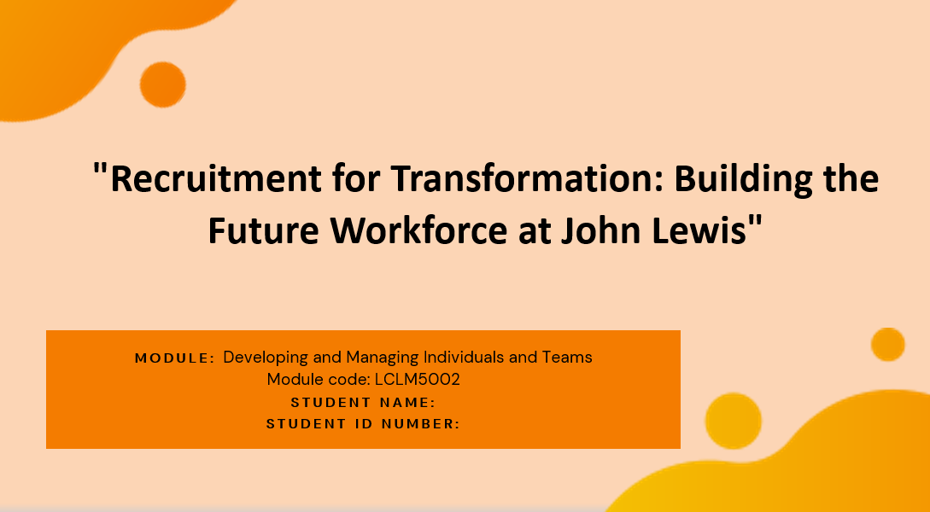
Slide 2: Table of Contents
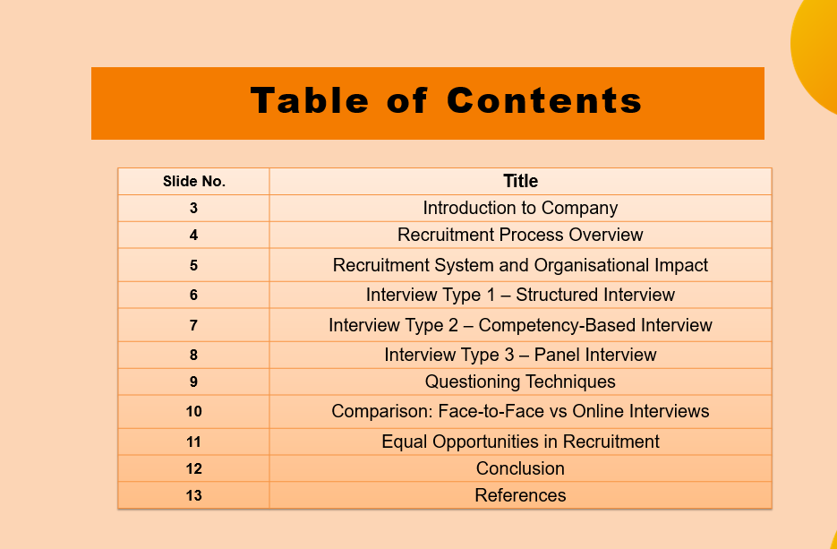
Slide 3: Introduction to Company
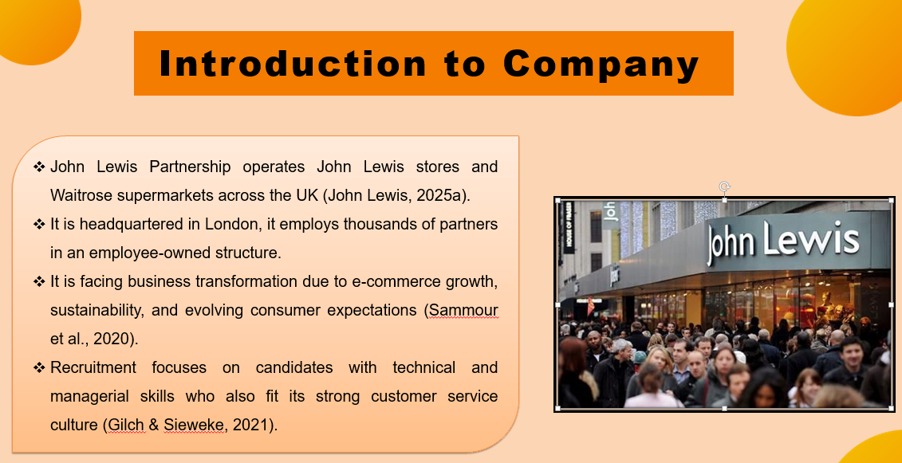
Among the most well-known organisations in the UK that are involved in retail are John Lewis Partnership, which operates John Lewis department stores and Waitrose supermarkets (John Lewis, 2025a). It is also unusual as the company is headquartered in London with thousands of employees. The transition to e-commerce, sustainability needs, and changing consumer needs are currently causing John Lewis to undergo an immense business transformation (Sammour et al., 2020). Recruitment is necessary because the organisation needs to recruit people who have skills, both technical and managerial, as well as integrate into its powerful customer service culture and employee ownership (Gilch and Sieweke, 2021). Change managers and project leaders are critical posts, and they should be hired well to ensure that they manage to bring about change successfully without causing the company to lose the essence of its values.
Slide 4: Recruitment Process Overview
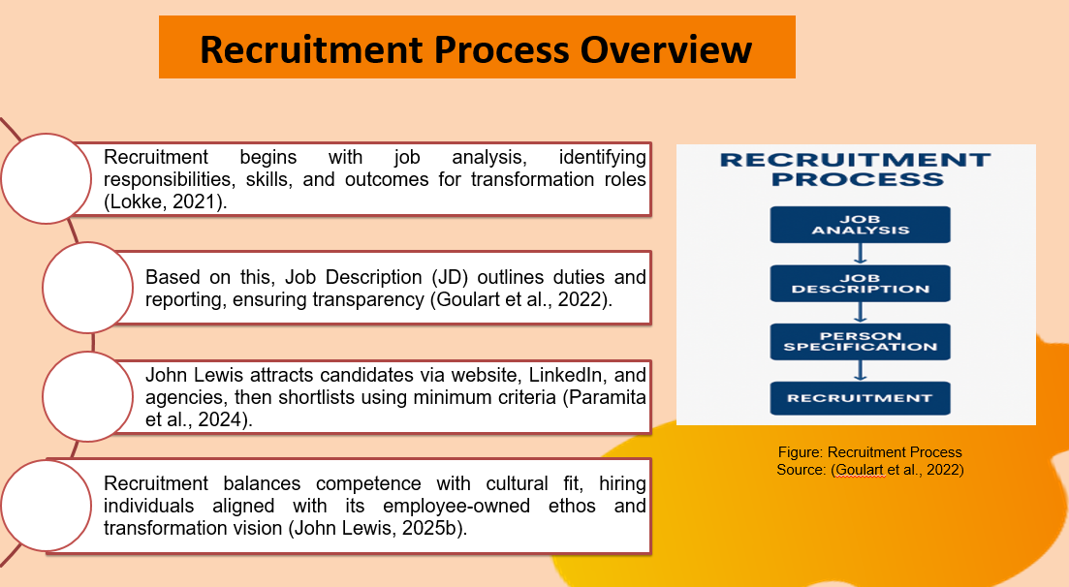
John Lewis recruitment process initiates with job analysis, which is carried out to determine the responsibility, skill and output required in particular transformation jobs (Lokke, 2021). For instance, agile solutions, stakeholders, and technology alignment are also other aspects that a digital transformation project manager must be competent in. Job description (JD) is based on this analysis in that it defines responsibilities, reporting structure, and anticipated outputs to provide the recruiting team and applicants with transparency (Goulart et al., 2022). Qualifications, skills, and behavioural aspects are then detailed in a person specification (PS), such as adaptability, problem-solving, and customer focus, being essential to the customer-focused ethos of John Lewis (Vernau et al., 2021). These measures bring about congruence between business requirements and the suitability of the candidates.
John Lewis employs multiple channels in attracting applicants; these include the company site, LinkedIn and recruitment agencies after JD and PS. Minimal criteria are used as the basis of initial shortlisting, after which structured interviews or assessment centres take place (Paramita et al., 2024). It is aimed to balance between technical competence and cultural fit, as the concept of hiring by Simon Sinek, who believes in hiring someone based on their beliefs and passion rather than competence. In the case of John Lewis, it implies focusing on the candidates who will be able to live in the environment of an employee-owned structure and contribute to the collaborative change (John Lewis, 2025b). John Lewis can reinforce their transformation initiatives by balancing job analysis with a values-focused approach without compromising its ability to be fair and consistent in its staffing procedures.
Slide 5: Recruitment System and Organisational Impact
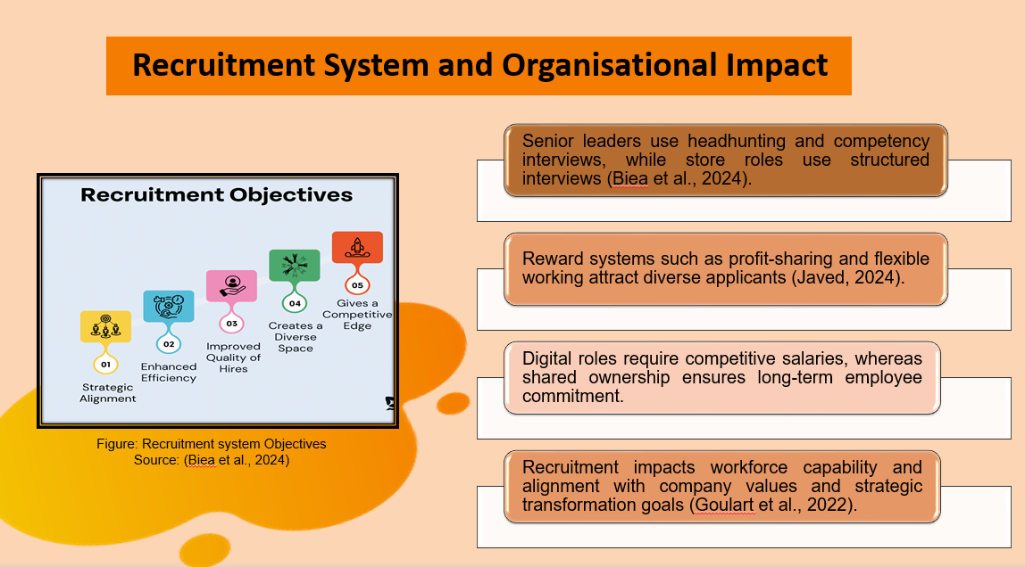
The way John Lewis recruits changes according to job level. Hiring of senior leaders is done using specially customised headhunting and competency-based interviews, whereas the store-level positions apply structured interviews (Biea et al., 2024). Reward systems such as profit sharing and flexible working are attractive to a variety of applicants. Notably, fair hiring facilitates inclusion, which is a culture of partnership at the company (Javed, 2024). As an example, in the case of digital positions, the salary has to be competitive, whereas in the case of shared ownership, the commitment is improved in the long term. Goulart et al. (2022) explain that recruitment, in turn, affects the workforce potential, as well as its compatibility with the values and strategic change objectives of John Lewis.
Slide 6: Interview Type 1 – Structured Interview
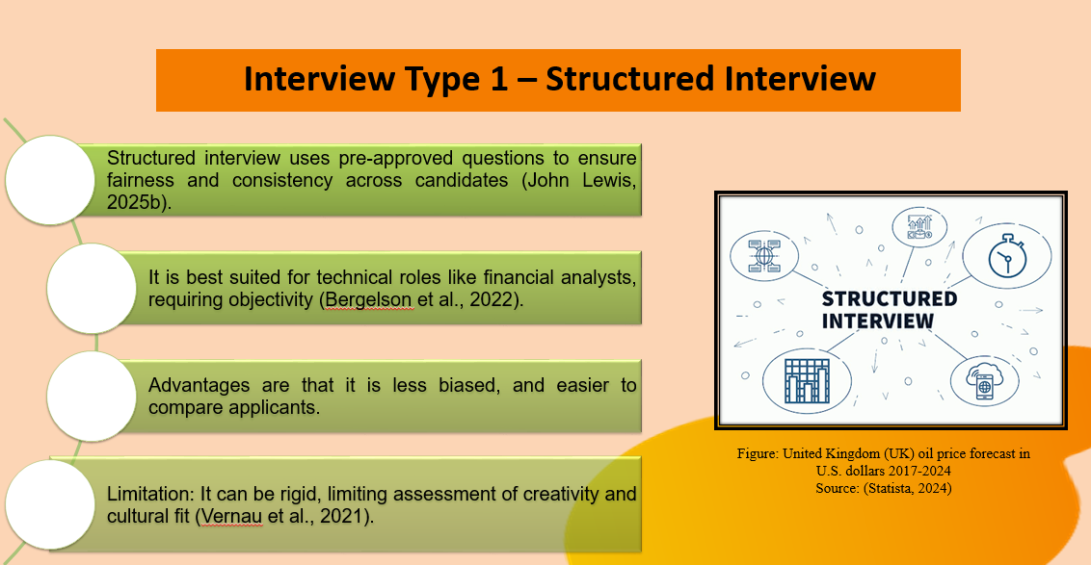
The John Lewis structured interviews use preapproved questions, making these interviews fair and consistent to all candidates (John Lewis, 2025b). They work exceptionally well when evaluating technical positions, such as financial analysts, where objectivity is a necessity. Among other benefits, it is less biased and easier to compare applicants (Bergelson et al., 2022). Nevertheless, the approach can be considered too strict and prevents studying human personality. One of the examples would be to pose the same questions to all candidates about budgeting or project delivery. Vernau et al. (2021) claim that although structured interviews enhance fairness, this should be complemented with other measures to measure creativity and fit in the culture.
Slide 7: Interview Type 2 – Competency-Based Interview
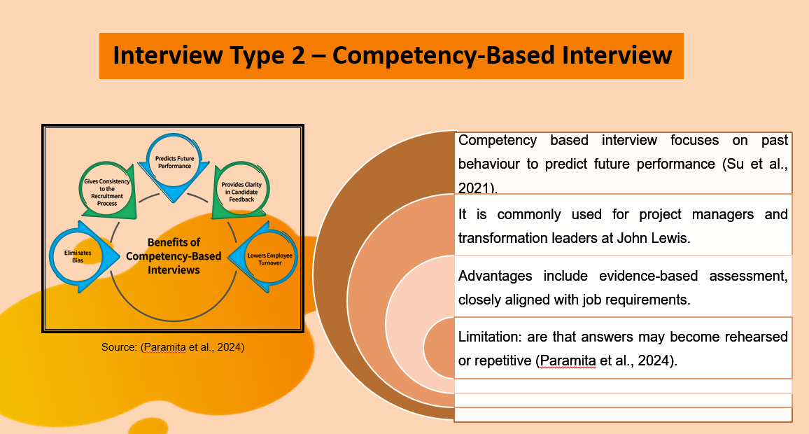
Competency-based interviews look at behaviour in the past as a predictor of future performance (Su et al., 2021). This approach is a common practice at John Lewis among project managers and transformation leaders. Situational questions like “Tell us about a time you had to deal with resistance in the face of organisational change” are posed to candidates. The advantages are a great fit with the job requirements and being evidence-based as opposed to being assumption-based. Disadvantages include the possibility of repetitive answers (Paramita et al., 2024). However, the methodology makes sure that John Lewis hires people who can deal with complex change situations in an effective and responsible manner.
Slide 8: Interview Type 3 – Panel Interview
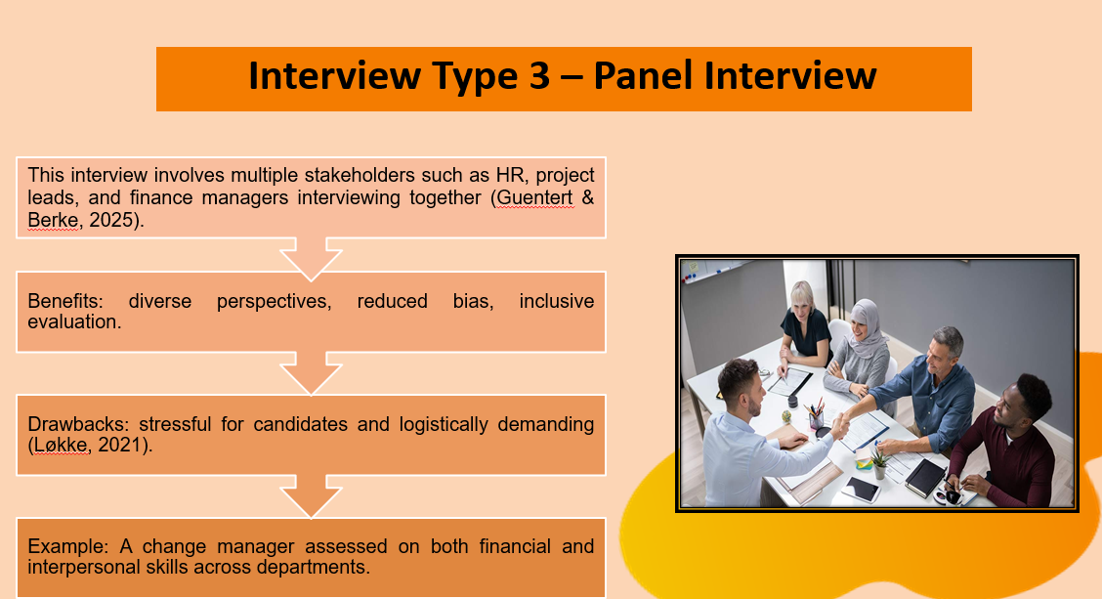
The panel interview is a form of interview where a group of John Lewis stakeholders, including the HR representatives, project leads, and finance managers, interview the candidate collectively. This offers a wide range of ideas and minimises personal bias (Guentert and Berke, 2025). They are especially applicable in the leadership positions where the decisions made touch more than one department. Pros are that it has balanced evaluation and inclusiveness, whereas cons are the stress of the candidates and logistical difficulty (Løkke, 2021). An example of this is that a change manager can be tested by a panel of individuals who test their skills based on their financial skills as well as their interpersonal skills. In spite of this, panel interviews guarantee joint, equal opportunity recruitment choices within John Lewis.
Slide 9: Questioning Techniques
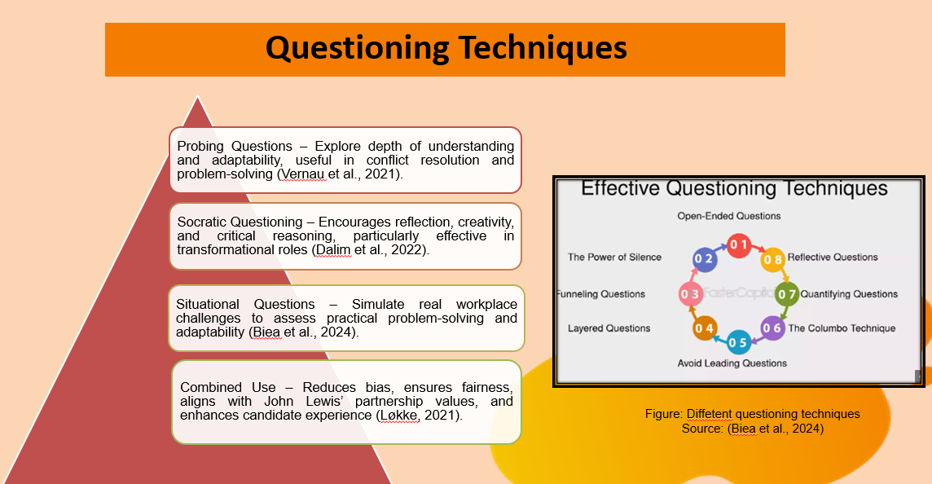
In the hiring process, John Lewis uses different interrogation methods in order to screen candidates. Probing Questions help deepen understanding, especially in problem-solving and adaptability (Vernau et al., 2021). For example, an inquiry such as “Why did you use that approach to conflict resolution?” may serve the purpose of demonstrating how the candidate thinks. Leading questions direct the candidates to particular directions but should be avoided in excessive use to prevent bias, e.g., “Would you agree that teamwork is the key to success at John Lewis?”
Socratic questioning is very effective in transformation roles as it stimulates good thoughts and reflections (Dalim et al., 20222). As an example, the question, “What assumptions can constrain your digital transformation strategy, challenge logic and creativity?” Situational questions, e.g. “How would you react to a team that resisted when trying to adopt new technology?” simulate real issues, which gives an insight into how to solve problems practically.
The merits of each method are considerable, but their combination is the best. Probing is used to verify accuracy, Socratic questioning assesses reasoning, and situational questions assess adaptability (Biea et al., 2024). The methods are in line with the values of John Lewis since they support fair and evidence-based recruitment and evaluation of competence and cultural fit. They also aid in getting the candidates motivated with the belief in the partnership ethos rather than just monetary rewards (Løkke, 2021). The combination of questioning methods decreases unconscious bias, increases the experience of the candidate, and makes the selection decisions more reliable in the transformation projects.
Slide 10: Comparison for Face-to-Face and Online Interview
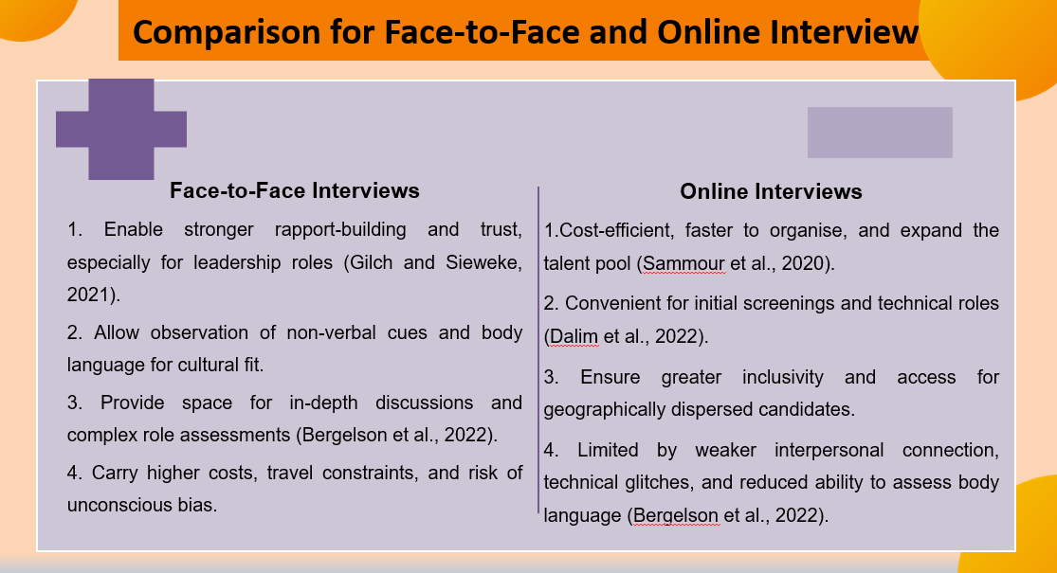
John Lewis employs face interviews as well as web-based interviews, according to the position. Face-to-face interviews can be beneficial in leadership roles like change managers because it is possible to build rapport, observe body language, and discuss in depth (Gilch and Sieweke, 2021). They enhance the trust and cultural evaluation, although they entail logistic costs, travelling obstacles, and unconscious bias.
Online interviews, which are conducted through websites such as Microsoft Teams, are effective, inexpensive and expand the talent base. They fit into positions that are technical, like financial analysts or initial screening (Sammour et al., 2020). Nevertheless, such disadvantages as poorer relationships, technical disturbances, and inability to evaluate non-verbal communication can be observed.
Comparative perspective reveals that face-to-face interviews are superior in the trust-building and leadership assessment, whereas online interviews are superior in convenience, speed and variety in candidates (Dalim et al., 2022). In the case of John Lewis, a hybrid model is most appropriate; online-based interviews would be utilised to eliminate candidates, and in-person testing would be used in the final stages. This approach saves on money and still allows a face-to-face contact where it would be most important (Bergelson et al., 2022). As John Lewis moves forward with its business change, these approaches need to be balanced to allow equity, inclusivity, and efficiency, which helps to keep the whole organisation focused on modernisation and sustainability.
Slide 11: Equal Opportunities in Recruitment
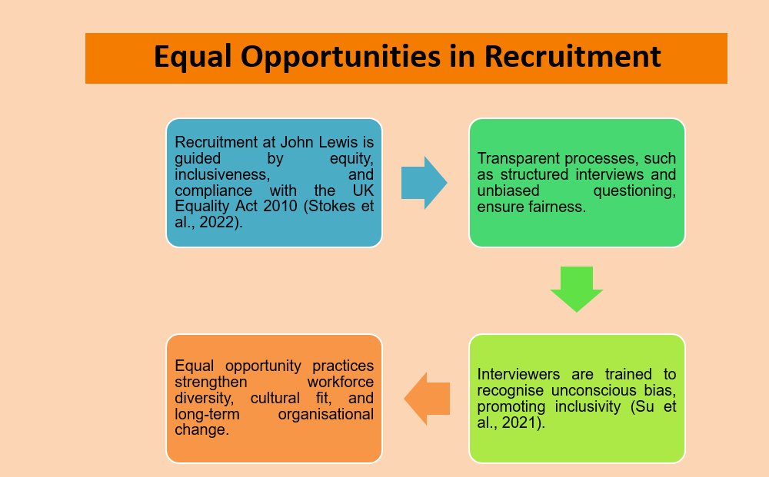
The philosophy of recruitment at John Lewis is based on equal opportunity. Equity and inclusiveness are the foundation of all hiring practices since it is an employee-owned business. The company complies with the UK Equality Act 2010 that does not allow any discrimination based on age, gender, ethnicity or disability (Stokes et al., 2022). The transparency is also carried out by the practices of recruitment that included arranged interviews and open-minded questioning. An example is also the unconscious bias that is learned by interviewers (Su et al., 2021). With the inclusion of equal chances, John Lewis will boost both the level of the workforce diversification, as well as the level of cultural fitment and business change results in the long term.
Slide 12: Conclusion
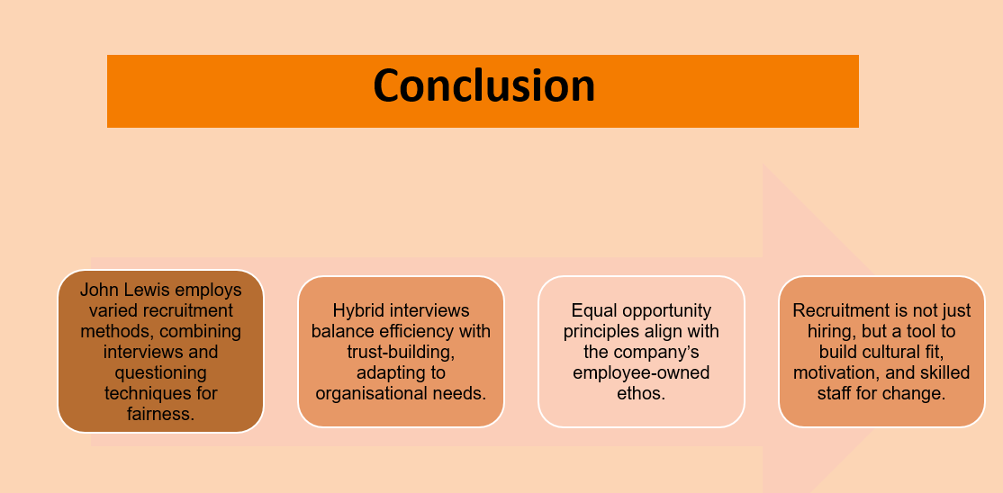
To conclude, John Lewis is able to civically recruit by incorporating routine recruitment functions, diverse methods of interviewing and questioning. The advantages of face-to-face interviews and online interviews exist, and a combination approach will be suitable to fulfil the evolving requirements of the company. The equal opportunities that the company maintains in the forefront support its business that the employees support by being employees made as owners. Through recruiting people who have a similar ethos to its own, John Lewis can achieve cultural fit and professional ability. Recruitment thus means not only staffing, but also initiating change by having aligned, motivated, and skilled staff.

Slide 13: References
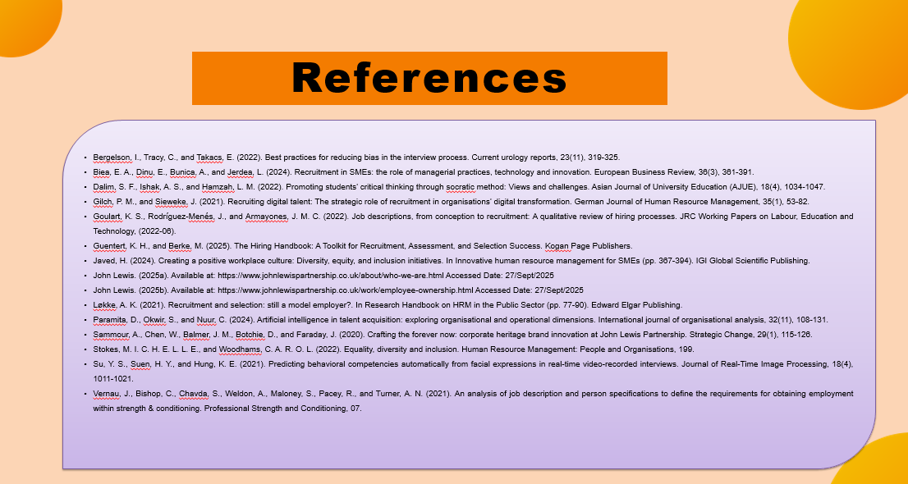
Bergelson, I., Tracy, C., and Takacs, E. (2022). Best practices for reducing bias in the interview process. Current urology reports, 23(11), 319-325.
Biea, E. A., Dinu, E., Bunica, A., and Jerdea, L. (2024). Recruitment in SMEs: the role of managerial practices, technology and innovation. European Business Review, 36(3), 361-391.
Dalim, S. F., Ishak, A. S., and Hamzah, L. M. (2022). Promoting students’ critical thinking through socratic method: Views and challenges. Asian Journal of University Education (AJUE), 18(4), 1034-1047.
Gilch, P. M., and Sieweke, J. (2021). Recruiting digital talent: The strategic role of recruitment in organisations’ digital transformation. German Journal of Human Resource Management, 35(1), 53-82.
Goulart, K. S., Rodríguez-Menés, J., and Armayones, J. M. C. (2022). Job descriptions, from conception to recruitment: A qualitative review of hiring processes. JRC Working Papers on Labour, Education and Technology, (2022-06).
Guentert, K. H., and Berke, M. (2025). The Hiring Handbook: A Toolkit for Recruitment, Assessment, and Selection Success. Kogan Page Publishers.
Javed, H. (2024). Creating a positive workplace culture: Diversity, equity, and inclusion initiatives. In Innovative human resource management for SMEs (pp. 367-394). IGI Global Scientific Publishing.
John Lewis. (2025a). Available at: https://www.johnlewispartnership.co.uk/about/who-we-are.html Accessed Date: 27/Sept/2025
John Lewis. (2025b). Available at: https://www.johnlewispartnership.co.uk/work/employee-ownership.html Accessed Date: 27/Sept/2025
Løkke, A. K. (2021). Recruitment and selection: still a model employer?. In Research Handbook on HRM in the Public Sector (pp. 77-90). Edward Elgar Publishing.
Paramita, D., Okwir, S., and Nuur, C. (2024). Artificial intelligence in talent acquisition: exploring organisational and operational dimensions. International journal of organisational analysis, 32(11), 108-131.
Sammour, A., Chen, W., Balmer, J. M., Botchie, D., and Faraday, J. (2020). Crafting the forever now: corporate heritage brand innovation at John Lewis Partnership. Strategic Change, 29(1), 115-126.
Stokes, M. I. C. H. E. L. L. E., and Woodhams, C. A. R. O. L. (2022). Equality, diversity and inclusion. Human Resource Management: People and Organisations, 199.
Su, Y. S., Suen, H. Y., and Hung, K. E. (2021). Predicting behavioral competencies automatically from facial expressions in real-time video-recorded interviews. Journal of Real-Time Image Processing, 18(4), 1011-1021.
Vernau, J., Bishop, C., Chavda, S., Weldon, A., Maloney, S., Pacey, R., and Turner, A. N. (2021). An analysis of job description and person specifications to define the requirements for obtaining employment within strength & conditioning. Professional Strength and Conditioning, 07.

