Assignment title: Blockchain-Based Secure Electronic Health Record Management
Name: Patel Vinay Bhikhabhai
Student id:2519364
Module Name: Research Methods and Professional Development
Module Code: ACFA7004

Abstract
The quick adoption of digital technologies within the sector has greatly facilitated the process of handling and making Electronic Health Records (EHRs) available, helping healthcare professionals to provide better patient care services. At the same time, the rising adoption of digital health information systems has exposed the sector to significant cybersecurity risks such as breaches, ransomware attacks, unauthorised access, insider threats, and violations of patient's privacy. Traditional centralised EHR systems are susceptible to such threats because of their dependency on single-point database system architectures, lacking data integrity and secure information sharing capabilities.
In this study, a novel blockchain-based architecture for secure Electronic Health Record management will be developed and evaluated to enhance the confidentiality, integrity, and availability of health information. In particular, this research will examine how blockchain technology, along with cryptography, smart contracts, and decentralised access control, can help to improve the level of healthcare cybersecurity as well as provide security and transparency during EHRs management. The research will follow Design Science Research approach, use a systematic literature review of existing research and compare results to traditional EHR systems.
These include increased security against cyber-attacks, better auditing, greater access control, and greater trustworthiness in healthcare information systems. The findings of this study will be useful in helping improve the cybersecurity processes in healthcare, through recommendations on how to implement Electronic Health Records management systems securely by blockchain technology.

Table of Contents
Abstract ........................................................................................................ i
1. Introduction ............................................................................................. 1
1.1 Context and Background ................................................................. 1
1.2 Research Problem ............................................................................ 3
1.3 Research Aim and Objectives .......................................................... 4
1.4 Significance of the Research ............................................................ 5
2. Literature Review .................................................................................... 6
2.1 Introduction ...................................................................................... 6
2.2 Cybersecurity Challenges in Electronic Health Records ................. 7
2.3 Blockchain Technology for Healthcare Security .............................. 8
2.4 Existing Blockchain-Based EHR Solutions ....................................... 9
2.5 Research Gap .................................................................................. 10
2.6 Relation to the Proposed Study ...................................................... 11
2.7 Literature Review Summary ........................................................... 11
3. Research Design and Methodology ......................................................... 12
3.1 Research Design .............................................................................. 12
3.2 Research Methods ........................................................................... 13
3.3 Research Materials .......................................................................... 15
3.4 Data Analysis and Evaluation .......................................................... 16
3.5 Ethical Considerations .................................................................... 17
4. Expected Outcomes ............................................................................... 18
4.1 Anticipated Results ......................................................................... 18
4.2 Implications of the Research .......................................................... 19
4.3 Limitations ...................................................................................... 20
5. Timeline ................................................................................................ 21
6. Conclusion ............................................................................................. 22
References .................................................................................................. 23

List of Figures
Figure No. | Figure Title | Page No.
Figure 1 | Traditional EHR vs Blockchain-Based EHR Architecture | 2
Figure 2 | Cybersecurity Challenges in Electronic Health Records | 6
Figure 3 | Security Comparison Between Traditional and Blockchain-Based Electronic Health Record Systems | 10
Figure 4 | Design Science Research (DSR) Process Adopted in This Study | 11
Figure 5 | Proposed Blockchain-Based EHR Architecture | 13
Figure 6 | Workflow of the Proposed Blockchain-Based Electronic Health Record Management System | 16
Figure 7 | Key Cybersecurity Features of Blockchain-Based Electronic Health Record Management | 18

1. Introduction
1.1 Context and Background
In the last ten years, there has been rapid digitalization in the health sector, resulting in the creation of Electronic Health Records (EHRs). EHRs are digital files of patients' medical history that include vital details like patients' diagnoses, lab results, medications, treatment plans, allergies, and medical images. Unlike paper-based records, EHR systems make healthcare more efficient by increasing access to patient information, preventing errors, and facilitating communication between different healthcare providers.
While there are many benefits of using EHR systems, these systems still pose numerous problems associated with security, privacy, interoperability, and patients' control. The majority of healthcare providers use centralized databases to store their patients' information. Although such an approach makes the handling of data simpler, it leaves all this information in one place, thus making it susceptible to cyberattacks, hacking, manipulation, and ransomware attacks. In recent years, hackers have started targeting healthcare organizations more often because of the value of this kind of information.
In addition, the lack of interoperability among healthcare organizations is another problem that exists today. The hospitals, clinics, laboratories, and even insurance companies usually have their own IT systems, which do not allow exchanging information easily. In turn, the healthcare professionals are unable to get full information about the history of a particular patient's health status. Moreover, in most cases, patients have no influence on who gets access to their personal health information and what information they share among healthcare organizations.
There is a new technology that allows solving some of the problems described above – blockchain. Blockchain is distributed ledger technology that stores the information in several nodes, but not in one central database. All transactions are cryptographically protected, timestamped, and connected with other records in such a way that the stored information is extremely difficult to change without any permission. Blockchain features, such as decentralization, immutability, transparency, and cryptography, can be used for managing the healthcare information.
The progress that is being made within blockchain platforms and smart contracts technology has also increased the possibilities of applying blockchain in the field of healthcare. For instance, smart contracts will help automate access to the information, so that access will be granted only to authorized healthcare providers according to certain criteria. On the other hand, blockchain can also facilitate the process of exchanging information between healthcare facilities, preserving the privacy of patients and documenting all actions related to accessing this information.
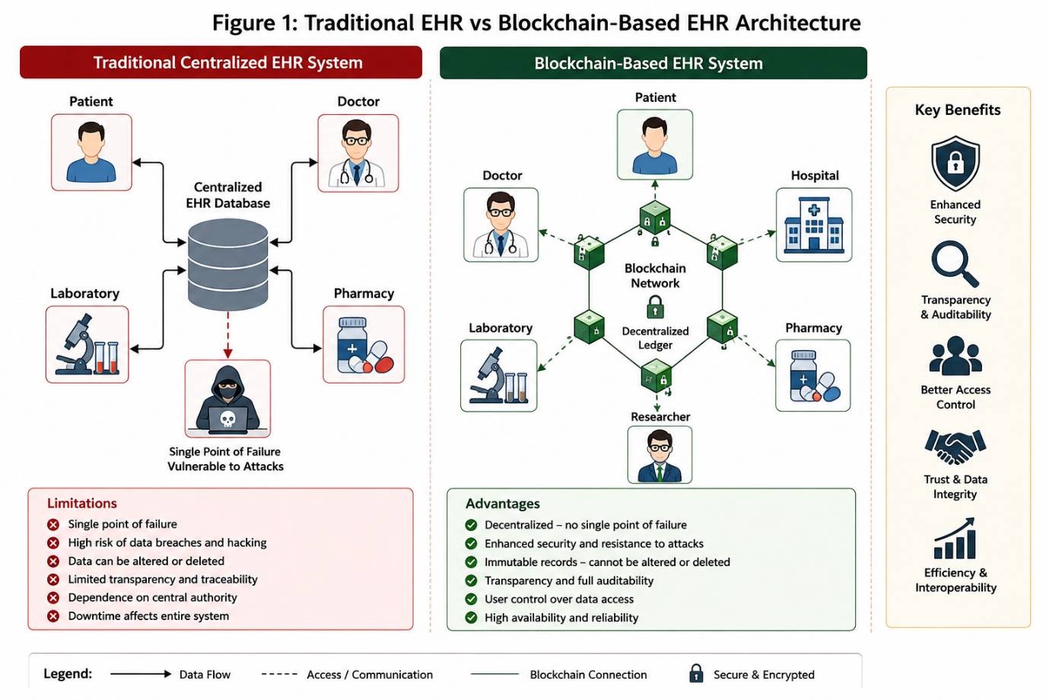
Figure 1: Traditional EHR vs Blockchain-Based EHR Architecture
The vast majority of healthcare practitioners rely on centralized databases for storing data about their clients. While this method simplifies the process of working with this data, it keeps all this data at one place, thereby exposing it to various cyberattacks, manipulation, and even ransomware attacks

1.2 Research Problem
The widespread application of EHR systems has greatly contributed to the efficiency of healthcare services; yet, the deployment of EHR systems has heightened the risk of sensitive patient data being exposed to complex cyberattacks. In today's world, modern healthcare organizations are common targets for cybercriminals due to the fact that patient files consist of various personal, financial, and medical information which can be used for committing identity fraud, blackmailing, etc. The fact that traditional centralized EHR systems utilize only one database server makes them subject to cyber attacks, unauthorized access, insider attacks, and data tampering. Successful cyber attack can affect the CIA of patient data causing disruption of healthcare services, financial losses and lowering patients' trust.
Even though healthcare organizations employ conventional cyber security techniques, like encryption, firewalls, intrusion detection systems, and role-based access control, they do not provide complete protection against advanced persistent threats and guarantee data integrity. Another challenge faced by healthcare organizations is interoperability and lack of patient control over medical records.
It has also been suggested that the use of blockchain technology can be seen as an alternative solution to the problem as it ensures enhanced security due to its decentralized structure, hashing technique, consensus protocols, and immutable ledger system. Nonetheless, it can be noted that currently available blockchain-based EHR solutions also pose certain problems associated with scalability, system integration, transaction speed, and regulatory compliance. Consequently, it is important to conduct further research to analyze the potential application of blockchain technology to increase cybersecurity in EHR management system

1.3 Research Aim and Objectives
Research Aim
The objective of this research is to assess the ability of blockchain technology to improve the cybersecurity, privacy, and integrity of EHR management systems through a proposed secure blockchain framework.
Research Objectives
The objectives of this research are:
1)For studying the cybersecurity problems related to the conventional Electronic Health Records management systems.
2)For analysing blockchain technology and its applications to secure healthcare information systems.
3)For understanding the ways through which the characteristics of blockchain technology like decentralisation, cryptographically secured environment, smart contracts, and immutable ledgers would help to enhance the confidentiality, integrity, and availability of Electronic Health Records.
4)For developing a cybersecurity framework for Electronic Health Records management based on blockchain technology.
5)For assessing the proposed cybersecurity framework against the traditional centralised EHR management systems by using the parameters of cybersecurity such as data confidentiality, integrity, access control, auditability, and resistance to cyber-attacks.
6)For finding the challenges faced while implementing blockchain technology in healthcare cybersecurity.

1.4 Significance of the Research
The research will add value to cybersecurity research as well as healthcare information security. On the cybersecurity front, the research will focus on exploring the role that blockchain plays in protecting healthcare information from cyber-attacks such as ransomware, data breaches, insider threat, and unauthorized access. In addition, the research will be focused on examining how the use of cryptography in blockchain architecture enhances integrity, authentication, and access controls in the health sector.
In terms of its practical applications, the framework proposed in this research could assist health care institutions in enhancing security and resilience of their Electronic Health Record system as well as enabling secure information exchange between authorized healthcare providers.
Furthermore, the findings from this study may serve to guide cybersecurity experts, health care administrators, and policymakers regarding the advantages and disadvantages of implementing blockchain within the healthcare information system. The results obtained from this study can be used in the design of an effective and resilient infrastructure that can safeguard patient data against cyber threats.

2. Literature Review
2.1 Introduction
EHRs have proved to be an integral part of the digital healthcare system through better management of patient information. Though EHRs have improved the effectiveness of the delivery of health services and clinical decision-making, they have increasingly become targets of cyber attacks due to the confidential nature of health data. Health records are made up of personal identification details, medical history, financial information and insurance information among others. These records are highly valuable to attackers who target systems using cyber attacks such as ransomware, phishing, insider threats and data breaches. Ensuring the security of health information systems has, therefore, become one of the major research areas within the field of cybersecurity and information assurance.
Some of the techniques suggested by researchers to ensure EHR security include encryption, access control, cloud computing security, intrusion detection and prevention system and use of blockchain. Blockchain has particularly gained a lot of traction due to its decentralized architecture, cryptography security, immutability of records and transparency of audits. This literature review critically examines some of the previous studies conducted on EHR security, application of blockchain in healthcare, the prevailing cybersecurity problems and the shortcomings of the existing solutions.

2.2 Cybersecurity Challenges in Electronic Health Records
The growing usage of Electronic Health Record systems has greatly increased the cyber attack surface of healthcare organizations. As stated by cybersecurity research, the healthcare industry is now one of the most frequently attacked industries due to high value of medical records on cybercrime market. Attackers regularly attack hospitals through ransomware attacks, phishing, malware, denial-of-service attacks, and insider threats to access the sensitive information about patients.
The traditional EHR systems utilize centralised database structures. Despite effective management of data that is provided by such structures, they create several vulnerabilities to cybersecurity issues. An attack against the central database may lead to CIA (confidentiality, integrity and availability) violation of patient records. Moreover, the centralised structure creates vulnerability to the failure of service and data breach attacks.
There are also problems related to secure authentication and access control, as well as to the activity monitoring of users. The weak password policy, user credentials compromise, and lack of audit logging make it possible for attackers and malicious insiders to access the confidential medical information.

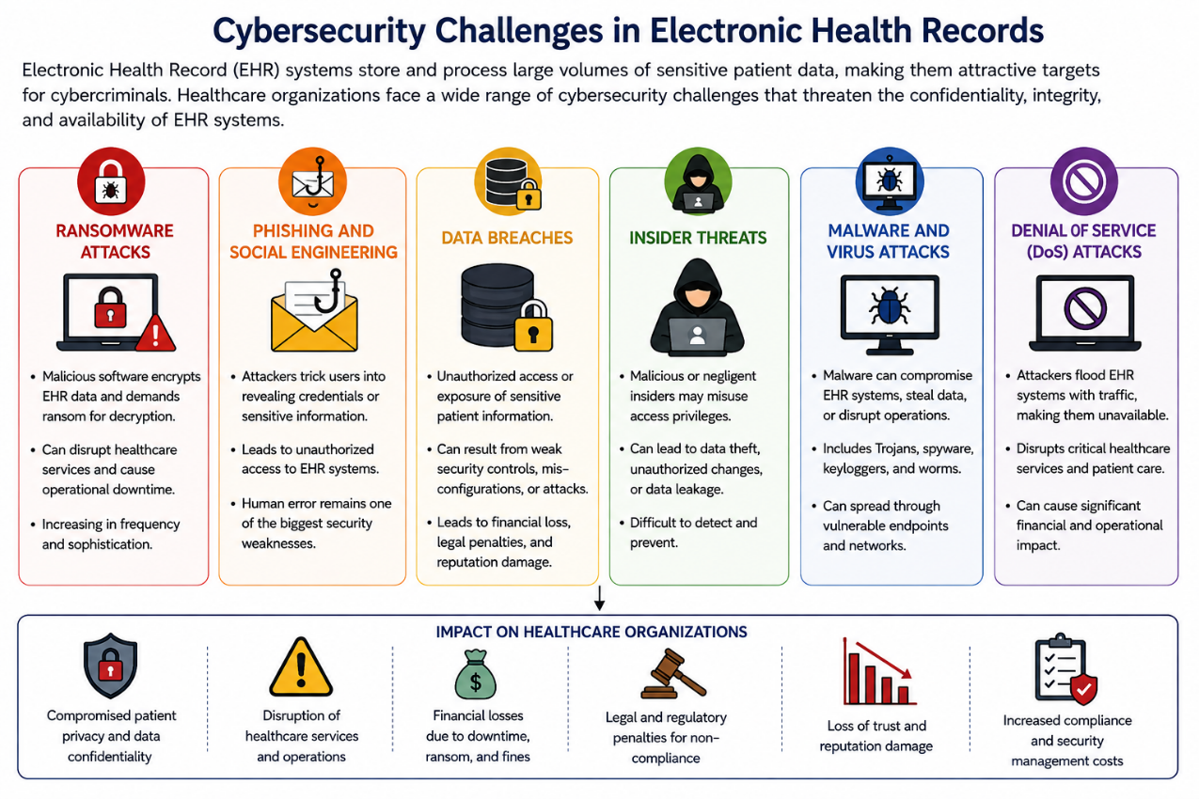
.

Figure 2: Cybersecurity Challenges in Electronic Health Records
The figure below shows the various types of cyber threats that could affect EHR systems. The cyber threats include ransomware, phishing, data breach, insider threat, malware, and denial-of-service (DoS). Such cyber attacks put at risk the security of sensitive patient information, emphasizing the need for secure technologies such as the blockchain technology.

2.3 Blockchain Technology for Healthcare Security
Blockchain technology can be considered a prospective technology to ensure cybersecurity of Electronic Health Records. The difference between the traditional database system and blockchain is that the latter stores all transactional information in many distributed nodes, which means no more reliance on a single central authority. Each transaction is checked by consensus and is secured via cryptographic hashing, therefore any change of records becomes impossible to make.
There have been several suggestions from different researchers regarding improving cybersecurity in healthcare via the use of blockchain technologies. These suggestions include maintaining data integrity, prevention of any unauthorized alteration of medical records, and creation of the transparent audit trail. Additionally, blockchain provides decentralized identity management and smart contracts to allow secure authentication and access control.
One of the key benefits of blockchain is providing tamper-proof records, meaning that each change in the patient record is recorded permanently and thus allows to verify the authenticity of information regarding health care. From the point of view of digital forensics, this aspect is especially important.

2.4 Existing Blockchain-Based EHR Solutions
Various blockchain-powered solutions for healthcare problems were proposed due to the shortcomings of the conventional Electronic Health Records systems. Currently, most of the existing approaches include the use of cloud storage with encrypted records stored in cloud databases and blockchain keeping all other data, including metadata, permissions and transactions' history. This approach increases scalability while retaining the benefits of blockchain technology.
Permissioned blockchain technologies such as Hyperledger Fabric have gained popularity in healthcare systems since they provide a higher level of security, transaction processing rate and privacy compared to public blockchains. Also, smart contracts are used in these systems to manage patients' consents and apply the necessary access control policies.
While the security, transparency and interoperability of these solutions are significantly enhanced, most of them are still experimental and not implemented on a wide scale in healthcare environment.

2.5 Research Gap
The current literature review shows that the use of blockchain technologies provides ample opportunities for improving the cybersecurity of Electronic Health Records systems. Yet, there are still some research questions which need further elaboration.
The majority of previous works concentrate on the implementation of the blockchain technology and neglect the aspects of cybersecurity evaluation. For instance, the number of studies, which consider the security of blockchain-based EHRs under modern types of cyber attacks like ransomware attacks, insider threats, unauthorised access, and advanced persistent threats, is relatively small. Moreover, most of the suggested frameworks lack a detailed comparison of the use of blockchain technology in healthcare with centralised healthcare systems in accordance with the criteria of cybersecurity.
In addition, the integration of blockchain into the current structure of healthcare organizations is technically challenging due to issues associated with scalability, interoperability, performance, and compliance with the regulations for protection of health data. It is necessary to solve these problems in order to implement the blockchain in the healthcare domain.
Thus, this research will try to explore the issue of secure blockchain-based EHRs management framework.

2.6 Relation to the Proposed Study
This research expands upon the current cybersecurity research based on blockchain technology in healthcare applications through the emphasis placed on enhancing the cybersecurity of EHR management systems. In contrast to prior research that mainly centers on the application of the blockchain technology, this study will assess the proposed framework from the cybersecurity standpoint through the evaluation of such elements as confidentiality, integrity, availability, authentication, access control, auditing, and resilience to cyberattacks.
The results will serve as contributions to cybersecurity research and healthcare information security.

2.7 Literature Review Summary
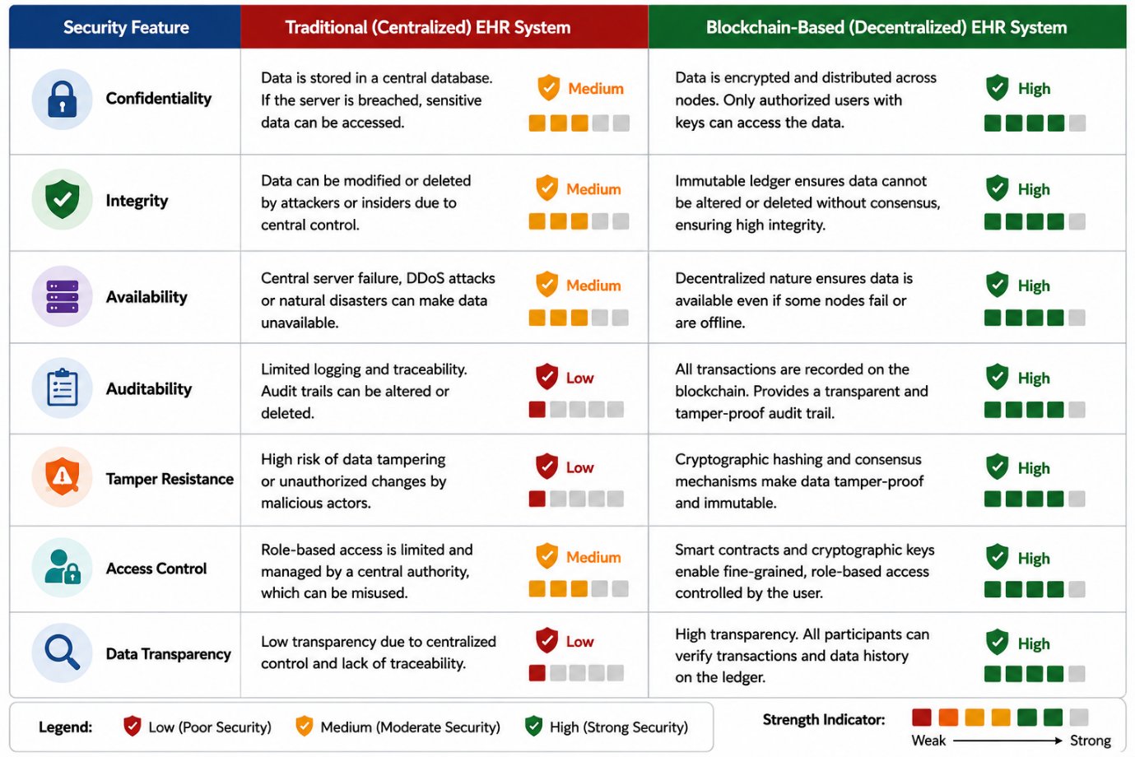
The literature review conducted in this paper has analyzed recent scholarly works on the issues of Electronic Health Record security, blockchain technology, and cybersecurity challenges in healthcare information systems. It has been shown from the analysis that existing works prove the effectiveness of the blockchain application in ensuring the integrity of the data, secure access control, traceability, and auditability of information. Nevertheless, certain limitations concerning scalability, interoperability, complex implementation process, and regulatory compliance still prevent its wide use. Such limitations motivate the need for further research.
Figure 3: Security Comparison Between Traditional and Blockchain-based Electronic Health Record Systems
This is illustrated through Figure 2 below, which shows the security measures of a centralized EHR system in contrast to the decentralized blockchain EHR system. The figure shows the improvement that blockchain technology makes in regards to data confidentiality, integrity, availability, access control, auditability, and transparency.

3. Research Design and Methodology
3.1 Research Design
In conducting this research, the Design Science Research (DSR) methodology would be applied since the core aim of the research is the creation of a secure blockchain-based framework for EHR management. The DSR approach is extensively used in cybersecurity research as it involves developing an innovation solution to deal with a specific cybersecurity challenge. In this research, the framework would combine the use of blockchain technology and EHR management for enhancing the confidentiality, integrity, availability and secure access control of health care information.
The research would follow the DSR methodology, including several steps such as problem identification, literature review, design, implementation, evaluation and validation. At the first stage, existing literature on cybersecurity in healthcare, blockchain technology, and security of Electronic Health Records would be analysed to determine the current challenges and gaps in the research area. Next, on the basis of these results, a secure blockchain architecture would be proposed. Finally, the framework would be evaluated against traditional centralized EHRs using established cybersecurity criteria.
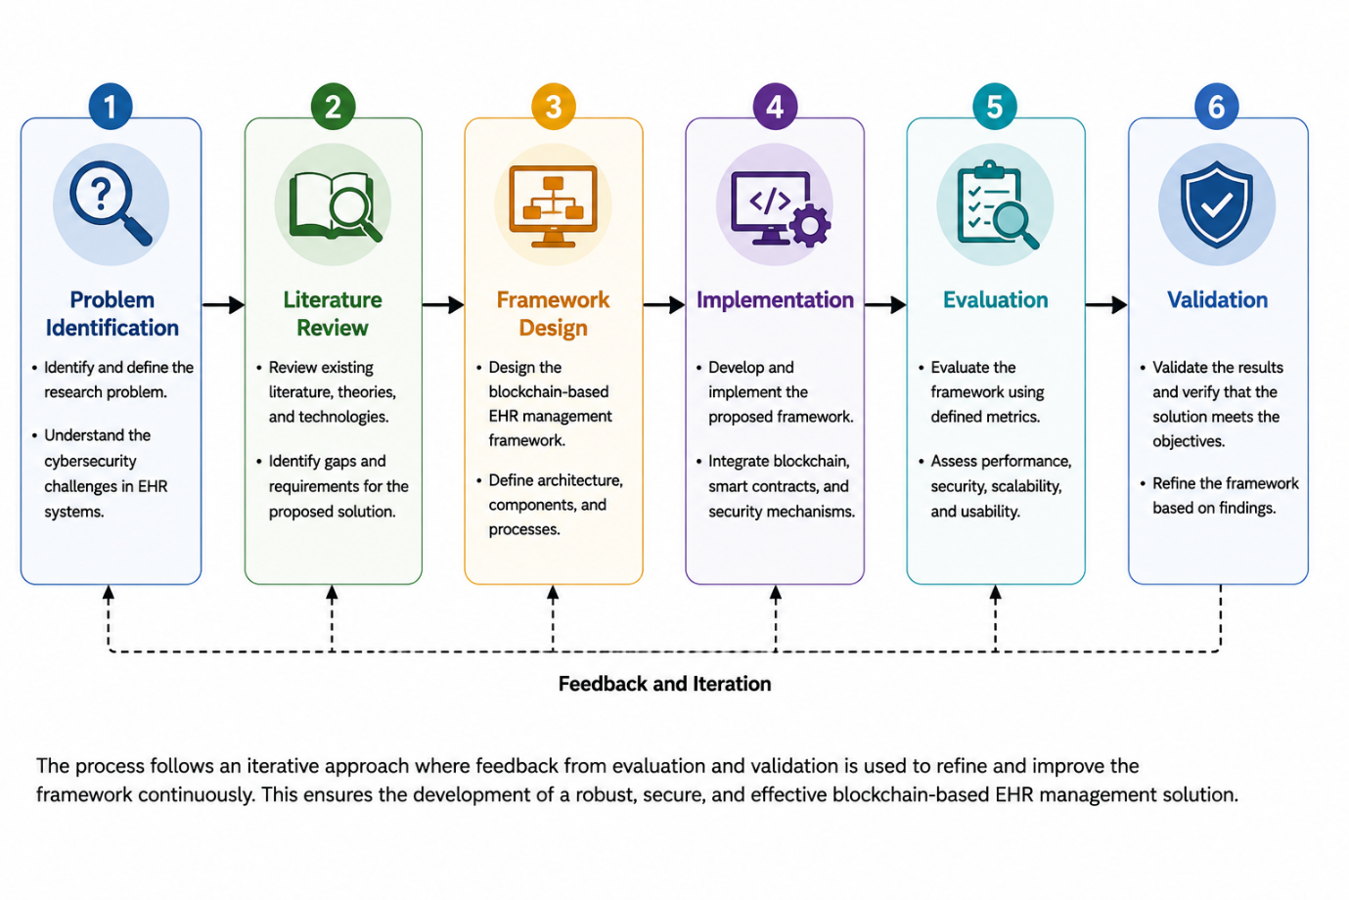
This research methodology would be suitable for this research as it implies the development of a practical cybersecurity solution together with the systematic evaluation of its efficiency in protection of health care data.
Figure 4. Design Science Research (DSR) Process Adopted in This Study
The Design Science Research (DSR) approach employed in this study is shown in Figure 4. It starts from the identification of the research problem to literature review, design of the framework, implementation, evaluation, and validation of a solution for the management of EHRs based on blockchain technology.

3.2 Research Methods
This study will use quantitative research methodology along with experimental evaluation. The use of quantitative methods is appropriate because they facilitate objective assessment of the security and performance features of the proposed blockchain architecture.
The research strategy will consist of the following stages:
Stage 1: Literature Review
Systematic research into recent scientific journals, conference papers, and standards of cyber security will be conducted to identify the current issues with the security of Electronic Health Record system, blockchain technology, and healthcare security frameworks.
Stage 2: Framework Design
From the literature review, a framework for the management of Electronic Health Records using blockchain will be developed. The components of the framework are:
Patient identity management
Authentication
Role-Based Access Control (RBAC)
Blockchain ledger
Smart contract
Cryptographic hash functions
Audit log
Data sharing among healthcare providers
The architecture design will focus on enhancing security and efficiency of healthcare delivery.

Stage 3: Experimental Evaluation
The new model will be assessed through simulation or prototype development. Comparison of its performance and security properties will be made to that of existing centralized EHR systems.
Key criteria include:
Confidentiality
Integrity
Authentication
Access control
Auditability
Availability
Cyberattack resilience
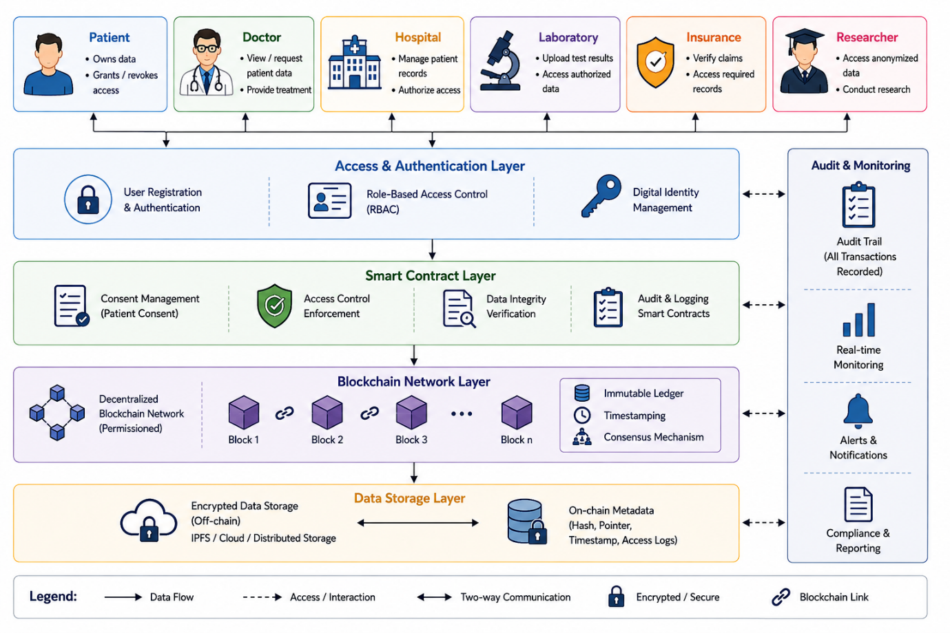
Transaction performance
Figure 5: Proposed Blockchain-Based EHR Architecture
As a result of the literature review, a framework for managing Electronic Health Records through the use of blockchain technology will be established.

3.3 Research Materials
Data Sources
This research will primarily use secondary data obtained from published academic literature, healthcare cybersecurity reports, and publicly available blockchain documentation. If a prototype implementation is developed, synthetic Electronic Health Record data will be used to avoid exposing sensitive patient information.
Software Requirements
The following software tools may be used:
Hyperledger Fabric
Ethereum (private blockchain)
Solidity (Smart Contract Programming)
Python
Visual Studio Code
Docker
Node.js
PostgreSQL or MongoDB
GitHub
Wireshark (network traffic analysis tool)
Hardware Requirements
The experiment can be performed by using a personal computer equipped with:
Intel Core i5/i7 CPU or its equivalent
At least 16 GB of RAM
512 GB SSD storage space
Operating system: Windows 11 or Ubuntu Linux
Cloud-based services can also be employed for blockchain implementation and testing purposes, should extra computing power be needed.

3.4 Data Analysis and Evaluation
The success of the blockchain-based architecture will be measured on the basis of both cybersecurity as well as performance metrics.
Cybersecurity Evaluation Metrics
- Confidentiality
- Integrity
- Availability
- Authentication accuracy
- Access control effectiveness
- Audit log transparency
- Resistance to unauthorised modification
- Protection against ransomware attacks
- Resistance to insider threats
Performance Metrics
- Transaction latency
- Throughput
- Scalability
- Storage efficiency
- Response time
his framework will be benchmarked against traditional centralised EHR architectures to identify any significant cybersecurity improvements through blockchain in the healthcare industry.
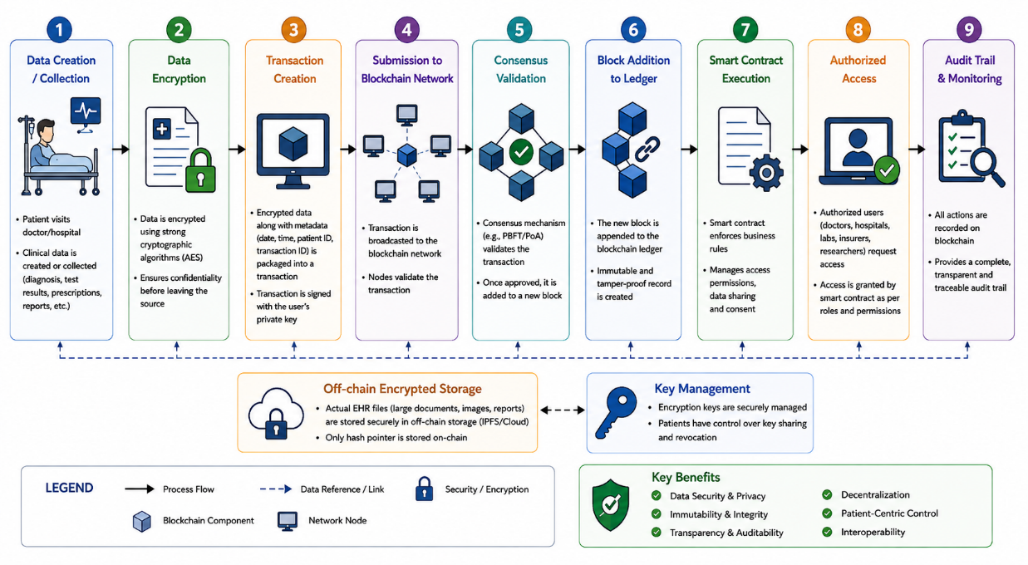
Figure 6. Workflow of the Proposed Blockchain-Based Electronic Health Record Management System.
As depicted in Figure 3, there is a workflow for the blockchain based management of Electronic Health Records that includes data generation and encryption to blockchain validation and secure data access.

3.5 Ethical Considerations
The study will meet the ethical requirements set forth by the University. The study will not collect any personal patient information or patient medical records. Whenever there is a need for demonstration purposes, synthetic and public information sources will be used.
The study will also take into consideration the legal and ethical concerns surrounding the protection of healthcare data. This will include the use of GDPR requirements. The software that is created within the study will not be used in practical healthcare.

4. Expected Outcomes
In view of the fact that this research project is still in its proposal stage, there are no results from experiments conducted. Nonetheless, based on the available literature and proposed methodology, some of the expected outcomes can be highlighted.

4.1 Anticipated Results
The introduction of the proposed blockchain-based EHR management system is expected to contribute significantly towards the improvement of cybersecurity of healthcare information systems. Through the introduction of the technology and cryptography techniques, cybersecurity risks of unauthorized access, manipulation of data and cyber attacks on healthcare facilities are expected to be mitigated.
In addition to that, the designed solution should offer a decentralised and immutable space for handling healthcare transactions. As opposed to the traditional centralised EHR management platforms, the use of blockchain technology is expected to ensure the presence of immutable logs of all performed operations, ensuring that any change or deletion of patient information becomes evident.
Moreover, the use of the suggested solution is expected to increase the level of authentication and access control, only providing access to patient records to authorised healthcare professionals based on the predefined permissions. The utilisation of smart contracts is expected to enhance the process of access management, decreasing the risk of the privilege escalation or human mistakes.
Considering the cybersecurity aspect, it can be stated that the developed framework is expected to show high resilience in terms of protection from the cyber attacks, such as ransomware, insider threats, credential abuse in case of phishing, and modification of medical records. Besides, the solution is expected to offer a complete audit logging system which will help to perform digital forensics after an attack.
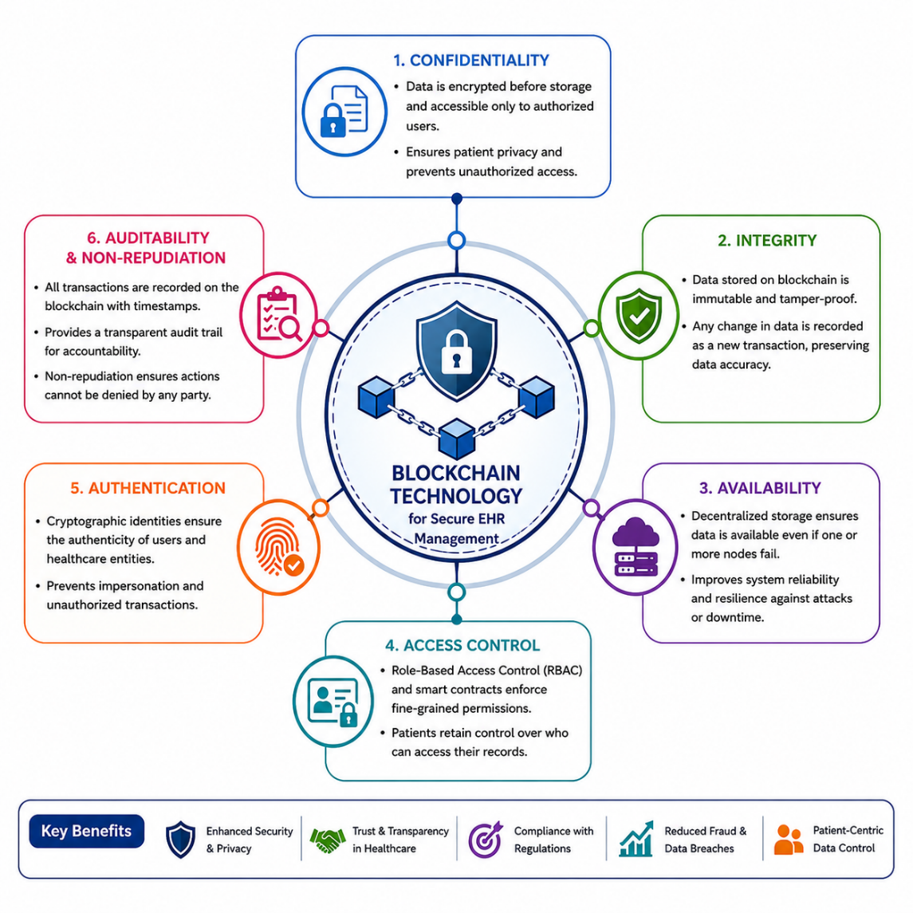

Figure 7. Key Cybersecurity Features of Blockchain-Based Electronic Health Record Management.
The cybersecurity features of the proposed blockchain based EHR management framework are illustrated in Figure 4 which include: confidentiality, integrity, availability, authentication, access control and auditability.

4.2 Implications of the Research
It is anticipated that the results of this study would be relevant from both the scientific and practical points of view.
In scientific terms, the study will enrich current knowledge about the use of blockchain technologies for enhancing Electronic Health Record system security. In particular, the study will allow for providing a comprehensive assessment of the possibility of using blockchain technologies to address cybersecurity issues within the healthcare environment while outlining issues that need to be further researched.
From the practical point of view, the proposed approach might be helpful for healthcare organizations in terms of enhancing the security of confidential patient data. In particular, through the use of decentralized storage of data, cryptographic confirmation, and permanent audit trails, healthcare organizations would be able to enhance their resilience to potential cyber attacks and comply with regulatory requirements related to the healthcare data protection.
Also, the study could be beneficial for cybersecurity experts and digital forensics specialists in regard to the possibility of using blockchain technologies for supporting secure evidence preservation and digital forensics.

4.3 Limitations
While blockchain has a number of advantages, there are certain limitations associated with the use of blockchain technology which might influence the suggested framework.
Firstly, one of the limitations is related to scalability issues as blockchain technology might have lower efficiency in terms of processing large amounts of healthcare transactions. Large amounts of clinical data are generated on a daily basis, and achieving a decent level of transaction speed in terms of blockchain technology might be difficult.
Secondly, another limitation of blockchain technology is implementation difficulty. Using blockchain technology and integrating it into existing Electronic Health Record systems might be complicated.
Moreover, the current research is limited by the amount of time and available resources. As the research is carried out within the context of an MSc research project, the suggested framework can be implemented only via simulations or prototypes. Thus, the results of the study might not reflect the situation in a real healthcare environment.
Finally,it is critical that healthcare organizations keep up with their legal and regulatory responsibilities. One area where this is pertinent is that of data protection laws like GDPR. Although the blockchain technology provides greater security and transparency, ensuring immutability of data while meeting certain requirements to change or delete data poses a challenging future research topic.

5. Timeline
This research is expected to last for three months, which would correspond with the period of time covered by the second semester. All phases of research have been structured around an activity that would make sure that the research process is well-organized.
Month | Task
Month 1 | Literature Review
Month 2 | Framework Design and Methodology
Month 3 | Framework Evaluation and Report Writing
During the first month of research, emphasis will be laid on reviewing the literature concerning EHR, blockchain technology, healthcare cybersecurity, and blockchain-based healthcare solutions currently in existence. This will allow identifying research gaps, determining the research problem and laying down the theory behind this proposed research.
The second month will entail designing the proposed EHR management framework using blockchain technology. This will involve designing the architecture of the system, determining the relevant blockchain technology, specifying the cybersecurity measures like cryptographic hash, smart contract, authentication, and access control, among others, and finally formulating the research methodology.
The third month will see the evaluation of the proposed framework based on comparison to conventional Electronic Health Record frameworks, using the cybersecurity measures such as confidentiality, integrity, availability, authentication, access control, and auditability, as benchmarks. The final stage will include analysis of the results, discussion of the anticipated results, drafting of the research proposal, proofreading the document and referencing it in IEEE style.

6. Conclusion
The adoption of EHR systems has led to major changes in the modern healthcare sector since they allow better storage, accessibility, and management of medical data. However, the adoption of such information systems is associated with a higher level of vulnerability to new types of cybersecurity threats, such as ransomware, data breaches, unauthorized access, and attacks from within. Such problems prove the necessity of developing new secure and reliable information systems for the healthcare sector that could guarantee the security and privacy of medical data.
The proposed research will focus on the evaluation of the effectiveness of a blockchain-based solution for increasing the security of EHRs management. The development of such a framework based on cryptography, decentralization, smart contracts, and secure access will allow increasing data protection and auditing capabilities and lowering the risks of cyber-attacks. Moreover, this research will be focused on solving existing problems associated with traditional centralised EHR systems and secure information exchange between healthcare organizations.
Overall, it can be assumed that the suggested research will be helpful for academia and cybersecurity practitioners in comprehending the opportunities offered by blockchain technology for enhancing information security in the healthcare industry. It might help stakeholders to create more secure, reliable, and transparent EHR management systems, which would be able to counteract the latest cyber threats.

References
[1] S. Nakamoto, Bitcoin: A Peer-to-Peer Electronic Cash System. 2008.
[2] A. Al Mamun, S. Azam, and C. Gritti, "Blockchain-Based Electronic Health Records Management: A Comprehensive Review and Future Research Direction," IEEE Access, vol. 10, pp. 5768–5789, 2022, doi: 10.1109/ACCESS.2022.3141079. This is one of the best review papers for your topic because it analyses blockchain-based EHR systems, privacy, security, scalability, and future research directions.
[3] E. R. Dulce Villarreal, J. Garcia-Alonso, E. Moguel, and J. A. Hurtado Alegria, "Blockchain for Healthcare Management Systems: A Survey on Interoperability and Security," IEEE Access, vol. 11, pp. 5629–5652, 2023, doi: 10.1109/ACCESS.2023.3236505. This survey focuses on interoperability and cybersecurity in blockchain-based healthcare systems.
[4] S. Koumpounis and M. Perry, "Blockchain-Based Electronic Health Record System with Patient-Centred Data Access Control," in Proceedings of the 2023 IEEE/ACM International Workshop on Emerging Trends in Software Engineering for Blockchain (WETSEB), 2023, pp. 17–24.
[5] M. A. Azaria, A. Ekblaw, T. Vieira, and A. Lippman, "MedRec: Using Blockchain for Medical Data Access and Permission Management," in Proceedings of the 2nd International Conference on Open and Big Data (OBD), 2016, pp. 25–30.
[6] National Institute of Standards and Technology (NIST), Security and Privacy Controls for Information Systems and Organizations, Special Publication 800-53 Revision 5, 2020.
[7] European Union Agency for Cybersecurity (ENISA), ENISA Threat Landscape 2024, 2024.
[8] World Health Organization (WHO), Global Strategy on Digital Health 2020–2025, Geneva, Switzerland, 2021.
[9] International Organization for Standardization, ISO/IEC 27001:2022 Information Security, Cybersecurity and Privacy Protection – Information Security Management Systems – Requirements, Geneva, Switzerland, 2022.
[10] IBM Security, Cost of a Data Breach Report 2024, IBM Corporation, 2024.

