Generating Business Data and Analysis (BMSP4004)
Alexander Hudson
Dr Roisin Mullins
4th May 2018

Contents
Abstract 3
Appliance Carbon Data 3
Prosumer Survey Data 9
Weather Data 17
Swansea Business School Data 21
Conclusion 23
References 24

Abstract

For this assignment, the task was to work on 4 excel documents which include the Prosumer Survey, the Appliance Carbon Survey, the Weather List File and the Electrical Data Set. Throughout this assessment, all four documents will be discussed with step by step instructions of how the data was cleared up while also providing before and after screenshots of the data clean up.

Appliance Carbon Data

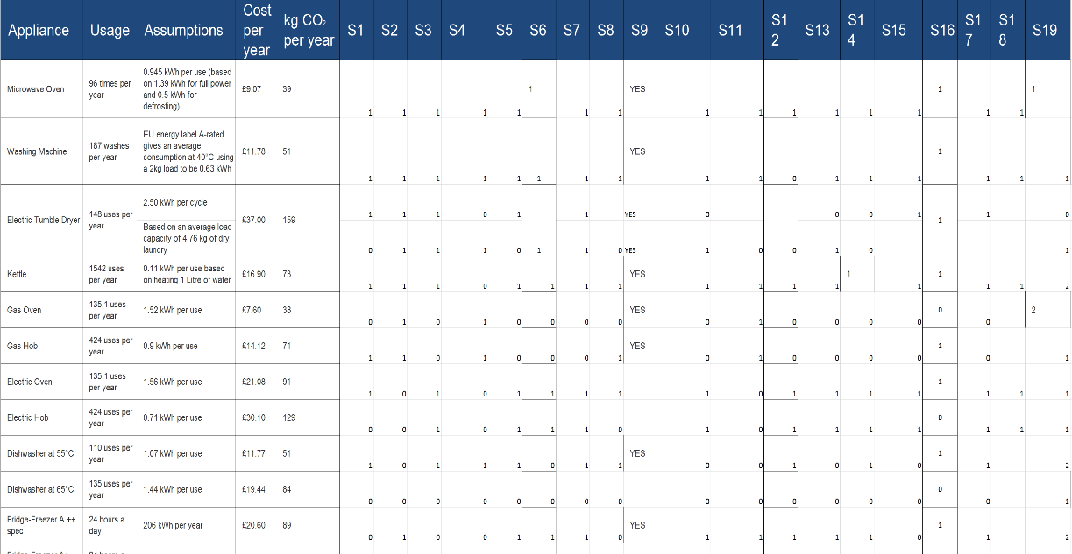
Within this document, it consists of information and data about household appliances along with their usage and assumptions. There are two parts to this document, part one focuses on kitchen products which covers kWh (kilowatt) assumptions and part two focuses on a living room product which are TVs which covers W (watts). With this document, the first task was to clean up the data.
This is a screenshot of the data before the clean-up. Some of the data within this document contain empty squares and in the column ‘S9’ instead of ‘0’ or ‘1’, the results are ‘yes’, and one of the cell rows contain two answers for the same appliance.

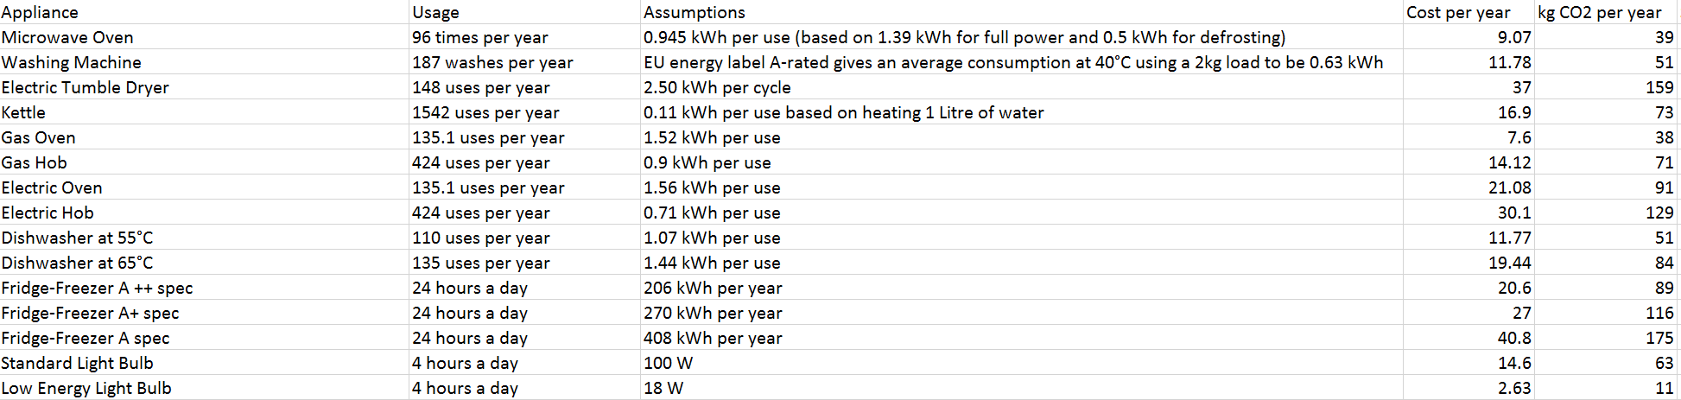

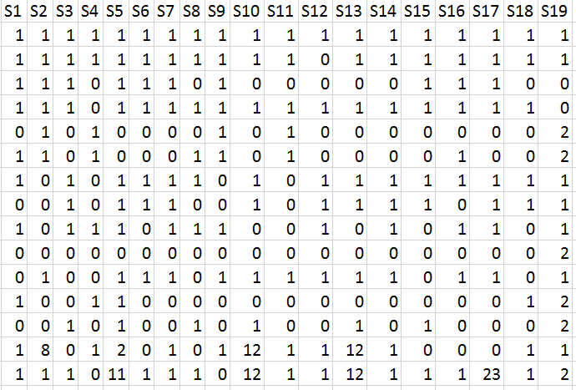
The screenshots provided here show the data after clear up. The first step of the clear up here was to restructure the table to make the data look tidier and make it more readable. The second step of the clear up was to erase or change any errors that were shown. One error that was changed was removing yes from the s9 column and replacing them with ‘1’ and any blank spaces were filled with ‘0’.

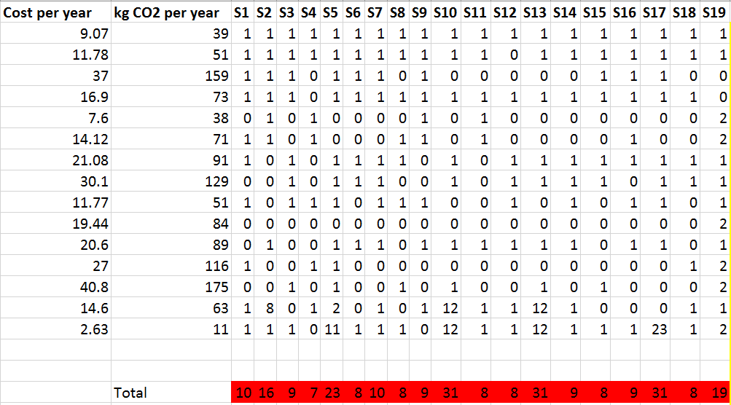
After cleaning up the data, the next task was to do the calculations for the ‘cost per person per year’ and ‘kg CO2 per year’. The first calculation made was adding each column and finding the total of each.
In this screenshot, the total for each month is shown below the data. The totals have been highlighted to show that they have been added to the database which also acts as a colour code. Columns ‘s10’, ‘s13’ and ‘s17’ have the highest totals.

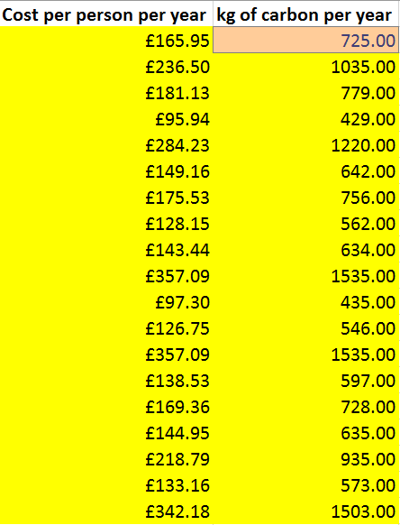
In this screenshot, the calculations for ‘cost per person per year’ and ‘kg of carbon per year’ were made. The step for calculating the first column was to add each data cell containing ‘1’ with the ‘cost per year’, and for the second column the same step had to be undertaken but with the ‘kg CO2 per year’. These were calculated by using an =SUM formula.

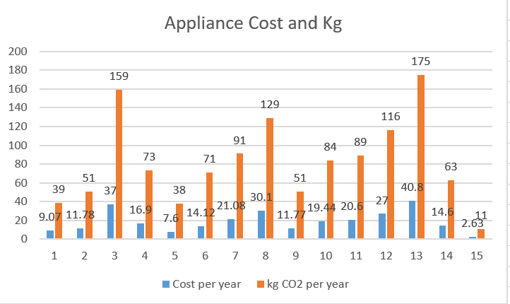
After working out the calculations, the final step was to add charts to compare the data of the totals. This was to make the data comparisons easier to understand.
This screenshot shows the first graph comparing the data for comparing the ‘Cost per year’ and the ‘kg CO2 per year’ that was already included in the data before clean up.

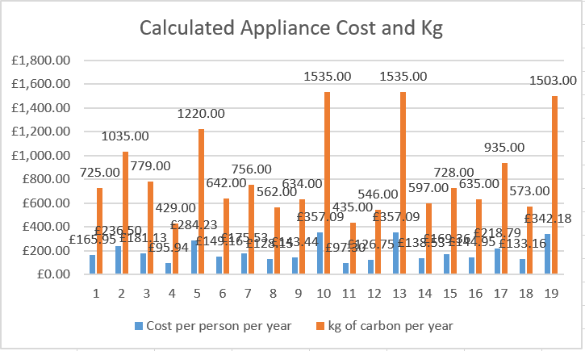
This screenshot shows the second graph which compares the calculated ‘Cost per year’ and ‘kg CO2’ after clean up. As shown the numbers have increased greatly compared to the first graph as the s columns were used to calculate these totals.

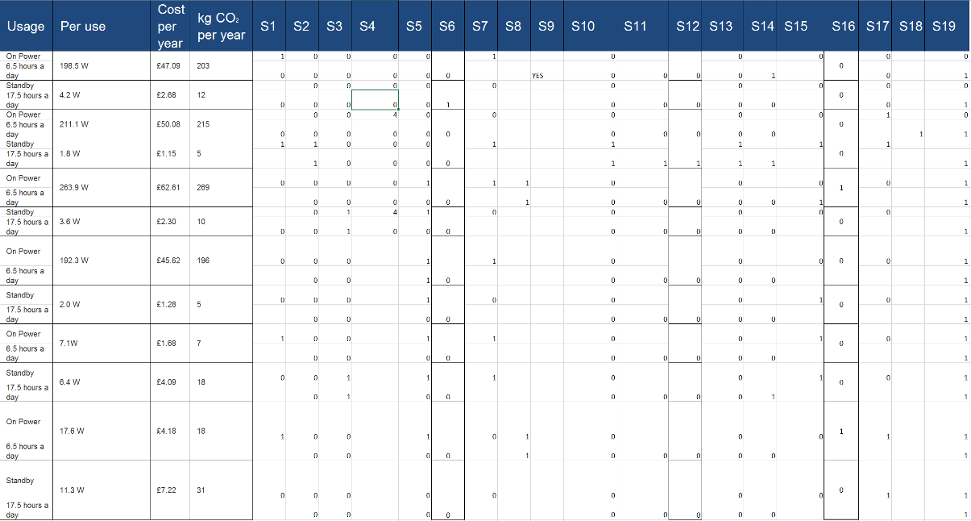
The Appliance Carbon data contains two parts and the screenshots provided above show part 1 of the worksheet. Part 2 of the appliance data will be provided below.
This screenshot shows the second part of the data before the clean-up. Just like the first part, there are some missing data within the data sheet along with a single ‘yes’ in the s9 column instead of ‘1’.

This screenshot shows a major error within the data. Some of the cells contained duplicates which can initially cause confusion when looking through the data.

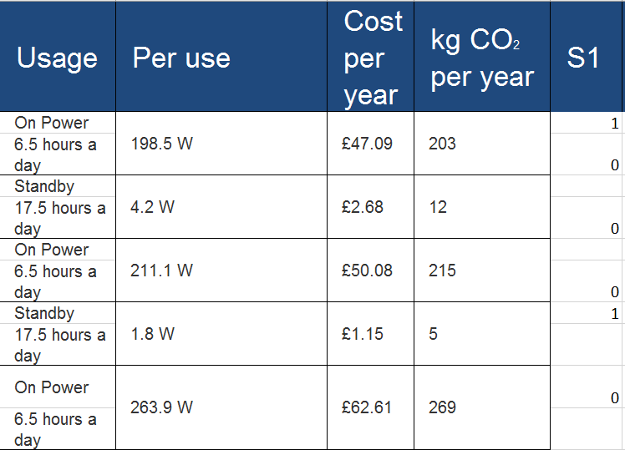

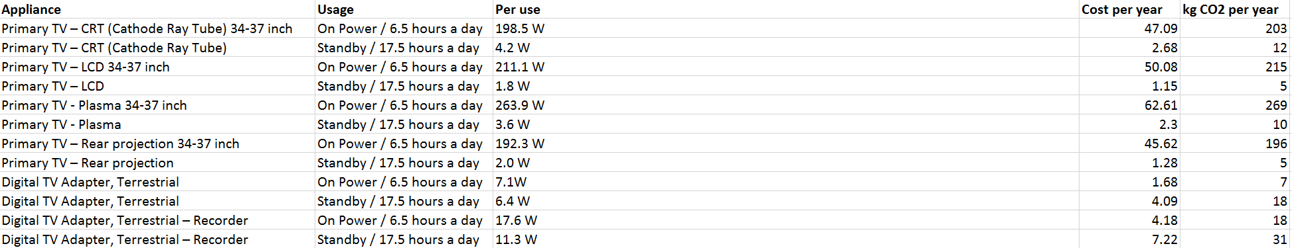

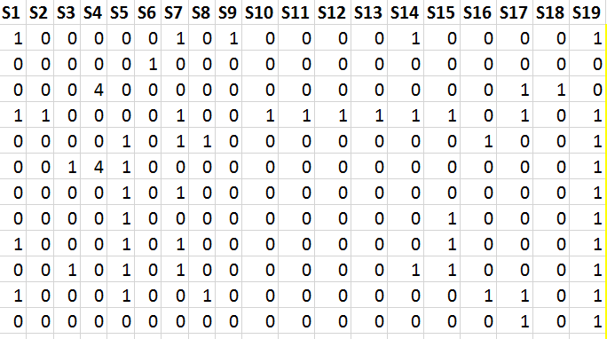
These screenshots show the data after the clean-up. Just like the first part, the first step was to restructure the table to make the data look tidier. The second step was to resolve any errors within the data so for example, getting rid of any duplicates, replacing the ‘yes’ with a ‘1’ and fill in blank spaces with ‘0’.

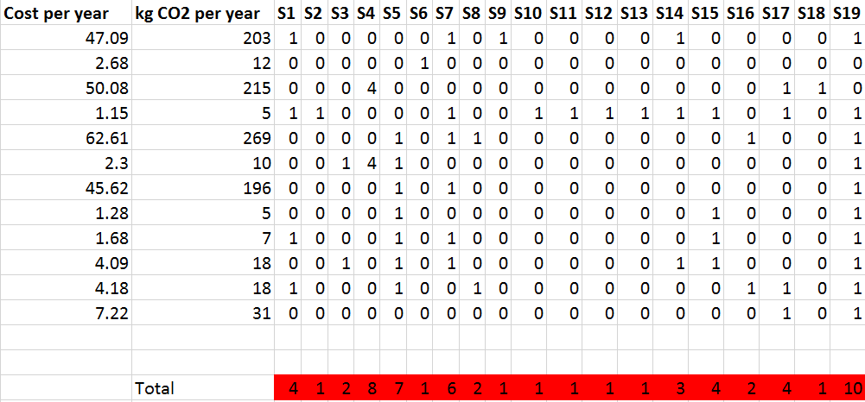
This screenshot shows the total for each month located at the bottom. As previously done in the first part, I have highlighted the totals to show that they are calculated results and also acts as a colour code. The column s19 has the highest total.

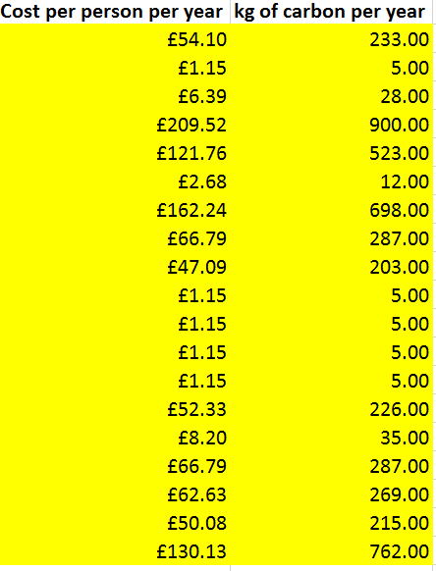
This screenshot shows the results of the ‘Cost per person per year’ and ‘kg of carbon per year’ calculations. The step to calculating involved the same procedure as part 1, add each cell that contained a ‘1’ with the data from the ‘Cost per year’ and ‘kg CO2 per year’. The same formula was used for these calculations which is the =SUM.

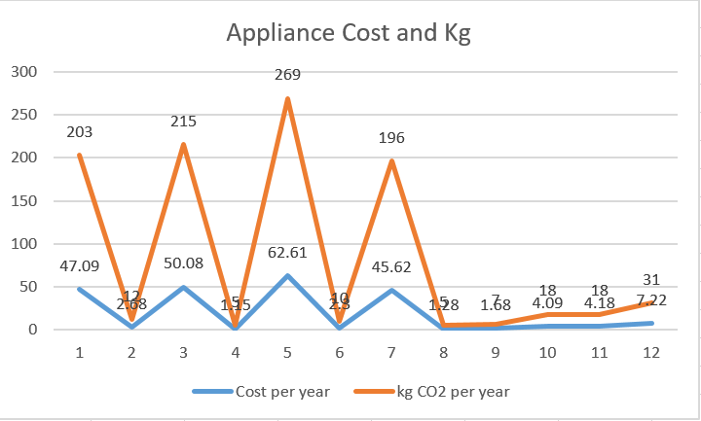
This screenshot shows the third graph of the appliance data. This graph compares the data of the ‘Cost per year’ and the ‘kg CO2 per year’ which was included in the survey before the clean-up.

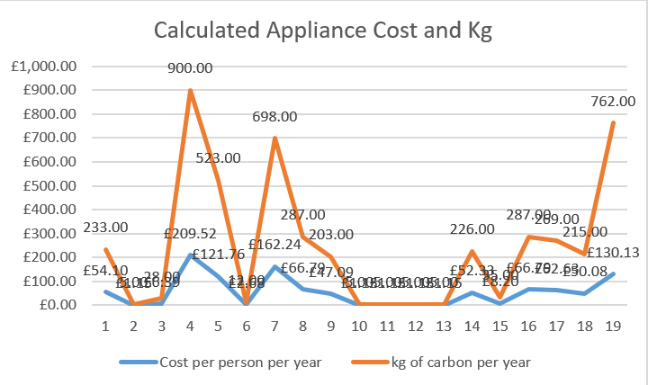
This screenshot shows the fourth graph of the appliance data. This graph compares the data results from the ‘Cost per person per year and ‘kg of carbon per year after clean-up and calculations. As done in the first part, the data from the s columns were added using the =SUM formula with the ‘Cost per year’ and the ‘kg CO2 per year’.

Prosumer Survey Data

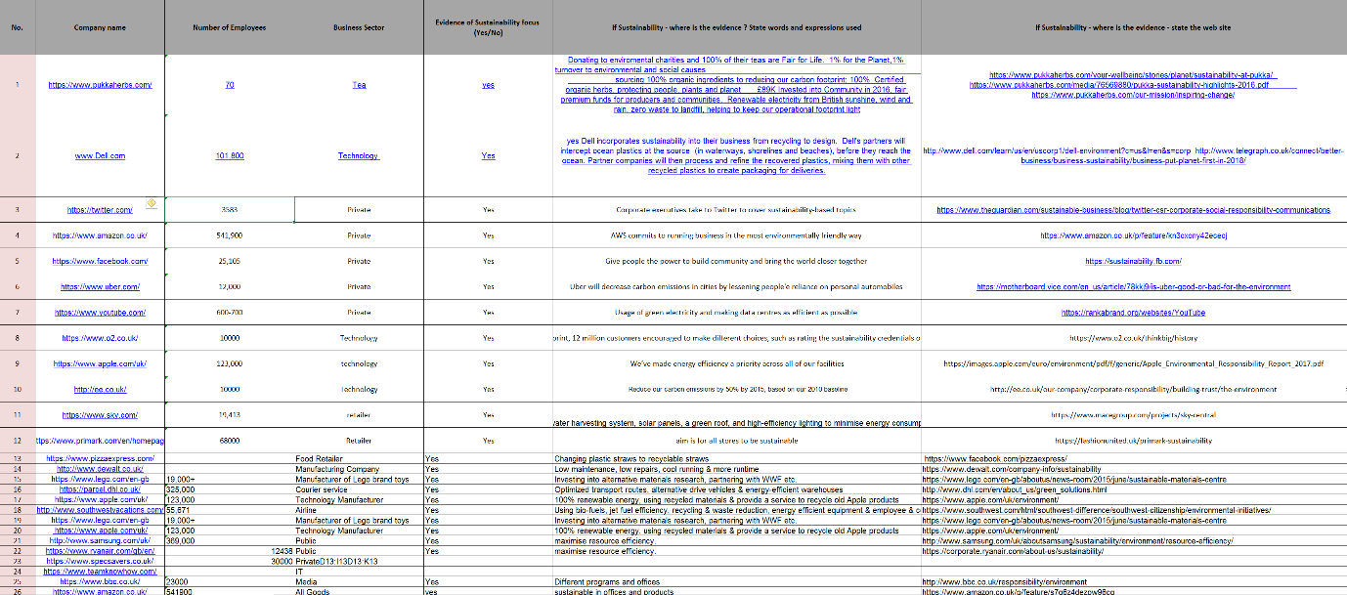
This excel document consists of data involving prosumers as stated in the title. A prosumer is an individual that is more than just a standard consumer and often shows interest professionally in a company and/or their services and products (Techopedia, 2018). Within this document, it contains four tabs which are Business Processes, Ways of Knowledge Sharing, Incentives and ICT. The task for this document was to clean all four of these tabs.

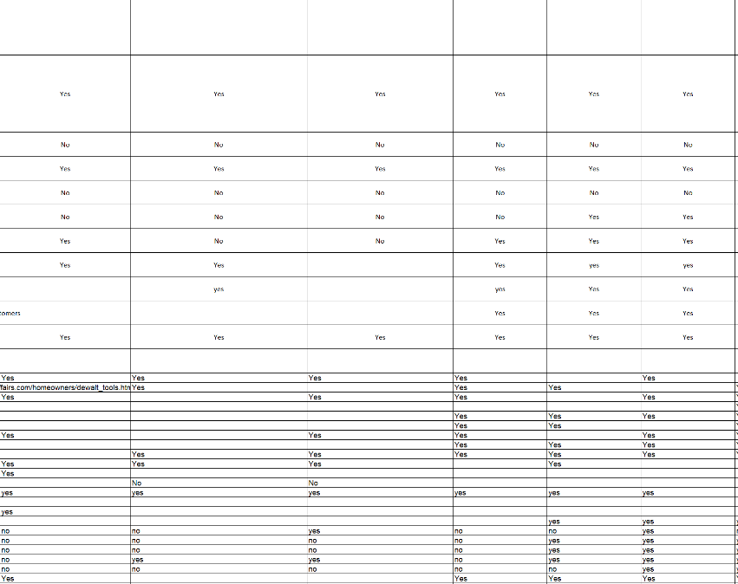
This screenshot shows the same tab before clean-up. Here there are quite a number of blanks spaces and again there are some different sized fonts and text styles.
The screenshot above shows the Business Process tab before clean-up. As shown in the screenshot, the company names are filled with hyperlinks to the websites of the companies, some of the wording has also been highlighted and there are different sized font’s and text styles and blank spaces. There are also some duplicated data within the data.
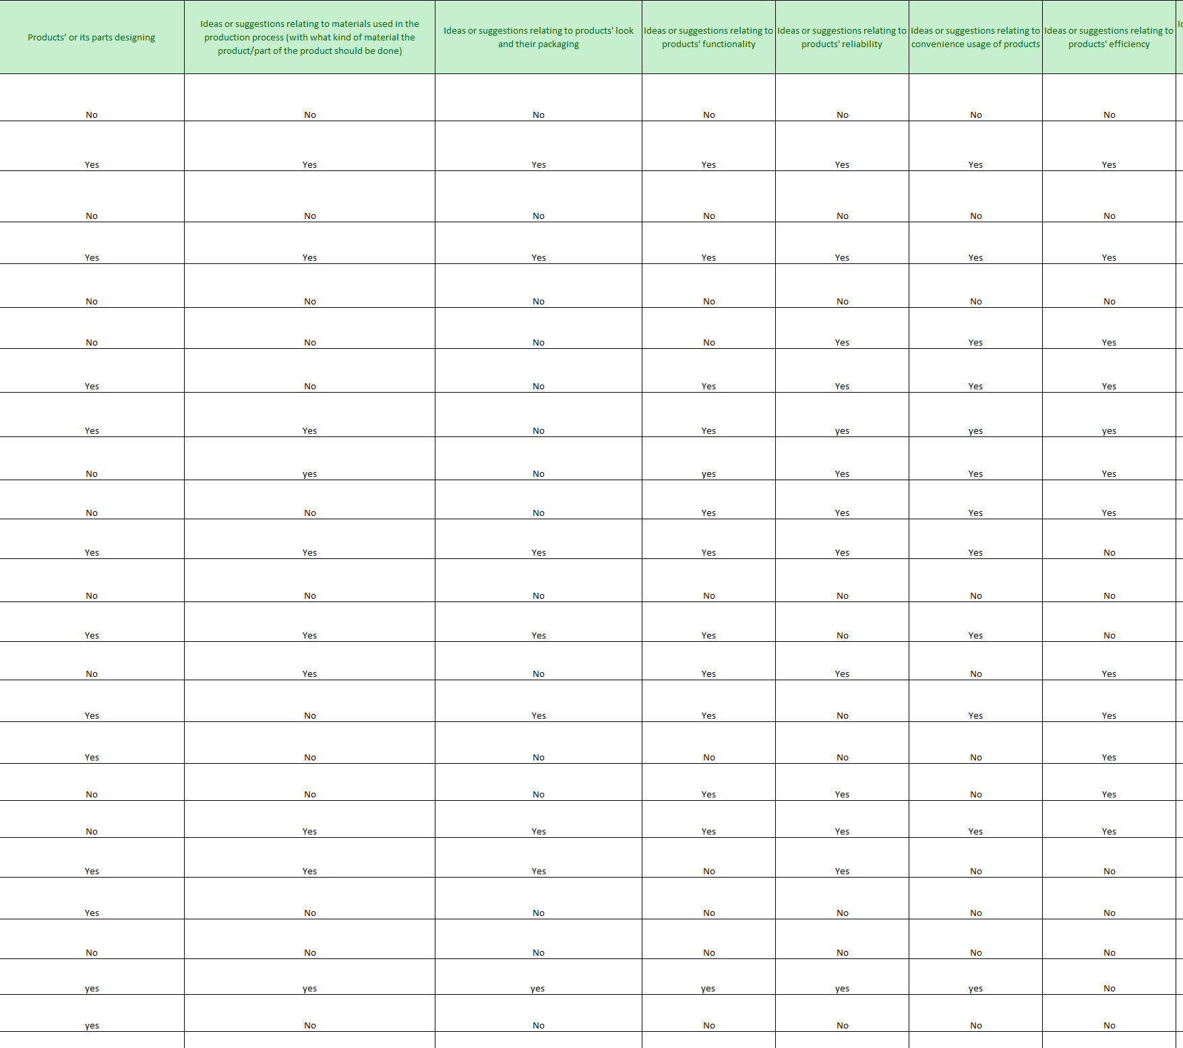
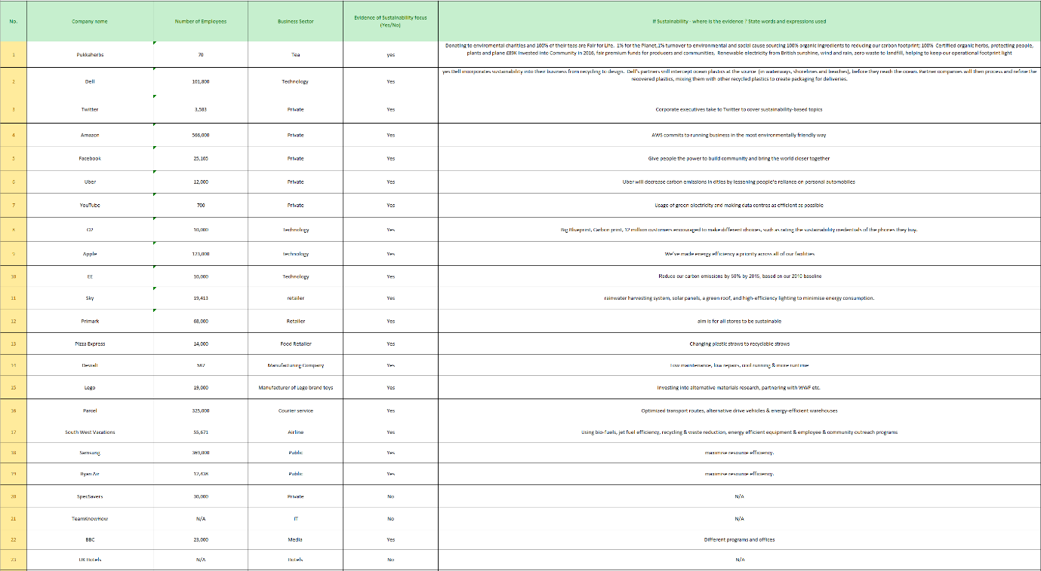
The screenshot provided above shows the Business Processes tab after clean-up. The first step of this clean-up was to change all font sizes to 11 and the text style to Calibri. The second step was resizing all cells to equal sizes to make the columns tidier. The third step was changing the colour of the column headers and row numbers to make the data look more appealing. All data duplicates were removed as duplicated data can complicate things.
This screenshot also shows the same tab after clean-up. The fourth step was to fill out all the blank spaces with ‘No’.
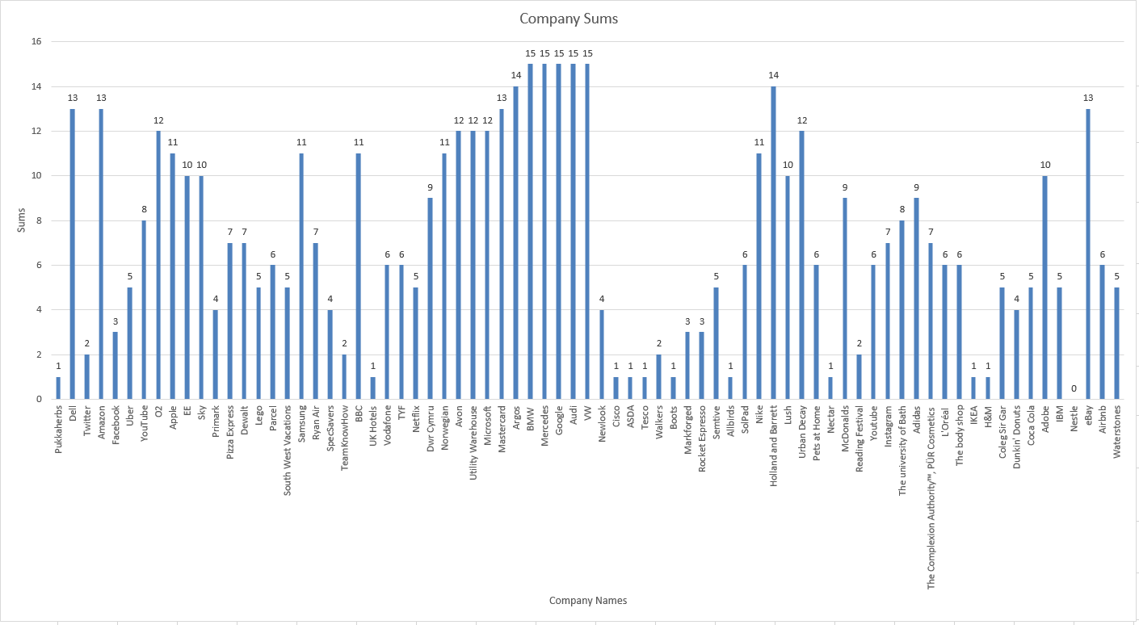
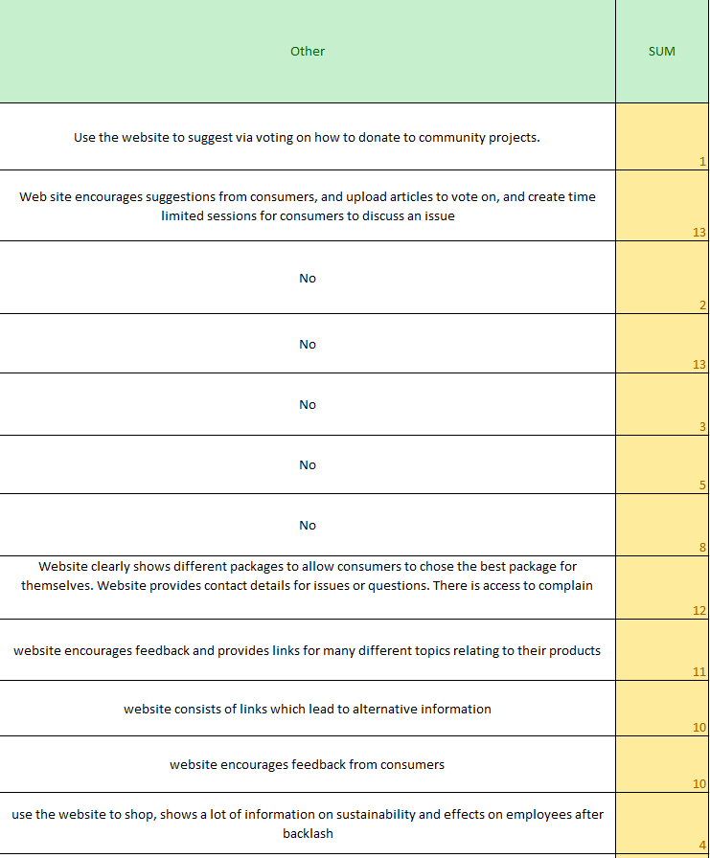
The screenshot below shows a graph that was added to the Business Processes tab after the clean-up. The graph combines the company names with the sums to give a more understanding represented result.
This screenshot shows the final step of the clean-up for the Business Processes tab. The step was changing all the incorrect sums at the end.
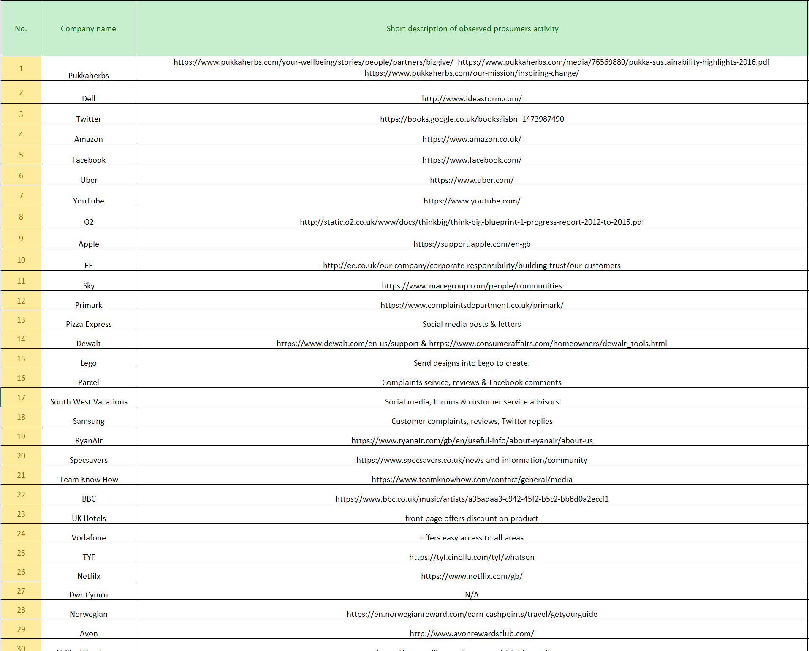
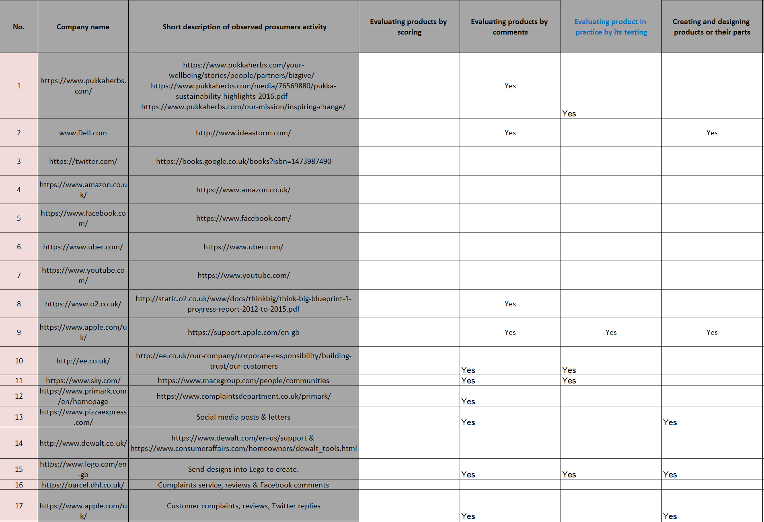
This screenshot shows the same tab after the clean-up. Just like the first tab, the clean-up steps are pretty much the same procedure. The text style was changed to Calibri and the font size was changed to 11. The hyperlinks were replaced with actual company names and the text was wrapped to fit into a single cell.
The screenshot above shows the Ways of Knowledge Sharing tab before clean-up. In this tab, there wasn’t as many columns as the first but basically consists of the same errors. The company names are again hyperlinks, there are quite a lot of blank spaces and one of the column headers is randomly in blue font.
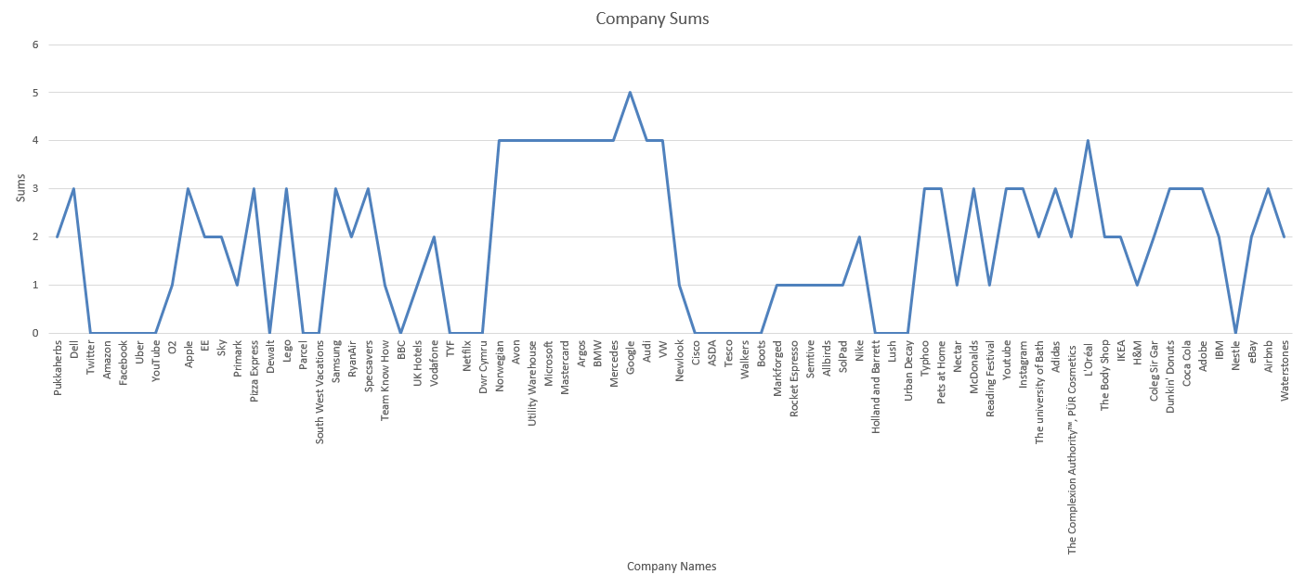
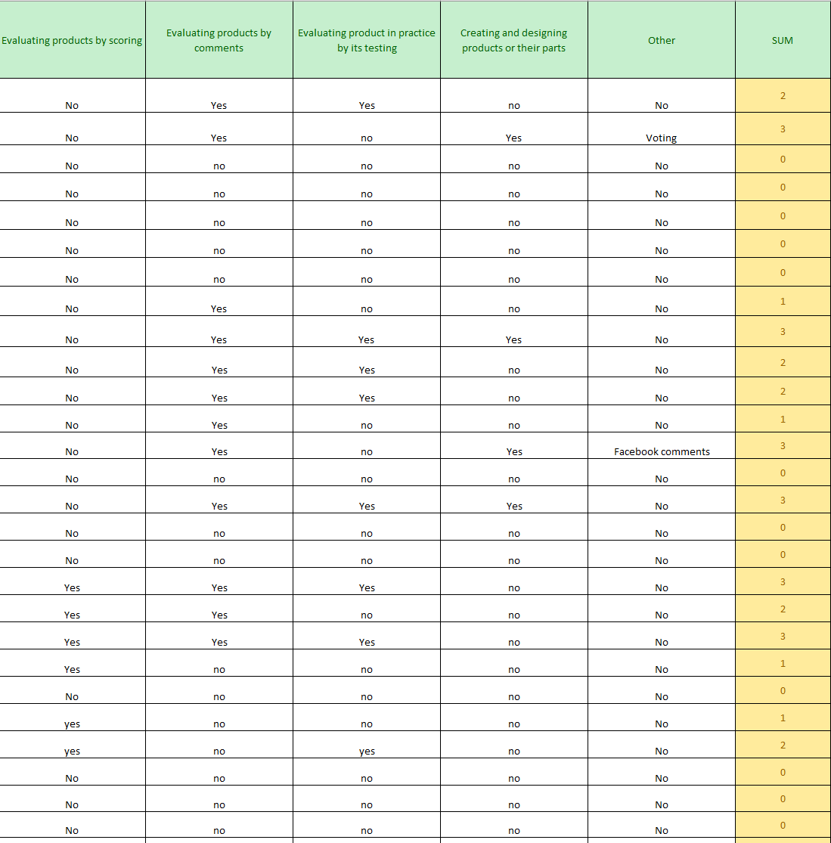
This screenshot shows the same tab after clean-up. The blank spaces have been filled with ‘No’ and the sums that were incorrect were changed. Some cells were already filled with answers other than ‘yes’ or ‘no’ but counted towards the sum.
The screenshot below shows the graph from the Ways of Knowledge Sharing tab. Just like the Business Processes graph, this graph combines the company names with the sums to give a more clear result on which company has the highest total sum.
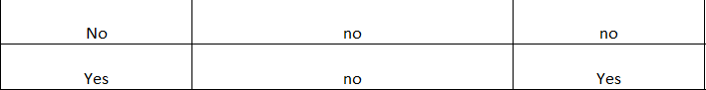
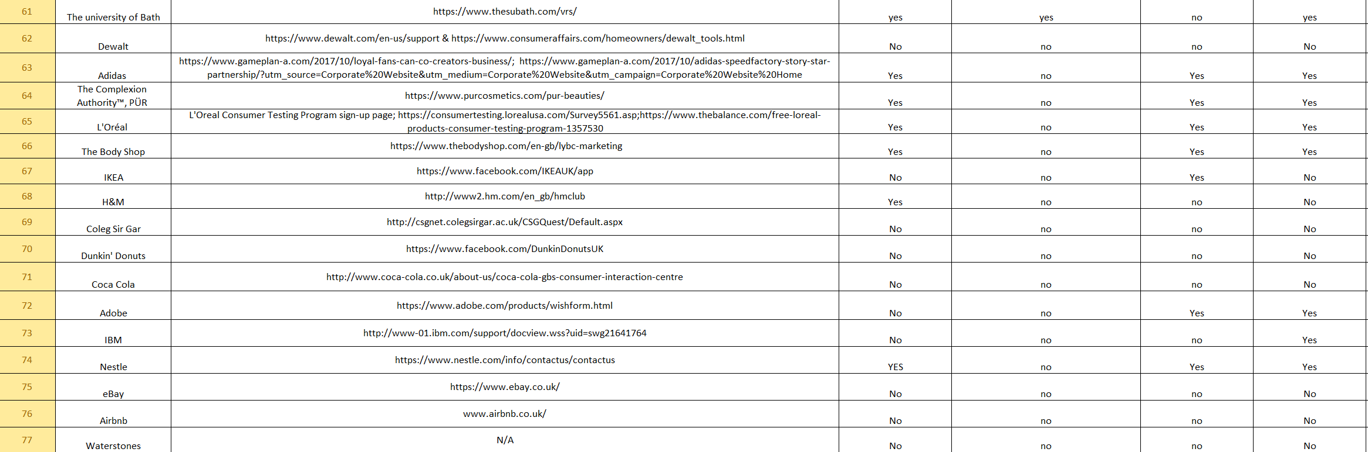
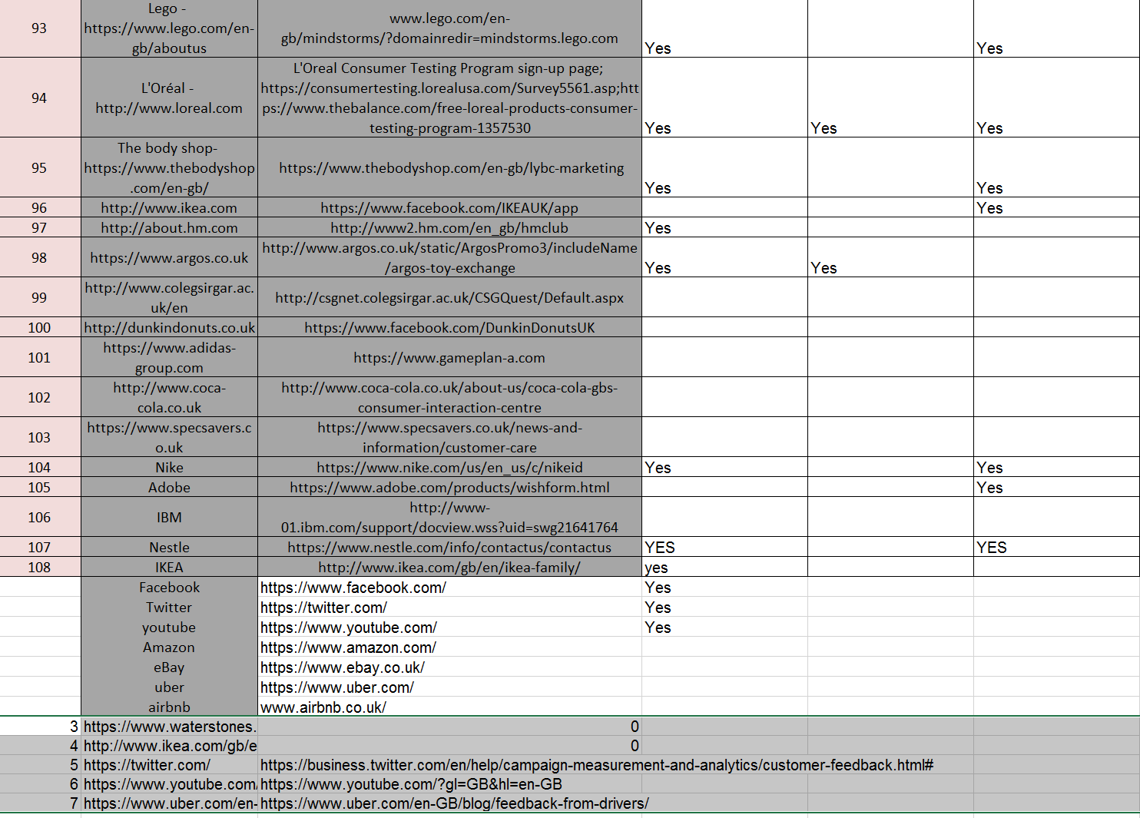
The screenshot above shows the same tab after clean-up. The highlights were removed to view the data easier and to make it look tidier. Boarders were added on the cells that didn’t include them before clean-up, and the caps were taken out of the two ‘yes’ answers.
This is a screenshot of the Incentives tab before clean-up. This tab has the same errors as the previous two, but however some of the data here hasn’t been highlighted and some of the answers are in caps.

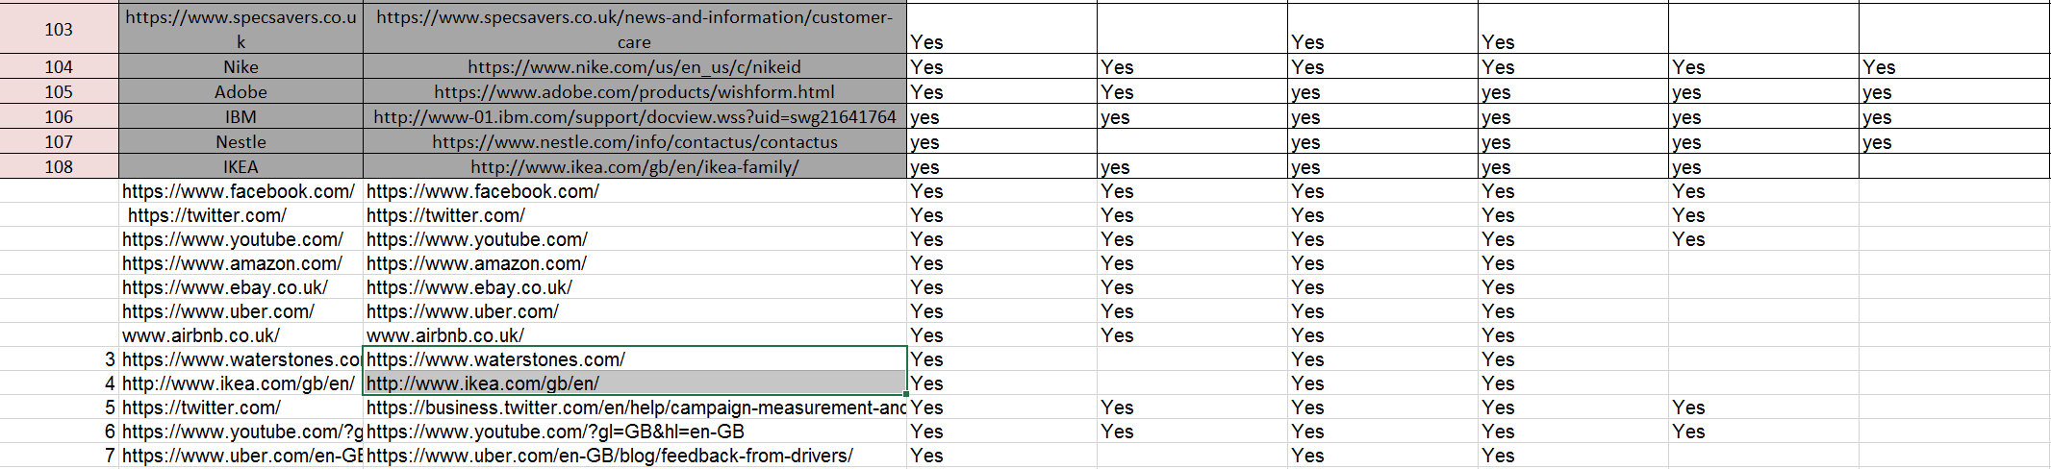
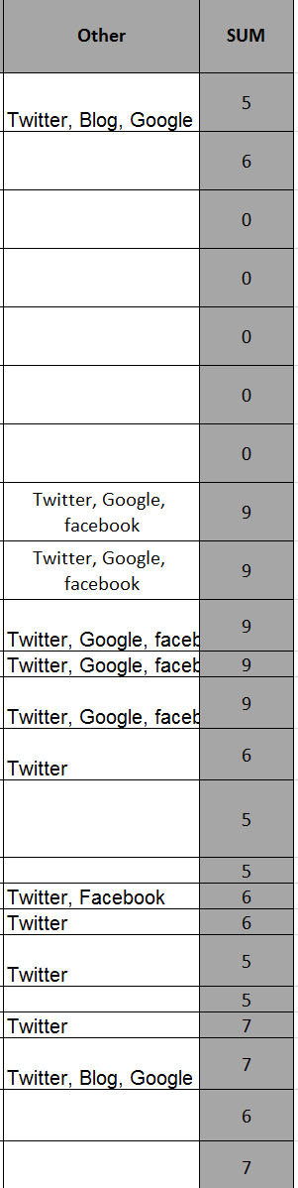
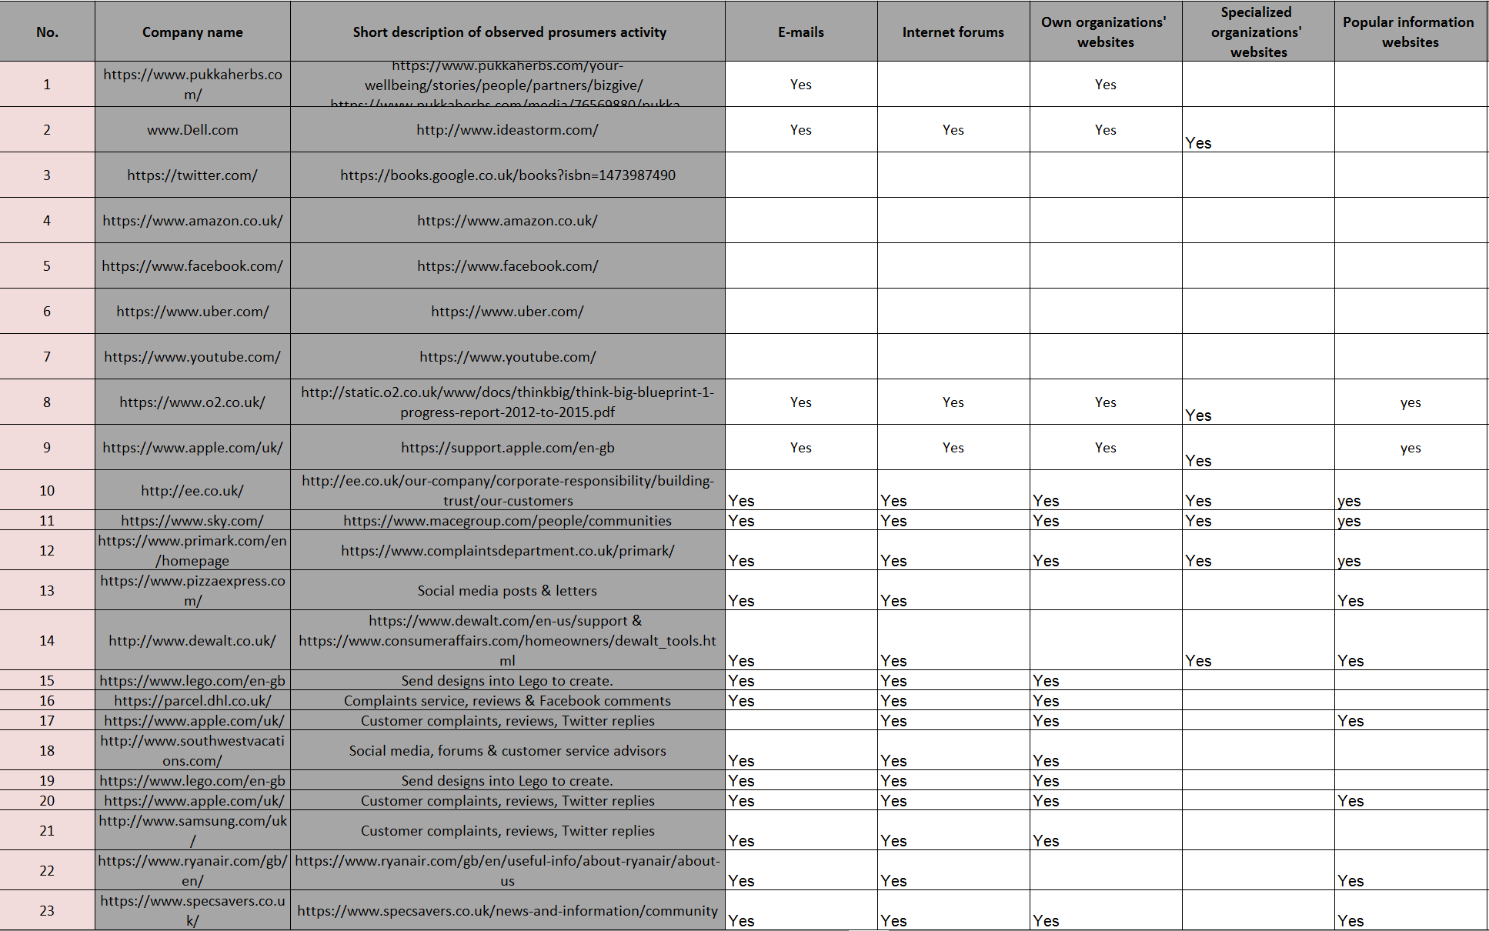
The screenshots provided above show the final tab of the prosumer survey which is ICT before clean-up. Just like the other tabs, there are differences in font sizes and text styles, some of the sums are incorrect, there are some blank cells and some of the data has been left without any highlight.
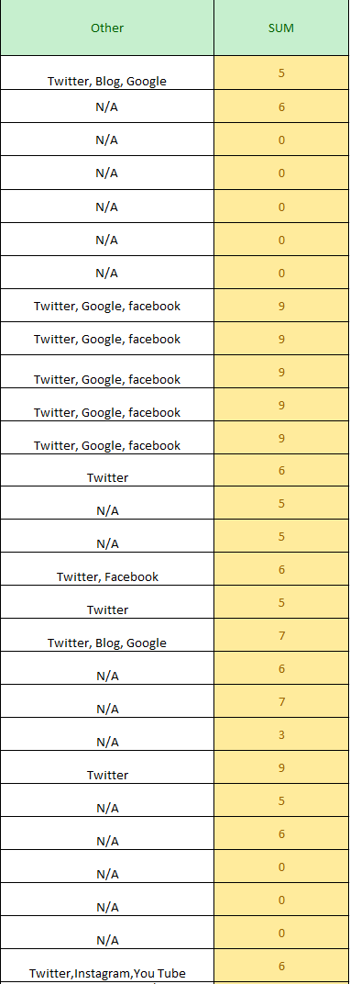
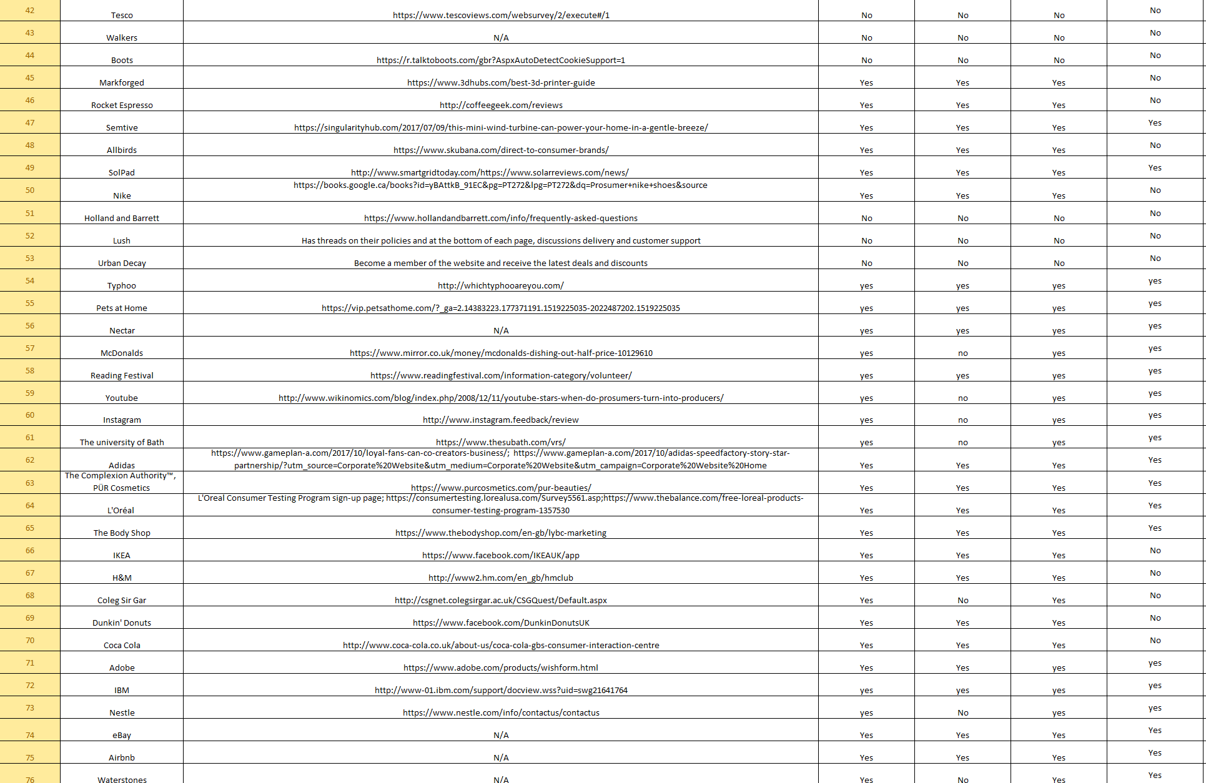

The screenshots shown above shows the final tab after clean-up. The blank spaces have filled in, the font sizes and text styles are all the same, the highlights have been removed and the incorrect sums have been corrected.

Weather Data

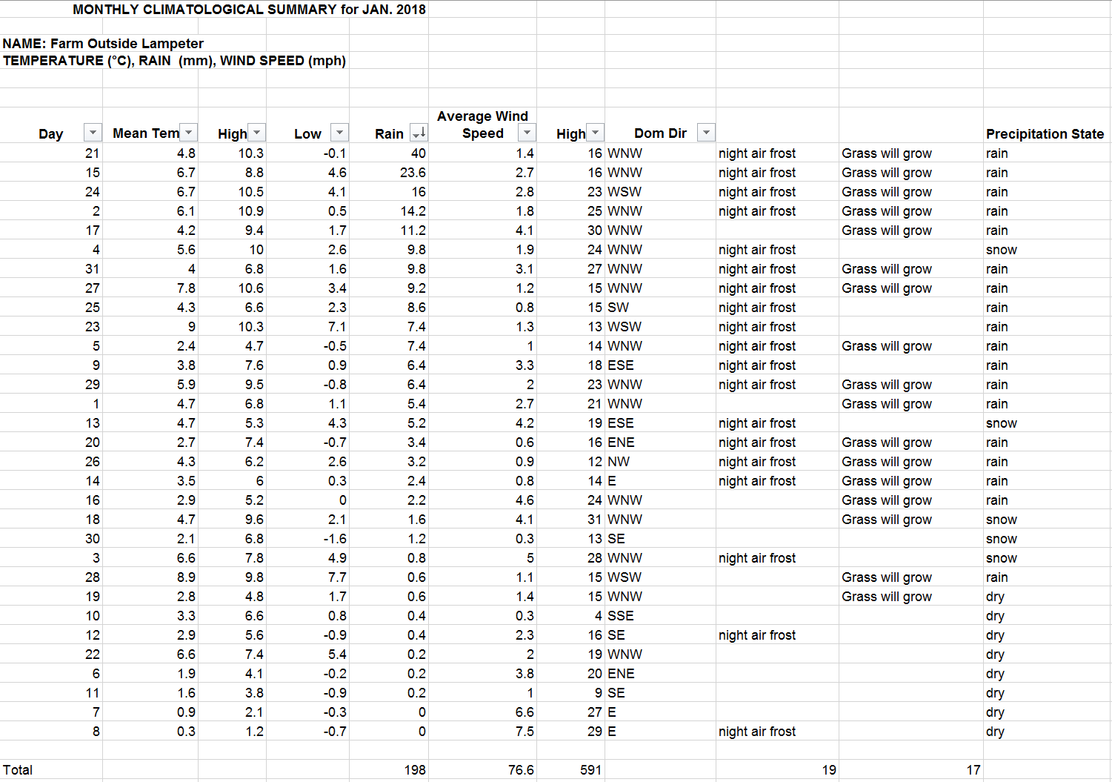
For this document, this is when IF statements and LOOKUP functions come into play. This document consists of two parts, a monthly summary for January 2018 and another monthly summary for January 2010.
An IF statement is a conditional programming statement that displays information or performs a function, if proved true (Computer Hope, 2017).

The screenshot provided here shows the 2018 summary of the weather data. This is the completed document with steps explaining how the clean-up and calculations worked.

In the screenshot above, each column header has drop down arrows which show that they have the filter setting active. Filters can enable the ability to sort the data in either ascending or descending order. For some of the columns, the task was to find the highest and lowest number, so the filter was used to find the results of both.

The screenshot above shows the average of Mean Temp and Rainfall, the was found by using the =AVERAGE function.

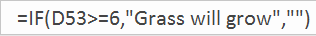
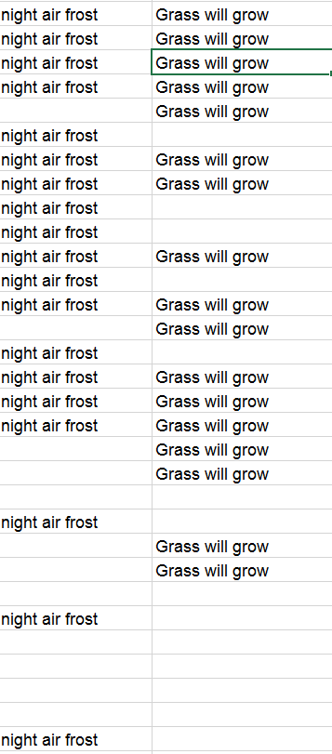
The screenshots above show the workings of the IF statement. The first column shows ‘night air frost’ and the second column ‘grass will grow’. To get these results to work, this function had to be inserted.

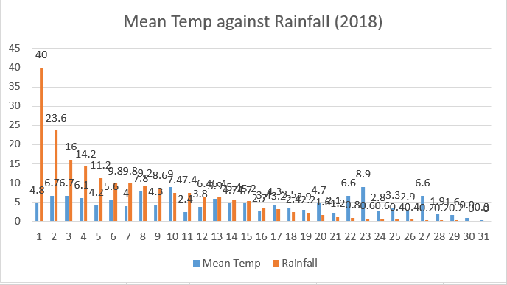

This screenshot above shows the graph for Mean Temp against Rainfall for 2018. The results for Rainfall gradually decline overtime and the results for the Mean Temp increase and decrease.

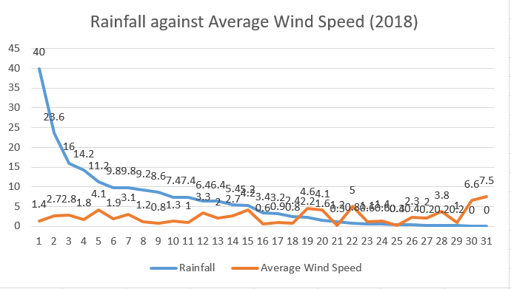
This screenshot shows the graph for Rainfall against Average Wind Speed for 2018. The results for Rainfall gradually decline overtime and the average wind speed increase and decreases but ends on a higher point than the start.

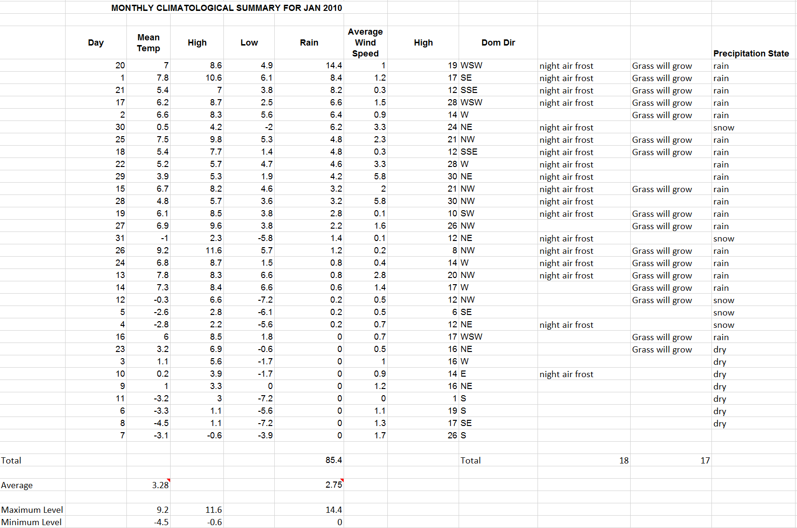
This screenshot shows the weather summary data for 2010. This document is also completed and the same steps apply when cleaning the data. This also applies to the calculations that were involved in the 2018 data.

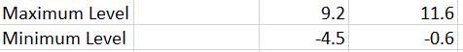

In the screenshots, each of the column headers have drop down arrows indicating that they have the filter setting active. Just like the other data set, the filters were used to find the highest and lowest level of the Mean Temp, High and Rainfall.

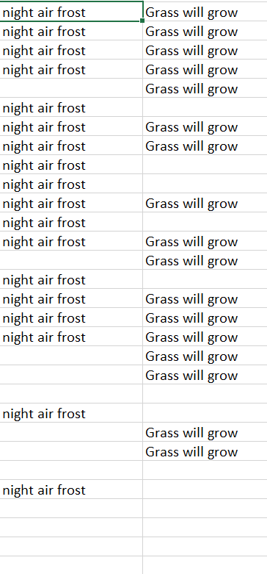
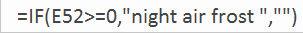

The screenshots provided here show the IF statement being used again. To calculate the results for the night air frost and grass will grow columns, the function above had to be used. What made excel a good data software was the feature to simply drag the cell with the IF function down and it would automatically fill in other cells that have the same requirements for the answer.

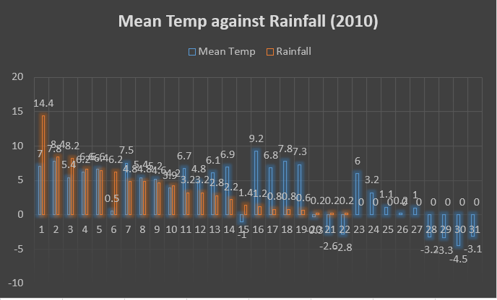
This screenshot shows the graph for the Mean Temp and Rainfall for 2010. The Rainfall data gradually declines just like the 2018 data and the Mean Temp increases and decreases.

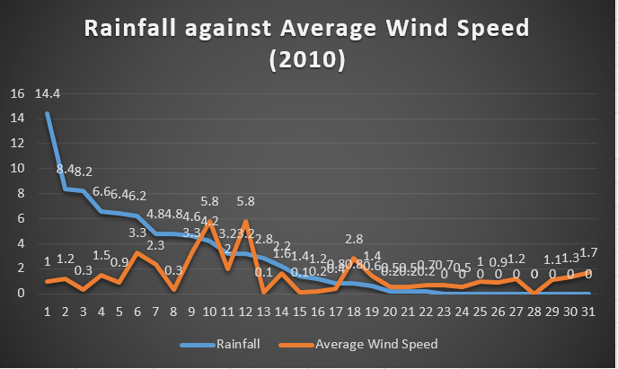
This screenshot shows the graph for the Rainfall against Average Wind Speed for 2010. The data is almost the same as the 2018 data, this is because the rainfall line gradually decreases and the average wind speed has a couple of minor spikes.

A lookup function or table is an array that is used within computer programming that takes hold of values that would require calculation. Once the values are required during a later performance, the lookup function does its intended function (Computer Hope, 2017).

Swansea Business School Data

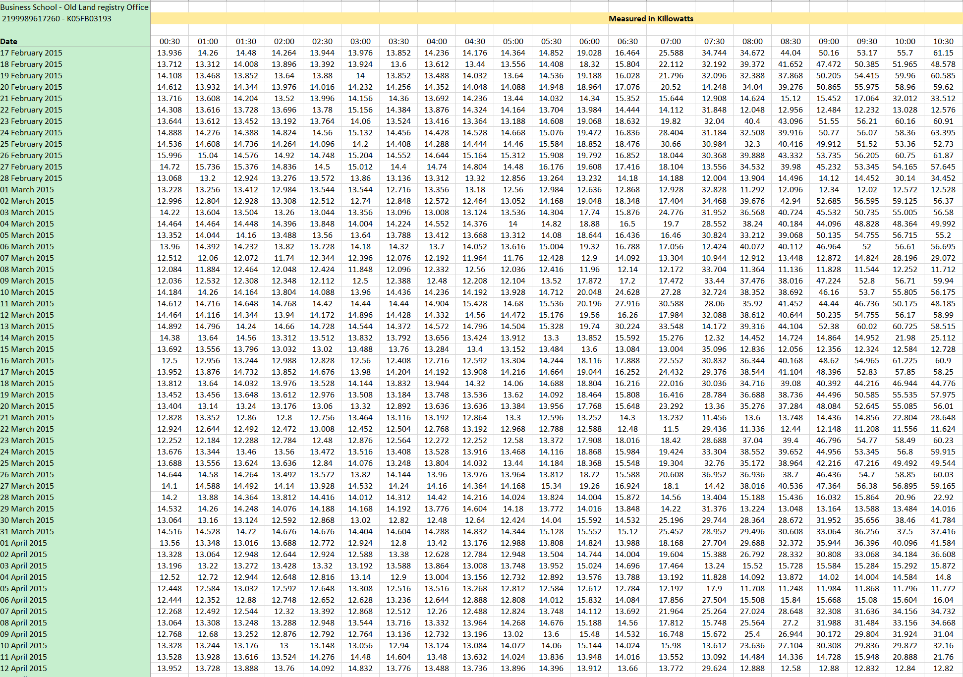
For this document, this is when PIVOT tables and graphs come together. The objectives for this was to find the total for each date and use the totals to make graphs and PIVOT tables.

The screenshot provided above shows the Swansea Business School after the clean-up. The first step to cleaning up this data was getting rid of all the blank spaces, the second step was adding up each date to find the total for each to use for the graph.

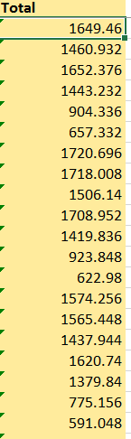
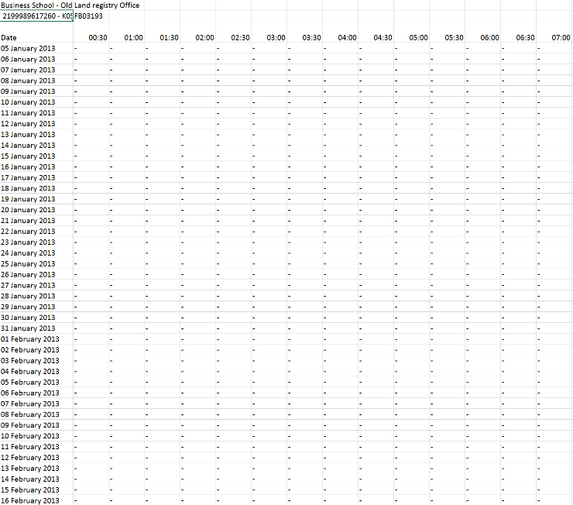

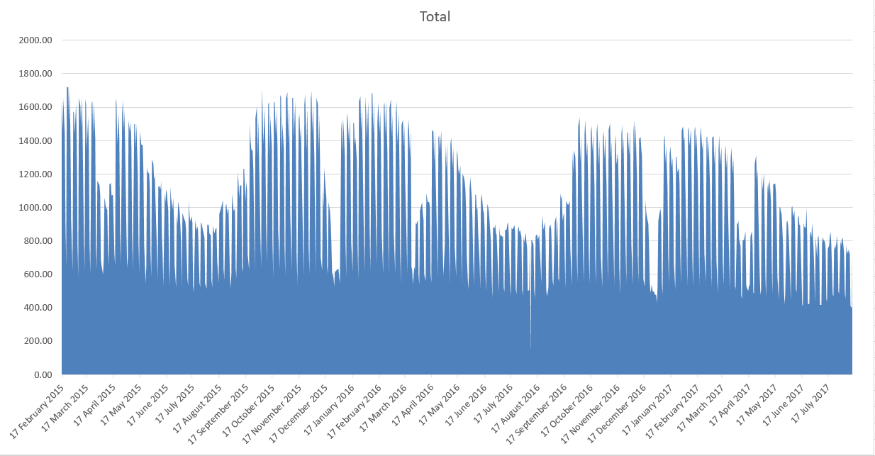

The screenshot above shows the graph for the Swansea Business School, as time goes on energy usage increases and decreases.

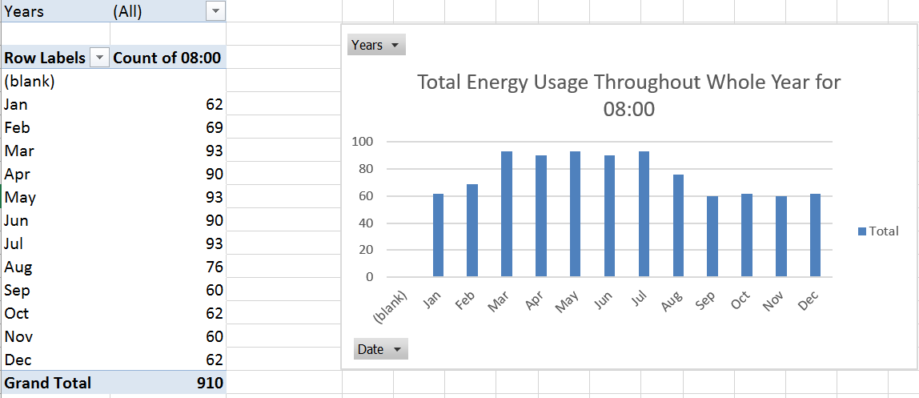
This screenshot provided here shows the PIVOT table for a small portion of the data. The step here was highlighting the data and choosing a field to work with, as shown in the screenshot the chosen filed was 08:00. The graph beside shows a clearer representation of the data.

A pivot table is a tool program that enables the user to restructure and sum up highlighted rows and columns of data in a database or spreadsheet table to acquire the expected report (Rouse, 2005). Pivot tables consist of 4 areas which are Columns, Rows, Filters and Values. The rows area is where building of the report normally starts, the values area is where the data is displayed that the user wants to sum up in their own pivot report and the column area works basically the same as the rows area (Acampora, 2014).

Conclusion

So overall, Microsoft Excel is the top application for use when working with data. The features that the software provides gives the user an ease of access and the opportunity to enhance their knowledge of database. While cleaning up the data, it provides a better understanding of how spreadsheets work and how data is handled. It also shows how sensitive data can be, so for example if one small error is made when it comes to functions, it can mess up the whole data if not handled with care.

References
Acampora, J. (2014, December 2). How Do Pivot Tables Work? Retrieved from Excel Campus: https://www.excelcampus.com/pivot-tables/pivot-tables-work/
Computer Hope. (2017, April 26). If Statement. Retrieved from Computer Hope: https://www.computerhope.com/jargon/i/ifstatme.htm
Computer Hope. (2017, April 26). Lookup Table. Retrieved from Computer Hope: https://www.computerhope.com/jargon/l/lookup-table.htm
Rouse, M. (2005, September). Pivot Table. Retrieved from TechTarget: https://searchsqlserver.techtarget.com/definition/pivot-table
Techopedia. (2018). Prosumer. Retrieved from Techopedia: https://www.techopedia.com/definition/29581/prosumer

