c Adding actions when clicking on table rows

1. When we click on a table row, lets add a pop-up.

Add the following to CafeTableViewController.swift. This will add a menu and a cancel button:

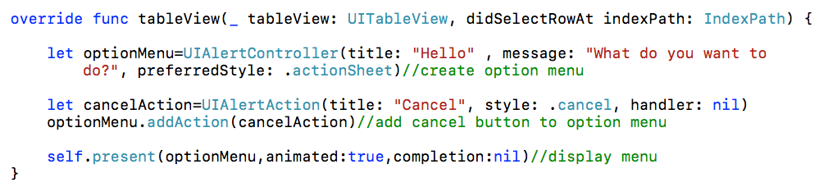

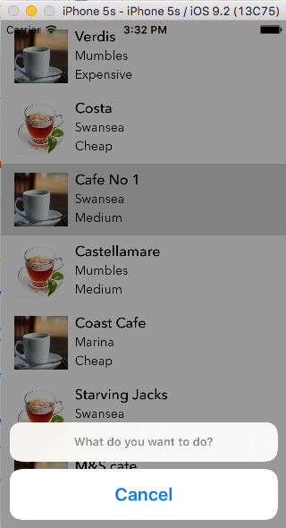

You can also use .alert instead of .actionSheet which gives a slightly different result:

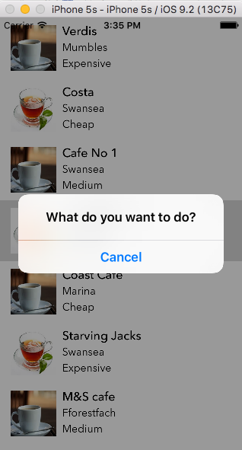

2. Add “Mark as visited” to the menu

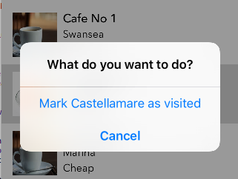

We will add this option to our new function including a handler to add a tick to the cell if we click on "Mark as visited".

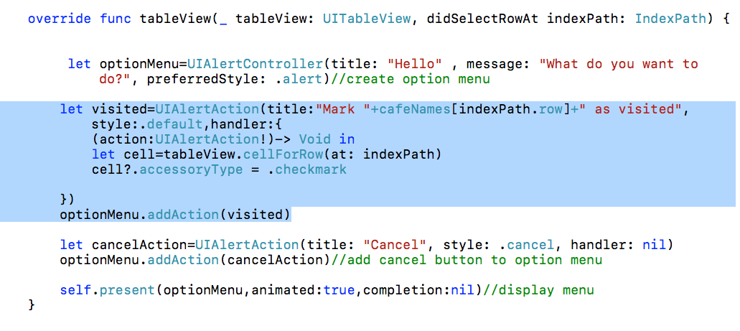

Unfortunately, because we are reusing cells, the checkmark starts appearing in random places:

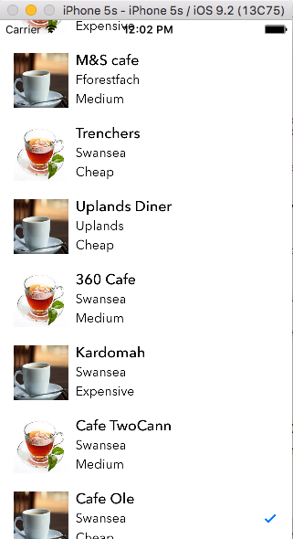

3. We need some way to store the visited state, so it stays on the right cell, even when the cells get reused.. Let’s make another array:

var cafevisited=[false,false,false,false,false,false,false,false,
false,false,false,false,false,false,false,false,false]

As well as setting the cell?.accessoryType=.checkmark in the action handler, we are also going to change the entry in the array for that cell to true if the user types "Mark as visited". This will keep a record of the cafes marks as "Visited".

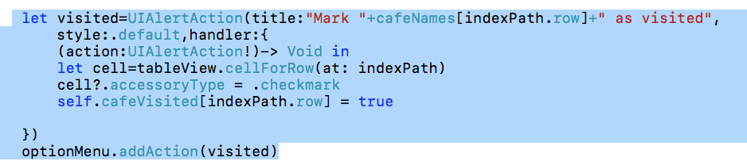

In the function controlling the cell, we are going to make sure that the checkmark remains when the table is scrolled by retrieving "true" or "false" from the array and returning it with the cell:

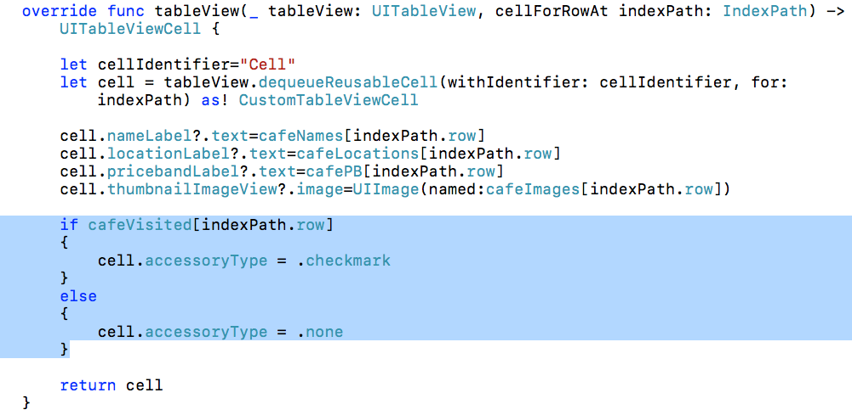

The app now behaves properly:

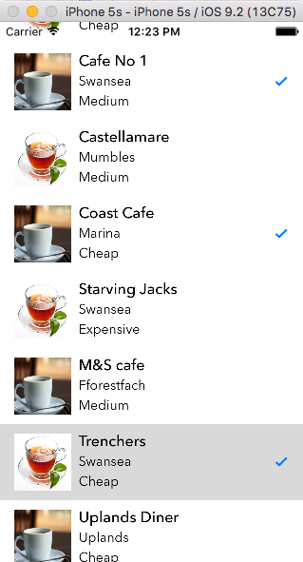

The complete code of CafeTableViewController.swift now looks like this:
import UIKit

class CafeTableTableViewController: UITableViewController {

var cafeNames:[String]=["Verdis","Costa","Cafe No 1","Castellamare","Coast Cafe","Starving Jacks","Trenchers","Uplands Diner","360 Cafe","Kardomah","Cafe Twocann","Cafe Ole","First Coffee","The Cwtch","Starbucks","M&S cafe"]

var cafeLocations:[String]=["Swansea","Swansea","Swansea","Swansea","Swansea","Swansea","Swansea","Swansea","Swansea","Swansea","Swansea","Swansea","Swansea","Swansea","Swansea","Swansea"]

var cafePB:[String]=["Cheap","OK","Pricey","OK","Pricey","Cheap","Extortionate","OK","Cheap","OK","OK","Pricey","OK","OK","Pricey","OK"]

var cafeImages:[String]=["cafe","cafe2","cafe3","cafe4","cafe","cafe2","cafe3","cafe4","cafe","cafe2","cafe3","cafe4","cafe","cafe2","cafe3","cafe4"]

var cafeVisited:[Bool]=[false,false,false,false,false,false,false,false,false,false,false,false,false,false,false,false]

override func viewDidLoad() {
super.viewDidLoad()

// Uncomment the following line to preserve selection between presentations
// self.clearsSelectionOnViewWillAppear = false

// Uncomment the following line to display an Edit button in the navigation bar for this view controller.
// self.navigationItem.rightBarButtonItem = self.editButtonItem()
}

override func didReceiveMemoryWarning() {
super.didReceiveMemoryWarning()
// Dispose of any resources that can be recreated.
}

// MARK: - Table view data source

override func numberOfSections(in tableView: UITableView) -> Int {
// #warning Incomplete implementation, return the number of sections
return 1
}

override func tableView(_ tableView: UITableView, numberOfRowsInSection section: Int) -> Int {
// #warning Incomplete implementation, return the number of rows
return self.cafeNames.count
}

override func tableView(_ tableView: UITableView, cellForRowAt indexPath: IndexPath) -> UITableViewCell {

let cellIdentifier="Cell"
let cell = tableView.dequeueReusableCell(withIdentifier: cellIdentifier, for: indexPath) as! CustomTableViewCell

cell.nameLabel?.text=cafeNames[indexPath.row]
cell.locationLabel?.text=cafeLocations[indexPath.row]
cell.pricebandLabel?.text=cafePB[indexPath.row]
cell.thumbnailImageView?.image=UIImage(named:cafeImages[indexPath.row])

if cafeVisited[indexPath.row]
{
cell.accessoryType = .checkmark
}
else
{
cell.accessoryType = .none
}

return cell
}

override func tableView(_ tableView: UITableView, didSelectRowAt indexPath: IndexPath) {

let optionMenu=UIAlertController(title: "Hello" , message: "What do you want to do?", preferredStyle: .alert)//create option menu

let visited=UIAlertAction(title:"Mark "+cafeNames[indexPath.row]+" as visited", style:.default,handler:{
(action:UIAlertAction!)-> Void in
let cell=tableView.cellForRow(at: indexPath)
cell?.accessoryType = .checkmark
self.cafeVisited[indexPath.row] = true

})
optionMenu.addAction(visited)

let cancelAction=UIAlertAction(title: "Cancel", style: .cancel, handler: nil)
optionMenu.addAction(cancelAction)//add cancel button to option menu

self.present(optionMenu,animated:true,completion:nil)//display menu
}

}

Toggling

Suppose we want to turn the checkmark on or off.

1. First, change the pop-up menu to reflect whether it should be visited or not visited. Check against the Boolean array (cafeVisited) to find out.

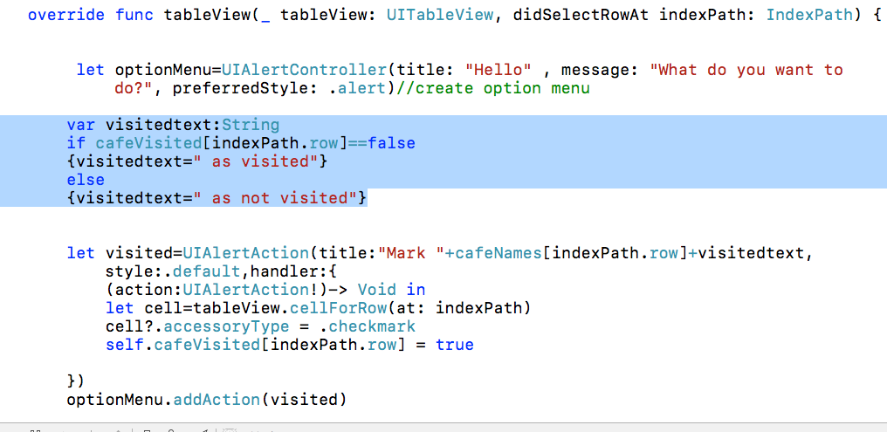

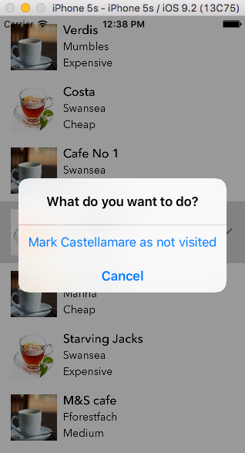

2. In the action handler, we previously set the Boolean in the array to true

Now we are going to toggle -ie if it's true, make it false, if it's false make it true. We will also turn the checkmark on or off accordingly.

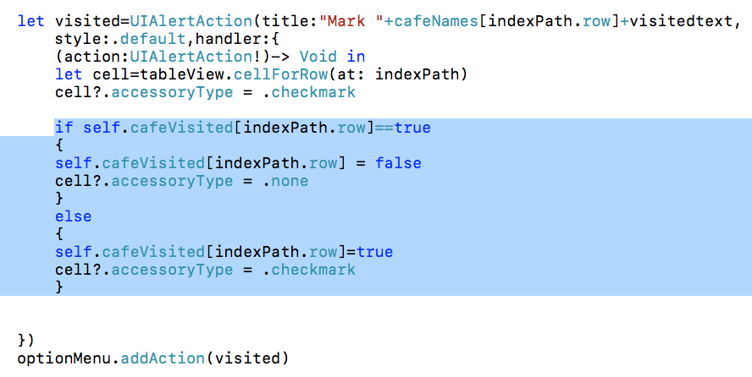

NOTE: Of course, the array values we have set only exist while the app is running, next time we run it the checkmark will be gone and the Boolean array will be back to false. We will come on to persistent storage in a later lesson.

