

Rhys Rosser (1809225)
Control and Automation - Assignment
ACMA5001

Contents

1. Introduction to Manufacturing Automation 4

2. Historical Overview: Evolution of Manufacturing Automation 4

3. Types of Manufacturing Automation 5
3.1 Fixed Automation 5
3.2 Programmable Automation 5
3.3 Flexible Automation 6

4. Industries and Applications of Each Automation Type 6
4.1 Fixed Automation Industries 6
4.2 Programmable Automation Industries 8
4.3 Flexible Automation Industries 9

5. Control Systems and Process Variables in Manufacturing Automation 10
5.1 Control Systems Overview 10
5.2 Process Variables in Fixed Automation 10
5.3 Process Variables in Programmable Automation 10
5.4 Process Variables in Flexible Automation 10

6. Case Study: Flexible Automation in Flat-Packed Furniture Production 11
6.1 Why Flexible Automation is Suitable for Flat-Packed Furniture Industry 11

7. References 12

Introduction to Manufacturing Automation

Manufacturing automation has experienced significant growth and expansion since its establishment post-World War II, becoming prevalent in industrial manufacturing by the 1970s. This automation involves the use of technology to mechanise production processes, tasks, and procedures with the aim of enhancing industrial output more rapidly and efficiently than manual labour (Appleton et al., 2017). The availability of increasingly automated manufacturing systems is crucial for achieving objectives related to capital utilisation, throughout time, flexibility, and quality (Jönsson, 2000). Moreover, leveraging automation and integration is highlighted as a key strategy to enhance manufacturing performance, particularly in uncertain environments (Liao & Tu, 2007).

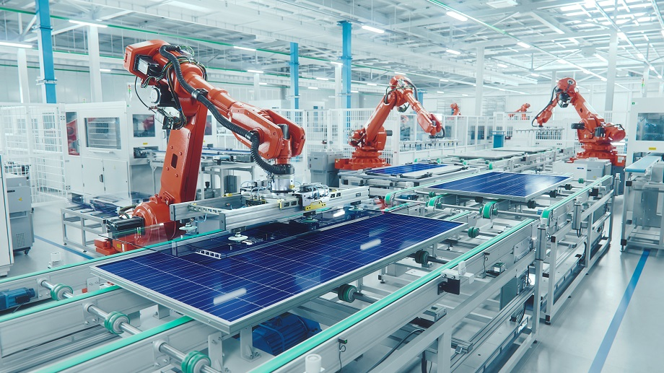
Manufacturing automation now plays a crucial role in many present industrial processes, providing chances for greater efficiency, improved quality, and workforce implications. Industries can overcome uncertainty, maximise performance, and propel breakthroughs across several sectors by integrating automation technologies.
Fig 1.

Historical Overview: Evolution of Manufacturing Automation

The industrial revolution of the late 18th and early 19th centuries, when mechanisation started to replace manual labour in factories to boost productivity and efficiency, is when manufacturing automation first emerged.

- Post WWII Era: Automations Emergence
Particularly in computer and electronic technology, the aftermath of World War II fuelled technological breakthroughs.
Early automation systems were primarily concerned with material handling, assembly line operations, and control systems.
- 1970s: Industrial Robotics' Rise
Industrial robots, which revolutionised assembly line processes with enhanced accuracy, adaptability, and productivity, first appeared in the 1970s.
Among the earliest industries to use robots into production lines for increased efficiency was the automotive sector.
- 1980s-1990s: Advancements in CNC and Computerisation
CNC machining and computerisation saw significant advances in the 1980s and 1990s, increasing the complexity, speed, and precision of manufacturing.
Time-to-market was shortened by streamlining the design and production processes through the integration of computer-aided design (CAD) and computer-aided manufacturing (CAM) systems.
- 21st Century: AI and Robotics
Automation made possible by robotics, artificial intelligence (AI), and sensor technologies advanced even farther in the 21st century.
Robots known as "cobots" were developed to operate alongside people to improve flexibility and safety. Artificial intelligence (AI) has revolutionised manufacturing supply chain management, quality assurance, and predictive maintenance.
- The Future
Industry 4.0 is the industrial industry's integration of cyber-physical systems, cloud computing, and the Internet of Things (IoT).
Concepts for smart manufacturing make use of data-driven insights and real-time networking to maximise production, mass customisation, and decision-making.
Manufacturing processes have evolved from being manual to being highly automated because of this progression, creating hybrid systems that combine robotic and human components.
The emergence of Industry 4.0 has been a significant milestone in this evolution, introducing a new era of digital manufacturing and automation (Tomar et al., 2023).

Types of Manufacturing Automation

Fixed Automation
Fixed automation in manufacturing refers to systems where the equipment and processes are set up in a way that they cannot be easily changed or adapted. These systems, such as the ElectroImpact E6000 and HAWDE, have a static infrastructure that limits their flexibility in accommodating variations in manufacturing processes (Ljasenko et al., 2016). In contrast to mobile robots that offer more adaptability, fixed automation systems are designed for specific tasks and lack the ability to quickly reconfigure for different production requirements (Ljasenko et al., 2017).

The rigidity of fixed automation systems can pose challenges in responding to changing market demands or introducing new product variations. While these systems may excel in repetitive and standardised production tasks, they may struggle to accommodate customisation or modifications without significant reconfiguration (Ljasenko et al., 2016). The fixed nature of these automation systems can limit their resilience and agility in adapting to unforeseen disruptions or changes in production requirements (Ljasenko et al., 2017).

Programmable Automation
Programmable automation in manufacturing refers to systems that utilise programmable logic controllers (PLCs) to control and automate various processes. These systems are designed to be flexible and adaptable, allowing for the programming of different tasks and sequences based on specific requirements (Hudedmani et al., 2017). Programmable automation enables manufacturers to easily modify and reconfigure production processes without the need for extensive physical changes to the equipment setup (Hudedmani et al., 2017).

By using PLCs, programmable automation systems can execute a wide range of tasks, from simple control functions to complex operations involving multiple components and sensors (Hudedmani et al., 2017). This flexibility allows for efficient customisation of manufacturing processes to meet varying production demands and optimise operational efficiency (Hudedmani et al., 2017). Additionally, programmable automation systems can integrate with other technologies such as Supervisory Control and Data Acquisition (SCADA) systems to provide comprehensive control and monitoring capabilities (Hudedmani et al., 2017).

Flexible Automation
Flexible automation in manufacturing refers to systems that are designed to be adaptable and versatile, allowing for easy reconfiguration and customisation of production processes. These systems, such as Flexible Manufacturing Systems (FMS), utilise advanced technologies to enable rapid changes in manufacturing setups to accommodate varying product specifications and production requirements (Stecke, 1983).

The key characteristic of flexible automation is its ability to handle a diverse range of tasks and product types without the need for extensive manual intervention or retooling. This flexibility is achieved through the integration of computer-controlled automation devices, such as numerically controlled machine tools and automated material handling systems, that can efficiently process different part types simultaneously (Stecke, 1983).

Flexible manufacturing systems play a crucial role in modern manufacturing environments by enabling agile responses to changing market demands, reducing setup times, and enhancing overall operational efficiency. These systems are particularly beneficial for industries that require frequent product changes, small batch production, or customisation, as they offer the agility and versatility needed to meet dynamic production requirements (Stecke, 1983).
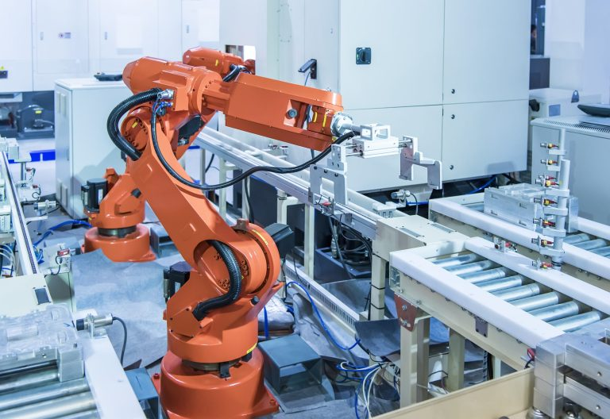
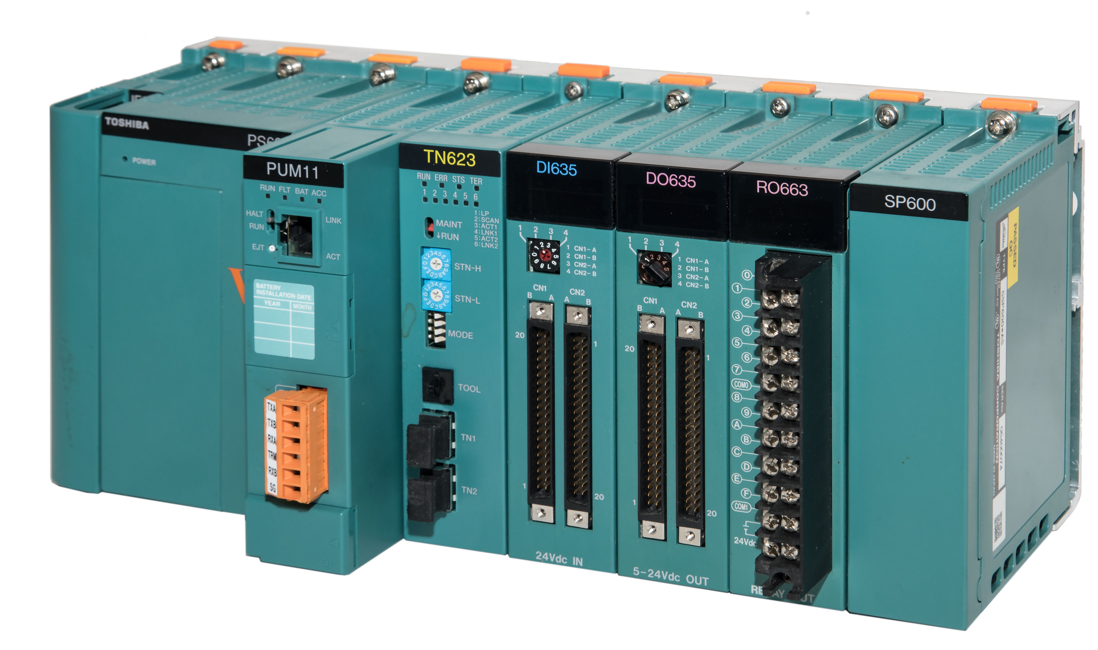
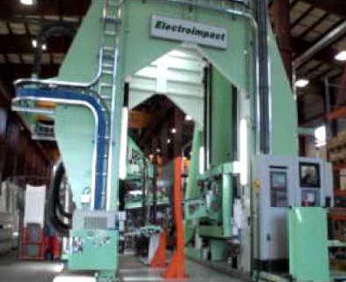
Fig 4.
Fig 2.
Fig 3.
Example of “Flexible Automation”
PLC, as described in “Fixed Programmable”
ElectroImpact E6000, as described in “Manufacturing Automation”

Industries and Applications of Each Automation Type

Fixed Automation Industries
A wide range of sectors and technologies are included in the industries and applications of manufacturing automation, which promote productivity, efficiency, and innovation in current manufacturing processes. Production processes have been completely transformed by the integration of automation technology across a range of industries, providing improved cost-effectiveness, quality control, and flexibility in response to shifting consumer needs.
One key area where manufacturing automation has made significant strides is in the automotive industry. Automation technologies have been instrumental in streamlining production processes, improving precision in assembly, and enhancing overall efficiency in automotive manufacturing plants (Karabegović et al., 2021). The application of Industry 4.0 concepts in the automotive sector has led to the development of smart automation solutions that optimise manufacturing processes and drive advancements in car assembly and component manufacturing (Karabegović et al., 2021).

Moreover, the adoption of automation technologies in the food industry has transformed production processes, particularly in areas such as fruit sorting. Automated fruit sorting systems, based on machine vision and image processing, have revolutionised the sorting and processing of fruits, reflecting the increasing automation levels in the food industry and the integration of advanced technologies for improved efficiency and quality control (Yu et al., 2021).

Additionally, the wood products industry has seen advancements in manufacturing automation, particularly in investment decisions related to automation technologies. Automation in the wood products industry, which includes sawmills and the production of furniture, joinery, and building materials, has played a crucial role in enhancing production efficiency, reducing costs, and improving overall manufacturing processes.

Advantages
- High Production Rates: Standardised products can be produced in large quantities using fixed automation systems. High production rates and throughput are achieved by their steady operation at high speeds and cycle times. Because mass manufacturing is economically feasible in businesses with steady and predictable demand, fixed automation is the best option.
- Minimal Human interaction: After fixed automation systems are configured and programmed, they require very little human interaction. They don't require constant oversight or manual control to effectively complete repetitive activities. Because human error and variability in production processes are eliminated, labour costs are decreased, and operational efficiency is increased.
Disadvantages
- Lack of Flexibility: Designed to carry out duties or processes, fixed automation systems are stiff and unyielding. They are not flexible enough to adjust to modifications in process specifications, manufacturing volumes, or product design. It can be expensive and time-consuming to retrofit or reconfigure fixed automation for new goods or processes, which reduces its scalability and versatility.
- Exorbitant setup and initial costs: Fixed automation necessitates a large upfront investment in specialised tools, machinery, and equipment. Fixed automation systems can be prohibitively expensive to design, construct, and commission, especially for small-scale or specialised manufacturing processes. The setup and integration of fixed automation may also need sophisticated programming and engineering knowledge, which raises the overall implementation costs.
Fig 5.
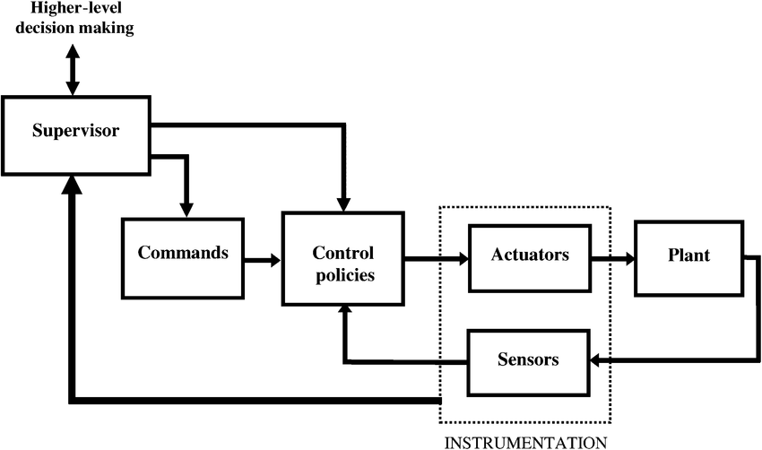
Typical example of industrial automation system, such as ElectroImpact 6000.

Programmable Automation Industries
Programable logic controllers (PLCs) and automation technologies are used in a wide variety of industries and applications, where they are essential for improving industrial processes' control, flexibility, and operational efficiency.

One significant application of programmable automation is in the energy sector, where PLCs are extensively used for monitoring and controlling energy production and distribution systems. PLCs enable precise control of energy generation processes, grid management, and equipment automation, contributing to improved operational performance and reliability in the energy industry (Alphonsus & Abdullah, 2016).

Moreover, the automotive industry leverages programmable automation for various applications, including assembly line operations, quality control, and process monitoring. PLCs play a crucial role in automating tasks such as robotic welding, part assembly, and material handling, enhancing production efficiency and ensuring consistency in automotive manufacturing processes (Alphonsus & Abdullah, 2016).

Additionally, programmable automation finds widespread use in the food and beverage industry for tasks such as packaging, bottling, and processing operations. PLCs enable the automation of production lines, recipe management, and quality assurance processes, ensuring compliance with food safety standards and optimising production efficiency in food manufacturing facilities (Alphonsus & Abdullah, 2016).

Advantages
- Flexibility: Programmable automation makes it simple to adapt production requirements to changing market conditions and introduce new goods in an effective manner.
- Efficiency: Programmable automation solutions minimise expenses, increase productivity, and provide real-time performance optimisation monitoring by automating processes and streamlining workflows.

Disadvantages
- Complexity: Implementing programmable automation can be difficult and time-consuming, particularly for specialised applications, as it involves programming and system integration skills.
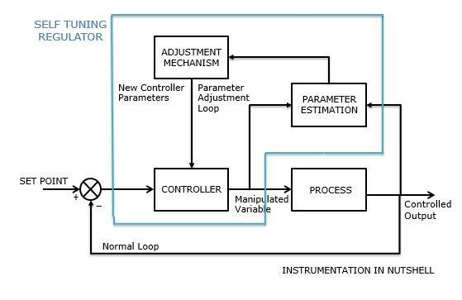
- Vulnerability: Because programmable automation systems primarily rely on software control, they are vulnerable to cybersecurity threats and software faults, which could jeopardise operations and data integrity.
Fig 6.
PID Controller: A self-tuning controller includes a traditional PID control function as well as a self-tuning function that tries to maintain optimal closed-loop performance by continuously updating the controller’s P, I, and D tuning parameters. An​ auto-tuning controller is similar except that it performs its tuning operation just once, then initiates closed-loop control using the parameters it has computed.

Flexible Automation Industries
Flexible automation finds applications across various industries, enabling agile and adaptable manufacturing processes to meet dynamic production requirements. One key industry where flexible automation is extensively utilised is the automotive sector. In automotive manufacturing, flexible automation systems allow for quick reconfiguration of production lines to accommodate different vehicle models and production volumes, enhancing operational flexibility and efficiency (Rojko 2017).

Flexible automation solutions are also advantageous for the food and beverage industry, especially for processes related to processing and packaging. Food businesses can quickly adapt production procedures, manage a variety of product varieties, and guarantee adherence to strict quality and safety regulations thanks to flexible automation solutions.
Furthermore, the pharmaceutical sector uses adaptable automation to handle jobs like packing and batch processing. Precise dosage and packaging of pharmaceutical goods are ensured, production efficiency is increased, and quick product line changes are made possible by flexible automation systems in the pharmaceutical manufacturing industry.

Advantages
• Flexibility to Adapt to Changing Production Needs: Systems for flexible automation are made to adapt to changes in process needs, production numbers, and product design. Because of their simple reconfiguration or reprogramming capabilities, manufacturers can react swiftly to shifting consumer tastes and market demands. In dynamic production environments, this versatility improves competitiveness and operational agility.

• Enhanced Productivity and Resource Utilisation: Flexible automation promotes efficient use of labour, machinery, and equipment, hence optimising resource utilisation. Flexible automation systems can achieve improved equipment uptime and production throughput because they can handle different tasks or processes. They also help to improve staff utilisation by automating repetitive or low-value operations and reallocating personnel to jobs that call for human knowledge.

Disadvantages
• Greater Initial Investment and Complexity: Because of the intricacy of the systems and the requirement for cutting-edge technologies like robotics, programmable logic controllers (PLCs), and complex control software, implementing flexible automation requires a larger initial investment than fixed automation. Implementation complexity and upfront costs are increased when flexible automation systems need to be customised and integrated, which calls for specific engineering knowledge.

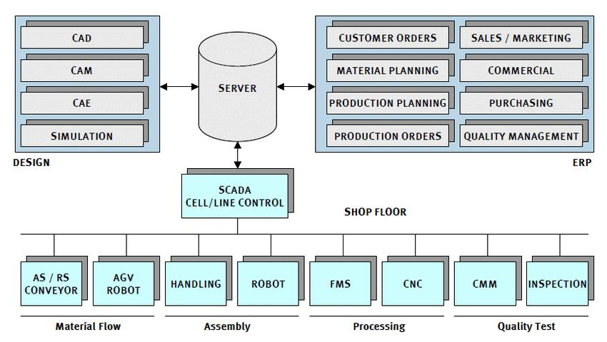
• Risks related to maintenance and downtime: Because of their complexity and reliance on several parts and subsystems, flexible automation systems may be more prone to maintenance problems and downtime than fixed automation. The performance and dependability of flexible automation systems depend on routine calibration, troubleshooting, and maintenance.
Fig 7.
Example of a Flexible Manufacturing System

Control Systems and Process Variables in Manufacturing Automation

Control Systems Overview
Control systems are essential components of manufacturing automation, overseeing and regulating various processes to ensure consistent and optimal performance. These systems utilise sensors, actuators, programmable logic controllers (PLCs), and human-machine interfaces (HMIs) to control and coordinate machinery, equipment, and processes within manufacturing environments (Thoben et al., 2017). They are crucial for maintaining operational efficiency, quality control, and productivity in industrial settings.

Control systems in manufacturing automation can be classified based on their complexity and functionality, ranging from simple on/off controls to advanced closed-loop systems with feedback mechanisms for precise control and monitoring (Thoben et al., 2017). The evolution of control systems has been motivated by the demand for enhanced automation, efficiency, and adaptability in manufacturing processes.

Process Variables in Fixed Automation
In fixed automation, the control of processes is typically deterministic, with fixed sequences and parameters that are hard-coded into the system. Process variables such as speed, timing, and positioning are predefined and optimised for specific tasks or operations. Fixed automation systems often use relay logic or dedicated control circuits to execute repetitive tasks with high precision and repeatability. While fixed automation offers reliability and consistency, it lacks the flexibility to adapt to changes in production requirements or process variations (Parasuraman & Riley, 1997).

Process Variables in Programmable Automation
Programmable automation systems are essential in manufacturing as they provide flexibility in controlling process variables, allowing adjustments to be made in response to changing production needs or requirements. These systems enable manufacturers to program and modify process variables such as speed, pressure, temperature, and sequencing using software-based control systems and PLCs (Meyer et al., 1989). By leveraging programmable automation, manufacturers can optimise production parameters, reduce setup times, and accommodate variations in product design or production volumes.

Process Variables in Flexible Automation
Flexible automation systems are crucial in manufacturing, providing a high degree of adaptability to control process variables in dynamic production environments with varying requirements and specifications (Parasuraman et al., 2000). These systems utilise advanced control strategies, such as robotic control, motion control, and adaptive algorithms, to manage various process variables across multiple tasks or operations (Parasuraman et al., 2000). The real-time adjustment of process variables enables rapid reconfiguration and optimisation of production processes, allowing manufacturers to achieve high levels of customisation, scalability, and efficiency in their operations (Parasuraman et al., 2000).

Case Study: Flexible Automation in Flat-Packed Furniture Production

Why Flexible Automation is Suitable for Flat-Packed Furniture Industry

A company that produces flat-packed furniture would benefit greatly from flexible automation because of the dynamic nature of the production environment and the demand for responsiveness to changing requirements and standards. Flexible automation systems may efficiently manage a variety of process variables across numerous tasks or operations by utilising complex control strategies like robotic control, motion control, and adaptive algorithms. This flexibility enables quick reconfiguration and optimisation of manufacturing processes to satisfy shifting demands in the furniture sector by allowing real-time alterations to process variables.

The manufacturing process for flat-packed furniture must be highly customisable and adjustable due to the wide number of designs, sizes, and configurations that are frequently used in its manufacture. The ability required to modify process parameters like speed, pressure, and sequencing to account for changes in product design or production volumes is best provided by flexible automation systems. Flexible automation is the best kind for the flat-packed furniture sector because it can dynamically adjust to changing requirements. In this industry, production needs might fluctuate greatly.

Additionally, by ensuring that targeted procedures and performance levels are maintained, feedback loops and adaptive control algorithms included in flexible automation systems improve operational efficiency and quality in the manufacturing of flat-packed furniture. Manufacturers can meet the demands of the furniture sector by optimising production parameters, cutting setup times, and achieving high levels of customisation and efficiency in their operations using flexible automation technology.
In conclusion, because of its versatility, scalability, and effectiveness in controlling process variables and satisfying the ever-changing demands of the industry, flexible automation is the best kind for a business that manufactures flat-packed furniture.
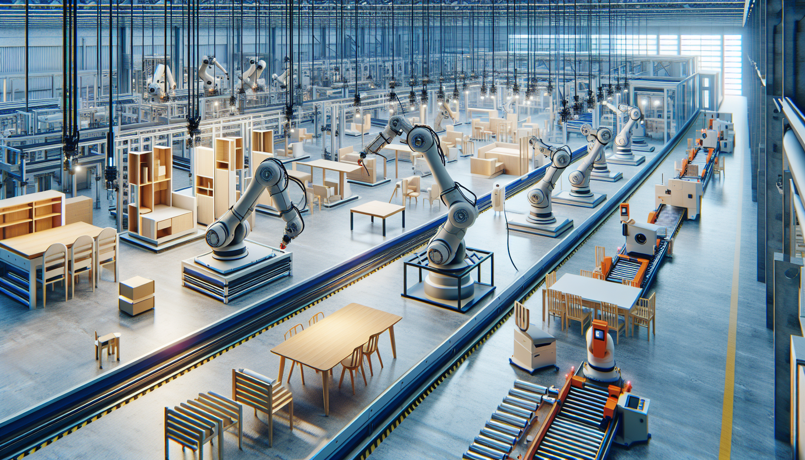
Fig 8.

References

Appleton, E., Densmore, D., Madsen, C., & Roehner, N. (2017). Needs and opportunities in bio-design automation: four areas for focus. Current Opinion in Chemical Biology, 40, 111-118. https://www.sciencedirect.com/science/article/abs/pii/S1367593117300753?via%3Dihub

Jönsson, P. (2000). An empirical taxonomy of advanced manufacturing technology. International Journal of Operations &Amp; Production Management, 20(12), 1446-1474. https://www.emerald.com/insight/content/doi/10.1108/01443570010353103/full/html

Liao, K. and Tu, Q. (2007). Leveraging automation and integration to improve manufacturing performance under uncertainty. Journal of Manufacturing Technology Management, 19(1), 38-51. https://www.emerald.com/insight/content/doi/10.1108/17410380810843444/full/html

Hashemi-Petroodi, S. E., Thevenin, S., Kovalev, S., & Dolgui, A. (2020). Operations management issues in design and control of hybrid human-robot collaborative manufacturing systems: a survey. Annual Reviews in Control, 49, 264-276. https://www.sciencedirect.com/science/article/abs/pii/S136757882030016X?via%3Dihub

Tomar, B., Kumar, N., & Sreejeth, M. (2023). Real time automation and ratio control using plc &amp; scada in industry 4.0. Computer Systems Science and Engineering, 45(2), 1495-1516. https://www.techscience.com/csse/v45n2/50404

Ljasenko, S., Lohse, N., & Justham, L. (2016). A comparison of the manufacturing resilience between fixed automation systems and mobile robots in large structure assembly. Procedia CIRP, 57, 235-240. https://www.sciencedirect.com/science/article/pii/S2212827116311957?via%3Dihub

Ljasenko, S., Lohse, N., Justham, L., Pereira, I., & Jackson, M. R. (2017). A self-organisation model for mobile robots in large structure assembly using multi-agent systems. Service Orientation in Holonic and Multi-Agent Manufacturing, 83-91. https://link.springer.com/chapter/10.1007/978-3-319-51100-9_8

Hudedmani, M. G., M, U. R., Kabberalli, S. K., & Hittalamani, R. (2017). Programmable logic controller (plc) in automation. Advanced Journal of Graduate Research, 2(1), 37-45. https://journals.aijr.org/index.php/ajgr/article/view/185

Stecke, K. E. (1983). Formulation and solution of nonlinear integer production planning problems for flexible manufacturing systems. Management Science, 29(3), 273-288. https://pubsonline.informs.org/doi/10.1287/mnsc.29.3.273

Karabegović, I., Karabegović, E., Mahmić, M., & Husak, E. (2021). The application of industry 4.0 in production processes of the automotive industry. Mobility and Vehicle Mechanics, 47(2), 35-44. http://www.mvm.fink.rs/Journal/Archive/2021/2021V47N2/2021V47N2-3.html

Yu, J., Miao, W., Zhang, G., Li, K., Shi, Y., & Liu, L. (2021). Target positioning and sorting strategy of fruit sorting robot based on image processing. Traitement Du Signal, 38(3), 797-805. https://www.iieta.org/journals/ts/paper/10.18280/ts.380326

Alphonsus, E. and Abdullah, M. (2016). A review on the applications of programmable logic controllers (plcs). Renewable and Sustainable Energy Reviews, 60, 1185-1205. https://www.sciencedirect.com/science/article/abs/pii/S1364032116000551?via%3Dihub

Rojko, A. (2017). Industry 4.0 concept: background and overview. International Journal of Interactive Mobile Technologies (iJIM), 11(5), 77. https://online-journals.org/index.php/i-jim/article/view/7072

Thoben, K., Wiesner, S., & Wuest, T. (2017). “industrie 4.0” and smart manufacturing – a review of research issues and application examples. International Journal of Automation Technology, 11(1), 4-16. https://www.fujipress.jp/ijat/au/ijate001100010004/

Parasuraman, R. and Riley, V. (1997). Humans and automation: use, misuse, disuse, abuse. Human Factors: The Journal of the Human Factors and Ergonomics Society, 39(2), 230-253. https://journals.sagepub.com/doi/10.1518/001872097778543886

Meyer, A. D., Nakane, J., Miller, J. G., & Ferdows, K. (1989). Flexibility: the next competitive battle the manufacturing futures survey. Strategic Management Journal, 10(2), 135-144. https://onlinelibrary.wiley.com/doi/10.1002/smj.4250100204

Image References

Fig 1. : Introduction to Manufacturing Image
https://iticollege.edu/blog/future-of-manufacturing-exploring-automation-and-electronic-systems/

Fig 2. : ElectroImpact E6000 https://www.google.com/url?sa=i&url=https%3A%2F%2Fm.youtube.com%2Fwatch%3Fv%3DH3fKn5kAqRU&psig=AOvVaw3QFKqeHtzqIZ66TFuxh1B7&ust=1713354917270000&source=images&cd=vfe&opi=89978449&ved=0CBIQjhxqFwoTCJDy4MnWxoUDFQAAAAAdAAAAABAE

Fig 3. : PLC – Example (Toshiba)
https://www.toshiba.com/tic/other-products/plcs

Fig 4.: Example of Flexible Automation
https://www.google.com/url?sa=i&url=https%3A%2F%2Fomnirobotic.com%2Fblog%2Fchoosing-equipment-flexible-automation%2F&psig=AOvVaw2J04dZVZl2vyblW0Bq5mQR&ust=1713355094915000&source=images&cd=vfe&opi=89978449&ved=0CBIQjhxqFwoTCIi3ha_XxoUDFQAAAAAdAAAAABAE

Fig 5. : Block Diagram of Industrial Automation System
https://doi.org/10.1109/TSMCC.2005.848154

Fig 6. : Block Diagram of PID Controller
Adaptive Control Lecture 4 – Control and Automation -- UWTSD (Rob Goodson)

Fig 7. : Block Diagram of Flexible Manufacturing System
https://www.researchgate.net/figure/Modular-flexible-manufacturing-system-block-diagram_fig1_292520032

Fig 8. : Flexible Automation in Flat-Packed Furniture Industry
https://praxie.com/automation-in-furniture-manufacturing/

