BLOGGING TO COMMUNICATE
Introduction
iPhone is a branch of a multinational corporation that creates electronics, commercial services and computer software, the name of the corporation is none other than Apple. This multinational company has its markets in California, Cupertino and sells its products all over more than 50 countries. It has various other hardware products like iPod and iPad. This renowned organization always uses their own system of operation in all of its products, and one of those operating systems is iOS, which is frequently used in their most popular invention, iPhone. In this assignment, we are gonna discuss the iPhone 14. The iPhone is so much popular with today's youth and elders as well that it alone increases their production yearly and brings extreme success and also its market share.

BLOG 1:
New model added to iPhone series
iPhone has announced the launch of its 14 series expectedly at the end of this year (Apple, 2021). Rumour says that there is a new claim by which LG Display will supply the LTPO panel which is, Low-temperature Polycrystalline Oxide, for this new series. Though it is very small, the order will be hugely profitable for LG display, LTPO panel is made to support 120Hz rate and it's an advanced technology that smartphone makers use in their premium smartphones also include OLED panels. On the other hand, Samsung is another rival company of LG, which dominates the OLED panel’s supply to the Apple group. Samsung has supplied its display panels for the previous iPhone which is the iPhone 13 pro model. LG helps Apple additionally as it helps to reduce the reliance of the company on Samsung and also gets products at affordable prices. Before iPhone 14 and iPhone 14 mini, the company has launched its previous version which is iPhone12, but it hasn't sold properly, and despite that poor sale iPhone still launches its next version, we will see four devices of this new version, which are- iPhone 14, iPhone 14 Max, iPhone Pro and iPhone Pro Max.
BLOG 2:
Why should you buy iPhone 14
If you are looking for an excellent and compatible phone and don't have a clue which one to buy, We have a perfect solution. You should definitely buy the iPhone 14 series. You must be thinking why? We will tell you the reasons,
- Design: The iPhone 14 will be made exactly like iPhone 12, and like the flat edges of the iPhone 4. The sides are made of titanium, to make it stronger than previous devices. The back of the phone will be made of the same glass which all the devices are made of. Apple would not use a wide notch for its punch hole like the camera. For the connectivity, Apple wants to stick with the lightning port, which it used previously. The rear camera of the iPhone can be seen as a redesign, and without the help of protrusion, it will sit flush.
- Display: we can see two sizes of display in the four models for the iPhone’s display, a 6.1 inch used on the iPhone 14 and iPhone 14 pro and a little large 6.7-inch display used for the Max and Pro Max devices. There is also a rumour that the iPhone will not use a 5.4-inch mini display from next year. The iPhone 13 Pro and Pro Max have a 120Hz rate of the display, but we can expect from Apple that it could extend to other models of the company.
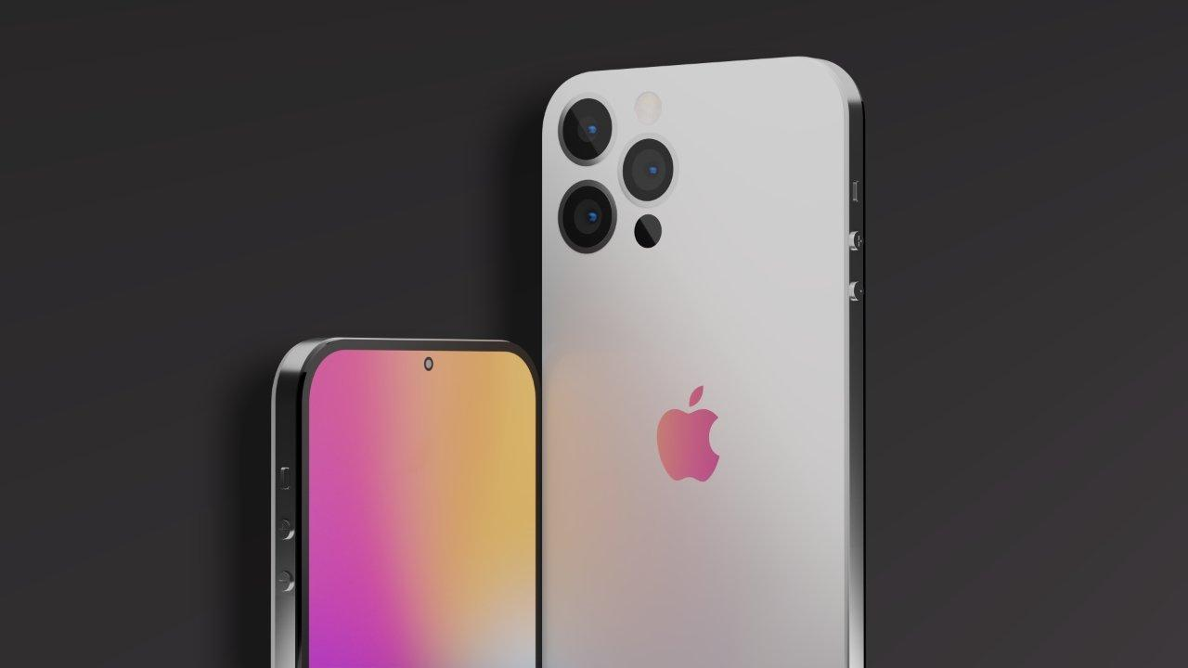
Figure 1: iphone14 camera
(Source: Apple, 2021)

- Camera: we haven't heard about the camera but you can expect that the biggest upgrade will be featured in iPhone 14. A 48MP primary sensor will be used in the next device which is a higher version from a 12MP sensor that we found in the iPhone 13 series. Also, we can expect better lenses with good capability and improved zoom quality.
- Touch ID: according to rumours Apple also brings back its special feature, touch ID, centred with a new power button. This is positive news for all Apple lovers I can say.
BLOG 3
Reasons to buy iPhone 14 and skip iPhone 13
Have planned to skip iPhone 13 and wait for the arrival of the iPhone 14 because 13 has poor pro upgrades and is not good enough to buy? Here we will tell you 5 reasons why you should buy iPhone 14 and not 13. Moreover, you can say these are the five upgrades.
- Kill the display notch: the iPhone 13 now finally has a smaller display notch, but I want to go further with the new series so that we could get rid of the notch thing totally, especially with Pro Max devices which will allow me to enjoy a retina display, which will be expansive and also uninterrupted. It has a 120Hz refresh rate. Apple will achieve all these things with the help of the under-display camera and a sensor suite, which Samsung has done with Galaxy Z Fold 3. I have a suspicion that because of this under-display camera technology would not be at its best stage where a selfie by Apple doesn't seem good.
- Bigger camera upgrades: iPhone 13 models have camera upgrades but received some minor tweaks, and the Pro and Pro Max have camera capabilities like telephoto and ultra-wide cameras. I am disappointed that Apple could not invent the best camera upgrades. So I would like Apple to add an additional fourth camera into the iPhone 14's and 14 pro's camera plate. Or at least it should have a camera that could offer something really different from a minor improved zoom lens and macro photography. Equally, I would like to see Apple take the way Samsung did, opting for a secondary telephoto camera with the power of 10X zoom quality. To combine it with the computer photography of Apple we could get to see that Apple got the zoom crown from Samsung. I just really have hope from it to fulfil my desire to feel worthy of waiting.
- Bring back the touch ID: about the under-display technology, I would say that I would like it if Apple could do something which Android phones have done for some time and bring back the fingerprint scanner on the back of iPhone 14. Nowadays, wearing masks can fail the face I'd system and the only thing left is fingerprint scanning so it could be helpful for phone's security. This touch ID has not been available in the 13 series. Even if it is not displayed under the display I can settle for the sided power button with this touch ID and a sensor that is likely present on the iPad Air.
- Fast charging: We have seen that Apple put some larger batteries in the iPhone 13 series, but I couldn't find the boost charging which can make the device charge faster. It is limited to 20 watts like before. That is highly disappointing because Android phones have 65W charging which is wireless too and some have 25W fast charging. I want to see these features in Apple's new edition iPhone 14. We have decided to go back to Android from iOS but it will be good if I wait for some time. Would you do the same? Well, that will depend on which type of camera do you have, or how old is your camera? If you have any iPhone 12 series we would suggest you wait for a while and get the new iphone14.
- USB-C Connectivity: sources said that the European Commission is introducing a universal charging function that will be applicable to all smartphones and will cut down on e-wastage. This means all the phones which will sell in Europe will get this USB-C charging function. Android phones already have the feature but Apple was stuck to its lighting port even though it is found in the iPhone 13. Aside from these environments, moving to USB would be a chance for future iPhones to open up more borderlines, iPhone 14 can do it, we will give you an example, you can use this connectivity to connect your iPhone to a 4k display TV for a better experience or it could be anything, like transferring photos from your DSLR to the iPhone. You can do these things with much easier editing apps on iOS. Such connectivity will allow your iPhone 14 to be connected to an external display, keyboard and mouse and you could use it as your desktop computer.
BLOG 4:
iPhone vs Android; which is better?
Do you want to buy a newer iPhone? then you should know that the A12 Bionic chip beats anything from Android. For example, Galaxy S10 has been beaten by the iPhone XS, which has snapdragon 855 and geekbench 4, which measures the whole performance. You could have also found that the new iPhones can transcode any video faster and with the iPhone XS you can do it in 39 seconds whereas Galaxy S10 took nearly 2.5 minutes. This difference is enjoyable.
- Easiest to use- Androids have made many promises that they streamline their skins but still I would say that iPhones are easiest to use. Some lacked the change in the look and can give the feel of iOS for years, but I would consider it as a plus that it works the same as it worked previously, like the pick, turn and touch to open the apps.
- No bloatware- Samsung and other companies have minimised and lumped all the bloatware into a single folder, which was giving pain. But it is still just crap that is taking up your phone's space. You will not be able to find a single carrier software that is preloaded on the iPhone, it makes your experience clean and out of the box. You can find some useless apps like the Apple watch but it has more restraint than other company's manufacturers. You can disable it if you don't need it.
BLOG 5:
Apple's developing advantage in iPhone photography
Apple is working hard so that it could improve the camera since it became popular for its camera among people. It used LED flash in iPhone 4 which was a very important step of its journey, today it has AR. You might get me wrong but we have seen other smartphones which have megapixels but it doesn't matter how big your image is if you don't have the optimising software and improvising hardware. For me, it's clear that someone in Cupertino might have experienced an exciting moment when they took good images and it is not about the size of the CCD, but it depends on the software.
While the iPhone these things are very rare to happen as everything goes through the firewall of Apple. We would suggest you should check everything before you download anything from a third party.
The company has used a promotional mix effectively to enhance the sales performance and moreover, the company knows how to attract more customers and handle them (Edwardlowe, 2021).
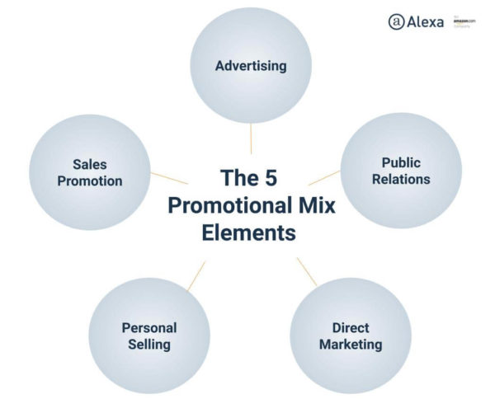
Figure 2: The 5 promotional mix elements
(Source: Edwardlowe, 2021)

BLOG 6:
Advantages of purchasing an iPhone.
iPhone can be the ideal phone if anyone has any other devices of Apple, such as MacBooks, Apple watch, or iPads, which are very convenient to connect one device to another. This could be really handy in transferring files or photos from laptop to phone or phone to laptop. iCloud is a very interesting system that Androids don’t have.
It's basically a storage service we get from Apple. When you turn it on the phone it automatically saves all your files, photos in the cloud and saves as a backup so we can find it easily, if your phone is lost. If you compare a three-year-old iPhone with a Samsung phone, which is the best Samsung phone in the market, you will find the score of geek bench for a single core in your iPhone equal to the Samsung phone. It becomes costly when you can enjoy the freedom on any Android, but Androids are easily accessible and hackers could get all the information of your phone.
Buying an iPhone can give you the opportunity to use various features like Apple pay, FaceTime, iMessage etc. it also gives you an image to flaunt. There are so many popular Apollo and drafts that you can't find on Android phones. iPhone's popularity is increasing daily because people are giving priority to the apps of iOS.

Conclusion
So you can see by reading all these why should anyone consider buying an iPhone. Here I discussed a variety of advantages of the iPhone which can easily convince you to buy it. I have pointed out above iPhone 14 which has not been released yet but there are plenty of reasons for you to wait for it and not to buy any other iPhone or any Android, I have shown you also the differences between the iPhone 13 and iPhone 14 so that you could see the result and decide for yourself.

Reference
Apple. (2021). About us. Available at www.apple.com/in/ios/ios-15 (accessed on 26th November 2021)
Edwardlowe. (2021). How to Establish a Promotional Mix. Available at. https://edwardlowe.org/how-to-establish-a-promotional-mix (accessed on 26th November 2021)

