Dylan Yeates
1901767
Internet technology and security assignment

Contents
Introduction 2
BYOT 2
What is BYOT? 2
BYOT Management Software 2
Features of Air-Watch 2
Advantages and Disadvantages of BYOT 3
Advantages 3
Disadvantages 3
Policies 4
Acceptable Uses 4
Security 4
Supported Operating Systems 5
BYOD Network Design 6
Countermeasures 7
Conclusion 8
References 8

Introduction
This document will cover the challenges of setting up a BYOD network and cover the ways to implement it. This guide is an example of how to keep your company network safe whilst using a BYOD network. I will also cover the ways to ensure users are enforced into safely browsing the internet and safe usage of their device. This document will include policies for a BYOT as well as a software recommendation and a general user guide for BYOT.

BYOT

What is BYOT?
BYOT stands for Bring Your Own Technology and it is an option a lot of employers are considering lately. It involves employees choosing their own devices to buy and maintain. Employers tend to pay a considerable part of the devices cost.

BYOT Management Software
The software I have personally chosen is Air-Watch by VMWare. The reason I have chosen this software is because it’s from a well-respected company whose software I have priorly used. They are also cost effective compared to alternative management software’s. Charging $3.78 (USD) per device per month.

Features of Air-Watch
Air-Watch allows a network manager to locate Devices on all available platforms if they have power and an internet connection. This can be good if a user loses a device or if a device is ever stolen as they can simply find it instantly.
Air-Watch allows users to sign themselves up if the network manager allows it. This can allow the process of setting up the BYOT network a lot easier as users can submit their devices remotely for the network manager to approve.
Air-watch supports remote lock which allows devices to be locked with no way on signing in until it is unlocked. This can help stop former employees from accessing the network in a malicious way. It also is useful in case the device is stolen as it will stop the thief from accessing the network. They also have a remote wipe which can allow a network manager to reset a device for a former employee so they can continue to use their device as their own device.
Air-watch can also support geofencing which uses GPS software to set a boundary of where the device can be used. This can be used to have some spare devices in the office to ensure if an employee cannot access their device, they are not stopped from doing work. Having the boundary means that the employee won’t be able to take the spare device home.
Air-watch have an option for round the clock 24/7 customer support to ensure that employees can work whenever they are available. This will allow a lot more flexibility for employees.
Air-watch are dedicated to having a unified management of all potential endpoint device. This means that they want to support as many devices and operating systems as possible. This is good for companies using BYOT as there will be more option for employees to choose from which means that they will have even more options to choose from so that as few users as possible have to use a device that isn’t their first choice. [1]

Advantages and Disadvantages of BYOT

Advantages
- The main advantage of a BYOT system is that all users can use devices there are comfortable with. They will be able to use the operating system that they are most familiar with which could yield a better work environment for all workers.
- It reduces the costs of maintaining and purchasing devices as users are more likely to take care of a device that they have chosen are kept themselves.
- It also allows employees to be more flexible and allows them to work from home. This is because their device will always have the software which allows them to work from home in any situation that calls for it.
- Having employees using their own devices results in happier employees. There won’t be any complains about mice, keyboards or the touch screen. It is their device and they know what they like. Each user can customise their experience rather than the company using generalised equipment which employees might complain about. [2]

Disadvantages
- The major challenge in implementing a BYOD network is always security. Employees will be able to access company information on a personal device which imposes several security risks. Protecting from malware is a necessity as personal devices might end up being used in several public and private networks out of the convenience.
- Another challenge is how a BYOT management software will only be able to support certain operating systems. This puts a severe limit on the options employees will have when they are choosing a device. It also means that less technologically incline employees may end up purchasing an unsupported device which could cause an employee to become frustrated to find out they spent money on a device incompatible with the company’s network.
- There is also the chance that an employee could end up losing their device and not contacting the network administrator which could result in unauthorized access to the network. If a malicious user happens to be the one who picks it up it could be extremely unsafe for the network.
- Employees might consider the software to be intrusive on their device and feel limited to what they can do with the device that they have paid for. This might result in upset employees. [3]

Policies
CoffeeCapulus allows employees the privilege of using their own devices whilst at work. These devices can be laptops, smartphones and tablets. CoffeeCapulus reserves the right to revoke this privilege if users do not abide by the policies and procedures. Employees must agree to the terms and conditions set forth in this policy in order to be able to connect their device to the CoffeeCapulus network.

Acceptable Uses
- During workplace hours the device’s user must follow acceptable business use. This is a requirement for the device as it is primarily a workplace device. This means that uses should not be installing anything on the device that isn’t company approved.
- CoffeeCapulus defines acceptable business use as directly or indirectly supporting the business of CoffeeCapulus.
- Employees will be blocked from accessing certain websites during work hours and whilst accessing the company network. Websites include but are not limited to: Social Media sites, Gaming sites, Video content sites.
- Devices are not permitted to be used for any of the following at any given time: Store/Transmit illicit materials, store or transmit information belonging to another company, harass others or engage in outside business activities.
- Apps not downloaded through an official app storefront will not be permitted. This is to help reduce the chances of a person
- Whilst personal use is not strictly prohibited it is requested to be kept to a minimum due to the confidential nature of having access to the CoffeCapulus network. By reducing personal use employees are directly reducing the chances that they get hacked, phished, get malware or a virus on their personal device.

Security
- In order to prevent unauthorized access to the network, devices must be password protected with a strong password as a requirement to access the CoffeeCapulus network.
- CoffeeCapulus consider a strong password to be a minimum of 8 characters with a required Upper case, Lower case, number and a symbol. Password’s will be reset every 90 days.
- The device must lock itself if it is idle for at least five minutes.
- After five failed attempts to login, a device will lock. To unlock it contact IT.
- The machine will be blocked from downloaded apps that are not from the list of approved apps.
- Employees devices that are used for personal use are not permitted to access the network.
- Employees access to company data will be limited based on their profile.
- The employee’s device is permitted to be remotely if the device is lost/stolen, if the employee terminates employment, IT detects a policy breach, virus or any threat to the technologies infrastructure.
- Any attempts to get around network restrictions put in place such as using a proxy server will result in the privileges of using your own device to be terminated.
- Employees are required to keep their devices up to date and ensure they are not bypassing any software updates. They are required to stop potential security flaws found in previous version from getting taken advantage of.

Supported Operating Systems
- Windows 10
- Chrome OS
- Android
- iOS
- macOS

CoffeeCapulus will play for 50% of the price of the device going up to £300 from the device price. If policies are not followed employees will be terminated. If an employee is terminated or leaves in the first three years of owning their devices the cost covered by the company will be subtracted from an employee’s final pay.
After three years using the same device employees are entitled to another discount from the employer for an upgrade on the device. It is the same discount as a first-time purchase. This should ensure an employee is never using outdated software or hardware. If an employee leaves the company in the first three years after purchasing the device the discount will be deducted from the employee’s pay. The discount is done with a reimbursement system so employees are required to bring their receipt to the company in order to get their 50% / £300 discount.
More serious cases that could result in termination include but are not limited to: Leaking private information about the company. Unauthorized access to the company’s network, this includes accessing files you were not meant to access. Sharing your password with anyone, regardless if they are employed by the company or not. All criminal activity especially committed whilst using their own device. Employees should ensure they do not break the data protection act and file all information correctly.

BYOD Network Design
Here is my BYOD network design for CapulusCoffee.
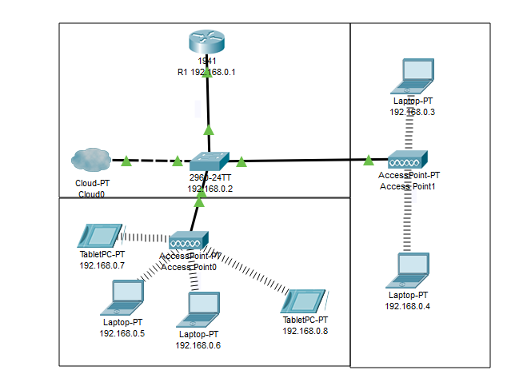I have given each room an individual wireless access point to ensure that everyone will have a stable connection to the network. Each rectangle represents a room in the office. If the office was bigger each room would continue to get their own Wireless Access Point. This will also help reduce redundancy in the network as if one WAP goes down they can connect to the next rooms access point.
All devices used on the network need to be configured and will be given their own IP address so that it is clear where each bit of traffic comes from. This can help deduce where the security floor was and what any unauthorized user would’ve had access too as if the IP was from someone from finance then they would have considerably more confidential information than someone who is from customer support.

DFD
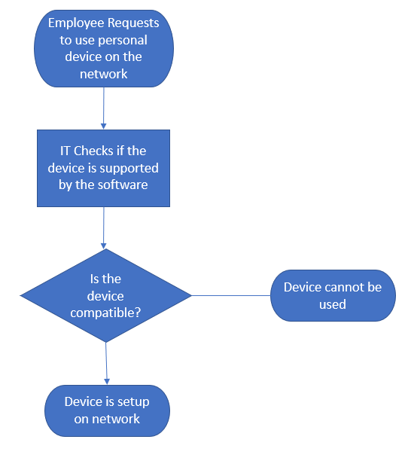
This shows the process of getting a device added to the BYOT network. This is quite a simple process but must be done through IT to ensure that users cannot install apps and can only access the files they need.

Countermeasures
Countermeasures are an essential part of ensuring a network is secure. It is used to stop potential exploits. An example of which is how the FTP (File Transport Protocol) is considered to be insecure as it can access files instantly . The countermeasure to avoid that becoming an insecurity in a network is setting up a username and password on each user so that they can only access the files remotely. This means that if a hacker does get in they can only access the files that the person who’s account they are using would have. This can several limit the damage a hacker can do. It also reduces the chance that it will ever actually become an issue full stop. The passwords need to be encrypted or it will not be considered safe.
The biggest counter measure to a cyber attack is educating employees so that, firstly, they know how they can help prevent the company’s network from getting compromised. If an employee knows the signs of a phishing site, they are less likely to fall for the attack. They are also less likely to download files that contain viruses as they will be able to see the tell-tale signs of a fake site. They will also know about the risks of using things like proxy’s to get around the networks restrictions which might reduce the odds of them attempting to use a proxy as a get around.

Conclusion
Whilst using BYOT imposes many risks for a network from many different angles I would consider it a nice option to have for employees so that they can feel more independent from the company using a device they are familiar with. BYOT reduces training costs as well as device purchase devices. There are benefits for long terms employee’s too as after three years of owning their device they will be able to keep the discount the employee offered on their device. It also offers some protection to the employers so that employees cannot simple just join a company, take advantage of the discount and then leave the company as they will lose the money from the device. I have also covered the ways on how to prevent malicious hackers from taking advantage of exploits in the network. The redesign of the network to support the new BYOT system should be a peaceful transition as its just an upgrade on the network that is already put in place.

References

Bibliography

[1] | VMWare, “Airwatch,” VMWare, [Online]. Available: https://www.air-watch.com/. [Accessed 14 April 2020].
[2] | “Advantages and Disadvantages of BYOD,” 1RTI, [Online]. Available: https://www.1rti.com/the-advantages-disadvantages-of-byod/. [Accessed 15 April 2020].
[3] | S. Lerner, “BYOD Advantages and Disadvantages,” EnterpriseMobilityExchange, [Online]. Available: https://www.enterprisemobilityexchange.com/eme-byod/articles/byod-advantages-disadvantages. [Accessed 16 April 2020].

marking criteria and Student FEEDBACK

This section details the assessment criteria. The extent to which these are demonstrated by you determines your mark. The marks available for each criterion are shown. Lecturers will use the space provided to comment on the achievement of the task(s), including those areas in which you have performed well and areas that would benefit from development/improvement.

Common Assessment Criteria Applied (Assignment 1) | Marks available | Marks  awarded
1. Engagement with Literature Skills
Extent of research and/or own reading, selection of credible sources, application of appropriate referencing conventions.
You have used limited references from only websites and did not engaged with any academic peer review article to make your work credible. Websites require careful consideration. Key concept considered. Utilise the University online resources and journals. (Grade mark: 46.67%) | 15 | 7
2. Knowledge and Understanding Skills
Extent of knowledge and understanding of concepts and underlying principles associated with the discipline.
Need to demonstrate more depth of the research, see comment above which can help in this area. (Grade mark: 46.67%) | 15 | 7
3. Cognitive and Intellectual Skills
Analysis, evaluation and synthesis; logic, argument and judgement; analytical reflection; organisation of ideas and evidence
Your report in some aspect only explain the terms rather than discussing them. Relevant areas done for this assignment; policy, DFD, network design, and a written conclusion. (Grade mark: 53.75%) | 40 | 21.5
4. Practical Application Skills
Deployment of methods, materials, tools and techniques; application of concepts; formulation of innovative and creative solutions to solve problems.
Your practical design is very basic with no security measures on core devices such as password. You have explain security measures in your report but did not configured any in the Packet Tracer design. Proper labelling/naming of LANs and host could be done rather than the default names. (Grade mark: 47.50%) | 20 | 9.5
5. Transferable Skills for Life and Professional Practice
Attributes in professional practice: individual and collaborative working; deployment of appropriate media; presentation and organisation.
Your report could be aligned justified. Writing need improvement (try to read more peer reviewed articles and emulate the writing style). Avoid writing in first person tense. See report for more comments. (Grade mark: 48.00%) | 10 | 4.8

Assignment Mark (Assessment marks are subject to ratification at the Exam Board. These comments and marks are to give feedback on module work and are for guidance only until they are confirmed. ) | Late Submission Penalties (tick if appropriate) |  | 50%
 | Up to four weeks late |  | 50%
 | First Attempt? |  | 50%

