‘What is the truth?’
Beth Agar
1701677
Surface pattern design year 1
Julia Lockheart
Ways of Perceiving (M4X01559)
Word count; 1337

Key words to think about within writing;
- Postmodernists- thoughts who don’t think about one truth they think about a group of truths. (open minded thinking about the bigger possibilities)
- Postmodern- metanarrative
- Simulacrum- the likeness of something original but not actually the original. Eg the photo of the modern day last supper has strong likeness to the original painting but it will never be the original painting.
- Semiotics- the way we are teach to believe in something.

‘What is the truth?’
In the age of Post-Modernism I have created an exhibition that challenges the way we think about the ‘truth’, using Jean Baudrillard’s theory of the real and unreal as well as the semiotics of religion. My exhibition questions what the real truth is. I have two pieces being exhibited within my gallery space at the Walker Art Gallery in Liverpool. The original painting of the last supper by Leonardo da Vinci and the other a live still life performance piece of 13 men recreating the painting using modern day formats. The modern-day form includes real life living breathing people we can see them, touch them, even smell them and we know they are real but which is the truth? A painting of a story told to be true or a re-creation of the painting from a story which is told to be true but using real life living human beings. This question by itself is confusing, complicated and from the beginning you a flooded with many more questions and possible answers. Which is exactly what I wish to happen, I want people to not understand and feel almost lost after hearing the question; because with this comes with the need to understand the meaning of seeing the world from a post-modernist point of view.
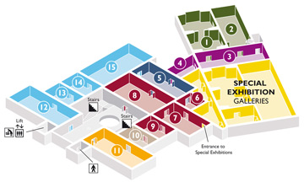
Walker Art Gallery (2018) Floor Plan- Liverpool

The layout of the gallery space will be simple and am using room 12 in the Walker Art
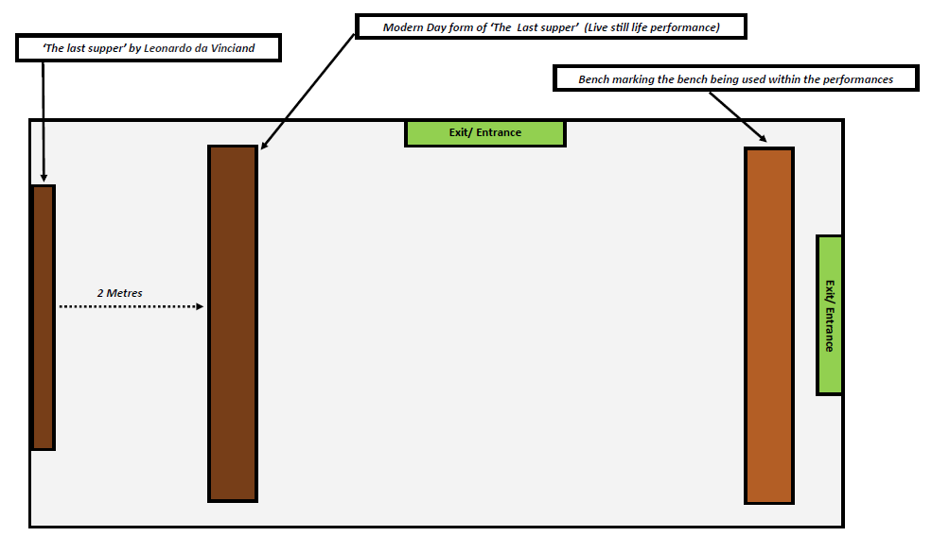
Gallery. On the very far end of the room will be the painting of the Last Supper about 2 metres away in front of it will be the live performance piece of the modern day last supper. Then at the very end of the room there will be a long wooden bench around the same length as the table being used within the piece. The viewers have the option of sitting down and watching almost like being the at the table themselves or they will be able to walk right up to both pieces (though no touch of either would be allowed.) They will have the opportunity of a 365 degree view of the performance piece whilst also observing the painting. The idea is that people can really feel part of the exhibit, getting up close which in away helps develop a deeper understanding of both the meaning behind the exhibit and their feelings overall.
Agar (2018) Floor Plan- Liverpool Walker Art Gallery and how my exhibition will be set up and displayed

Baudrillard’s book ‘Simulacra and Simulation’ questions what we see as the real and unreal, the truth and the untruth. He feels that our society questions everything and has been replaced by the reading of signs and symbols, which is why semiotics plays such a key role within society today. Due to this since from our birth we are told what to believe, we are taught how to read everything as a sign and symbol analysing everything around us, as having deeper meaning. Semiotics is prominent within religion, Baudrillard states that

All western faith and good faith became engaged in this wager on representation: that a sign could refer to depth of meaning, that a sign could be exchanged for meaning and that something could guarantee this exchange- God of course (Baudrillard, 1994: 5)

Many children are taught through Faith and Sunday School to believe in what the bible them to be true and are also told not to question what was said and to “trust God” (Matthew, n.d : 5-7)(Luke 6, n.d : 268).

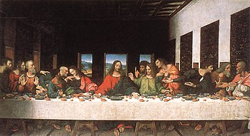
The painting of ‘The Last Supper’ is a perfect example of a simulacrum in that it is a copy without original source. The painting was created by Leonardo da Vinci, between the years 1495 and 1498 and was taken down from display through the orders of Francis I shortly after being finished. It was then left in storage till around 1540 where it was then moved several times, with other artists making slight repairs due to the damage that had occurred during its time in storage. In 1726 the monks felt that the painting needed to be and “employed a mediocre artist, who covered it with a secret varnish.” (Heath , 1886: 630) It was later in 1770 an artist named Mazzo actually repainted the heads of the 13 men portrayed. By 1801, not much of the original paint from Da Vinci was left after so many different artist had made touch ups. (Heath, 1886, 630) So in fact the image we see today is not actually the painting that da Vinci created it is the altered image worked on by many artists such as Mazzo, which poses the theory, is the image itself actually real? We know it’s a painting we can see it on the wall with our own eyes but is it the reality truth. The story that is being told within the design is an image with no source, it becomes a copy of something with no original. There is no completely solid one hundred percent proof that ‘The Last Supper’ was an actual event that occurred 3000 years ago. It has been painted by an artist in 1498 referencing imagery from the book with no pictures; then over the process of 303 years was worked into many times that it no longer has the original paint.

Leonardo da Vinci (1498) The Last Supper [Oil Painting] Convent of Santa Maria delle Grazie, Milan

My performance piece will consist of 13 men gathered around a long wooden retangular table mirroring the Da Vinci design. On reflection of society today these are the four-key elements I think of; fast food, fashion/ branding, alcohol and technology. How we are constantly surrounded by these on a daily basis, to the point where they are just a normal part of society, something which 3000 years ago when the painting is set would be non existent. The men will be dressed in modern branded clothing such as ‘Nike’ and they will be surrounded by fast food like McDonalds and new modern technology for example ‘iphones’ ‘apple watches and laptops’. The men will have a contemporary style which we see around the world today. I want it to almost look like 13 average men have walked in from the high-street and sat frozen still at a table creating a still life image. My inspiration for this design came from a photograph named Marcos López who recreated his own vision of the last supper in 2001 named ‘Asado en Mendiolaza’. His design looks closely at the modern images used within advertising and society today as well as Hispanic culture, although the subject matter speaks to many cultures through its diversity of models and subject matter. His design like mine depicts men around a table surround by food drink and wearing modern clothes but unlike mine Lopez’s design has a commercial feel to the viewer. The image itself denotes stereotypical male environment such as football shirts, vests, meat and alcohol.

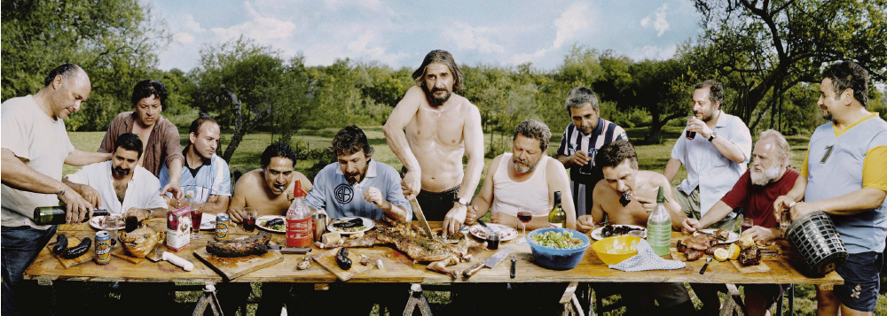
Marcos López (2001) ‘Asado en Mendiolaza’ [photograph]

My exhibition questions what is the real truth?
A painting of a sense from a book written over 3000 years ago or a live still life performance piece recreating the painting in modern day style. It poses the theory what is real, the recreation of image with no original or a recreation of a recreation with no original. So my question is how can this be a true source of reality, the truth is an endless amount of possibilities. Post-modernists believe that truths is an endless series of possibilities. In fact there is no right or wrong answer it is an internal interpretation. It depends on the individual and the belief system they hold. Through their development process and the contexts that surround them, they have constructed a way as to how they themselves read signs and symbols; because “nothing is a sign unless it is interpreted as a sign” (Peirce 1931: 58). In the end we will never know what the truth is because one person’s truth is somebody else’s lie. My exhibitions aim is to provoke people to think about how they view what’s around them and if they leave my exhibition with just one thought or one feeling of what they see as the ‘truth’, in my eyes it will have been a success.

Bibliography
Books
Baudrillard, J. (1994). Simulacra and Simulation University of Michingan press

Case, i. X. (n.d.). iPhone Acessories. Retrieved 2018 from apple.com: Author iPhone X Silicone Case

Heath, R. (1886). The "Last Supper" of Leonardo Da Vinci. The Sunday Home: A family magazine for Sabbath reading (1692), 630- 631.

Foster, D.W. (2005) “Homosocialism- Homoeroticism in the Photography of Marcos Lopez,” Dissidences: Vol. 1: Iss. 1 Article 5. https://digitalcommons.bowdoin.edu/cgi/viewcontent.cgi?article=1004&context=dissidences

Yelle, R. A. (2013). Semiotics of Religion. London, New York: Bloombury Publishing.

Online Article
Cacone, S. (2018). Leonardo da Vinci Made a Secret copy of 'The Last supper. [online] Available at: < https://news.artnet.com/art-world/leonardo-da-vinci-last-supper-copy-1247756> [Accessed: 4 May 2018]

Websites
N/A. (n.d.). JD Sports. Retrieved 2018 from https://www.jdsports.co.uk/: https://www.jdsports.co.uk/
N/A. (2014, November 19). JD Sports Christmas 2014 Men's Lookbook. (BeansPublishing Limited ) Retrieved April 2018 from www.fashionbeans.com.2014/jd-sports-christmas-2014-mens-lookbook/: http://www.fashionbeans.com/2014/jd-sports-christmas-2014-mens-lookbook/
N/A. (n.d.). McDonalds. Retrieved 2018 from https://www.mcdonalds.com/gb/en-gb.html
N/A. (n.d.). Room guide- Walker Art Gallery, Liverpool museums. Retrieved 2018 from Liverpoolmuseum.org.uk: http://www.liverpoolmuseums.org.uk/walker/visit/room-guide/

