HEALTH ASSESSEMENT REPORT

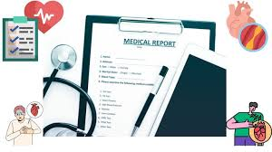
(Pandey, K, S., 2022)

Student Name: SEFIA BIBI
Student Number: 2014087
Module Code: BMHP5003
Module: INTRODUCATION TO PHYSIOLOGY
Lecturer: MUHAMMAD HUMZA SAEED

1

Table of Contents

Introduction………………..3
Case Report………………..4
Assessment Report………5-8
Care Plan………………...…8-9
Recommendation…………9
Conclusion…………………10
References…………………11-12
Lifestyle Questionnaire …13-14

2

INTRODUCATION

I have been asked to write a report on a person's health and one disease that they may be suffering from. Teresa Morris, who has coronary heart disease, is the name of the anonymous person I have selected. The impacts on the cardiovascular system have been the main focus of this report.

Using the preliminary details Teresa has provided, I will create a case report in this document. Based on the results of the health-based Lifestyle Questionnaire, she was selected as a candidate. A basic health monitoring question is among the many items on the lifestyle questionnaire that are based on the current lifestyle.

Speaking with Teresa, conducting a medical review, and accepting any medical records that Teresa will present are all parts of an assessment. I will be able to assess her health and develop a care plan to support her and her medical requirements using all the information that I have learned by talking to her and some information that I have from the websites for health services.

3

CASE REPORT

Teresa, who is 50 years old, is married with four kids and enjoys a high quality of life. When there was a special event, Teresa would smoke and occasionally drink. She also works part-time and leads a healthy lifestyle. She enjoys spending her free time with her family, playing sports and enjoys doing the garden. She regularly goes for walks outside to stay in shape, and she eats daily fruits and vegetables.

Teresa started to experiences chest pain (angina), pains throughout the body, shortness of breath and feeling sick. She did not feel herself and was tired all the time due to this she was taking days off work, couple of times Teresa thought she was having heart attack. At times she would get up during the night with chest pain and discomfort. Shortness of breath caused Teresa to cease taking walks, which had an impact on her health and weight. Teresa consequently began to acquire weight. After speaking to the doctor and having bloods and a scan and coronary angiography she was diagnosed with coronary heart disease and has been taking medication ever since.

The chest pain, light-headedness, and fatigue are still there for Teresa on occasion. She makes an effort to relax because she finds it challenging to undertake some tasks due to her illness, such as mowing the grass, playing sports, or walking up hills. Teresa tries to unwind and take it easy but is suffering from worry, anxiety, and bad mood as a result of everything. She is not eating much but still gaining weight.

4

ASSESSMENT REPORT
The normal functioning of your cardiovascular system, which includes your heart and blood vessels, is important because it carries nutrients, oxygen, and many other healthy substances to all of your body's cells. They also take carbon dioxide and trash out. The cardiovascular system's primary functions are to eliminate waste and provide nutrients. You can consult your doctor, who can perform a stress test, to assess your cardiovascular health to determine how your body uses oxygen while you exercise.

Cardiovascular system

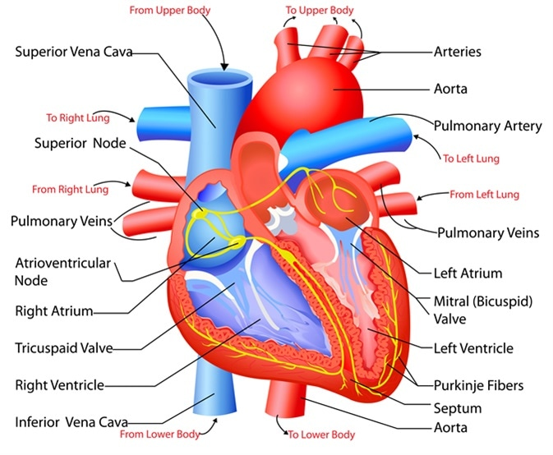
(Miranda, G, M 2021)

- Moves oxygen and eliminates carbon dioxide
- Moves nutrients and eliminates waste
- Fights Illness
- Delivers Hormones
- Controls Body Temperature.

5

The abnormal functioning of cardiovascular

Poor cardiovascular function, which can result in conditions like heart disease, stroke, coronary artery disease, heart attack, and congestive heart failure, can be caused by the abnormal functioning of the cardiovascular system, an interruption, obstruction, or disease that affects how your heart or blood arteries pump blood. Any of these conditions could be fatal if they are not treated or kept under control. (Felson et al., 2021). Coronary heart disease is another condition that develops when the arteries are unable to adequate blood, oxygen, and nutrition to the heart. The formation of plaque and cholesterol deposits, which restrict your arteries and lessen blood flow to your heart, are almost always to blame. Shortness of breath or chest pain could occur from this, among other heart attack symptoms.

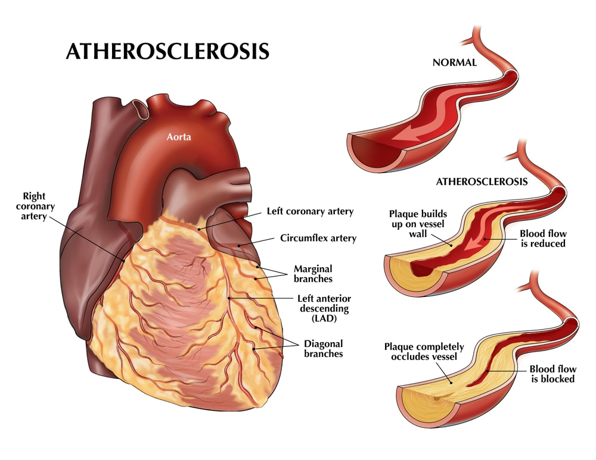
(Raj, S., 2019).

6

The symptoms of Coronary heart disease and long term affects.
- Chest pain (angina) - Your chest may feel tight or under strain.
- Respiration difficulty- You can experience difficulty breathing.
- Fatigue- You may experience unusual fatigue if the heart can't pump enough blood to keep up with your body's needs.
- Heart attack
- Pulmonary Hypertension
- Congestive Heart failure
- Endocarditis
- Arrhythmias

Your heart and kidneys are two of your body's most vital organs. To keep you healthy, they cooperate. The other is also impacted when one is. In other words, the condition of your kidneys might have an impact on the health of your heart, and vice versa. There are several different potential risk factors for coronary heart disease. The status of the cardiac arteries can be impacted by age, genetics, other medical disorders, and lifestyle choices.
Coronary artery disease risk factors include:
Age- Age may raise the likelihood of damaged, constricted arteries.
Sex- The risk of coronary heart disease is higher in men.
Family history- history of heart disease in your family is more likely to get this disease.
Smoking- this is a bad risk for heart health.
High blood pressure- If you have high blood pressure, your arteries may become stiff and rigid, narrow, and slow blood flow.
High cholesterol- The risk of atherosclerosis may be increased by high blood cholesterol levels.
Diabetes- can increase risk of Coronary heart disease.
Overweight/ not enough exercise-this could affects overall of your health and physical activities are important for your health.
Chronic kidney disease- this could increase the risk of having Coronary heart disease.
Unhealthy Diet-- Eating foods high in saturated fat, salt, and sugar can raise your chance of developing coronary heart disease.
Alcohol use- drinking too much alcohol consumption can harm muscles and risk of coronary heart disease.
Sleep- not having enough sleep and having too much sleep both are linked to increased risk of having coronary heart disease.

7

CARE PLAN
Once you have been diagnosed with coronary heart disease, there is no treatment for it, and it cannot be reversed. However, you can alter your lifestyle to lower your chance of subsequent health issues, such a heart attack.
All medical advice should be strictly followed. Every medical and professional appointment needs to be kept regularly. Regular monitoring of tests and examinations will aid specialists in tracking progress and modifying the treatment plan to suit the patient's condition at the time of consultation. This will also make it possible to monitor changes and identify adverse effects early.

- Eating healthy foods i.e. fruit and vegetables more often
- Keeping active doing at least 30 minutes’ walk every day
- Keeping your weight within the normal range on a body mass index (BMI)
- There is also heart foundation- where you could go its group activities to keep your heart healthy.
- You can also check your own pulse at home, you can get the smart watches that tell you your pulse rate and how many step you have done.
- Social groups could one of them as you can have a chat with people this would help with anxiety depression and also will help to maintain blood pressure due to having high blood pressure can lead to stiffen and narrow your artery wall and could block the blood flow to your heart.
- Support individuals with equipment or aid that they require.

Regular tests and monitoring
- Regular bloods
- Exercise stress test
- ECG
- Regular blood pressure check
- Check cholesterol regularly 8
Teresa needs to do exercises on a regular basis to keep her fit and healthy. Pick an aerobic exercise like bike, light running, swimming, or walking. At least 3 to 4 times per week, perform this. Spend 5 minutes stretching or moving about before working out to warm up your muscles and heart. After your workout, relax for a while.

8

RECOMMENDATION

Recommendations are statements that are meant to help us decide, the most effective method to carry out particular actions, such treatment programmes, diagnostic procedures, or medical self-help methods, in order to obtain the greatest potential health outcomes. Teresa needs to put herself first, prioritise herself, and give herself time to recuperate at her own speed. For Teresa to look after herself and take it easy to do tasks. Coronary heart disease is a serious condition that could lead to other problems i.e. heart failure, stroke. For Teresa to stop alcohol and smoking as another risk that could lead to making things worse.

By eating more fruit and vegetables, less red meat and more white meat and fish, Teresa can add foods to her diet that are low in cholesterol and saturated fats.
According to researchers and dieticians, heart disease cannot be cured, but it may be reversed, and one of the best ways to do so is through cardiac rehabilitation.

9

CONCLUSION

The cardiovascular system, which consists of your heart and blood vessels, must be in proper working order for all of your body's cells to receive oxygen, nutrients, and other important elements. They also eliminate carbon dioxide and waste. The cardiovascular system's main functions are to transport nutrients and eliminate waste.
Teresa has coronary heart disease, which is brought on by fatty deposits accumulating on the artery walls surrounding the heart. The build-up of fat causes the arteries to become smaller, which limits the amount of blood that can reach the heart muscle. Because of this condition Teresa is founding it hard to do certain task, as this affects her breathing, sleeping and also gets chest pains.
Within any guidelines your cardiologist tells you, Teresa will need to maintain her body weight and engage in a few activities each week. She also needs to have her cholesterol levels checked on a regular basis.

One should strive to eat nutritious foods like fruit and vegetables in order to prevent disease. They should eat wholesome foods that are high in vitamin A. Your heart needs magnesium more than any other organ in your body, and since spinach and walnuts are high in magnesium, you should include them in your diet for a healthy heart. Another crucial element, omega 3, which helps to avoid blood clots and maintain a healthy heart, can be discovered in flax seeds and salmon. Green leafy vegetables are also a wonderful source of folate.

The results of earlier meta-analyses have been confirmed by this systematic analysis, which found that exercise-based cardiac rehabilitation lowers total and cardiac mortality but not the risk of subsequent myocardial infarction or revascularization 5, 6, 7, 8. Our study reveals that the mortality benefits of exercise treatment appear to be consistent across a number of coronary heart disease subgroups (such as post-myocardial infarction, post-revascularization, and angina), as well as a range of exercise-based therapies.

10

REFERENCES

Barth, J., Schumacher, M. and Herrmann-Lingen, C., 2004. Depression as a risk factor for mortality in patients with coronary heart disease: a meta-analysis. Psychosomatic medicine, 66(6), pp.802-813.

Bethell, H., Lewin, R. and Dalal, H., 2009. Cardiac rehabilitation in the United Kingdom. Heart, 95(4), pp.271-275.

Dibsdall, L.A., Lambert, N., Bobbin, R.F. and Frewer, L.J., 2003. Low-income consumers' attitudes and behaviour towards access, availability and motivation to eat fruit and vegetables. Public health nutrition, 6(2), pp.159-168.

Felson, S, MD., (2021). Cardiovascular Diseases [Online] Available at: https://www.webmd.com/heart-disease/guide/diseases-cardiovascular (Accessed on 30th July 2022).

Ference, B.A., Yoo, W., Alesh, I., Mahajan, N., Mirowska, K.K., Mewada, A., Kahn, J., Afonso, L., Williams, K.A. and Flack, J.M., 2012. Effect of long-term exposure to lower low-density lipoprotein cholesterol beginning early in life on the risk of coronary heart disease: a Mendelian randomization analysis. Journal of the American College of Cardiology, 60(25), pp.2631-2639.

Gordan, R., Gwathmey, J.K. and Xie, L.H., 2015. Autonomic and endocrine control of cardiovascular function. World journal of cardiology, 7(4), p.204.

Mayo clinic, (2022) Coronary artery disease [Online] Available at: https://www.mayoclinic.org/diseases-conditions/coronary-artery-disease/symptoms-causes/syc-20350613#:~:text=CAD%20happens%20when%20coronary%20 (Accessed on 30th July 2022.

11

Miranda, G. M., (2021). Structure and Function of the Heart [Online] available at: https://www.news-medical.net/health/Structure-and-Function-of-the-Heart.aspx (Accessed on 30th July 2022).
Ornish, D., Brown, S.E., Billings, J.H., Scherwitz, L.W., Armstrong, W.T., Ports, T.A., McLanahan, S.M., Kirkeeide, R.L., Gould, K.L. and Brand, R.J., 1990. Can lifestyle changes reverse coronary heart disease? The Lifestyle Heart Trial. The Lancet, 336(8708), pp.129-133.

Pandey, S, K., (2022) Heart disease report for health professionals. [Online] Available at: https://hospitalranchi.in/heart-disease-report/ (Accessed on 30th July 2022.

Raj, S., (2019). [Online] Available at: https://www.oplushealthcare.com/latest-update/atherosclerosis-and-/14060 (Accessed on 30th July 2022).

Taylor, R.S., Brown, A., Ebrahim, S., Jolliffe, J., Noorani, H., Rees, K., Skidmore, B., Stone, J.A., Thompson, D.R. and Oldridge, N., 2004. Exercise-based rehabilitation for patients with coronary heart disease: systematic review and meta-analysis of randomized controlled trials. The American journal of medicine, 116(10), pp.682-692.

12

LIFESTYLE QUESTIONNAIRE
Introduction:
In order to help us focus our Health Promotion activities in the practice, we would be grateful if you could fill in this short questionnaire. If you have already completed one on a previous visit, please return this questionnaire to the receptionist.

Name …Teresa Morris …………………………Date of Birth ………30/08/1972

Do you smoke? |  | Yes | [ | /] No [ ]
If Yes, do you –
smoke less than 1 | cigarette/day |  | [/ | ]
1 – 9 | cigarettes/day |  | [ | ]
10-19 | cigarettes/day |  | [ | ]
20-39 | cigarettes/day |  | [ | ]
more than 40 | cigarettes/day |  | [ | ]
smoke a pipe |  |  | [ | ]
smoke cigars |  |  | [ | ]

If No, have you –

never ever smoked  given up smoking in the last year not smoked for more than 1 year |  | [  [  [ | ]  ]  ]
Do you have high blood pressure? | Yes | [ | ] | No | [ | /]
Have you ever had a heart attack or suffered from angina? | Yes | [ | /] | No | [ | ]

Have you ever had a stroke, “shock”
or any weakness down one side? Yes [ ] No [ /] Have any of the following – mother, father,
brothers or sisters had –
a heart attack below the age of 60 | Yes | [ | ] | No | [/ | ]
a heart attack above the age of 60 | Yes | [ | ] | No | [ | /]
a stroke | Yes | [ | ] | No | [ | /]
trouble with very high cholesterol | Yes | [ | ] | No | [ | /]

(hyperlipidaemia)

………………………………………………………………………………………

13

Practice Use Only
Health Education Smoking N/A………….

BP 130 / 85

Height 5ft-5

Weight 89kg

14

EXERCISE

Healthy exercise usually involves activity that lasts for at least 20 minutes, raises your pulse and produces hard breathing. In younger people this might be running, cycling or sport, or brisk walking for older people.

Do you take this type of exercise –

daily [ ]
3 times weekly [ /]
once weekly [ ]
once monthly [ ]
seldom [ ]

I cannot take exercise because of disability [ ]

DIET
Please tick the one category which is closest to your usual eating pattern.

I eat no meat, fish, or dairy produce [ ]
I eat no meat [ ]
I eat a mixture including daily fruit and vegetables [ / ]
I eat a mixture including regular chips and fries [ ]
I eat frozen meals (e.g. TV dinners) 3 or 4 times/week [ ]
I eat mainly snacks [ ]
I eat a special medical diet [ ]

Please specify ………………………………………………………………………

ALCOHOL
Please tick the statement which most closely describes your usual average alcohol intake. (1 unit is 1 glass wine, ½ pint beer or a single measure of spirit.)

I never drink alcohol [ ]
I drink less than 1 unit per day [/ ] only on special occasions
I drink between 1 and 2 units a day [ ]
I drink between 3 and 6 units a day [ ]
I drink between 7 and 9 units a day [ ] I drink more than 9 units a day on average [ ]

15
……………………………………………………………………………………….

Practice Use Only

Health Education Alcohol [ ] N/A
Alcohol Brief Intervention [ ] N/A

16

