Module: Human Capital Management (LCMB7023)

Assessment Component 1: Individual Report

Building Human Capital Capability for Strategic Renewal: Helios Urban Mobility (HUM)
Lecturer: Gladius Kulothungan (London) / Eno Maycock (Birmingham)
Student name: Hiren Kishorbhai Adroja
Student ID number: 2527939

Word count: Approx. 2,513 words
Submission date: 19 June 2026

List of Abbreviations

Abbreviation | Meaning
AI | Artificial Intelligence
HUM | Helios Urban Mobility
JCM | Job Characteristics Model
HR | Human Resources
HRM | Human Resource Management

Table of Contents
List of Abbreviations 2
Introduction 4
TASK A: Socialisation, Identity and Business Activism Helios Urban Mobility (HUM) 4
1.1 Critical evaluation of traditional onboarding and strategic organisational socialisation 4
1.2 A structured socialisation framework for Helios Urban Mobility 5
1.3 Cultivating organisational identification, ethical professionalism and business activism 6
2. Task B: Job Design 8
2.1 A relational and proactive job design strategy 8
2.2 How the design strengthens motivation and innovation 11
3. Task C: Reflective report 12
3.1 Using AI as a decision-support tool 12
3.2 Personal capability development plan 13
References 14

Introduction
Helios Urban Mobility (HUM) isn't just a narrow induction issue; it's a matter of a flow of meaning, coordination and capability. The firm has had to rush to expand multiple locations, leaving it with long ramp-up times, and an easily fractured commitment and/or graduate turnover. In knowledge-intensive organisations the business is not only to hire people, but to also assist in their interpretation of the work, the relationship and purpose that allow output to be delivered. This report makes the case for the need to develop a new sensemaking-based model of socialisation within HUM, a work design model based on relational and proactive job redesign, and an AI practice model based on human judgement, rather than automated decision replacement. The report takes an unique approach from a traditional onboarding solution. Task A redefines newcomer integration as a process of realistic preparation, the creation of networks and an orientation towards public value. Task B sees job design as an evolving portfolio of activities (and not a fixed organogram), Job Characteristics Model and job crafting and skills mobility. Task C considers AI as an assistant to judgement and outlines a capability development plan which facilitates future employability.

TASK A: Socialisation, Identity and Business Activism Helios Urban Mobility (HUM)

1.1 Critical evaluation of traditional onboarding and strategic organisational socialisation
For Helios Urban Mobility (HUM), a strategic socialisation approach is needed instead of the classic onboarding process. While conventional onboarding mainly concentrates on administrative tasks, like compliance training, policy briefings and access to systems, organisational socialisation is about building understanding, commitment and organisational membership. This distinction is crucial as it is how newcomers understand certain early experiences in the organisation as indicators of support, trust and future opportunities. Weick (1995) states that employees create meaning as part of sensemaking and Morrison (1993) proposes that newcomers proactively seek information to cope with uncertainty when entering an organisation. Early experiences are emphasized by the psychological contract. Rousseau (1995) proposes that employees' expectations of development opportunities, fairness and career progression arise. Failure to do so can lead to a loss of commitment within the organisation. This is especially important for HUM as they will be seeking structured learning and career pathways for graduate recruits. Van Maanen and Schein (1979) offer a more powerful model which says that the socialisation strategy determines the adjustment process. Collective, sequential and investiture strategies can decrease ambiguity and acknowledge newcomers' capabilities. This view is substantiated by recent research, which saw Bauer et al. (2025) pinpointing social acceptance, proactive behaviour and perceived fit as pivotal adjustment factors. Hence, we must think of socialisation as an ongoing process of identity formation and organisational integration and not just an induction event.

1.2 A structured socialisation framework for Helios Urban Mobility

A socialisation plan that starts prior to entry and lasts until 1st year of HUM should be established. 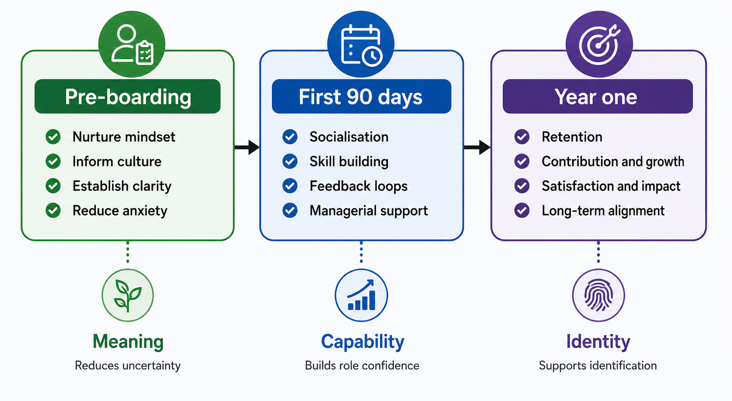
Figure 1. Helios Urban Mobility socialisation architecture
Based on Weick (1995) and on Van Maanen and Schein (1979), Rousseau (1995) and Bauer et al. (2025) and designed by the author.
To avoid this, the responsibilities and standards of performance should be clearly communicated through realistic job previews, mentor assignments and expectation charters during the pre-boarding process. This is a way to reinforce the psychological contract: it matches expectations and the realities of the organisation and minimises uncertainty prior to starting work. Role clarity, relationship building/competence development are the main priorities for the first 90 days. Mentoring, job shadowing and regular feedback sessions should be undertaken by new staff and they should be given meaningful tasks which result in early achievement. These experiences build confidence, facilitate faster learning and promote integration in the organisation. A structured approach is better as having well-defined milestones and steady support will help minimize the chances of dropping out. The first year should focus on building the long-term buy in with cross functional rotations, communities of practice, stakeholder engagement activities. Such experiences enable staff members to gain an appreciation of the impact of their work on the organisational objectives and public value. Bauer et al. (2025) indicate that social acceptance and perceived fit have a significant positive effect on newcomer adjustment, and this is beyond induction—the continuous socialisation process is important.
Table 1. Helios Urban Mobility socialisation roadmap
Phase | Core actions | Why it matters | Success signal
Pre-boarding | Realistic preview, mentor match, expectation charter, role map | Reduces ambiguity and aligns expectations | Clearer psychological contract
First 90 days | Shadowing, quick wins, check-ins, developmental feedback | Builds trust, role clarity and competence | Faster adjustment and engagement
Year one | Rotation, communities of practice, stakeholder immersion | Turns learning into identity and commitment | Higher retention and stronger identification
Source: Author's compilation

1.3 Cultivating organisational identification, ethical professionalism and business activism
HUM needs to reinforce organisational identity, connect employees' daily activities to a larger organisational goal. Ashforth and Mael (1989) propose identification is formed through people's sense of belonging to the organisation. Thus, leaders need to show how decisions on operations have an impact on enhancing urban mobility and public value. Communication and recognition programs driven by mission can help to strengthen this link and foster greater organisational attachment, while visible leadership support can help to reinforce this link. Being professional with ethics should not be regarded as a compliance exercise but rather as part of socialisation. Data governance standards and speak up mechanisms, within the framework of ethics workshops, can foster responsible decision making, especially with regard to HUM's work around data and public infrastructure. This way, employees are able to understand the impact of their actions and it also builds trust and legitimacy within the organisation. HUM should also try to develop business activist attitude among its employees by sensitizing them to question non-productive practices and think about the impacts on the stakeholders. In their article, Ulrich et al. (2011) reiterate the fact that today's professionals need to be strategic players, not administrative experts. In keeping with stakeholder capitalism, workers ought to consider the impact of choices on customers, communities and the broader surroundings. It is therefore possible to foster more responsible and sustainable organisational decision making through stakeholder reviews and social-value discussions.
Table 2. Mechanisms for identity, ethics and business activism
Capability | Mechanisms | Expected effect
Organisational identification | Mission stories, mentor sponsorship, recognition rituals, cross-functional projects | Stronger sense of belonging and purpose
Ethical professionalism | Ethics clinics, data stewardship standards, confidential speak-up channels | More responsible judgement and trust
Business activism | Stakeholder reviews, improvement forums, social-value metrics | More critical, strategic and socially aware behaviour
Source: Author's compilation, informed by Ashforth and Mael (1989), Mael and Ashforth (1992), Ulrich et al. (2011), Paine (2023)
Taking all the above into account, HUM should regard socialisation as a strategic ability, rather than a mere induction activity. A phased process that starts prior to joining, is reinforced during the first 90 days, and is enhanced over the first year is more likely to yield clarity, commitment and identification than a checklist of procedures to go through during onboarding. Together with professional ethics and business activism, HUM can help to make newcomers into committed organisational citizens, who not only help to improve the operational performance of the organisation but also to enhance its public value and sustainable legitimacy.

2. Task B: Job Design

2.1 A relational and proactive job design strategy
The working of HUM should not be organized based on a set organogram, but should be structured as a portfolio. For knowledge intensive companies static job boxes foster specialisation, but can also immobilise talent and hamper learning. The Job Characteristics Model is still relevant as it relates job design with skill variety, task identity, task significance, autonomy and feedback to motivation. Hackman and Oldham (1976) demonstrate that these attributes enable work to be meaningful and to be felt as personally responsible. For HUM, it means that the data analyst should not just be responsible for processing the data, but also understand how the data analysis results affect decisions by clients, product reviews and improvements of services. Hackman and Oldham (1976) argue that meaningfulness and internal work motivation are increased with enriched jobs which offer autonomy, feedback and a sense of task significance. Hence, HUM's work design should include roles that enable them to experience the impact of their work in terms of projects and stakeholders.
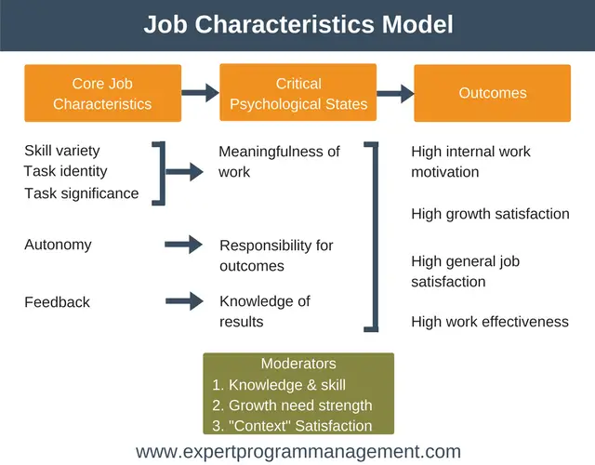
Figure 2. Job Characteristics Model and motivational outcomes.
Source: Adapted from Hackman and Oldham (1976).
However, the classic model isn't sufficient on its own as HUM requires work that's relational and proactive as well. Grant and Parker (2009) claim that in the design of work, today, the focus should be on both the ways employees interact with others and how they take the initiative to shape work. Additionally, Parker, Morgeson and Johns (2017) point out that technology, complexity and interdependence should be considered in the design of modern work. HUM should therefore provide space for the employees to give shape to tasks, relationships and meaning. Tims, Bakker and Derks (2012) demonstrate that job crafting can be beneficial to increase the fit when workers have the opportunity to rewrite demands and resources. This translates to giving your employees the freedom to contribute to project results in different ways, shift from analytical to client-facing roles and join project squads as temporary members.
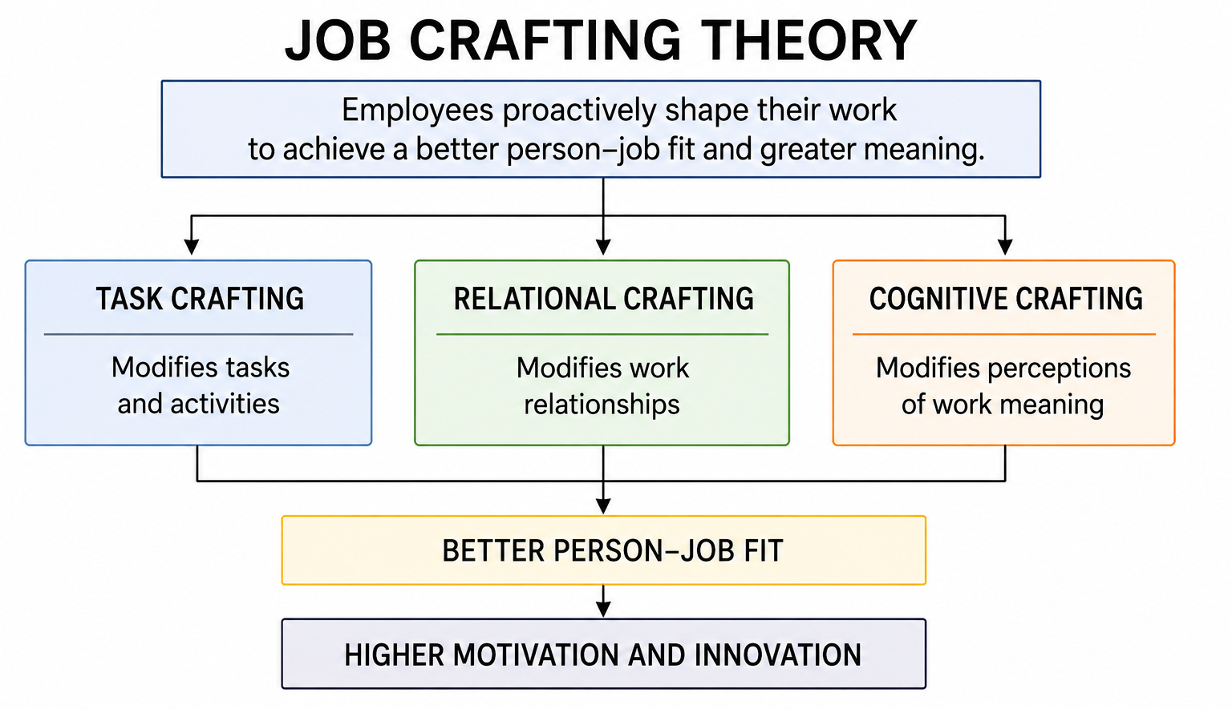
Figure 3. Application of Job Crafting Theory within Helios Urban Mobility.
Source: Designed by the author, informed by Tims, Bakker and Derks (2012), Grant and Parker (2009), and Parker, Morgeson and Johns (2017).
This should be topped with a skills-based layer. HUM should instead have a skills inventory and an internal project market beyond just the job title and hierarchy. The rationale is very pragmatic – if matchmaking can be done to work on the basis of work and not just title, then the firm is more agile, and the employee has a future within the firm. This is especially critical for retaining graduates, as they can feel that the first years of their career are limited and not relevant to their growth. The advantage of a skills-based framework is especially important in the case of HUM, where mobility and technology industries demand constantly evolving abilities. Aligning skills to opportunities based on skills and not hierarchical rank enhances agility, aids lifelong learning and optimises the use of talent across projects.
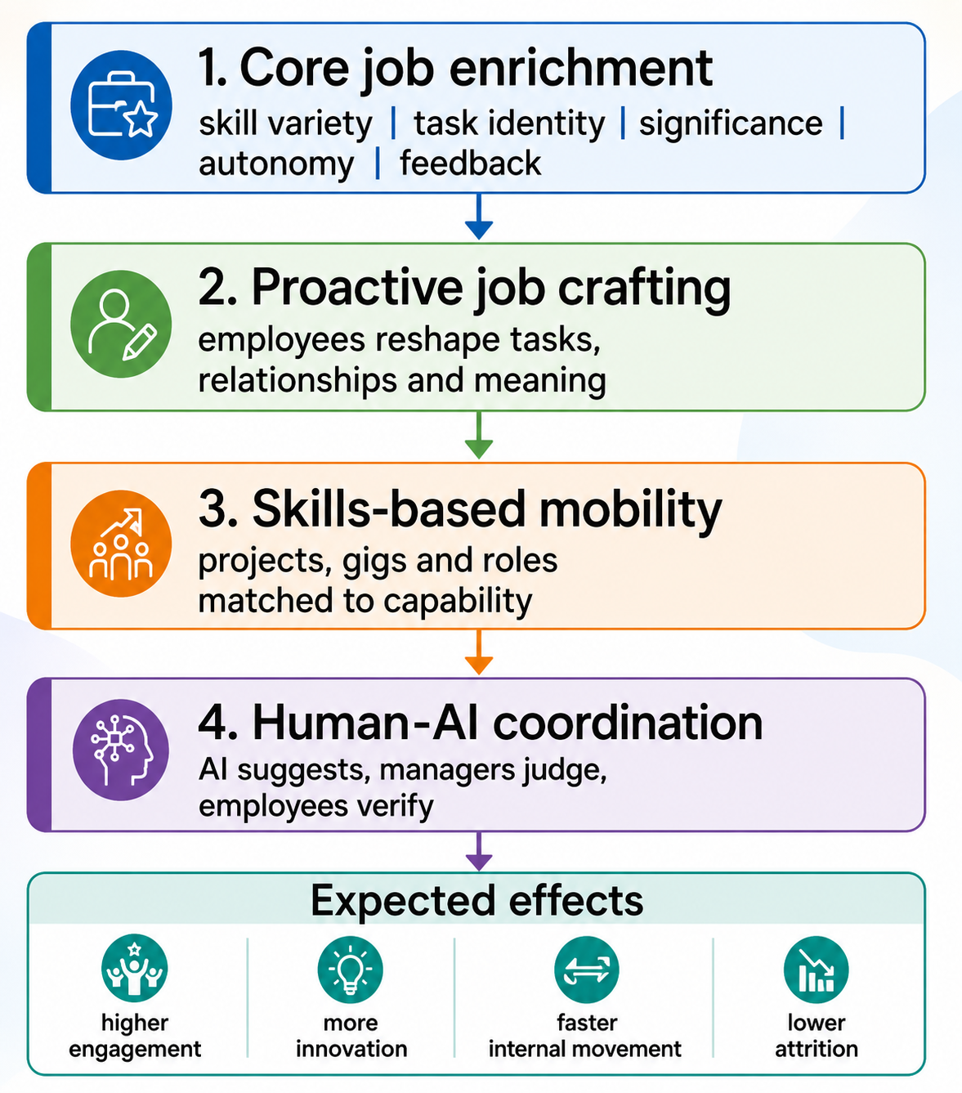
Figure 4. Work design architecture.
Source: Designed by the author, informed by Hackman and Oldham (1976), Grant and Parker (2009), Parker, Morgeson and Johns (2017) and Tims, Bakker and Derks (2012).
Table 3. Integrated work design strategy for HUM
Design lever | Implementation | Theory link | Expected effect
Enriched roles | Add client, product and review exposure to core tasks | JCM | More meaningful work
Job crafting | Allow task and relationship adjustment within clear boundaries | Grant and Parker; Tims et al. | Higher fit and innovation
Skills marketplace | Match people to projects using capabilities and not just titles | Work design and internal mobility logic | Faster movement of talent
Capability liquidity | Use shared skill profiles for staffing and learning decisions | Parker et al. (2017) | Better agility and retention
Source: Author's compilation, informed by Hackman and Oldham (1976), Grant and Parker (2009), Parker, Morgeson and Johns (2017) and Tims, Bakker and Derks (2012).

2.2 How the design strengthens motivation and innovation
The design proposed enhances motivation, due to its enhancement of autonomy, competence and relatedness. Project-based portfolio provides flexibility for people to contribute, competence is made visible through feedback loops and socially people are connected through cross-functional work. Ryan and Deci (2024) state that the most powerful motivation is when the activity meets the needs. For HUM, that translates to saying that if we're going to depend on motivation, it's not going to be through slogans, it's going to be through the way work is organised. The wider roles lead to knowledge recombination and that is followed by innovation. Analysts, engineers and people who interact with the client move from project to project, spreading ideas from one to the next. This is a valuable attribute in a mobility business because being technically insightful, but not transforming that into operational or customer value will not put that insight to commercial use. Diffusion of responsibility is the key risk and HUM should allow flexibility with clear responsibility – every project should have an owner, a finish line and a review point.

3. Task C: Reflective report

3.1 Using AI as a decision-support tool
In the future, I would use AI as an aid to decision making not as a decision-making tool. What makes AI so appealing is it has the capacity to sift through vast quantities of information and raise trends and accelerate typical analysis. However, Jarrahi (2018) reasons that AI is most beneficial when it is used in conjunction with the human judgement. That's the one that I would use. In either of the two cases above - where an AI solution provides a short list for recruitment or a mobility match/performance risk, these would all be considered a hypothesis requiring context, explanation and human review. This is significant because algorithmic systems have the ability to exacerbate bias, or to conceal uncertainty. Algorithms can serve as a mechanism of control as well as of coordination (Kellogg, Valentine and Christin (2020)) and AI can make work more efficient and more fragile at the same time (Raisch and Krakowski (2021)). So I would say, if you do test data quality, if you do check to see if there's a logic that is explainable, and if you do hold a manager or HR individual accountable for final results then you're on the right track. Collaborative Intelligence, which places a machine as an extension of the human, rather than replacing the ethical and contextual aspects of judgement is the best approach, suggest Wilson and Daugherty (2018).
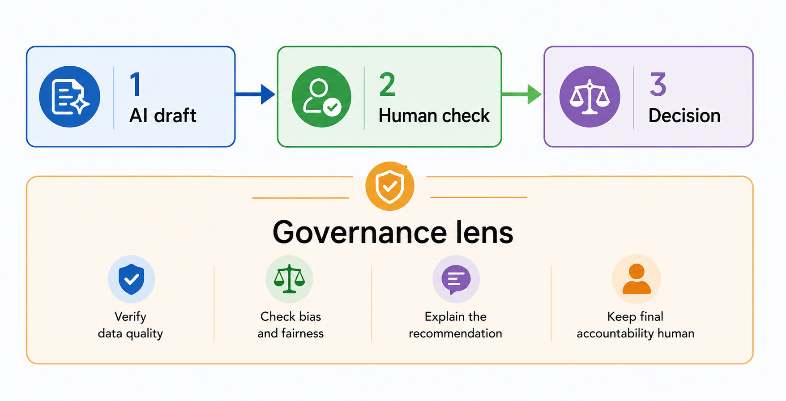
Figure 5. Human-AI decision cycle.
Source: Designed by the author, informed by Jarrahi (2018), Kellogg, Valentine and Christin (2020), Raisch and Krakowski (2021) and Wilson and Daugherty (2018).

3.2 Personal capability development plan
It is against that reflective attitude that my capability plan comes. First, I would like to be more literate with data and to not just take data metrics for granted, but to be able to question them and assess data quality, interrogating data dashboards. Second, I need to become AI literate, and know when to not rely on a model, know how to evaluate a prompt, and know how to avoid biases. Thirdly, strategic influencing is important as insight without an effective way of communicating persuasively to senior stakeholders is insight without change. Fourth, because HUM is a global business, a world mobile awareness is crucial to your future HR professional, and you need to understand the labour markets, cultural expectations and local constraints.
Table 4. Personal capability development plan
Capability area | Development action | Evidence of progress | Timeframe
Data literacy | Complete HR analytics training and review dashboards monthly | Can challenge data quality and trend logic | Months 1-3
AI literacy | Practise prompt design and bias-testing routines | Uses AI with transparent verification | Months 3-6
Strategic influencing | Write executive briefs and stakeholder maps | Can turn analysis into decisions | Months 6-9
Global mobility awareness | Study cross-border HRM and local employment context | Applies locally sensitive judgement | Months 9-12
Source: Author's compilation

References

Ashforth, B. E. and Mael, F. (1989) 'Social identity theory and the organization', Academy of Management Review, 14(1), pp. 20-39.
Bauer, T. N., Erdogan, B., Ellis, A. M., Truxillo, D. M., Brady, G. M. and Bodner, T. (2025) 'New horizons for newcomer organizational socialization: A review, meta-analysis, and future research directions', Journal of Management, 51(1), pp. 344-382.
Bauer, T.N., Bodner, T., Erdogan, B., Truxillo, D.M. and Tucker, J.S. (2007) Newcomer adjustment during organizational socialization: a meta-analytic review of antecedents, outcomes, and methods. Journal of Applied Psychology, 92(3), pp. 707-721.
Bauer, T.N., Truxillo, D.M., Tucker, J.S., Liden, R.C. and Erdogan, B. (2025) New horizons for newcomer organizational socialization. Journal of Applied Psychology.
Grant, A.M. and Parker, S.K. (2009) Redesigning work design theories: The rise of relational and proactive perspectives. Academy of Management Annals, 3(1), pp. 317-375.
Hackman, J. R. and Oldham, G. R. (1976) 'Motivation through the design of work: Test of a theory', Organizational Behavior and Human Performance, 16(2), pp. 250-279.
Jarrahi, M. H. (2018) 'Artificial intelligence and the future of work: Human-AI symbiosis in organizational decision making', Business Horizons, 61(4), pp. 577-586.
Kellogg, K. C., Valentine, M. A. and Christin, A. (2020) 'Algorithms at work? The new contested terrain of control', Academy of Management Annals, 14(1), pp. 366-410.
Mael, F. and Ashforth, B. E. (1992) 'Alumni and their alma mater: A partial test of the reformulated model of organizational identification', Journal of Organizational Behavior, 13(2), pp. 103-123.
Morrison, E.W. (1993) Newcomer information seeking: Exploring types, modes, sources, and outcomes. Academy of Management Journal, 36(3), pp. 557-589.
Paine, L. S. (2023) 'What does stakeholder capitalism mean to you? A guide to the four main types', Harvard Business Review, 101(5), September-October.
Parker, S.K., Morgeson, F.P. and Johns, G. (2017) One hundred years of work design research: Looking back and looking forward. Journal of Applied Psychology, 102(3), pp. 403-420.
Raisch, S. and Krakowski, S. (2021) Artificial intelligence and management: The automation-augmentation paradox. Academy of Management Review, 46(1), pp. 192-210.
Rousseau, D. M. (1995) Psychological Contracts in Organizations: Understanding Written and Unwritten Agreements. Thousand Oaks, CA: Sage.
Ryan, R.M. and Deci, E.L. (2024) Self-Determination Theory: Basic Psychological Needs in Motivation, Development, and Wellness. New York: Guilford Press.
Tims, M., Bakker, A.B. and Derks, D. (2012) The development and validation of the job crafting scale. Journal of Vocational Behavior, 80(2), pp. 173-186.
Ulrich, D., Younger, J., Brockbank, W. and Ulrich, M. (2011) HR from the Outside In: Six Competencies for the Future of Human Resources. New York: McGraw-Hill.
Van Maanen, J. and Schein, E. H. (1979) 'Toward a theory of organizational socialization', in Staw, B. M. (ed.) Research in Organizational Behavior. Greenwich, CT: JAI Press, pp. 209-264.
Weick, K. E. (1995) Sensemaking in Organizations. Thousand Oaks, CA: Sage.

Weisman, H., Wu, C.-H., Yoshikawa, K. and Lee, H.-J. (2023) 'Antecedents of organizational identification: A review and agenda for future research', Journal of Management, 49(6), pp. 2030-2061.
Wilson, H.J. and Daugherty, P.R. (2018) Collaborative intelligence: Humans and AI are joining forces. Harvard Business Review, 96(4), pp. 114-123.

