LCCB4005
The Global Business Environment
Assessment 2

Name: Mihaela Madalina Calugaru
Student ID: 2013036
Module Title: LCBB4005 The Global Business Environment
Module Lecture’s Name: Dr. Jhon-Paul Okeke

Table of Contents
Introduction 3
1. Analysis of the changes in business model. 4
2. Explaining of critical stages of competitive advantage. 9
Conclusion 14
Reference 15

Introduction
The stakeholders are the people who are somehow associated or affected with the business. The stakeholders can effect or get affected with business activities. The business operation requires fulfilling the need of consumers and must perform activities by maintaining societal interest. The selected case analysis on BMW will helps to get the insight of operating the business. The corporate strategies include profit making and social responsibilities effectively. Freeman (2017) illustrates that the corporate social responsibilities (CSR) are effectively taking part in the stakeholder concept. The businesses must handle the internal and external activities. The societal activities, environmental factors, ethical approaches might be performed efficiently.

Analysis of the changes in business model.
The stakeholders are widely associated with the business infrastructure. It is the responsibility of business to understand the demand of stakeholders along with it the corporate social responsibilities are effective part of it. BMW have huge number of competitors who tries to replicate the automobiles of the organisation. However, it must be opt for a healthy competition. The corporate social responsibilities among the automobile brands are required to fulfil effectively. According to Agudelo et al. (2019), the corporate social responsibilities are the common responsibilities towards the societal factors. The present business situation is quite different than the past. The businesses need to adapt the new model to operate business activities. It must think about the benefit of stakeholders. For instance, BMW is a popular brand and it requires focusing on the stakeholders’ betterment and needing to maintain the social responsibilities. The corporate or business world scenario has changed in the last few years (Abbas, 2020). The organisations are relying upon the sources to handle business sustainability. The business are focusing on three core factors currently which are discussed below
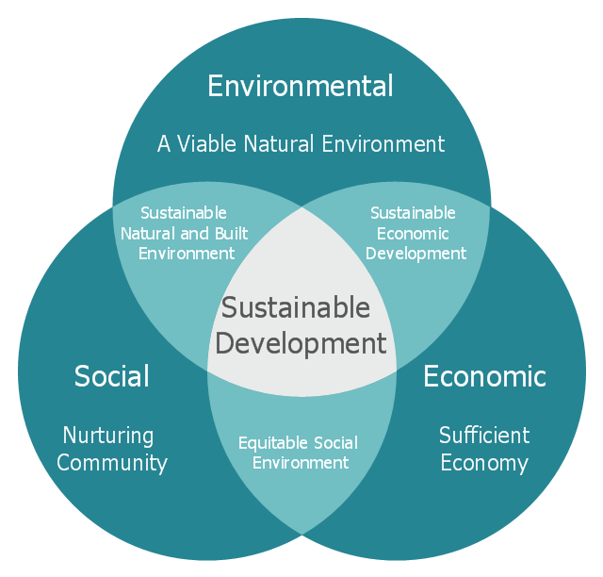
Figure 1 business models that emphasizes on the sustainability
Source: Theodoulidis (2017)
Economic
The economic factors stands still to maintain a profit rate. The economic factors include the maintenance of sustainability of business. Profit and risk maximization are integral part of business. He (2020) determines that the less profit means the downfall of operating activities. BMW is popular automobile brand with large number of customer support. Every year it requires maximizing the sales to a certain level to attract the customers. It requires handling financing, marketing, and Human resources management and so on. The economic factors determine the GDP, recession, employment rate, bank rates, government policies etc. The economic environment consists of the activities to help in maximizing the profit.
Environmental
The environmental factors are part of the present business model to gain the sustainable environment. The environment is required to focus in order to create a safe and sound world. The business is considered to be a crucial part of polluting the environment. Most of the organisation are highly criticised for not maintaining the environmental activities (Abbas, 2020). Also, many business organisations are associated with high level of carbon emission and destroying the trees and agricultural factors. However, the business firm are reconsidering to include environment as prime activity to achive the special honorary. In fact, Governments are highly encouraging the business firms to contribute in environmental activities. Awards are distributed effectively.
Social
The social responsibilities are equally important along with other responsibilities. Theodoulidis (2017) discusses that the business firms are centred on the society. BMW ensures the wages labour cost timely to fulfil the social duties. Society helps to deal with many hindrances. Society, culture, social persistency are frequent part of business organisations. Besides, the stakeholders are part of this society. BMW is considered to be highly sufficient for handling the social responsibilities. The social sustainability can be achieved through participating in social welfare. Social responsibilities include donations, fulfilling the civic duties, accountability for unethical approaches etc. The social responsibilities help to gain the maximum potential growth (Farooq et al. 2019). It helps persistently develop a medium to interpret the ability to maintain the growth. It is an effective part of business model.
The CSR is a wide area of present business scenario. It handles the wide part of stakeholders demand. According to Nikolova (2017), the business firms must collaboratively perform the corporate social responsibilities to remain sustainable sceptical about the business management. As BMW emphasizes on the profitability and it has got immense brand identity. So, It requires efficiency to handle the stakeholder’s interest. The business model has evolved in the present world. The business firms are mandatorily participating in performing the societal activities. Many businesses are awarded for paying the highest level of taxes.

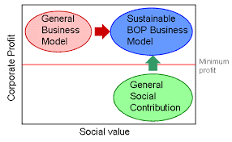
Figure 2 profit maximization model
Source: Abbas (2020)
The previous business models that emphasizes on profit making tactics and social contribution are combined together to create a new model that involves both terms. The business models are no more thinking about only making profits (Stellner et al. 2015). This model is also followed by BMW to get core advantage in competitive climate. Instead, it is performing the social and ethical approaches to get the effective result. The stakeholder is quite proactive about businesses to perform social responsibility. The significance of performing the activities are discussed below
Economic growth
The economic growth is quite dependent on business firms. BMW has marginal sales growth of 1.8% in the last few years. The manufacturing of resources for creation of automobile requires paying huge charges. It is associated with state wide manufacturing services that provide enough efficiency. it creates additional 3 jobs for each which is considered to be social responsibility. However, the social responsibilities and ethical terms promote in economic growth. Freeman (2017) illustrates that the moral compasses of contributing in social institutions are increasing the performance the different marginalised sector of economy. BMW is quite responsibly donating an amount in different societal welfares. Besides, it is creating job opportunities for large number of people which is reducing the unemployment rate.
Social Growth
The social growth is the prime consideration of including CSR in the business model. Values, environmental standards, stakeholders are part of the core societal activities. BMW ensures to engage in development and growth of society. It is an integral part f social fibre that heps the social resources. According to Agudelo et al. (2019), performing a social growth integrates the growth planning and healthy profitability effectively. It is a part of corporate strategy itself.
Influences Ethical Approaches
Stakeholders emphasizes on the firms to ensure the contribution in performing business ethically. BMW has effective corporate culture that distributes clear responsibility, lawful activities, and human rights effectively. Stakeholders are middle area of responsibility. He (2020) determines that Stakeholders have the capability to put a halt on the business activities. It is important to think about the interest of them to get the competitive advantage. It sufficiently processes the working conditions of the organisation.

Explaining of critical stages of competitive advantage.
The case study has focused on the different terms that help businesses to perform the ethical and social responsibilities effectively. The stakeholders focus on their own potential rights. The businesses get competitive advantages through performing the activities. BMW is quite effectively handling the benefits of its stakeholders (Abbas, 2020). Thus, it influences the customers to invest in the automobile brand. The competitive advantages that are influencing the business activities are given below

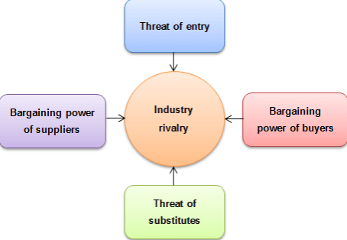
Figure 3 Porter's five forces model
Source: Stellner et al., (2015)
Competitive Rivalry
The intense and competitive rivalry has impact on the customers and suppliers. The competitive rivalry provides extreme challenges to the organisation profitability. Theodoulidis (2017) discusses that the effective strategies help to deal with the huge challenges and to create market position with maintaining the standard. BMW must deal with the other competitive automobile brands. There are institutions which labels the product standards to ensure the product quality to the stakeholders. The highly competitive industry needs to evolve with time. In fact, the number of competitive rivals play huge role to enhance the quality. The product and services differentiation play huge role to get the effective competitive rivalry.
Supply Power
The suppliers are those who provide raw materials and other components that are directly used in the making of product or service. The supply power is the core significant way to gain competitive advantage. The market has pre-existing number of suppliers who supplies the materials to help the business running smoothly. The supply power has impact on the production and profitability activities (Farooq et al. 2019). BMW is keeping it ahead by ensuring speed and model of cars than the efficient number of competitors. The supply power targets the niche market mostly. It is required to hire the primary suppliers who can help to provide sufficient amount of resources. In fact, the pricing and quality of product must be determined efficiently.
Buyer Power
The Buyer power starts with setting the prices and quality. The bargaining power helps to get the materials or all kind of resources at cheap prices that improve the profitability. According to Nikolova (2017), the buyer power gets from the stores that are not in convenient location. It helps to gain comprehensive advantage. The buyer power is considered to be monopsony. The influences in prices and qualities can really make a huge difference in reducing the costs. However, the maximum number of business firms can hardly survive because of less control over buying power. The distinguish forces helps to define the actual price of the material.
Threat of Substitution
The market is filled with same type of products and services and buyers can have as much option as they want. Basically, threat of substitution is the idea of having more options and chooses a suitable option among them. The buyer can easily replace the product or service with other product or service (Stellner et al. 2015). It is highly detrimental in holding the potential number of customers. It is quite important to understand the buyers need and wants on a deeper level. Otherwise, there is always a threat of getting replaced. The firms must focus on creating a base for consumers.
Threat of new Rivalry
Threat of new Rivalry means the entry of new competitor. The markets are full of competition. It is hard to survive in the market without having proper knowledge and strategies to perform the operation efficiently. BMW has legacy but other competitor might take over the position. It is really important to have the access of enough resources to perform the activities. According to Agudelo et al. (2019), the rivalry of business firms can really make a huge impact on the business sustainability. The businesses are required to create an effective business profile to ensure the strengths and weaknesses are added in the list. The consideration of industry analysis is another part to track the threats.
The case study reluctantly adds many points that validates and show the significance of stakeholders. The environmental and social responsibilities are necessary part of maintaining a supportable business functions. However, it is important to get the competitive advantage in the challenging market. It requires analysing the market scenario and product life cycle to ensure the growth of products. The BMW must ensure to establish an effective product life cycle to maximize the growth.
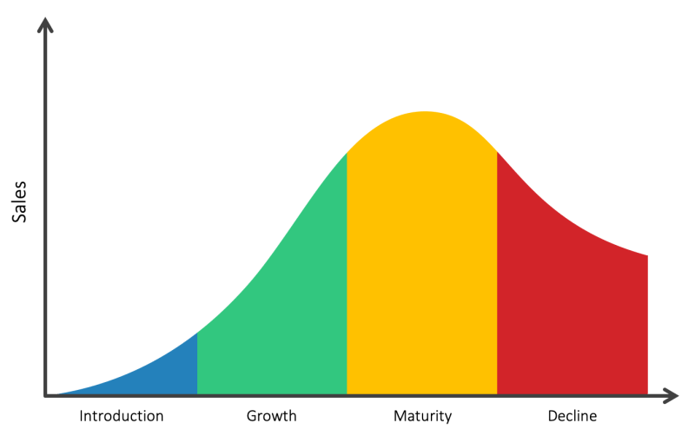
Figure 4 Product life cycle model
Source: He (2020)
Introduction
The introduction phase denotes the market development. Freeman (2017) illustrates that The BMW has introduced the wide range luxury cars to the customers. The cars are serving with needs of racer and sports brands. However, BMW launches luxury cars under fair price. In the introduction stage BMW must develop a market for the car enthusiasts and to attract the customers.
Growth
The growth stage ensures to retain the primary level of customer base. It must opt for a highly beneficial marketing strategy to enter into a new segment. He (2020) determines that the growth helps to target the new customers. The growth is the most effective time to understand the rates of survival. BMW requires focusing on additional promotional activities to get the competitive advantage. It has effective advertising campaign and technology driven fastest car.
Maturity
The maturity stage determines the way to expand the market through emphasizing on the size of production. The market can be segmented into different parts. BMW focuses on critical branding to improve the maturity of sales. According to Agudelo et al. (2019), the market segment ensures to focus on different criteria. For BMW, the market can be segmented into different parts based on age, gender, income, location etc. The expansion helps to increase the customer’s base.
Decline
The declining means the number of customers who are refusing the products. The refusal can make a negative impact on the sales and profitability. The declining stage is the crucial stage of product life cycle (Stellner et al. 2015). BMW believes in withdrawal of products if the products are denied by customers. It is easy to impress the new customers than impressing the customers who have already used the products. The declining is the stage where the sales rate drops and products are rejected. The improvement of quality and strategies can help to get rid of the declining stage.

Conclusion
The core objective of business functions includes the social activities along with other prime activities. The social and human responsibilities plays huge role to ensure the maximum profit. BMW has global sales network with the efficient supply chain management system. It is a luxury car maker with ensuring the fulfilling of social responsibilities. It is high time to emphasize on the business sustainability. It helps to survive the business for longer period of time. CSR has provided enough advantages in the business growth. Stakeholders can demand from the business firms to perform the activities efficiently.

Reference
Abbas, J., 2020. Impact of total quality management on corporate green performance through the mediating role of corporate social responsibility. Journal of Cleaner Production, 242, p.118458.
Agudelo, M.A.L., Jóhannsdóttir, L. and Davídsdóttir, B., 2019. A literature review of the history and evolution of corporate social responsibility. International Journal of Corporate Social Responsibility, 4(1), pp.1-23.
Farooq, Q., Hao, Y. and Liu, X., 2019. Understanding corporate social responsibility with cross‐cultural differences: A deeper look at religiosity. Corporate Social Responsibility and Environmental Management, 26(4), pp.965-971.
Freeman, R.E. and Dmytriyev, S., 2017. Corporate social responsibility and stakeholder theory: Learning from each other. Symphonya. Emerging Issues in Management, (1), pp.7-15.
He, H. and Harris, L., 2020. The impact of Covid-19 pandemic on corporate social responsibility and marketing philosophy. Journal of Business Research, 116, pp.176-182.
Nikolova, V. and Arsić, S., 2017. The stakeholder approach in corporate social responsibility. Engineering management, 3(1), pp.24-35.
Stellner, C., Klein, C. and Zwergel, B., 2015. Corporate social responsibility and Eurozone corporate bonds: The moderating role of country sustainability. Journal of Banking & Finance, 59, pp.538-549.
Theodoulidis, B., Diaz, D., Crotto, F. and Rancati, E., 2017. Exploring corporate social responsibility and financial performance through stakeholder theory in the tourism industries. Tourism Management, 62, pp.173-188.

