

Student Name: Buha Viraj Manishbhai

Student ID: 2506581

Module Name: Dissertation

Module C ode: LCMB7035

Lecturer’s Name: Dr Ghulam Mujtaba

Word count: 13998

Term 3

AI use acknowledgement
The use of artificial intelligence (AI) technologies has been employed in the preparation of this dissertation for language improvement, proofreading, sentence construction, and clarity. Artificial intelligence was also applied to help with the organization of thoughts and the presentation of the research. All research, analysis, interpretations, arguments, and conclusions are the author's own responsibilities.

Acknowledgement
I want to thank my supervisor for all of his helpful advice, helpful criticism, and unwavering support during this research. I am also grateful to my school, scholarly sources, and trade journals that helped with my research. Lastly, I would want to express my gratitude to everyone who helped to complete it, whether directly or indirectly.

Thanks and regards,

Abstract
The research identifies the impact of digital marketing strategies on sportswear industry’s business performance by using secondary social media influence and marketing, mobile application digital advertising, and digital commerce. This research is significant in identifying how the strategy relates to sales performance, customer engagement, and brand image for a leading global sportswear company.
The literature review chapter reviews the literature on digital marketing strategies of sportswear industries and their impact on business performance. It identifies that digital marketing is significant and that sportswear industry's key approaches consist of performance metrics, channel effectiveness, and strategic input. The uses and gratification theory and customer relationship management theory explain customer engagement and relationships and their justification for sportswear industry's business performance.
The methodology chapter explained the research methodology used to examine digital marketing strategies in the sportswear industry. It outlined that an interpretivist philosophy, an inductive approach, an exploratory design, and a qualitative strategy, with secondary data collection, were used. The chapter also described thematic analysis and source selection with inclusion and exclusion criteria and ethical considerations, which were maintained.
The data analysis applied thematic analysis to secondary evidence from academic literature, company reports and industry publications. Five themes showed that digital marketing contributes differently across customer engagement, brand equity, online consumer adoption, social media effectiveness, and brand visibility. The study found that digital activities are not necessarily correlated with stronger business performance. Rather, the key to commercialisation is turning visibility and interactions into action and relationships.
UGT explains consumers’ selective engagement with valuable digital experiences, while CRM explains relationship development and retention. The effectiveness of digital marketing depends on a range of channel-specific and organisational and market factors which are not related to digital marketing.
The final chapters conclude the study by summarizing the key findings on digital marketing and business performance in the industry. It identifies and addresses the research question, highlights the theoretical and practical contribution, and acknowledges the study limitations. The concluding chapter gives practical recommendations with future research directions to increase the strength of understanding of dynamic digital marketing practice.

Table of Contents
Chapter 1: Introduction 12
1.1 Background of the research 12
1.2 Rationale 13
1.3 Problem statement 15
1.4 Aim 16
1.5 Objective 16
1.6 Research question 16
1.7 Significance of research 17
1.8 Theoretical framework 18
1.9 Structure of dissertation 18
Chapter 2: Literature review 20
2.1 Introduction 20
2.2 Significance of digital marketing strategies 20
2.3 Assess the effects of the digital marketing strategies employed by sportswear companies on its business performance 21
2.4 Critically analyse the most important digital marketing approaches adopted by global sportswear industry in the last five years 23
2.5 Correlation between sportswear industry's digital marketing activities and its business performance metrics 26
2.6 Effectiveness of different digital marketing channels employed by sportswear companies 28
2.7 Recommendations on how digital marketing strategies can be enhanced 30
2.8 Theoretical framework 30
2.9 Literature gap 34
2.10 Conceptual framework 35
2.11 Summary 35
Chapter 3: Methodology 37
3.1 Introduction 37
3.2 Research philosophy 37
3.3 Research approach 38
3.4 Research design 39
3.5 Research strategy 40
3.6 Data collection and analysis 41
3.7 Validity and reliability 42
3.8 Ethical considerations 42
3.9 Methodological limitation 43
3.10 Summary 43
Chapter 4: Findings and Analysis 44
4.1 Chapter Introduction 44
4.2 Theme 1: Digital Marketing Channels and Customer Engagement 44
4.3 Theme 2: Digital Marketing and Brand Equity 45
4.4 Theme 3: Digital Marketing and Online Consumer Adoption 47
4.5 Theme 4: Social Media Marketing Activity and Effectiveness 49
4.6 Theme 5: Digital Advertising and Brand Visibility 51
4.7 Chapter Summary 53
Chapter 5: Discussion 54
5.1 Chapter Introduction 54
5.2 Interpretation of Digital Marketing Performance 54
5.3 The Engagement–Performance Relationship 55
5.4 Uneven Performance Across the Digital Consumer Journey 57
5.5 Reconsidering Digital Marketing Effectiveness 58
5.6 Chapter Summary 60
Chapter 6: Conclusion 61
6.1 Overall purpose of the study 61
6.2 Summary of the key findings 61
6.3 Outcomes identified in the data analysis 61
6.4 Value of the study on theory and practice 62
6.5 Practical insights in research for professionals 62
6.6 Limitations of the study 63
6.7 Recommendations 63
6.8 Implementation and directions for future research 64
6.9 Reflective statement 65
References 66
Appendix 77

List of figures
Figure 1.1: Internet use growth 11
Figure 1.2: Global sportswear market 13
Figure 2.1: Nike revenue 21
Figure 2.2: Poster of global running day 24
Figure 2.3: Market size 26
Figure 2.4: Uses and Gratifications Theory 30
Figure 2.5: CRM theory 32
Figure 2.6: Conceptual framework 34
Figure 4.1: Adidas Net Sales Share by Channel 44
Figure 4.2: Leading Sports and Outdoor Online Shops Ranked by Brand Awareness 46
Figure 4.3: Leading Sports and Outdoor Online Shops Ranked by Usage 48
Figure 4.4: Average Number of Weekly Brand Posts on Instagram in 2024 49
Figure 4.5: Sports and Outdoor Online Shops Buzz by Brand 51

List of tables
Table 1: Inclusion and exclusion criteria 41

Chapter 1: Introduction

1.1 Background of the research
Digital marketing is a central component of business strategy as consumers are increasingly identifying, evaluating, and purchase product by the digital platforms (Wali et al. 2026). It involves the use of channels like social media, search engines, websites, mobile applications, online advertising, email, and influencer communication. All of these help in developing awareness, engagement, and conversation. The strategic significance is to increase strength through the scale of the digital audience.
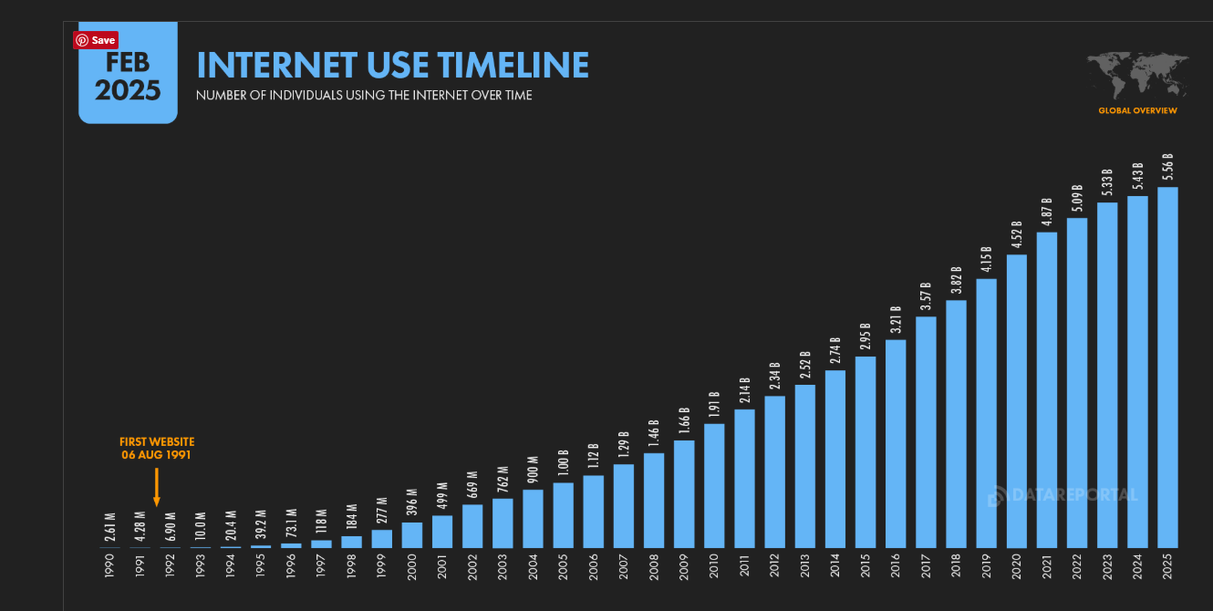

Figure 1.1: Internet use growth
(Source: Kemp, 2025)
As seen in the above graph, the Digital Data Report 2025 identified that 5.24 billion active social media user identities globally represent 63.9% of the world population (Kemp, 2025). This growth gives organisations opportunities to communicate directly with consumers and personalise marketing messages according to their needs. The development of a stronger relationship with the target audience is also achieved through these. Marketing is particularly strong in the sportswear industry, in which brand image, athlete association, lifestyle positioning, and consumer communities impact the purchasing decision (Fonseca, 2026). Unlike traditional marketing, digital channels help sports companies to communicate with consumers continuously and identify major responses by indicators like engagement, website traffic, app activity, conversion rates, and online sales. Social media campaigns, influencer partnerships, digital storytelling, and mobile applications can help support both the short-term goal and the long-term outcome, like customer loyalty and brand equity.
The global sportwear industry valued 399.4 billion in the year 2025. It is showing projected growth rate of 7% to 10% into 2026 (Mordor Intelligence, 2025). The overall result highlights that a strong digital presence alone does not guarantee improved growth and raises questions about the effectiveness, timing, and strategic connection with digital marketing activities. Hence, identifying the digital marketing strategy of sportswear industry is justified for understanding how digital communication and consumer engagement can impact business performance. The study focuses on the past 5 years and identifies evidence from academic literature, corporate reports, and industry publications.
In sportswear industry for example Nike Inc. provides a justified case for identifying the relationship because it has developed a good and integrated digital ecosystem around the brand. Nike's digital activities include social media communication, digital advertising, E-Commerce mobile applications, and personalised customer experience (Zhang, 2026). The channels help sportswear companies to connect brand building with customer relationships and digital commerce. But the relationship between digital marketing and business performance should not be assumed to be automatically positive. It is identified from recent company evidence reflects the need for critical assessment.

1.2 Rationale
The rationale for this research developed from the increased strategic importance of digital marketing in the global sportswear industry and the requirement of understanding whether digital activity translates to measurable business outcomes or not. Digital marketing helps companies communicate with the customer by social media, mobile applications, digital advertising, eCommerce platforms, and personalized content (Pierce, 2026). High digital visibility does not result in strong financial performance. Hence, identifying the relationship between digital marketing and strategic and business performance is extremely significant for both academic understanding and management. The sportswear sector provides a good contest of this investigation, as consumer behaviour is increasingly connected to digital platforms and online communities (Galić et al. 2026). A report published in 2025 identified that 84% of sporting goods executives were concerned about the impact of the geopolitical environment on their businesses (McKinsey, 2025). This percentage reflects the uncertain conditions in which they need to pursue growth.
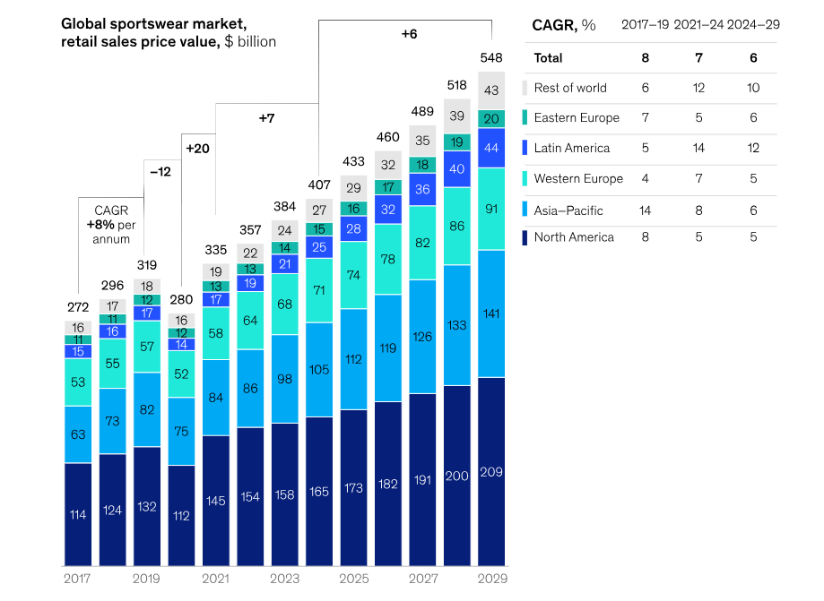

Figure 1.2: Global sportswear market
(Source: McKinsey, 2025)
The same report indicates that the sporting goods industry will grow approximately 6% annually between 2024 and 2029 (McKinsey, 2025). This is creating pressure for development to find a collective and effective way to attract and retain consumers. This condition makes the evaluation of effectiveness particularly important for growing the sportswear companies as well. This is because the digital strategy can potentially increase the strength of consumer relationships, supporting competitive differentiation.
Nike is an extremely appropriate case in this research as the business model of the company connects physical retail with a substantial digital ecosystem (Wang, 2026). A recent industry report reflects that the leading companies in the global sportswear industry operate across multiple international markets through digital commerce platforms. The international market contributed a significant share to the overall industry revenue as well. The global reach of digital marketing is strategically justified, as digital performance helps sportswear companies to communicate consistently with consumers in geopolitically diverse markets while adapting content to local preferences and cultural expectations. Social media, e-commerce websites, mobile applications, and digital advertising help brands engage consumers uniquely and strengthen brand visibility. Digital marketing supports personalized communication, targeted audiences, and real-time consumer engagement, which help sportswear companies to respond quickly to genuine consumer requirements and maintain competitiveness in the international market. The global consumer goods has invested in the digital consumer experience, but dynamic market conditions, consumer preferences, and increased competition mean that the effectiveness of the investment cannot be assumed.

1.3 Problem statement
The rapid increase in digital marketing has put pressure on global brands to transform digital engagement into measurable business performance (Munizu et al. 2026). Although global sportswear industry has developed extensive digital marketing activities through social media, mobile applications, digital tracking, and online retail. The effectiveness of the strategy is not always clear. High consumer engagement does not necessarily translate into increased sales. Intense competition in the sportswear market is creating additional challenges. Hence, there is a need to critically identify how digital marketing strategy relates to business performance using reliable evidence from academic, corporate, and industry sources.

1.4 Aim
The research aims to critically assess the effects of the digital marketing strategies employed by global sportswear industry on business performances using secondary data in academic literature, company reports, and industry publications.

1.5 Objective
- To critically analyse the most important digital marketing approaches adopted by global sportswear industry in the last five years.
- To examine the correlation between sportswear industry's digital marketing activities and business performance metrics such as sales, customer interaction and brand equity.
- To evaluate the effectiveness of different digital marketing channels employed by sportswear companies, such as social media, influencer marketing, mobile applications, and digital advertising.
- To give recommendations on how digital marketing strategies can be enhanced to increase business performance as a result of the findings in the secondary data analysis.

1.6 Research question
Main Research Question
- What have been the implications of sportswear industry’s digital marketing strategies on its business performance over the past five years using the evidence provided by academic articles, corporate publications, and other publications in the industry?
Subordinate Research Questions
- What are the most important digital marketing strategies that have been pursued by sportswear industry in the last five years?
- What implications do the digital marketing communication channels at sportswear industry have on sales growth, customer engagement, and brand equity?
- What can be suggested to improve the digital marketing strategies that sportswear industry uses and make the business work more effectively?

1.6 Significance of research
The research identifies the impact of digital marketing strategies on the business performance of sportswear companies. It focuses on the social media marketing influence are marketing mobile application digital advertisement and digital commerce. By using different evidence, the study identifies academic literature on corporates report and credible industry publications. It identifies how the marketing strategy relates to sales performance, customer engagement, and brand image for a leading global sportswear company. The research is significant as digital marketing is a major source of competition in the sportswear industry. Consumer are trying to communicate with brand by digital platform before making purchasing decisions (Yadav and Shelke, 2026). It helps to identify whether the strategies by global sportswear industry can be replicated or adopted by other companies operating in a similar competitive market. It also considers how sportswear companies can incorporate digital channels into a unified marketing ecosystem to increase the strength of the customer relationship and maintain a competitive advantage in a rapidly dynamic digital environment.
However, strong online visibility does not mean higher sales or stronger customer loyalty (Isen et al. 2026). For these reasons, identifying digital marketing gives sportswear industry a chance to understand whether the digital marketing activities are connected with measurable improvement or not. The findings can also support marketing managers in making better decisions about digital investment and customer engagement with brand development. The research is insightful because it connects the digital marketing activities at sportswear industry with specific business outcomes, instead of identifying marketing campaign independence of digital marketing in the global sportswear sector. It also helps sports companies who improving their digital marketing efforts. It also highlights areas for further primary research to develop stronger evidence of the relationship between regional marketing and business performance. Additionally, it boosts a more critical understanding of how digital transformation is resetting consumer behaviour and brand strategy in the modern retail landscape.

1.7 Theoretical framework
The research topic is evaluated more efficiently by using Uses and Gratifications Theory (UGT) and Customer Relationship Management (CRM) theory to identify how sportswear industry's digital marketing strategy can impact business performance. Uses and Gratifications Theory reflects that consumer activities select media to satisfy specific requirements, like information, entertainment, social interaction, and personal identity (Trisilowaty et al. 2026). In the context of sportswear industry, the theory is justified to explain why consumers interact with social media content and mobile application digital campaigns and how the interaction can impact the purchase related behaviour.
On the other hand, customer relationships develop and maintain long-term relationships with its customer by digital platforms. CRM focuses on how organisations use data and personalise communication for a continuous engagement strategy (Gaurav et al. 2026). It identifies how sportswear companies can attract, retain, and develop customer loyalty. The use of a mobile app membership program, personalised segmentation, and targeted social media advertising of sportwear company reflect the principle of Customer Relationship Management Theory. Overall, the theories give a Framework for identifying the Research question. UGT helps in identifying why consumers engage with digital channels, while CRM explains how sportswear industry and their managers manage and sustain the relationship with customers to impact loyalty, brand equity, and repeat purchasing behaviour. The frameworks hence connect with sportswear industry’s digital marketing strategies with consumer engagement and long-term relationship building. Ultimately, the theoretical frameworks contribute to Sportswear industry 's business performance.

1.8 Structure of dissertation
The following chapter represents a critical review of the existing literature on digital marketing strategy and its relationship with business performance. The literature will have a particular focus on sportswear industry. The subsequent chapter outlines the research methodology adopted for the study, including the research approach, design, and data collection method. The following 3rd chapter represents the analysis of the data and identifies key findings of the digital marketing activities of sportswear industries and their business performance. The fourth chapter discusses the findings in relation to the literature and research objective. Finally, the concluding chapter provides recommendations for improving sportswear industry's digital marketing strategy.

Chapter 2: Literature review

2.1 Introduction
The use of digital marketing has become a part of the marketing strategy of today as it gives organisations the great opportunity to engage with their customers, establish their relationships with them and exert the influences towards purchasing decisions. Sportswear industry has built out a variety of digital media channels that encompass social media, the mobile app, advertising/membership and influencer marketing. This chapter examines the digital strategies being adopted by companies in industry and how they relate to performance. The literature review considered how the strategies impact consumer behaviour, engagement, brand equity, and financial outcomes. The following section also identifies the limitations, contrasting academy perspective, and highlights gaps that need further investigation.

2.2 Significance of digital marketing strategies
Digital marketing is significantly and strategically important, as digital tools can impact both market-facing activities and overall business performance. According to Grijalba et al. (2025), organisations are using digital tools that can be better positioned to maintain business activity and develop sales opportunities. This reflects that digitalisation can directly contribute to the organisation's resilience as well as marketing performance. However, the relationship is not a business outcome, but it depends on the organisation's ability to integrate digital capabilities with wider business performance. Social media is particularly significant as it can increase the strength of customer equity, loyalty, and purchase intention. Here, ElSayad and Saad (2024) examine 971 customers and found that several social media marketing activities, which include interactivity, informativeness personalization, and trendiness. This influences customer equity and indirectly impacts departure intention through brand priority. The overall result suggesting the digital marketing can develop business value through immediate customer outcomes instead of producing immediate sales alone. For particularly sportswear industry, the distinction is significant, as engagement with digital content can contribute to long-term loyalty and brand relationship.
The importance of digital marketing is also for brand equity. Here, France et al. (2025) argued that traditional brand equity can be insufficient in the digital environment and call for greater attention to digital awareness share and digital brand sentiment. This gives a useful perspective for the sportswear industry as a whole in which social media interaction and online visibility should not be treated as a complete measure of marketing success. Social media marketing capabilities can directly increase the organization performance by stronger brand equity. The positive relationship between social media capabilities, brand equity, and organisational performance is proven, but general digital capability or other organisational factors. Hence, digital marketing should be viewed as a strategic capability that can support business performance through customer relationship of the standalone driver of financial results.

2.3 Assess the effects of the digital marketing strategies employed by sportswear companies on its business performance
The digital marketing strategies of sportswear industry have become connected with the wider business model that links consumer communication, engagement, and digital commerce. Digital marketing can improve overall business performance, but the strength of the relationship is totally dependent on the organisation's capability and market conditions. Gao (2025), using survey data from 390 professionals in China and kajakistan that, found a relationship with digital transformation capability. The digital transformation capability had a strong impact on business performance. Digital marketing can influence performance directly through engagement and organisational capability, instead of promotional sales alone. Similarly, Qiao et al. (2025) identified that, by using panel data from the listed companies between 2010 and 2023, digital marketing significantly impacts corporate performance. However, the findings also show that financing challenges mediated the relationship. This is extremely important for sportswear industry, as the effectiveness of digital marketing needs to be considered along with financial resources and larger beaten sense condition.
In contradiction Abakpa and Dvouletý (2025), by a systematic review of 30 studies founded the digitalisation can easily improve profit level sales growth and market share but identify limitation in existing evidence and called for greater long term research. The finding indicate the digital marketing is giving support to business performance under specific condition but the effect should not be treated as an automatic or uniform corporate the requirement for the critical assessment.
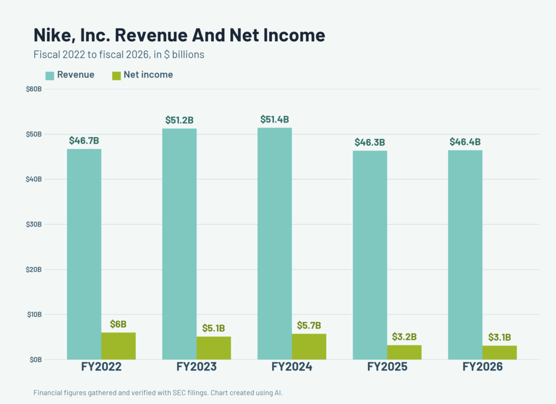

Figure 2.1: Nike revenue
(Source: Montgomery, 2026)
For examples a leading sportwear company Nike in the industry reported in the financial year 2025, total revenue of 46.3 billion, which represents a 10% decrease, while its direct revenue fell 13%, partly because Nike brand digital revenue decreased by 20% (Montgomery, 2026). The figures reflecting substantial digital activity do not necessarily correspond with immediate digital revenue. In fiscal year 2026, total revenue of 46.4 billion, while brand digital revenue decreased by 12% (Montgomery, 2026). Marketing performance needs to be identified together with product demand, pricing, and channel strategy, along with wider market conditions.
The digital marketing is an important part of the overall marketing approach within the sportswear industry with companies using various platforms and tactics to reach diverse target audiences. Pereira et al. (2025) stated that digital marketing can enhance the performance by creating awareness of products, driving customers to online shops, retention and increasing online relationships. However the growth of the business is not guaranteed by digital investment alone as industries data reflect fluctuation in the resilient performance. For example despite of significant investment in the digital channel the sportswear sector has experienced periods of reduction in sales that reflect digital strategies need to be integrated with large organization capability to sustain the long term success.
There may be intermediate effects from digital marketing, these include engagement, customer satisfaction, loyalty and brand equity which may help drive sales and retention. It implies that some measure should involve financial and non-financial factors when looking at Sportswear industry 's digital results.

2.4 Critically analyse the most important digital marketing approaches adopted by global sportswear industry in the last five years
Global sportswear companies have adopted a simply integrated digital marketing approach which connects the social media influencer marketing, digital community, mobile application, and personalized experience. Here, Gensler and Rangaswamy (2025) argued that digital marketing is continuously transforming from simple online promotion towards a connected, data-dependent ecosystem in which physical and digital experiences are connected. This perspective positions different sportwear companies like Adidas, Nike as digital activities exchange beyond advertising and connects content, sports participation, and shopping.
Social media marketing is an important factor for the industry as it supports brand storytelling with direct interaction with customers. However, the effectiveness depends on the type of communication used. Kumar et al. (2025) found that both brand-directed and influencer-directed social media marketing positively impact engagement and purchase behaviour. But here the outcome is different as well. Social media marketing was more effective for engagement, while influencer-directed marketing had a strong effect on purchase behaviour. This overall suggests that sportswear comonies should not analyse social media by a single metric like likes or followers. Different approaches can target different stages of the customer Journey.
Influencer marketing is another integrated approach, for industry as companies here historically connected its brand to athletes and cultural figures. Aldlimi et al. (2025) review 43 scholarly studies and found that influencer engagement is shaped by the source content and audience characteristics. This reflects that influencer popularity is not sufficient Alone. Credibility, content relevance, and audience characteristics also influence engagement. Weiger et al. (2025) have answered the question by finding that mega influencers can be less effective in driving purchase and that the influence on engagement does not always increase the strength of brand performance.


Figure 2.2: Poster of global running day
(Source: Districtrunningcollective, 2025)
Mobile application and digital communities give sports ride industry with a strategic environment for consumer engagement. In the above poster it is identified that events like global running date supported the fitness collective and digital platform.com mine training plan virtual challenges and community participation (Districtrunningcollective, 2025). These initiatives reflect how digital ecosystem increased strength of the brand equity and promote loyalty across the industry. This reply focuses on real-world participation instead of treating the application simply as a sales channel.
One of the key strategies for industry on social media is its social media strategy. Peggiani and Lamberti (2026) again stated that social media platforms like Instagram, TikTok and YouTube enable sports companies to broadcast its releases and individual accomplishments to the world, as well as its lifestyle and brand narratives. It allows for bi-directional participation and communication. NGO et al. (2025) however viewed that when people are engaged, it does not always translate to immediate sale and social media should also be measured for its impact on brand equity as well.
Another strategy is influencer and marketing with athletes. De Araujo et al. (2026) credibility, visibility, and symbolicness are provided by sportswear companies contacts with star athletes and celebrities. Influencers have the potential to influence the attitude of their consumers, as they might be thought of as reliable and relatable by the followers. Credibility, relevance from the audience, brand fit is key for effectiveness and sportswear industry should focus on maintaining the quality of the relationship more than number of followers.
Apps have also introduced themselves to be essential to digital presence. For example fitness and training/experiences on Nike Run Club and Nike Training Club, and shopping applications to discover products and make purchases. Lemmens et al. (2025) however argues that applications enable seamless communications, as well as personalization and loyalty. Digital advertising provides channels for specific communications, but too much can lead to ad fatigue and privacy issues.

2.5 Correlation between sportswear industry's digital marketing activities and its business performance metrics
The relationship between digital marketing activities and business performance can be addressed by both financial and non-financial indicators. Customer engagement provides an important immediate measure, as digital marketing can impact how consumers interact with a brand before purchasing. Vo et al. (2025), based on a study of 406 respondent founded that authenticity and trust are impacted by engagement with virtual influencers, while engagement subsequently contributes to brand priority. This is reflecting digital interaction can support long-term customer outcomes instead of producing only immediate transactions. Brand equity provides another important connection between digital activity and performance. Here, Shrestha (2026) identifies Instagram, social media marketing activities and found that content consistency, informative news relevance, and interactive features can impact the dimensions of customer-based brand equity. It impacts awareness, image, perceived quality, and quality. This is justified for global sportswear industry, as social media presence can increase strength brand-related outcomes even when the direct sales impacts are difficult to isolate. However, it is also true that effects cannot be transferred directly to brands in the industry, making company-specific performance data necessary. The financial results of sportswear industry reflect market size below which proof why the distinction matters.
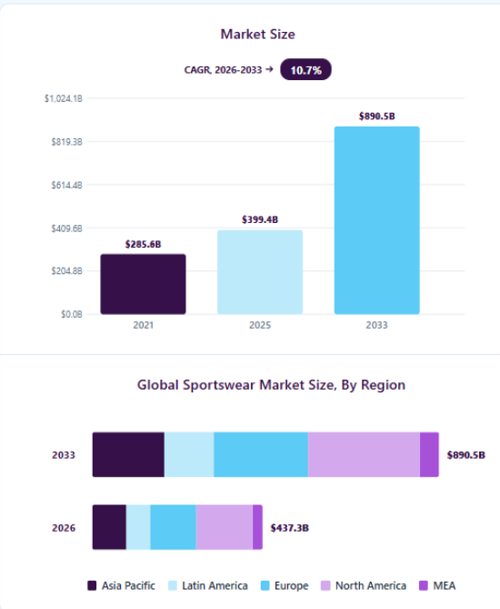

Figure 2.3: Market size
(Source: Grandviewresearch, 2025)
The financial performance of the sportswear industry in 2025 give useful evidence for comparison. It is noted from the above figure that in the year 2026 the global sportswear market size was approximately 437.3 billion (Grandviewresearch, 2025). The sector developed substantial revenue growth that driven by the demand creation strategies and included brand marketing digital advertising and sports sponsorship. However Kilmer (2026), contradicted that net income across several leading organizations decreased sharply during the same time that increase critical issues about the effectiveness of the market expenditure. While the companies increase the investment in digital and promotional activities the overall profitability did not improve proportionately. With operating margin failing significantly. This reflect a requirement for more substantial and integrated marketing strategies. The contrasting movement suggests that digital performance and total business performance do not always move together. Furthermore, in 2025, a study by Ghosh and Islam (2025) found that entertainment value drives engagement. This supports the view that the quality of digital communication can matter more than exposure alone.
Sportswear’s companies digital marketing and their business performance can be studied based on the sales, customer interaction and brand equity. According to Biemans and Malshe (2024) digital activities can be used to complement sales efforts with a higher awareness, easier discovery of the product, and an online conversion. But, there is also an influence of prices, goods, economic situation and competition on sales. Customer engagement is a more "now" result. Eslami, Ghasemaghaei and Hassanein (2022) on the other hand, found that consumer response in the form of likes, comments, shares, application activity, membership participation. So it becomes an important intermediate outcome; customer engagement.
Brand equity is a valuable link between digital and business performance. Rochefort and Ndlovu (2024) again explored that great digital marketing can boost brand awareness, brand associations, brand quality and brand loyalty. Having strong brand equity can lead to preference and repeat buying. Thus, the connection can be thought of as digital marketing being determined on engagement that in turn will make a contribution to the brand equity of boosting the business performance.

2.6 Effectiveness of different digital marketing channels employed by sportswear companies
Jeswani (2023) opined that as communicating quickly and involving customers in marketing, social media is an extremely powerful platform for raising awareness, engagement and community building. Eslami, Najafabadi and Gharehgozli (2024) on the other hand discussed that when done right, relevance of influencers to target consumers, influencer marketing can work well for credibility and social proof and product advocacy. If the influencers are not selected properly, it can actually lead to a lesser authenticity.
Mobile applications can be used for retention and for personalisation as they offer ongoing communication opportunities. Sportswear companies are able to utilize applications for training information, suggestions, challenges and membership perks. Sharma and Ashfaq (2023) however viewed that digital advertising works well at targeting and conversion as their interests and behaviours can be categorised. But factors like advertising wear-out and privacy standards and competing for Internet eyeballs can detract from effectiveness. Hence it is better to adopt an integrated multi-channel approach. Each consumer will interact differently to digital, and channel integration is vital to successful and effective digital reaching and effective brand messaging.
It is extremely important to recognize that the effectiveness of the digital marketing channel in the sportswear industry is highly context-dependent. Arıkan, (2026), noted that for example, social media marketing not only promotes engagement but also helps brands develop communities around lifestyle values like fitness, sustainability, and inclusivity. The community-driven approach can differentiate sportswear companies in a crowded marketplace. Similarly, influencer marketing is also dynamic, from celebrity endorsements to micro-influencers who provide authenticity and reliability, particularly in segments like running, yoga, and sportswear.
However Madondo and Akindeji (2026) argued that over reliance of the influencers without strategic alignment also increased risk in the brand credibility. Mobile applications are increasingly central to retention strategies, which provide personalized training plans, gamified challenges, and loyalty rewards. The features extend consumer interaction beyond purchase, which incorporate brand into daily routines. The digital advertisement remain impacting for targeting, but increasing concern over privacy, ad fatigue, and algorithm changes demand adaptive strategies. Ultimately, adapting an integrated multi-channel approach is significant. Each consumer interacts differently with digital touchpoints, and synergy across platform which confirm consistent messaging and maximizes reach.

2.7 Recommendations on how digital marketing strategies can be enhanced
The effectiveness of the digital marketing channels needs to be addressed according to the strategic purpose. Social media is useful for brand communication and customer engagement. Krowinska and Dineva (2025) reflected that different forms of branded social media content can easily boost active customer engagement. But the impact can vary by content type and customer responses. These is suggested that companies in sportswear industry needs to focus on relevant and engaging content instead of posting frequency. The content quality is an extremely significant factor here. Khandolkar et al. (2025) identify that customer-based brand equity mediates the relationship between social media content and brand engagement. Instead of engagement automatic development there should not be treated as proof of marketing effectiveness. Influencer marketing provides another channel. Here, Kim et al. (2026) found that influence and marketing develops stronger sales effects and high long term return then the online and television advertising in studies of a global consumer company. Research identifies electronic word of mouth as an indirect route through which influence can impact influencer-affected sales.
Sportswear industry must implement responsible personalisation based on customer data and educate on it by clearly communicating the way it handles privacy. Xu and Chen (2025) stated that personalisation can boost relevance however if too much information is gathered it could affect the trust that users place. Gómez et al. (2024) however stated that gamification, AI-assisted recommendation, virtual experiences and digital communities can help to enhance differentiation and relationships. Such ventures can be more interactive, and keep customers engaged with the Sportswear industry brand past each purchase.

2.8 Theoretical framework
Uses and Gratifications Theory (UGT)
Uses and Gratifications Theory (UGT) identifies why consumers select and use particular media to satisfy requirements such as information, entertainment, social interaction, and self-expression (Inkesar et al. 2026).
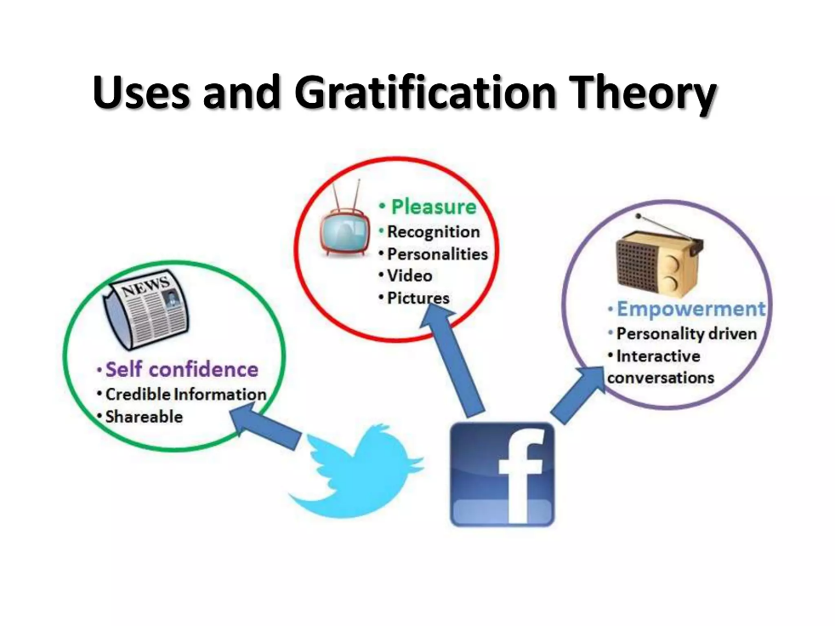

Figure 2.4: Uses and Gratifications Theory
(Source: Alharbi et al. 2026)
From the above image, it is clear that the theory basically impacts three factors: self-confidence, pleasure, and empowerment. The theory views customers as active participants instead of passive recipients of marketing messages. This makes the UGT justified for digital marketing, in which consumers choose which brands to view, engage with, share, or ignore (Alharbi et al. 2026). The relationship between consumer motivation, brand experience, and engagement on Instagram is justified by this theory. Information seeking, social interaction, and inspiration at the important factors which impacting the engagement and purchase influences in sportswear company’s digital marketing activities. Consumers can interact with social media content to gain product information, follow athletes and Sporting inspiration, or participate in digital communities. The influence of campaigns by sportswear companies can provide entertainment, social identification, and product-related information. Hence, the uses and gratifications theory helps in explaining how consumers engage with digital channels in the sportswear industry and how different consumer requirements can impact engagement and purchasing behaviour.
However, uses and gratification theory mainly explains consumer motivation and responses, which means it provides limited explanation of how engagement is converted into long-term business value. UGT is also highly justified in identifying differences in digital engagement. Customers in industry can use the platforms for functional purposes, like compare in product or obtaining information, while other can need emotional or social benefits by supporting the community and influencer content. This distinction is important, as the same Digital campaign can develop different approaches among consumers.
Customer Relationship Management (CRM)
Customer relationship management is focused on developing and maintaining a long-term relationship between the organisation and the customer (Akkala et al. 2026). In digital marketing, the customer relationship management theory consists of understanding customer requirement management of the customer information to give them personalised communication, and maintaining continuous interaction in different channels. Effective customer relationship management can directly contribute to customer loyalty by improving customer understanding and personalized service.
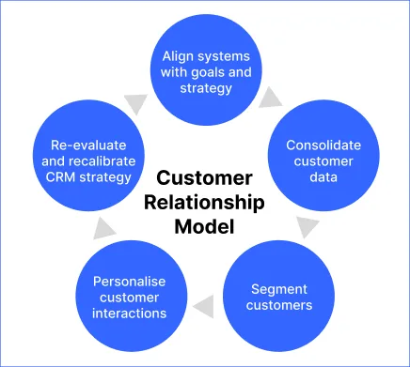

Figure 2.5: CRM theory
(Source: Shah et al. 2026)
From the above, it is clear that the customer relationship model consists of five factors that connect the system with goals, consolidate customer data, segment customers, personalise customer data, and reevaluate the CRM strategy (Shah et al. 2026). Customer relationship management is important for the industry as the digital ecosystem helps build relationships. Mobile applications, membership programs, social media, and e-commerce platforms provide opportunities for repeated communication and a personalized customer experience. Electronic customer relationship management may be the connection between digital marketing strategies and electronic loyalty. The customer relationship management theory also reflects the significance of customer retention instead of focusing only on acquiring new customer for step digital platform helps companies in sportswear industry maintain continuous contact with customers and use customer information to develop more relevant communication and experience. This supports satisfaction, loyalty, and repeat purchasing over time. However, effective digital CRM requires responsible management of customer data, as excessive personalisation or inappropriate communication can decrease trust. From a customer relationship management theory perspective, it is possible to analyse whether the digital marketing strategies of sportswear companies effectively build strong customer relationships or not. CRM helps to move the relationship to a deep emotional connection and make sportswear brands more acceptable and trusted in the market. By integrating the CRM theory companies in sportswear industry can increase the loyalty and enhance the consumer engagement for the competitive advantage in a highly competitive market.

2.9 Literature gap
There are some gap areas in the existing literature relating to the relationship between digital marketing, its customer engagement outcomes on brand and business results. One of the literature gaps can be to critically identifying the emerging digital marketing trend like AI dependent personalization or sustainability focused campaign and compare the personal and potential impact of this trend on future business performance in global sportswear industry. It is extremely important to know about digital marketing trends for a future-oriented perspective that reflects awareness of the industry evaluation.
Third, a lot of studies only use consumer perceptions and surveys, not a correlation to digital actions related to actual business metrics. Fourth, the state of the artwork in computer science, Artificial Intelligence, personalisation and digital communities is changing rapidly, and previous results might no longer cover the techniques used. Lastly, while sportswear companies are active in various foreign markets, the digital consumer behaviors vary according to culture and region, with cultural and regional differences being underestimated. The gaps provide adequate justification for the secondary analysis of sportswear industry’s digital marketing activities and performance indicators.

2.10 Conceptual framework
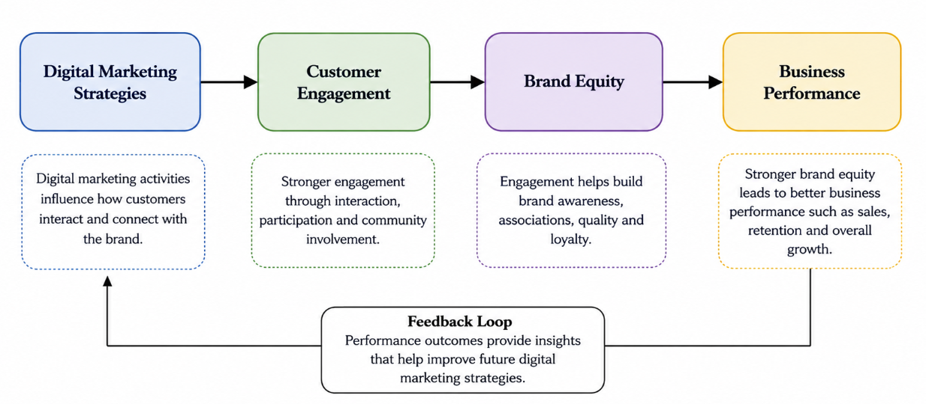

Figure 2.6: Conceptual framework
(Source: Self-created)
According to the proposed conceptual framework, the independent variable is digital marketing strategies, such as social media marketing, influencer marketing and mobile applications and digital advertising. These activities are likely to impact customer engagement (interaction, participation and community involvement). Customer engagement will be expected to reinforce brand equity, via brand awareness, brand associations, brand quality and brand loyalty. The brand equity is then expected to drive the performance of the business in terms of sales, customer retention and other indicators of performance.

2.11 Summary
This chapter´s primary objective was to explore academic articles about sportswear industry’s digital marketing and business performance. According to the analysis, social media, influencer marketing, mobile apps and digital advertising can all be a factor in awareness, customer engagement, brand equity and profits. But, digital marketing does not magically translate to better financial results as other factors like product, pricing, competition, economics and distribution will be influencing sales. All literature recommends the correlation, such that a good digital marketing process can lead to customer engagement, engagement can positively influence brands and brand equity can help with sales and retaining customers. Uses and gratification theory, customer relationship management theory is focused on brand equity and integrated marketing communications in the global sportswear market. The revealed literature gaps inform secondary research to gain insights into the relationship between sportswear industries digital marketing efforts and tangible business outcomes.

Chapter 3: Methodology

3.1 Introduction
The research methodology chapter gives an overall plan to achieve the research outcome. The following section evaluates the researcher's philosophy, approach, design, and strategy, with justification. It also discusses the data collection and analysis process. In addition the ethical consideration and methodological limitation of the research is also identified in the following section.

3.2 Research philosophy
The researcher has chosen the interpretivist research philosophy as it needs to understand how digital marketing strategies impact the business performance of the sportswear industry through customer engagement, their perception, and customer relationships. The interpretivist research philosophy involves subjective consumer experiences that cannot be identified by numerical measurement alone (Manafe, 2026). Interpretivism is appropriate as digital marketing is impacted by the meanings and experiences developed between brands and consumers. Sportswear industry consumers can respond differently to social media content, influencer recommendations, online communities, personalised advertising, and brand storytelling (Meng et al. 2026). Responses are shaped by individual preferences, cultural background, expectations, and previous experience with the brand. Hence, understanding digital marketing effectiveness needs attention to how consumers interpret the activities instead of only examining the numerical performance indicators. Interpretivism approach helps the researcher to compare different academic perspectives and industry findings to identify common themes. On the other hand, positivism is focus only on objective facts and measurable relationships. The interpretivist philosophy uses research to critically identify meanings and different interpretations with existing academic and industry evidence.
Realism assume the reality exists independently of individual perception and can be investigated by observable evidence and underlying structure (Gkevrou and Stamovlasis, 2025). The realism philosophy would therefore focus more on identifying the real factors that impact digital marketing performance, like sales growth, customer acquisition, brand awareness, and so on. However, the present study is more connected to understanding how consumers perceive and interpret the digital marketing activities within the sportswear industry. As the study focus to the secondary data collection so the interpretivism philosophy guides the researcher to provide a deep understanding of the real-life phenomenon. Therefore, the adaptation of the interpretivism research philosophy was justified to present a different view about the sportswear industry's digital marketing effectiveness. This supports a deep and contextual understanding of the research problem.

3.3 Research approach
The researcher here has adopted an inductive research approach, as it develops understanding from patterns and findings that are identified within the existing secondary evidence. The inductive research approach was justified for identifying the digital marketing strategies of the global sportswear industry, as the relationship between digital activity and business performance can differ across different channel consumers market condition and even different companies. The other research approach, like the deductive approach, starts with developing theory and testing predefined hypotheses from the literature review and company evidence (Khurshid et al. 2026). In comparison, the deductive approach moves from developed theory to specific propositions or hypotheses that are tested using collected evidence. The deductive approach is significant when the research aims to confirm whether the existing theoretical relationship applies to a particular context or not (Robinson et al. 2026). However, it may give less flexibility when identifying the changing nature of digital marketing in the sportswear industry.
The abductive approach was not selected, as the research does not primarily need to identify the relationship between existing theory and unexpected empirical observations. The abductive approach connects elements of deduction and induction by transitioning between existing theories and unexpected findings to develop the most suitable explanation (Van Hulst and Visser, 2025). Although this can be useful for identifying surprising results, it is less appropriate for the present study, as the research needs to identify patterns from the existing secondary evidence instead of developing a new explanation from the unexpected findings. In contrast, the inductive approach helps themes and relationships emerge from the reviewed evidence (Yip and Zeng, 2025). Therefore, it supports the flexible examination of social media marketing, influencer marketing, customer engagement, brand relationships, and business performance. This makes induction the most justified approach for achieving the research objective. The inductive approach was justified as support for the flexible and deep analysis of the digital marketing activities by sportswear companies related to customer engagement and relationships, and business performance by developing larger interpretation from the identified patterns.

3.4 Research design
The research adopts an exploratory research design as it develops an analysis of the different digital channels for consumer engagement and brand relationships without limiting the investigation to a predetermined outcome. Other research designs, like descriptive research design, represent characteristics or existing conditions. While an exploratory research design helps researchers investigate relationships and identify emerging patterns within the secondary evidence (Ma and Lee, 2026). The descriptive research design focuses mainly on representing the characteristic trend or current condition of a particular subject (Grzenkowicz and Wildfeuer, 2025). It can reflect how sportswear companies use digital marketing channels, but it may not provide sufficient flexibility to identify why these strategies impact customer engagement and business performance.
An explanatory research design, on the other hand identifying cause and effect relationship between the variables and needs clearly defined variables and hypotheses (Skinner and Dancis, 2026). Although these could help identify relationships between digital marketing activities and business outcome but, it can be restrictive when the available secondary evidence presents different findings across companies and digital platforms. For this reason, the exploratory research design is justified, as it helps the researcher to investigate the subject from different perspectives and identify themes that emerge from existing study reports and industry evidence. It also supports critical identification of changing consumer behaviour, social media trends, and influencer activities. The exploratory research design gives the flexibility needed to achieve the research objective.The exploratory design was selected as the research aims to established causal relationship between digital marketing activity and business performance. Hence, it is justified to use the exploratory design to provide flexibility in the complicated and changing nature of digital marketing activities in the sportswear industry.

3.5 Research strategy
The researcher has used a qualitative research strategy as it as an objective to develop an understanding of digital marketing strategies and their impact on business performance. A qualitative strategy identifies meaning in consumer engagement, brand relationships, and strategic practices instead of depending on numerical measurement (Prayuda et al. 2026). On the other hand, the quantitative strategy focuses on numerical data and statistical relationship research (Khatun, 2026). The quantitative research strategy mainly identifies measurable variables by numerical data, statistical analysis, and hypothesis testing (Lim, 025). It provides precise measurement of digital marketing performance, such as engagement rate, conversion rate, sales growth, and return on investment. The numerical results cannot fully identify why consumers respond to digital marketing activities or how they develop a relationship with a sportswear brand. The mixed-method strategy also connects the qualitative and quantitative approaches, which can give a broader understanding, but it needs more time and resources and is not necessary for the present study, which depends on secondary qualitative evidence.
Hence, the qualitative strategy is suitable as it helps the researcher to critically compare the findings from academic literature, company reports, industry publications, and other secondary sources (Almusaed et al. 2025). The approach helps in identifying recurring themes, differences, and contextual factors which are related to digital marketing, customer engagement, brand relationship, and business performance. Qualitative research helps the researcher to interpret different perspectives reflected in existing literature and company evidence. A mixed-methods strategy was not selected as the study does not involve collecting and combining primary quantitative and qualitative data. The research uses secondary Sources that include themes and patterns. Hence, the qualitative strategy was appropriate to choose, which supports detailed and contextual interpretation of the data.

3.6 Data collection and analysis
The researcher has collected secondary qualitative data from public academic and professional resources. The main sources have included beer review journals, books, conference papers, company reports, official publications, and authoritative industry analysis that cover the past 5 years. To digital marketing strategies in the sportswear industry, customer engagement, and social media marketing influence on digital advertising, and so on. The collected evidence was then analysed using thematic analysis. The thematic analysis was appropriate, as identification and interpretation of the pattern at secondary sources can be easily done with it (Littlewood and Gardner, 2026). Initially, relevant materials were carefully reviewed, and key information was coded with the research objective. Similar quotes were then grouped into latitude themes, including customer engagement, brand equity, sales performance, digital innovation, and competitive advantage.
By following the process, the identified themes were compared across different academic and industry sources to identify areas of agreement and disagreement. The researcher has assessed how digital marketing activity impacts customer engagement, brand perception, sales performance, and competitive advantage in the sportswear industry. Particular attention was given to developing findings and differences between companies' platforms and consumer groups. The thematic analysis also considered the context in which the evidence was developed to prevent interpreting individual findings in isolation (Ahmed et al. 2025). Themes were connected to research objectives and questions first. The systematic process of thematic analysis helped the researcher to develop a clear, balanced interpretation of the available secondary evidence and identify significant implications for the sportswear companies.

3.7 Validity and reliability
Both validity and reliability are important pillars of the overall efficiency of the research (Awasthi, 2026). Validity in this research has been supported by selecting sources that are directly connected to digital marketing strategies for sportswear companies and the industry. The inclusion of the pear review journal articles, official reports, scholarly books, and reputable industry publication as improve the credibility and relevance of the evidence. Limiting the publication to 2020 to 2025 and English-language sources confirms that analyses reflect recent developments. The unpublished reports blocks opinion-based article and sources lacking academic integrity have been excluded.
Inclusion criteria | Exclusion criteria
Peer-reviewed journal articles have been included | Non-peer-reviewed journal articles have been excluded
Studies published between 2020-2025 has been included | Studies not published between 2020-2025 have been excluded
Studies in English language has been included | Studies in non-English language have been excluded
Studies that are freely accessible and in PDF format have been included | Studies that are not freely accessible and not in PDF format have been excluded

Table 1: Inclusion and exclusion criteria
(Source: Self-created)

3.8 Ethical considerations
Ethical considerations are important as it makes the research more integrated and reliable (Taherdoost, 2026). In this case, although it does not involve any human participants or primary data collection, ethical considerations need to be maintained. The study has used only publicly available and readily accessible secondary sources, including academic publications, company reports, official publications, and industry report also, and has prevented plagiarism. The research has maintained the academic information honestly, and selective reporting of the findings has been interpreted according to the evidence provided by the sources instead of being altered to support free determined conclusion. Proper citation of the external data was also maintained for copyright requirements when using the published material. The sources have been selected according to credibility, while different perspectives have been considered to decrease research bias.

3.9 Methodological limitation
The study has some methodological limitations. First, the interpretivist philosophy can introduce research subjectivity in interpreting the secondary evidence (Acharya, 2025). The inductive approach also develops themes impacted by the researchers' judgement. An exploratory design offers flexibility but may not develop a direct causal relationship between digital marketing and business performance. The use of a qualitative strategy and secondary data limits access to consumers' direct experience and may decrease the generalizability of findings. To mitigate this limitation, the researcher can use credible and recent academic and industry sources, apply clear selection criteria, and compare findings across multiple sources. The major improved consistency of the overall research.

3.10 Summary
From the above, it is summarized that the chapter provides the methodological foundation of the research. The interpretivist philosophy, inductive approach, exploratory, and qualitative strategy have been used along with secondary data collection. After collecting the secondary data, thematic analysis has been incorporated for the data analysis. Proper ethical considerations have been maintained to make the research more reliable and valid.

Chapter 4: Findings and Analysis

4.1 Chapter Introduction
This chapter presents the findings generated from the secondary qualitative data. Thematic analysis was used to identify common themes associated with digital marketing and business performance from the evidence. Five themes are explored: customer engagement, brand equity, sales performance, digital innovation, and competitive advantage, given the context of the sportswear industry on a global level.

4.2 Theme 1: Digital Marketing Channels and Customer Engagement
Customer engagement was found to be one of the factors by which digital marketing can contribute to business performance in the sportswear sector. From sporadic promotions to ongoing brand interaction, social media, mobile apps, online communities, and e-commerce have brought about fundamental transformations in engagement. These channels also have dissimilar roles in the relationship with consumers. Social media can start engagement; mobile apps and online communities can enable ongoing interactions. These interactions are then linked to the buying process via e-commerce. Engagement is then commercially more effective when each individual digital touchpoint acts as part of a joined-up customer journey and not a standalone marketing touchpoint or campaign.
This pattern has become significant in the commercial world due to the rising connection between engagement and the digital world, where purchases and retention take place. This is evident in the industry. For instance, e-commerce sales made up 18% of Adidas' net sales in 2024, and the company's direct-to-consumer sales channels made up 40% of its net sales in 2024 (Adidas, 2025). These figures do not show an adidas-specific impact, but rather an indication of the business relevance of digital consumer relationships in a large sportswear company.
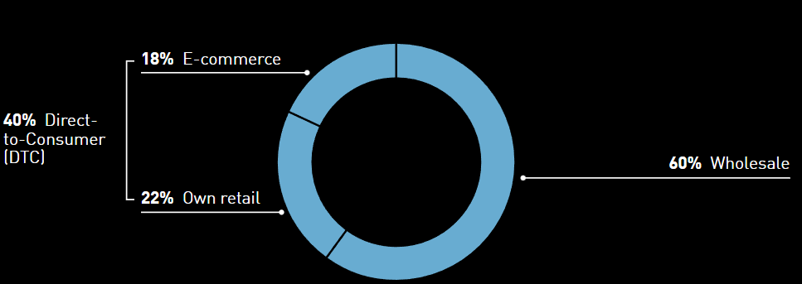

Figure 4.1: Adidas Net Sales Share by Channel
(Source: Adidas, 2025)
Platania et al. (2026) also showed that digital engagement utilizing athlete celebrities can create value based on consumer trust and brand equity. This fits with the idea that the value of engagement is not just about the volume but the quality as well. Tan et al. (2024) explain that digital content marketing can develop consumer engagement, trust, and value through meaningful interactions. Their study preceded the period of research, but their mechanism aids in understanding the current results. Repeated interactions can keep consumers engaged in sportswear businesses and foster relationship continuity. But engagement itself is not directly correlated with sales. The contribution depends on whether interactions lead to trust, retention, advocacy, or purchasing behaviour. Based on this, the theme suggests that the effect of sportswear business performance through engagement is more clearly realized when interaction becomes a more intentional process towards deeper relationships, retention, and commerce.

4.3 Theme 2: Digital Marketing and Brand Equity
Another pathway in which digital marketing can affect sportswear business performance is through brand equity. The brand KPI data, as provided by Statista (2024a), reveal significant variations between specific sports and outdoor online brands. Nike boasts the highest recognition rate, 93%, followed by Adidas (92%), Reebok (87%), Under Armor (85%), Columbia (75%), and Lululemon (58%) (Statista 2024a). Such disparities signify that operating in one digital marketplace does not generate the same degree of brand exposure. When the communication builds unique and identifiable brand associations, digital presence seems more valuable. But awareness is just a part of brand equity. Consumers do not always believe that higher digital recognition leads to greater value or to higher-levels of loyalty. The commercial impact will depend on whether sportswear brands tend to have distinct meanings through repeated digital interactions, as this will differentiate them from competitors.
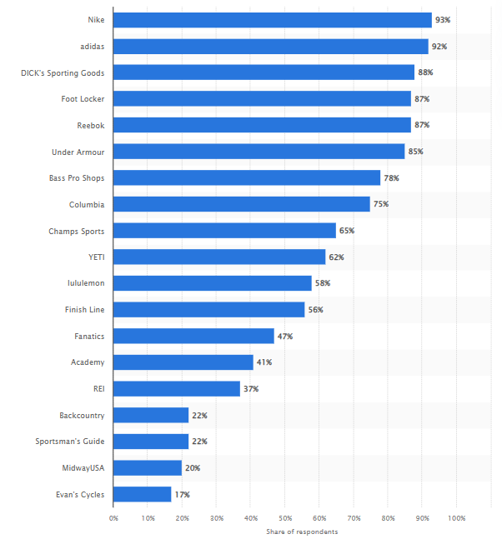

Figure 4.2: Leading Sports and Outdoor Online Shops Ranked by Brand Awareness
(Source: Statista, 2024a)
Loureiro et al. (2024) advance this trend in fashion sportswear. They discovered that, besides owning the brand, online brand prestige and lifestyle congruency positively affect online brand identification, and that brand love has a positive influence on bringing in brand advocacy. This connection also depends on the quality of customers' online experiences. Zia et al. (2022) found that social media marketing activities contribute to consumer-based brand equity through brand experience. This suggests that digital channels have the opportunity to provide added value beyond exposure due to the ability of interactions to influence the way consumers perceive and experience a brand. Sportswear brands can, therefore, strengthen a known brand identity and brand perception by ensuring that there is consistency throughout social media, mobile applications, and their online platforms.
This is a trend that illustrates a move from digital “visibility” to “identification” and deeper brand relationships. Therefore, in the context of business performance, digital marketing can enable certain capabilities, such as the promotion of brand equity, but it cannot ensure consumer attachment or advocacy. The results, in turn, suggest that brand equity is an intermediate business benefit that is not guaranteed by digital activity. When awareness evolves to positive perceptions, identification, preference, and lasting loyalty, its performance value improves even more.

4.4 Theme 3: Digital Marketing and Online Consumer Adoption
The rate of consumer adoption online became significant as an advertisement of how digital marketing can turn one's brand visibility into actual behaviour. Statista (2024b) shows clear differences in the usage of leading sports and outdoor online shops. This indicates a disparity in online adoption between sportswear companies based on their digital visibility. But with visibility alone, it is not enough to understand the sense of progression towards the actual use of the platform. The adoption also relies on the extent of eliminating the barriers between the first usage of a digital communication channel and the purchasing activity. This transition can be made easier through convenient navigation, relevant communication, and connected digital touchpoints. So, the variations in adoption may be attributable to sportswear companies' ability to translate consumer interest into functional online engagement. This is especially important when viewed in relation to brand awareness, as consumers can know about a brand without using the brand's digital purchasing avenues.
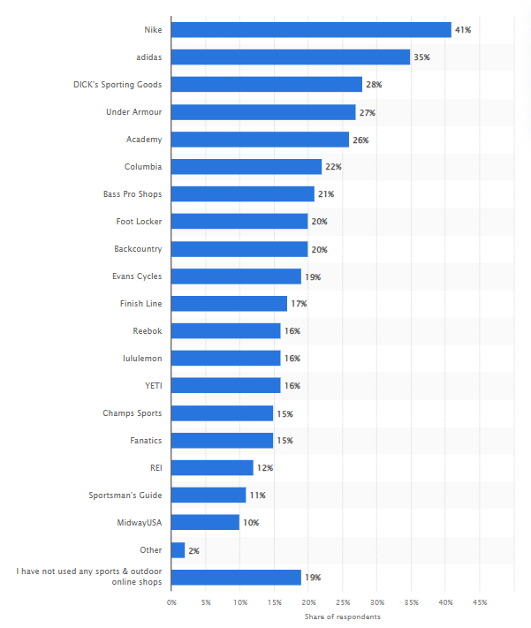

Figure 4.3: Leading Sports and Outdoor Online Shops Ranked by Usage
(Source: Statista, 2024b)
Eslami et al. (2022) also concluded that social media marketing activities may affect behavioural responding via brand-related mechanisms. The relationship implies that adoption is incremental, rather than immediate, following marketing exposure. The study by Rosário and Raimundo (2021) revealed that digital marketing has a potential impact on creating engagement and influencing online purchases. For sportswear companies, this shift is significant, from engagement to traffic. Consumers who engage with digital content can subsequently visit online stores, access branded apps, or buy directly online. These behaviours help to articulate marketing closer to commercial outcomes.
Thus, the effectiveness of digital marketing should not be limited to raising awareness or brand exposure online. Once consumers are able to recognise and engage with sportswear brands and move into using them digitally, the effect on business performance increases. The online adoption is therefore a process between communication and commercial behaviour. However, adoption is a more reliable measure of the effectiveness of digital marketing than visibility since it reflects consumer movement towards commercially relevant behaviour.

4.5 Theme 4: Social Media Marketing Activity and Effectiveness
Frequent social media posts do not constitute marketing effectiveness but are still considered marketing activity. The difference was reflected in the Instagram data. Statista (2024c) also saw 19.8 weekly posts per sports team, which is significantly higher than the numbers for both fashion (5.2) and retail brands (5.6). The high frequency shows how reliant sport-related organisations are on ongoing social content to stay relevant to their viewers. However, posting intensity only adds value to a business when everyone thinks it is relevant enough to act on it. It is a key difference between doing social media and doing social media well. Sustained presence can help keep the brand visible, while poor consumer reactions can help cut across to broader marketing results.
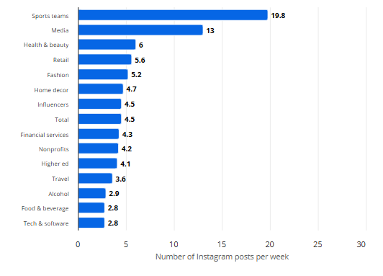

Figure 4.4: Average Number of Weekly Brand Posts on Instagram in 2024
(Source: Statista, 2024c)
However, adding to the content can be counterproductive for sportswear brands because people end up seeing the same type of sales messages repeatedly. So instead, the effectiveness will be determined by the extent to which posts are being used to solicit interaction, identification, and responses from consumers. Cheung et al. (2021) determined that social media marketing (SMM) can enhance and augment consumer engagement, thereby affecting the outcomes associated with the brand. It goes against the trend of measuring communication frequency in favor of measuring the impact of that communication. Content that sparks engagement, discussion, and consumer brand interaction can therefore be more valuable for sportswear brands than repetitive promotional content.
Wong and Hung (2023) provide relevant sportswear evidence that online brand identification can escalate to brand love and brand advocacy. Based on the findings, it can be concluded that posting frequency should be integrated with the relevance of the content and relationship building. Regular activity ensures providers have opportunities to have contact with the consumer, while meaningful interactions help to build the potential for increased consumer contact. This distinction is a key reason there is no direct proof that social media activity helps businesses to be more successful. Thus, the key finding is not that more Instagram posts produce better performance. Instead, social media adds value when regular communication helps to build positive consumer relationships.

4.6 Theme 5: Digital Advertising and Brand Visibility
Comparing visibility between sportswear brands gets more complicated when it comes to comparing performance with digital advertising. On Statista's (2023) buzz rankings, Nike came in at 49%, followed by Adidas (39%), Dick's Sporting Goods (35%), and Under Armour (26%). Those ranging differences are more significant when contrasted with the foregoing themes. These differences suggest that digital communication can draw attention to different extents, even for well-known sportswear brands. But higher buzz is not a conclusive sign of commercial success. A brand can gain considerable exposure, but consumers might not interact or buy its products.
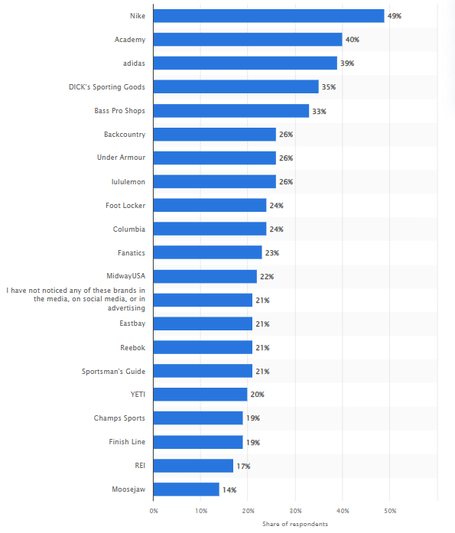

Figure 4.5: Sports and Outdoor Online Shops Buzz by Brand
(Source: Statista, 2023)
The ranking for brand awareness might not match that of online usage, even though awareness comes from high promotional exposure. So digital advertising is another strand of a larger performance mechanism that creates and shapes the results. This distinction is significant as it can influence advertising effectiveness based on what occurs once brand messages are delivered to consumers. According to Hübner et al. (2026), the surrounding digital experience or advertising relevance affects online consumer behavior in the context of digital advertising. Sports brands, therefore, can create an opportunity to engage in increased visibility, but the quality and relevance of the ad determine whether it advances to the next phase.
Consumers need to perceive marketing communication first, and then their response relies on how relevant the brand is, whether they have their own experience, and the strength of the digital relationship with consumers. This is important to consider in the context that it is not always a correlation between advertising visibility and sales or engagement. Therefore, it is important to see visibility as a first step to marketing and not a final result measure. Its commercial component relies on subsequent consumer reactions like engagement, brand consideration, and digital adoption. The theme thus highlights an important constraint in measuring the performance of digital marketing: the visibility itself may generate a potential for business value but the value will only be realised if contained in a subsequent process of interaction.

4.7 Chapter Summary
The chapter found 5 themes that connect digital marketing and business performance in the Sportswear industry. The results spoke up about Customer engagement, Brand equity, Online consumer adoption, ‘effective’ implementation of social media, and brand visibility. Digital strategies helped to achieve a different result on each channel and brand across the board. Their effectiveness depended on converting digital exposure and interaction into meaningful consumer responses.

Chapter 5: Discussion

5.1 Chapter Introduction
This chapter critically addresses the relationship between digital marketing strategies and business performance in the sportswear industry. It goes beyond reporting individual results to interpreting their implications in relation to the research questions, previous research, and the theory under study. Specific focus is placed on the implications of digital marketing activities for both consumers and businesses. The discussion further appraises aspects of agreement and disagreement before reflecting on the study's value in addressing the identified literature gap.

5.2 Interpretation of Digital Marketing Performance
Digital marketing performance in the sportswear sector seems to materialize as a transition from digital behavior to relevant consumer and commercial responses. That calls into question any direct link between the increase in digital presence and the increase in business performance. This directly returns to the research problem of whether extensive digital marketing activity translates into measurable business performance. It also addresses the study aim by interpreting digital marketing in relation to customer engagement, brand equity, sales-related behaviour, and wider performance. Across the five themes, the central finding is that digital channels create different forms of value, but their contribution depends on progression beyond exposure. Digital marketing is also seen as a strategic option in Chapter 2, rather than an autonomous source of results for the investor (France et al. 2025). This current analysis further elaborates on this idea and suggests that the digital value is dependent on what happens following the initial consumer exposure. Engagement can then be seen as a means to convey communication with increased relational and commercial relevance.
This is also an interpretation that examines the potential of judging digital performance with individual indicators. For marketing, visibility, communication intensity, and consumer interaction are various levels of marketing performance, not synonymous with success. This approach aligns with Gao's (2025) assertion that the effectiveness of digital marketing outcomes is contingent on the broader organizational competencies. The study goes further than this, though, and finds that the transformation of consumer interest is a significant element, too. Striking communication results can therefore be achieved without commensurate business value when there is a low drive for deeper consumer relationships. This answers the research questions by showing that the implications of digital channels cannot be reduced to sales growth alone. Instead, engagement and brand equity operate as important performance outcomes connecting marketing communication with subsequent commercial behaviour.
The analyses of the combined evidence further illuminate the complementary, explanatory functions of UGT and CRM. UGT adds more value in explaining the initial consumer impact, but lacks as much explanatory power in how it enables business value. CRM has more compelling explanatory power in repeated interaction - the building of relationships, retention, and purchasing behaviour. This is in line with Wong and Hung (2023), who found that online brand identification is related to better relational outcomes. They are mutually supportive rather than mutually exclusive, and thus have different values in various phases of the digital relationship. Digital marketing performance is therefore not necessarily transactional, and it is important to revise one's understanding of the performance and embrace a conditional and relational perspective. Its contribution is based on the ability to transform consumer attention into a relationship and commercially desirable behaviour. But the secondary evidence only points to associations, rather than to direct causes of business behavior, given that broader organizational and market contexts may also influence business conditions. This also contributes to the identified literature gap by connecting fragmented digital indicators with a broader performance pathway. Rather than assuming uniform effects, the study clarifies why digital activity may generate engagement and brand value without producing equivalent financial outcomes.

5.3 The Engagement–Performance Relationship
Customer engagement occupies an uncertain position between digital communication and business performance. A consumer can react to the content, join a brand community without being a loyal or buying customer. So, engagement is not a measure of success in itself. It is worth depends upon what emerges from the interaction. This distinction directly addresses the research question concerning how digital communication channels relate to customer engagement and wider business performance. Chapter 4 showed that social media can initiate engagement, while applications, communities, and e-commerce can support continuing interaction and purchasing processes. The principal issue emerging from these findings is therefore not whether engagement occurs, but whether consumers progress beyond their initial response. Similarly, Tan et al. (2024) relate meaningful digital interaction to positive trust and value for consumers. From a CRM point of view, this demands more weight than its occurrence because commercial worth lies in the extent to which the contact becomes a relationship.
When the intensity of communication is combined with the quality of the engagement, the difference will be more obvious. Frequent digital exposure provides opportunities to be engaged, but successive exposure can be low if the consumer has little motivation to remain engaged. Cheung et. al. (2021) relates social media marketing to engagement and brand outcomes. Even with the posting frequency complaints found in the findings, UGT believes that communication activity does not automatically equate with engagement because consumers engage selectively based on the value that can be derived from digital content. This is the reason it is not a reasonable measure of effectiveness to count the number of communications. It may be better to have a few relevant interactions rather than many superficial ones. This interpretation explains the apparent tension between high digital activity and uncertain performance. Consumer motivation, content relevance, and relationship quality can interrupt the assumed progression from exposure towards commercial behaviour.
Engagement becomes really important when it influences the consumer's relationship with the brand. However, initial interaction can be enough to create a reason to interact without fostering attachment. CRM comes into play here with the ability to build relationships beyond the initial contact. Wong and Hung (2023) have argued this point as they have tied the online identification of brands with brand love and advocacy. They conclude that the performance value of engagement is not a function of interaction totals but of a process of building relationships. This supports the study's conceptual pathway while also qualifying it: engagement should be treated as an intermediate mechanism rather than an automatic bridge to business performance. Therefore, the engagement–performance relationship is conditional on the subsequent course of events. The value of engagement occurs when participation grows into trust, identification, involvement, or behavioural responses. Effectively, without this line of progression, apparent interaction can suggest that the communication has reached the target audience but overestimate the extent to which it has impacted business performance. The secondary evidence cannot establish that engagement directly causes these outcomes, since product, competition, and wider market conditions may also affect performance. Nevertheless, this interpretation contributes to the literature gap by clarifying the mechanism between digital activity and business outcomes. Rather than treating engagement as an endpoint, the study positions its quality and development as central to understanding how digital marketing can acquire commercial value.

5.4 Uneven Performance Across the Digital Consumer Journey
The findings found that there are some inconsistencies that run through the entire customer journey, even within the digital environment, contradicting the belief in a linear customer journey. Most importantly, there is an indication that success at one stage of digitalization does not automatically translate to success at the next. Brand strength can provide awareness, but the further journey will rely on the ability to deliver enough relevance and value to consumers to further grow the relationship. Digital performance, therefore, is influenced by changes from one stage to the next, rather than the process being purely additive, i.e., the more the exposure, the better the digital performance. This is an interpretation based on Loureiro et al. (2024), who focused on the congruency of brands with lifestyle and the prestige of the brand as mechanisms for understanding the uneven progression. Recognition can get the consumer aware of a sportswear brand, but identification makes it meaningful to the actual individual. UGT adds to the argument by highlighting that the movement of users is still selective; people still interact where there are digital experiences that meet their motivations. Therefore, differences in unevenness can arise because of consumer–brand mismatches, not just differences in digital activity.
Another implication is related to the understanding of commercial effectiveness. Rosário and Raimundo (2021) traced digital marketing back to engagement and online buying, but the results did not suggest that both are sequential. Actions can weaken, halt, or alter between touchpoints. This renders the traditional funnel approach to sportswear consumption too determining. Digital consumers' journeys should then be considered 'non-linear' and 'conditional'. The critical aspect of solving any performance problem is not how well a brand is doing at one point, but whether value is maintained when consumers move through the points. This is the reason for the difference in digital-to-behavioural conversion levels. This interpretation directly addresses the research question concerning the implications of digital channels for engagement, brand equity, and sales by showing that these outcomes need not develop together. It also refines the study’s conceptual framework because the connections between engagement, brand equity and business performance should represent pathways rather than guaranteed progression. However, secondary evidence cannot determine exactly where or why individual consumers leave this journey, limiting causal interpretation. The study nevertheless contributes to the identified literature gap by explaining why strong digital indicators can coexist with weaker commercial outcomes and by presenting consumer progression as variable across digital touchpoints and contexts.

5.5 Reconsidering Digital Marketing Effectiveness
Whether a brand creates visibility, engagement, or instant sales is not the only measure to determine the effectiveness of digital marketing in any sportswear brand. The research problem questioned whether extensive digital activity translates into measurable business performance, and the combined findings indicate that this translation is neither uniform nor automatic. Rather, effectiveness will rely on the execution of efforts that help to reach broader consumer and commercial results. It responds to the research questions to reveal distinct impacts of digital channels and variations in value depending on the sequence in which individual outcomes relate. The literal translation of interpretation introduces a vigorous debate on the application of common measures between channels. While Jeswani (2023) declares that social media is uniquely important for awareness, engagement, and community building, Sharma and Ashfaq (2023) take note of the targeting and conversion capabilities of digital advertising. It would now, therefore, wrong to base the assessment of both channels solely on immediate sales, because they serve different strategies. The results support this distinction, as high activity or visibility was not always reflected in greater consumer reactions. Efficacy, therefore, must be concerned with the match between the purpose of the channel and the measure of the efficacy, and not with the expectation that all digital activities should yield the same kind of efficacy.
Another issue relates to the quality of digital execution. There is a conflicting opinion about the effect of branded social media content on active engagement, with Krowinska and Dineva (2025) suggesting that branded social media content can strengthen engagement. This helps explain why communication intensity alone provides weak evidence of effectiveness. In the UGT perspective, the content's informational, social, or experiential value determines whether the user continues engagement. CRM's added value is the long-term element—that repeated contact can help to deepen understanding, relevance, and retention, not just the volume of communication. This is also revealing some restrictions in business performance interpretation. Product, pricing, competition, and economic conditions all have an impact on sales, and digital marketing cannot explain the entire picture. The secondary qualitative design also helps to identify patterns and associations and does not establish causal effects. This, however, increases the importance of the need for a multidimensional assessment.
The study thus fills the gap in the literature identified by the link between intermediate digital outcomes and overall business performance without immediately assuming such a relationship. It takes a different approach to measuring effectiveness and concentrates on strategic contribution; visibility can bring opportunity, engagement can bring consumer involvement, and developing relationships can bring behavioural outcomes. This lens helps to make sense of the larger digital presence for uneven commercial outcomes and offers a more context-sensitive way of critiquing sportswear digital marketing through different channels and market environments.

5.6 Chapter Summary
This chapter critically interprets how digital marketing contributes to sportswear business performance. The discussion established that visibility, engagement, and brand equity do not automatically generate commercial outcomes. UGT and CRM explained various stages of consumer relationships, while the findings demonstrated conditional performance pathways and addressed the identified literature gap through integrated interpretation.

Chapter 6: Conclusion

6.1 Overall purpose of the study
The overall purpose of the study was to identify the impact of digital marketing strategies on business performance in the global sportswear industry by using secondary data. First, the research identified how social media marketing, influencer marketing, mobile application digital advertising, and digital commerce impact customer engagement, brand equity, online consumer adoption, and business outcomes. The academic literature, corporate reports, and industry publications were evaluated to identify key patterns and relationships. The study also has an objective to determine whether digital marketing activity can directly contribute to sales growth and customer retention while identifying that effectiveness depends on wider market and organizational factors.

6.2 Summary of the key findings
The finding identifier five main themes that connected digital marketing with business performance in the sportswear industry. Media, mobile applications, online communities, and e-commerce were found to support customer engagement and stronger digital relationships. Digital marketing directly contributes to brand equity by increasing awareness, brand association, and customer identification. The online consumer adaptation reflected that digital visibility can easily develop into actual digital purchasing behaviour. Although frequent social media activity alone did not guarantee effectiveness, meaningful interactions and relevant content were more important. Finally, it was also identified that digital advertising increases brand visibility, but visibility did not always translate directly to sales or engagement. Digital marketing develops value when exposure develops into meaningful consumer responses.

6.3 Outcomes identified in the data analysis
The data analysis identified different outcomes from the use of digital marketing in the sportswear industry. The digital channel supports customer engagement by regular interaction in online communities and e-commerce activities. Findings also showed that digital marketing directly contributes to brand liquidity by increasing the strength of brand awareness association and customer identification. From the data analysis, the research questions are answered by establishing the fact that online consumer adaptation demonstrates a connection between digital visibility and commercial behaviour. However, it is also noted in the data analysis that high social media activity and advertising visibility did not automatically produce higher sales. The overall outcome was that digital marketing developed stronger business value when consumer exposure is transferred to meaningful engagement, brand relationship, and online purchasing behaviour.

6.4 Value of the study on theory and practice
The study gave value to theory by applying the Uses and Gratifications Theory and Customer Relationship Management theory to digital marketing in the sportswear industry. The Uses and Gratifications Theory helps in explaining why and consumer engage with social media mobile applications and digital content for information, entertainment, and social interaction. On the other hand, the CRM theory explains how digital platforms can support personalized communication, customer retention, and long-term relationships. However, in practice, the findings reflect that sports organizations or companies should not judge digital marketing only by visibility or immediate sales. Good attention should be given to customer engagement, brand equity, and online consumer adaptation and relationship development. The study also highlights the significance of integrating different digital channels instead of developing them separately. This can help marketing to develop more focused campaigns, improve customer experience, and strengthen brand relationships. Hence, the study gave both the theoretical understanding and practical guidance for improving digital marketing effectiveness and business performance.

6.5 Practical insights in research for professionals
The study gives practical information for managers and other professionals in the sportswear industry. Marketing managers should focus on the quality of digital engagement instead of simply increasing social media activity or advertising frequency. Social media influencer marketing, mobile applications, and digital commerce need to be incorporated to develop a consistent customer experience. Due to this, managers should also measure digital marketing by customer engagement, brand equity, online adoption, and retention instead of depending only on visibility or short-term sales. Policymakers and industry stakeholders can support responsible digital marketing by promoting transparency, consumer protection, and responsible use of customer data. The study also reflects that companies should use customer insight for develop more relevant and personalized communication. Overall, professionals can improve business performance by connecting digital exposure with meaningful customer relationships and purchasing behaviour. Can be done while regularly reviewing whether the digital activities were producing measurable business value or not and supporting long-term customer loyalty and sustainable business growth.

6.6 Limitations of the study
The study has several limitations that need to be considered when interpreting the findings. The research depends entirely on secondary data, including academic articles, corporate reports, and industry publications. Hence, the study did not collect primary information directly from the sportswear customer managers or employees. Restricting the ability to understand the individual experience and organizational decision-making in a deeper way. The study focused on the global sportswear industry, which provides product information but cannot fully reflect the differences between countries' markets and consumer groups. The qualitative analysis depends on the information available in existing sources. This means that access to detailed company-level performance data was restricted. The study cannot develop a direct causal relationship between the digital marketing activities and business performance. Finally, the rapidly changing nature of digital technologies, including artificial intelligence and personalization, reflects that some findings can become less relevant as digital marketing practice continues to develop.

6.7 Recommendations
To integrate digital marketing channels
Sportswear companies need to integrate social media influencer marketing, mobile applications, and digital advertising instead of managing each channel separately. A consistent message across the platform can improve customer engagement and give a smoother customer journey. Managers need to use customer feedback and digital interaction data to make campaigns more relevant and responsive. The approach can help in converting the digital visibility into strong customer relationships and purchasing power.
To measure engagement and business outcomes
Managers need to evaluate digital marketing by using a good range of performance indicators; they should include customer engagement, brand equity, online customer adaptation, retention, and sales performance. Posting frequency or advertising visibility should not be treated as evidence of effectiveness by itself. Regular performance reviews help companies to identify whether the campaigns are useful for customer response and allocate resources to more effective activities. Companies can develop a monthly dashboard to compare the campaign result in platform and identify changes in customer responses. Handling conversion rates, repeat purchases, and engagement levels can give unambiguous evidence of value. The evidence can support better budgeting and adjustment of underperforming campaigns. It also gives accountability in marketing teams
To increase strength in personalization and customer relationships
Sportswear companies need to use digital platforms to develop personalized communication and strong long-term customer relationships. Mobile applications, social media communities, and digital commerce can be used to understand digital performance and provide relevant content. Managers should also confirm that responsible use of customer data is being maintained in the company. This supports customer loyalty, brand relationship, and sustainable business performance over time.

6.8 Implementation and directions for future research
Future research needs to use primary data from sportswear customer marketing managers and employees to gain deep insight into the digital marketing practice. Comparative research in countries and consumer groups can explore how cultural and regional differences influence digital marketing activities. For future research, the emerging technology is practicality of the artificial intelligence personalization and digital communities’ areas where evaluated which are developing rapidly longitudinal research can examine whether digital marketing strategy is produced sustained improvements in customer engagement and business performance that can be integrated into future research. In the future can compare different sportswear brands to identify which digital strategies are most effective under different market conditions.

6.9 Reflective statement
The study reflect the digital marketing is a significant part of business performance in the sportswear industry. I have identified the findings that social media influencer marketing, mobile application digital advertising, and digital commerce can develop customer engagement and strengthen brand equity when they are used strategically. Digital visibility alone does not guarantee higher sales or a strong relationship with customers. The value of digital marketing totally depends on the organization that can convert online exposure to engagement, customer adaptation, and long-term responsiveness. The study highlights the requirement for the sportswear company to focus on meaningful interaction and measurable business outcomes instead of activity levels alone. I have found that although the research was limited by its dependence on secondary qualitative evidence, but give a good foundation for understanding digital marketing practice. Research can easily develop from these findings by using primary and quantitative evidence to identify how emerging technology continues to reshape customer behaviour and business performance.

References
Abakpa, A. and Dvouletý, O., (2025). How does digitalization shape the business financial performance: a systematic review. Future Business Journal, 11(1), p.235.
Acharya, R., 2025. Examining interpretivism in social science research: Exploring subjectivity, context, and meaning in social inquiry. Education Science & Technology.
Adidas (2025). Markets and Sales Channels. [Online] Available at: https://report.adidas-group.com/2024/en/group-management-report-our-company/description-of-business-model/markets-and-sales-channels.html [Accessed: 5 September 2026]
Ahmed, S.K., Mohammed, R.A., Nashwan, A.J., Ibrahim, R.H., Abdalla, A.Q., Ameen, B.M.M. and Khdhir, R.M., (2025). Using thematic analysis in qualitative research. Journal of Medicine, Surgery, and Public Health, 6, p.100198.
Akkala, A.K., Talamala, S., Kanchumarthi, M.R. and Reddy, M.R.D., (2026). Customer Relationship Management. BR Publications.
Aldlimi, T., Priporas, C.V. and Chang, S.W., (2025). Engagement in influencer marketing: A systematic review of key drivers, behaviors, and future research directions. Journal of Consumer Behaviour, 24(3), pp.1541-1566.
Alharbi, A., Kamalul Ariffin, S. and Mohd Nor, Z., (2026). Digital advertising attributes, Muslim consumers’ attitude, and purchase intention toward dairy products: the moderating role of health consciousness. Journal of Islamic Marketing, pp.1-36.
Almusaed, A., Almssad, A. and Yitmen, I., (2025). Introduction to quantitative research. In Practice of Research Methodology in Civil Engineering and Architecture: A Comprehensive Guide (pp. 489-528). Cham: Springer Nature Switzerland.
Arıkan, E., (2026). Cultural Construction Through Marketing Communications: Societal Impacts and Ethical Considerations. In The Impact of Marketing Strategies on Society: Examining Critical Aspects of Marketing and their Implications for Societal Well-being (pp. 215-236). Cham: Springer Nature Switzerland.
Awasthi, R. (2026). Validity and Reliability: The Twin Pillars of Robust Research Instrument. MSW Management Journal.
Biemans, W., and Malshe, A. (2024). How marketing and sales use digital tools for innovation ideation. Industrial Marketing Management, 123(18), pp.304–316. doi:10.1016/j.indmarman.2024.10.012.
Cheung, M.L., Pires, G.D., Rosenberger III, P.J., Leung, W.K. and Ting, H. (2021). Investigating the role of social media marketing on value co-creation and engagement: An empirical study in China and Hong Kong. Australasian Marketing Journal, 29(2), pp.118-131.
De Araujo, S.V.I., Dhaigude, A.S., Kamath, G.B., Pai, R.R., Nayak, S. and Prabhu, V. (2026). Understanding the impact of sports influencer attributes on follower attitudes and purchase behavior in India. Acta Psychologica, [online] 268(18), p.107422. doi:10.1016/j.actpsy.2026.107422.
Districtrunningcollective, (2025). New month, new energy! It is a special week! On Wednesday, join us for some miles to celebrate Global Running Day. [online] Nike.com. Available at: https://www.instagram.com/p/DZCpe5LEfca/ [Accessed 17 Aug. 2026].
ElSayad, G. and Md Saad, N.H., 2024. Unmasking the power of social media marketing activities in cultivating customer equity, loyalty, and repurchase intention. Journal of Marketing Communications, pp.1-21.
Eslami, P., Najafabadi, M. and Gharehgozli, A. (2024). Exploring the journey of influencers in shaping social media engagement success. Online social networks and media, [online] 41(100277), pp.100277–100277. doi:10.1016/j.osnem.2024.100277.
Eslami, S.P., Ghasemaghaei, M. and Hassanein, K. (2022). Understanding consumer engagement in social media: The role of product lifecycle. Decision Support Systems, [online] 162(0167–9236), p.113707. doi: https://doi.org/10.1016/j.dss.2021.113707
Fonseca, T.M.C., 2026. Brand equity and consumer loyalty in the sportswear industry: the role of community engagement among Generation Z in Portugal. Zhang, W., 2026, June. A Strategic Optimization Study of Nike's Digital. In Proceedings of the 2025 International Conference on Hybrid Commerce, Human Capital, and Economic Dynamics (ICHCH 2025) (p. 342). Springer Nature.
France, S.L., Davcik, N.S. and Kazandjian, B.J., (2025). Digital brand equity: The concept, antecedents, measurement, and future development. Journal of Business Research, 192, p.115273.
Galić, T., Žuvela, F. and Franjko, I., 2026. Globalization, digital influence, and local market screening: Evidence from half-marathon running footwear choices. Journal of Physical Education and Sport, 26(4), pp.692-703.
Gao, S., (2025). Digital marketing tools and digital transformation capability as a factor in enhancing business performance in China and Kazakhstan. Scientific Reports, 15(1), p.36929.
Gaurav, K., Dwivedi, R., Verma, R. and Kumar, V., 2026. Design and Implementation of an AI-Driven Data-Centric CRM System for Enhanced Customer Engagement and Personalized Experience.
Gensler, S. and Rangaswamy, A., (2025). An emerging future for digital marketing: From products and services to sequenced solutions. Journal of Business Research, 190, p.115230.
Ghosh, M. and Islam, A.S., (2025). The effect of social media influencers’ content characteristics on millennial consumers’ engagement on Facebook brand pages. Journal of Contemporary Marketing Science, 8(2-3), pp.146-172.
Gkevrou, M. and Stamovlasis, D., (2025). Merger of critical realism and complexity theory: Laying the foundations for a unified ontological and epistemological perspective for the study of social systems. Foundations of Science, pp.1-21.
Gómez, R., Patricia, L., Chiappe, A., and González, E.O. (2024). Gamifying learning with AI: A pathway to 21st-Century skills. Journal of Research in Childhood Education, 18(18), pp.1–16. doi:10.1080/02568543.2024.2421974.
Grandviewresearch (2025). Sportswear Market Summary [online] Nike.com. Available at: https://www.grandviewresearch.com/industry-analysis/sportswear-market [Accessed 17 Aug. 2026].
Grijalba, M.A., Hernández, Y.B., Pérez-Encinas, A. and Urda, B.S., (2025). Does the use of digital tools improve a firm’s performance?. Review of Managerial Science, 19(7), pp.2193-2210.
Grzenkowicz, M. and Wildfeuer, J., (2025). Addressing TikTok’s multimodal complexity: a multi-level annotation scheme for the audio-visual design of short video content. Digital Scholarship in the Humanities, 40(4), pp.1143-1166.
Harefa, D., (2025). Integration of Local Wisdom in Nias Myths about Natural Phenomena as a Basis for Developing Science Learning and Strengthening Scientific Argumentation. KOHESI: Jurnal Pendidikan Bahasa Dan Sastra Indonesia, 6(1), pp.28-49.
Hübner, M., Henseler, J. and Thalmann, J. (2026). Consumers’ perception of native advertising on social media–A systematic literature review. Journal of Marketing Communications, pp.1-31.
Inkesar, A., Alam, S., Hasan, A., Alazzaz, S.A., Khan, N., Ahmad, F.R. and Chishty, S.K., (2026). Influencer marketing and purchase intention among Millennials and Generation Z in Saudi Arabia: the mediating role of brand trust—Frontiers in Sustainability, 7, p.1838170.
Isen, B., Moyosore, F.O., Adetola, T.P., Lawal, A.K., Amuna, M., Ntim, P.Y. and Kwarteng, R.A., 2026. The Impact of Customer Analytics on Sales Funnel Conversion and Customer Retention in the E-Commerce Industry. Asian Journal of Economics, Business and Accounting, 26(1), pp.207-224.
Jeswani, R. (2023). The role and importance of social media marketing in brand building. [online] ResearchGate. Irish Interdisciplinary Journal of Science and Research. Available at: https://www.researchgate.net/publication/375731382_The_Role_and_Importance_of_Social_Media_Marketing_in_Brand_Building [Accessed 17 Aug. 2026].
Kemp, S., 2025. Digital 2025: Global Overview Report [Online] Available at: https://datareportal.com/reports/digital-2025-global-overview-report [Accessed on: 1.08.2026]
Khandolkar, T., Hegde Desai, P., Barpanda, S. and Mekoth, N., (2025). Building social media brand engagement: The role of content quality, source credibility, and customer-based brand equity. Journal of Promotion Management, 31(6), pp.975-997.
Khatun, T., 2026. Qualitative vs Quantitative Research: What is the Difference?.
Khurshid, F., Veen, M., Thompson, J. and Hegazi, I., (2026). Navigating thematic analysis: practical strategies grounded in abductive reasoning. Teaching and Learning in Medicine, 38(1), pp.106-115.
Kilmer, B., (2026). Stability and turbulence in illegal drug markets. Proceedings of the National Academy of Sciences, 123(33), p.e2512078123.
Kim, H., Park, S., Hong, J. and Byun, S., (2026). Influencer Marketing Effectiveness: Direct and Indirect Effects through Electronic Word-of-Mouth in a Multichannel Environment. 경영학연구, 55(1), pp.183-204.
Krowinska, A. and Dineva, D., (2025). The role and forms of social media branded content driving active customer engagement behaviours. Journal of Marketing Management, 41(9-10), pp.1030-1060.
Kumar, A., Rayne, D., Salo, J. and Yiu, C.S., (2025). Battle of influence: Analysing the impact of brand-directed and influencer-directed social media marketing on customer engagement and purchase behaviour. Australasian Marketing Journal, 33(1), pp.87-95.
Lemmens, A., Roos, J., Gabel, S., Ascarza, E., Bruno, H., Gordon, B., Israeli, A., Mcdonnell Feit, E., Mela, C. and Netzer, O. (2025). Personalization and targeting: How to experiment, learn & optimize. International Journal of Research in Marketing, [online] 18(19). doi:10.1016/j.ijresmar.2025.07.004.
Lim, W.M., (2025). What is quantitative research? An overview and guidelines. Australasian Marketing Journal, 33(3), pp.325-348.
Littlewood, K.E. and Gardner, D.H. (2026). A brief guide to qualitative research in veterinary science: interviews, focus groups, surveys and reflexive thematic analysis for practitioners and researchers. New Zealand Veterinary Journal, pp.1-11.
Loureiro, S.M.C., Rodrigues, Á. and Martins, C. (2024). Love power: From identification to advocacy in fashion sportswear in the social media context. Journal of Creative Communications, 19(3), pp.366-385. DOI: https://doi.org/10.1177/09732586231190267
Ma, T., and Lee, Y. (2026). Overview of quantitative research. Family Medicine, 58(2), p.81.
Madondo, E. and Akindeji, E., (2026). The Role of Social Media Influencers in Brand Communication Strategies. ASEAN Marketing Journal, 18(1), p.2.
Manafe, L.A. (2026). WHEN VARIABLES ARE NO LONGER SUFFICIENT: AN INTERPRETATIVE PHENOMENOLOGY OF THE VOLCANIC TOURISM EXPERIENCE IN EAST JAVA. Jurnal Ilmiah Edunomika, 10(2).
McKee, K., Dahl, A.J. and Peltier, J.W., (2026). Personalized digital marketing value-in-use: examining the influences on consumers’ continuum of interactive marketing avoidance behaviors. Journal of Research in Interactive Marketing, 20(4), pp.491-508.
McKinsey (2025). Sporting Goods 2025—The new balancing act: Turning uncertainty into opportunity [Online] Available at: https://www.mckinsey.com/industries/retail/our-insights/sporting-goods-industry-trends [Accessed on: 1.08.2026]
Meng, Z., Zhang, X., Duan, Q., Shen, H. and Meng, H., 2026. Beyond likes and clicks unpacking the dual cognitive-affective pathways of influencer marketing in sportswear fashion. Asia Pacific Journal of Marketing and Logistics, pp.1-18.
Montgomery, T. (2026). Nike CFO: “Our Consumer Is Under Pressure Around the World” [Online] Available at: https://shop-eat-surf-outdoor.com/news/nike-cfo-our-consumer-is-under-pressure-around-the-world/620865/ [Accessed on 3.08.(2026)]
Mordorintelligence (2025). SPORTS APPAREL MARKET SIZE & SHARE ANALYSIS - GROWTH TRENDS AND FORECAST (2026 - 2031) [Online] Available at: https://www.mordorintelligence.com/industry-reports/global-sports-apparel-market-industry [Accessed on: 1.08.2026]
Munizu, M., Arsyad, M. and Munir, A.R. (2026). The Relationship Between Digital Marketing, Business Performance, and Capability: A Resource-Based View and Dynamic. Enterprise Development and Microfinance, 36(3s), pp.269-289.
nature (2025). Customer-based brand equity in marketing strategies | marketing management | marketing | social sciences | topics | nature index. [online] NatureIndex. Available at: https://www.nature.com/nature-index/topics/l4/customer-based-brand-equity-in-marketing-strategies [Accessed 17 Aug. 2026].
NGO, T.T.A., AN, G.K., DANG, N.Y., DOAN, T.T. and NGUYEN, V.M.H. (2025). The psychological impact of social media marketing on consumer willingness to pay for tech gadgets: A study on brand perception and decision-making. Acta Psychologica, [online] 262(18), p.106130. doi:10.1016/j.actpsy.2025.106130.
Pan, J., Ishak, N.A. and Qin, Y. (2024). The application of Moore’s online learning interactions model in learning outcomes: The SOR (stimulus-organism-response) paradigm perspective. Heliyon, [online] 10(7), pp.e28505-e28505. doi:10.1016/j.heliyon.2024.e28505.
Peggiani, G. and Lamberti, L. (2026). Beyond the post: Crafting influencer marketing strategies across the funnel. Journal of Business Research, [online] 207(15), p.116037. doi:10.1016/j.jbusres.2026.116037.
Pereira, Schmitt, B., Cordeiro, B.A., Schmitt, B., Gabriela, M., Eugenia, S. and Gonçalves, M.C. (2025). Factors of customer loyalty and retention in the digital environment. Journal of Theoretical and Applied Electronic Commerce Research, [online] 20(2), p.71. Available at: https://www.mdpi.com/0718-1876/20/2/71 [Accessed 17 Aug. 2026].
Pierce, J.R. (2026). Digital Marketing Strategies and Consumer Buying Behavior. Corps et Psychisme. Recherches en Psychanalyse et Sciences Humaines, 13(1), pp.2570-2575.
Platania, F., Toscano Hernandez, C. and Appio, F.P. (2026) Beyond the game: Leveraging athlete celebrities for value creation in sportswear brands in the digital era, European Management Review, pp.1–23. DOI: https://doi.org/10.1111/emre.70064
Prayuda, A.B., Syuheri, A. and Hakim, Z., (2026). Assessing The Effectiveness of TikTok-Based Digital Marketing Communication: A Social Media Analytics Study of Consumer Engagement. Progress in Social Development, 7(2), pp.526-539.
Qiao, T., Marimuthu, A. and Mei, S., (2025). Digital marketing, financing constraints, and enhancements in corporate performance. Finance Research Letters, p.108221.
Robinson, O.C. and Bailey-Rodriguez, D., 2026. Deductive qualitative research: an integrative approach to designing studies. Qualitative research in psychology, 23(2), pp.369-384.
Rochefort, T. and Ndlovu, Z. (2024). Digital Marketing Strategies in building brand awareness and loyalty in the online era. Startupreneur Business Digital (SABDA Journal), [online] 3(2), pp.-. doi:10.33050/sabda.v3i2.539.
Rosário, A. and Raimundo, R. (2021). Consumer marketing strategy and E-commerce in the last decade: a literature review. Journal of theoretical and applied electronic commerce research, 16(7), pp.3003-3024.
Shah, S., Pathak, P., Sharma, A., Mehra, A., Jadeja, A. and Thomas, S., (2026). A Multi-Theoretical Approach to Unveiling the Factors Influencing Donation Intention on CRM-Embedded Social Gaming Apps: Unifying Self-Determination, Heuristics, and Identity Theories. Journal of Nonprofit & Public Sector Marketing, pp.1-36.
Sharma, Ms.S. and Ashfaq, D.R. (2023). Targeting the digital consumer: A study of the role of social media in modern advertising. Journal of Humanities, Music, and Dance, 3(34), pp.22–35. doi:10.55529/jhmd.34.22.35.
Shrestha, S., (2026). The Impact of Instagram Marketing on the Growth of Small Businesses in Helsinki.
Skinner, E. and Dancis, J., 2026. Descriptive and explanatory designs. Human Development-Revision.
Statista (2023). Sports and outdoor online shops buzz in the United States in 2023, by brand. [Online] Available at: https://www.statista.com/statistics/1416102/sports-and-outdoor-online-shops-buzz-us/ [Accessed: 5 September 2026]
Statista (2024a). Leading sports and outdoor online shops ranked by brand awareness in the United States in 2024. [Online] Available at: https://www.statista.com/statistics/1341610/most-well-known-sports-and-outdoor-online-shops-in-the-united-states/ [Accessed: 5 September 2026]
Statista (2024b). Leading sports and outdoor online shops ranked by usage in the United States in 2024. [Online] Available at: https://www.statista.com/statistics/1344663/leading-sports-and-outdoor-online-shops-in-the-united-states/ [Accessed: 5 September 2026]
Statista (2024c). Average number of weekly brand posts on Instagram in 2024, by vertical. [Online] Available at: https://www.statista.com/statistics/873935/daily-instagram-brand-posts-by-vertical/ [Accessed: 5 September 2026]
Taherdoost, H. (2026). Ethical Considerations and Academic Integrity in Research. Taylor & Francis.
Tan, P.L., Tee, P.K. and Ahmad, R.B. (2024). The impact of digital content marketing on customer engagement in an online fashion store. International Journal of Advanced Business Studies, 3(special issue), pp.107-123
Trisilowaty, D., Surya, Y.W.I. and Rahayu, T.P. (2026). Social media use among adolescents with limited family support: Insights from Uses and Gratifications Theory. Digital Theory, Culture & Society, 4(1), pp.293-303.
Van Hulst, M. and Visser, E.L., (2025). Abductive analysis in qualitative research. Public Administration Review, 85(2), pp.567-580.
Vo, T.H., Wei‐Han Tan, G., Pham, N.T., Truong, T.H.D. and Ooi, K.B., (2025). Promoting customer engagement and brand loyalty on social media: The role of virtual influencers. International Journal of Consumer Studies, 49(2), p.e70028.
Wali, F., Rahman, S., and Thakur, S. (2026). Digital marketing.
Wang, M. (2026, June). From Sneakers to Superapp: Nike’s Transition to a Tethered Digital Platform. In 2025 International Conference on Hybrid Commerce, Human Capital, and Economic Dynamics (ICHCH 2025) (pp. 410-418). Atlantis Press.
Weiger, W.H., Giertz, J.N., Hammerschmidt, M. and Hollebeek, L.D., (2025). Blurred lines? Disentangling the roles of consumers’ influencer-and brand engagement in shaping brand performance. Journal of Business Research, 194, p.115280.
Wong, A. and Hung, Y.C. (2023). Love the star, love the team? The spillover effect of athlete sub brand to team brand advocacy in online brand communities. Journal of Product & Brand Management, 32(2), pp.343-359.
Xu, Y., and Chen, L. (2025). Personalized recommendations and consumer trust: The role of perceived control and locus of control. Acta Psychologica, 261(18), p.105936. doi:10.1016/j.actpsy.2025.105936.
Yadav, S.K. and Shelke, D.G. (2026). Social Media and Consumer Buying Decisions in the Indian Automobile Market. Public Administration and Law Review, 2 (26), pp.131-146.
Yip, S.Y. and Zeng, S.A., (2025). Developing an analytical framework for multi-level data analysis in qualitative inductive studies. International Journal of Qualitative Methods, 24, p.16094069251401328.
Zhang, Q. and Abdullah, F., (2025). The psychological mechanisms through which digital content marketing by online influencers affects customer loyalty: Evidence from multiple countries—Frontiers in Communication, 10, p.1702657.
Zia, S., Khan, A., Tufail, M.M.B., Ismat, J. and Idrees, A. (2022). Impact of social media marketing on consumer-based brand equity. Journal of Marketing Strategies, 4(1), pp.120-139.

Appendix: Data Source
No. | Source | Year | Source Type | Evidence/Data Used in Chapter 4 | Chapter 4 Theme | Analytical Use
1 | Adidas | 2025 | Company report | E-commerce represented 18% of net sales and direct-to-consumer channels represented 40% of net sales | Theme 1: Customer Engagement | Used to assess the commercial relevance of digital consumer relationships and online commerce
2 | Platania, Toscano Hernandez & Appio | 2026 | Academic journal | Athlete-celebrity digital engagement creates value through consumer trust and brand equity | Theme 1: Customer Engagement | Used to interpret engagement quality, trust and brand value
3 | Tan et al. | 2024 | Academic study | Digital content marketing supports consumer engagement, trust and value | Theme 1: Customer Engagement | Used to explain how meaningful digital interactions can strengthen relationships
4 | Statista | 2024a | Industry/statistical source | Brand recognition: Nike 93%, Adidas 92%, Reebok 87%, Under Armour 85%, Columbia 75%, Lululemon 58% | Theme 2: Brand Equity | Used to compare digital brand awareness across sports and outdoor brands
5 | Loureiro et al. | 2024 | Academic journal | Online brand prestige and lifestyle congruency influence brand identification and brand love supports advocacy | Theme 2: Brand Equity | Used to interpret movement from brand awareness towards identification and advocacy
6 | Zia et al. | 2022 | Academic study | Social media marketing contributes to consumer-based brand equity through brand experience | Theme 2: Brand Equity | Used to connect digital interaction with consumer-based brand equity
7 | Statista | 2024b | Industry/statistical source | Usage differences among leading sports and outdoor online shops | Theme 3: Online Consumer Adoption | Used to examine differences between brand awareness and actual online platform usage
8 | Eslami et al. | 2022 | Academic study | Social media marketing activities influence behavioural responses through brand-related mechanisms | Theme 3: Online Consumer Adoption | Used to explain progression from digital exposure towards consumer behaviour
9 | Rosário & Raimundo | 2021 | Academic literature | Digital marketing can support engagement and influence online purchasing | Theme 3: Online Consumer Adoption | Used to connect engagement with online purchasing behaviour
10 | Statista | 2024c | Industry/statistical source | Average weekly Instagram posts: sports teams 19.8, fashion brands 5.2 and retail brands 5.6 | Theme 4: Social Media Effectiveness | Used to assess social media activity and posting intensity
11 | Cheung et al. | 2021 | Academic study | Social media marketing enhances consumer engagement and brand-related outcomes | Theme 4: Social Media Effectiveness | Used to distinguish communication frequency from communication effectiveness
12 | Wong & Hung | 2023 | Academic study | Online brand identification is associated with brand love and brand advocacy | Theme 4: Social Media Effectiveness | Used to assess the importance of meaningful interactions and relationship development
13 | Statista | 2023 | Industry/statistical source | Online brand buzz: Nike 49%, Adidas 39%, Dick's Sporting Goods 35%, Under Armour 26% | Theme 5: Digital Advertising & Brand Visibility | Used to compare brand visibility generated through digital communication
14 | Hübner et al. | 2026 | Academic journal | Digital experience and advertising relevance influence online consumer behaviour | Theme 5: Digital Advertising & Brand Visibility | Used to evaluate whether advertising visibility can progress towards consumer response

