

University of Wales Trinity Saint David
School of Engineering

Engine Performance Characteristics

Harrison Boakes
1805555

HND Motorsport engineering

Abi Summerfield

M4X02196

Contents

List of figures…………………………………………………………..Page 3
Introduction ……………………………………………………………Page 4
Experimental procedure …………………………………………Page 5
Results…………………………………………………………………… Page 8
Analyses ……………………………………………………………….. Page 10
Conclusion ……………………………………………………………. Page 14
Evaluation …………………………………………………………….. Page 15
Further work …………………………………………………………. Page 16
Bibliography …………………………………………………………. Page 17

List of figures

Figure 1 > Engine dynamometer
Figure 2 > weight secured on load arms
Figure 3 > engine securely fixed to dyno bed
Figure 4 > DSG dyno software information
Figure 5 > using the dyno whilst manually controlling loads and revs
Figure 6 > engine speed and brake power graph
Figure 7 > S.F.C/Engine speed graph
Figure 8 > Torque/Engine speed graph
Figure 9 > B.M.E.P and Thermal efficiency table
Figure 10 > raw data calculated in excel

Introduction
This assignment will investigate engine dynamometer results and how to safely and accurately obtain these results. Important results such as correct power, torque, BMEP, SFC and overall thermal efficiency will be generated using the appropriate equations in excel. This data will there be used to compose graphs and analyses of the graphs will be carried out.

  - Background research
There are two main tests commonly used for engine dynos to find outputs and characteristics. These tests are called sweep tests and step tests, both have their advantages and disadvantages. The sweep test is often used as a quick test to check the engine is performing correctly. This test takes a matter of seconds to complete and relays sufficient data to the data analysis. Since the test takes only a few seconds there is little to no risk of damaging the engine or over heating as the whole operation usually takes around 8s-10s. However, there are some disadvantages associated with sweep testing, these being that it is extremely hard to read live data as its being produced because the test is happening so quickly. Another noticeable disadvantage is less precise data readings, as the test is running considerably quick than other forms of tests meaning the dyno software must produce more rough data to keep up with the live test. The step test is often used by race teams as one of the main advantages of the test is that it gives more precise data compared to the sweep test. This test does take considerably longer than other forms of testing especially if more accurate data needs to be generated however, during this time data can be analysed in real time as the test is being carried out. The disadvantage of this test is that the engine is at risk of overheating especially if insufficiently cooled.
The test engine used on the dyno is the Honda D16 1.6L. This particular engine is a Japanese standard engine meaning it has been slightly altered in the mapping to meet to emissions standards. This means that the engine is slightly less powerful both in torque and brake horsepower. The engine is an inline 4 design as was used from 1986 until 2001. The long production of this engine was a result of its renowned reliability. The engine produced roughly 80BHP from new.

  - Aims
The aims of this assignment will be to explain exactly how to carry out an engine dynamometer test and obtain raw data such as load, speed and fuel consumption and rate of throttle opening. The dynamometer tests will be carried out in groups. The main aim is to use this raw data to calculate other parameters of the engine. From the collected data graphs will be generated reflect the data. The assignments main purpose is to further ones understanding on dyno testing and the variety of test that can be run and to calculate and analyse results gathered from the testing the analyses is a vital part as it helps to identify possible anomalies and data characteristics.

Experimental Procedure

Equipment used
>Eddy current brake dynamometer
>DSG data pro V26xx software
>load arms x 2
>Honda d16 1.6l (2001)
>Weights x 2
>Fuel pump control board
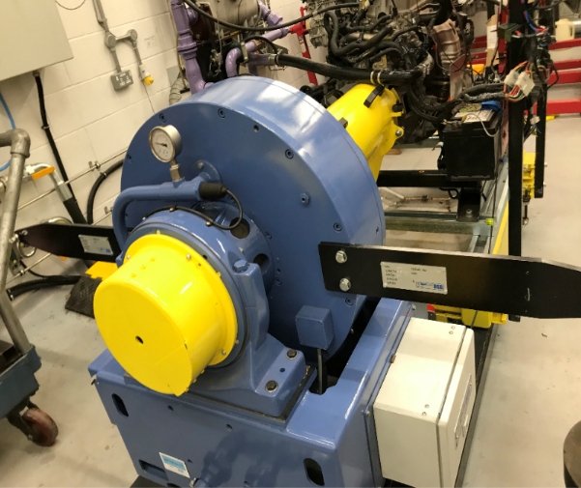
>PPE (steel toe cap boots)
The type of dyno that will be used is the Eddy current dynamometer. The dyno works by measuring the change in magnetic flux to determine power and torque. When entering the dyno testing room ensure appropriate PPE is on and there are no obvious health hazards within the room. When setting up the dynamometer ensure the balance arms are attached securely to the main body of the dynamometer using the two bolts as highlighted in the image.
Figure 1: engine dynamometer
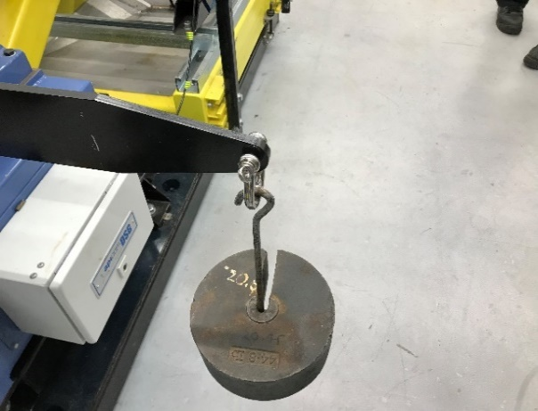
Once the arm is fixed in place used the weights provided and attach them via the hook to the arms ensuring the weights are secure on the hook (figure 2) to eliminate the risk of the weight moving whilst the test is undergoing. The weight attached to the end of the balance arms is unknow but using the equation T=WR we can find the weight by making W the subject of the formula W=T/R. Using this rearranged equation, you should get 20.45kg.
Figure 2: weight secured to balance arms

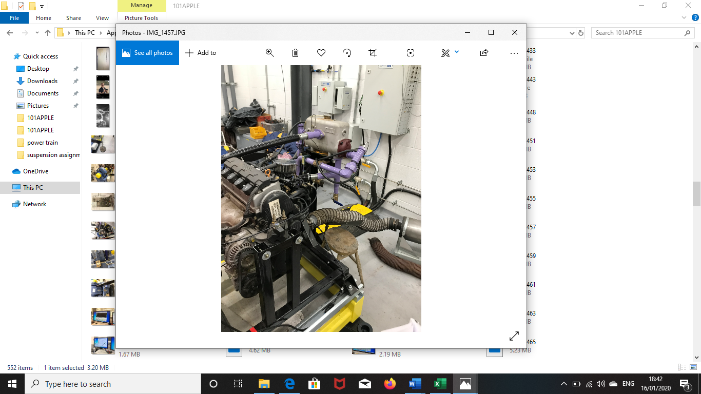
Ensure that the engine is secured adequately to the bed and check for any leaks, exposed wiring and proper ventilation installed for the exhaust gases. In order to stop the spread of harmful exhaust gases use the ventilation system supplied. Give a visual inspection for any anomaly’s that are obvious and could result in engine problems or inaccurate data.
Figure 3: engine securely fixed to the dyno
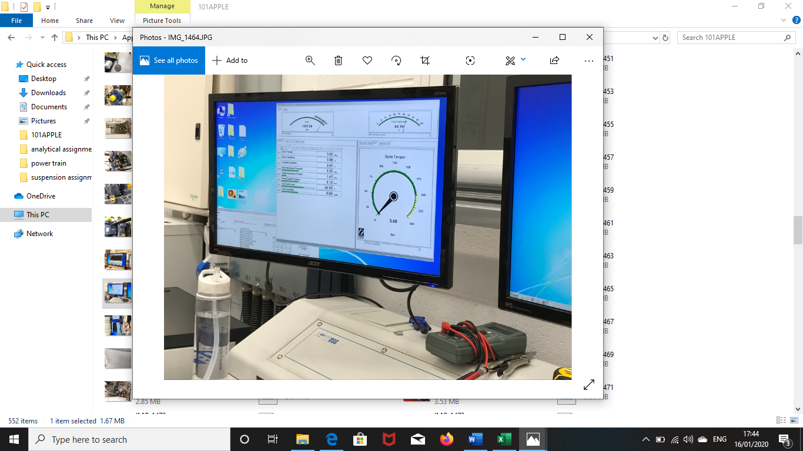
Once satisfied that the engine is securely fastened to the bed and there are no issues with the engine and dyno proceed to enter the testing room ensuring to close the door behind. Next load the DSG software up on the computer and should be greeted with a similar image as shown in (figure 4). This standard screen will display torque.
Figure 4: DSG dyno software information

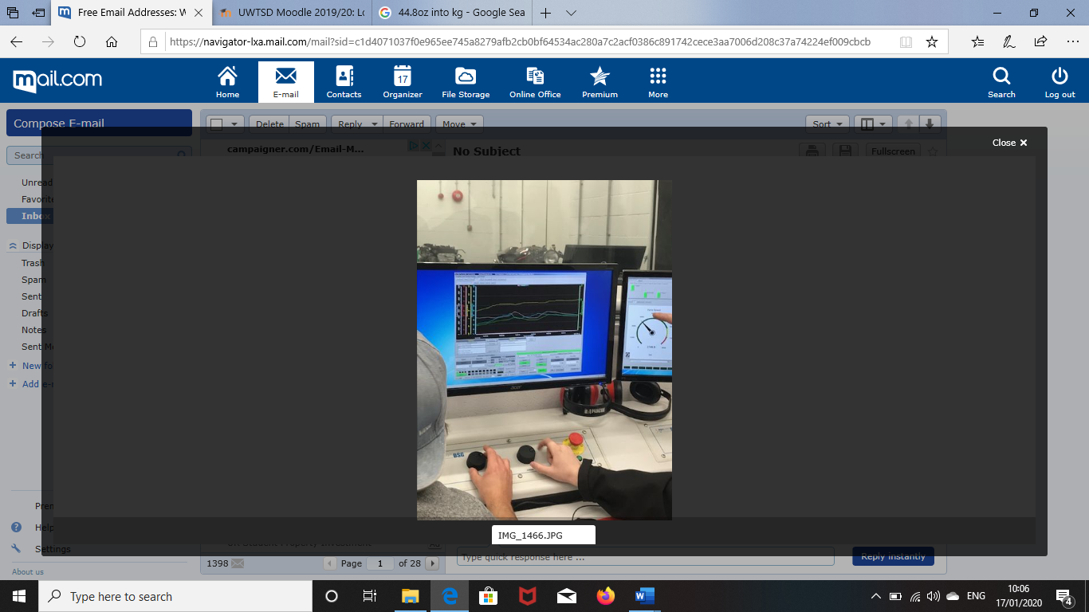
Now that the software has been started. Select the trend option on the top menu and there should be a black scale as depicted in (figure 5). This scale will be used to collect and measure the data being produced by the dyno. In order to understand how the rpm relates to engine load it is suggested that you begin a manual test using the control knobs. To start the engine simply hold the Ctrl key and click the “crank engine” button. During this operation you should aim to see how the rpm is affected by increasing or decreasing the load.
Figure 5: manual use of the dyno using the load and engine controls.

In order to gain a large variety of consistent results tests should be used on the DSG software. The main two tests in question are sweep and step test. Both are easy to carry out and provide excellent linear data that is clear and easy to understand.
To carry out the step test simply select the trend tab at the top menu of the screen and proceed to enter the minimum and maximum rpm you would like the test to take place, these values should ideally between 1000-5500rpm as these are safe rpm ranges for the Honda d16 engine. Then enter the amount of rpm you would like to incrementally increase during the step test an example being 500rpm increments. To obtain more data for more detailed analysis you could use a lower increments value to give out more data. Another parameter that must be entered is the duration you would like the engine to remain at the different rpm ranges a good time duration would be 5s-10s as this gives enough time to read the data as its being produced via the dyno and engine. Once you are satisfied with the parameters you have entered begin the test by cranking the engine. The step will conduct the test on the engine and report all the data gathered during that time. The data will be present on the graph highlighting throttle feedback, dyno torque and engine rpm.

The second test that will need to be conducted is the sweep test. This test is vital as it will provide that data that will be used in the spreadsheet to find other engine characteristics and values. The same chart will be needed as the step test. Select the trend and a black graph should appear on screen. For the test to be both accurate and reliable some parameters will need to be entered manually, this will also ensure the test will always be under control and there is no chance of the engine over revving. The first parameter that will need to be set is the minimum to maximum rpm range that the test will start at and end at. A value of 1000rpm is a good starting point and a value of 5500rpm is a good ending rate as it does not over rev the engine as this could result in overheating. Next the increments will need to set use the value of 50rpm as this will give smooth data. Setting these increments will tell the DSG dyno software that you wish to record the data at these points during the running of the test. The last parameter that will need to be entered is the total time for the test to take place, a time of 10s is ideal as it will run the test quickly and record data. Once all the parameters have been set start the test by cranking the engine and unselecting the idle button and select the begin test button. This test will take significantly longer shorter than the step test as data is gathered in a shorter time. This is due to the engine revving to a through the revs and not stopping and any rpm range.

3) Results
Raw data
Figure 6: Engine speed/Brake power graph
Figure 8: Torque/Engine speed graph
Figure 7: S.F.C/Engine speed graph
Bore | stroke | area | cylinders | BMEP | Thermal Efficiency
m | m | m² |  |  | %
0.081 | 0.0774 | 0.0047 | 4 | 7045223.176 | 17.69667
0.081 | 0.0774 | 0.0047 | 4 | 7397484.334 | 18.42362759
0.081 | 0.0774 | 0.0047 | 4 | 7749745.493 | 19.56026109
0.081 | 0.0774 | 0.0047 | 4 | 8102006.652 | 21.21862291
0.081 | 0.0774 | 0.0047 | 4 | 8454267.811 | 22.1533352
0.081 | 0.0774 | 0.0047 | 4 | 8806528.969 | 22.18423929
0.081 | 0.0774 | 0.0047 | 4 | 9158790.128 | 23.82694478
0.081 | 0.0774 | 0.0047 | 4 | 9511051.287 | 25.33243215
0.081 | 0.0774 | 0.0047 | 4 | 9863312.446 | 25.73787787
0.081 | 0.0774 | 0.0047 | 4 | 10215573.6 | 26.93451498
0.081 | 0.0774 | 0.0047 | 4 | 10567834.76 | 27.24858145
0.081 | 0.0774 | 0.0047 | 4 | 10920095.92 | 27.24142943
0.081 | 0.0774 | 0.0047 | 4 | 11272357.08 | 27.53398737
0.081 | 0.0774 | 0.0047 | 4 | 11624618.24 | 27.75544519
0.081 | 0.0774 | 0.0047 | 4 | 11976879.4 | 28.37130123
0.081 | 0.0774 | 0.0047 | 4 | 12329140.56 | 28.48566608
0.081 | 0.0774 | 0.0047 | 4 | 12681401.72 | 27.72390661
0.081 | 0.0774 | 0.0047 | 4 | 13033662.87 | 27.42886924
0.081 | 0.0774 | 0.0047 | 4 | 13385924.03 | 27.50739936
Figure 9: B.M.E.P & Thermal efficiency data table
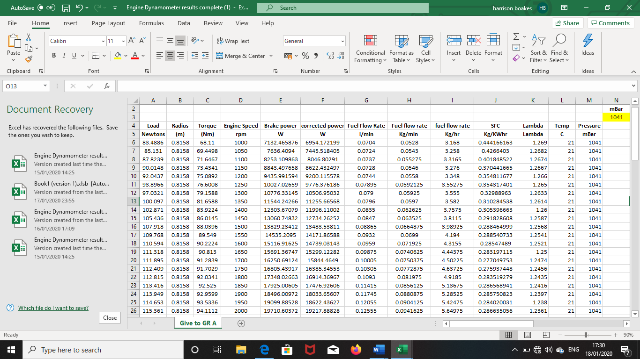
Figure 10: Raw data calculated in excel

4) Analysis
Graphs & Data analysis

The above graphs represents the engine speed and brake power. The graph highlights the change in brake power as the engine rpm is gradually increased. From the graph it can seen that the engine reaches maximum brake power output at roughly 4600rpm. The graphs data then goes on to show a small decrease in brake power at higher rpm. This is to be expected as most if not all production car engines have a maximum power output at a desired rpm. There are many reasons why brake power varies with the engine speed. The main reasons being that the more rpm is increased fuelling will increase and throttle body position will change to capacitate for the engine producing higher rpm.

The above graph highlights how the torque curve is manipulated in conjunction with engine speed. The torque clearly varies relatively significantly and peaks at two points of the rev rang (2500rpm-3500rpm). The main reasons for the torque dipping could be under or over fuelling, possible slight timing issues or simply from insufficient intake and exhaust flow. The pressure wave that travels through the inlet manifold and into the combustion chamber might have been slightly missed timed with the inlet valve. This can be stopped by using a variable intake manifold.

The above highlights how S.F.C(Specific fuel consumption) varies as rpm is increased. The graph shows how the S.F.C is noticeable higher when the engine is idling compared to when the engine is in the 1400-3800rpm range. The reasoning for the S.F.C being higher during idling is due to the fact of the engine burning more fuel on start up to reach an idle running temperature more quickly. As the rpm are increased the S.F.C reduces initially this is because cars are designed with fuel efficacy in mind at common rpm ranges. Once the rpm has exceeded that of the normal rev range S.F.C is increased again as the engine needs more fuel to accommodate for the increase in rpm.

The spreadsheet shows all the values found from the engine dyno test. Some of the data was given such as load, engine speed and fuel flow rate. From this data other outputs and characteristics had to be calculated beginning with torque. This calculation was made by using the torque equation T=WR this translates on excel to =A6*B6 as these are the two cells that contain the load and radius. As the data shows the torque gradually increases as the load increases, this is a common trend as the loads increases and decreases the torque matches to ensure there is always an ideal output.
The next calculation that needs to be made on the excel sheet is brake power. The equation used to find brake power is $BP=2πNT/60$. This when entered into the excel format should appear as =((2*PI()*D6*C6)/60). This will give the power output in Watts (W). The brake power as expected has a direct relationship with the engine speed as the brake power runs parallel and increases and decreases along with the engine speed and load. This highlights that the D16 engine is understand the conditions it is being put under and as adjusting to meet them. The engine has a maximum brake power output of 43724.41239W
The corrective brake power now needs to be calculated using the original brake power. The equation used is $\frac{Ps}{BP}=\frac{1.01325}{Pa}\sqrt{Ta/293}$. Some aspects of the equation are specific to each individual and example being the barometric pressure in Mbar. For this data the pressure in Mbar was 1041. The equation once entered in the excel sheet should look like =((1.01325/(M6/1000))*(SQRT((L6+273)/293))*(E6)). This corrective power is more accurate representation of the power being produced as it takes into consideration the conditions on the day such as air pressure and temperature. Analysing the corrective power shows that the engine does not produce as much brake power as originally predicted showing a decrease of roughly 200W.

Finding the Specific fuel consumption (S.F.C). The equation used is S.F.C=$\frac{V X 0.75 X 3600}{t x 1000 x BP}$ this equation once entered into the spread should give a variety of figures starting from 0.444166163Kg/Kwh and going down to 0.274660241 Kg/Kwh. Analysing the data, it could be said that the engine demands more fuel on start up to maintain a steady idle and temperature but, once the engine starts increasing rpm the S.F.C decreases initially. This is due to the engine being more fuel efficient through the normal rev range rev range used for typical driving. Looking further at the data its shown a increase in S.F.C in the higher RPM as the engine needs to pump more fuel to accommodate for the higher rpm.
Bore | stroke | area | cylinders | BMEP | Thermal Efficiency
m | m | m² |  |  | %
0.081 | 0.0774 | 0.0047 | 4 | 7045223.176 | 17.69667
0.081 | 0.0774 | 0.0047 | 4 | 7397484.334 | 18.42362759
0.081 | 0.0774 | 0.0047 | 4 | 7749745.493 | 19.56026109
0.081 | 0.0774 | 0.0047 | 4 | 8102006.652 | 21.21862291
0.081 | 0.0774 | 0.0047 | 4 | 8454267.811 | 22.1533352
0.081 | 0.0774 | 0.0047 | 4 | 8806528.969 | 22.18423929
0.081 | 0.0774 | 0.0047 | 4 | 9158790.128 | 23.82694478
0.081 | 0.0774 | 0.0047 | 4 | 9511051.287 | 25.33243215
0.081 | 0.0774 | 0.0047 | 4 | 9863312.446 | 25.73787787
0.081 | 0.0774 | 0.0047 | 4 | 10215573.6 | 26.93451498
0.081 | 0.0774 | 0.0047 | 4 | 10567834.76 | 27.24858145
0.081 | 0.0774 | 0.0047 | 4 | 10920095.92 | 27.24142943
0.081 | 0.0774 | 0.0047 | 4 | 11272357.08 | 27.53398737
0.081 | 0.0774 | 0.0047 | 4 | 11624618.24 | 27.75544519
0.081 | 0.0774 | 0.0047 | 4 | 11976879.4 | 28.37130123
0.081 | 0.0774 | 0.0047 | 4 | 12329140.56 | 28.48566608
0.081 | 0.0774 | 0.0047 | 4 | 12681401.72 | 27.72390661
0.081 | 0.0774 | 0.0047 | 4 | 13033662.87 | 27.42886924
0.081 | 0.0774 | 0.0047 | 4 | 13385924.03 | 27.50739936
0.081 | 0.0774 | 0.0047 | 4 | 13738185.19 | 27.67502699

The above table shows the BMEP and thermal efficiency. In order to find B.M.E.P the equation used is BP=$\frac{B.M.E.P X L X A X N X n}{60 x 2}$ this must be rearranged to make B.M.E.P the formula. The rearranged formula should appear as B.M.E. P=$\frac{B.P X 60 X 2}{L X A X N X n}$ .This rearranged equation once entered into the formula bar should be =(E6*120)/(S6*A6*T6*R6) the B.M.E.P as shown is quite a large number but this is to be expected. The B.M.E.P continuously rises as the rpm is increased this is normal characteristic for any engine to have.
Finally finding the brake thermal efficiency using the equation nt=$\frac{(\frac{BP}{1000})}{S.F.C\left(\frac{kg}{\sec{}}\right)x C.V}$. This should look as shown in the spreadsheet =((E6/1000)/((H6/60)*45800)*100). The thermal efficiency peaks at roughly 28%. This is a fair percentage especially given the year of the engine considering modern car engines have only slightly risen to 30%-40%.

5) Conclusion
To conclude I large variety of engine outputs and characteristics were found using the spread sheet calculations. The graphs produced mad it easier to understand digest the figures. Overall the engine performed as expected with no major anomalies. The major of import information that was found was accurate for the engine and particular test. The majority of data found such as thermal efficiency and B.M.E.P were accurate and support by the research conducted, there were some small indiscrepancies comparing the researched figures to the figures generated but that is to be expected.

6) Evaluation
In evaluation not many errors were found from the data. There is potential for refining the data and calculations to gain an even more in-depth view of exactly how the engine reacted under the test conditions. Some measure could be taken to ensure more accurate results one of these being checking to make sure there is no over fuelling happening whilst the test is running as this will have a knock-on effect with other data.

Further work
To refine the engine and prevent a dip in the torque curve it could be suggested that variable inlet manifold is used instead of the stock one as this will aid in timing the pressure wave of air just as the inlet valve is opening. This means more air is forced into the combustions chamber meaning more power is generated. Other refinements to the engine could include better cooling systems and replace of all major fluids including oil and coolant. A full service would benefit the engine also by removing any impurities dwelling in the engine. The air filters could also be replaced with better flowing ones to allow more air into the throttle body.
Improvements to the dyno could be made as well. One of these being using more accurate weights on the load arms as this will aid in producing more accurate data from the dyno as there would be no risk of uneven weight on either side.

Bibliography

Bosh Automotive Handbook, 5th edition (2005) USA Massachusetts: Bentley publishers
Honda D16 specification (2018) available at https://www.parkers.co.uk/honda/civic/hatchback-2000/specs/ (accessed:17th of January 2019)

Dyno step testing information (2019) available at (https://www.dynomitedynamometer.com/dyno-tech-talk/dyno-tech-talk.htm (accessed:18th of January 2019)

