Assignment PD13 A4
Upload the following:
1 - A customer demand received by your warehouse management system – RN form S145
RN Form S 145 (Revised 3/85)
 |  | Input  Code |  |  | SPC |  | RDD |  |  |  |  |  | Demand Reference |  |  |  |  |  |  |  |  |  |  |  |  |  |  | STANDARD MATERIAL DEMAND (RN)  (Electronic Version)
 |  |  |  |  |  |  |  |  |  |  |  |  | UIN |  |  |  |  |  | Date |  |  |  |  |  | SER No
 |  | 1 |  | 3 | 4 | 5 | 6 |  |  |  |  | 11 | 12 |  |  |  |  | 17 | 18 |  |  |  |  | 23 | 24 |  | 26
 |  | 1 | 8 | 2 | 0 | 9 | 1 | 0 | 0 | 7 | 1 | 9 | N | 1 | 2 | 7 | 1 | A | 0 | 8 | 0 | 6 | 1 | 9 | 5 | 1 | 2
Line  No |  | MOD STOCK REFERENCE |  |  |  |  |  |  |  |  |  |  |  |  |  |  | DofQ |  | Quantity |  |  |  |  |  |  | Mat  Con |  | R | I | Q | R | Demanding  Unit  Stowage |  |  |  |  | Short Item Name |  |  |  |  |  | A  C
 |  | DMC |  |  |  |  |  | NCB |  | IIN |  |  |  |  |  |  |  |  |  |  |  |  |  |  |  |  |  | F | D | D | R |  |  |  |  |  |  |  |  |  |  |  | A  C
 |  |  | NSC |  |  |  |  |  |  |  |  |  |  |  |  |  |  |  |  |  |  |  |  |  |  |  |  | D | Q | Q | C |  |  |  |  |  |  |  |  |  |  |  | A  C
27 |  | 28 |  |  |  |  | 33 | 34 | 35 | 36 |  |  |  |  |  | 42 | 43 | 44 | 45 |  |  |  |  |  | 51 | 52 | 53 | 54 | 55 | 56 | 57 | 58 |  |  |  | 62 |  |  |  |  |  |  | 63
1 |  |  | 1 | 6 | 2 | 0 |  | 9 | 9 | 4 | 7 | 9 | 7 | 3 | 1 | 3 | E | A |  |  |  |  |  | 0 | 1 | A | 1 | W |  |  |  |  | P | L | 1 | 1 | HARPOON ASSY |  |  |  |  |  | P
2
3
4
5
6
7
8
9
79 |  | Special Instructions |  |  |  |  |  |  |  |  |  |  |  |  |  |  |  |  |  |  |  |  |  |  |  |  |  |  |  |  |  |  |  |  |  |  | 120 |  |  |  | 121 A/C UIN 126
P | O | C |  | L | S | C |  | W | I | L | L | I | A | M | S
Consignee |  |  |  |  |  | Consignee For Material If Different From Demanders UIN
127 UIN 132 |  |  |  |  |  | 133 |  | Non Standard Address |  |  |  |  |  |  |  |  |  |  |  |  |  |  |  |  |  |  |  |  |  |  |  |  |  |  |  |  |  |  |  |  |  | 177
178 |  | Non-Standard Address (Cont.) |  |  |  |  |  |  |  |  |  |  |  |  |  |  |  |  |  |  |  |  |  |  |  |  |  | 208 |  | 209 |  | Customers Own Reference  PE Project Code |  |  |  |  |  |  |  |  |  | 228
REMARKS |  |  |  |  |  |  |  |  |  |  |  |  |  |  |  |  |  |  |  |  |  |  |  |  |  |  |  |  |  |  |  |  | Return Note Ref No |  |  |  |  |  |  |  | Task No
 |  |  |  |  |  |  |  |  |  |  |  |  |  |  |  |  |  |  |  |  |  |  |  |  |  |  |  |  |  |  |  |  | 246 |  |  |  |  |  | 255 |  | # | 260
To |  |  |  |  |  |  |  |  |  |  |  |  |  |  |  |  |  |  |  |  |  |  |  | From (Inc Authorisation)
RNAS YEOVILTON, YEOVIL, UK BA22 8HT |  |  |  |  |  |  |  |  |  |  |  |  |  |  |  |  |  |  |  |  |  |  |  | PO READY
 |  |  |  |  |  |  |  |  |  |  |  |  |  |  |  |  |  |  |  |  |  |  |  |  |  |  |  | Ready |  |  |  |  |  |  |  | Rank |  | PO
 |  |  |  |  |  |  |  |  |  |  |  |  |  |  |  |  |  |  |  |  |  |  |  | Signature |  |  |  |  |  |  |  |  |  |  |  | Date |  | 05/06/2019

2 - A despatch advice notes sent to a customer
PACKING NOTE |  |  | Sheet No. |  |  | PACKAGE COPY
RN Form D71 Local Type B (Revised 9/93)
FROM: - | TO: - |  |  |  | CONSIGNING/STOWAGE INSTRUCTIONS
Outward Shipper RNAS YEOVILTON | INWARD SHIPPER, HMNB PORTSMOUTH, HAMPSHIRE, PO12 4ER |  |  |  | Deliver between 0800 - 1700
Outward Shipper RNAS YEOVILTON |  |  |  |  | PRIORITY CODE | DATE REQUIRED
Outward Shipper RNAS YEOVILTON |  |  |  |  | 09 | 10/07/2019
IMC | DESCRIPTION | DIMENSIONS (In CMS) |  |  | DATE PACKED
j101 | CTN | 25 | 40 | 45 | 02/07/2019
STOCK NO. OR REF NO. OR DRAWING/PART NO. | DESCRIPTION |  | DENOM OF QTY | QUANTITY PACKED | REGISTER NO. OF ISSUE VOUCHER | SHIPS SERIAL NO. CUSTOMER REF. OR OTHER AUTHORITY
2145 99 5437881 | Turbo |  | EA | 1 | IV24511 | N0275A
PACKED BY |  | PACKAGING LEVEL |  | TYPE OF PACKAGE
SIGNATURE | PAY No. |  |  | CTN
M Williams
RECEIVED THE ABOVE PACKAGE |  | MODE OF DESPATCH | DATE | CONSIGNMENT NOTE NO. S
IN GOOD ORDER
…………………………2019……….
3 - A picking list given to warehouse personnel
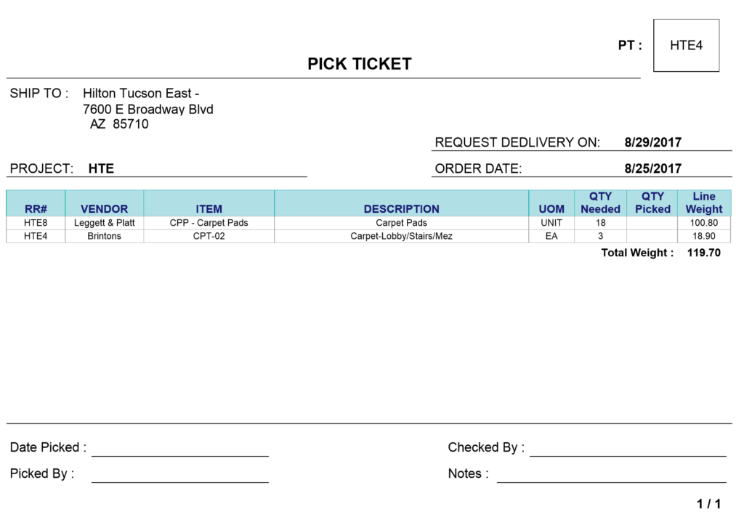
4 - If your WMS is electronically linked to fork lift trucks: A Put away list
If your WMS is NOT electronically linked to forklift trucks: A short note (150 words) on how such functionality might affect your warehouse operations
Warehouse management system (MWS)
This system improves efficiency, improves management and saves money within a warehouse environment. By scanning in bar codes to the mobile devices stock numbers are uploaded quickly and accurately onto the main database. MWS defines the quantity and order by priority of tasks. This system is useful for refining process control, setting stock constraints, financial integration, analysis and reporting. It provides the ability to track stock inwards, outwards and the stock holdings.
Tasks are created to push forward numerous activities which include Put-away, movements, replenishment demands, picking, stocktaking, packing and vehicle loading ready for despatch. MWS can reduce management time due to the staff being more empowered to what tasks they need to achieve on a daily or weekly basis. MWS software can help the barcode connect to carousel picking systems. It improves stock accuracy due to this use of barcodes which eliminates human error regarding writing down the wrong stock number. Put-away is how stock is accepted and moved into storage locations.

