DS 1 Assignment

My Screenshots/Photos
- Please add 4–6 screenshots or photos of your digital life.
- You can use your phone or laptop.
- For each screenshot, write one or two sentences explaining what it shows.

Screenshot/Photo 1
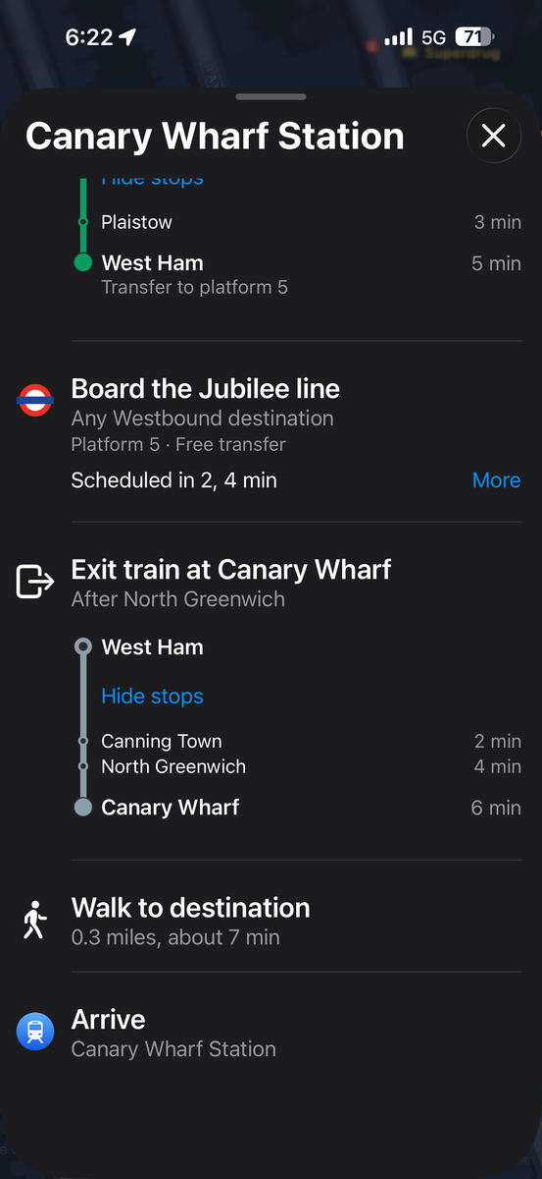
This is Apple Maps on my phone, showing the train route I take to Canary Wharf on the Jubilee line. I use it to plan my journeys, see which platform to use and arrive on time.

Screenshot/Photo 2
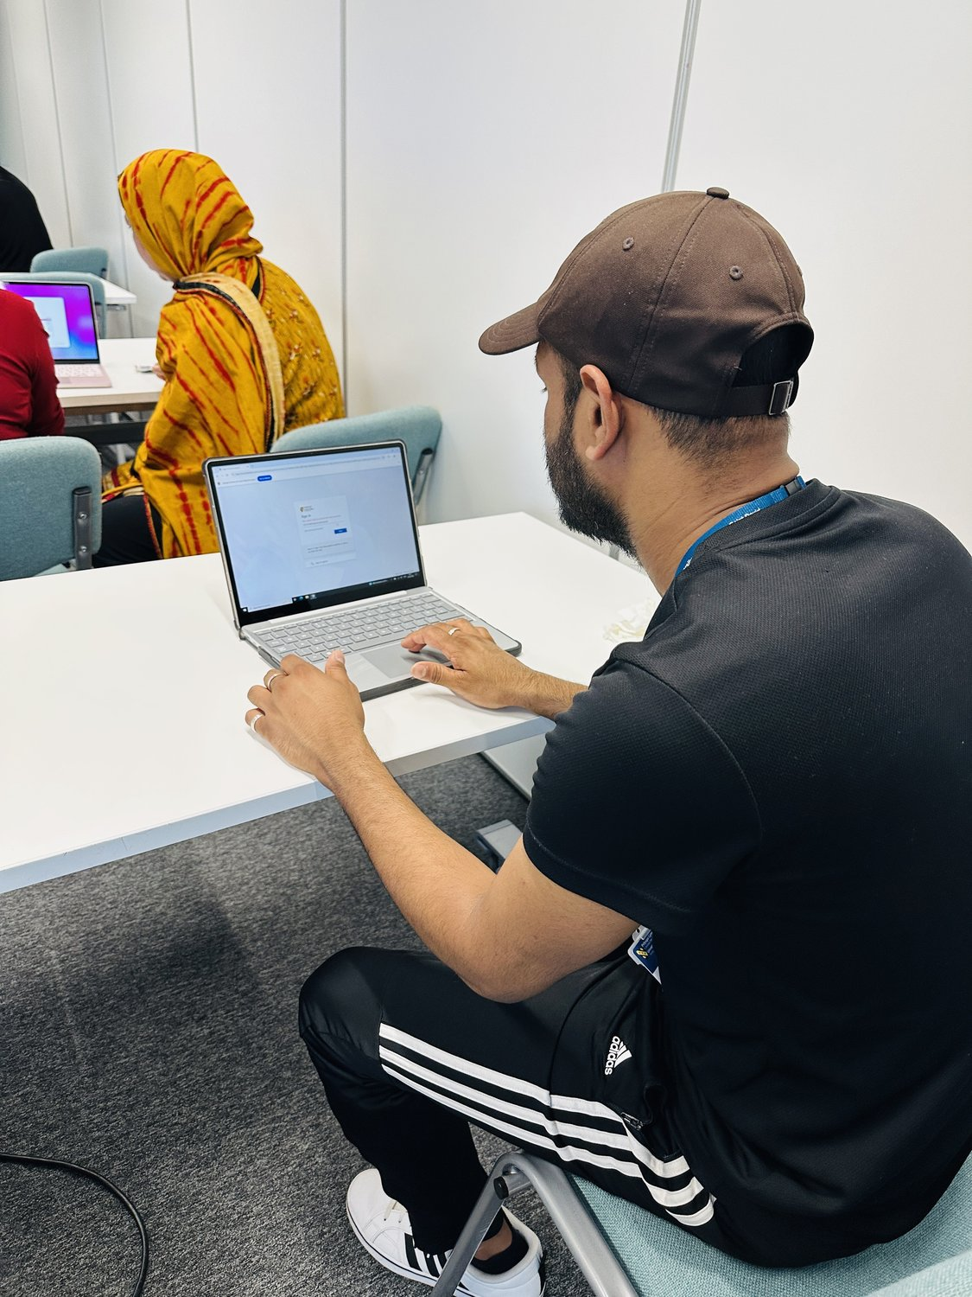
Here I am on my laptop, signing in to my university student account before I start my work. Logging in safely is the first step in my digital study routine.

Screenshot/Photo 3
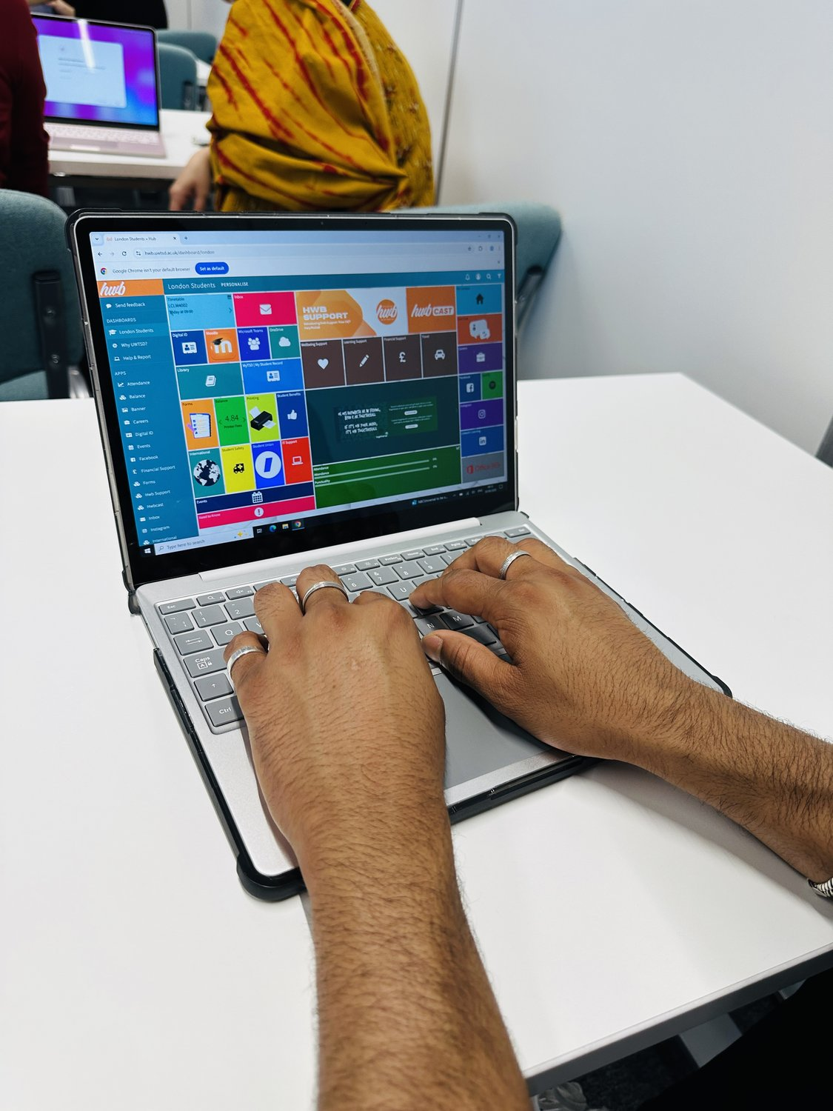
This is my UWTSD Hwb student dashboard, where I open Moodle, Microsoft Teams, OneDrive and my timetable. It keeps all my study tools and course information in one organised place.

Screenshot/Photo 4
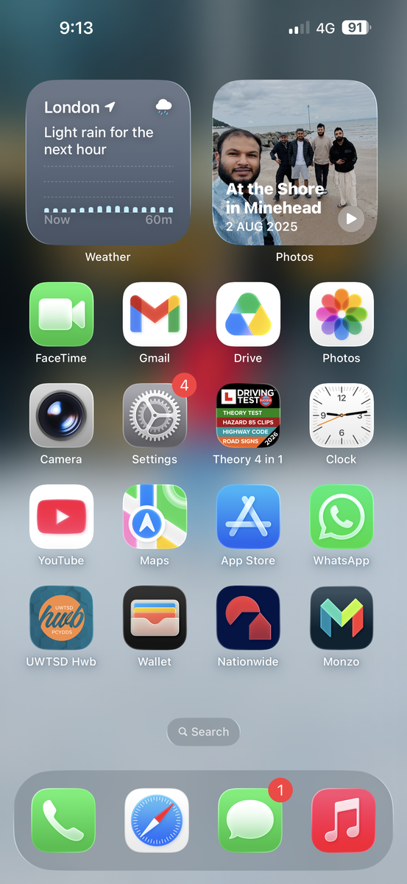
This is the home screen of my phone. I keep the apps I use most here, such as Gmail, Google Drive, WhatsApp, my banking apps (Nationwide and Monzo) and my driving theory app.

My Short Reflection
- Write 5–8 simple sentences about your digital life.
- You can use the sentence starters below if helpful.
For my studies, for travelling around London, for talking to family and friends and for managing my money, that's every day of my life.
I feel that I have the confidence to log into my UWTSD Hwb account and use Moodle, Microsoft Teams and OneDrive for my coursework.
I use the following regularly: Gmail, Google Drive, WhatsApp, Apple Maps and my banking apps Nationwide and Monzo.
I use Apple Maps to look at train routes, so I can figure out which line to take and get here on time at University.
I go to my home screen with my apps that I use the most often so that I can easily find them and keep myself organized.
Sometimes I feel I am not safe online and secure in my passwords and finances.
I would like to develop my confidence in the use of Microsoft Word, Teams and OneDrive to improve my skills in the workplace and in studies. Digital skills are important to me as they will enable me to learn, communicate and organise my day to day life, I hope that through this module I will become more confident with technology.

Sentence starters
- I use digital tools to …
- I feel confident when I …
- I want to improve …
- I often use these tools: …
- I sometimes feel nervous about …
- I hope this module will help me …
- Digital skills are important for me because …
You can write more if you want.

Submission Checklist
Before you submit, please check:
​​​ ☑ I added 4–6 screenshots
☑ I wrote short sentences for each screenshot
☑ I wrote my short reflection
☑ My work is my own
☑ My file opens correctly
​​☑ My file opens correctly

