
Student Name: Kavya Raghuraman

Student ID: 2519354

Module Name: Strategic Management

Module Code: LCMB7003

Lecturer’s Name: Amare Desta

Work Count: 5000

Term 2

Strategic Management
Topic: Strategic Analysis as well as Evaluation of Competitive Strategy of KitKat of Nestle in the UK Confectionery Market

Table of Contents
Section 1: Strategic Analysis and Evaluation 3
1. Organisational Context as well as Overview of Nestle 3
2. External and Internal Analysis of Nestle for Kitkat in the UK market 4
3. Comprehensive and holistic view of the organisation 13
4. Strategic Choices and Implementation 17
Section 2: Reflection 22
References 24
Appendix 30

Section 1: Strategic Analysis and Evaluation

1. Organisational Context as well as Overview of Nestle
About the company
Nestlé was established by Henri Nestlé in Vevey, Switzerland, in 1866 with a broader range of portfolio (nestle.com, 2026). It is one of the well-established and successful food and beverage companies. It is successfully operating in 185 countries with more than 2,000 brands across different categories. In Nestle, Kitkat was initially introduced as "Rowntree's Chocolate Crisp” in 1935 in the UK. KitKat is one of Nestlé's most successful global brands in its confectionery portfolio, specifically in the UK. Through its iconic branding, widespread availability, and ongoing investment, KitKat is well known for maintaining a strong market position.
Mission
Nestle’s mission is to provide consumers with the best tasting, most nutritious choices in a wide range of food and beverage categories and eating occasions, from morning to night. It is well known for its tagline "Good Food, Good Life” (nestle.com, 2026).
Vision
The vision of the company is to “lead, competitive, Nutrition, Health and Wellness Company delivering improved shareholder value by being a preferred corporate citizen, preferred employer, preferred supplier selling preferred products” (nestle.com, 2026).
Business model followed by Nestle
Nestlé’s business model for KitKat in the UK is a Fast-Moving Consumer Goods (FMCG) mass-market approach. According to Wilhelm, (2025), the mass-market approach emphasises generating revenue through large sales volumes rather than high profit margins per unit. Eventually, allowing the firm to reach a broad consumer base by offering affordable chocolate products through an extensive retail network.
Nestlé operates within the UK confectionery industry, a highly competitive market comprising chocolate confectionery, sugar confectionery and chewing gum. The UK confectionery market remains resilient and is projected to grow in the future despite economic uncertainty. The rising demand for the product has significantly contributed to the intense competition in the market. As per the recent data, Cadbury (Mondelez International) and Mars Incorporated represent the most serious competitive threats to KitKat in the UK.
Market position
Nestlé's KitKat holds a strong and well-established position within the UK confectionery market. In 2025, 94% of UK consumers recognised the KitKat brand as a prominent company as per latest consumer survey (statista.com, 2025). It is further possible due to the firm's continuous product innovation, iconic brand image, and extensive distribution network. "Have a Break, Have a KitKat" campaign has a huge role in acquiring high consumer recognition in the UK market. In this report, the competitive strategy of Nestlé's KitKat within the UK confectionery market will be critically analysed and evaluated briefly.

2. External and Internal Analysis of Nestle for KitKat in the UK market
PESTLE analysis
The external macro-environmental factors of Nestlé's KitKat are evaluated using the PESTLE framework comprehensively in the case of the UK market. Further providing valuable insights into how these external forces influence KitKat's market position in the UK market via the analysis. These factors are further responsible for influencing Nestlé's performance and strategic decision-making.
External factors | Justification | Opportunity or Threat
Political | The recent policies introduced by the UK government are responsible for promoting environmental responsibility and sustainable supply chains. van Tulleken, (2025), claimed that these UK government policies effectively align with Nestlé's long-term strategy in the food and beverage industry. The latest reports revealed that 96.2% of Nestlé's global cocoa was sourced through the Nestlé Cocoa Plan, involving 178,821 cocoa farmers in 2025 [Referred to Appendix 1]. Thus, Nestlé's substantial investment in sustainable cocoa sourcing positions KitKat favourably within the UK market. | The political environment in the UK presents both opportunities and challenges for Nestlé's KitKat, particularly through sustainability policies, trade regulations, and food governance. However, the political environment represents an opportunity primarily.
Economic | As per the current economic circumstances in the UK market, the performance of Nestlé's KitKat is intensely affected. The key economic challenges remain fluctuations in raw material prices, rising inflation and consumer purchasing power. In 2026, food inflation was 1.7%; meanwhile, the UK Consumer Price Index (CPI) inflation stood at 2.6% (gov.uk, 2026). This demonstrated that despite improving economic conditions, the household budget remains constrained. In addition, the confectionery business of Nestle during 2025, with KitKat remaining one of its strongest-performing brands by reporting 4.5% organic sales growth in the UK market (globalnewswire.com, 2026). Thus, the UK confectionery market remains resilient despite these pressures. | Rising inflation and cocoa prices increase manufacturing costs and reduce profit margins, making economic conditions a significant threat for KitKat. Therefore, the economic environment represents primarily a threat for KitKat in the UK market, which is quite manageable with effective investment and measures.
Social | In the UK confectionery market, the evolving social trends and preferences have a huge role in influencing the purchasing behaviour of the customers. Recently, customers in the UK market are seeking ethically produced food products with healthier diets and reduced sugar consumption. Latest surveys revealed that approximately 64% of adults are overweight or obese in the UK landscape [Referred to Appendix 2]. This further motivates customers to prefer healthier alternatives by considering their health aspects. In the UK, billions of KitKat products are consumed by customers, suggesting its huge popularity among users. This trend poses a challenge for confectionery brands such as KitKat in the UK. | Therefore, growing health consciousness threatens long-term chocolate consumption, potentially reducing demand for traditional unhealthy confectionery products. Thus, these social factors emerge as potential threats for KitKat in the UK market.
Technological | According to Nasirov, (2025), KitKat's competitive position within the UK confectionery market is further strengthened due to intense technological innovation. Nestlé makes major investments in advanced supply chain systems and digital manufacturing to reduce operational costs and better production efficiency. In 2025, due to continuous product innovation and digital transformation initiatives, the company reported 4.5% organic sales growth (nestle-mena.com, 2026). Thus demonstrating Nestle's successful heavy investment in research and development. Nestle is able to forecast consumer demand more accurately and optimise inventory management in the UK market with advanced data analytics. | The technological factors of the analysis portray an immense opportunity for KitKat in the UK market. Further, Nestlé's competitive advantage supports long-term growth within the UK market. Thus, technological advancements provide substantial opportunities by improving operational efficiency, accelerating product innovation, and enhancing customer engagement.
Environmental | Mainly for the UK confectionery industry, environmental sustainability has become a critical strategic issue, where Nestle is no exception. Donato, (2025), claimed that in major cocoa-producing countries, rising temperatures, irregular rainfall, and increased crop diseases cause barriers for cocoa production. These disruptions contributed to record cocoa prices during 2024–2025, eventually boosting the production costs for KitKat products in the UK market. | Climate change represents a major threat because declining cocoa production directly affects raw material availability and increases manufacturing costs. Therefore, environmental factors present a threat for Nestle in manufacturing KitKat in the UK market.
Legal | In the competitive market, Nestlé requires compliance with stringent regulations via proper legal policies. In the words of Cheah et al. (2025), stated that these policies basically ensure safety, nutrition, product labelling, advertising, environmental protection, and consumer rights precisely. High Fat, Salt and Sugar (HFSS) legislation is one of the prominent and well-established regulatory developments in the UK market. | Legal requirements suggest a significant threat to KitKat's commercial performance in the UK market with increased compliance costs and restricted marketing activities. Overall, the legal environment represents a threat primarily for Nestle.
Table 1: PESTLE analysis of KitKat in the UK market
(Source: Self-Created)
The above-conducted PESTLE analysis demonstrated that Nestlé KitKat operates within a dynamic UK business environment characterised by both significant opportunities and considerable challenges. Therefore, effective strategic initiatives enable KitKat to adapt effectively to changing market conditions and achieve sustainable long-term growth in the UK confectionery industry.
VRIO analysis
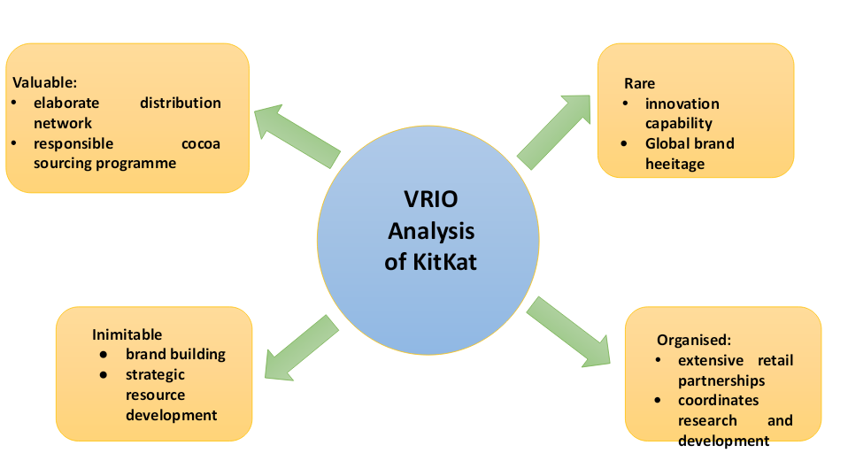
Figure 1: VRIO analysis
(Source: Self-Created)
Valuable: The resources and capabilities that hold significant value are termed valuable factors. In the UK confectionery market, Nestlé's KitKat possesses various highly valuable resources for sustaining competitive advantage. This brand equity enables Nestlé to maintain strong customer loyalty and premium shelf positioning across UK supermarkets. In 2025, Nestlé's confectionery division recorded 8.2% organic growth with strong international appeal and substantial commercial value (statista.com, 2025). In addition, Nestlé's elaborate distribution network and responsible cocoa sourcing programme in the UK market further serve as valuable resources and capabilities. DESI, (2026), opined that the company's investment in the Nestlé Cocoa Plan and recyclable packaging are responsible for strengthening consumer trust in the UK market.
Rare: Among the different resources and capabilities, some have the potential to be unique and different from others; eventually holding a strong foundation is termed as rare. Nestlé's resources supporting KitKat are relatively rare within the UK confectionery industry due to the limited imitation capability of rivals. In the words of Virgen, (2026), stated that KitKat leverages economies of scale while maintaining strong retail relationships across the UK. Some of the other rare resources and capabilities are global brand heritage, innovation capability, sustainability leadership and operational scale. Thus, KitKat's resource portfolio is relatively rare for preserving Nestlé's competitive differentiation within the UK market.
Inimitable: According to Gao et al. (2025), stated that other firms in a similar industry tend to imitate the key capabilities and resources for securing a competitive landscape are termed inimitable factors. Nestlé's competitive advantages associated with KitKat are highly difficult to imitate because they have been developed over several decades. Therefore, Nestlé's KitKat possesses inimitable resources and capabilities in such a competitive confectionery market in the UK. It has also secured this stance by sustained investment, brand building and strategic resource development. The barrier to imitation is intensely high because of the company's extensive experience in chocolate manufacturing, proprietary production processes and well-established supplier relationships. Thus, demonstrating that KitKat's competitive advantages remain highly inimitable amongst its rivals.
Organised: An organisation's ability to exploit its resources and capabilities properly is referred to as the organising capability. In the UK market, Nestlé is effectively organised to exploit the valuable resources and capabilities for supporting KitKat. As per Willie, (2025), opined that Nestle efficiently coordinates research and development, production, marketing and distribution activities by means of organisational capabilities. Also, through its sustainability governance, KitKat’s Nestlé demonstrates strong organisational capability. KitKat further remains widely accessible to consumers due to Nestlé's extensive retail partnerships across UK supermarkets, convenience stores and digital platforms.
Strengths and weaknesses
As per the VRIO analysis, Nestlé KitKat's key strengths include its globally recognised brand, strong customer loyalty, extensive UK distribution network, continuous product innovation, and sustainable cocoa sourcing through the Nestlé Cocoa Plan. On the other hand, Nestlé KitKat's weaknesses include high dependence on cocoa, increasing operational costs from sustainability investments, and reliance on traditional chocolate products.
SWOT analysis
The strategic model used for determining any firm's internal strengths and weaknesses alongside external opportunities and threats is known as the SWOT framework. In this report, the SWOT analysis is developed by integrating the findings from the above-conducted internal and external analysis.
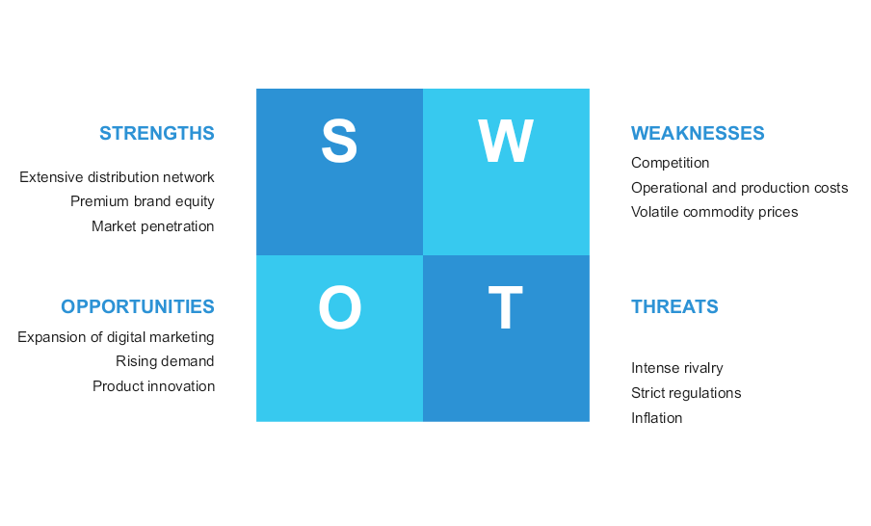
Figure 2: SWOT analysis
(Source: Self-Created)
Strengths | Weaknesses
- High market penetration due to Nestlé KitKat’s extensive UK distribution network across supermarkets, convenience stores and digital platforms (Badal, 2025).  - Globally recognised KitKat brand with premium brand equity in the UK market.  - Flavour diversification and continuous product innovation suggest strong research and development capability. | - Maintaining competitive advantage requires continuous investment in innovation, sustainability and digital transformation.  - Relying heavily on cocoa serves as a weakness for Nestle's KitKat because supply shortages and volatile commodity prices affect overall productivity significantly.  - Operational and production costs increase intensely due to the adoption of sustainability initiatives and responsible sourcing measures.
Opportunity | Threat
- Expansion of digital marketing, e-commerce and AI-driven consumer engagement suggests various opportunities for Nestle's KitKat in the UK market.  - Increasing demand for product innovation in terms of healthier and reduced sugar alternatives.  - Growing UK demand for ethically sourced and sustainable confectionery also contributes to the growth opportunities for Nestle's KitKat. | - Inflation and reduced consumer purchasing power encourage customers to switch to cheaper alternatives, posing a further threat.  - Intense competition from well-established brands in the UK confectionery market (JEVTIĆ, 2025).  - UK HFSS regulations and policies further emerge as potential threats for KitKat in the UK market.
Table 2: KitKat’s SWOT analysis
(Source: Self-Created)
Overall, the SWOT analysis demonstrates that Nestlé KitKat maintains a strong competitive position in the UK through its globally recognised brand, extensive distribution network, innovation capability and sustainability initiatives. Threats include cocoa price volatility, inflation, stricter HFSS regulations and intense market competition. Moreover, healthier confectionery products and growing demand for sustainability serve as major opportunities. Eventually providing operational resilience to effectively overcome future market challenges in the UK.

3. Comprehensive and holistic view of the organisation
Current CSR strategy analysis of Nestle
The corporate strategy of Nestle, as per Cheah et al. (2025), significantly connects environmental, social, and economic sustainability with its long-term business objectives. In the context of Kit Kat in the UK, it is considered highly significant due to the dependency of Kit Kat on agricultural commodities, including wheat, sugar, cocoa, and milk, whereas manufacturing and packaging processes of the product also impact the environment. Therefore, Nestlé’s CSR strategies include responsible sourcing, sustainable packaging, regenerative agriculture, farmer community development, and climate action.
According to Rahman and Hasan, (2024), Nestlé's cocoa plan is considered a major element in its CSR strategy. It is analysed that Nestle UK and Ireland have ensured 100% certified sustainable cocoa sourcing for the production of chocolate and biscuits since 2015, shifting the Kit Kat brand to Rainforest Alliance certification in October 2020 (nestle-confectionery.co.uk, 2025). Due to the strategy, the brand is able to address child labour, gender inequality, farmer livelihoods, productivity, and environmental protection. This consequently highlights the direct relationship between CSR and business objectives of Nestle, as a resilient cocoa supply chain has the potential to reduce supply and reputational risk while ensuring product quality and long-term availability. On the other hand, Rishi, (2022), argued that climate action is a crucial component in CSR strategies. Kit Kat ensured its commitment to emission reduction across manufacturing, ingredients sourcing, and distribution by expanding renewable electricity and regenerative agriculture. It is reported that Nestle achieved a 24.5% reduction in greenhouse gas emissions against its baseline in 2018, representing measurable progress (nestle.com, 2026). Also, for packaging, Nestle strongly focuses on the reduction of virgin plastic and using recyclable packaging to support the circular economy. It has been analysed that 80% of recycled plastic was used to redesign KitKat wrappers, with a change of approximately 20% in reducing the carbon footprint of two-finger packaging, compared to previous materials (nestle.co.uk, 2022).
Balanced Scorecard analysis of Nestle
Balanced Scorecard, according to Kumar et al. (2024), is considered a strategic management tool that helps organisations to evaluate financial and non-financial performance, considering financial, customer, internal processes, and learning perspectives. An analysis of Nestle for its product KitKat is given below, considering the balanced scorecard to discuss the financial and non-financial performance of the brand.
Financial perspectives
The financial perspective highlights the efficiency of KitKat’s strategy to generate sustainable economic value. KitKat is considered highly important to Nestle due to its establishment as a major confectionery brand, especially in the UK market. Nestle has reported that more than 60% of UK households purchase from the brand each year (nestle.co.uk, 2026).
Objectives: Major objectives are sales growth, cost efficiency, profitability, and market-share production.
Key Performance Indicators: Relevant key performance indicators would be revenue growth of Kit Kat, operating margin, sales per product variant, market share, return on marketing investment, and production cost per unit.
Targets: Targets would include protecting margin against energy, cocoa, and packaging-cost inflation as well as maintaining revenue growth.
Initiatives: Product innovation, like 2025 KitKat sharing bars and mini ranges, sustainable sourcing, and efficient manufacturing can create additional consumption occasions by reaching different customer needs, which can meet this objective.
However, sustainable sourcing can increase expenses initially, but it can help the brand to reduce supply chain vulnerability and enhance brand reputation, allowing the brand to generate long-term value.
Customer perspectives
Customer perspective primarily focuses on the efficiency of Kit Kat to create value for its customers.
Objectives: Core objectives are increasing customer satisfaction and loyalty along with brand trust, reputation, and perceived quality.
Key Performance Indicators: Relevant KPIs are repeat purchase rate, customer satisfaction scores, net promoter scores, market share, consumer perception of sustainability, and social media sentiment.
Targets: Targets are to maintain and increase customer satisfaction as well as strengthen sustainability perception by responding to the changing demands of customers.
Initiatives: Introducing new flavours, prioritising sustainable packaging, and responsible marketing, as well as sharing products, can support this objective.
By using customer KPIs, Nestlé can measure the efficiency of sustainability to influence perception and purchasing behaviour of consumers instead of making assumptions regarding automatic loyalty creation by environmental claims.
Internal business processes perspectives
This perspective evaluates the required processes to sustainably and efficiently deliver Kit Kat.
Objectives: Major objectives for this party include supply chain resilience, manufacturing efficiency, product quality, emission reduction, and waste reduction.
Key Performance Indicators: Important KPIs are considered production waste, energy consumption per tonne of product, GHG emissions, packaging material used per unit, percentage of traceable cocoa, and delivery efficiency.
Targets: Targets include constant reduction of carbon emissions and decrease in waste generation, as well as lowering energy consumption.
Initiatives: The use of renewable energy, maintaining supply chain traceability, and recycling packaging, as well as regenerative agriculture, can support the objective.
Sustainability performance of Nestlé in 2025 reported that 96.7% of the primary supply chains of the brand are deforestation-free (nestle.com, 2026). Thus, sustainable process initiatives are considered highly efficient to create environmental benefits.
Learning and growth perspectives
The learning and growth perspective highlights the organisational capabilities, which are required to achieve long-term strategy.
Objectives: For Kit Kat, major object is include the development of employee abilities, sustainability knowledge and innovation, along with research and development and organisational engagement.
Key Performance Indicators: Relevant KPIs are sustainability training hours, employee engagement rates, innovation success rates, number of new products developed, and employee participation in improvement initiatives.
Targets: Targets include regular product and process innovations, along with increasing training programs for employees and their engagement.
Initiatives: Employee training initiatives, digital capabilities, and sustainability programs, along with R&D development, can support the objective.
From the entire balanced scorecard analysis of Nestle regarding Kit Kat, it is evaluated that the financial performance of the brand is based on customer loyalty, which is influenced by responsible behaviour and product quality. However, the internal process of the brand is highly efficient, as it supports both sustainability and profitability. The learning and growth perspective shows constant improvement in the organisation. Therefore, the analysis of four perspectives offers a holistic performance management system of Nestle.

4. Strategic Choices and Implementation
Examination of available business-level strategic choices for Nestle Kit kat
Implementing strategic choices, mentioned by Tojiri, (2023), for a business organisation, it is necessary to use the power of its resources and gain optimum results from the business operations in a particular market. On the other hand, Küng, (2024) opined that strategic choices for a business organisation are required to meet the market demand, beat the competition, and boost returns in business. In this scenario, Nestle needs to find out its strategic position for the product Kitkat in the UK confectionery market, implementing strategic business choices to gain a competitive advantage in the UK confectionery market.
On a business level, mainly three types of strategic choices are present, such as
Cost leadership
Cost leadership, as stated by Jerab and Mabrouk, (2023), is a strategic business plan in which an organisation develops its business strategy to address the needs of price-sensitive customers and gain profit with a low-cost production process. In the context of Nestle, presently the company uses the cost leadership strategic choice because the company gains profit by keeping production costs low (nestle.com, 2025). Raw materials (sugar, flour, milk, cocoa butter, vegetable fats, and others) sourcing for producing Kitkat is a cost-effective process. Apart from this, the distribution process of Kitkat of Nestle also includes a hybrid process in which companies move the product to direct local shops, so the third-party association is less and requires less investment. Overall, the sourcing, manufacturing, and distribution process is cost-effective for Nestle Kitkat, which makes the “Cost Leadership" strategy justified for this organisation.
Product Differentiation
Differentiation, as mentioned by Noor et al. (2025), is the process that helps an organisation to increase the sales rate by creating unique features and distinct offers during product sales in a market. Product differentiation is effective for Nestle for strategic positioning in the UK confectionery market. It is also strongest among the other business-level strategic choices because, through developing and creating new features in the product, packaging, and quality, "Kitkat" Nestle can attract more customers in the UK market. For instance, through the advertisement of “Have a Break,” Kitkat also tried to create differentiation from other products in the market by not targeting hunger but the stress level of the customers, which is relevant for the product positioning in the UK market as well. Hence, in order to stand out in the UK market, the product differentiation strategic choice is also effective.
Differentiating Niche market
Differentiating the niche market, as mentioned by Olagunju et al. (2025), is a business strategy in which an organisation creates an impression in its target market by analysing the behaviour of the buyers. In the context of Nestle Kitkat, the company needs to focus on the customers who are impulsive buyers, convenient shoppers, teenagers, and price-sensitive customers.
Identification of Appropriate strategy for Nestle Kitkat using Ansoff matrix
Ansoff matrix, as opined by Zugay and Zakaria, (2023), is a strategic framework that helps an organization develop its business planning by delivering an understanding of four factors such as Market penetration, Market Development, Product Development, Diversification.
Based on the above discussion, it can be stated that product differentiation is the most appropriate strategy for Nestle Kitkat because it can help the company better penetrate its product into the UK confectionery market.
Product development
Kitkat can develop its product by introducing new flavours like sweet and strawberry flavours, matcha flavours, which are currently trendy in the market and are very popular among teenagers and the young generation in the UK. Apart from that, Kit Kat can try premium combination, sustainable packaging, which can attract more customers in the UK. Analysing the sustainable packaging growth in the UK confectionery market is expected to increase at the rate of 3.9% from 2023, which is expected to reach $19 billion by the end of 2034 (skyquestt.com, 2025). In this situation, sustainable packaging can be an effective strategic choice for Kitkat.
Market development
“Product differentiation" strategic choice of Kitkat can help the company to develop its existing market in the UK confectionery industry by creating demand among the customers. Creating customised packaging, flavours and premium offers can attract customers in the UK confectionery market.
Market penetration
Limited editions, new flavours, and promotional activity in social media campaigns help the company to engage with a large number of customers and understand their viewpoint. It can help the company further modify its products, which can help in better penetration in the UK confectionery market.
Diversification
Adding distinct features for different segments of customers, Kit Kat can diversify its product and create differentiation by not targeting one group of customers in the UK market.
Importance of product differentiation of Nestle Kit Kat in delivering optimum performance in the UK confectionery industry
“Product differentiation” strategic choice can provide optimum performance in the UK confectionery industry by creating product awareness among customers through social media platforms. Distinct features, flavours, and packaging can attract customers and increase the distribution network of the company among a diverse customer base. Healthier options, such as integrating vegan components and reducing sugar the company can also attract health-conscious customers in the UK market. For example, Kitkat can provide mini bars and sharing bars which can attract teenagers. The previous campaigns for example, Nestle’s “Break Better” campaign in the UK helped the company in which the company received 62% positive response from the customers and it has also positioned 5% of top advertisement in UK (nestle.com, 2025). Hence, understanding the examples and current market scenario, it can be stated that product differentiation can provide optimum performance to Kitkat in the UK.
Potential challenges and mitigation strategies
Factors | Challenge | Mitigation strategies
Intense market competition | Although product differentiation is an effective strategy for Kitkat, existing companies like Cadbury, Ferrero and Mars can give a fierce competition to the company. | Targeted promotional activities, seasonal offers and discounts can be an effective strategy to mitigate this issue.
Rising cost of raw materials | Due to market inflation, the company can face high prices of raw materials. | Local sourcing can be an effective strategy to mitigate this issue.
Table 3: Potential Challenges and mitigation strategies
(Source: Self-developed)

Section 2: Reflection
Considering this assessment, a reflection is going to be provided using Gibbs reflection framework. This reflection can help me to understand what kind of experience I have faced during conducting this report and what challenges I have faced, which can help me to develop my skills in the future.
Description
As a consultant for Nestle, I was liable to develop a proper business plan for the company to increase its business profitability in the UK market and develop its growth. A business plan is necessary for an orientation that guides the company to make effective decisions to develop its business process in a market by developing its product quality and service (Sari and Aulia, 2025). However, for preparing a proper business plan, I understood that an analysis of the external market and internal business environment is necessary for the company. For research purposes, I have gathered information from various sources like company websites, financial reports of the company, valid secondary journals that align with the situation, and others. Market analysis is essential for developing a business plan because it helps the organisation to understand the customer’s behaviour, weaknesses of other rivals in that market, and reduce financial risk factors (Sudirjo, 2023). Furthermore, for developing business growth, I also analysed the UK confectionery industry growth, market trends, and the factors that affected this industry to position Nestle in the UK market effectively by developing the marketing activities of Kitkat.
Feelings
During the initial stage of developing the business plan for Nestle, I thought this process was going to be easy for me. However, with time, I understood that in each process I have to refine the findings and align with the company’s objectives to achieve the goal through the business plan, considering the UK market, which makes the work challenging for me. Understanding the competitive market, I became cautious about which strategy could be effective for Nestle in the UK market. I also had to analyse the strategies of rival organisations so that I could compare the choices for the company, which was also time-consuming. Collecting the information from various sources was a hectic job for me. I often got puzzled in that process and also got nervous about choosing the right choices for Nestle considering the UK market.
Evaluation
Evaluating the experiences and work process, I have understood that during the process of developing a plan for Nestle, I was focused on following a structured framework/ firstly I decided to analyse the external factors of the UK confectionery market which can affect the business process of Nestle. After that, I comprehended the strengths and weaknesses of the company. Based on the external factors, I identified threats through the process. Identification of threat factors during making a business plan is necessary because it helps an organisation to develop risk mitigation strategies to prevent the potential threat factors (Pritchard and PMP, 2026). Over time, I have improved my data collection process, which helped me to develop my business plan for Nestle.
Analysis
In order to develop the growth of Kit Kat in the UK confectionery market, I also prepared a market penetration plan for the company, which can help the company to attract more customers and increase their purchasing rate. Furthermore, I have also analysed my performance regarding the positioning process of the company in the UK market. Understanding the entire performance, I have found that my time management skills were strong, while I faced challenges during the data synthesis process and extracting the core data from valid sources. I have also understood that my theoretical concepts were not strong enough, and I faced issues in interpreting the concepts with the business objective.
Conclusion
This entire journey helped me to improve my theoretical knowledge and practical experience about the UK confectionery market and the importance of developing product quality to increase growth in a market. I also understood the process of evidence collection for developing a business plan. Apart from this, I also understood different business frameworks like PESTLE and SWOT, which helped me to understand their importance regarding analysing the internal and external factors of an organisation. I also learned about delivering structured plans through this entire process, which can help me in the future to become a successful and skilled professional in the business landscape.
Action plan
For developing my skills in the data collection and data synthesis process. I started to observe others’ research and learn about market analysis. I also developed skills in data analytics to analyse the UK confectionery market effectively. I also read about different business-related theories to develop my concepts and interpretation process. Hence, these activities helped me to develop my skills and increased my performance capacity, through which I can understand business content more effectively than earlier.

References
Badal, A. (2025). Nestlé Group: Manoeuvres Stratégiques. Journal of Case Research, 16(1), 12. [Available at: https://xim.edu.in/wp-content/uploads/2025/03/Case01-Dec2025-Nestle-Group-Manoeuvres-Strategiques-.pdf]
Cheah, S.L.Y., Yi, E.T.S., Zhi, J.N.J. and Shineng, L.W., (2025). Nestlé: Serving up sustainable food. In Corporate entrepreneurship and sustainability (pp. 75-95). Routledge. [Available at:https://api.taylorfrancis.com/content/chapters/edit/download?identifierName=doi&identifierValue=10.4324/9781003598060-6&type=chapterpdf]
Cheah, S.L.Y., Yi, E.T.S., Zhi, J.N.J. and Shineng, L.W., (2025). Nestlé: Serving up sustainable food. In Corporate entrepreneurship and sustainability (pp. 75-95). Routledge. The UK.
DESI, D. E. (2025). The resource-based view (rbv) approach as the main foundation for achieving sustainable competitive advantage through the VRIO framework. Qawwam: The Leader’s Writing, 6(1), 30-38. [Available at:https://www.jurnalfuad.org/index.php/qawwam/article/view/389]
Donato, C. (2025). Eco-label as a sustainable communication tool. In Eco-label visual design and sustainability: The impact on consumer perceptions and market trends (pp. 5-38). Cham: Springer Nature Switzerland. [Available at:https://link.springer.com/chapter/10.1007/978-3-031-82761-7_2]
futuremarketinsights.com, (2025), about Cocoa Powder Market.[Available at: https://www.futuremarketinsights.com/reports/cocoa-powder-market] [Accessed on: 02.08.2026].
Gao, Y., Liu, S. and Yang, L., (2025). Artificial intelligence and innovation capability: A dynamic capabilities perspective. International Review of Economics & Finance, 98, p.103923. [Available at:https://www.sciencedirect.com/science/article/pii/S1059056025000863]
globalnewswire.com, (2025), about Nestle strategic change. [Available at: https://www.globenewswire.com/news-release/2026/02/19/3240773/0/en/full-year-results-2025-and-strategic-update-strong-momentum-accelerating-strategic-change.html] [Accessed on: 5.8.2026]
gov.uk, (2026), about economic and inflation in the UK. [Available at: https://www.ons.gov.uk/economy/inflationandpriceindices/bulletins/consumerpriceinflation/june2026] [Accessed on: 5.8.2026]
gov.uk.com, (2026), about Obesity in the UK. [Available at: https://www.gov.uk/government/statistics/update-to-the-obesity-profile-on-fingertips/obesity-profile-short-statistical-commentary-may-2024] [Accessed on: 02.08.2026].
Jerab, D. and Mabrouk, T., (2023). Achieving competitive advantage through cost leadership strategy: Strategies for Sustainable Success. Available at SSRN 4574945. [Available at: https://papers.ssrn.com/sol3/Delivery.cfm?abstractid=4574945].
JEVTIĆ, J., (2025) Communication Strategies Development: The Role of Responsible Marketing, Storytelling, and Crisis Management–A Case Study of Nestlé Brands. [Available at:https://thesis.unipd.it/handle/20.500.12608/88245]
Kumar, S., Lim, W.M., Sureka, R., Jabbour, C.J.C. and Bamel, U., (2024). Balanced scorecard: trends, developments, and future directions. Review of managerial science, 18(8), pp.2397-2439. [Available at: https://ideas.repec.org/a/spr/rvmgts/v18y2024i8d10.1007_s11846-023-00700-6.html].
Küng, L., (2024). Strategic management in the media: Theory to practice. SAGE Publications Ltd: UK
Nasirov, R. R. (2025). BRAND-LED INNOVATION IN EMERGING MARKETS: A FRAMEWORK FOR FMCG GROWTH IN THE GCC AND CIS., 2(6 (87)), 31-43. [Available at: https://cyberleninka.ru/article/n/brand-led-innovation-in-emerging-markets-a-framework-for-fmcg-growth-in-the-gcc-and-cis]
nestle.co.uk, (2022), about recycled plastic packaging of Kit Kat [Available at: https://www.nestle.co.uk/en-gb/media/pressreleases/confectionery-packaging-innovation]. [Accessed on: 02.08.2026].
nestle.co.uk, (2026), about UK households buying from Nestle. [Available at: https://www.nestle.co.uk/en-ie/brands/chocolate-confectionery/kitkat]. [Accessed on: 02.08.2026].
nestle.com, (2025), about the business strategy. [Available at: https://www.nestle.com/about/strategy]. [Accessed on: 5.8.2026]
nestle.com, (2025), about the positive response. [Available at: https://www.nestle.com/media/news/kitkat-break-better-kantar-award]. [Accessed on: 5.8.2026]
nestle.com, (2026), about Nestle company, its mission and vision. [Available at: https://www.nestle.co.uk/en-gb]
nestle.com, (2026), about the deforestation-free supply chain of Nestle. https://www.nestle.com/sustainability/performance-reporting]. [Accessed on: 02.08.2026].
nestle-confectionery.co.uk, (2025), about cocoa sourcing of Nestle. [Available at: https://www.nestle-confectionery.co.uk/sustainability/cocoa-plan]. [Accessed on: 02.08.2026].
nestle-mena.com, (2026), about Nestle half year outcome. [Available at: https://www.nestle-mena.com/en/media/pressreleases/allpressreleases/nestle-2025-half-year-results] [Accessed on: 5.8.2026]
Noor, N.A.M., Till, B. and Hafeez, K., (2025). Differentiation Strategies in Competitive Markets. Copyright© 2025 Eurasian Research Institute, 184. [Available at: https://www.gbppublications.com/_files/ugd/5e526c_d512b35bd3f04b9eac3a95ed47ef78ea.pdf#page=197].
Olagunju, K.O., Angioloni, S. and Canavari, M., (2025). Niche markets for sustainable agri-food systems: A systematic review. Heliyon, 11(3). [Available at: https://www.cell.com/heliyon/pdf/S2405-8440(25)00726-1.pdf].
Pritchard, C.L. and PMP, P.R., (2026). Risk management: concepts and guidance. CRC Press: USA.
Rahman, K.S. and Hasan, M.D., (2024). Balancing Ethics and Profitability: Strategies for Nestle to Overcome Ethical Scandals and Enhance Reputation. [Available at: https://www.theseus.fi/bitstream/handle/10024/859440/Rahman_Hasan.pdf?sequence=2&isAllowed=y].
Rishi, P., (2022). Integrating CSR with climate change and sustainability. In Managing climate change and sustainability through behavioural transformation (pp. 105-135). Singapore: Springer Singapore.
Sari, S.E. and Aulia, Z., (2025). The Importance of a Business Plan in Building a Business. INTERNATIONAL JOURNAL OF FINANCIAL ECONOMICS, 1(11), pp.669-680. [Available at: http://wikep.net/index.php/IJEFE/article/download/996/826].
skyquestt.com, (2025), about confectionery Packaging Market Size. [Available at: https://www.skyquestt.com/report/confectionery-packaging-market]. [Accessed on: 5.8.2026]
statista.com, (2025), about KitKat market position. [Available at: https://www.statista.com/statistics/1345451/most-well-known-chocolate-brands-in-the-uk] [Accessed on: 5.8.2026]
statista.com, (2025), about Nestlé's confectionery division. [Available at: https://www.statista.com/statistics/236101/global-sales-of-the-confectionery-sector-of-nestle-by-segment/?srsltid=AfmBOooiOij9gWzccnjR-DGITCNDcpjg-F0Fjo0ZXxiNJAKgV8EFDAZo] [Accessed on: 5.8.2026]
Sudirjo, F., (2023). Marketing strategy in improving product competitiveness in the global market. Journal of Contemporary Administration and Management (ADMAN), 1(2), pp.63-69. [Available at: http://journal.literasisainsnusantara.com/index.php/adman/article/download/24/39].
Tojiri, Y., (2023). Product differentiation strategy for organizational financial profitability: Enchancing market share and profitability-A comprehensive literature review. Atestasi: Jurnal Ilmiah Akuntansi, 6(2), pp.856-876. [Available at: https://jurnal.feb-umi.id/index.php/ATESTASI/article/download/821/638].
van Tulleken, C. (2025). Ultra-processed foods and public health: evidence of harm and of conflicts of interest in the food industry to evade regulation. Future Healthcare Journal, 12(2), 100263. [Available at: https://www.sciencedirect.com/science/article/pii/S2514664525000426]
Virgen, M. (2026). From Resources to Sustainable Advantage A Deep Examination of the VRIO Framework in Strategic Management and Entrepreneurship. Available at SSRN 6165507. [Available at:https://papers.ssrn.com/sol3/papers.cfm?abstract_id=6165507]
Wilhelm, L. (2025). Formulating development: How Nestlé shaped the industry (p. 288). Manchester University Press. [Available at: https://library.oapen.org/handle/20.500.12657/106483]
Willie, M. (2025). Leveraging digital resources: a resource-based view perspective. Golden Ratio of Human Resource Management, 5(1), 01-14. [Available at:https://goldenratio.id/index.php/grhrm/article/view/415]
Zugay, B. and Zakaria, R., 2023. Ansoff matrix. SAGE Publications, Inc.:USA

Appendix
Appendix 1: Cocoa Powder Market
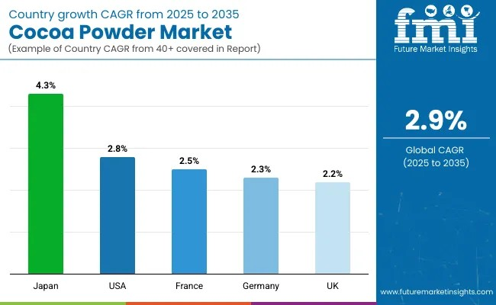
Figure 1: Global Cocoa Powder Market
(Source: futuremarketinsights, 2025)

Appendix 2: Obesity in the UK
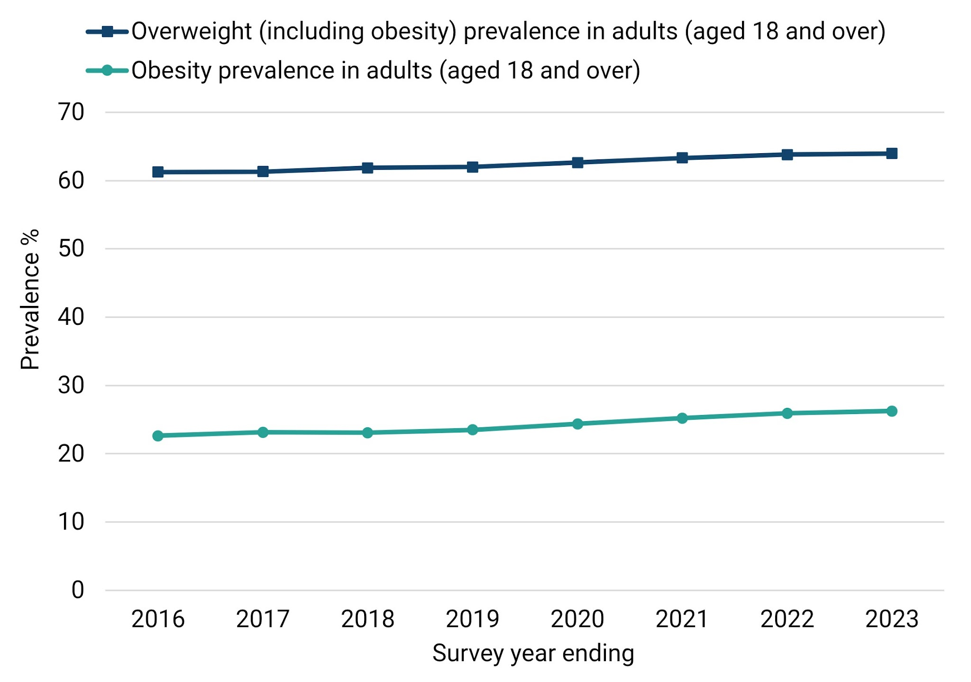
Figure 2: Obesity in the UK market
(Source: gov.uk, 2026)

