Problem solving and decision making

Name: Tabitha junior Downes
Student ID: 2008823
Lecturer: Dr Inge Hill
Module code: BMSW4004
Module: Problem solving and decision making
Assignment Title: Report Task 2

Report

Content

Report 1
Introduction 2
It’s scope and Impact 2
Define the problem 4
Analysis of organisation and problem 4
How can Gs' and other retailers make an option for exchanging clothes 6
How can staff time be reduced 7
Implementation Grid 9
Solution 9
Evaluation 10
Plan for implementing solution, Monitoring and Review Process/System 11
References 11

Introduction

This report is going to reflect the complex problems customers are facing due to the rise of living costs and how the pestle analyst picks out those complex problems, and how we can use different solutions to solve issues that Gs are facing to get clothes exchanged for hygiene reasons within the workplace ever since lockdown there has been a rise in everything and people are scraping what they can.

The novel coronavirus (COVID-19) pandemic has had an unprecedented effect on the global economy. Everywhere around the world, businesses have been affected in a variety of ways, both positively and negatively.

Retail businesses have been one of the sectors most affected by the pandemic in 2020. As steps have been taken to limit the spread of COVID-19, public health officials have ordered the temporary closure of stores and restricted the ability of customers to shop in-person. This has resulted in both the loss of revenue and customers for these retailers, as well as an increased cost of doing business due to the need to implement safety measures.

Adding to this, many retailers have had to grapple with reduced demand due to the economic recession caused by the pandemic, a firm slowdown in tourism, and an overall reduction in consumer spending. This has forced merchants to reduce costs and invent ways to increase sales. Many have had to rely on digital services, such

Better decisions come from understanding how emotional and physiological responses brought about by the environmental conditions we are experiencing govern our thought processes. Emotions and reactions can override our attempts to be rational.
Williams, (2023)

It’s scope and Impact

Covid-19 has disrupted the retail industry across the globe. Many stores, particularly smaller retailers, have had to close due to health and safety concerns or economic hardship. The pandemic has also drastically changed the way consumers shop, with online shopping and delivery now accounting for a bigger share of retail sales than ever before.

As a result, retailers have had to adjust their strategies in order to survive in this new landscape. This has involved expanding online operations, rethinking their supply chain operations, and offering more personalised services to customers. In addition, retailers have had to focus on customer safety protocols such as contactless delivery and curb side pickup.

Finally, retailers have also had to contend with more customer service challenges in the context of pandemic, as customers complain about back-orders, longer delivery times and prices that are higher than pre-pandemic levels.

In short, the retail industry has had to make a number of changes in response to

The Coronavirus pandemic has had a significant impact on the retail industry. Traditional retail stores have had to temporarily close due to the virus, while many e-commerce websites have had to cope with increased demands of customers buying online. Retail customers have had to adjust to the new normal of reduced in-store shopping, delayed shipping times and navigating online buying. There have also been many changes in consumer behaviour, such as stocking up for longer periods of time, a shift to digital payment options and an increase in the use of digital marketplaces. Many customers are also opting for buying from smaller stores or entrepreneurs in an effort to support their local economies. With job losses, customer incomes have been affected, leading to more customers to be on the lookout for bargains or discount options. Many retail customers also switched to buying essentials or basics, rather than luxury items. These changes have had an overall impact on the industry and will require retailers to shift their strategies as the pandemic progresses.

Customers are also struggling financially due-to the increase in living costs that they are unable to afford basic necessities and have limited to no disposable income. The cost of living, especially in urban areas, is rising and wages remain stagnant, causing a financial strain on working-class customers. Many customers are facing rising rent and housing costs, skyrocketing health care costs, rising transportation costs, and higher costs for many everyday goods and services. With their limited income, customers are struggling to cover their needs and may be forced to choose between paying basic bills and buying food. For some customers, this may mean relying on public assistance programs to help make ends meet.

According to Annaldewar et al., (2021) There has been a severe setback towards the sustainability in textiles and clothing sector due to the outbreak of the COVID-19 global pandemic. There has been a loss of momentum towards sustainable textile production, and also the 3R’s (Reduce, Recycle and Reuse) have taken a back seat.

Define the problem

Since the start of the Covid-19 pandemic, retailers have had to pay extra attention to hygiene - making sure to keep their customers and staff as safe as possible. This includes an increased emphasis on keeping shopping areas and surfaces clean, regular hand washing, regular cleaning and disinfection, staff wearing protective masks and gloves, and providing hand sanitiser or wipes to customers when they enter the store. Retailers have also implemented social distancing measures such as installing physical barriers around checkouts, putting in signs reminding customers to keep a safe distance, and limiting the number of customers allowed in the stores at any given time.

According to Kim & Kim,(2022) Nonetheless, during the global pandemic, consumers were confined to homes, lost jobs, and had to increase spending on essential goods. As COVID-19 brought such an abrupt shift in consumer behaviour, it is worth examining how the pandemic affected consumers’ secondhand fashion consumption

Analysis of organisation and problem

With the spread of Covid-19, numerous business issues have developed, particularly inside the retail area. Pestle investigation is a structure of distinguishing and breaking down the outside elements that may affect or hinder a business. Utilising Pestle examination, retailers can find various options to tackle the business complications created by Covid-19. A portion of the solutions that can be seen are:

1. Cost Cutting and Streamlining of Business Operations – Cost-cutting and process improvement is one of the most evident approaches to manage the cost pressures caused by Covid-19. This could mean utilising computerised tools to lessen manual tasks, eliminating non-basic items and services, and changing to a more effective form of team building and work/life balance.

2. Increase Online Presence – Retailers should ensure that their digital presence is strong and that they are taking advantage of all the latest digital trends and technologies. This implies creating a solid web based life presence

Going back to task 1 pestle analysis heres a list of my pestle analysis but with more in-depth points regarding the issue within Gs' and customer due to Covid-19 and hygiene measures and living costs.

Political - Adapt new strategies to recognise changes in the business environment due to political risks, such as tariffs and taxes;

Economic - Invest in online shopping platform that utilises omni-channel marketing, explore opportunities to enhance target market's purchasing power, implement cost-effective promotional strategies, identify new ways to leverage existing market data and insights;

Social - Improve customer access with mobile-friendly online shopping experience, technology-driven customer service, raise awareness and create new campaigns targeted at key demographics such as millennials;

Technological - Introduce more technologically advanced software and hardware systems, such as robotics and AI, to streamline processes;

Legal - Update compliance measures to comply with government policies and provide protection to customer data;

Environmental - Utilise renewable energy sources and/or develop green technologies to reduce the impact of operations on the environment;

Cause:
The living cost crisis has caused a decrease in the disposable income of customers as wages remain stagnant while prices are increasing. This, coupled with the economic effects of the current global health crisis, has made it difficult for customers to afford costlier items such as disinfectant.

Effect:
As a result of the decreased disposable income, customers are unable to afford disinfectant on a regular basis. This leads to insufficient sanitation and an increased risk of disease for those in the home or workplace. Not only does this put individuals and families at risk, but it also can lead to a further economic burden due to the expensive costs associated with medical treatment.

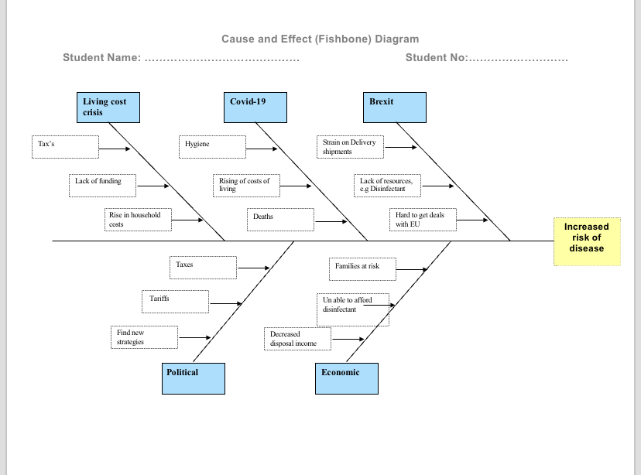

How can Gs' and other retailers make an option for exchanging clothes

offering online exchanges or digital gift cards instead of actual clothing exchanges in light of Covid-19. Many stores are also offering extended return periods and free returns to ensure customer satisfaction. They are also implementing different strategies like contactless pickups, virtual styling, and digital ordering to prioritise safety. Lastly, retailers should consider discounts or special promotions for loyal customers in order to keep their trust and foster customer satisfaction.

This can really help customers and be able to have fresh exchanged clothes due to the rise in living costs.

According to Trajanov & Gramatikov, (2021) This struggle, however, presented an opportunity. In order to motivate more people to donate clothing and to help create relationships with brands that work with expensive clothing, an idea was born

During the pandemic, many people are faced with financial problems, forcing them to opt for free or cheaper clothing. If more affluent people were driven to donate more of their clothing, this situation would significantly improve. Therefore, we proposed the following solution: for each clothing item given away, the donor acquires points, which can be accumulated and used as a discount at many stores that rent or sell more expensive clothing Trajanov & Gramatikov, (2021)

How can staff time be reduced

Reducing shop staff working time can help to reduce labor costs, improve efficiency, and increase customer satisfaction. Here are a few ways to reduce shop staff’s time.

1. Automating Processes & Introducing Self-Service Technology: Introducing automation and self-service technologies such as point-of-sale systems, automatic checkout, and barcode scanners can simplify processes and reduce the amount of time staff are required to spend on each customer transaction.

2. Streamline Internal Processes: Introducing a streamlined internal process, such as creating a simpler checkout process and providing staff with easy-to-follow cheat sheets that cover simple tasks, can reduce the amount of time spent dealing with customer enquiries and ensure staff are able to quickly complete tasks.

3. Leverage Technology: By taking advantage of high-tech tools such as sustainable energy-saving lighting and automated temperature control, shop owners can reduce their energy bills and create more comfortable working conditions for

1. Use self-service checkout systems where possible to reduce the need for staff presence at tills.

2. Utilise automated stocktaking systems to save time spent manually counting items.

3. Train staff on how to best use the available inventory management software.

4. Offer delivery services for customers to save staff time spent on packaging and handling orders.

5. Automate billing and loyalty programs to reduce the need for manual processing.

6. Utilise automated reminder systems to inform customers when supplies are running low.

7. Install video monitoring systems so that staff can monitor the shop floor from a central location.

8. Hire additional staff to perform tasks such as stocking shelves, handling returns, and processing orders.

9. Implement comprehensive employee scheduling and task management software to better track and manage overall staff workloads.

10. Outsource some of the shop’s tasks to third

Due to Covid-19

1. Implement contactless payment options: Encourage customers to pay for their purchases digitally via payment apps, QR codes, and other contactless payment methods. This reduces the amount of time spent at the checkout line.

2. Allow customers to shop online: Reduce time spent in-store by allowing customers to shop online and pickup purchases at their convenience.

These are also ways to reduce time spent in store.

According to Spiegelaere & Piasna, (2017) Working too much means getting tired, and being tired at work is a safety hazard. One of the main arguments in the demand for reduced working time relates to the negative health effects of working long hours.

So working long hours can have negative impact on health it can lead to a number of things that can have a negative impact your ability to work.

Implementation Grid

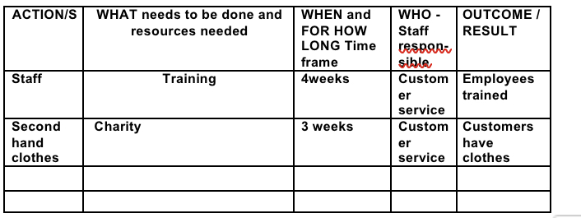

Solution

Solutions how you would go about this:

Alternative 1: Online Clothes Swap
In response to retail issues as a result of the Covid-19 pandemic, online clothes swap is an effective strategy for exchanging clothes at an economical price. An online clothes swap offers consumers an opportunity to trade or sell clothes that they do not wish to use anymore and purchase clothes from other people at a much cheaper rate than if they had purchased those clothes at the retail store. By leveraging the veritable strength of social media, the platform allows people from all over the world to view, bid and purchase/exchange clothes. Furthermore, customers who choose to participate also have access to a vast selection of clothing styles being traded by other people, which further helps to add variety for customers. Lastly, the ability to review ratings and feedback from other users on the platform helps in ascertaining the quality of the garments before purchase, thus providing assurance to the customers.

Alternative 2: Second Hand Stores

Second hand stores are an alternative solution to retail

Evaluation

Decision making is crucial in the work field according to Keeney, (2004) Decision analysis has been used to help solve numerous complex decisions over the last few decades. However, its power as a basis for structuring one’s thinking to resolve decisions has barely been tapped. To realise this potential, we in the decision analysis community must train people to think about their decisions using the concepts and principles of decision analysis.

Decision making helps to tackle complex problems without decision making the problems in the workplace will go unsolved.

The tool used below is the P-M-I Chart which evaluates what’s good, what’s bad and what’s interesting which is the positive and negatives.
And how the plus and minus are acknowledged within this company.

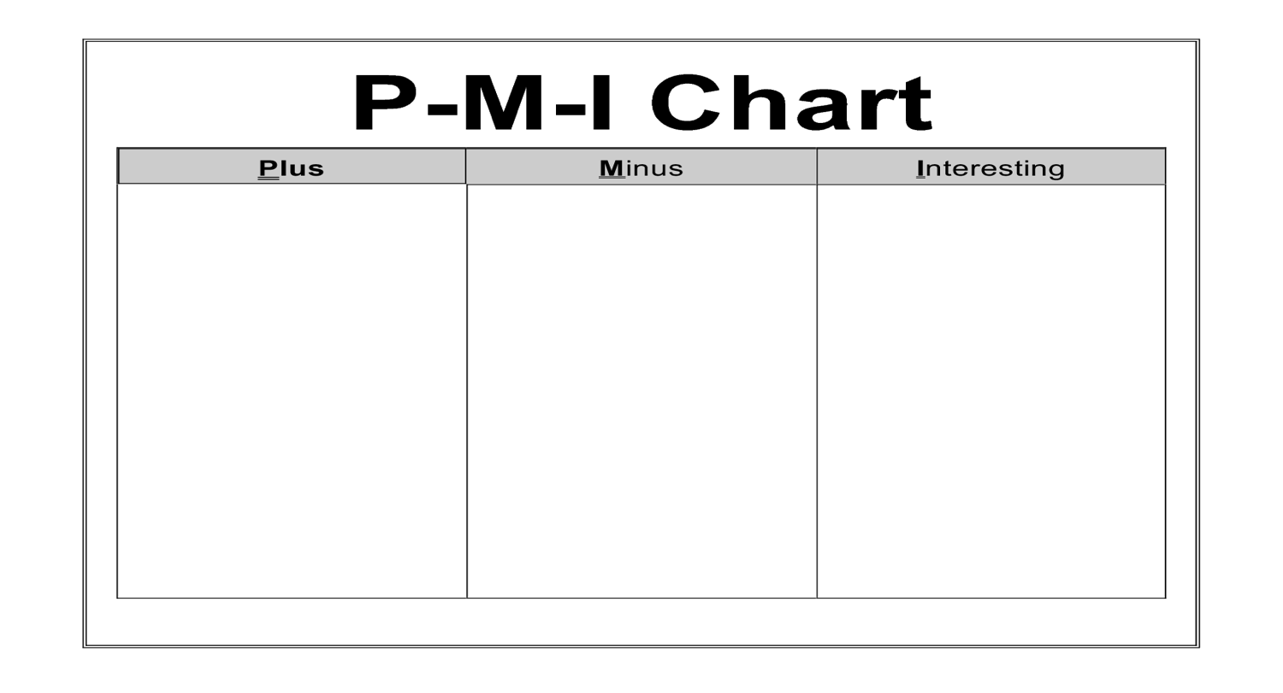
- Work colleagues can get help (4)
- Opportunity for struggling families (5)

- Recycle clothes (+5)
- Customers can have new work clothes (+6)
- More charity clothes (+4)

- Not enough recycled clothes (-3)
- Customers wont have new work clothes (-4)
- Not enough clothes from charity (-2)

Plan for implementing solution, Monitoring and Review Process/System

Critical reflection is used increasingly in professional and academic contexts as a means of focusing our attention back onto our own experience. Reflection in this context refers to specific kinds of mental discipline. It involves clarifying our thinking, deepening understanding and reinforcing learning in ways that, ideally, lead to transformation and change (Cottrell, Stella,2023).

References

Annaldewar, B.N., Jadhav, N.C. and Jadhav, A.C. (2021) “Impact of COVID-19 on sustainability in Textile & clothing sectors,” Environmental Footprints and Eco-design of Products and Processes, pp. 93–116. Available at: https://doi.org/10.1007/978-981-16-3860-2_4.

Cottrell, Stella. Critical Thinking Skills : Effective Analysis, Argument and Reflection, Bloomsbury Publishing Plc, 2017. ProQuest Ebook Central, http://ebookcentral.proquest.com/lib/trinity/detail.action?docID=6234915.
Created from trinity on 2023-02-14 12:48:08.

Keeney, R.L. (2004) “Making Better Decision Makers,” Decision Analysis, 1(4), pp. 193–204. Available at: https://doi.org/10.1287/deca.1040.0009.
Kim, N.L. and Kim, T.H. (2022) “Why buy used clothing during the pandemic? examining the impact of covid-19 on consumers’ secondhand fashion consumption motivations,” Breaking Boundaries [Preprint]. Available at: https://doi.org/10.31274/itaa.13537.

Spiegelaere, S.D. and Piasna, A. (2017) (PDF) the why and how of Working Time Reduction - Researchgate. Available at: https://www.researchgate.net/publication/321576822_The_why_and_how_of_working_time_reduction (Accessed: March 12, 2023).
Trajanov, D. and Gramatikov, S. (2021) (PDF) the impact of covid-19 on sharing economy: Use-case on sharing ...Available at: https://www.researchgate.net/publication/352864064_The_impact_of_COVID-19_on_sharing_economy_Use-case_on_sharing_and_renting_clothing (Accessed: March 12, 2023).

Williams, Steve W.. Making Better Business Decisions : Understanding and Improving Critical Thinking and Problem Solving Skills, SAGE Publications, Incorporated, 2001. ProQuest Ebook Central, http://ebookcentral.proquest.com/lib/trinity/detail.action?docID=996932.
Created from trinity on 2023-02-14 12:44:55.

