
UNIVERSITY OF WALES TRINITY & SAINT DAVID
MODULE CODE: ACCA5026
Dr. Suresh Shanmugasundaram
Andrey Atanasov
2324732
2324732@student.uwtsd.ac.uk
database and application development

BSC applied computing

Contents
TASK A: CAMPUS CLUB MANAGEMENT SYSTEM (CCMS) 3
INTRODUCTION 3
DATABASE DESIGN 3
Main entities 3
Entity Relationship Diagram 5
Tables & Constraints 5
Normalization 6
IMPLEMENTATION DOCUMENTATION 6
Members 6
Clubs 8
MemberClubs 9
ClubEvents 10
EventAttendance 11
ClubAnnouncements 12
STORED PROCEDURE AND TRANSACTIONAL SCENARIO 12
Add Member 12
Update Member 13
Delete Member 14
PERFORMANCE TUNING ENHANCEMENT 15
CONCLUSION AND REFLECTION 15
REFERENCES PART A 16
TASK B: PHP WEBSITE DEVELOPMENT 17
INTRODUCTION 17
OVERVIEW OF WEBSITE TOPIC 17
DATABASE DESIGN FOR WEBSITE 17
TABLES & RELATIONSHIPS 17
SAMPLE DATA 19
PHP IMPLEMENTATION 21
Catalog page 22
Dynamic Retrieval of Catalog Data 23
Dynamically Retreived Database Records Within an HTML table 23
DYNAMIC CONTENT DISPLAY 24
CRUD OPERATIONS 24
Admin Page 24
Manage Games 24
Add 25
Edit 25
SEARCH/FILTER FUNCTIONALITY 25
User-side 25
Code 26
SECURITY MEASURES (LOGIN. INPUT VALIDATION) 26
Log In Page 27
Code 28
SQL INJECTION OVERVIEW 28
EXPLANATION AND EXAMPLES 28
VULNERABILITIES IN WEBSITE CODE 29
ANTI-SQL INJECTION MEASURES IMPLEMENTED 29
SCREENSHOTS OF TESTS AND RESULTS 30
CONCLUSION 31
References 32

TASK A: CAMPUS CLUB MANAGEMENT SYSTEM (CCMS)

INTRODUCTION
The focus of the project is to design and implement a relational DB for CCMS in order to support students union in managing clubs, memberships, events and communications
The aim is to replace fragmented, manual record-keeping with a structured and reliable database solution that improves efficiency, data integrity and accessibility.
The report outlines the process, implementation and optimisation techniques.

DATABASE DESIGN

Main entities
In the Campus Club Management System, I have identified six core entities to represent the data objects required by the Students Union: Members, Clubs, MemberClubs, ClubEvents, EventAttendance, ClubAnnouncements.
Members represents individual students who participate in clubs.
Key Attributes include:
- member_id (PK)
- given_name
- uni_email (this has been constrained to be unique to prevent duplicate records)
- family_name
- enrol_year
Clubs models each student club or society supported by the Union.
Key attributes include:
- club_id (PK)
- club_title
- club_type (restricted to a predefined set of values (for example, STEM & Engineering or Gaming & Esports) to maintain consistent classification of clubs)
- year_founded
MemberClubs is a junction table that resolves the many-to-many relationship between Members & Clubs.
Key attributes include:
- member_club_id (PK)
- member_id (FK to Members)
- club_id (FK to Clubs)
- joined_on
- member_role
- membership_status
This design allows a single member to join multiple clubs and a single club to have multiple members.
It also records roles and whether the membership is currently active.
ClubEvents represents events organised by clubs.
Key attributes include:
- event_id (PK)
- club_id (FK to clubs)
- event_title
- event_datetime
- event_location
- max_capacity
Each club schedules many events, but each event belongs to exactly one club, forming a one-to-many relationship between Clubs and ClubEvents.
EventAttendance is a second associative entity used to capture member participation at events.
Key attributes include:
- attendance_id (PK)
- Member_id (FK to members)
- Event_id (FK to ClubEvents)
- Checkin_timestamp
- attended_flag
This resolves the many-to-many relationships between Members & ClubEvents and enables analysis of engagement and attendance.
ClubAnnouncements stores official communications sent by clubs.
Key attributes include:
- announcement_id (PK)
- club_id (FK)
- announcement_heading
- announcement_body
- sent_timestamp
Each club can issue multiple announcements, creating a one-to-many relationship between Clubs and ClubAnnouncements.

Entity Relationship Diagram
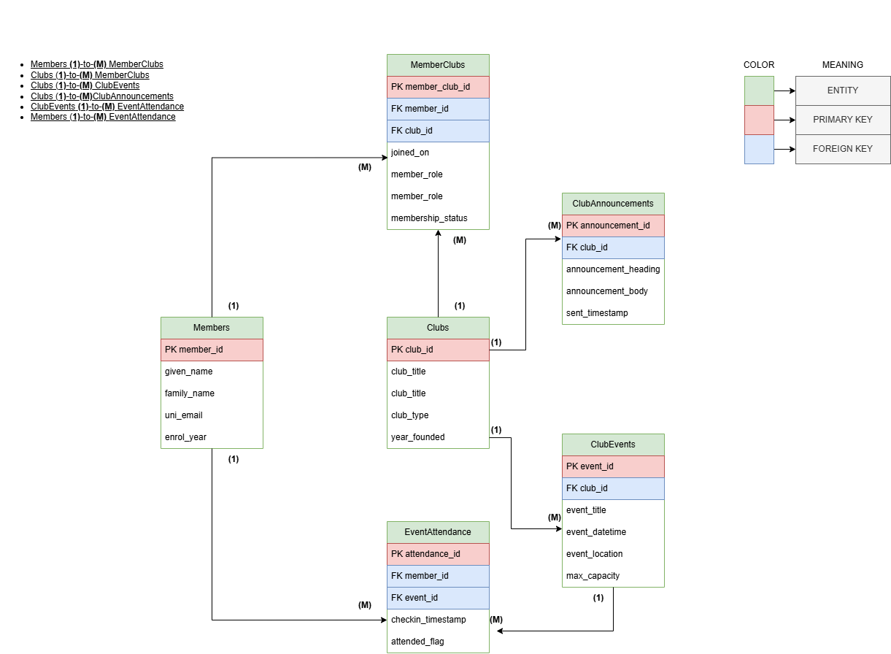
Img 1: EDR
The EDR provides the overall structure of CCMS, and it shows how the six entities are connected.
Clubs act as central entity with one-to-many relationships to both ClubEvents and ClubAnnouncements.
Members participate in clubs and attend events, resulting in two many-to-many relationships resolved using the associative tables MemberClubs and EventAttendance, which store attributes specific to each membership or attendance record. PK and FKs are clearly defined.
The EDR establishes a clear and normalized schema.

Tables & Constraints
The database was implemented directly from the ER model by creating tables with clearly defined primary keys, foreign keys, and integrity constraints.
Using the InnoDB engine allowed the system to enforce referential integrity through foreign key relationships, ensuring that parent–child links between entities such as Clubs, Members, and Events remain valid [1].
Additional constraints, including UNIQUE and CHECK rules, were applied to prevent invalid or duplicate data and to improve overall reliability. According to Connolly & Begg, the use of constraints at the schema level is essential for maintaining consistent and accurate data across relational systems [2].
This structured implementation ensures that the final database aligns precisely with the logical model and supports the functional requirements of the CCMS.

Normalization
Normalization was applied to refine the database design and reduce redundancy. All entities were decomposed to satisfy the requirements of Third Normal Form (3NF), meaning that each non-key attribute depends solely on the primary key, with no transitive or partial dependencies.
This is consistent with database design best practices, where 3NF helps minimise update anomalies and improves data consistency [3].
The use of associative tables (MemberClubs and EventAttendance) enabled the representation of many-to-many relationships without storing repeated values, reflecting the principles outlined by Codd’s normalization theory [4].
As a result, the final schema is efficient, logically structured, and resistant to data anomalies.

IMPLEMENTATION DOCUMENTATION

*For constraints I’ve referred to [5]
All tables
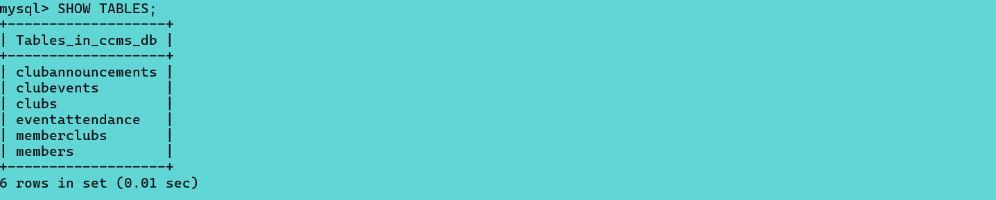

Members
Creation
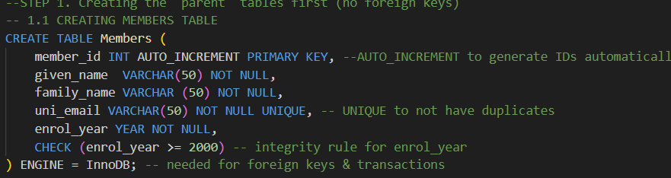

Constraints
The Members table enforces data integrity through a primary key on member_id, NOT NULL constraints on all mandatory attributes, a UNIQUE constraint on uni_email to prevent duplicate records, and a CHECK constraint to ensure valid enrolment years.

Design view
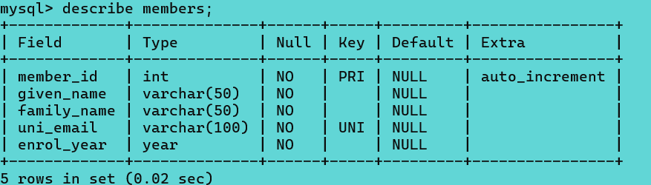

Clubs
Creation
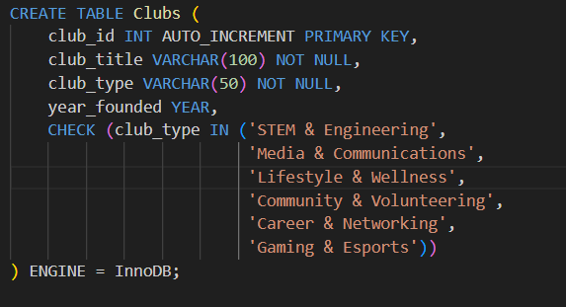
Design View
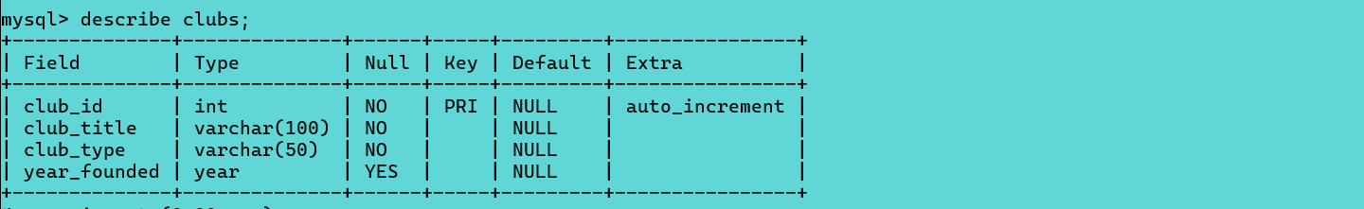
Constraints
The Clubs table applies the same primary key and NOT NULL constraint approach as the Members table, with an additional CHECK constraint used to restrict club_type values to predefined categories.

MemberClubs

Creation
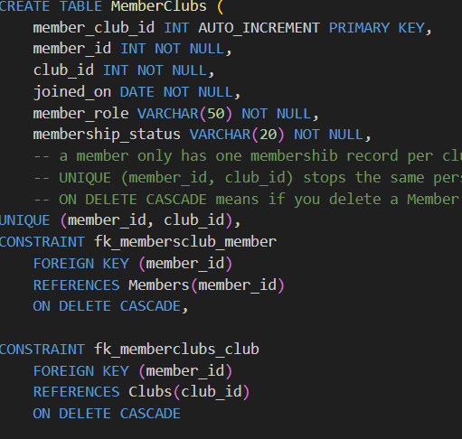

Design View
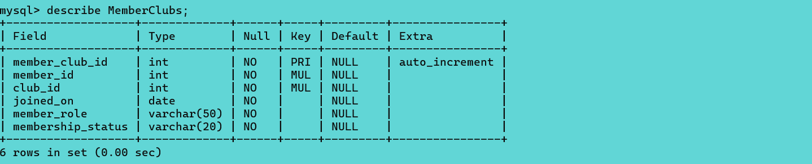
Constraints
The MemberClubs table follows the same integrity principles as previous tables, while additionally implementing foreign key constraints to link members and clubs and a composite UNIQUE constraint to prevent duplicate membership records.

ClubEvents

Creation
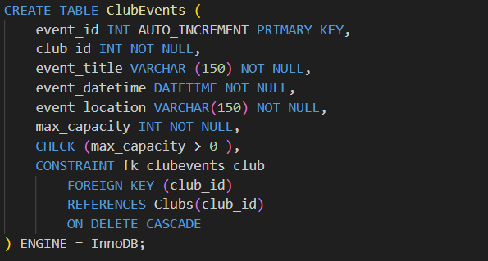

Design View
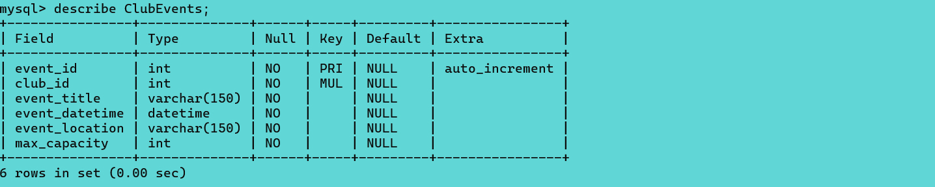
Constraints
Similarly, the ClubEvents table enforces referential integrity through a foreign key to Clubs and applies the same NOT NULL and primary key constraints used in earlier tables, alongside a CHECK constraint on max_capacity.

EventAttendance
Creation
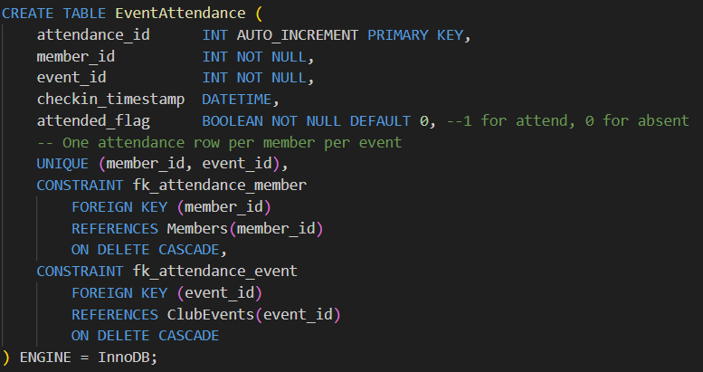
Design View
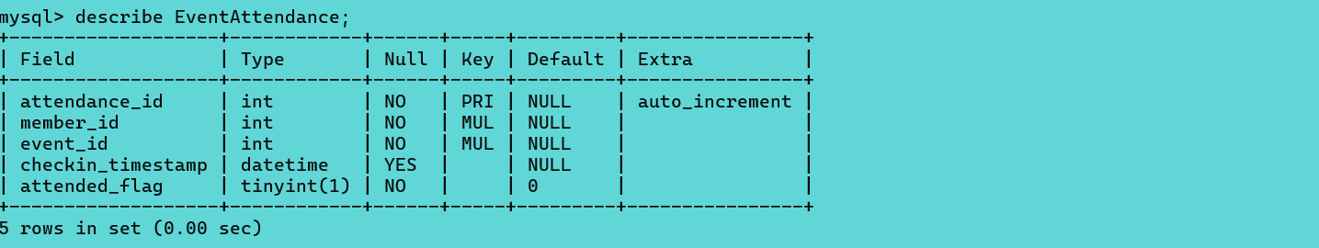
Constraints
The EventAttendance table uses the same primary key and foreign key strategy as MemberClubs, with a composite UNIQUE constraint to avoid duplicate attendance entries and a default constraint to standardise attendance values.

ClubAnnouncements
Creation
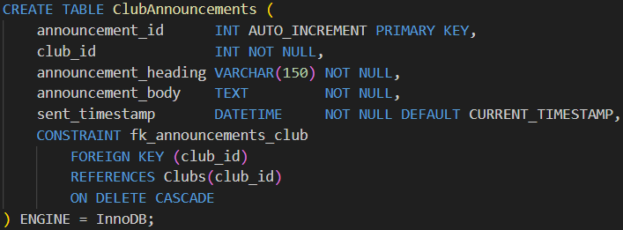

Design View
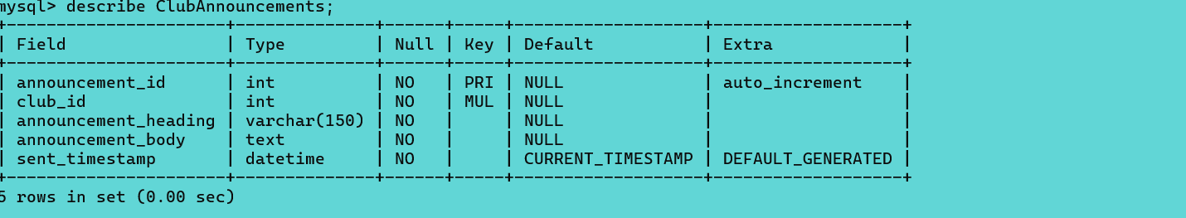
Constraints
Finally, the ClubAnnouncements table applies the same constraint structure as the ClubEvents table, using foreign keys, NOT NULL constraints, and a default timestamp to maintain accurate communication records.

STORED PROCEDURE AND TRANSACTIONAL SCENARIO
To demonstrate how data is managed within the system, I’ve created stored procedures for common operations such as adding, updating, and deleting records. Each procedure was executed and the results were verified using SELECT queries, with screenshots included below to show both the execution and the changes made to the data.
For this I’ve referred to [6]

Add Member
Code
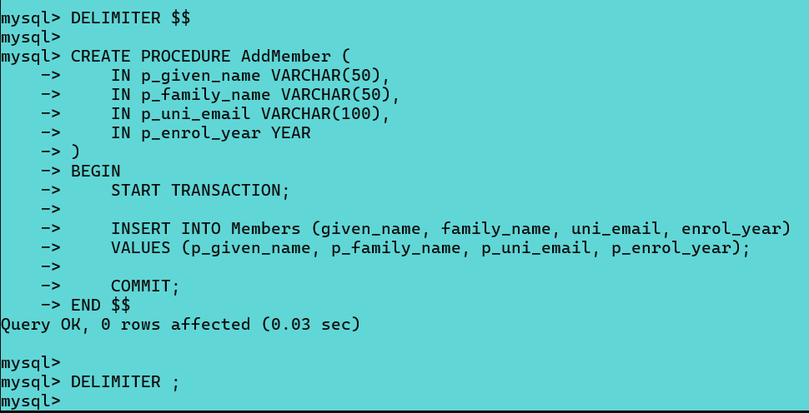
Test
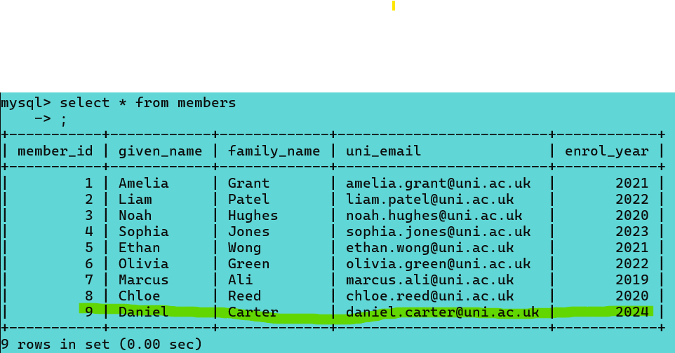
Member successfully added

Update Member
Code
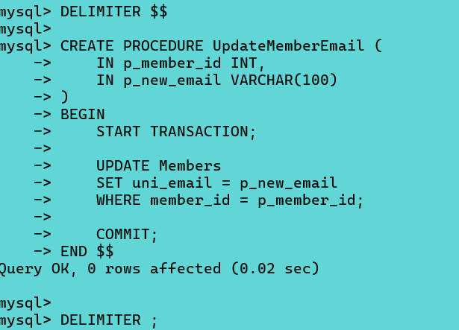

Test
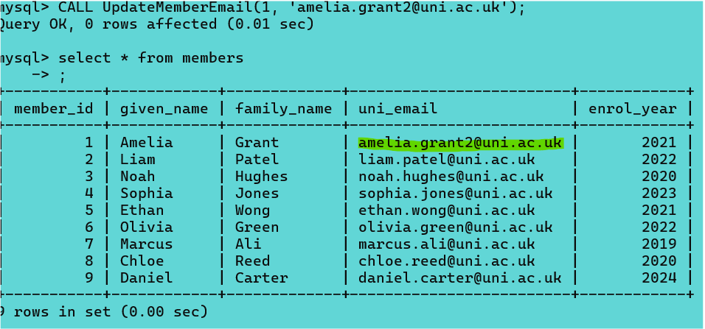
Email was successfully changed.

Delete Member
Code
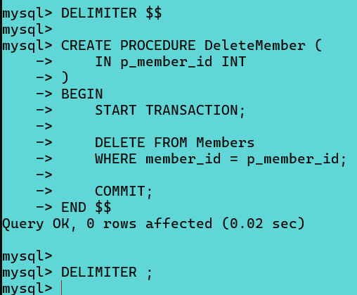

Test
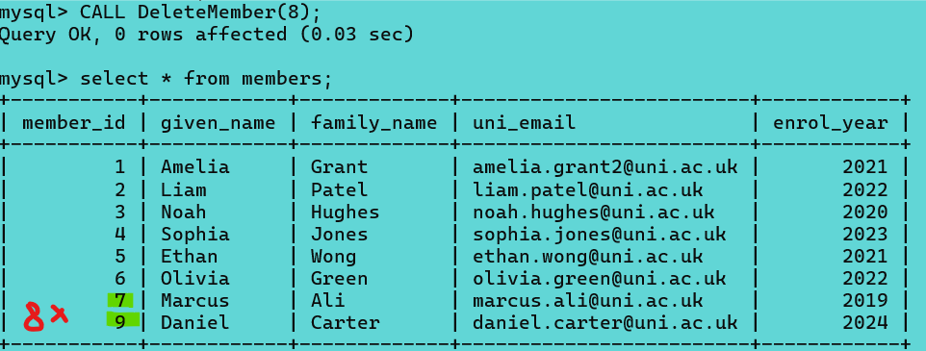
8th member successfully deleted

PERFORMANCE TUNING ENHANCEMENT
Performance tuning was implemented by adding secondary indexes to foreign key columns frequently used in join queries. This optimisation improves query efficiency by enabling faster data retrieval for membership, event, and attendance operations.
For indexing and why it’s used: [7]
Code
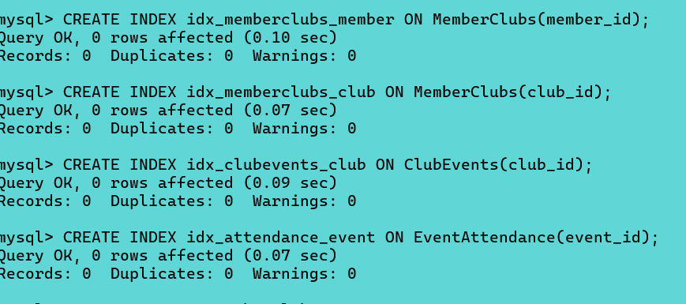

CONCLUSION AND REFLECTION
The project implements a relational database for the Campus Club Management System and supports the management of clubs, members, events, attendance and announcements.
Database design is in 3nf and was implemented using constraints, stored procedures, transactions and indexing to ensure integrity and efficiency.

Through the implementation, challenges such as managing foreign key dependencies and enforcing data consistency were addressed.
Future improvements can include integrating a UI, role-based access control and adding automated notifications to enhance system usability.

REFERENCES PART A
[1] Oracle Corporation, “InnoDB Storage Engine,” MySQL 8.0 Reference Manual, 2023. [Online]. Available: https://dev.mysql.com/doc/refman/8.0/en/innodb-storage-engine.html
[2] T. Connolly and C. Begg, Database Systems: A Practical Approach to Design, Implementation and Management, 6th ed. Pearson, 2015. [Online]. Available: https://books.google.com/books?id=kl1TDwAAQBAJ
[3] A. Silberschatz, H. Korth, and S. Sudarshan, Database System Concepts, 7th ed. McGraw-Hill, 2019. [Online]. Available: https://www.db-book.com/
[4] E. F. Codd, “A Relational Model of Data for Large Shared Data Banks,” Communications of the ACM, vol. 13, no. 6, pp. 377–387, 1970. [Online]. Available: https://dl.acm.org/doi/10.1145/362384.362685
[5] “SQL Constraints,” W3Schools. [Online]. Available: https://www.w3schools.com/sql/sql_constraints.asp.
[6] “SQL Stored Procedures,” W3Schools. [Online]. Available: https://www.w3schools.com/sql/sql_stored_procedures.asp.
[7] “SQL Indexes,” W3Schools. [Online]. Available: https://www.w3schools.com/sql/sql_create_index.asp

TASK B: PHP WEBSITE DEVELOPMENT

INTRODUCTION
The website was structured using a clear separation of concerns to improve maintainability, readability, and security. Files were segmented into logical directories such as public, admin, includes, and config to separate presentation, functionality, and configuration logic. This approach aligns with recommended PHP development best practices, which emphasise modular code organisation and clear responsibility boundaries within applications [12].
Consistent and descriptive file naming was used to ensure that each file’s purpose is immediately identifiable, reducing complexity during development and testing. Separating administrative functionality from public-facing pages also limits exposure of sensitive operations, contributing to a more secure and scalable design [12].

OVERVIEW OF WEBSITE TOPIC
The website developed for this assignment is a database-driven catalog of Blizzard Entertainment games. The purpose of the website is to allow public users to view and search a list of games, while providing an administrator with the ability to manage the catalog through secure login and CRUD functionality.
Public users can browse the catalog and filter results by game name and genre. All catalog content is retrieved dynamically from a MySQL database using PHP. Administrative functionality is restricted to authorised users and allows games to be added, edited, or deleted as new titles are released or existing records require updates.
This topic was selected as it provides clear scope to demonstrate PHP server-side programming, relational database design, dynamic content display, and basic web security measures, including authentication and protection against SQL injection attacks.

DATABASE DESIGN FOR WEBSITE
The website uses a relational MySQL database to store and manage all catalog and administrative data. The database was designed to support dynamic content display, efficient searching, and secure administrative CRUD operations. Normalisation principles were applied to reduce data redundancy and ensure data integrity.
The database structure separates different types of data into individual tables, allowing relationships to be established using primary and foreign keys. This design supports scalability, making it possible to add new games, genres, or platforms without restructuring existing data. The use of relational links also ensures consistent data management across the website.

TABLES & RELATIONSHIPS

TABLES
The primary tables include games, genres, platforms, game_platforms, and admins. Each table uses a primary key to uniquely identify records and foreign keys to define relationships between tables. 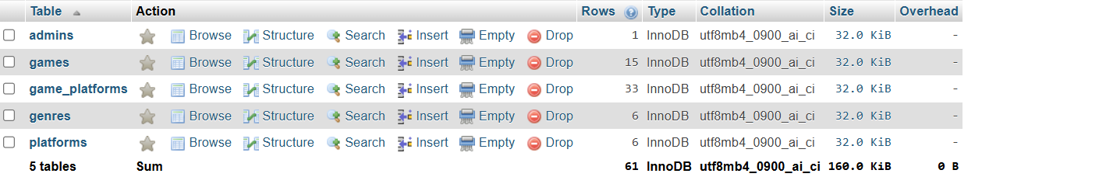
games stores information about each Blizzard game available in the catalog.
Key attributes include:
- game_id (PK)
- game_name
- release_date
- price
- genre_id (FK)
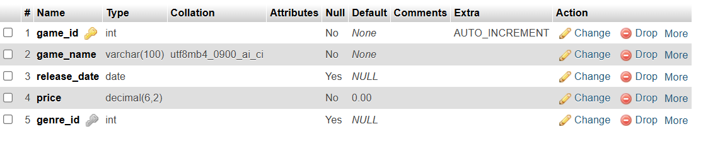
genres stores the different game genres used to categorise games in the catalog.
Key attributes include:
- genre_id (PK)
- genre_name
platforms stores the platforms on which games are available.
Key attributes include:
- platform_id (PK)
- platform_name
game_platforms acts as a junction table to manage the many-to-many relationship between games and platforms.
Key attributes include:
- game_id (PK, FK)
- platform_id (PK, FK)
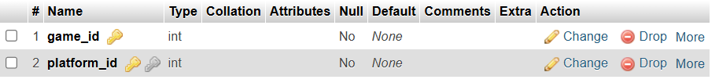
admins stores administrator login details required to manage the website content securely.
Key attributes include:
- admin_id (PK)
- username
- password_hash
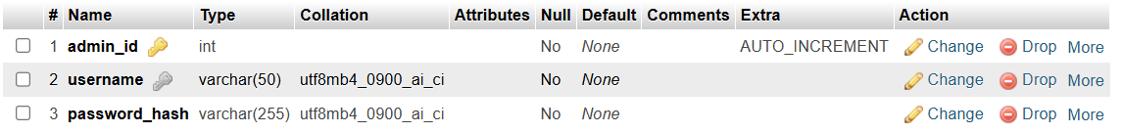

RELATIONSHIPS
Relationships between tables are enforced using foreign keys to maintain referential integrity. This design reduces data redundancy, supports scalability, and ensures consistent data management across the website.
- genres (1) → games (M)
Each genre can be associated with multiple games.
This relationship is implemented using the genre_id foreign key in the games table.
- games (M) ↔ platforms (M)
Games can be available on multiple platforms, and each platform can support multiple games.
This many-to-many relationship is implemented using the game_platforms junction table.
- admins
The admins table is not directly related to other tables and is used solely for authentication and access control.
Designer view:
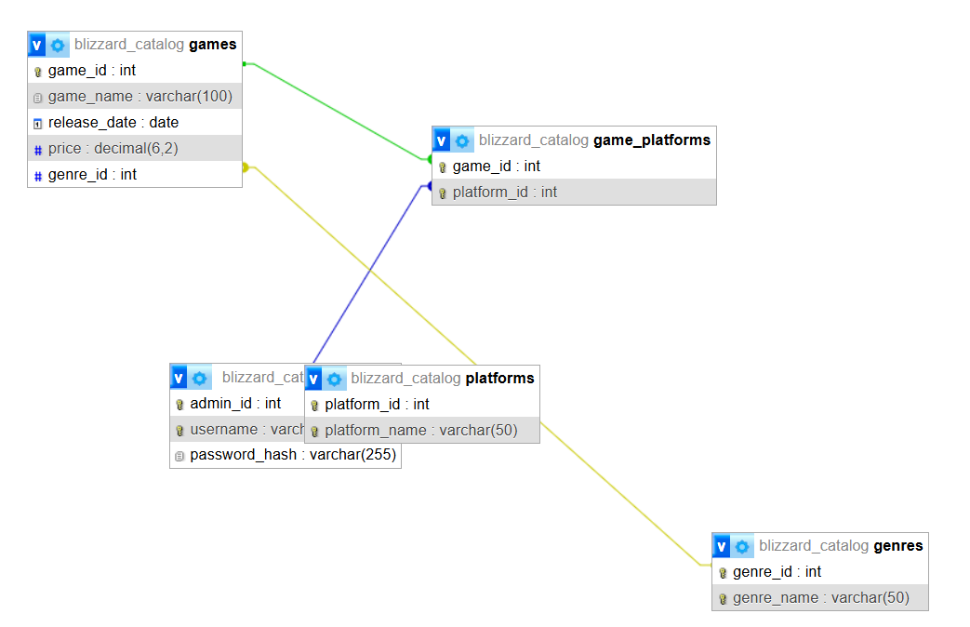

SAMPLE DATA
To populate the database with relevant sample data, records were inserted across the main lookup and catalog tables. The genres and platforms tables contain multiple entries to support categorisation and filtering. The games table was populated with approximately 15 Blizzard titles, each including a game name, release date, price, and an associated genre via genre_id.
To demonstrate the many-to-many relationship between games and platforms, the game_platforms junction table contains multiple links per game. Basic administrator data was also added to the admins table to enable secure login for management functions.

Games
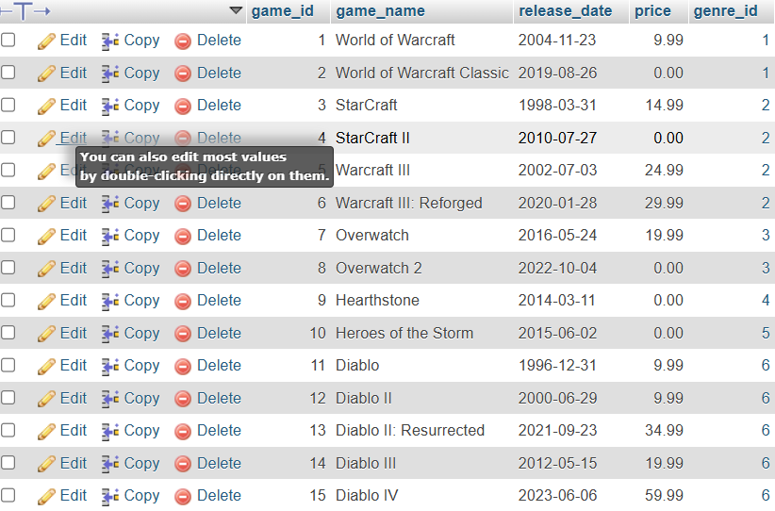
Genres
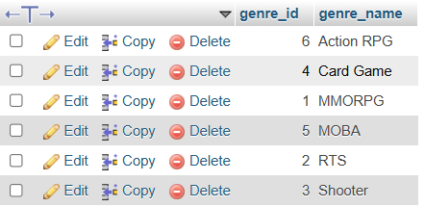
Platforms
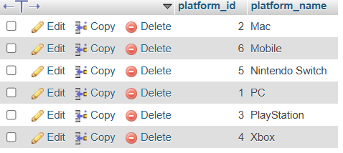
Admins
Administrator credentials are stored securely and used solely for authentication purposes.
Game_platforms
Contains multiple records to represent many-to-many relationships.

PHP IMPLEMENTATION
PHP was used as the server-side language to connect the website to the MySQL database and deliver dynamic functionality. PHP scripts handle data retrieval, user input processing, and administrative operations, allowing the website content to update automatically based on database changes.[13]
The implementation includes dynamic content display, search and filter functionality, full CRUD operations for administrators, and basic security measures such as login handling and input validation.

Catalog page
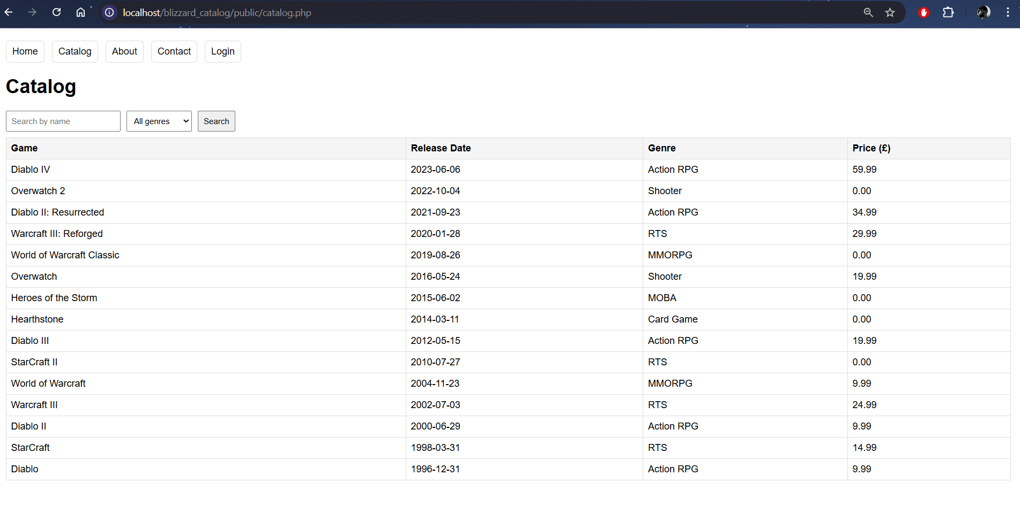
Here the games table is shown with multiple rows and genre names (joined from another table). As well as prices/release dates.

Dynamic Retrieval of Catalog Data
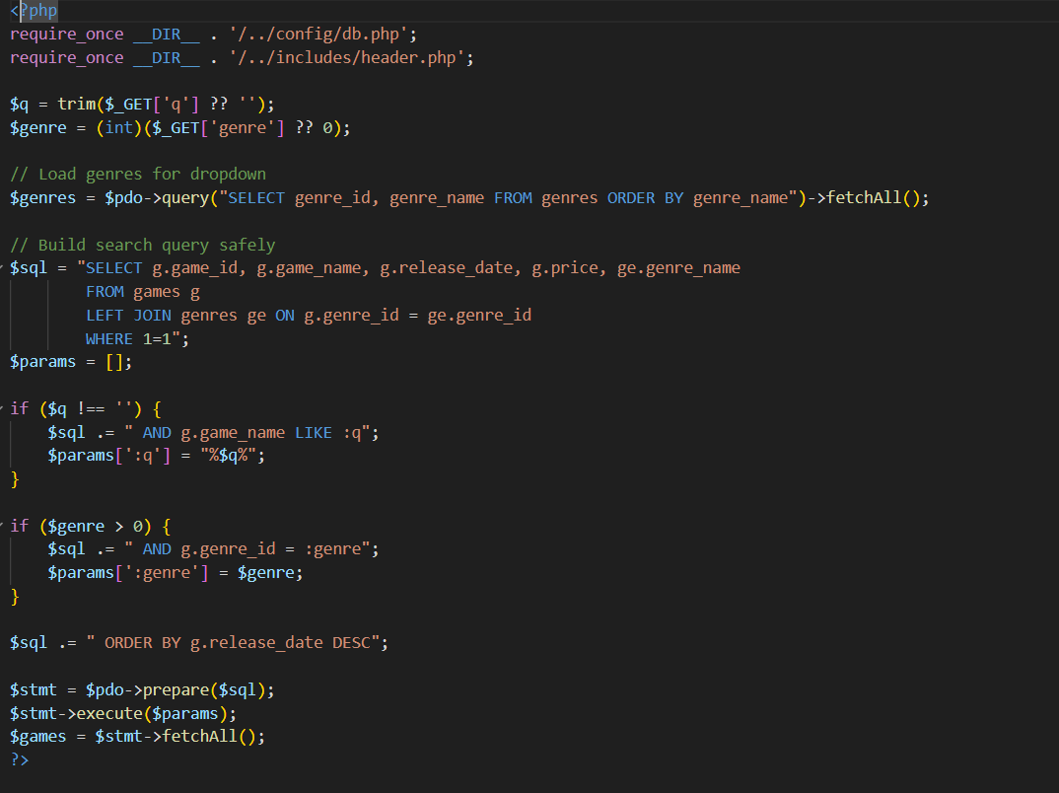
code demonstrating dynamic retrieval of catalog data from the database.
The screenshot shows the use of PHP Data Objects (PDO) to safely construct and execute a SQL query based on user input. Prepared statements and bound parameters are used to retrieve game records dynamically from the games and genres tables. The results are stored in an array using fetchAll() for later display within the catalog page.

Dynamically Retreived Database Records Within an HTML table
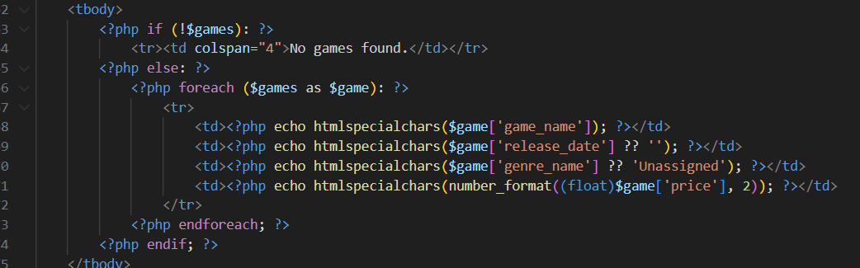
The screenshot shows a PHP foreach loop iterating over the array of game records returned from the database query. Each record is output dynamically into table rows, with data safely rendered using htmlspecialchars() to prevent malicious input from being displayed. This demonstrates how PHP integrates database data into the webpage at runtime.

DYNAMIC CONTENT DISPLAY
As shown in the screenshots above, PHP is used to retrieve game data from the MySQL database using prepared statements and dynamically display the results within the catalog page. The database query is constructed based on user input, and the returned records are rendered at runtime using a PHP foreach loop, demonstrating that the website content is fully database-driven rather than static

CRUD OPERATIONS
The website implements full CRUD (Create, Read, Update, Delete) functionality for managing the games catalog. These operations are restricted to authenticated administrators and are accessible through a dedicated admin interface. [14]

Admin Page

Administrator dashboard is accessible only after successful authentication. From this interface, the administrator can navigate to management features such as the games catalog. This demonstrates role-based access control and restricted access to administrative functionality.

Manage Games
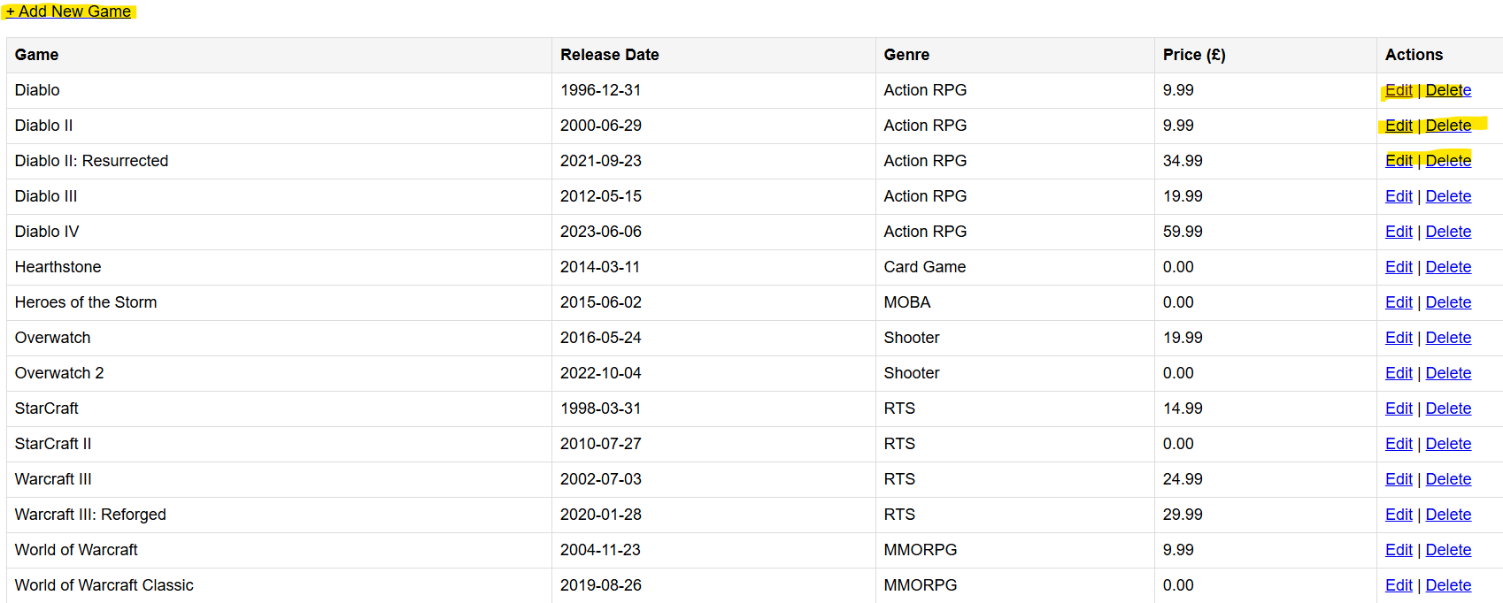
Administrative interface used to manage game records stored in the database. The page provides full CRUD functionality, allowing administrators to create new games and edit or delete existing records. All changes made through this interface are processed using PHP and are immediately reflected in the public catalog.

Add
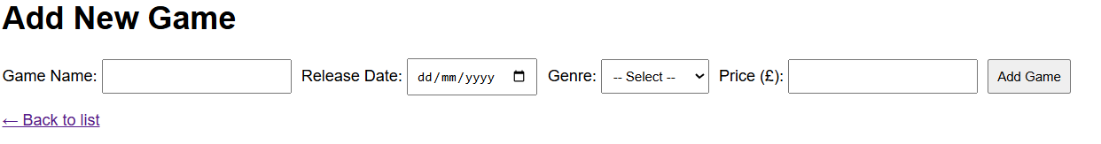
Form used by administrators to create new game records within the catalog. Submitted data is validated and processed using PHP before being securely inserted into the database.

Edit

Form used to update existing game records, with current values pre-loaded from the database. Administrators can modify and save changes, which are processed by PHP and applied to the database in real time.
Delete simply deletes an item.

SEARCH/FILTER FUNCTIONALITY
The website includes search and filter functionality to help users find specific games within the catalog. On the catalog page, users can search by game name using a text input and optionally filter results by selecting a genre from a dropdown list. [15]

User-side
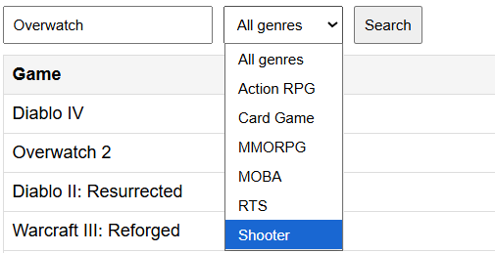
Here you can see “Overwatch” written in the search field and “Shooter” selected in the genres field.
The output is overwatch and overwatch 2 which both fit the search criteria

Code
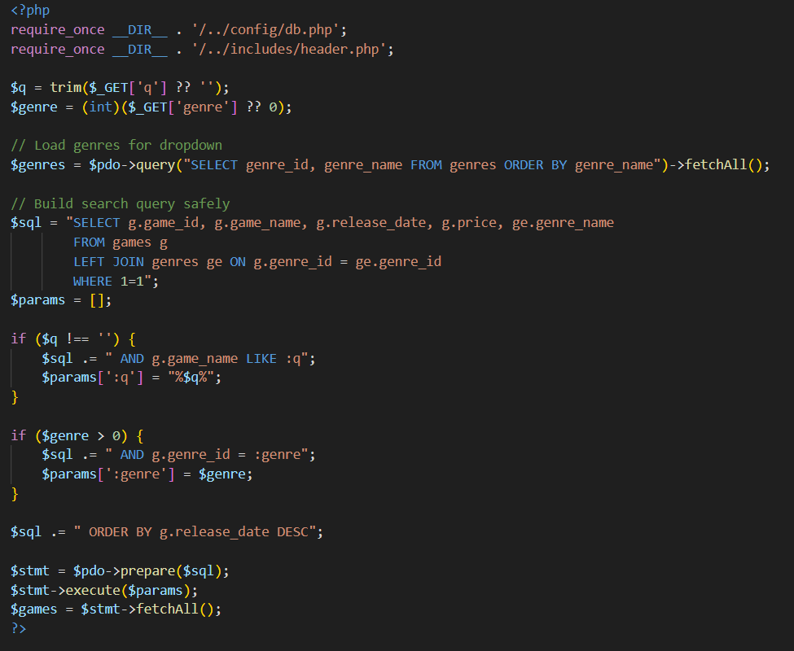

SECURITY MEASURES (LOGIN. INPUT VALIDATION)
Basic security measures were implemented to protect administrative functionality and reduce the risk of malicious input. Administrator access is restricted using a login system based on PHP sessions, ensuring that only authenticated users can access management pages such as the dashboard and game maintenance features.
Passwords are not stored in plain text; instead, hashed passwords are used with password_hash() and verified with password_verify(). Input validation is applied to form submissions (e.g., required fields and numeric validation for price), and output is sanitised using htmlspecialchars() to prevent unsafe content from being rendered in the browser. These measures improve confidentiality and integrity of both user and catalog data. [16]

Log In Page
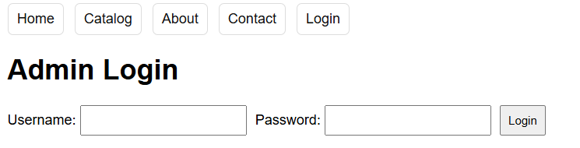
Login page used to authenticate users before granting access to protected management features.

Code
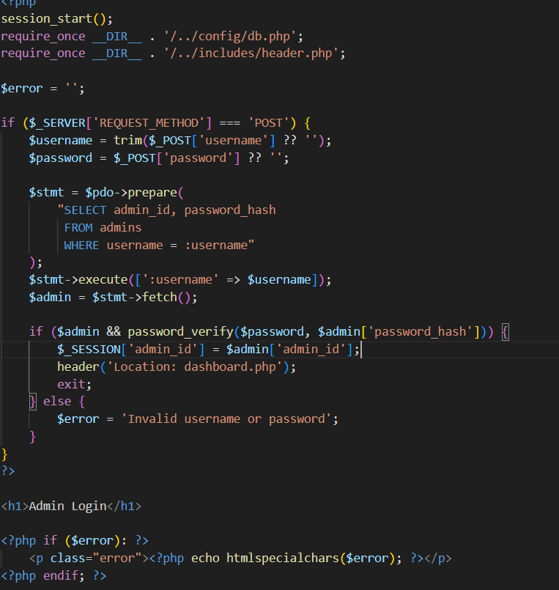
PHP login authentication code using prepared statements and password_verify() to securely validate administrator credentials and establish a session.

SQL INJECTION OVERVIEW

EXPLANATION AND EXAMPLES
SQL Injection is a web security vulnerability that occurs when an application allows untrusted user input to be included directly within SQL queries sent to a database. When input is not properly validated or sanitised, an attacker can manipulate the structure of a query and execute unintended SQL commands. This can result in unauthorised access to data, modification of records, or deletion of entire database tables [8], [11].

A common cause of SQL Injection is the use of dynamically constructed SQL statements that concatenate user input directly into the query string. For example, if a login query is written without protection, an attacker may input malicious SQL code instead of expected values. A well-known example is the input ' OR '1'='1, which can cause a conditional statement to always evaluate as true. This may allow an attacker to bypass authentication controls and gain unauthorised access to restricted areas of a website [9].

SQL Injection attacks pose a significant risk because they directly target the database layer, where sensitive information such as user credentials, personal data, or administrative records are stored. According to OWASP, SQL Injection remains one of the most common and dangerous web application vulnerabilities due to its simplicity and potentially severe impact [8]. Cloudflare further highlights that SQL Injection continues to be widely exploited in real-world attacks, often leading to large-scale data breaches and service compromise [11].

Websites that rely on server-side languages such as PHP and databases such as MySQL are particularly vulnerable if secure coding practices are not followed. Forms that accept user input, including login forms, search fields, and administrative CRUD interfaces, are frequent targets. Without appropriate defensive measures, attackers can exploit these entry points to interact directly with the underlying database [10].

VULNERABILITIES IN WEBSITE CODE
Web applications that accept user input are common targets for SQL Injection attacks if appropriate safeguards are not implemented. In the context of the Blizzard games catalog website, several areas could potentially be vulnerable if insecure coding practices were used. These include the login form, search and filter functionality, and administrative CRUD operations, all of which rely on user-supplied input to interact with the database.
If SQL queries were constructed by directly concatenating user input into query strings, an attacker could inject malicious SQL code to alter query logic. For example, a search field or login form could be exploited to bypass authentication checks or retrieve unauthorised data. OWASP identifies such input-handling points as primary attack vectors when applications fail to separate user input from SQL commands [8]. Cloudflare also notes that injection attacks frequently exploit poorly secured input fields to gain access to backend databases [11].
In this project, these risks were considered during development. Without the use of prepared statements and input validation, the website would be susceptible to common SQL Injection techniques such as conditional manipulation or union-based attacks. This highlights the importance of secure database interaction, particularly for features that process user input dynamically [9], [11].

ANTI-SQL INJECTION MEASURES IMPLEMENTED
To mitigate the risk of SQL Injection, the website implements several defensive coding techniques when interacting with the database. All SQL queries are executed using PHP Data Objects (PDO) with prepared statements, ensuring that user input is never interpreted as executable SQL code. This approach separates the SQL query structure from user-supplied data, significantly reducing the risk of injection attacks [10], [11].
Prepared statements are combined with bound parameters to safely incorporate user input into database queries. Values entered through login forms, search fields, and CRUD interfaces are passed as parameters rather than being directly concatenated into SQL strings. As a result, any malicious input is treated strictly as data and cannot alter the logic of the underlying SQL query [8]. Cloudflare highlights prepared statements as one of the most effective defences against SQL Injection attacks in modern web applications [11].
Additional input handling measures are also applied throughout the website. User input is trimmed and type-cast where appropriate, such as converting numeric values to integers before processing. Output data is sanitised using htmlspecialchars() to prevent unsafe content from being rendered in the browser. Together, these measures strengthen the overall security of the application and align with recommended best practices for preventing SQL Injection in PHP-based web applications [10], [11].

SCREENSHOTS OF TESTS AND RESULTS
‘ OR ‘1’ = ‘1
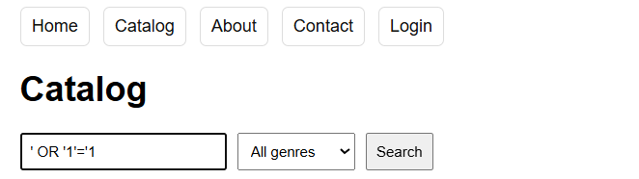
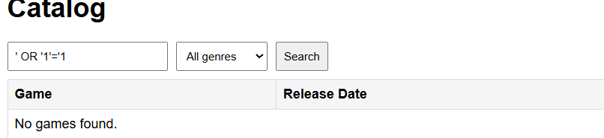
Attempted SQL Injection using a common payload entered into the catalog search field.
The input ' OR '1'='1 was submitted to test whether the search query could be manipulated to return all records. As shown in the screenshot, the application does not return any results and instead displays a “No games found” message.
This SQL Injection attempt fails because the application uses prepared statements with bound parameters when executing database queries. The injected string is treated strictly as a data value rather than executable SQL, preventing it from altering the query logic. As a result, the database does not interpret the input as a conditional statement, demonstrating effective protection against SQL Injection attacks.
User Input Capture
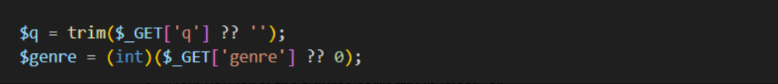
This screenshot shows how user input from the search field and genre dropdown is retrieved using PHP $_GET parameters. Basic sanitisation is applied by trimming text input and casting numeric values, ensuring the data is prepared safely before being used in database queries. This represents the entry point for all user-supplied input in the application.

Conditional Query Construction
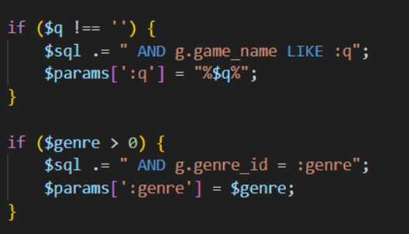
This screenshot shows how user input from the search field and genre dropdown is retrieved using PHP $_GET parameters. Basic sanitisation is applied by trimming text input and casting numeric values, ensuring the data is prepared safely before being used in database queries. This represents the entry point for all user-supplied input in the application.
Secure Query Execution
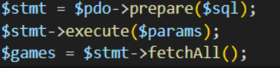
This screenshot shows the execution of the SQL query using a prepared statement and bound parameters. The query is prepared and executed securely, ensuring all user input is treated strictly as data. This mechanism is the primary defence that prevents SQL Injection attacks within the application.

CONCLUSION
This assignment demonstrated the development of a database-driven PHP website capable of displaying dynamic content and supporting full CRUD functionality. A structured relational database was designed and integrated to store and manage game-related data efficiently, while PHP was used to retrieve, display, and modify this data in real time. Administrative functionality was secured through authentication mechanisms and session-based access control.
Particular emphasis was placed on secure coding practices, especially in mitigating SQL Injection vulnerabilities. By implementing prepared statements, parameter binding, and input validation, the website effectively protects against common injection attacks. Overall, the project showcases practical application of PHP programming concepts, database interaction, and fundamental web security principles.

References
[8] OWASP, “SQL Injection,” OWASP WebGoat Project. [Online]. Available: https://owasp.org/www-community/attacks/SQL_Injection.
[9] W3Schools, “SQL Injection,” W3Schools Online Web Tutorials. [Online]. Available: https://www.w3schools.com/sql/sql_injection.asp.
[10] PHP Documentation, “PDO Prepared Statements,” PHP Manual. [Online]. Available: https://www.php.net/manual/en/pdo.prepared-statements.php.
[11] Cloudflare, “What is SQL Injection?,” Cloudflare Learning Center. [Online]. Available: https://www.cloudflare.com/learning/security/threats/sql-injection/.
[12] PHP: The Right Way, “PHP Best Practices,” PHP: The Right Way. [Online]. Available: https://phptherightway.com/
[13] Cloudways, “How to Connect MySQL Database with PHP,” Cloudways Blog. [Online]. Available: https://www.cloudways.com/blog/connect-mysql-with-php/
[14] Budibase, “What Is a CRUD App? A Complete Guide,” Budibase Blog. [Online]. Available: https://budibase.com/blog/crud-app/
[15] Meilisearch, “How to Build a Fast Search Engine in PHP,” Meilisearch Blog. [Online]. Available: https://www.meilisearch.com/blog/php-search-engine
[16] PHP Security, “Input Validation,” PHP Security Documentation. [Online]. Available: https://phpsecurity.readthedocs.io/en/latest/Input-Validation.html

