
Games Programming & Graphics: Opengl based 3d game (assignment 1b)
Steffan Davies – P149401


Table of Contents
Introduction 2
Algorithms/Coding Techniques used and their Implementations 2
User Guide 2
Appendices 3
References 8

Introduction
The aim of this report is to provide an overall highlight of the algorithms and coding techniques that has been used and implemented into making a finding pairs game. This report will also include a test schedule, and user guide for the game. Screenshots that show the code in further detail can be seen in the appendices.

Algorithms/Coding Techniques used and their Implementations
The program features the use of OpenGL to create a game based in a 3D environment. Using ‘glut’ based functions such as draw and display allowed 3D objects to be created and shown. To better understand the basics of OpenGL, sources such as OpenGL tutorials[1] and Learn OpenGL[2], [3] were used to learn more about its programming interface as well as resources available from Moodle[4].
The program also includes a bitmap file loader. This allows bitmap files to be attached to the 3D objects as textures. The bitmap file loader was provided via Moodle resources[4] and has been altered to be fit for purpose.
Although the program only allows keyboard use, attempts were made to also allow the mouse to be used. This would have included collision detection methods that would have flipped the card that was clicked on. The vector header and source files were also used to attempt achieving this.
The cards can also be successfully flipped between both the front and back of the cards. However, attempts to make a pair of cards that are the same stay flipped or not the same flip back has not been successful. Screenshots showing specific sections of code can be seen in appendices.

User Guide
To aim of the game is to find all the pairs of cards. If you open two cards consecutively and they do not match, they must be flipped back over. If they are found however, then they stay flipped. All cards must be flipped to win the game.
The controls to navigate through the cards are on the keyboard. To move up, press ‘w’. to move down, press ‘s’. To move right, press ‘d’. To move left, press ‘a’. After you have highlighted the desired card, press the space bar to flip the card and show the hidden shape.
It is also possible to move the environment by using ‘t’ to move forward, ‘f’ to move left, ‘h’ to move right and ‘g’ to move back. You can also rotate left by pressing ‘z’ and right by pressing ‘x’.

Appendices
Appendix 1: loading bitmap files
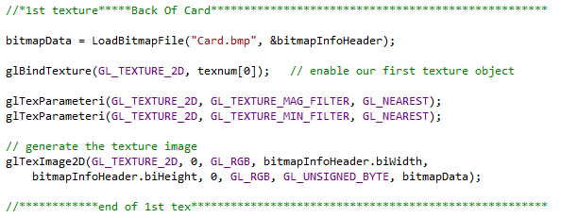
This screenshot shows the first bitmap file being loaded as a texture. This was done 14 times due to there being 14 bitmap textures.

Appendix 2: drawCard function
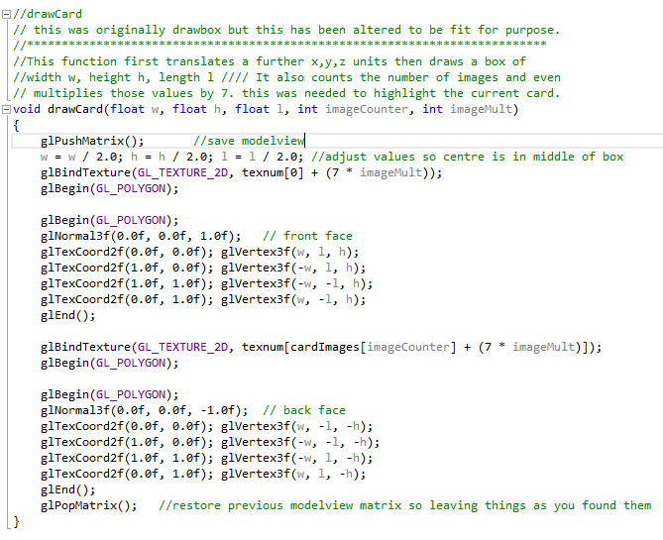
This screenshot shows the ‘drawCard’ function. This function was used to draw two textures onto one object one being the back of the card and the other being decided based on the image counter. The ‘glVertex3f’ is what is used to allow the textures to appear on both sides of the card.
Appendix 3: display function
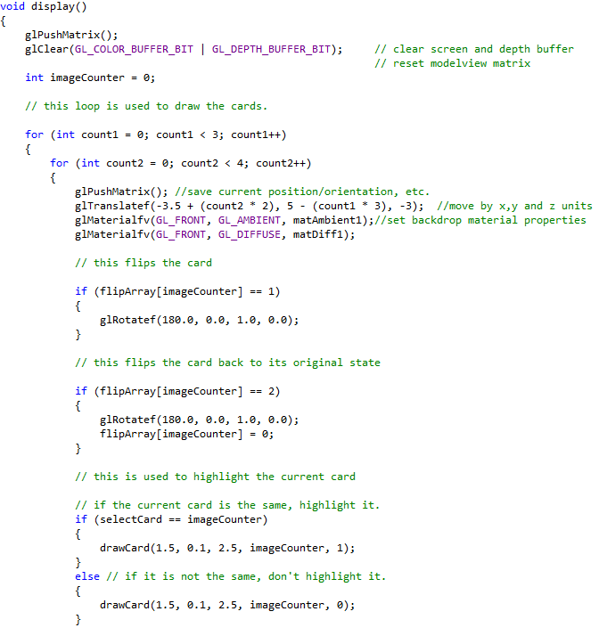
This screenshot shows part of the display function. Here, the function goes through a two for loops that counts the number of cards for a row and column that is to be displayed. Before the cards are drawn, it uses the ‘flipArray’ and the ‘imageCounter’ to count the number of images and to allow the cards to be flipped over back and forth. It also uses ‘selectCard’ to know which card is to use the highlighted bitmap texture.

Appendix 3: display function (Cont)
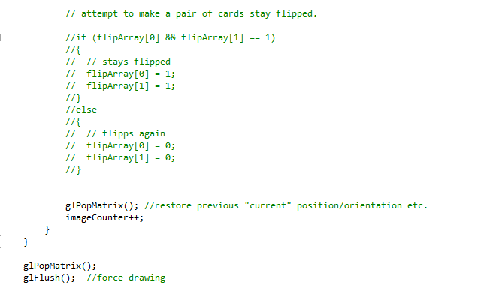
This screenshot shows the attempt that has been made to make the correct pair of cards stay flipped and inaccessible for the user to flip the card again. However, after testing this, the cards are not able to be flipped at all and by changing the index in the ‘flipArray’, it can be locked on either the back of card texture or front of card texture.

Appendix 4: keyboard function
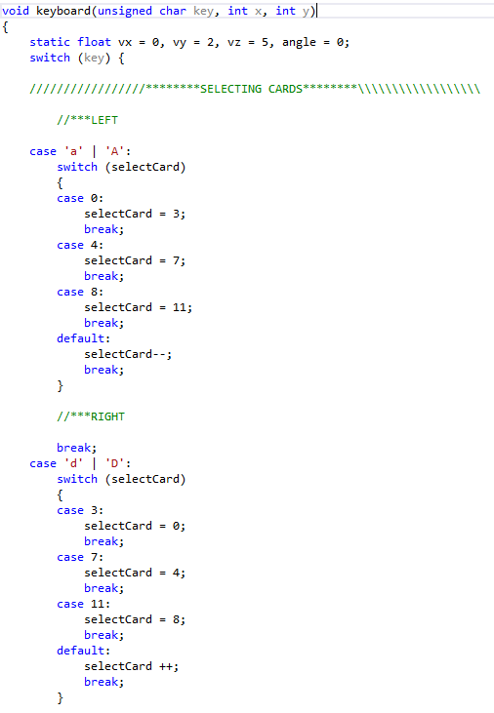
This screenshot shows part of the keyboard function. By using the switch cases, certain keys on the keyboard can be used to navigate through the cards. This function was also used to allow the user to move through a 3D environment.

Appendix 5: attempt at collision detection
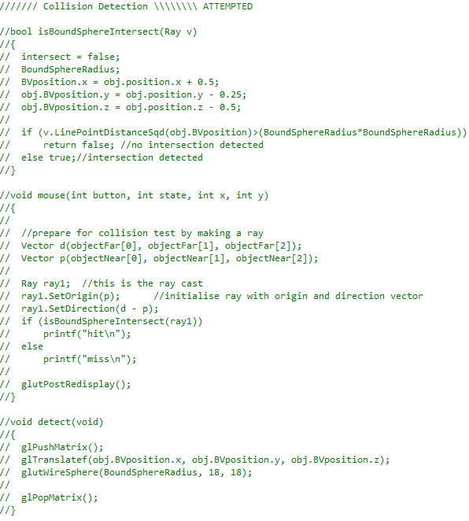
This screenshot shows the attempt that was made on the collision detection. If this was successful, it would have allowed the user to pick a card to flip by clicking on the card. The vector source and header files would have also been used to help with the collision detection.

References
[1] ‘OpenGL Tutorial’. [Online]. Available: http://www.opengl-tutorial.org/.
[2] J. De Vries, ‘Learn OpenGL An offline transcript of learnopengl.com’, 2015.
[3] ‘Learn OpenGL, extensive tutorial resource for learning Modern OpenGL’. [Online]. Available: https://learnopengl.com/.
[4] ‘Moodle Course: L5 - Games Programming &amp; Graphics (M5X01038)’. [Online]. Available: https://moodle.uwtsd.ac.uk/course/view.php?id=2276.

