How did Supreme become one of the largest names in fashion without the use of traditional advertising or marketing strategies?

Submitted in partial fulfilment of the requirements for the degree of BA (Hons) Advertising and Brand Design, University of Wales Trinity Saint David, Swansea.

List of Contents

List of Figures 2
Abstract 5
Introduction 6
Chapter 1 8
The Brand and its origin 8
Collaboration 12
Fashion World’s Interest 13
Limited Stock and ‘Drop Days’ 15
The Supreme Aftermarket 17
The Brick and the Box Logo 18
Chapter 2 22
Celebrity Endorsement 22
The Good 23
The Bad 25
Why are we Influenced by Celebrity? 27
Our Commodity Culture and the ‘Spectacle’ 28
The Role of Celebrity in the ‘Spectacle’ 30
Conclusion 32
Bibliography 34

List of Figures

Figure 1: Supreme Skate Video Premiere. (1995). [image] Available at: http://www.vashtie.com/blog/wp-content/uploads/2014/03/Supreme-store-new-york-ninetiess.jpg [Accessed 30 Oct. 2019].
Figure 2: Perez, D. (1996). Supreme Ad. [image] Available at: https://www.shadinyc.com/image/20158873514 [Accessed 30 Oct. 2019].
Figure 3: George Condo (2010). My Dark and Beautiful Twisted Fantasy Album Cover. [image] Available at: https://uk.phaidon.com/agenda/art/articles/2011/october/18/kanye-west-plays-impromptu-gig-at-george-condo-london-opening/ [Accessed 4 Dec. 2019].
Figure 4: Condo, G. and Supreme (2010). Supreme x George Condo Decks. [image] Available at: https://paddle8.com/work/george-condo/71840-supreme-skate-decks-set-of-three/ [Accessed 4 Dec. 2019].
Figure 5: Supreme (2019). Fall / Winter Look Book. [image] Available at: https://www.supremenewyork.com/lookbooks [Accessed 4 Dec. 2019].
Figure 6: Vice (2016). Photos of the Hundreds of People Who Queued Overnight to Buy the New Supreme Collection. [image] Available at: https://www.vice.com/en_uk/article/zng95x/Supreme-ss16-london-drop-photos [Accessed 30 Oct. 2019].
Figure 7: Ebay (2019). Search Results Screenshot. [image] Available at: https://www.ebay.co.uk/sch/i.html?_from=R40&_sacat=11450&_nkw=supreme+new+york&_sop=12 [Accessed 4 Dec. 2019].
Figure 8: Stock X (2019). Supreme Box Logo Crewneck (FW18) Black. [image] Available at: https://stockx.com/supreme-box-logo-crewneck-fw18-black?utm_source=bybuybye&utm_source=af&utm_medium=rak&utm_campaign=3539667&ranMID=43272&ranEAID=3539667&ranSiteID=BezHM9PFMlA-MZZlKJ5U1_0MLrnG9CrcMw [Accessed 4 Dec. 2019].
Figure 9: GQ (2015). The Kanye West Look Book. [image] Available at: https://www.gq.com/gallery/kanye-west-every-outfit-look-book [Accessed 4 Dec. 2019].
Figure 10: Supreme (2016). Supreme Fall / Winter Look book 16. [image] Available at: https://www.supremecommunity.com/season/fall-winter2016/overview/ [Accessed 4 Dec. 2019].
Figure 11: Complex (2004). Gallery: Celebrities Wearing Supreme. [image] Available at: http://Gallery: Celebrities Wearing Supreme [Accessed 4 Dec. 2019].
Figure 12: Paul E. Writ Fountain Pen Company (1904). Mark Twain Advertisment. [image] Available at: http://www.twainquotes.com/FountainPens.html [Accessed 4 Dec. 2019].
Figure 13: Slowthai (2019). WHEN I DIE SMILE GOODBYE. [image] Available at: https://www.instagram.com/p/B470jZvnTfT/ [Accessed 4 Dec. 2019].
Figure 14: Pepsi (2017). Live for Now Campaign Still. [image] Available at: https://www.prweek.com/article/1429606/social-media-trashes-pepsis-new-kendall-jenner-spot-calling-tone-deaf [Accessed 4 Dec. 2019].
Figure 15: Fairy Liquid (2012). Fairy Liquid Advert Still. [image] Available at: https://www.campaignlive.co.uk/article/watch-30-years-fairy-ads-grey-london/1385259 [Accessed 4 Dec. 2019].
Figure 16: LIFE Magazine (1952). Opening night screening of Bwana Devil at Hollywood's Paramount Theatre. [image] Available at: https://time.com/3878055/3-d-movies-revisiting-a-classic-life-photo-of-a-rapt-film-audience/ [Accessed 5 Dec. 2019].
Figure 17: Hussein, A. (1997). [image] Available at: https://time.com/5682006/princess-diana-landmines/ [Accessed 5 Dec. 2019].

Abstract

In April 1994, James Jebbia founded Supreme in a small office space in SoHo, New York. What began on Lafayette street has now transformed into a global icon worth over a billion US dollars. This paper focuses on the growth of the brand from a small shop front to where it is today and how its brand developed such a massive cult like following. How its customers are reselling their products for multiples of the original price. It will also reflect the current state of the world within which we are influenced by celebrities daily and other popular culture icons through social media especially within the social environment we live in today.

Introduction

Hundreds stand queuing for hours upon hours every Thursday morning across the globe, they wait in anticipation of streetwear giant Supreme’s doors to open at 11am (Woodhall, 2016). Wanting to spend their money on the newest streetwear and accessory releases from the brand. To outsiders this seems absurd and laughable but to the cult like followers of Supreme the countless hours waiting is a must.
This independent inquiry is an attempt to study and explain the success of the clothing brand Supreme. Being a long time Supreme follower and consumer, I have noticed the brand’s popularity rapidly growing over the years and I was curious as to what aspects of the brand are so attractive to outsiders and the why wearing the brand is such a statement. Bringing my own personal experience as well as knowledge I would not otherwise know if I hadn’t been a follower of the brand for years. The subject also relates to my own study as an advertising student and I strongly believe that understanding the success of the brand’s strategies will benefit me in my own professional practice as well as new age advertising strategies. Advertising is constantly changing within our modern society (Sorrell, 2019). Having knowledge on what works and what doesn’t is crucial information for anyone within this field.
As advertising and marketing has greatly changed during the lifespan of Supreme (Tuten, 2008). I intend to discover the history of the brand, the different marketing strategies the brand created which separated it from its competitors and the way the brand introduced artists and musicians to their audiences. The study will interpret the exclusive and ‘cult like’ following of the brand and will evaluate the importance of the commercial environment of today’s world in which the brand thrived. To further explain and compare this environment, I plan to review and study the theories and beliefs of Guy Debord’s ‘La Société du Spectacle’ which describes capitalism’s pacification and distraction of consumers (Jappe, 1995). I will also analyse the role of celebrity within the ‘spectacle’, as the use of celebrity is prominent In Supreme’s strategy.
In chapter 1, I introduce and discuss the brand itself and the marketing strategies that the brand used and still use today, as well as examples of these methods and the effect they have on consumers as well as outsiders. I analyse the marketing cycle which describes the unique way that the brand distributes its clothing which results in huge demand for the brand’s product and massive online aftermarkets (Babcock, 2005; Kulkarni, 2019).
In the chapter 2, I focused on the massive influence of celebrity in the modern world (Clifton, 2016. Supreme’s use of celebrity endorsement as well as celebrity endorsements as a whole; successful examples, poor examples and the role of celebrity within our current society. I also explore the theories of Guy Debord and its connection to Supreme.
This independent inquiry matters because Supreme’s strategy is unique, understanding how the strategy was so successful would be beneficial to any company that intend to replicate this strategy to market their product or service using celebrity or methods which aren’t considered traditional. The inquiry could be extended by looking at any attempts to replicate the strategy to see if this success was unique to Supreme or is a viable strategy for any business.

Chapter 1

The Brand and its origin

Supreme, a clothing brand that was for skateboarders by skateboarders. Now a fashion powerhouse with a massive cult following and whose customers will readily wait in line at the brand’s eleven stores for hours to get the highly sought after clothing they desire. The brand is now valued at over a billion dollars after it sold half its equity for five hundred million dollars in 2017 (Segran, 2017). It all started in a small store based in SoHo, a space described by its creator James Jebbia as:
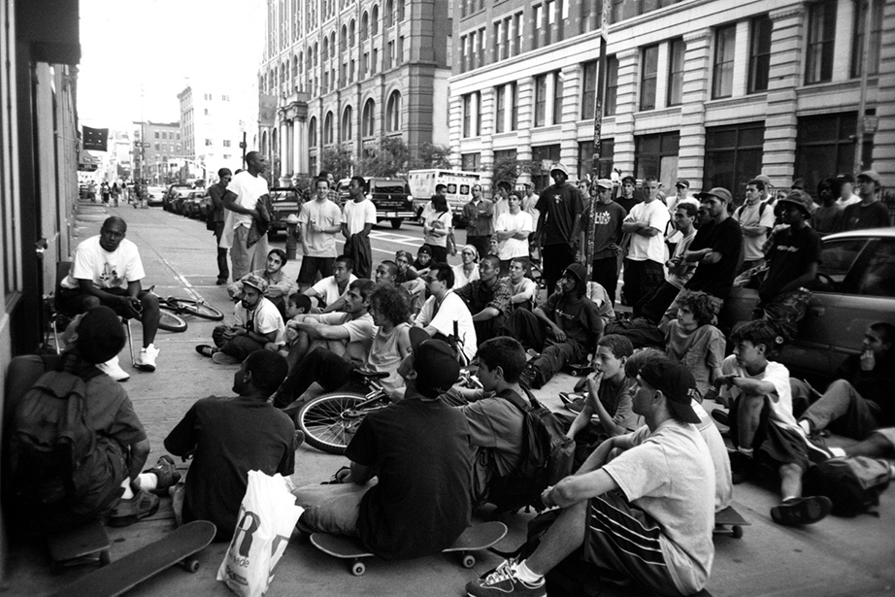
The cool, cool shop, the shop that carries the cool stuff that everybody was wearing—no big brands or anything. (Jebbia, 2017)

Fig. 1: (Supreme Skate Video Premiere, 1995)

This independent boutique would display the newest skate videos in the shop window (See Fig. 1) and played heavy rock and gangster rap music so loudly that you could hear it before you even walked through the door. The effectiveness of the shop floor’s layout gave skaters the opportunity to use the space as a hangout and a spot for all the ‘cool’ people to socialise at, making it the meet up spot for skaters across New York (Wilson, 2017).

It was marketing and branding choices such as this which gave Supreme its cool but intimidating edge, the same edge which still attract so many people years later garnering up to thirteen million followers online. SoHo in the mid-nineties, the epicentre of what was being considered fashionable, with new trends starting daily and yesterday’s being forgotten.
In the early days it was like come in, don’t touch; you can look with your eyes but not with your hands. It was a crazy way to sell garments but the customer learned the deal: don’t fuck with us and we won’t fuck with you. T-shirts were folded tightly like it was art … all the while the skate team and crew were just hanging-pretty heavy for an outsider. (The Business of Fashion, 2012)

Skateboarding was the new in thing- the fashion world became captivated by the style, attitude and overall aesthetic of skaters, putting the brand in the focal point of this emerging trend (Gordon, 2017). The importance of marketing and advertising decisions that Supreme had to make were crucial in how the brand was perceived at the start of its existence.
Even today, an individual who is a part of this culture, who knows its ins and outs, who is aware of the brand history and who has been a part of it since its origin is depicted as someone cool and respectable within the overall streetwear scene. Newcomers within this culture strive to be depicted as these people and this ties in with the desire of the brand; wearing the clothes, especially the more expensive and rare pieces give people the perception of your brand knowledge and loyalty therefore portraying you as a member of a higher society within the culture.

Both US stores, New York and Los Angeles, are still known for their poor and boorish customer service which has little or no tolerance for customers with limited knowledge about the in-store rules (BallerStatus.com, 2019). These rules work on a strict ‘get in’ and ‘get out’ policy and exceptionally this gave the brand this ‘edge’ which drew customers toward the brand giving it this exclusive feeling, knowing these rules you feel like you fit in within this cool subculture which is so exclusive. Supreme’s creative director talks on this matter of customer service and how it’s always stayed authentic to its skater employees.
Skateboarding has never been nice. Let’s make that clear. It started as an outsider thing, and skateboarders have always been assholes, so if you have legitimate skaters working in stores then they are going to be fucking assholes. I love them for being who they are. If you don’t like it then don’t fucking shop. (Marfa Journal, 2019)
This quote illustrates the cult like nature and authenticity which resides within the brand’s identity which is adopted by its consumers as they are notoriously cliquey, they won’t talk to you if you don’t know about the brand. ‘If you don’t like it then don’t shop’, The statement shocks as it is so unlike usual customer service, it is this shock and careless aspect which some audiences find so attractive about the brand.
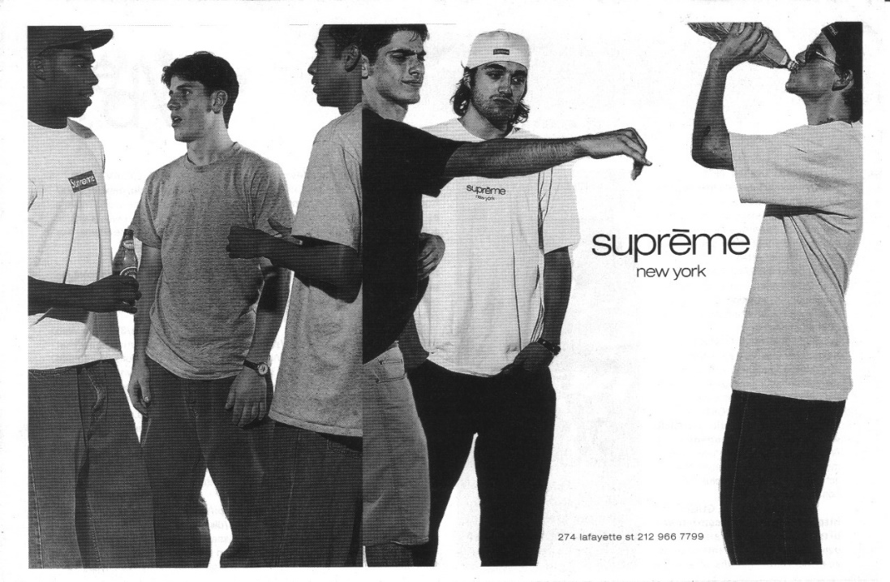
Fig. 2: (Perez, 1996)
This black and white newspaper print ad (See Fig. 2) from 1996 really illustrates the ‘Supreme culture’ that was so appealing at this period, young men drinking wearing dirty Supreme branded clothing. There is nothing attractive about this image, but it epitomised what they were and what they wanted to be; ‘We are Supreme, and we don’t care’. This image being a central to the representation of the brand’s identity: a young crew of New York City skaters with a profound understanding and interest with hip-hop and punk culture (Supreme New York, About Page, 2019). This advert would have been contrasted on a larger scale in comparison to other types of adverts shown in the newspaper, it would likely have only appealed to a specific group of people. To this audience however, it would have completely resonated with them; these were the young skaters of New York looking for an outlet and a hub which fit this new social scene.

Collaboration

Keeping the ‘cool’ status for Supreme is crucial to its popularity, using traditional advertising techniques such as video, print or even digital could potentially tarnish the brand’s edgy and non-commercial image. The brand found other means of staying relevant in the fast-changing fashion world; collaborating with huge industry giants and reach different audiences, such as Louis Vuitton, Nike, Vans and Comme des Garcon and many more (AuthenticSupreme.com, 2019). The collaboration with these brands allowed Supreme to be noticed by celebrities who would, in turn, boost the recognition of the brand further down the line.
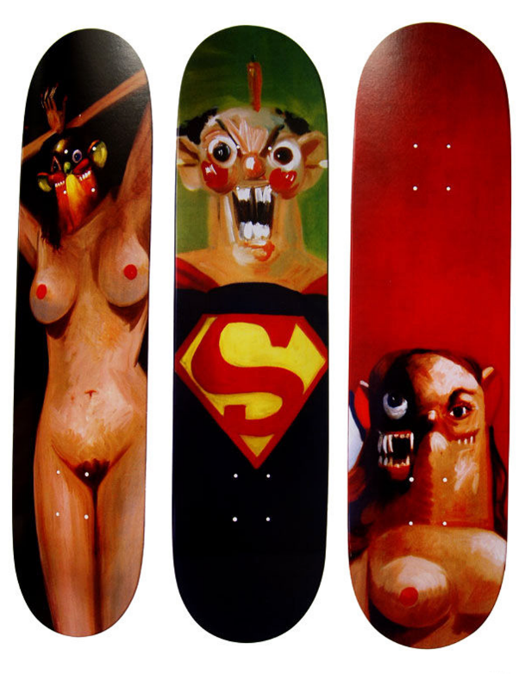
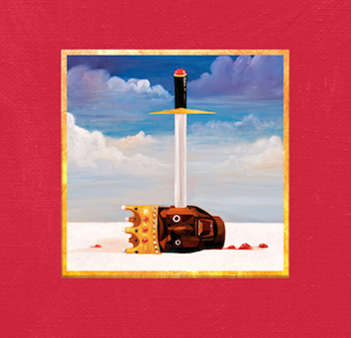
Not only fashion industry giants but Supreme also collaborate with trending artists to boost interest in the brand some being some of the biggest names in art and the most notable being Roy Lichtenstein, Mark Flood, Jeff Koons and Damien Hirst (The Idle Man, 2019). It is one of the aspects which led Supreme to be the industry giant it is today.
(Fig. 3: Condo, 2010) (Fig. 4: Condo, 2010)

An example of this would be the artist George Condo, who received his recognition from designing the album cover for Kanye West’s ‘My Dark and Beautiful Twisted Fantasy’ (See Fig. 3), before the album he collaborated with Supreme creating skateboard decks (Silver, 2019). (See Fig. 4)
West and Supreme have had a solid relationship for years, West being a large endorser and a long time representative of the brand. One could suggest that Supreme’s introduction of George Condo to Kanye West influenced West to contract Condo for his album cover. West’s following is one of the largest in the world with an estimated number around the hundreds of millions and hence West is arguably the most influential person to the younger generations. Condo’s album covers therefore reached millions of people via the success of West’s album (Billboard, 2019). Kanye West and others influence on audiences and consumers will be discussed and reviewed further in this dissertation as it is most likely the largest factor in the brand’s marketing strategy.

Fashion World’s Interest

It was this very attitude and appeal that attracted fashion giants to the skate culture of the nineties exposed it to the world. The appropriation of skater culture by the fashion world is an ongoing feud:
One day you're an outcast and the next day everybody wants to wear the clothes you're into and lay claim to it? You're going to be a little annoyed by that. (Babenzien, 2017)

This is a quote from Babenzien, a streetwear company owner and one of the original skaters from the nineties. He explains that skaters take offence to the appropriation of their culture as it is something that for a long time was looked down upon and was never respected. Now that the clothes skaters wear and the way they act is now fashionable it feels forced and they are taking a fascination into the culture for all the wrong reasons. This new scene was vibrant and young and everybody wanted to have a piece of it. Part of what made Supreme and this culture so special is that you could not be a part of it without skating. Unfortunately, for the culture it is these aspects which made it so appealing in the first place, like being part of a private club. For Supreme it was this fascination that allowed its marketing strategy to work so well further down the line.
Cultural exploitation: the appropriation of elements of a subordinated culture by a dominant culture without substantive reciprocity, permission, and/or compensation. (Rogers, 2006)

Rogers argues that this is not simply appropriation of cultures but that of exploitation where these massive industry giants prey on the growing popularity of a minority culture such as the nineties skateboarding movement. There would appear to be some truth in this as the fashion industry uses this movement for monetary gain without any thought of recourse toward the culture itself. Now Supreme being situated at the centre of the currently skateboarding culture obsessed fashion world, paired with the before mentioned aspects of exclusivity clique like skate scene, collaboration, the store itself and the identity of the brand made Supreme increasingly appealing.

Supreme is exactly what it is, it typifies its name, as a lifestyle, as the higher echelon, the best of the best, the cream of the crop. … Knowing that it began as a skate brand, it’s a state of mind that defines who you are, 24/7, 365. Now though, I think Supreme as a brand is part of skate, hip-hop, and fashion, it encompasses all of them. (Rajendran, 2012)

Limited Stock and ‘Drop Days’

The unique marketing strategies outlined so far in the previous sections aided Supreme in growing its brand hugely. However, it was its exclusivity which contributed to the brand skyrocketing in popularity. From its creation to the current day, the way Supreme sells its clothing is like no other, leveraging it’s cool and desirable appeal as well as its exclusive perception. Supreme will only stock a very limited batch of a specific item, meaning once it’s gone, it’s gone.
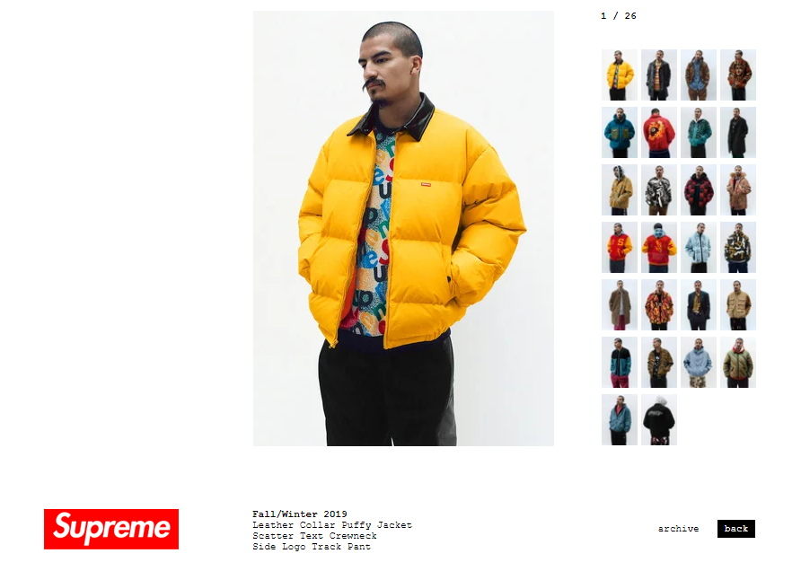
This creates a marketing cycle for its products. It starts with ‘planting the seed’, before a season e,g Spring / Summer, the brand will release a ‘look book’ which is a catalogue of all the products and clothing they will be releasing on a weekly basis throughout the season (see Fig. 5).
Fig. 5: (Supreme, 2019)

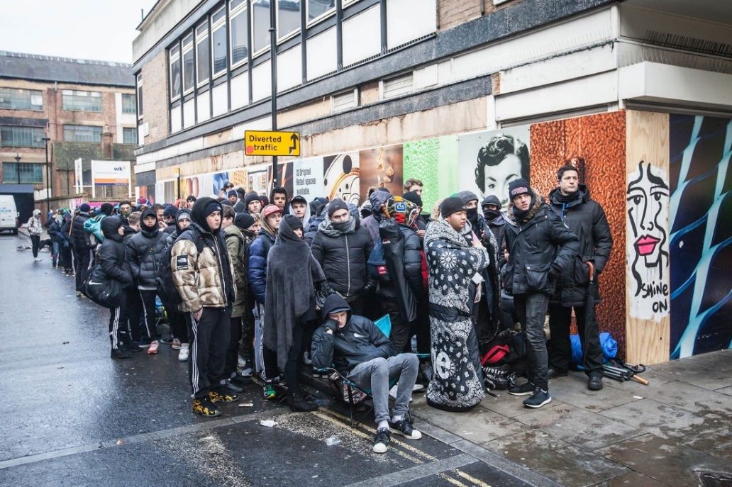
This ‘look book’ is typically launched a few weeks prior to the initial store opening, allowing excitement to build for items seen in the preview. Each week a new set of items will be released on Thursday at 11am (Ffooks and Maoul, 2019). On the Wednesday preceding the release day the brand will ‘leak’ which items from the ‘look book’ will be releasing the next day. This ‘leak’ happens on Twitter and is shared by user ‘@DropsByJay’ who’s connection and affiliation with the brand is unknown, possibly to add to the exclusive and mysterious façade that is associated with Supreme. Notably, following the end of a season Supreme will close the store for a two month period while the brand is preparing for the season e,g January the store will be completely closed and the brand will go radio silent on all social media. The closing between seasons coupled with the brand’s reoccurring collaboration with artists it could be comparable to that of an art gallery and therefore reinforcing their exclusive marketing strategy.
Fig. 6: (Vice, 2016)

By releasing their seasonal collections on a weekly basis as well as on supplying a very limited amount of stock, it allows the brand to retain interest and desire throughout the store’s opening period, as it makes people wait for specific items, also this way there will be one or two particular items per week which will have the most hype / interest and will be the most desired for that particular week, meaning hundreds queuing up for days to get their hands on this item which would invariably sell out. (see Fig. 6)

The Supreme Aftermarket

The demand for Supreme was quickly outgrew the availability of the products due to the before mentioned marketing strategies. This created a large after market for the Supreme clothing with people willing to spend hundreds on items that originally cost fractions less. This aftermarket quickly spread awareness of the brand and enhanced its already fast-growing popularity. These online aftermarkets are mainly present on platforms such as Ebay and Depop, which garner tens of thousands of search results. (See Fig. 7)
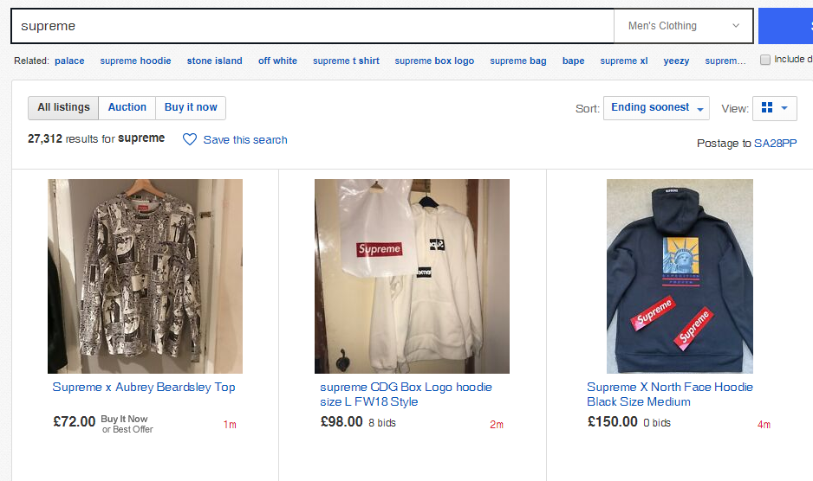
Fig. 7. (Ebay, 2019)

Prior research has often pointed out consumers’ desire for exclusivity as a driver of preference for scarce products due to limited supply (Kim, 2018)
This quote illustrates the psychology of Supreme’s marketing and sales strategy, due to the massive demand for the product before release paired with a limited stock the item will no doubt sell out. The exclusivity of owning that product is now much higher, driving consumer’s desire and the want for the product much higher than before.
For example, the desire for a piece of clothing grows exponentially when it becomes limited, as an item is far less available. The best example of which being the Supreme Brick. In the latter half of 2016, during their Fall / Winter collection Supreme released a clay brick. (See Fig. 10)

The Brick and the Box Logo

A singular brick with the iconic ‘Box Logo’ which is the staple logo that Supreme use, this logo is put on either a hoodie or a t shirt once a season. The ‘box logo’ or commonly referred and abbreviated to ‘Bogo’ products are the most desired amongst Supreme consumers as it is their most iconic and recognisable branding, owning a ‘box logo’ ties in with the exclusivity of owning the brand as these specifically branded products are much harder to come by than the rest of their products.
The branding of Supreme is important to note as the recognisability of its logo plays a role in the brand’s success, it is so recognisable and eye catching that it entices curiosity in the audiences that view the logo whether on a website or on hoodie someone on the street is wearing. The cost of these ‘box logo’ clothes often costing five or six times the retail value in the aftermarket. To people who already recognise the logo, the ‘box logo’ is a statement piece, resembling of a declaration of social class within the subculture of streetwear, celebrities or people of influence often wear a ‘box logo’.
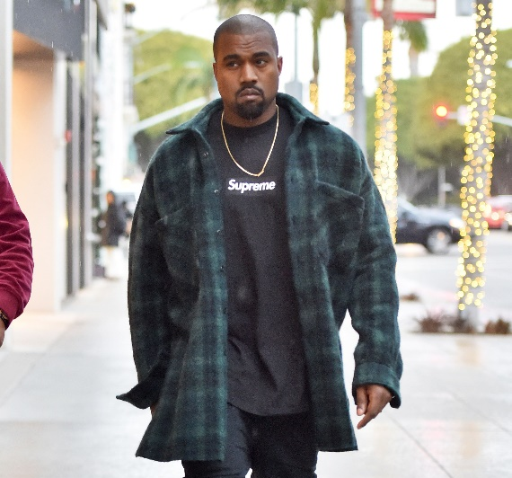
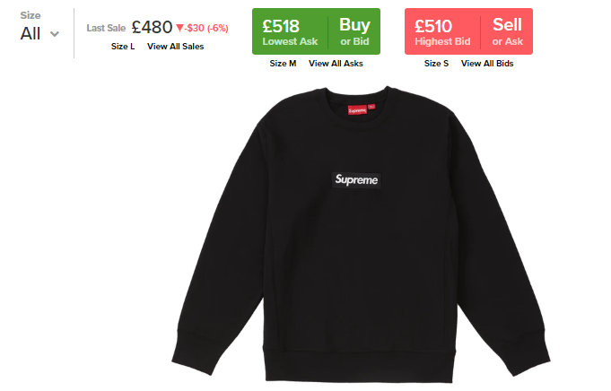
Fig. 8: (Stock X, 2019) Fig. 9: (GQ, 2015)
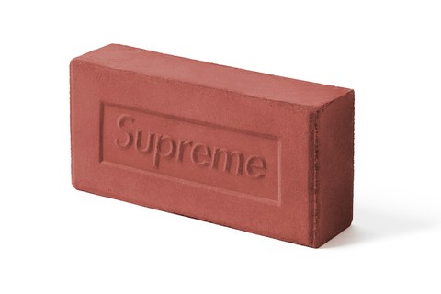
These figures show the aftermarket value of a ‘Box Logo’ product, the retail value of which being about £138, though the fact that this particular piece was worn by Kanye West fuels more desire for that product and inturn increasing it’s aftermarket value. The common conception is that Supreme’s influence is so large and impactful due to its original marketing strategies that it’s consumers will buy anything with a ‘box logo’ on it, hence the ‘box logo’ branded brick. The brand sold the brick as what it was, no jargon to distract consumers on the fact that they were paying £40 for a ceramic brick on release day. Why a singular brick with no real purpose?
Fig. 10: (Supreme, 2016)
what unites Supreme’s accessories is that most of them have some sort of illicit/underworld connotation having to do with violence or drugs. (Shaprio, 2016)
A common theme among Supreme’s accessories is the connection with the nineties and the crime that surrounds that era. The accessories being ‘box logo’ branded baseball bats, knives, hammers and crowbars. Reason being because they want to retain that same edge they first pioneered in the beginning. The same feeling it produced in that decade with their loud music and poor customer service, which is still present today, intimidating but also very appealing which still plays a role in their marketing strategy.
The true genius of Supreme is that it is just a brick, they are aware of their own influence and that regardless of what they sell people will consistently buy it. For people on the outside looking in, this seems absurd that people are willing to spend this amount of money on a clay brick, especially when at its peak the aftermarket value of the brick was up to a thousand dollars. This is where the marketing strategy takes place, of course general media are going to report on this. Websites, newspapers and radio and television news shows all sharing the story about this brick, in turn boosting the brand’s recognisability and awareness which will turn audiences into consumers. It is this aspect of mischievous marketing behaviour in its brand identity and marketing strategy, which is so attractive to young people as well. rarely are brands seen doing this strategy it is very tongue and cheek and appealing to some audiences which is a key aspect of their brand identity.

Chapter 2

Celebrity Endorsement

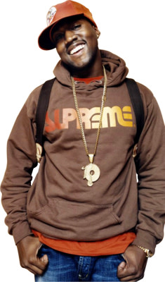
Celebrity Endorsement played a massive role in Supreme’s successful strategy, using the influence of celebrity figures to increase the recognition and in time the desire for the brand. Examples of this are present early as 2004.

Fig. 11: (Complex, 2011)
Here is an image of Kanye West wearing a Supreme hoodie in 2004, (See Fig. 11) as you can see West’s affiliation with the brand is long standing and has been around before the brand’s popularity skyrocketed in the 2010s. It was down to West and other figures of influence such as Victoria Beckham, Travis Scott, Justin Bieber and Kate Moss (Nast, 2017). These people of influence contributed largely to this surge in popularity, as popular icons were attracted Supreme for the reasons mentioned previously such as the fashionable but exclusive aesthetic of the skateboarding culture and the social superiority of owning clothing pieces from the brand.
The curiosity of why we are influenced to desire these items solely because a celebrity wears the clothing. Society has always examined people of influence for social cues, a notable example being the now omnipresent white wedding dress, the popularisation of which credited to Queen Victoria (Miller, 2018). In a time where access to celebrity news via the internet or television was non-existent, monarchs at that period would be considered as celebrity.
Not only does that celebrity bring new value, excitement, or humour but they bring an energy and memorability that you don't get sometimes with non-celebrity advertising. (Alleyne, 2002)

The Good

Promotion and advertising have become fundamental to any modern business. Celebrity endorsements are a staple of modern-day advertising, it seems that every celebrity has a specific brand or brands that they are partnered with. Even one hundred years ago, before the existence of modern-day advertising, celebrities such as Mark Twain were being endorsed by brands (See Fig. 12). These endorsements can create massive success for businesses, such as when Nike endorsed golfer Tiger Woods in 1996, which increased the sales of golf balls by $50 million dollars by 2002. (Madhav and Vemuri, 2004). Or that of the Jordan brand a subsidiary of Nike, which uses the name of basketball legend Michael Jordan to sell basketball equipment and shoes, recently the subsidiary of Nike generated $3.14 billion in 12 months. (Badenhausen, 2019). Comparing to Supreme, these brands have used their celebrities on traditional advertising methods such as television or print advertisements, whereas Supreme give them the product knowing that the celebrities will wear the clothing because of the brand’s recognition and the perception that goes along with the brand (See Fig. 13).
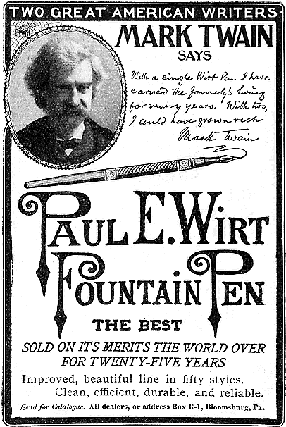
Fig. 12 (Paul E. Writ Fountain Pen Company, 1904)
Celebrities can influence via tabloid magazines, social media, film and television. Which leads to people looking to celebrity for guidance in fashion, home life and behaviour etc, in turn influencing what they desire e,g a specific t-shirt a celebrity is wearing. Which in this case is hard to come by as the result of Supreme’s market strategy. As this would exert influence on many, creating higher numbers of demand for the product as well as people who have a desire for the particular t-shirt, paired with the limited stock strategy it increases the aftermarket value of the specific item consequentially making it more expensive solely because a celebrity has worn it, garnering more attention and starting the marketing cycle again.

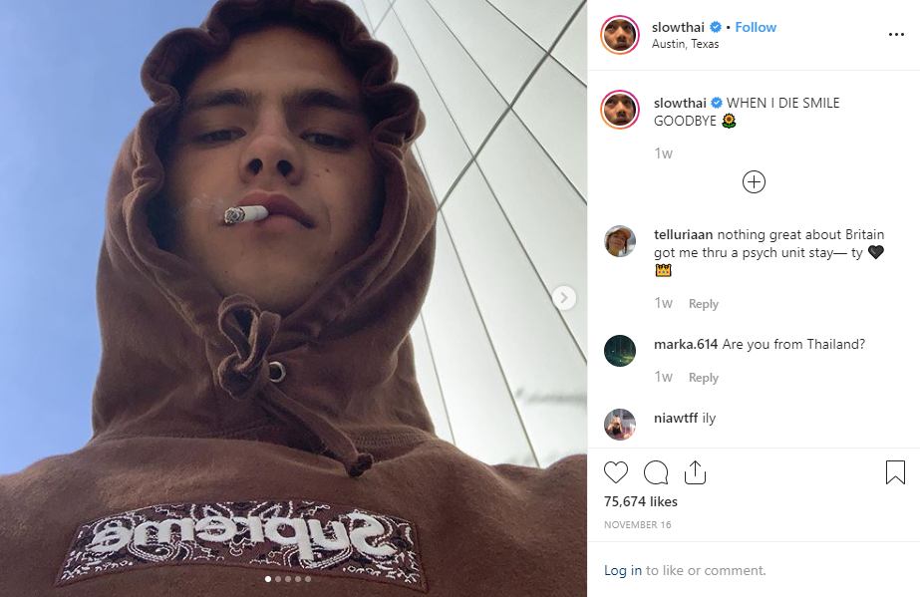
Fig. 13: (Slowthai, 2019)
Pictured is Slowthai (See Fig. 13), a British rapper with a large following whose fanbase would be considered the ideal Supreme consumer. Sharing a picture of himself wearing a brown Supreme box logo hoodie which is a part of the Fall/Winter 2019 season. The clothing piece at the date of the post has yet to be released, this is an example of Supreme using celebrity to advertise the brand to wider audiences before release. Notably besides from the clear box logo branding there is no mention or further endorsement of the brand in the post, only a relevant person of influence wearing the clothing, as having a strapline or ‘buy now’ would ruin the ‘cool’ appeal of the brand as well as contradict its identity.

The Bad

Although celebrity endorsements are often successful, there are many examples in which these endorsements have had serious backlash which has resulted in severe consequences for the businesses that endorse the celebrity. The most significant in recent years being Kendall Jenner’s endorsement of the Pepsi, in their 2017 ‘Live for now campaign’ (Schultz, 2017). The widely criticised campaign depicts a scene resembling a black rights protest in which tensions are high and violence could break out at any moment, ultimately the advert saw Jenner offering a can of Pepsi to one of the police officers, (See Fig. 14) defusing tensions and ending racism.
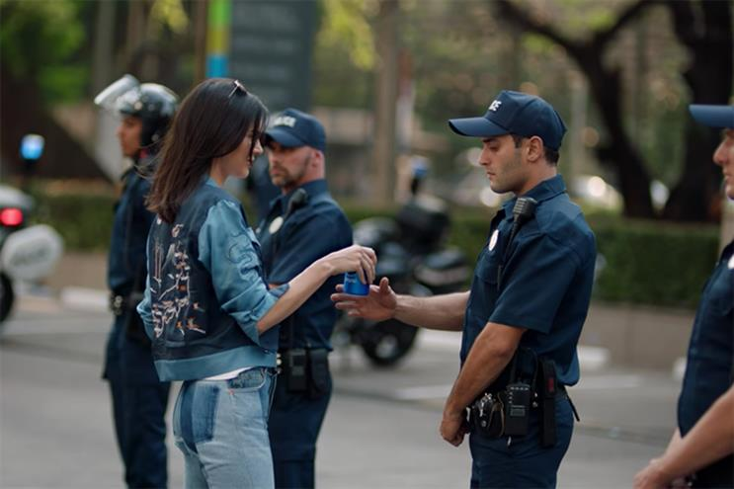
Fig. 14 (Pepsi, 2017)
The outrage poured in as the campaign was released, deeming the Pepsi and its campaign insensitive and tone-deaf. Immediately, Pepsi were called out for commercialising social movements for monetary gain, issuing an apology via twitter: ‘Clearly we missed the mark, and we apologise. We did not intent to make light of any serious issue. We are removing the content and halting any further rollout’ (Pepsi, 2017). In the aftermath of the campaign’ s release, the brand’s awareness and recognition were at its highest in the brand’s history, but not in the way they had hoped when they initially released the advertisement. The brand’s social mentions had increased by 21000% and being mentioned over a million times on the day of release (Joyce, 2017). The failure of the campaign had little effect on Pepsi’s sales. The campaign’s flop still stands as a warning to other large corporations that use celebrity endorsements in their marketing strategy.
The evidence of successful examples of celebrity endorsements is clear and businesses gain massive recognition and monetary gain using celebrity. Understanding why these celebrities have so much influence in our modern world is increasingly important to the explanation of Supreme’s success.

Why are we Influenced by Celebrity?

One is just learning what high-status individuals do so you might more effectively become one, and two, it's basically political. Knowing what is going on with high-status individuals, you'd be better able to navigate the social scene. (Kruger, 2012)
Evolutionary psychologist Dan Kruger presents the thought that the reason we are so easily influenced by celebrity, is down to our primal desire to be higher in the social ladder and achieve better social status. It is clear within our modern world that this conception is more present than ever, with the benefit of mass media and our highly consumer orientated culture, it makes sense that the celebrity of today hold such influential power. Particularly with luxury commodities such as watches, houses, cars or in this case designer clothing, these reflections being commonly associated with that of celebrity or person of social significance today. In correlation to Kruger, Dr Dimitrios Tsivrikos, consumer psychologist as UCL professor tells VICE:
In the past, tribes would decorate themselves with feathers or precious stones to set them apart from other tribe members and attract potential mates. In the same way, collecting Supreme really allows people to build their identities with rare objects. (Clifton, 2016)
Kruger’s and Tsivrikos’ statements are massively emphasised within our own lives which is focused heavily on our desires for property and commodities. Coupled with our primal desires to reach higher in the social scene and to separate ourselves, it illustrates the effectiveness of celebrity endorsements especially with Supreme and its exclusive style of marketing.

Our Commodity Culture and the ‘Spectacle’

The alienation of the spectator, which reinforces the contemplated objects that result from his own unconscious activity, works like this: The more he contemplates, the less he lives; the more he identifies with the dominant images of need, the less he understands his own life and his own desires. The spectacle’s estrangement from the acting subject is expressed by the fact that the individual’s gestures are no longer his own; they are the gestures of someone else who represents them to him. The spectator does not feel at home anywhere, because the spectacle is everywhere. (Debord, 1967)

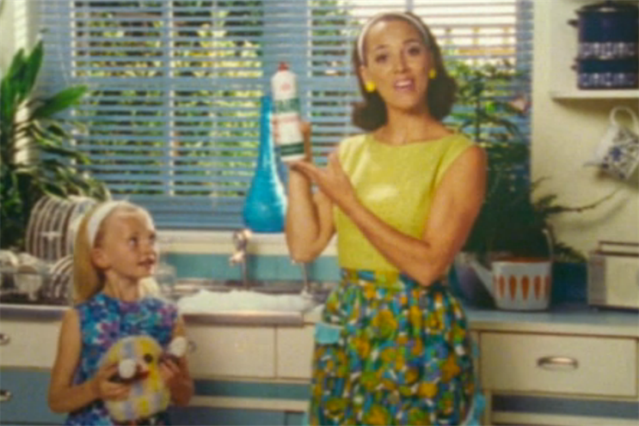
The quote from French situationalist Guy Debord’s book which epitomises the ‘Spectacle’, the term coined by Debord to define our consumer culture and the media that fuel it. He depicts the ‘Spectacle’ as capitalism’s distraction of the general public through mass media, borrowing Marxist themes such as social alienation and commodity culture. Though the book was written over fifty years ago, his beliefs are more significant today as the ‘Spectacle’ takes many forms that surround us constantly such as social media and advertisements.
Fig.15 (Fairy Liquid, 2012)
The ‘Spectacle’ reduces and reconstructs the world in simple narratives, such as advertisements which portray fictional individuals with the ‘ideal’ lifestyle, a lifestyle which is completely fabricated and unrealistic to anyone in the real world (Sheehan, 2013). Most commonly seen in domestic products advertising that target women, usually stereotyping women as the house wife who live in the perfect house with their perfect children. (See Fig. 15). Today the reduction of our lives can be seen by the use of apps that are described as ‘social medias’ but are truly unsocial and artificial intelligence assistants such as Siri or Alexa which diminish the use of interpersonal communication. (Morgan and Purje, 2016).
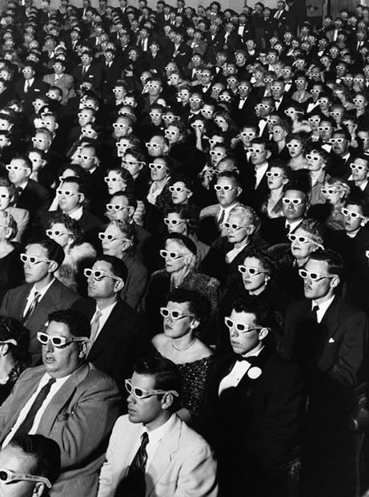
Relatedly, Supreme’s use of celebrity endorsement across social media is central to comparing Debord’s beliefs with the strategies of the brand. Rappers, singers and fashion icons sharing images of themselves wearing the brand to their huge online following, often wearing items which haven’t released adding yet another layer of hype and exclusivity to the strategy (See Fig. 13)
Fig. 16: (LIFE Magazine, 1952)

This image (See Fig. 16) famously used as a cover by LIFE Magazine as well as the cover for Debord’s book. It truly encapsulates the context of the ‘Spectacle’, the image shepherds the individuals present into strict rows of spectators with no clear identity. Lined up in awe, constantly distracted by something which we cannot see in the image, something that doesn’t truly exist within the image which is an apt metaphor for our own lives according to the ‘Spectacle’.

The Role of Celebrity in the ‘Spectacle’

stars serve as superficial objects that people can identify with in order to compensate for the fragmented productive specializations that they actually live. The function of these celebrities is to act out various lifestyles or socio-political viewpoints in a full, totally free manner (Debord, 1967)

The role of celebrity within the ‘Spectacle’ is to sell commodity, through the idealisation of celebrity and their lifestyle, reflecting thoughts such as ‘I should have this body’ or ‘own that car’. In a sense buying the commodities they endorse make the masses feel more complete. Debord’s beliefs define the environment that made Supreme’s use of celebrity so successful, by having these figures wear and endorse the brand, which is a commodity within itself, allowed desire for the brand to grow significantly following the endorsement. The same can be said for any corporation in which uses celebrity endorsement, though the use of celebrity practise and its ethical qualities is highly questionable.
His qualities -- or rather his lack of qualities -- illustrate our peculiar problems. He is neither good nor bad, great nor petty. He is the human pseudo-event. He has been fabricated on purpose to satisfy our exaggerated expectation of human greatness. He is morally neutral...He is made by all of us who willingly read about him, who like to see him on television, who buy recordings of his voice, and talk about him to our friends. His relation to morality and even to reality is highly ambiguous. (Boorstin, 1985)

Boorstin reinforces the notions of Debord in this quote as he alludes to the fabrication of celebrity in our own society, he questions the necessity and the reliance of celebrity as a source of topic, entertainment, inspiration and self-expression e,g the fashion we chose to wear, are we truly expressing ourselves if we copy what celebrities wear? The quote ‘who buy the clothes he wears’ is one that would not be questioned if it were present in Boorstin’s writing. Boorstin expresses his concern for the relation and necessity of celebrity in our modern world.
Fig. 17 (Hussein, 1997)
Though it is through the influence of celebrity which can be used for good as well as bad. Instances like Princess Diana’s solo tours to Angola with British Red Cross to tackle the issue of landmines and their effect on the lives of the Angolan people (See Fig. 17) (Coward, 2007). Leonardo DiCaprio has also famously devoted his career and his influence to prevent climate change (Teirstein, 2019).

Conclusion

The chapters demonstrate the strategies that Supreme used to get to the position they are in today, these strategies are not considered traditional advertising. The methods mentioned in the first chapter in turn created an exclusive cult like following which the brand would integrate into its skater attitude identity, this aspect would attract many to the brand. The marketing cycle was one of the largest contributors to the growth in the brand’s popularity, this unique method of distribution not only boosted the brand’s popularity from news reports of teenagers queuing for hours to get a t-shirt but also increased the brand’s online awareness as the digital after market for the brand grew because of the massive demand the product carried (See. Fig 8). Supreme developed their own unique way of marketing their brand through distribution, free publicity through external sources, collaboration with significant artists and people of influence (See. Fig 4), the closure of their stores between seasons, massive online after markets and tongue and cheek products. What stands out the most is from its creation to where it is today the brand and its identity has never changed, it’s skater aesthetic is still much the same as it was at the beginning. This originality and authenticity are what keeps the brand relevant to this date. The success of Supreme’s strategy is epitomized by the release of the Supreme brick (See Fig. 11).
The use of influential figures is also the paramount to the success of the strategy, the casual endorsement from celebrity figures appealed to Supreme’s consumers as it wasn’t commercial or traditional. The research establishes that the influence of celebrity is not new to advertising, the examples of successful celebrity endorsements campaigns are clear, though endorsements can go wrong for both influencer and business as seen within the Pepsi campaign.
The true explanation of Supreme’s success comes from the advent of new medias which have become fundamental a part of today’s society, in which the ‘Spectacle’ and commodity consumerism flourish (Sorrell. 2019; Tuten. 2008). It is the consumer centric society we live by described by Debord. In conjunction with Supreme’s advertising and marketing strategies which allowed the brand’s popularity to grow significantly to the size it is today. To conclude the brand’s strategies are very new age if not unique to the brand, creating the exclusive appeal of the brand by leveraging influencers whether fashion icon, artist or musician and its distribution method combined with the interconnectivity of today’s world via mass media to spread awareness of Supreme and influence consumers into having a desire for its limited products driving the marketing cycle. As Supreme continues to grow as a brand and its popularity increases, there is no doubt that eventually the ‘bubble will burst’ and consumers will move onto the next supreme.

Bibliography

Alleyne,, S. (2002). The celebrity sell: advertisers use black celebrity endorsers to pump up sales. Black Entreprise. [online] Available at: http://ibscdc.org/Free%20Cases/Celebrity%20Endorsement%20Through%20the%20Ages%20p1.htm#2 [Accessed 30 Nov. 2019].

Authenticsupreme.com. (2019). Ultimate Supreme Collaboration List. [online] Available at: https://www.authenticsupreme.com/supreme-collaboration-list [Accessed 3 Dec. 2019].

Babcock, G. (2005). Everything You Need to Know About Reselling Supreme. [online] Complex. Available at: https://www.complex.com/style/2015/03/how-to-resell-supreme/ [Accessed 3 Dec. 2019].

Babenzien, B. (2017). How Skateboarding Became a High-Fashion Obsession.

Badenhausen, K. (2019). How Michael Jordan Will Make $145 Million In 2019. [online] Forbes.com. Available at: https://www.forbes.com/sites/kurtbadenhausen/2019/08/28/how-michael-jordan-will-make-145-million-in-2019/#7a1367821064 [Accessed 30 Nov. 2019].

BallerStatus.com. (2019). Supreme's Customer Service is Terrible & You Have to Deal With It. [online] Available at: https://www.ballerstatus.com/2016/05/16/supreme-employees-holes-customer-service-terrible-deal/ [Accessed 4 Dec. 2019].

Billboard. (2019). Kanye West Chart History. [online] Available at: https://www.billboard.com/music/kanye-west/chart-history [Accessed 4 Dec. 2019].

Boorstin, D. (1985). The Image: The Image: A Guide to Pseudo-Events In America. New York: Vintage Books.

Choi, C. and Berger, R. (2009). Ethics of Celebrities and Their Increasing Influence in 21st Century Society. Journal of Business Ethics, 91(3), pp.313-318.

Clifton, J. (2016). Why Are So Many People So Obsessed with Supreme?. [online] Vice. Available at: https://www.vice.com/en_uk/article/5gq393/supreme-and-the-psychology-of-brand-devotion [Accessed 3 Dec. 2019].

Coward, R. (2007). Diana. Kansas City, Mo.: Andrews McMeel Pub., LLC, p.286.

Debord, G. (1967). La société du spectacle. Paris: Buchet/Chastel, pp.16, Chapter 30.

Debord, G. (1967). La société du spectacle. Paris: Buchet/Chastel, pp.16, Chapter 60.

Ffooks, A. and Maoul, Z. (2019). How to beat the Supreme drop system. [online] British GQ. Available at: https://www.gq-magazine.co.uk/article/beat-the-supreme-drop-system [Accessed 3 Dec. 2019].

Gordon, G. (2017). https://www.savoirflair.com/fashion/332118/fashion-decoded-skate-culture-fashion. [online] Savoir Flair. Available at: https://www.savoirflair.com/fashion/332118/fashion-decoded-skate-culture-fashion [Accessed 4 Dec. 2019].

Jappe, A. (1995). Guy Debord. [online] University of California Press. Available at: https://libcom.org/files/jappe%20-%20guy%20debord.pdf [Accessed 1 Dec. 2019].

Jebbia, J. (2017). Charting the Rise of Supreme, From Cult Skate Shop to Fashion Superpower.

Joyce, G. (2017). Data On the Extent of the Backlash to the Kendall Jenner Pepsi Ad. [online] Brandwatch. Available at: https://www.brandwatch.com/blog/react-kendall-jenner-pepsi-ad/ [Accessed 30 Nov. 2019].

Kim, Y. (2018). Power moderates the impact of desire for exclusivity on luxury experiential consumption. Psychology of Marketing. [online] Available at: https://onlinelibrary.wiley.com/doi/pdf/10.1002/mar.21086 [Accessed 19 Nov. 2019].

Kruger, D. (2012). Why Celebrities Fascinate Us.

Kulkarni, S. (2019). The SUPREME theory of hype branding. [online] Medium. Available at: https://medium.com/predict/https-medium-com-strategy-insider-the-supreme-theory-of-hype-branding-af3f9acd7fe [Accessed 3 Dec. 2019].

Madhav, T. and Vemuri, K. (2004). Celebrity Endorsement: Through the Ages. Mumbai: IBS Case Development Center.

Marfa Journal, M. (2019). Interview with Angelo Baque. Marfa Journal, (3).

Miller, J. (2018). How 20-Year-Old Queen Victoria Forever Changed Wedding Fashion. [Blog] Vanity Fair. Available at: https://www.vanityfair.com/style/2018/04/queen-victoria-royal-wedding [Accessed 27 Nov. 2019].

Morgan, T. and Purje, L. (2016). An Illustrated Guide to Guy Debord's 'The Society of the Spectacle'. [online] Hyperallergic. Available at: https://hyperallergic.com/313435/an-illustrated-guide-to-guy-debords-the-society-of-the-spectacle/ [Accessed 27 Nov. 2019].

Nast, C. (2017). Is Supreme Hollywood’s Favorite Fashion Brand?. [online] Vogue. Available at: https://www.vogue.com/article/supreme-celebrity-fans-the-one-brand-everyone-can-agree-on [Accessed 30 Nov. 2019].

Pepsi (2017). Twitter. [online] Twitter.com. Available at: https://twitter.com/pepsi/status/849711408770158594?lang=en [Accessed 3 Dec. 2019].

Rajendran, M. (2012). The Development of Streetwear and the Role Of New York City, London, and Supreme NY. Masters. Ryerson University.

Rogers, R. (2006). From Cultural Exchange to Transculturation: A Review and Reconceptualization of Cultural Appropriation. Communication Theory, [online] 16(4), pp.474-503. Available at: http://Cultural exploitation: the appropriation of elements of a subordinated culture by a dominant culture without substantive reciprocity, permission, and/or compensation.

Schultz, E. (2017). After Kendall Jenner Ad Debacle, What's Next for Pepsi?. [online] Adage.com. Available at: https://adage.com/article/cmo-strategy/kendall-jenner-ad-debacle-pepsi/308587 [Accessed 30 Nov. 2019].

Segran, E. (2017). Cult streetwear brand Supreme is now a unicorn. [online] Fast Company. Available at: https://www.fastcompany.com/40480149/supreme-is-now-a-unicorn-500-million-carlyle-group-deal [Accessed 30 Nov. 2019].

Shaprio, D. (2016). Supremacist. New York: Tyrant Books.

Sheehan, K. (2013). Controversies in Contemporary Advertising. Thousand Oaks: SAGE Publications, p.8.

Silver, E. (2019). New York Magazine: George Condo Explains His Five Covers for Kanye West’s Twisted Fantasy. [online] HYPEBEAST. Available at: https://hypebeast.com/2010/11/new-york-magazine-george-condo-explains-his-five-covers-for-kanye-wests-twisted-fantasy [Accessed 4 Dec. 2019].

Sorrell, M. (2019). New Era, New Age.

Supreme New York. (2019). About Page. [online] Available at: https://www.supremenewyork.com/about [Accessed 3 Dec. 2019].

Teirstein, Z. (2019). What HAS Leonardo DiCaprio done for climate change? Grist investigates.. [online] Grist. Available at: https://grist.org/article/what-has-leonardo-dicaprio-done-for-climate-change-grist-investigates/ [Accessed 1 Dec. 2019].

The Business of Fashion. (2012). Inside Supreme: Anatomy of a Global Streetwear Cult — Part II. [online] Available at: https://www.businessoffashion.com/articles/intelligence/inside-Supreme-anatomy-of-a-global-streetwear-cult-part-ii [Accessed 18 Nov. 2019].

The Idle Man. (2019). A History Of Supreme's Collaborations With Artists. [online] Available at: https://theidleman.com/blogs/style/history-supremes-collaborations-artists [Accessed 4 Dec. 2019].

Tuten, T. (2008). Advertising 2.0. Westport, Conn.: Praeger Publishers, p.1.

Wilson, R. (2017). Supreme's OG Store Manager Reveals What the Shop Was Like Back in the Day. [online] Highsnobiety. Available at: https://www.highsnobiety.com/2017/03/01/supreme-clothing-history-new-york/ [Accessed 4 Dec. 2019].

Woodhall, A. (2016). Meet the people who queue outside Supreme every week - Shift London. [online] Shift London. Available at: https://www.shiftlondon.org/fashion/meet-people-queue-outside-supreme-every-week/ [Accessed 3 Dec. 2019]

