Staff Research Seminar Series – No.4
Date: 26th February 2021

The fourth staff research seminar will be held on Friday 26th February online via the Exploratory Research and Praxis Team Group (see your Teams Calendar for link or for click on title link above to join the Teams meeting) at 1.00pm and will be led by Dr Ross Head.

Cerebra Innovation Centre; creative design for bespoke manufacture.

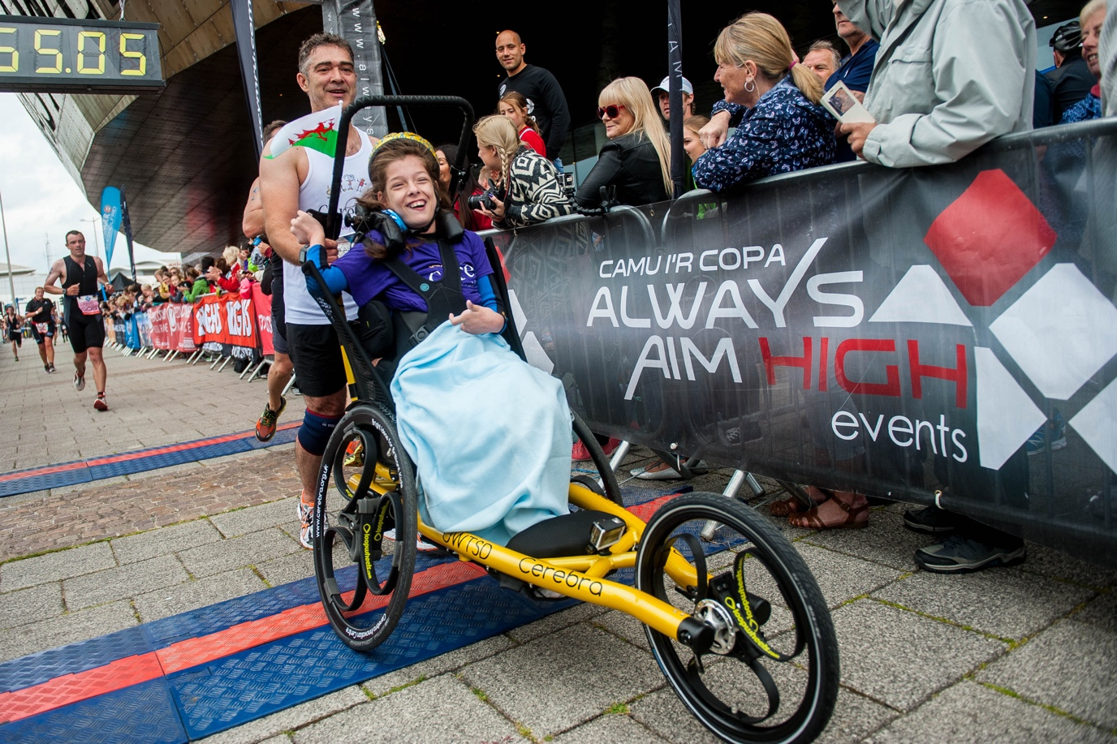

Ross Head runs Cerebra Innovation Centre. Based in ALEX, the CIC team design and develop bespoke equipment for children with Brain conditions. This can include things to help mobility, play, school and sport. The team focus heavily on good design principles to ensure their products are visually appealing and to help the child with inclusion- giving them great products that other children would love to use rather than something adequate, as these children deserve to have the best!

