
The Global Business Environment

STUDENT NAME: Cristina Miloiu
STUDENT ID: 2008582
MODULE: LCBB4005
ASSIGNMENT TITLE: Environmental Analysis of an industry
Assessment 1
a) Analyse the impact of the pandemic and explain the major forces that have shaped the business environment of the fashion industry.
b) In light of the COVID19 pandemic, critically assess the opportunities and challenges that these forces have presented to the key players in the fashion industry and explain why and how some firms have been able to adapt better than others to this changing business environment. You should use the academic frameworks learnt in class such as PESTEL, SWOT, Porter’s 5 Forces, Product Life Cycle, Porters Value chain, etc and should focus on just ONE case study.

Lecturer`s Name: Dr. John-Paul Okeke

Table of Contents
Introduction 3
About Marks and Spencer 4
Current Situation of Global Fashion Industry 5
PESTEL Analysis 5
Porter’s Five Forces Model 11
Strategies Marks and Spencer have used for Covid-19 Pandemic 14
Conclusion and Recommendation 15
References 16

Introduction
Marks and Spencer Group PLC is a multinational retailer brand. The headquarter is located in London of England. This is a retailer brand which sells starting from clothes to household utensils. Marks and Spencer Group PLC started their journey from 1884 and now they have 1463 stores worldwide. Among them 1035 stores are located in the UK (Rigby, 2020). Their net income and operating income in this year is GBP 27.4 million and GBP 254.8 million respectively. Their market capital is GBP 3110.86 million. Total 78,000 employees are working for them. Marks and Spencer cut 7000 jobs in previous year i.e. 2020 due to this covid-19 pandemic (M&S to cut 7,000 jobs over next three months, 2020). So, in this report current situation of global fashion industry will be analyzed using 2 models which are PESTEL analysis and Porter’s Five Forces Model. Side by side what strategies Marks and Spencer adopted to survive this Covid-19 pandemic will also be discussed. Based on these analysis conclusion and recommendations will be given too.

About Marks and Spencer
Marks and Spencer Group PLC is a multinational retailer brand. The headquarter is located in London of England. This is a retailer brand which sells starting from clothes to household utensils. Marks and Spencer Group PLC started their journey from 1884 and now they have 1463 stores worldwide. Among them 1035 stores are located in the UK (Rigby, 2020). Their net income and operating income in this year is GBP 27.4 million and GBP 254.8 million respectively. Their market capital is GBP 3110.86 million. Total 78,000 employees are working for them. Marks and Spencer cut 7000 jobs in previous year i.e. 2020 due to this covid-19 pandemic (M&S to cut 7,000 jobs over next three months, 2020). Side by side, they are thinking to close 100 shops by 2022 and among them they have already closed 47 stores (Mustoe, 2019).

Current Situation of Global Fashion Industry

After the spread of this pandemic from 2019, not only fashion industry but also all sorts of industrial sectors faced economic loss due to this. So to know about the current situation of the global fashion industry, two models PESTEL and Porter’s Five Forces Model will be used. They are analyzed below-

PESTEL Analysis
PESTEL analysis is used to understand the micro and macro factors which control a company or an organization. Organizations use PESTEL analysis to take decisions regarding expand of their businesses to analyze risks. PESTEL stands for Political, Economic, Social, Technology, Environmental and Legal factors to analyze. The PESTEL analysis on global fashion industry have been analyzed below:
- Political Factors:
The political factors are:
- Government Policy:
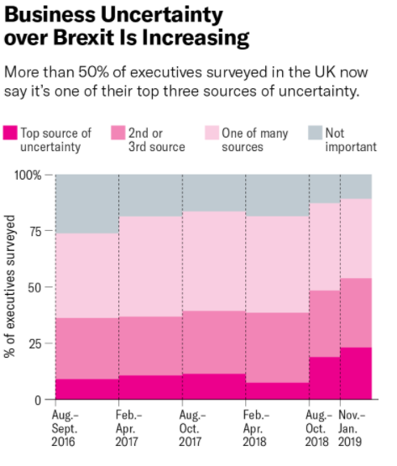
Figure: Business Uncertainty due to Brexit. (Source: Bloom et al., 2019)
In 2019 a survey was conducted on executives of different companies. Thinking of more than 50% executives were that Brexit would cause uncertainty in their business. Because when Brexit will permanently happen trade policies are going to change. So in case of Marks and Spencer too, this multinational clothing retailer brand is going to face this too.

- Political Stability:
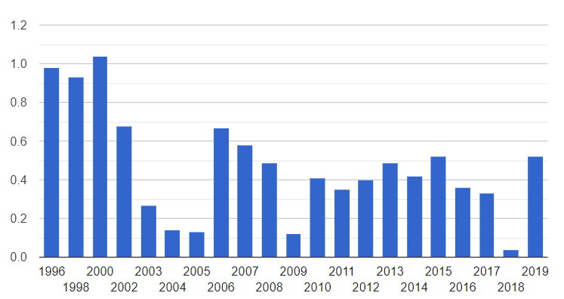
Figure: Political Stability of UK. (Source: World Bank, 2019)
From the above graph it can be seen that UK is more or less politically stable. But in 2018, the bar declined drastically which can be due to the Brexit decision. But in 2019 it became stable again after the new government came. So it is a good sign for Marks and Spencer or other clothing retailers to do businesses.
- Exchange Rate:
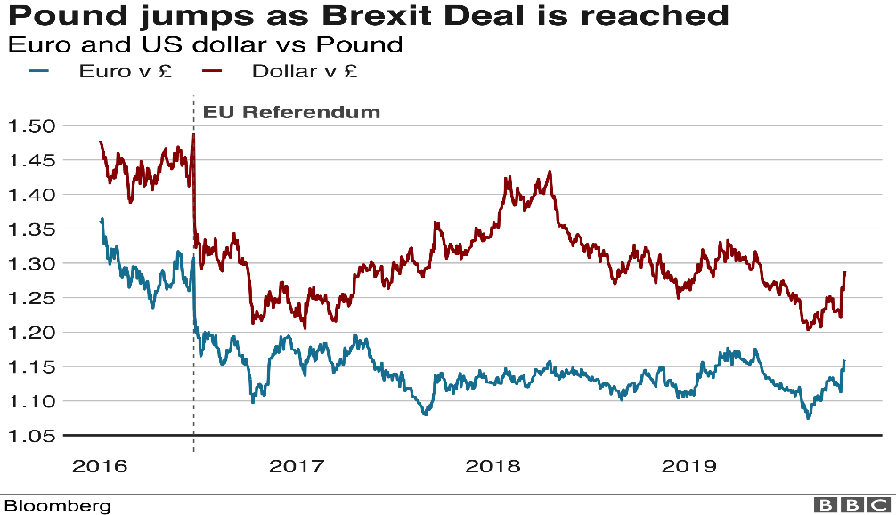
Figure: Exchange rate fluctuation of British Pound. (Source: Mustoe, 2019)
The above chart shows due to the implication of Brexit, the price of Pound against Euro is fluctuating. But it was declining till mid of 2019. So, due to this, exports of clothing retailers like Marks and Spencer will become cheap causing expensive in import.
- Economic Factors:
The economic factors are:
- Economic Growth:
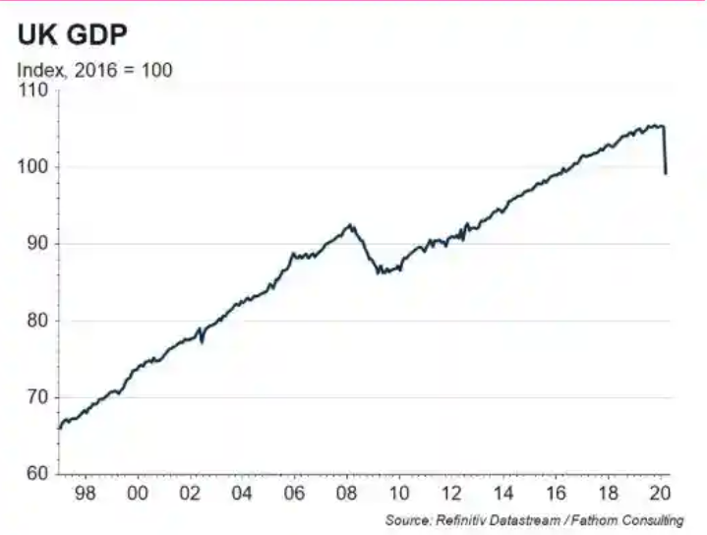
Figure: GDP Growth of UK. (Source: Wearden, Partridge and Jolly, 2020)

Due to this Covid-19 pandemic, GDP of UK has been dropped by 20% causing UK’s economy in recession stage. It is because companies like Marks and Spencer or others could not make sales nor could export which impacted in GDP.
- Unemployment and Interest Rate: Due to this pandemic, many companies were forced to close their businesses. Some companies closed permanently and some closed temporarily. Companies which closed permanently were unable to pay rents, loans etc. as they could not make sales. Again, as companies were closed, many people lost their jobs too. So to support them UK government passed the Recovery Loan Scheme for companies which will give up to GBP 10 million as loan to support businesses (HM Treasury and Department for Business, Energy & Industrial Strategy, 2021). On the other hand, Kickstart Scheme has been made for employees of 16 to 24 years to support them (United Kingdom, 2020).

- Social Factors:
Social factors are:
- Demographic Trend:
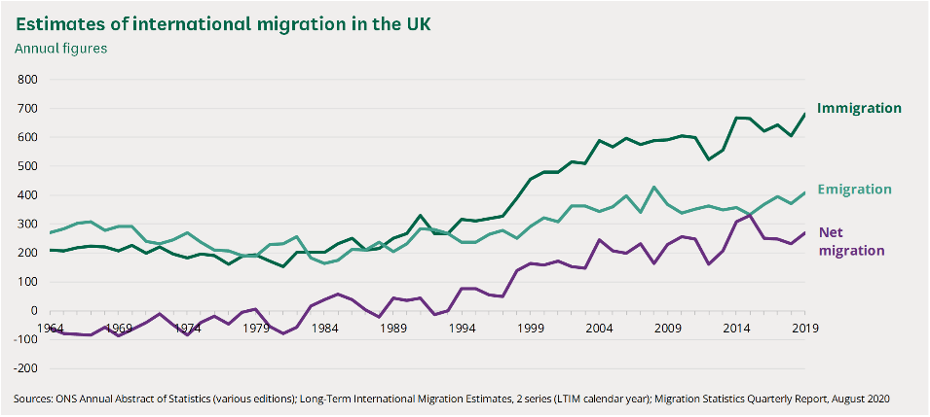
Figure: Migration Trend of UK. (Source: Sturge, 2020)
The above trend shows how diversified UK is in case of its people. The migration trend in UK is increasing rapidly. But when Brexit will be implemented permanently, there is high chance that people from European countries who are not citizen and working in UK with work visa or permit might have to move to their own countries (Thomas-Bryant, 2021). If this happen then companies like Marks and Spencer or others will lose employee if they are from European countries.
- Equality and Power Distance: The power distance score of UK is 35, where masculinity score is 66 (United Kingdom - Hofstede Insights, 2021). It indicates that in UK power distance is comparatively low but men’s dominance in job sector is high. It indicates that in companies like Marks and Spencer or others, though they have less power distance in their organization, women are not treated equally as men.

- Technological Factors:
The Technological factors are:
- Technology Innovation:
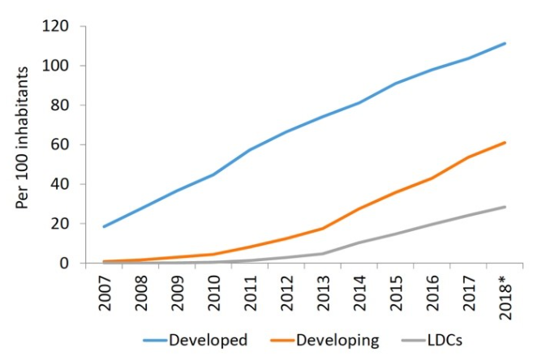
Figure: Technology Adaption. (Source: Can digital technologies really be used to reduce inequalities?, 2019)
It is seen from the above trend that people are buying from online is increasing than before. Marks and Spencer has arranged their website in such a way that customers will be able to buy products from their website and will be delivered at their door.
- Research and Development: For bringing new products or services and to sustain in the businesses, importance of research and development department is immense. Now-a-days more or less all companies have research and development (R&D) team. Marks and Spencer also has research and development department to help them with business and innovations.
- Environmental Factors:
The environmental factors are:
- Packaging Waste Regulation: The packaging waste regulation was made in 1997 with the aim of increasing recovery and recycle of the packages. As Marks and Spencer is a clothing retailer, they have to maintain this.
- Environmental Regulation: In UK, Environment Protection Act was passed on 1974 to protect environment as it is an issue of concern now-a-days. So companies like Marks and Spencer Group PLC has to obey this law.

- Legal Factors:
The legal factors are:
- Employee Protection Law: Employee protection law has been made to establish employee rights, fare wages, health and safety at work place etc. In UK, to ensure health and safety of employees at work places, the Health and Safety Act was passed in 1974. So companies like Marks and Spencer Group PLC has to ensure a healthy and safe work environment for employees according to this law.
- Intellectual Property Law: To protect patents, important documents, trademarks etc. of an individual or a company, intellectual property laws have been made. To register and protect the trademarks of the companies in UK, Trade Mark Act was passed on 1994. So, as a result of this act companies like Marks and Spencer Group PLC will be able to protect their trade mark and due to this no other companies will be able to use their trade mark.

Porter’s Five Forces Model
Porter’s Five Forces Model is a tool to analyze the business environments. Porter’s five forces model are:
Porter’s Five Forces | Level of Risk | Description
Competitive Rivalry | Extremely High | Competitive rivalry looks at the numbers and strength of the competitors. Marks and Spencer has high competitors in the market. Some rivals of Marks and Spencer are Debenhams, Macy’s, Aldi UK etc. So, to survive in the competition Marks and Spencer has to offer higher quality products or services at low prices. Side by side they have to also go for aggressive marketing too by cutting price and intense marketing as chances of shifting of buyers and sellers are extremely high to other competitors.
Supplier Power | Low | Suppliers have the power to control the prices. In the market where number of supplier is less ask higher prices on the basis of quality of products or services as there are no other suppliers. The markets where there are many suppliers, companies will be able to purchase at low prices increasing their profit. As there are many suppliers in this sort of markets, companies may shift to other suppliers offering less prices. In case of Marks and Spencer, supplier power is low. Because as Marks and Spencer is an established retail chain, supplier need them to sell their products or services.
Buyer Power | Extremely High | Buyers have power of manipulating prices of products or services. They are able to bringing prices down. They also have tendency to shift to other companies where they will get same products or services at less prices. So Marks and Spencer Group PLC has to set prices keeping ideas on their customer base and loyal customers.
Threat of Substitution | Low | Substitute products or services is a threat for other company’s products or services. Customers always look for buying products or services of those countries which will offer at low prices. The market where there is less substitute products or services tend to be controlled by the companies. On the other hand, the market which offers substitute products or services, customers of that market have tendency to switch companies. As Marks and Spencer is a retail of clothing and foods they have less substitutes.
Threat of New Entrants | Low | It is always for any companies if new entrants enter in the market. This increases the competition. So, in case of Marks and Spencer, even if new entrants enter into the market will not be threat for them. Because it requires lots of investment and time to be an established retail chain like Marks and Spencer.

Strategies Marks and Spencer have used for Covid-19 Pandemic
Due to the outbreak of Covid-19, all businesses were affected. Those who could make strategies only survived. To survive this pandemic Marks and Spencer has also adopted some strategies, like:
- Selling clothing and foods online
- They remodeled and reshaped their businesses for this pandemic (Busby, 2020)
- Marks and Spencer digitalized their businesses more than before
- Going partnership with Ocado on September 1 of 2020 to sell foods online (Rigby, 2020)
- To support their finances for next 18 months, they are going to make arrangement with landers, will apply for government scheme for corporate companies and will also cancel dividend of GBP 210 million (Ford Rojas, 2020)
These are the strategies they have used and taken for this Covid-19 pandemic.

Conclusion and Recommendation
Due to this covid-19 pandemic many businesses were closed permanently. Some people lost their jobs too. But due to this pandemic consumers’ behavior have changed. Because they are now comfortable more to buy online for their safety and consciousness of Corona virus. Marks and Spencer have been able to make some profit by digitalizing their operations. But Marks and Spencer needs to be more careful.
Some recommendations for Marks and Spencer -
- They have to make their online services more strong
- As they are selling online, they have to be careful to protect their customer database
- To increase their sale, they can write a thank you note or wish well being of their loyal customers while delivering the products
- They have to make their supply chain more strong
- They have to offer more innovative and quality products or services to defeat their rivals

References
BBC News. 2020. M&S to cut 7,000 jobs over next three months. [online] Available at: https://www.bbc.com/news/business-53817598
Bloom, N., Bunn, P., Chen, S., Mizen, P., Smietanka, P. and Thwaites, G., 2019. Brexit Is Already Affecting UK Businesses — Here’s How. [online] Harvard Business Review. Available at: https://hbr.org/2019/03/brexit-is-already-affecting-uk-businesses-heres-how
Development Matters. 2019. Can digital technologies really be used to reduce inequalities?. [online] Available at: https://oecd-development-matters.org/2019/02/28/can-digital-technologies-really-be-used-to-reduce-inequalities/
Ford Rojas, J., 2020. Coronavirus: M&S plans 'never the same again' shake-up as lockdown bites. [online] Sky News. Available at: https://news.sky.com/story/coronavirus-m-s-plans-never-the-same-again-shake-up-as-lockdown-bites-11979912
Mustoe, H., 2019. How does Brexit affect the pound?. [online] BBC News. Available at: https://www.bbc.com/news/business-46862790
Mustoe, H., 2019. The M&S stores closing their doors for the final time. [online] BBC News. Available at: https://www.bbc.com/news/business-48137882
Sturge, G., 2020. Migration Statistics. [online] House of Commons Library. Available at: https://commonslibrary.parliament.uk/research-briefings/sn06077/
Wearden, G., Partridge, J. and Jolly, J., 2020. UK economy shrinks by 2%; Fed chair warns of 'prolonged' US recession - business live. [online] the Guardian. Available at: https://www.theguardian.com/business/live/2020/may/13/uk-economy-gdp-q1-2020-march-covid-19-recession-business-live
World Bank, T., 2019. United Kingdom Political stability - data, chart | TheGlobalEconomy.com. [online] TheGlobalEconomy.com. Available at: https://www.theglobaleconomy.com/United-Kingdom/wb_political_stability/

