Strategic Management (LCMB7003)

Strategic Analysis of Norwegian Airlines
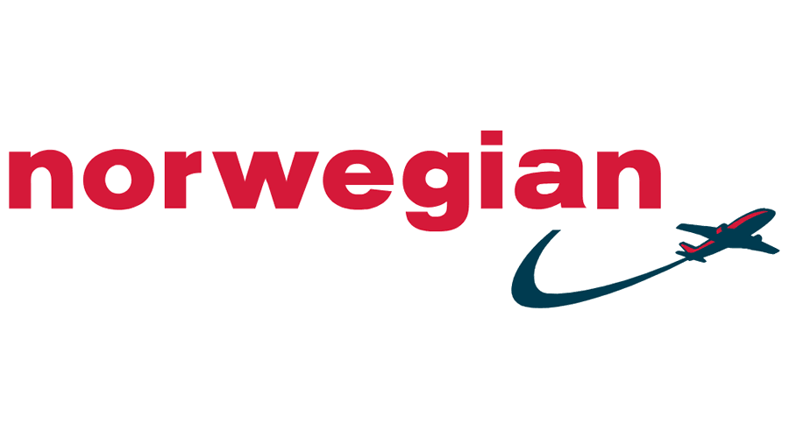

Introduction
Bogers et al.(2019) defined strategic management is the process that is being adopted by organizations for setting goals objectives as well as procedures for enhancing the overall competitive age of the organization. Thus the most common formation of strategic management looks something quite different from staff engagement and resources only. In reality, it is much more than that. The certain real-life implications of strategic management ensure that the companies can make maximum use of the current staff as well as the other resources for fulfilling the different goals and objectives of the organization.
Thus in the field of Management, the concept of strategic management in most cases involves the effective formulation as well as the implementation of the different major goals along with the initiatives that are taken by the managers of the organization. These decisions are being taken on behalf of the stakeholders and it considers the internal capabilities as well as the external environmental factors of the organization as well. The importance of strategic management lies in the fact that it lays the basic foundation of every significant decision that has been taken by an organization (Ardo et al, 2019). It thus places a significant role in adding a proper direction to the overall organization by creating plans as well as policies with the sole aim of achieving the goals. However implication of resources as well as the other plans are also significant aspects of strategic management in the case of an organization.
The report that will be included in the below segment will try to incorporate the different aspects of strategic management in the case of an organization of choice. The organization that has been selected in this scenario is Norwegian Airlines. The report below will include the macro environmental analysis micro environmental analysis as well as the internal analysis of the selected organization. It is expected that at the end of the report, the student will be able to develop a proper real-life idea as to the concepts of strategic management and the ways in which these are being conducted in real-life and practically existing business organizations.

Background

The Norwegian air shuttle ASA now trading as Norwegian is an example of a low-cost airline it is also Scandinavia's 2nd largest airline just after this Scandinavian airline. In Europe, Norwegian Airlines accounts for the fourth largest low-cost carrier. The organization has been founded in the year 1993 and has been operating since then.
Norwegian Air is one of those airlines which is often considered synonymous with long-haul travel which is also budget-friendly. It has been acting as a disruptor to both the traditional long-haul giants as well as the low-cost carriers. If the overall operational history of the organization is seen and studied it can be seen that Norwegian Airlines had expanded much more quickly as compared to its competitors and right now it operates around 500 routes on a global scale. The organization has also been able to create a name for itself particularly due to its continuous introduction of long haul low-cost routes. Norwegian Airlines has often been recognized as Europe’s best cost airline as well as the world’s best cost long haul airline.
The current fleet size of Norwegian Airlines is 45 excluding subsidies and 81 including the subsidiaries. The organization is currently headquartered in Forenbu, Norway. The current revenue generation of the organization has been estimated at around 40.265 billion NOK (norweian.com, 2023).
A key competence of the business model of Norwegian Airlines is the Introduction of the new and fuel-efficient aircraft level which allows low-cost keeping. At the same time, the ability of the organization to continuously incorporate its strategic as well as technological innovations is often considered a key lesson for the different aviation players across the world.

Mission and Objectives

The mission of the organization has been to maintain low operating costs and operational excellence while at the same time also providing nothing but best of the services to the customers.
The key goals of the organization have been
- Affordable fares for all
- Sustainability
- to be the preferred airline for everyone
Norwegian Airlines gives significant priorities towards ensuring safety, simplicity as well as the service provided by the organization to its stakeholders
Innovation teamwork and simplicity are the key values of Norwegian Airlines (norwegian.com, 2023)

Macro environmental analysis
Lombardi et al.(2023) Has defined macro environmental analysis as that particular aspect of strategic management which enables an organization in analyzing as well as identifying potential opportunities along with the hazards that may impact the overall business. The macro environmental analysis particularly helps in the identification and analysis of those factors which impact the business but are still not quite in control of the business. The goal of the macro environmental analysis has always been to prepare the management of the organization in advance with different information that helps them in making operational decisions.
The PESTEL analysis is one of the most useful of the macro-environmental frameworks that are in use in the contemporary business world

PESTEL analysis
Political: In recent times, some parts of Europe particularly the United Kingdom have become quite verbal regarding their concerns about environmental pollution levels. The United Kingdom and the corresponding government had already introduced a range of rules and regulations the applications of which can be useful in deterring the levels of environmental pollution. For example, as part of the recent government rules light pollution in the case of airlines can be reduced By turning off the lights in situations when they are not needed. At the same time, the government has also been giving significant importance towards more planning in terms of aeroplane operation (gov. uk, 2023)
Environmental: it is quite known to all that the airline industry contributes a major part towards air pollution levels. In the year 2022, the aviation Industry contributed around 20 per cent of the overall CO2 emissions.
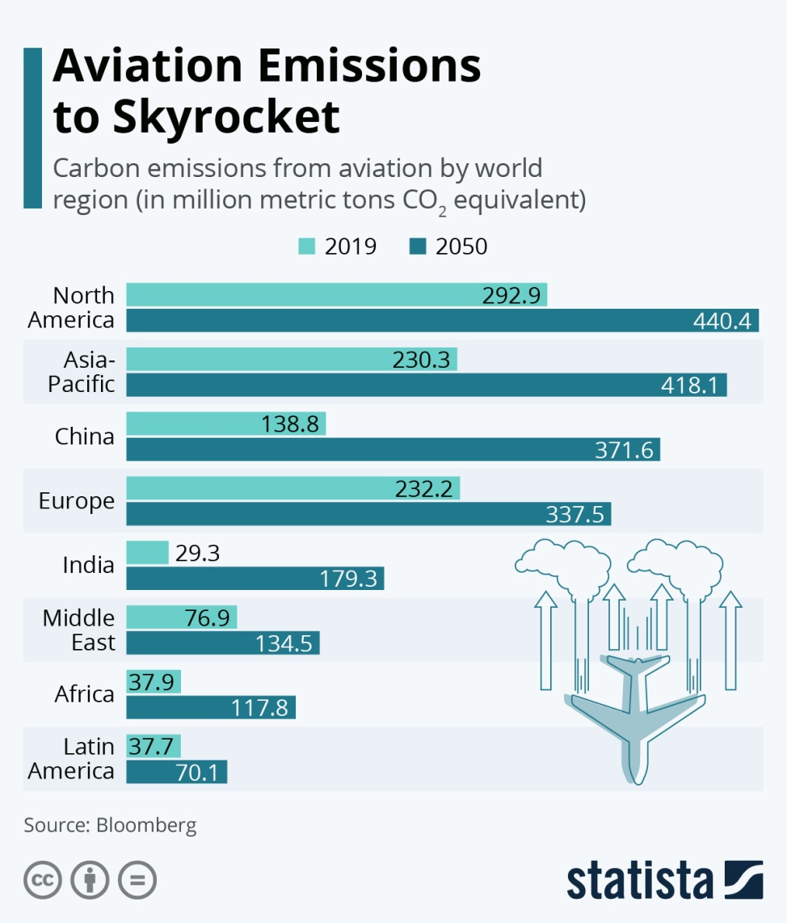
Figure 1 : The Co2 emissions from the aviation industry
(Source: Statista, 2023)
The impacts of this on the environment as well as the ecological life of the Earth are something that can never be appreciated. Hence Norwegian Airlines need to consider more sustainable options that can help them in reducing these adverse effects on the environment.

Social: With the increase in competition and the need of people to be in more than one place at a time airlines have indeed been able to become an inseparable part of the social life. People prefer airlines for short-term travel as it helps them in saving time.
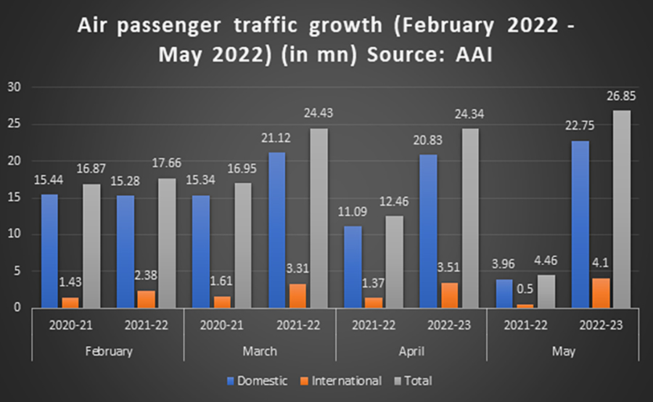
Figure 2 : The air passengers, traffic rowt rates
(Source : media4rowt.com, 2023)
Technological: Technology is indeed quite an essential aspect of airlines and there has been a range of technologies that are incorporated in this particular sector in the past years.
Economic: Norwegian Airlines is already one of the most budget-friendly and low-cost airlines operating in Europe. It is thus quite suitable for all of the countries in Europe irrespective of the economic conditions and the background that these countries cater to.
Legal: Norwegian Airlines needs to follow the different rules and regulations that have been put forward by the aviation authority of Europe for ensuring the safety of the passengers as well as of the aircraft. As per the recent regulation number 300/2008, It is mandatory for the aircraft to opt for servicing after every six months at the same time the conditions of the aircraft need to be checked every time before it starts its journey. This will ensure reduced rates of accidents and greater safety for the passengers. At the same time, the aircraft also need to have a proper screening of transfer as well as transit passengers and cabin luggage. There should also be effective screening done of the transfer hold luggage (easa.europa.eu, 2023)
Additionally, the other regulations regarding airworthiness environmental specifications should also be followed by all of the airlines, operating to and from Europe.

Micro Environment Analysis
The Micro Environmental Analysis as the name suggests plays a significant role in analyzing and evaluating the different key elements of the microenvironment of the organization. The concept of micro environment in this case refers to that particular environment which impacts the organization and is also within the control of the organization. Thus the internal organizational structure and the different factors impacting the same are often considered significant elements of the microenvironment. The microenvironment is made up of factors which are immediately under the control of the current organization ( Serpa and Ferreira, 2019).
A proper analysis of the micro-environmental factors helps the organization in developing an idea to own self as well as the area where they are lacking and the areas where improvements are needed. There has been a range of tools and frameworks developed in the past years for analyzing the microenvironment of an organization

Industry Life Cycle
The concept of the industry life cycle refers to the process associated with the evolution of any industry or company. It has four distinct phases and these are introduction, growth, maturity and decline phases (Pangarkar and Yuan, 2022).

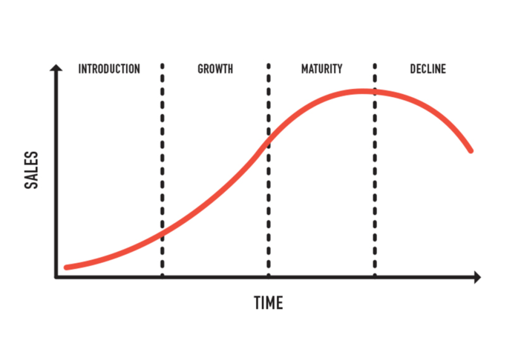
Figure 3 : The different phases of the industry life cycle
(Source: Learning, 2023)
The selected organization Norwegian Airlines has been in operation for the last 20 years and it will also never be wrong to mention that it has been loved by people across the world. The basic competitive advantage of the organization has always been its ability to provide cheap flights locally as well as in long journey hauls. However, for the past few years, things have not been quite great for the organization and it can be seen that Norwegian Airlines is indeed passing through a tough phase. The current financial reports of the organization point out that it is running at a complete loss with almost no profit generated for the past years.
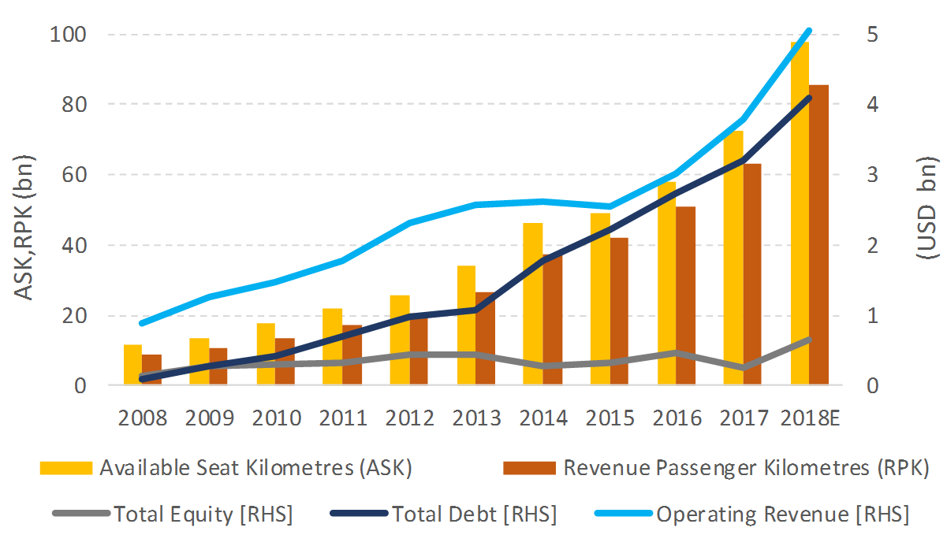
Figure 4 : The current finances of the Norwegian airlines
(Source: spglobal.com. 2023)
The steep decline in terms of sales of tickets and hence the revenue generated per passenger per kilometre is visible in the case of the above graph. Thus it can be stated that considering and comparing it with the industry life cycle Norwegian Airlines is currently passing through a declining phase of the same.
However, in the past years, the company has pointed out that they are already aware of this declining phase and are planning to get rid of the same. The organization has added several flights as well as routes to their journey map for attracting more customers towards themselves. As per the latest reports the organization had enhanced the number of fleets from 51 to 70 (Norwegian.com, 2023).
This points out that the organization is currently trying to cope with its declining phase. There has been also a range of strategies about sustainability as well as financial welfare that has been developed by the organization in the past years. It is expected that the corrective combination of the strategies will be useful for the organization to overcome its current position in the industry life cycle and thus move to a much better and sustainable one.

Porters Industry Five Forces Analysis

Porter’s industry five forces analysis is quite an interesting tool that provides an idea as to the current industry of operation as well as different factors impacting the same.
Power of suppliers: In the words of Le Fueure (2019), The power of supplies in the case of the aviation industry has always been identified to be quite the significant type. It is because three important resources of the industry are being obtained from external sources only. For instance, fuel is one of the most significant resources in the aviation industry. Any change in fuel prices will always impact the overall prices of the aviation industry. At the same time, the next important source of suppliers is of course the labour workforce who works for the organization. In situations when there is increased power of the labour unions the chances of bargaining inconsistent labour flows impact the overall operations of the organization.

The threat of new entrants: Speaking about the entry or exit barriers in the case of the airline industry it is quite known to all that this particular industry demands huge capital investment. These investments are incurred not only in the entry but in certain times when an airline tries to exit the industry also. In the words of Ratlhagane (2022), A proper entry into the airline industry often demands that organizations have a high infusion of capital. Thus it becomes quite tough for everyone to enter the airline industry. At the same time, a proper sophisticated knowledge of the different trends of global aviation is also of great importance for anyone who plans to enter this particular industry. These overall situations make it quite tough for the new entrants to enter this industry and keep their own pace of success. hence the threat of new entrants, in this case, is quiet.

Power of buyers: As part of the recent consumer trends people have been opting more for online ticketing options rather than offline ones. With the increase in online ticketing as well as distribution systems, Customers do not need to depend on any offline agents or other intermediaries for tickets. Apart from that in recent times, there has also been a steady increase in the entry of a range of low-cost carriers ( Norwegian Airlines being an example). This often gives the customers a huge range of options to choose from depending on their budget. At the same time, for the past years, there has been a range of tight regulations most of which are developed for the welfare of the consumers only. These further state that the power of buyers in the case of the airline industry is indeed quite high. At the same time, most online airline ticketing sites provide options for price discovery. It helps the customers to know about the prices of the same ticket on different airlines before making their final purchase.
The threat of the substitutes: Air travel is one of the most common means of travel but on the other hand it also needs to be noted that it is not the only means of travel. In fact, there are still people who love travelling by road and in certain cases if possible by the waterways two. Thus in the case of people who love to enjoy travel, the airline is not quite a great option in such a situation. On the contrary, Airlines have often been identified as the best transport mode, particularly in the case of business trips where time is of great importance. However, in the case of global travel options, the airlines are also the only option without any substitutes. The threat of substitutes in the case of the airline industry can be considered the mixed types
Competitive Rivalry: With a range of key players already dominating the global airline market, competitive rivalry is quite high in the case of the airline industry. In the words of Pangarkar and Yuan (2022), The global airline industry is often considered one of the most competitive industries due to a large number of key players dominating the same. Additionally, the airline industry is regulated much on the supply side as compared to the demand side. Hence the competitive rivalry in the case of the airline industries is indeed quite high

Internal Analysis

Strategic Resources and Capabilities
Buzatu et al.(2019) Has defined the concept of resources as the different ownings of an organization. The concept of capabilities on the other hand refers to what the organization can do. More specifically capability is more about the ability of the organization to bundle manage or maybe exploit the resources in such a way that it can provide added value and hence advantage over the other competitors.
The resources that are available in the case of an organization can be divided into two parts which are the tangible resources and the intangible resources.
Tangible resources: The different tangible resources that are being owned by Norwegian airline services at this point are its workforce and the fleet of superb airlines. Though the organization is currently running through financial turmoil, as part of overcoming the same Norwegian Airlines has already acquired some of the fleets. They have also increased their total number of leads up to 70 which further adds to the different tangible resources that are being owned by the organization. However, at the same time, the current financial reports of the organization point out to budget some of the issues that the company is currently facing while maintaining a good relationship with the different stakeholders of the organization. At the same time, the organization has also been caught in some of the financial risks regarding changes in market dynamics there has also been a steep increase in the fuel price which is one of the most significant resources of Norwegian airlines.
Intangible Resources : Lombardi et al.(2023) Has defined the concept of intangible resources as the stocks of strategic information along with the different intangible assets that can be employed by an organization for fulfilling different goals. In most of the cases information, technology, and finances are considered as part of intangible assets Norwegian Airlines Services is one of those companies which is quite strong when it comes to its implications of Technology as well as innovation. At the same time, sustainability is also one of the significant strategic moves that can be witnessed in the case of the organization. The organization aims to be the only low-cost airline operating in Europe in the days to come which points out its confidence in the current strategic capabilities of the organization.
Capabilities: Norwegian Airlines is the second largest airline operating in Scandinavia which also operates in 150 destinations across the world. The organization has been operational in a highly competitive and volatile market for the past 20 years which stands as proof of its capabilities. Norwegian Airlines are planning to create a new market with long-haul low-cost flights alongside the different domestic and short-haul range of flights. This will further enhance the current market base and presence of the organization.
At the same time, it can be seen that automation is indeed one of the significant capabilities that have helped Norwegian Airlines in reaching to its pinnacle of success. Though the airline is currently passing through a tough phase different strategies of the organization that has been developed lately are expected to help it in overcoming the same in the years to come

Value Chain Analysis
The concept of value chain analysis refers to the process that is associated with the evaluation of each of the activities involved in the value chain of an organization. It helps in understanding the different opportunities that are available for the organization for incorporating improvements in their current operations.
Firm Infrastructure: Low-cost flights in short and long distances, Regulatory compliances, legal framework, Automation, Sustainability approaches
human Resources Management: operations training, human resource training, regulations training
Technology development: Online reservations technique, Flight scheduling systems yield management systems usage of technology in flight
Procurement: Procurement of fuel, fleet, maintenance of good relations with the different stakeholders associated
Inbound Logistics | Operations | Outbound logistics | Marketing & Sales | Service
- Selection of new routes  - Procurement of new flights  - Facility planning  - Acquisition of airport | - customer services  - Ticketing system  - Gate operations  - Handling of baggage  - Aircraft services and operations | - Flight connections  - Reservation System  - Baggage System | - Promotion of services  - advertising In the different online and offline media  - Travel agent programmes | - Low-budget domestic flights  - Comfortable travel to the customers  - Baggage lost and found  - Servicing in Scandinavia as well as other parts of Europe
Table 1: The Value Chain Analysis of the Norwegian Airlines
(Source: Created by the student)

VRIO analysis
The VRIO analysis is quite an essential tool that provides an idea as to the internal resources and capabilities of an organization. It provides an idea as to the current resources and how these have turned out to be useful and have thus contributed towards the competitive edge of the organization (Serpa and Ferreira, 2019)

Resources | valuable | Rare | Imitable | Organized
The current business model of providing cheap air flights | Yes | Yes | No | Yes
innovative abilities of the organization | Yes | Yes | No | Yes
providing nothing but the best quality of services to the customers | Yes | Yes | Yes | Yes
industrial experience for the last 20 years | Yes | No | Yes | Yes
good customer focus | Yes | No | No | Yes
great brand image | Yes | No | No | Yes
great employee workforce | Yes | No | Yes | Yes
high frequency of domestic flights | Yes | Yes | no | Yes
Strong presence in the region in which it operates | Yes | No | No | Yes
Table21: The VRIO analysis of the Norwegian Airlines
(Source: Created by the student)

SWOT analysis
The SWOT analysis is quite an interesting tool for developing an insight into the organization.
Strength | Weakness
- One of the most popular low-budget airlines  - It is noted as Europe’s best low-cost airline  - Provides affordable alternatives towards traditional carriers  - It operates in around 150 destinations worldwide  - One of the only airlines that are capable of providing a great combination of affordable prices and that too at high quality  - It enables the passengers in enjoying more of an upmarket flying experience  - In most cases, the company chooses to fly from less popular airports which helps them in cutting on their costs and also be more efficient | - Despite providing some of the best services at low cost the organization had been running at a loss for some time  - The organization is currently strangled in a Whirlpool of low profits and high depth levels which questions its existence to some extent
Opportunities | Threats
- Norwegian Airlines can venture into other countries, particularly in some of the Southeast Asian countries  - Can concentrate more on innovation as well as opting for sustainable options  - Can provide better services to the customers for enhancing loyalty and hence customer retention | - there have been increasing concerns regarding the rapid expansion of the organization following its net losses  - Increase in airline regulations mostly in favour of the customers  - Increase in the fuel costs which is expected to increase more in the days to come  - Increase in competition in the airline industry  - Increasing concerns regarding environmental pollution concerns
Table 3: The SWOT analysis of the Norwegian Airlines
(Source: Created by the student)

Strategies to sustain competitive Advantage
Competitive advantage is indeed quite an essential aspect as it helps organizations in standing apart from the crowd (Le Fuevre, 2019).
Environmental sustainability is one of the significant strategies that can contribute towards the competitive advantage of Norwegian Airlines.
Strategy 1: Environmental sustainability
The organisation has already been setting a pace towards environmental sustainability and aiming to be the traveller's sustainable choice. As per the recent reports, Norwegian Airlines has been working actively towards a reduction of plastic waste and has also been incorporating the concepts of recycling as and where needed. Same time Norwegian Airlines is also one of the significant patrons of aviation fuel and the organization aims to achieve a 45% reduction in CO2 emissions within the year 2030.
Strategy 2: More Direct Routes
Norwegian Airlines is already planning to introduce a range of more direct routes across different parts of Europe. It will enhance the global presence of the organization which will impact the overall sales margin. At the same time, it will also contribute towards the competitive advantage of Norwegian Airlines in the aviation industry
Strategy 3: Automation and Technology
Norwegian Airlines has always been a clear patron of technology when it comes to providing the best services. The Avtec mobile application as introduced and operated by Norwegian Airlines helps the pilots in flying using efficient fuel it helps in reducing the total CO2 emissions per flight by around 2%. At the same time, Norwegian Airlines also contribute much to new technologies and also have one of the youngest fleets in the world.
The recent technological advancements of Norwegian Airlines also enabled the pilots to make use of advanced weather data and thus adopt a much smarter route (norwegian.com, 2023)

Growth strategies
Norwegian Airlines is one of the airlines which makes use of its innovative approach along with great customer focus as part of its growth strategy. One can witness the incorporation of innovative approaches in all possible sectors of operations of the organization, something that helps Norwegian Airlines in standing apart in the crowd. At the same time, the organization has also been planning to be the first long-haul low-cost airline in the world. As part of its good strategies, Norwegian Airlines has also been planning to introduce and establish new routes, particularly in the case of international destinations.
Thus it can be clearly stated that global expansion is indeed one of the most useful growth strategies that is being adopted by Norwegian Airlines. Analyzing the need and the importance of globalization particularly as part of growth strategies Tompson (2023) has pointed out that globalization often helps organizations in creating its sky in the global market. It is often considered one of the most effective growth strategies because it enhances the overall reach of the organization while at the same time also creating a much more sustainable supply chain for the organization.

Green Strategies and CSR
The concept of green strategies is indeed quite an essential part of Norwegian Airlines. That organization has already been working towards ensuring environmental sustainability and stands as proof of the same. Norwegian Airlines is one of those few organizations that has been concentrating more on recycling and reducing the usage of plastic waste to as low as 0% at the same time environmental sustainability is also quite an essential aspect of the organization and it aims to follow them in all of the strategies that are being developed. Norwegian Airlines have also been planning to use 28% of sustainable aviation fuels within the next ten years.
CSR
Norwegian Airlines always tries to be the best corporate citizen in all of its areas of operation. The organization is one of those few companies operating in the aviation sector that is committed completely to operating as part of ethically responsible sustainable principles. At the same time, the organization also has equal respect for people, society as well as the environment. The fact that Norwegian Airlines has been powered by the vision of Affordable fares for all has helped in bringing cultures people as well as economies together. This is also one of the major contributors towards local tourism in Scandinavia and at the same time has also driven the economic growth as well as the social progress of the particular place.
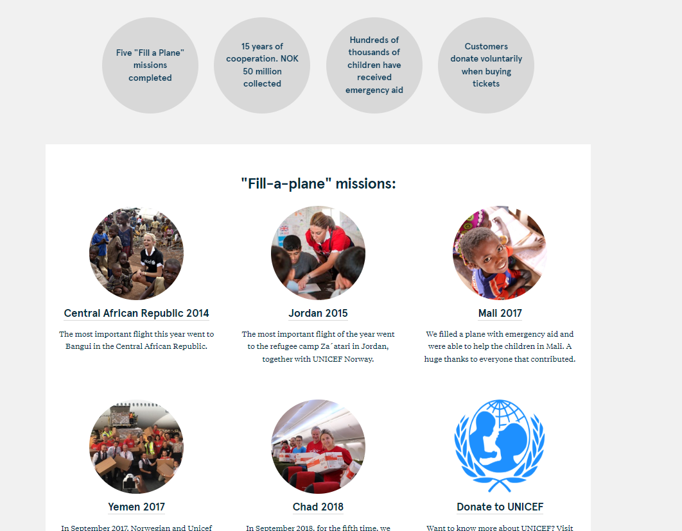
Figure 5: The different CSR activities of Norwegian Airlines by UNICEF
(Source: norwegain.com. 2023)
At the same time, Norwegian Airlines also accounts for itself as one of the most active partners of UNICEF on humanitarian grounds. Indeed been working towards ensuring the holistic and overall development of Scandinavia in all possible ways which stands as clear proof of the different corporate social responsibilities that are being portrayed by the organization.

Conclusions
The research that has been conducted so far has been able to provide a clear overview of Norwegian Airlines one of the most famous low-cost budget airlines operating in Scandinavia. It can be seen that this particular airline has been in operation for the past 20 years and has indeed witnessed a range of up and downs throughout its tenure. There have been times when the organization has indeed performed quite well while for the past few years, things have not been quite great for Norwegian Airlines. Keeping up with the current customer trains it can be seen with the help of the strategic analysis of Norwegian Airlines that automation and innovation are indeed an essential part of the airline’s operation. The organization is a clear patron of technology and automation when it comes to providing the best of services the major reason for which it uses some of the next-level technologies for providing nothing but the best services to the customers of the organization. The VRIO and the SWOT analysis that has been included in the above segment have provided further insight into the current resources as well as the microenvironment of the organization. Overall, it can be seen that Norwegian Airlines is indeed quite a responsible organization, someone who thinks about the society environment as well as the economy as a whole.

Recommendations
- One of the significant recommendations that can be useful for Norwegian airlines is of course to venture into the Euro Asia airspace. This will help Norwegian Airlines in laying his footsteps in the Asian subcontinent and thus exploding a whole range of new countries, and new cultures. It will also contribute explicitly towards the current growth drive of the organization.
- As part of the growth strategies, Norwegian Airlines can also opt for diversification. Instead of introducing new fleet airlines or new routes, only Norwegian Airlines can also venture into new modes of transport. For example, Scandinavia has a great coastline hence opting for the waterways of transport can also be a great advantage for Norwegian Airlines to expand their business. As part of the same, Vikings date back their origin to the Scandinavian coastline and at the same time, this particular coastline also had a long run history. All of these factors in mind Norwegian Airlines can also opt for more vintage troops and tours along this region. Since keeping up with the current vision the cost of these troops will also be quite low it will also attract huge customers across the globe. At the same time, it will also contribute towards the sustainable approach of the organization as it is expected to contribute towards the growth of tourism. The growth of tourism on the other hand will also contribute towards the overall social economic development of the entire place.

References
About us (2023). Available at https://www.norwegian.com/
Air passenger volume growing month-on-month in India (2023). Available at: https://www.media4growth.com/ooh-news/air-passenger-volume-growing-month-on-month-in-india-6339 (Accessed: 16 August 2023).
Ardo, F.M., Lim, J.W., Ramli, A., Lam, M.K., Kiatkittipong, W., Abdelfattah, E.A., Shahid, M.K., Usman, A., Wongsakulphasatch, S. and Sahrin, N.T., 2022. A review in redressing challenges to produce sustainable hydrogen from microalgae for the aviation industry. Fuel, 330, p.125646. Available at: https://d1wqtxts1xzle7.cloudfront.net/84363378/article_64_vol_8_3__2019-libre.pdf?1650257585=&response-content-disposition=inline%3B+filename%3DThe_Relationship_between_Corporate_Strat.pdf&Expires=1692271340&Signature=Mkk75RpvTl6xtAQKzKEDPHJLlvUqhgEwzuMPKuDFs9ym0rLJyan2tg5Yvytt9HOkdggjpLtGRKIiLXbynuUa3XpYmTgK2MGk3kFki9SvIQKqbBdgRcmRk8v2vFH0AQJPhZW8Y8E~-RQfHj-~0pRoV7Dt3tYTFpPEHwtRBn3buBHk9IZ5LFwIehy4ZU7sYcmaQUSnHlf7KRGIAQPNHodzIDV~GK-3Yx1QyG6X1Ot2nvbhp-UUkHWvz2sAL~RwXsn3q2pWgDl3qqGA0kQ-iT-j1Pt3xWVjBTzfTDC9ysu0KSUdPjz6Oov9dZOAkP8t9WHhy0wbxNPdEii1aIy5UPYl1w__&Key-Pair-Id=APKAJLOHF5GGSLRBV4ZA
Bogers, M., Chesbrough, H., Heaton, S. and Teece, D.J., 2019. Strategic management of open innovation: A dynamic capabilities perspective. California Management Review, 62(1), pp.77-94. Available at: https://journals.sagepub.com/doi/full/10.1177/0008125619885150
Buzatu, A.I., Pleșea, D.A., Iulian, C. and Valentin, W.P., 2019. Managing organizations for sustainable business development: Interaction between VRIO framework and Mckinsey 7s framework. New trends in sustainable business and consumption, pp.243-251. Aailable at : https://www.researchgate.net/profile/Ann-Katrin-Arp-2/publication/333902657_Study_on_European_funding_programmes_for_sustainable_development/links/5dbaf94d299bf1a47b05a8d3/Study-on-European-funding-programmes-for-sustainable-development.pdf#page=243
CSR and UNICEF(2023). Aailable at : https://www.norwegian.com/en/about/company/corporate-responsibility/unicef/
EASA (2023). Available at: https://www.easa.europa.eu/en/regulations
Flying Into The Danger Zone; Norwegian Air Shuttle (2023). Available at: https://www.spglobal.com/marketintelligence/en/news-insights/blog/flying-into-the-danger-zone-norwegian-air-shuttle (Accessed: 17 August 2023).
Fuertes, G., Alfaro, M., Vargas, M., Gutierrez, S., Ternero, R. and Sabattin, J., 2020. A conceptual framework for the strategic management: a literature review—descriptive. Journal of Engineering, 2020, pp.1-21. Available at: https://www.hindawi.com/journals/je/2020/6253013/
Infographic: Aviation Emissions to Skyrocket (2023). Available at: https://www.statista.com/chart/23321/aviation-emissions-by-continent/ (Accessed: 16 August 2023).
Le Feuvre, P., 2019. Are aviation biofuels ready for take off? Aailable at : https://policycommons.net/artifacts/1343579/are-aviation-biofuels-ready-for-take-off/1955732/
Learning, N. (2020) Industry Life Cycle in Mergers and Acquisitions - Notes Learning, Notes Learning. Available at: https://noteslearning.com/industry-life-cycle-in-mergers-and-acquisitions/ (Accessed: 17 August 2023).
Light pollution (2019). Available at: https://www.gov.uk/guidance/light-pollution#:~:text=Lighting%20schemes%20could%20be%20turned,potentially%20require%20this%20where%20necessary. (Accessed: 17 August 2023).
Lombardi, M.J., Riggi, M. and Viviano, E., 2023. Workers’ Bargaining Power and the Phillips Curve: A Micro–Macro Analysis. Journal of the European Economic Association, p.jvad016. Aailable at : https://academic.oup.com/jeea/advance-article-abstract/doi/10.1093/jeea/jvad016/7074563\
Norwegian.com (2023) . Available at: https://www.norwegian.com/globalassets/ip/documents/about-us/company/investor-relations/reports-and-presentations/annual-reports/norwegian-annual-report-2022.pdf (Accessed: 17 August 2023).
Pangarkar, N. and Yuan, L., 2022. Industry life cycle, geographic diversification and performance of international new ventures. Multinational Business Review, 30(1), pp.62-80. Aailable at : https://www.emerald.com/insight/content/doi/10.1108/MBR-04-2020-0080/full/html
Ratlhagane, K., (2022) The influence of macro-environmental factors on strategy implementation (Doctoral dissertation, University of Johannesburg).
Resposnible flt (2023). Aailabl at : https://www.norwegian.com/en/about/experience-us/responsible-travel/new-aircraft/
Serpa, S. and Ferreira, C.M., 2019. Micro, meso and macro levels of social analysis. Int'l J. Soc. Sci. Stud., 7, p.120. Aailable at : https://heinonline.org/HOL/LandingPage?handle=hein.journals/ijsoctu7&div=36&id=&page=
Sundvor, I., Thorne, R.J., Danebergs, J., Aarskog, F. and Weber, C., 2021. Estimating the replacement potential of Norwegian high-speed passenger vessels with zero-emission solutions. Transportation Research Part D: Transport and Environment, 99, p.103019. Available at: https://www.sciencedirect.com/science/article/pii/S1361920921003175
Thompson, G., 2023. Globalisation versus regionalism?. In Perspectives on Development: the Euro-Mediterranean Partnership (pp. 59-74). Routledge. Aaiable at : https://www.taylorfrancis.com/chapters/edit/10.4324/9781003417095-5/globalisation-versus-regionalism-grahame-thompson
Thorne, R., Aguilar Lopez, F., Figenbaum, E., Fridstrøm, L. and Müller, D.B., 2021. Estimating stocks and flows of electric passenger vehicle batteries in the Norwegian fleet from 2011 to 2030. Journal of Industrial Ecology, 25(6), pp.1529-1542. Available at: https://onlinelibrary.wiley.com/doi/full/10.1111/jiec.13186
vision/ Mission. Available at: https://www.norwegian.com/en/about/our-story/vision-and-values/
Xiong, M. and Wang, H., 2022. Digital twin applications in the aviation industry: A review. The International Journal of Advanced Manufacturing Technology, 121(9-10), pp.5677-5692. Available at: https://link.springer.com/article/10.1007/s00170-022-09717-9

