BMIH6007
International Meetings Management for the
Hotel Industry

Assignment 1

Student name: Alina Elena Grigore
Student id: 2127382
Lecturer: Kathryn Flynn

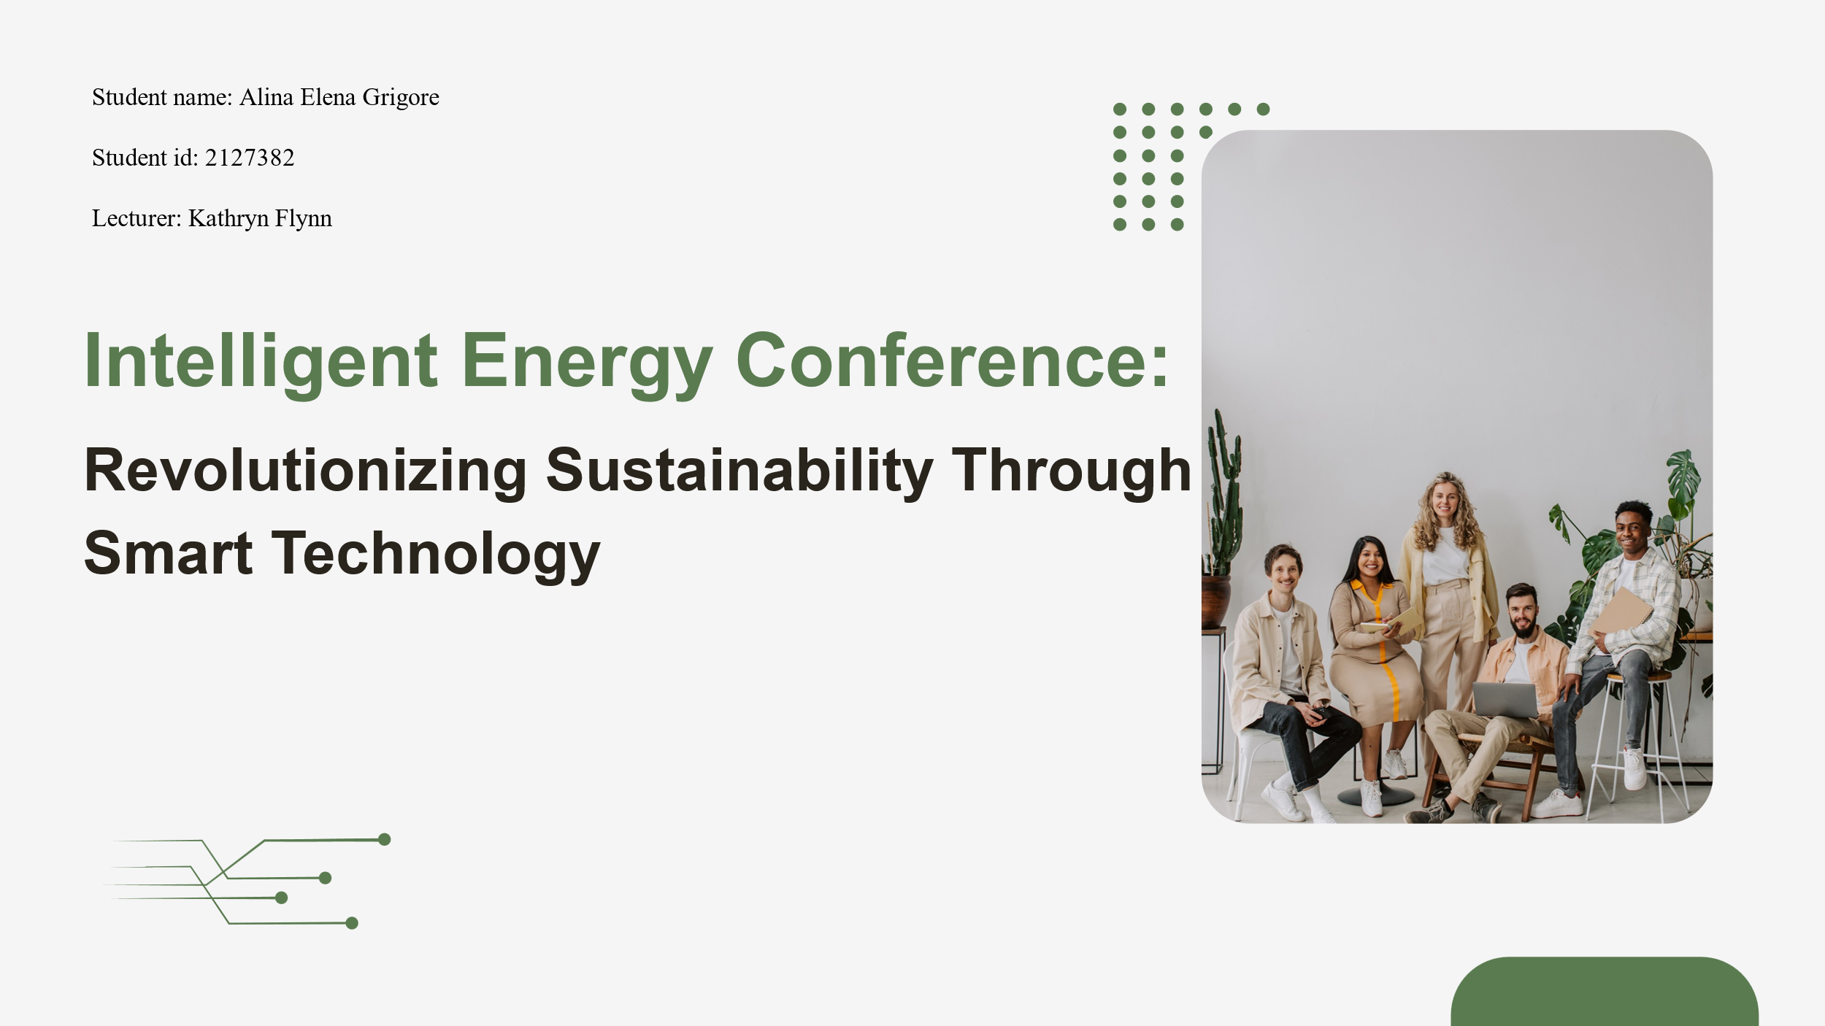

Introduction
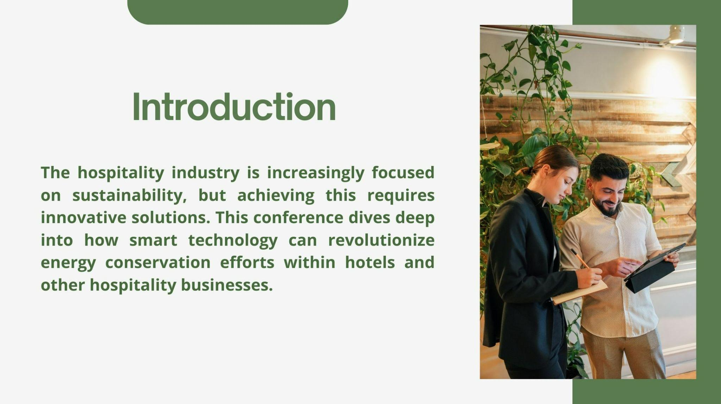

The hospitality industry has recently moved towards sustainability, but it's difficult without innovative ideas. During this conference, we will review the smart technology feature that can completely transform the way hotels and other businesses in the hospitality industry implement energy conservation efforts. The rest of the presentation aims at the cost-benefit analysis of the event including market demand and operational requirements. In conjunction with this, we shall provide a showcase of state-of-the-art technologies and their predicted effect on sustainability in the hospitality industry (Hagen, 2021).

Market Analysis: Target Market
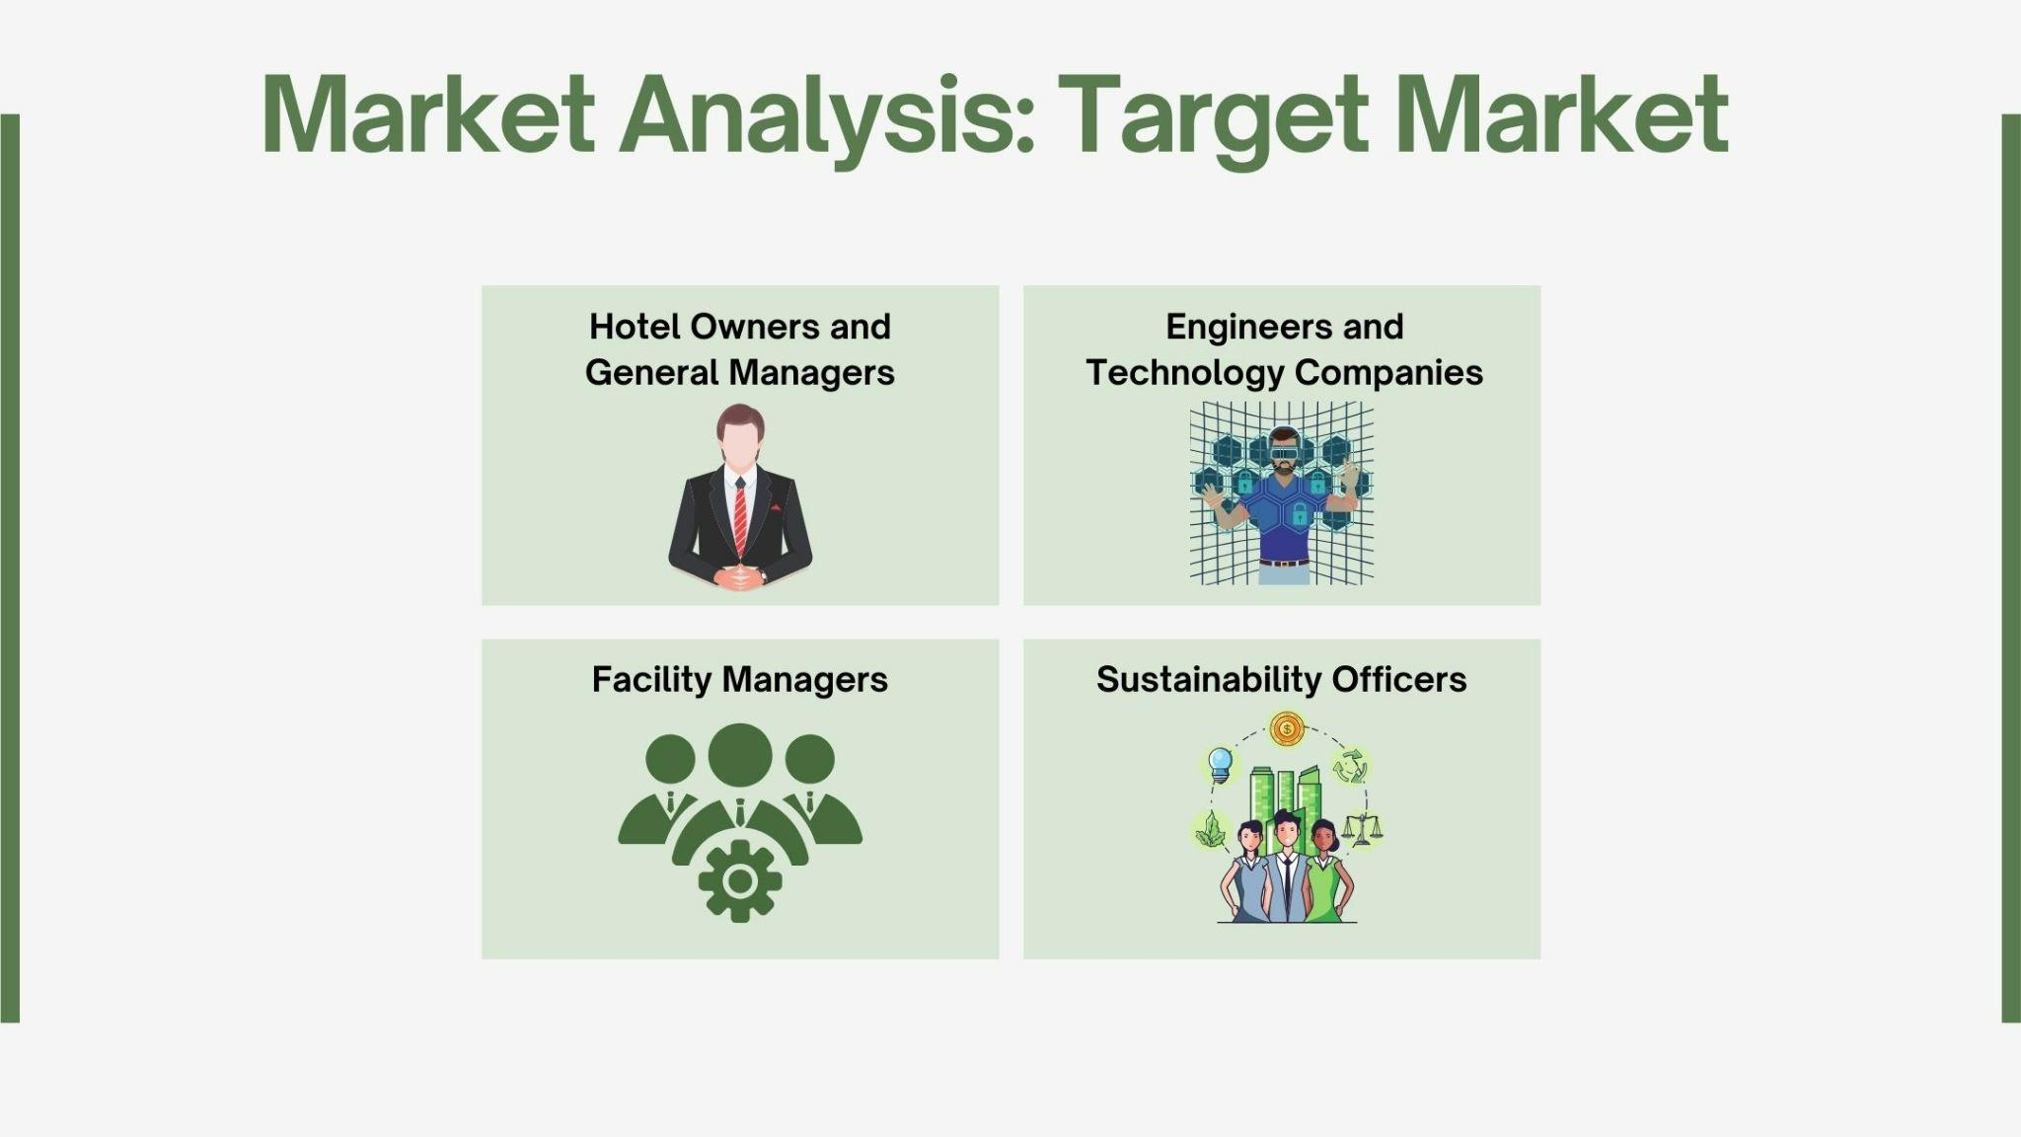

The target group of the Intelligent Energy Conference is set as being the group of environmental hotels and not the one whose only intention is to make a quick profit. Through our solution, we cater to the needs of hotel owners and general managers looking for reliable and sustainable solutions to minimize their costs of power and ultimately boost their environmental friendliness. We also take up the smart energy solution-enabling engineers and tech companies as hospitality industry partners (Fox et al., 2014).

The case study conclusions will be appreciated by sustainability officers and facility managers tasked with introducing green technologies in hotels as the insight and strategies on incorporating smart technologies into their operations will be among their key considerations. This gathering will be an opportunity for all stakeholders to collaborate and participate in a knowledge transfer and exchange, which will subsequently quicken the transportation of smart technologies in the hospitality industry toward a thriving tomorrow (Zhang and Cao, 2021).

Reason of Demand for the Intelligent Energy Conference
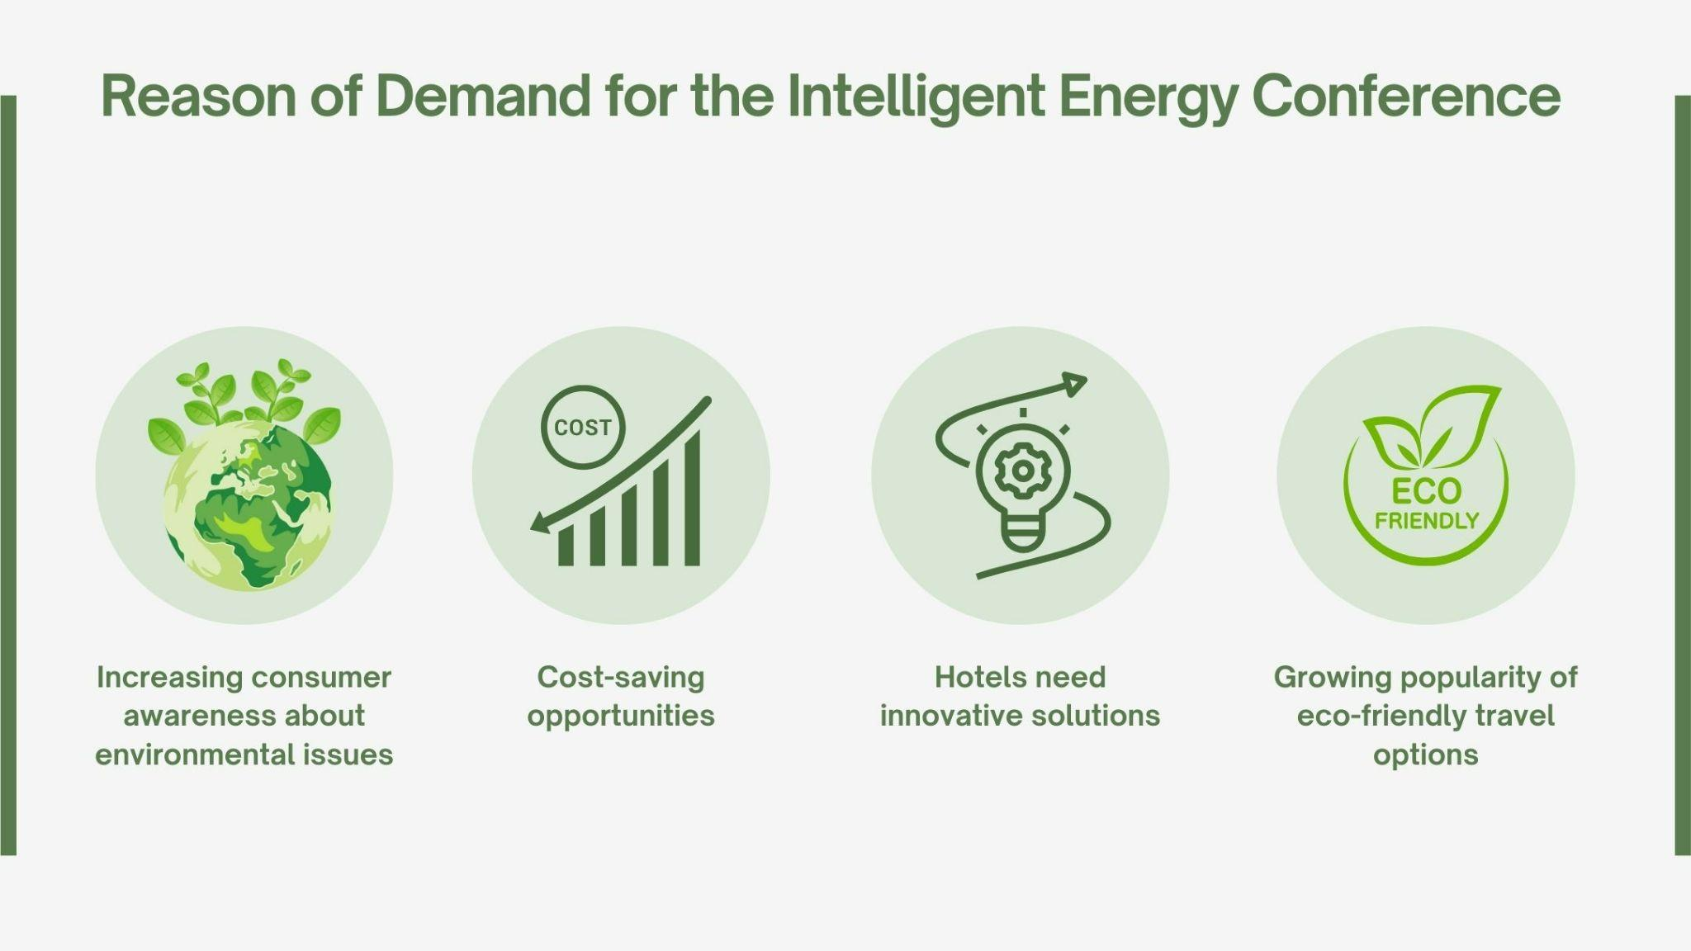

The predicted rise in demand for the Intelligent Energy Conference from the hospitality industry results from the toiling of these trends. Consumers nowadays care more about solving environmental problems and prefer this kind of eco-friendly travel option. This consequently leads to hotels being in a corner, and their way out is to come up with creative solutions. On the plus side, increasing the technology of smart devices provides a great chance for the lowering of fiscal prospects thanks to the drop in energy consumption (Nižetić et al., 2019).

Hotels must adopt these solutions to maintain competitiveness and meet the expectations of the visiting consumers who are also asking for sustainable practices. The Intelligent Energy Conference fills this gap by highlighting the smart technology that has solutions for these issues, and it helps hotels to use it in pursuing a brighter ecological future that they enjoy (Driessen, 2023).

Intelligent Energy Conference landscape
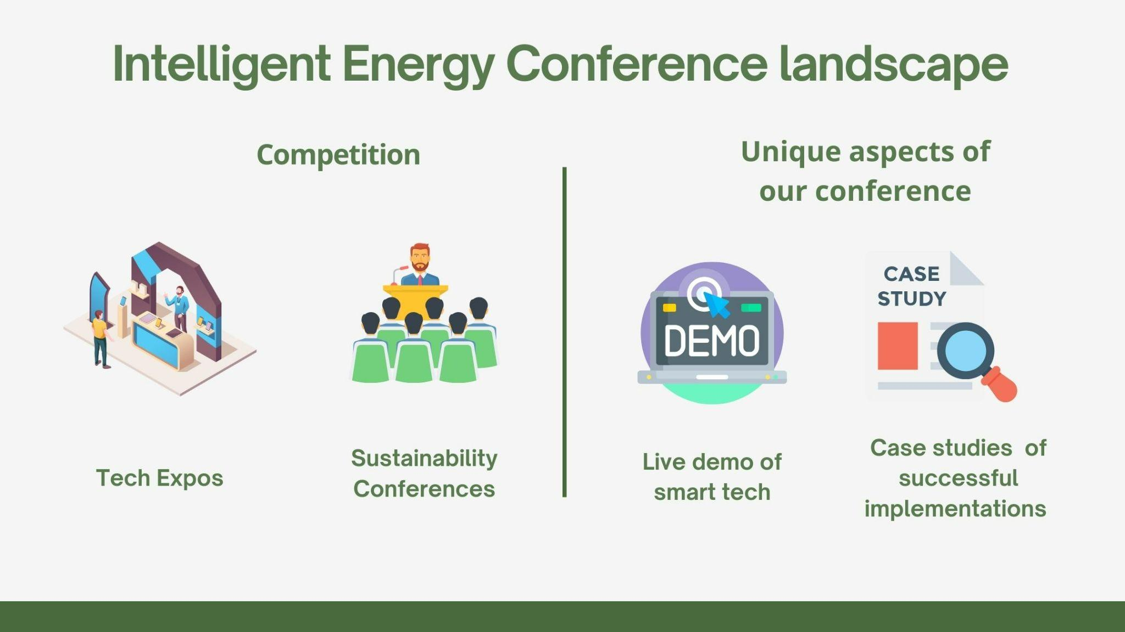

The Intelligent Energy Conference isn't necessarily the only event concerned with sustainability but this specific conference offers a special view. Smart technology as applied to the hospitality industry forms the main thrust of the trade show and conference that we are planning (Rogers and Davidson, 2016).

They showcase various smart technology advancements and display a wide range of eco-friendly solutions. What sets us apart? We're going to make demo sessions for people to feel the color, sound & temperature themselves and see for example how the new technologies are used in a hotel (Rogers and Wynn-Moylan, 2022).

Besides that, we'll illustrate real-time case studies of successful implementation in hotels that will be presented in terms of eventual results and solved issues. This narrow focus enhancement by our events will give some competition, but our specific services and hospitality can be cobbled together to fulfill needs in the market. This special way of thinking puts the Intelligent Energy Conference among the key venues for hospitality businesses and related companies interested in smart technology targeted at their specific issues (Smith, 2012).

Operational Analysis: Venue selection
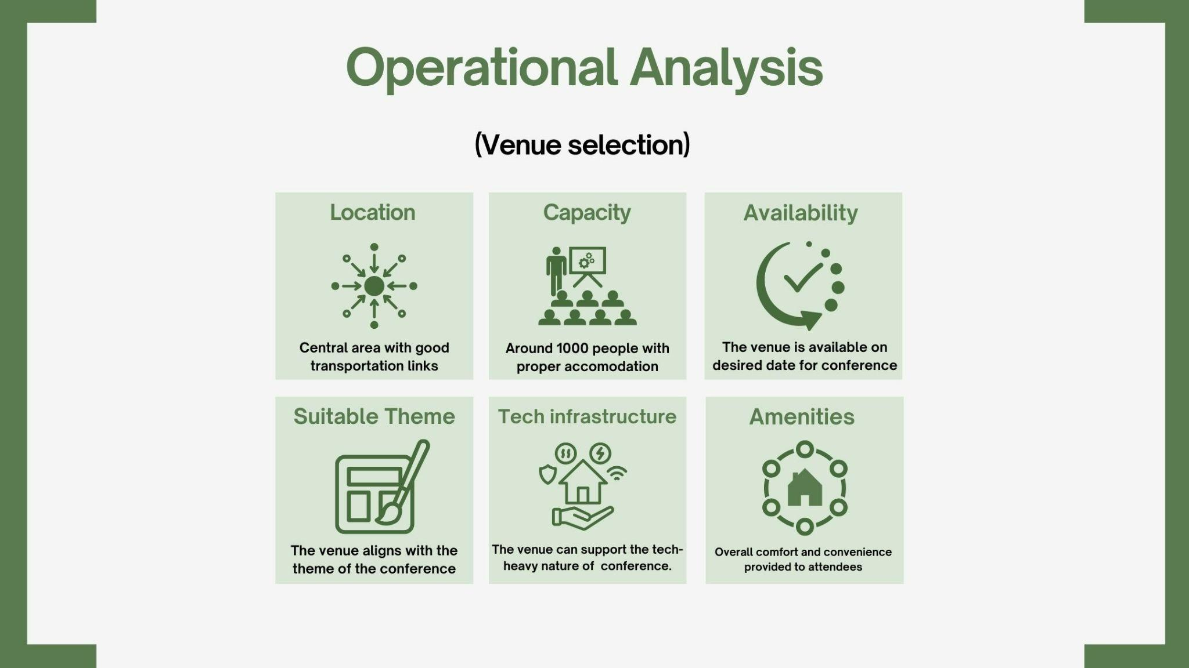

In the choice of location for our Intelligent Energy Conference we firstly made it accessible that is secured by the venue being close to the local hotels and transport means. With an expected crowd of up to 1000 people, we sought a big venue so our guests could have enough space to move in, the venue also must have the capacity for different seating arrangements or breakout rooms depending on the occasion (Vrana, 2023).
The technological capabilities constituted the base of the class so advanced audiovisual equipment and a fast internet connection must be at hand to intensify the teaching with interactive presentations and demonstrations. Also, we looked into features like a catering system and enough parking that would ensure a better experience. Beyond the venue's selection, we were very deliberate and cautious about its alignment with our conference theme which focused on technology and sustainable solutions. Lastly, accepting value and availability were critical factors that made our selection meet our desired budget as well as the dates matching, our preferred conferences (Sufi, 2022).

Operational Analysis: Staff needed.
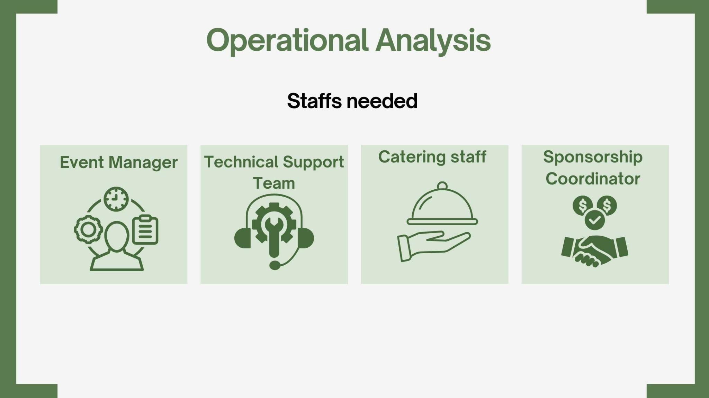

To achieve an Intelligent Energy Conference success, you'll have to deal with a skilled team. The manager of the event will organize all the steps of the process. Hands-on assistance from a technical support team would certainly be a requirement to operate presentations and to ensure smooth technology integration (Getz and Page, 2019).

The buffet will be taken care of by our kitchen and catering staff who will also provide refreshments and breaks for the attendees. Sponsorship coordinators are going to have to bring on board a sponsorship for the event (Tan and Wright, 2022).

The conference will be promoted through different channels via an articulate marketing team to our target audience. Also, volunteers will have their role equally important with tasks like registration and attendee assistance. As a result, we will have a team that is composed of these experts, and we can utilize their expertise to provide a professional, and interactive atmosphere for all conference participants (Kalsi et al., 2023).

Resources required.
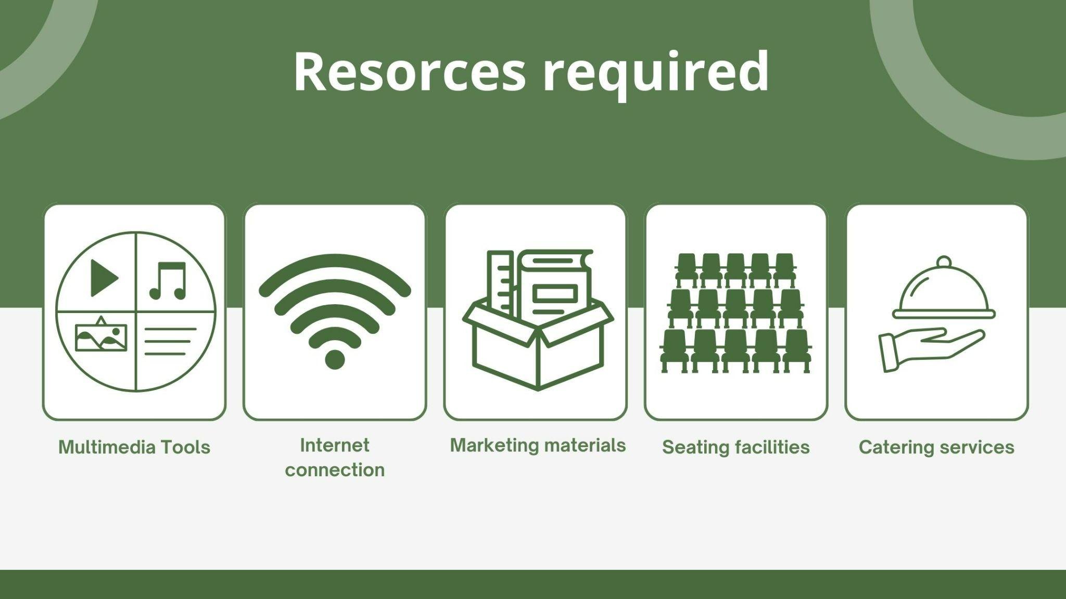

In addition to the core team that we spoke about earlier, there are also essential resources we should devote to the development of a Smart Energy Conference. Proficient catering services will provide guests with food, drinks, and breaks which will be ongoing during the meeting (Miller and Torres-Delgado, 2023).

The latest technology is a useful point in demonstrations and presentations. This will require a projector, screen, microphone, and high-speed internet (CHUKWU, 2023).

Posters, flyers, and websites would help advertise the conference and give necessary direction to visitors on site. Based on the location, one may hire and arrange for furniture for different areas. Through the utilization of such resources wisely, we can build a professional and comfortable space where instrumental figures like speakers, exhibitors, and attendees will feel like participants and not outsiders (O´Toole, 2011).

Conference financial breakdown
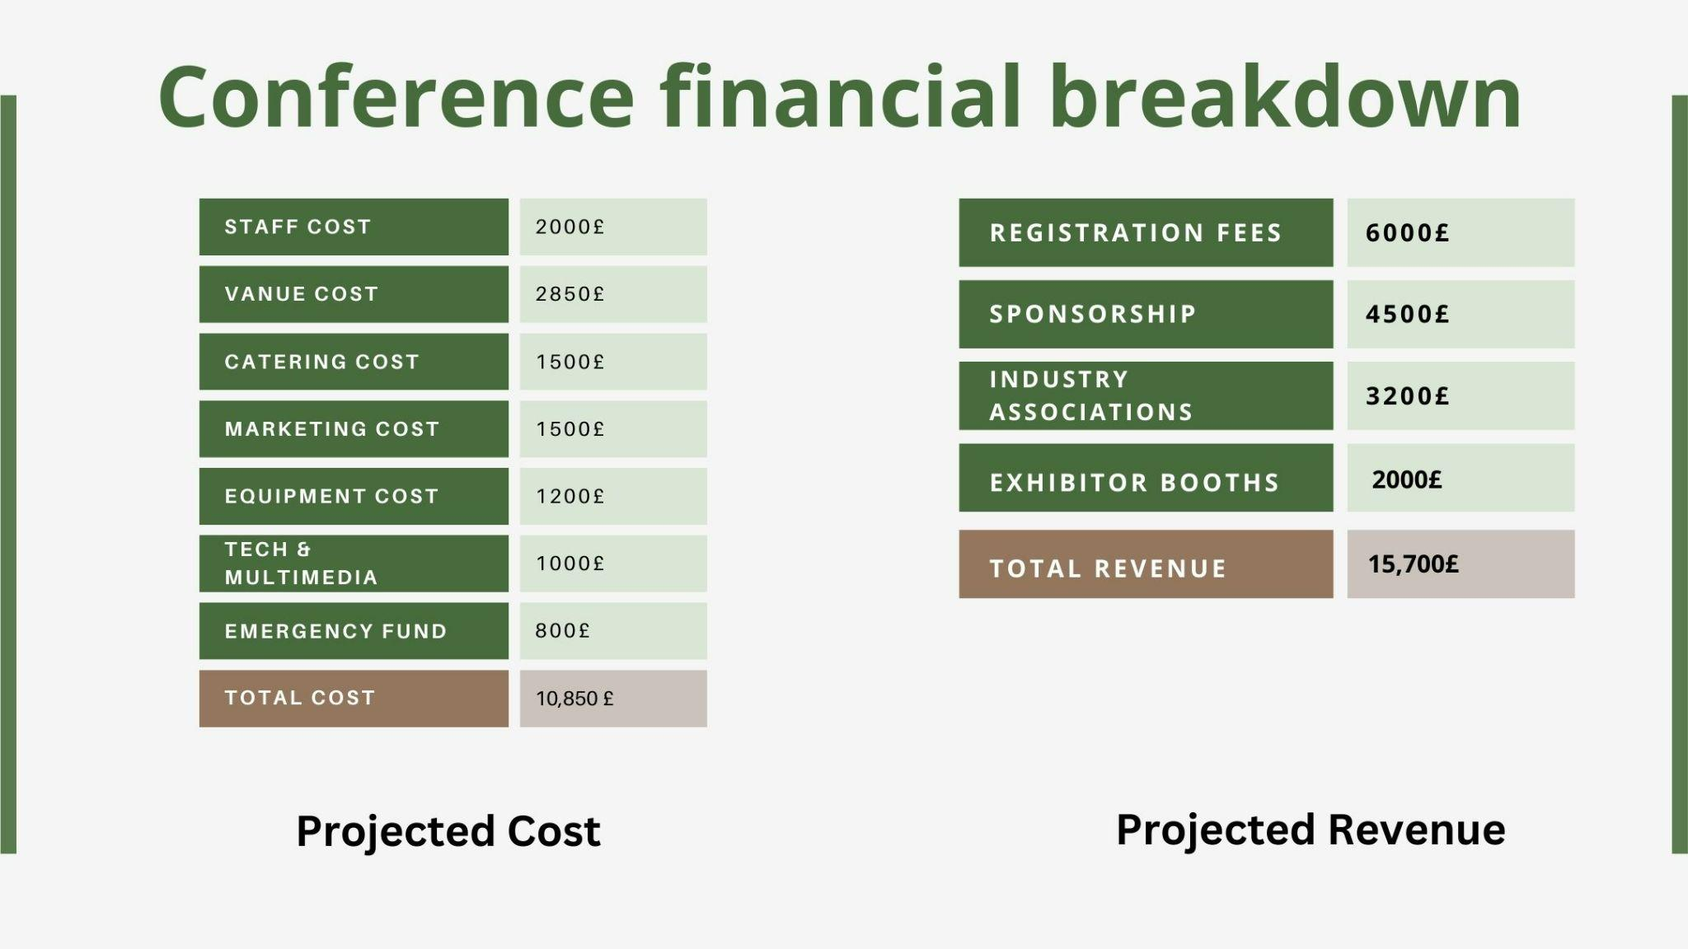

Let's tackle the financial viability of the Intelligent Energy Conference. To conduct this event, we expect to spend a total of £10,850. We need to provide for essential expenditures like hiring (£2,000), venue rental (£2,850), catering (£1,500) and marketing allocations (£1,500). Furthermore, equipment expenses such as screens and projectors will amount to £1,200 and technical services and multimedia will cost £1,000. In addition to this, we included an £800 emergency fund to take care of unplanned occurrences (Rogers and Davidson, 2016).

What is great is that we have several sources of revenue to fund the expenses. Registration money from attendees is going to be approximately £6,000 from ticket sales. Through sponsorships, we can raise an extra £4,500, while industry associations could give £3,200. As a final point, selling exhibitor booths would result in £2,000 in revenue. In general, with these additional revenue streams, we could bring in £15,700, which is higher than our expected costs. This financial feasibility analysis foresees a strong and enduring Intelligent Energy Conference, that can be a resounding success (Casais and Ferreira, 2023).

Income projection
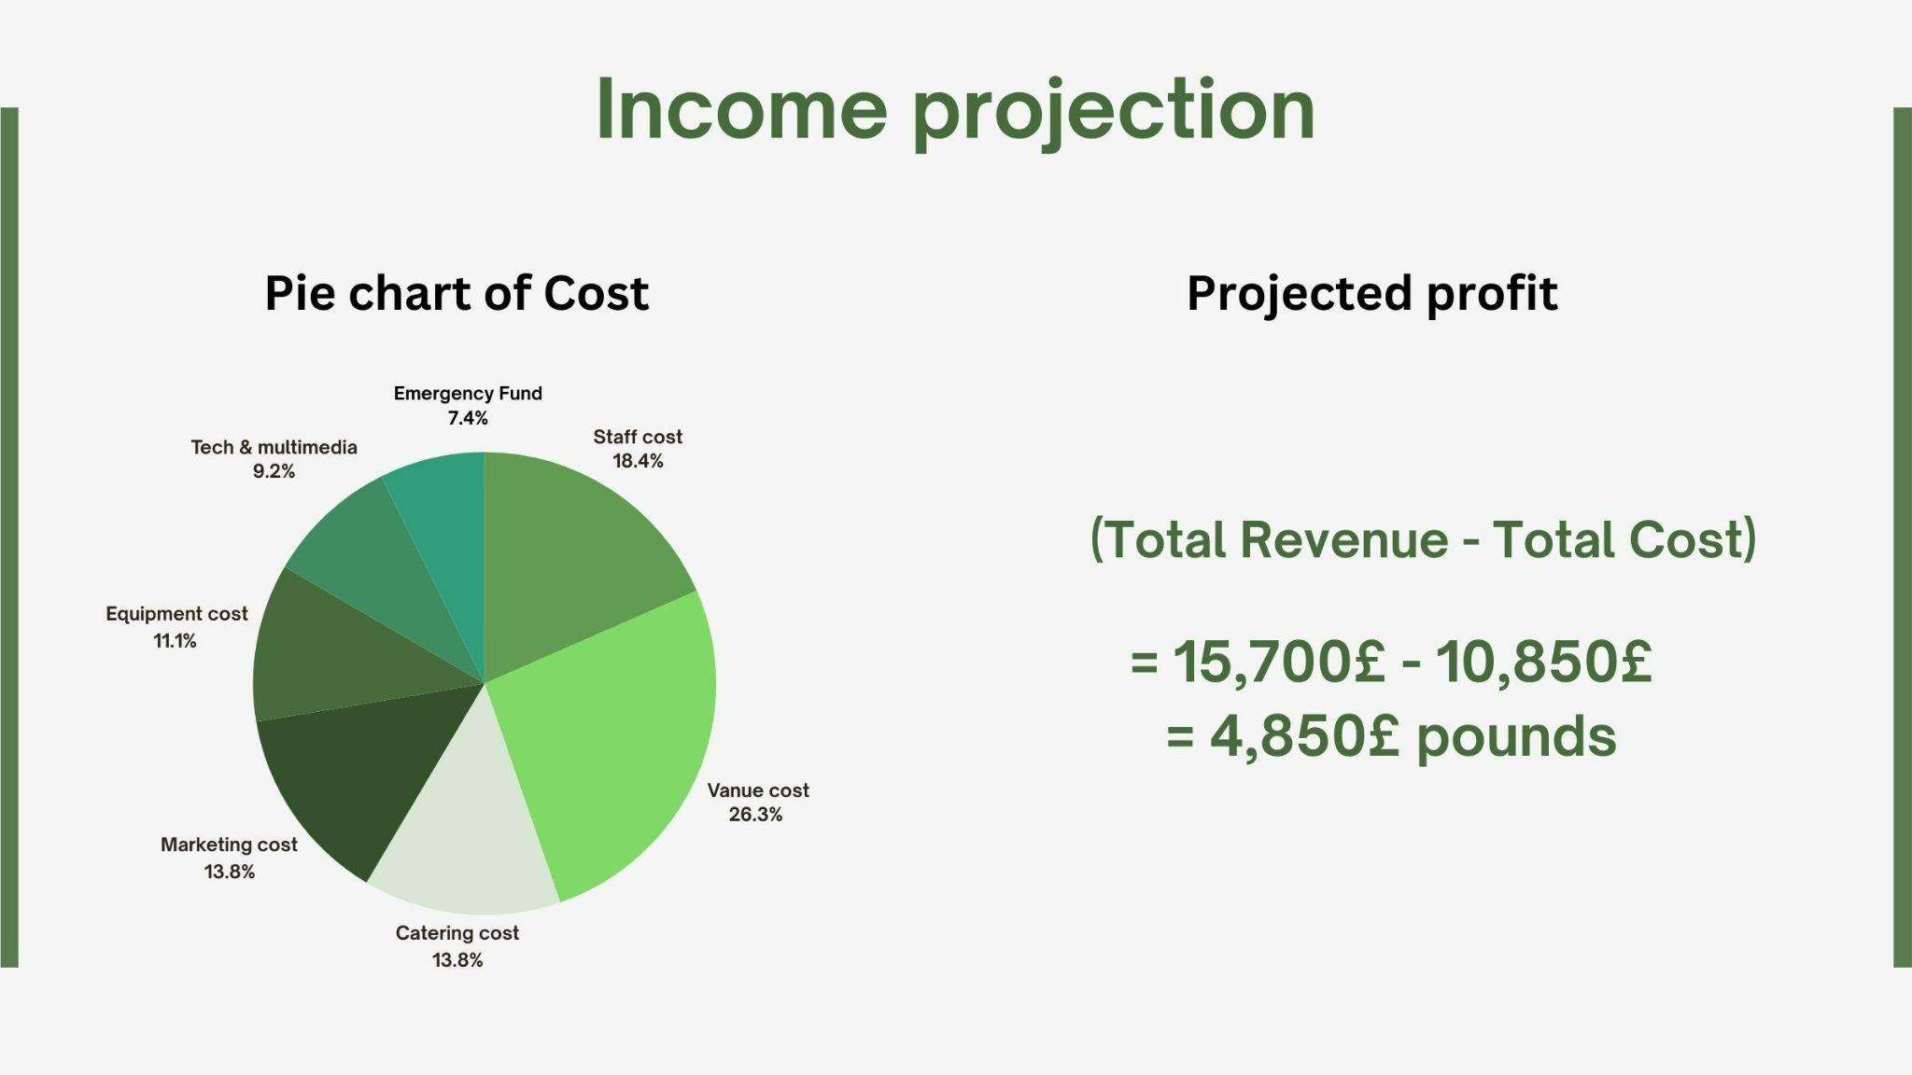
As the provided pie chart demonstrates, the conference on Intelligent Energy may be commercially lucrative. This figure in blue is the total cost of the conference and it amounts to £10,850. The green area with the largest population mass represents the anticipated budget of £15,700 from registration fees, sponsorships, industry association contributions, and exhibitor booths (Meredith, 2022).

If we only subtract our expenses from the revenue, we can come up with our projected profit. Therefore, £15,700 - £10,850 = £4,850 will be the resulting profit. The positive profit margin shows that the Intelligent Energy Conference can serve as a self-sufficient event with the capital accumulated during the previous conferences or industry endeavors being reinvested into future conferences (Agarwal et al., 2022).

Conclusion
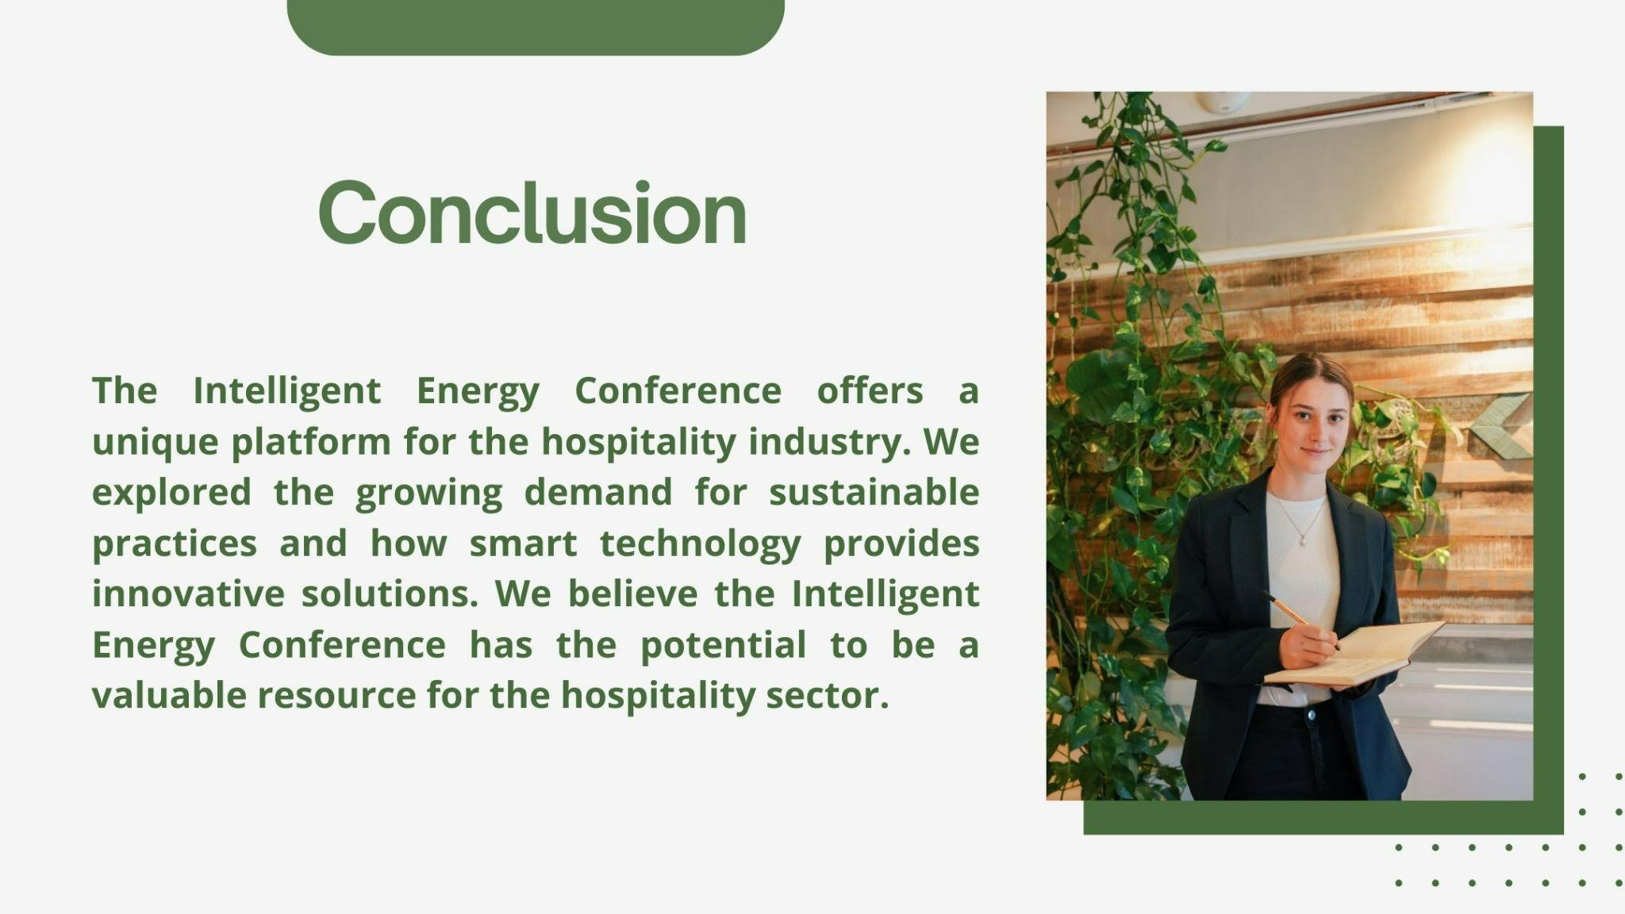

In conclusion, the Intelligent Energy Conference holds a special stage for hotels. We looked at the requirements to make sustainable practices cool and how smart technology provides alternative approaches. The conference can develop a platform to demonstrate these technologies and their connection to cost reduction and environmental benefits. This will enable hotels to accelerate positive changes. We think the Intelligent Energy Conference can be an important tool for the hospitality industry to cooperate and quicken the process of technology assimilation for a greener future.

References
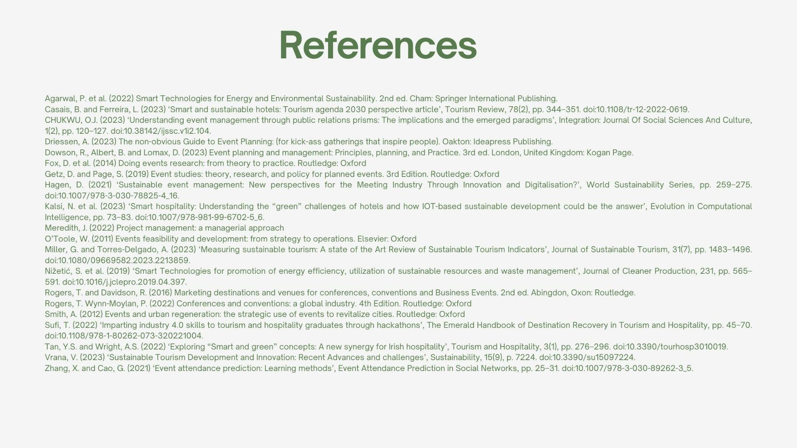

Agarwal, P. et al. (2022) Smart Technologies for Energy and Environmental Sustainability. 2nd ed. Cham: Springer International Publishing.
Casais, B. and Ferreira, L. (2023) ‘Smart and sustainable hotels: Tourism agenda 2030 perspective article’, Tourism Review, 78(2), pp. 344–351. doi:10.1108/tr-12-2022-0619.
CHUKWU, O.J. (2023) ‘Understanding event management through public relations prisms: The implications and the emerged paradigms’, Integration: Journal of Social Sciences And Culture, 1(2), pp. 120–127. doi:10.38142/ijssc.v1i2.104.
Driessen, A. (2023) The non-obvious Guide to Event Planning: (for kick-ass gatherings that inspire people). Oakton: Ideapress Publishing.
Dowson, R., Albert, B. and Lomax, D. (2023) Event planning and management: Principles, planning, and Practice. 3rd ed. London, United Kingdom: Kogan Page.
Fox, D. et al. (2014) Doing events research: from theory to practice. Routledge: Oxford
Getz, D. and Page, S. (2019) Event studies: theory, research, and policy for planned events. 3rd Edition. Routledge: Oxford
Hagen, D. (2021) ‘Sustainable event management: New perspectives for the Meeting Industry Through Innovation and Digitalisation?’, World Sustainability Series, pp. 259–275. doi:10.1007/978-3-030-78825-4_16.
Kalsi, N. et al. (2023) ‘Smart hospitality: Understanding the “green” challenges of hotels and how IOT-based sustainable development could be the answer’, Evolution in Computational Intelligence, pp. 73–83. doi:10.1007/978-981-99-6702-5_6.
Meredith, J. (2022) Project management: a managerial approach
O’Toole, W. (2011) Events feasibility and development: from strategy to operations. Elsevier: Oxford
Miller, G. and Torres-Delgado, A. (2023) ‘Measuring sustainable tourism: A state of the Art Review of Sustainable Tourism Indicators’, Journal of Sustainable Tourism, 31(7), pp. 1483–1496. doi:10.1080/09669582.2023.2213859.
Nižetić, S. et al. (2019) ‘Smart Technologies for promotion of energy efficiency, utilization of sustainable resources and waste management’, Journal of Cleaner Production, 231, pp. 565–591. doi:10.1016/j.jclepro.2019.04.397.
Rogers, T. and Davidson, R. (2016) Marketing destinations and venues for conferences, conventions, and Business Events. 2nd ed. Abingdon, Oxon: Routledge.
Rogers, T. Wynn-Moylan, P. (2022) Conferences and conventions: a global industry. 4th Edition. Routledge: Oxford
Smith, A. (2012) Events and urban regeneration: the strategic use of events to revitalize cities. Routledge: Oxford
Sufi, T. (2022) ‘Imparting industry 4.0 skills to tourism and hospitality graduates through hackathons’, The Emerald Handbook of Destination Recovery in Tourism and Hospitality, pp. 45–70. doi:10.1108/978-1-80262-073-320221004.
Tan, Y.S. and Wright, A.S. (2022) ‘Exploring “Smart and green” concepts: A new synergy for Irish hospitality’, Tourism and Hospitality, 3(1), pp. 276–296. doi:10.3390/tourhosp3010019.
Vrana, V. (2023) ‘Sustainable Tourism Development and Innovation: Recent Advances and challenges’, Sustainability, 15(9), p. 7224. doi:10.3390/su15097224.
Zhang, X. and Cao, G. (2021) ‘Event attendance prediction: Learning methods’, Event Attendance Prediction in Social Networks, pp. 25–31. doi:10.1007/978-3-030-89262-3_5.

