Critical and Real-Time Application Programming
Part 1
Robert McIntyre
M6X01090
Mike Dacey

Table of Contents
Introduction 3
Real-time Systems 3
Hard Real Time System 3
Soft Real Time Systems 3
Sat navigation Example 3
Alpha Blending 4
Testing 4
Test 1 – Test of one byte 4
Test 2 – Testing the whole ARGB of one pixel. 5
Test 3 – Calculation on whole image 7
Micro Controller steps for the washing machine cycle 8
Safety feature steps for washing machine 11
Appendices 12
FunctionExample.s 12
main.c 16

Introduction
This report demonstrates the roles of critical systems and some safety aspects needed in the equipment. It describes different types of real-time systems available and where they are used. The report includes programming a microcontroller board in assembler to alpha blend two images together. The final section includes the steps in a washing machine cycle.

Real-time Systems
There are two main types of real-time systems in computer systems. These are hard and soft real-time systems. Real Time Operating Systems (RTOS) are usually found in the embedded systems. Time is the constraint in these systems as there is a need to produce accurate outputs at a particular time. This differs from a General Purpose Operating system (GPOS) which produces accurate results with no time limit. The main difference between the hard and soft real time systems is how a failure could be tolerated.

Hard Real Time System
A hard real time system has software which must operate on a time deadline. There is no delay allowed and a missed deadline will result in a critical failure. This type of system is used when there cannot be any failures. Examples of this type of system are aircraft control systems, airbags in vehicles and pacemaker.

Soft Real Time Systems
Soft real-time systems can miss a couple of instructions without it affecting the overall outcome. The critical times in these systems may be delayed slightly but this will result in a reduced performance of the software output. Examples of these are mobile phones, digital cameras and virtual reality.

Sat navigation Example
A sat navigation system is a soft real-time system as it is not a critical failure when the updating and recalculating of the sat nav is slightly late. In the sat nav there is a GPS system that locates the correct position of the car and compares the GPS coordinates to a map that is stored in memory. The CPU calculates the route from the location to the destination and displays the result on the screen. There is a latency of 1.5 seconds in updating to the user. Therefore, the deadline for acquiring new data can be missed slightly without the route. Even if the data is missed for a short time because of loss of signal due to a tunnel for example the system does not fail. When the signal is reestablished it will update a new GPS location.

Alpha Blending
In order to complete the alpha blending task first the code was written to combine the first red byte of information from the foreground and background array. In this stage the correction value was also used changing it from 1 – 255 to 2 – 256. This is shown in test one. Next the calculation of a whole pixel is done including a loop and a counter to count 4 bytes see test two. Finally the calculation on the whole image is done see test three.

Testing

Test 1 – Test of one byte
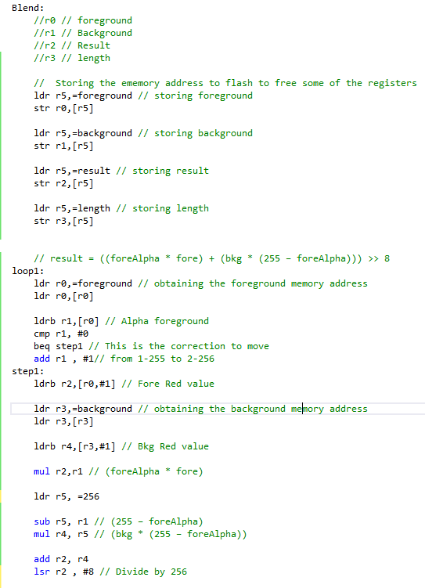
This test involves changing the first value in the ARGB. The first value being Red value which is 0x00 and the alpha value being 0x80. The correction has been added in where
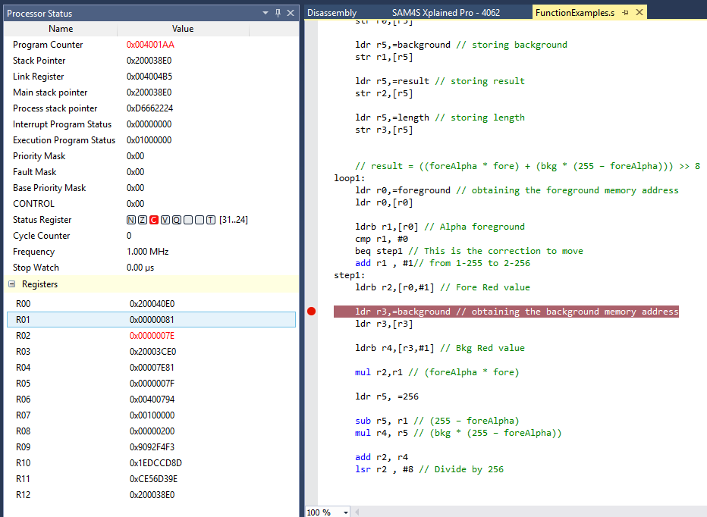
With the calculations placed in with the included offsets in the memory address for both the foreground and the background. This tests to see if this has worked with one value. The next step is to see if I can do it with the red and the green value.

Test 2 – Testing the whole ARGB of one pixel.
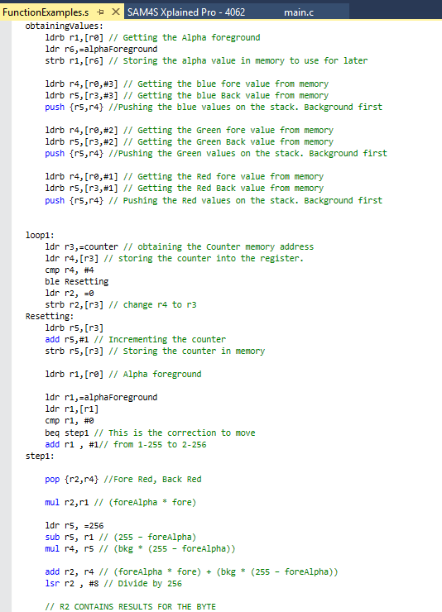

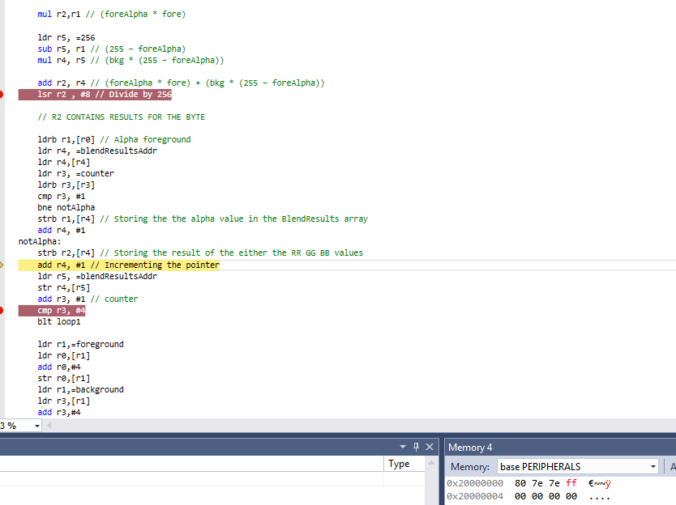
To do the first pixel I have place the RR GG BB values on to the stack in reverse order as the stack is a first in last out operation. The Alpha is stored on the memory to enable it to be used throughout the loop. The answers are stored in an array. The Answer for the first pixel is 80 7E 7E FF.

Test 3 – Calculation on whole image
There is another counter and loop added from test two. The results of the alpha blending go from the memory space 0x20000000 - 0x200003FF. Memory address for the foreground and background are increased by 4 to move to the next pixel to continue the calculation.
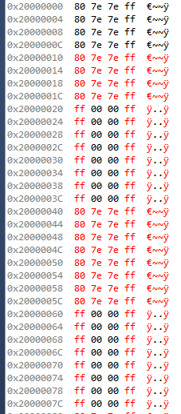
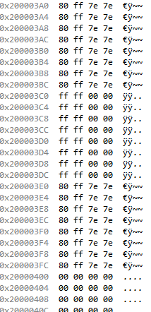

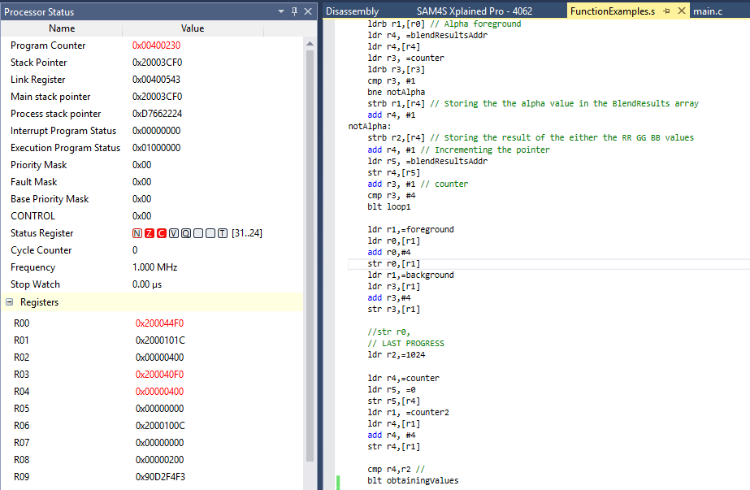

Micro Controller steps for the washing machine cycle

No | Action | Duration | Delay
 | Starting the Wash  - User selects a wash cycle on the machine. The values of this cycle are sent from the interface module and stored on the EEPROM module on the main board.  - Button to start the process is pressed. | 1 sec | 1 sec
 | Locking the Door  - When the button is pressed the When the door is shut there is a latch to check if door is properly shut (Bit check of an off or on state)  - Once the latch is in the on state the electromagnet will turn on with an on state so the door cannot be opened.  - When the door is not properly locked the buzzer alerts the user.  - The user re-attempts to shut the door | 2 sec | 1s
 | Turning of the drum sequence  - The main CPU sends a signal to through the output buffer to the communication bus and to the power driver  - Once the signal reaches the power driver the CPU that is on the power board uses a sequence to turn on the motor module clockwise for 1min stop for 3 seconds anti-clockwise for a 1min stop for 3 seconds and then repeat on a loop. Carries on sequence until it is given a signal to stop. | 2 min per loop | 6 sec
 | Adding the Water to the Drum  - The main CPU sends the signal through the communication bus to the power driver to open the valves on the pump to allow water to enter the drum | 10 min | 2 min
 | Close Water pump  - Power driver board sends the signal to close the valve in the pump | 1 sec | 10 min
 | Turn on the heater  - The main CPU sends the signal through the communication bus. The CPU on the power driver will send a signal to the heater module to turn on the module | Until temp reached  ~30 min | 5 min
 | Measure Temperature  - Gather the information from the EEPROM memory to see what temperature the user wanted their clothes at  - The main CPU sends a signal to the input module to measure the temperature to the required temperature from the user | Until temp reached  ~30 min | 5 min
 | Turn off heater  - Signal sent from input sensor to the CPU that the temperature has been reached.  - The main CPU sends the signal through the communication bus. The CPU on the power driver will send a signal to the heater module to turn off the module | 1 sec | Until temp  reach
 | Open drain valve  - The main CPU sends the signal through the communication bus to open the drain valve to drain the water that is in the drum | 1 sec | 1 hour 40 min
 | Increase spinning speed  - The main CPU sends the signal through the communication bus to the power driver to change the value to increase the speed of the motor. The CPU increases the speed of the drum | 5 min | 3 sec
 | Stop spinning  - The main CPU sends the signal through the communication bus to the power driver to turn off the power module. | 30 sec | 5 min
 | Close drain valve  - The main CPU sends the signal through the communication bus to close the drain valve | 1 sec | 30 sec
 | Rinse Cycle  - The main CPU sends a signal through the communication bus to the interface module and changes the output interface to a rinse cycle. | 1 sec | 1 sec
- 1sec | Open water valve  - The main CPU sends the signal through the communication bus to the power driver to open the valves on the pump to allow water to enter the drum | 10 min | 2 min
 | Turn drum  - The main CPU sends a signal to through the output buffer to the communication bus and to the power driver  - Once the signal reaches the power driver the CPU that is on the power board uses a sequence to turn on the motor module clockwise for 1min stop for 3 seconds anti-clockwise for a 1min stop for 3 seconds and then repeat on a loop. Carries on sequence until it is given a signal to stop. | 2 min per loop | 6 sec
 | Close Water pump  - Power driver board sends the signal to close the valve in the pump | 1 sec | 10 min
 | Open drain valve  - The main CPU sends the signal through the communication bus to open the drain valve to drain the water that is in the drum | 5 min | 1s
- Tu | Increase spinning speed  - The main CPU sends the signal through the communication bus to the power driver to change the value to increase the speed of the motor. The CPU increases the speed of the drum | 5 min | 3 sec
 | Close drain valve  - The main CPU sends the signal through the communication bus to close the drain valve | 1 sec | 30 sec
 | Turn drum  - The main CPU sends a signal to through the output buffer to the communication bus and to the power driver  - Once the signal reaches the power driver the CPU that is on the power board uses a sequence to turn on the motor module clockwise for 1min stop for 3 seconds anti-clockwise for a 1min stop for 3 seconds and then repeat on a loop. Carries on sequence until it is given a signal to stop. | 2 min per loop | 6 sec
Repeat from step 14 x3
- This is repeating from step 14 three times
 | Open drain valve  - The main CPU sends the signal through the communication bus to open the drain valve to drain the water that is in the drum | 5 min | 1s
 | Spin Cycle  - The main CPU sends a signal through the communication bus to the interface module and changes the output interface to a rinse cycle. | 1 sec | 1 sec
 | Increase spin speed  - The main CPU sends the signal through the communication bus to the power driver to change the value to increase the speed of the motor. The CPU increases the speed of the drum | 10 min | 3 sec
 | Stop Spinning  - The main CPU sends the signal through the communication bus to the power driver to turn off the power module. | 1 sec | 10 min
 | Turn Drum  - The main CPU sends a signal to through the output buffer to the communication bus and to the power driver  - Once the signal reaches the power driver the CPU that is on the power board uses a sequence to turn on the motor module clockwise for 1min stop for 3 seconds anti-clockwise for a 1min stop for 3 seconds and then repeat on a loop. Carries on sequence until it is given a signal to stop. | 2 min per loop | 6 sec
 | Close drain valve  - The main CPU sends the signal through the communication bus to close the drain valve | 1 sec | 30 sec
 | Stop the drum  - The main CPU sends the signal through the communication bus to the power driver to turn off the power module. | 30 sec | 1 sec
 | Release the door lock  - The main CPU sends a signal to turn off the electro magnet to open the door. There needs to be a delay | 1 sec | 1 min
 | Sound the buzzer  - The main CPU sends a signal to the speaker to making a beeping sound to alert the user the washing machine is finished. | 1 min | 1 min

Safety feature steps for washing machine
A washing machine cycle has critical steps that need safety features which may require delays in the system. The first of these is locking the door. This is required to prevent the door being open when either the drum is turning, or the machine is full of water. If the temperature of the system is above the required value the system needs to automatically turn off the heater. There needs to be a safety feature where the pump will not start if water valve is not open. When the cycle has finished there needs to be a delay to check the drum has stopped turning and there is no water in the drum before the door lock is released so that the door can be opened safely. This also happens if the user cycle has been interrupted.

Appendices

FunctionExample.s

/*
* FunctionExamples.s
*
* Created: 26/09/2016 12:43:18
* Author: sc-md
*/
.section .text
.global myFunction, BlendByPixel, Blend, ClearRegister
.type myFunction, %function
.type Blend, %function
.type ClearRegister, %function
.type BlendByPixel, %function

BlendByPixel:

/*
//result = foreAlpha * fore + (1 – foreAlpha) * bkg
result = 1 * fore + (1 – 1) * bkg = fore (the foreground image is opaque/fully visible)
result = 0 * fore + (1 – 0) * bkg = bkg (the foreground image is invisible)
result = 0.5 * fore + (1 – 0.5) * bkg = 50% of both (foreground is 50% transparent)
*/
myFunction:

Blend:
// Order of arguments being passed to function
// foreground
// Background
// Result
// length

// Storing the ememory address to flash to free some of the registers
ldr r5,=foreground // storing foreground str r0,[r5]

ldr r5,=background // storing background
str r1,[r5]

ldr r5,=length // storing length
str r2,[r5]

ldr r2,=blendResultsAddr // loads the memory address for blend results
ldr r5,=blendResults // storing length
str r5,[r2]

// ldr r6, =0 // Counter for the number of 4 x 1 bytes
ldr r7, =0 // Counter for ARGB

// Maths equation to calculate the pixel
// result = ((foreAlpha * fore) + (bkg * (255 – foreAlpha))) >> 8

ldr r0,=foreground // obtaining the foreground memory address
ldr r0,[r0]

ldr r3,=background // obtaining the background memory address
ldr r3,[r3]

// This is placing the AARRGGBB Values into the stack pointer
obtainingValues:
ldrb r1,[r0] // Getting the Alpha foreground
ldr r6,=alphaForeground
strb r1,[r6] // Storing the alpha value in memory to use for later

ldrb r4,[r0,#3] // Getting the blue fore value from memory
ldrb r5,[r3,#3] // Getting the blue Back value from memory
push {r5,r4} //Pushing the blue values on the stack. Background first

ldrb r4,[r0,#2] // Getting the Green fore value from memory
ldrb r5,[r3,#2] // Getting the Green Back value from memory
push {r5,r4} //Pushing the Green values on the stack. Background first

ldrb r4,[r0,#1] // Getting the Red fore value from memory
ldrb r5,[r3,#1] // Getting the Red Back value from memory
push {r5,r4} // Pushing the Red values on the stack. Background first

loop1:
ldr r3,=counter // obtaining the Counter memory address
ldr r4,[r3] // storing the counter into the register.
cmp r4, #4
ble Resetting
ldr r2, =0 // reseting counter
strb r2,[r3]
Resetting:
ldrb r5,[r3]
add r5,#1 // Incrementing the counter
strb r5,[r3] // Storing the counter in memory

ldrb r1,[r0] // Alpha foreground

ldr r1,=alphaForeground // Loading the address for the alpha foreground
ldr r1,[r1]
cmp r1, #0
beq step1 // This is the correction to move
add r1 , #1// from 1-255 to 2-256
step1:

pop {r2,r4} // loading the pixels of Foreground Red, Background Red

mul r2,r1 // (foreAlpha * fore)

ldr r5, =256
sub r5, r1 // (256 – foreAlpha)
mul r4, r5 // (bkg * (256 – foreAlpha))

add r2, r4 // (foreAlpha * fore) + (bkg * (255 – foreAlpha))
lsr r2 , #8 // Divide by 256

// R2 CONTAINS RESULTS FOR THE BYTE

ldrb r1,[r0] // loading the Alpha foreground
ldr r4, =blendResultsAddr // loading the alpha blend address
ldr r4,[r4]
ldr r3, =counter // loads the counter for AARRGGBB
ldrb r3,[r3]
cmp r3, #1 // checks to see if the counter is equal to one to load the alpha value into memory
bne notAlpha
strb r1,[r4] // Storing the the alpha value in the BlendResults array
add r4, #1
notAlpha:
strb r2,[r4] // Storing the result of the either the RR GG BB values
add r4, #1 // Incrementing the pointer
ldr r5, =blendResultsAddr //loading the blend result address
str r4,[r5]
add r3, #1 // incrementing the counter
cmp r3, #4 // checks to see if it the end of the loop
blt loop1

// loads the foregound and background into the registers ready for the next loop
ldr r1,=foreground
ldr r0,[r1]
add r0,#4
str r0,[r1]
ldr r1,=background
ldr r3,[r1]
add r3,#4
str r3,[r1]

ldr r2,=1024 // length of the array // this could retreive the value from memory instead

ldr r4,=counter
ldr r5, =0 // resets the counter to 0
str r5,[r4]
ldr r1, =counter2
ldr r4,[r1]
add r4, #4 // add the memory address by 4
str r4,[r1] // Stores the new value of the counter

cmp r4,r2 //
blt obtainingValues
pop {pc} // Takes off the program counter from the stack
add r1, #1 // This line needs to be taken out

ClearRegister: // This is to set all the registers to 0
push {lr}
ldr r0, = #0
ldr r1, = #0
ldr r2, = #0
ldr r3, = #0
ldr r4, = #0
ldr r5, = #0
ldr r6, = #0
ldr r7, = #0
pop {pc}

.section .data
blendResults: .space 4 * 1024 // This is the array to store the blended results
blendResultsAddr: .space 4 // Stores the address of the Blended Results
background: .space 4 // Stores the address for th background when passed as an argument
foreground: .space 4// Stores the address for th foreground when passed as an argument
alphaForeground: .space 4 // Stores the alpha value when looped each AARRGGBB
result: .space 4 // Stores the result
length: .space 4 // Stores the length of the array when passed as an argument
counter: .space 4 // Stores the counter for each pixel
counter2: .space 4 // Stores the counter for the whole picture
.end
.LTORG

main.c

/**
* \mainpage User Application template doxygen documentation
*
* \par Empty user application template
*
* This is a bare minimum user application template.
*
* For documentation of the board, go \ref group_common_boards "here" for a link
* to the board-specific documentation.
*
* \par Content
*
* -# Include the ASF header files (through asf.h)
* -# Minimal main function that starts with a call to board_init()
* -# Basic usage of on-board LED and button
* -# "Insert application code here" comment
*
*/

/*
* Include header files for all drivers that have been imported from
* Atmel Software Framework (ASF).
*/
/*
* Support and FAQ: visit <a href="http://www.atmel.com/design-support/">Atmel Support</a>
*/
#include <asf.h>
#include <stdio.h>

extern int myFunction(int i);

extern void Blend(unsigned char fore[], unsigned char back[], int length); // If width in pixels then multipy by 4
extern void ClearRegister();
extern void BlendByPixel(unsigned char fore[], unsigned char back[], int length); // If width in pixels then multipy by 4
int main (void)
{
unsigned char foregroundImage[] = {
0x80,0x00,0x00,0xFF,0x80,0x00,0x00,0xFF,0x80,0x00,0x00,0xFF,0x80,0x00,0x00,0xFF,0x80,0x00,0x00,0xFF,0x80,0x00,0x00,0xFF,0x80,0x00,0x00,0xFF,0x80,0x00,0x00,0xFF,0xFF,0x00,0x00,0xFF,0xFF,0x00,0x00,0xFF,0xFF,0x00,0x00,0xFF,0xFF,0x00,0x00,0xFF,0xFF,0x00,0x00,0xFF,0xFF,0x00,0x00,0xFF,0xFF,0x00,0x00,0xFF,0xFF,0x00,0x00,0xFF,
0x80,0x00,0x00,0xFF,0x80,0x00,0x00,0xFF,0x80,0x00,0x00,0xFF,0x80,0x00,0x00,0xFF,0x80,0x00,0x00,0xFF,0x80,0x00,0x00,0xFF,0x80,0x00,0x00,0xFF,0x80,0x00,0x00,0xFF,0xFF,0x00,0x00,0xFF,0xFF,0x00,0x00,0xFF,0xFF,0x00,0x00,0xFF,0xFF,0x00,0x00,0xFF,0xFF,0x00,0x00,0xFF,0xFF,0x00,0x00,0xFF,0xFF,0x00,0x00,0xFF,0xFF,0x00,0x00,0xFF,
0x80,0x00,0x00,0xFF,0x80,0x00,0x00,0xFF,0x80,0x00,0x00,0xFF,0x80,0x00,0x00,0xFF,0x80,0x00,0x00,0xFF,0x80,0x00,0x00,0xFF,0x80,0x00,0x00,0xFF,0x80,0x00,0x00,0xFF,0xFF,0x00,0x00,0xFF,0xFF,0x00,0x00,0xFF,0xFF,0x00,0x00,0xFF,0xFF,0x00,0x00,0xFF,0xFF,0x00,0x00,0xFF,0xFF,0x00,0x00,0xFF,0xFF,0x00,0x00,0xFF,0xFF,0x00,0x00,0xFF,
0x80,0x00,0x00,0xFF,0x80,0x00,0x00,0xFF,0x80,0x00,0x00,0xFF,0x80,0x00,0x00,0xFF,0x80,0x00,0x00,0xFF,0x80,0x00,0x00,0xFF,0x80,0x00,0x00,0xFF,0x80,0x00,0x00,0xFF,0xFF,0x00,0x00,0xFF,0xFF,0x00,0x00,0xFF,0xFF,0x00,0x00,0xFF,0xFF,0x00,0x00,0xFF,0xFF,0x00,0x00,0xFF,0xFF,0x00,0x00,0xFF,0xFF,0x00,0x00,0xFF,0xFF,0x00,0x00,0xFF,
0x80,0x00,0x00,0xFF,0x80,0x00,0x00,0xFF,0x80,0x00,0x00,0xFF,0x80,0x00,0x00,0xFF,0x80,0x00,0x00,0xFF,0x80,0x00,0x00,0xFF,0x80,0x00,0x00,0xFF,0x80,0x00,0x00,0xFF,0xFF,0x00,0x00,0xFF,0xFF,0x00,0x00,0xFF,0xFF,0x00,0x00,0xFF,0xFF,0x00,0x00,0xFF,0xFF,0x00,0x00,0xFF,0xFF,0x00,0x00,0xFF,0xFF,0x00,0x00,0xFF,0xFF,0x00,0x00,0xFF,
0x80,0x00,0x00,0xFF,0x80,0x00,0x00,0xFF,0x80,0x00,0x00,0xFF,0x80,0x00,0x00,0xFF,0x80,0x00,0x00,0xFF,0x80,0x00,0x00,0xFF,0x80,0x00,0x00,0xFF,0x80,0x00,0x00,0xFF,0xFF,0x00,0x00,0xFF,0xFF,0x00,0x00,0xFF,0xFF,0x00,0x00,0xFF,0xFF,0x00,0x00,0xFF,0xFF,0x00,0x00,0xFF,0xFF,0x00,0x00,0xFF,0xFF,0x00,0x00,0xFF,0xFF,0x00,0x00,0xFF,
0x80,0x00,0x00,0xFF,0x80,0x00,0x00,0xFF,0x80,0x00,0x00,0xFF,0x80,0x00,0x00,0xFF,0x80,0x00,0x00,0xFF,0x80,0x00,0x00,0xFF,0x80,0x00,0x00,0xFF,0x80,0x00,0x00,0xFF,0xFF,0x00,0x00,0xFF,0xFF,0x00,0x00,0xFF,0xFF,0x00,0x00,0xFF,0xFF,0x00,0x00,0xFF,0xFF,0x00,0x00,0xFF,0xFF,0x00,0x00,0xFF,0xFF,0x00,0x00,0xFF,0xFF,0x00,0x00,0xFF,
0x80,0x00,0x00,0xFF,0x80,0x00,0x00,0xFF,0x80,0x00,0x00,0xFF,0x80,0x00,0x00,0xFF,0x80,0x00,0x00,0xFF,0x80,0x00,0x00,0xFF,0x80,0x00,0x00,0xFF,0x80,0x00,0x00,0xFF,0xFF,0x00,0x00,0xFF,0xFF,0x00,0x00,0xFF,0xFF,0x00,0x00,0xFF,0xFF,0x00,0x00,0xFF,0xFF,0x00,0x00,0xFF,0xFF,0x00,0x00,0xFF,0xFF,0x00,0x00,0xFF,0xFF,0x00,0x00,0xFF,
0xFF,0xFF,0x00,0x00,0xFF,0xFF,0x00,0x00,0xFF,0xFF,0x00,0x00,0xFF,0xFF,0x00,0x00,0xFF,0xFF,0x00,0x00,0xFF,0xFF,0x00,0x00,0xFF,0xFF,0x00,0x00,0xFF,0xFF,0x00,0x00,0x80,0xFF,0x00,0x00,0x80,0xFF,0x00,0x00,0x80,0xFF,0x00,0x00,0x80,0xFF,0x00,0x00,0x80,0xFF,0x00,0x00,0x80,0xFF,0x00,0x00,0x80,0xFF,0x00,0x00,0x80,0xFF,0x00,0x00,
0xFF,0xFF,0x00,0x00,0xFF,0xFF,0x00,0x00,0xFF,0xFF,0x00,0x00,0xFF,0xFF,0x00,0x00,0xFF,0xFF,0x00,0x00,0xFF,0xFF,0x00,0x00,0xFF,0xFF,0x00,0x00,0xFF,0xFF,0x00,0x00,0x80,0xFF,0x00,0x00,0x80,0xFF,0x00,0x00,0x80,0xFF,0x00,0x00,0x80,0xFF,0x00,0x00,0x80,0xFF,0x00,0x00,0x80,0xFF,0x00,0x00,0x80,0xFF,0x00,0x00,0x80,0xFF,0x00,0x00,
0xFF,0xFF,0x00,0x00,0xFF,0xFF,0x00,0x00,0xFF,0xFF,0x00,0x00,0xFF,0xFF,0x00,0x00,0xFF,0xFF,0x00,0x00,0xFF,0xFF,0x00,0x00,0xFF,0xFF,0x00,0x00,0xFF,0xFF,0x00,0x00,0x80,0xFF,0x00,0x00,0x80,0xFF,0x00,0x00,0x80,0xFF,0x00,0x00,0x80,0xFF,0x00,0x00,0x80,0xFF,0x00,0x00,0x80,0xFF,0x00,0x00,0x80,0xFF,0x00,0x00,0x80,0xFF,0x00,0x00,
0xFF,0xFF,0x00,0x00,0xFF,0xFF,0x00,0x00,0xFF,0xFF,0x00,0x00,0xFF,0xFF,0x00,0x00,0xFF,0xFF,0x00,0x00,0xFF,0xFF,0x00,0x00,0xFF,0xFF,0x00,0x00,0xFF,0xFF,0x00,0x00,0x80,0xFF,0x00,0x00,0x80,0xFF,0x00,0x00,0x80,0xFF,0x00,0x00,0x80,0xFF,0x00,0x00,0x80,0xFF,0x00,0x00,0x80,0xFF,0x00,0x00,0x80,0xFF,0x00,0x00,0x80,0xFF,0x00,0x00,
0xFF,0xFF,0x00,0x00,0xFF,0xFF,0x00,0x00,0xFF,0xFF,0x00,0x00,0xFF,0xFF,0x00,0x00,0xFF,0xFF,0x00,0x00,0xFF,0xFF,0x00,0x00,0xFF,0xFF,0x00,0x00,0xFF,0xFF,0x00,0x00,0x80,0xFF,0x00,0x00,0x80,0xFF,0x00,0x00,0x80,0xFF,0x00,0x00,0x80,0xFF,0x00,0x00,0x80,0xFF,0x00,0x00,0x80,0xFF,0x00,0x00,0x80,0xFF,0x00,0x00,0x80,0xFF,0x00,0x00,
0xFF,0xFF,0x00,0x00,0xFF,0xFF,0x00,0x00,0xFF,0xFF,0x00,0x00,0xFF,0xFF,0x00,0x00,0xFF,0xFF,0x00,0x00,0xFF,0xFF,0x00,0x00,0xFF,0xFF,0x00,0x00,0xFF,0xFF,0x00,0x00,0x80,0xFF,0x00,0x00,0x80,0xFF,0x00,0x00,0x80,0xFF,0x00,0x00,0x80,0xFF,0x00,0x00,0x80,0xFF,0x00,0x00,0x80,0xFF,0x00,0x00,0x80,0xFF,0x00,0x00,0x80,0xFF,0x00,0x00,
0xFF,0xFF,0x00,0x00,0xFF,0xFF,0x00,0x00,0xFF,0xFF,0x00,0x00,0xFF,0xFF,0x00,0x00,0xFF,0xFF,0x00,0x00,0xFF,0xFF,0x00,0x00,0xFF,0xFF,0x00,0x00,0xFF,0xFF,0x00,0x00,0x80,0xFF,0x00,0x00,0x80,0xFF,0x00,0x00,0x80,0xFF,0x00,0x00,0x80,0xFF,0x00,0x00,0x80,0xFF,0x00,0x00,0x80,0xFF,0x00,0x00,0x80,0xFF,0x00,0x00,0x80,0xFF,0x00,0x00,
0xFF,0xFF,0x00,0x00,0xFF,0xFF,0x00,0x00,0xFF,0xFF,0x00,0x00,0xFF,0xFF,0x00,0x00,0xFF,0xFF,0x00,0x00,0xFF,0xFF,0x00,0x00,0xFF,0xFF,0x00,0x00,0xFF,0xFF,0x00,0x00,0x80,0xFF,0x00,0x00,0x80,0xFF,0x00,0x00,0x80,0xFF,0x00,0x00,0x80,0xFF,0x00,0x00,0x80,0xFF,0x00,0x00,0x80,0xFF,0x00,0x00,0x80,0xFF,0x00,0x00,0x80,0xFF,0x00,0x00
};
unsigned char backgroundImage[] = {
0xFF,0xFF,0xFF,0xFF,0xFF,0xFF,0xFF,0xFF,0xFF,0xFF,0xFF,0xFF,0xFF,0xFF,0xFF,0xFF,0xFF,0xFF,0xFF,0xFF,0xFF,0xFF,0xFF,0xFF,0xFF,0xFF,0xFF,0xFF,0xFF,0xFF,0xFF,0xFF,0xFF,0xFF,0xFF,0xFF,0xFF,0xFF,0xFF,0xFF,0xFF,0xFF,0xFF,0xFF,0xFF,0xFF,0xFF,0xFF,0xFF,0xFF,0xFF,0xFF,0xFF,0xFF,0xFF,0xFF,0xFF,0xFF,0xFF,0xFF,0xFF,0xFF,0xFF,0xFF,
0xFF,0xFF,0xFF,0xFF,0xFF,0xFF,0xFF,0xFF,0xFF,0xFF,0xFF,0xFF,0xFF,0xFF,0xFF,0xFF,0xFF,0xFF,0xFF,0xFF,0xFF,0xFF,0xFF,0xFF,0xFF,0xFF,0xFF,0xFF,0xFF,0xFF,0xFF,0xFF,0xFF,0xFF,0xFF,0xFF,0xFF,0xFF,0xFF,0xFF,0xFF,0xFF,0xFF,0xFF,0xFF,0xFF,0xFF,0xFF,0xFF,0xFF,0xFF,0xFF,0xFF,0xFF,0xFF,0xFF,0xFF,0xFF,0xFF,0xFF,0xFF,0xFF,0xFF,0xFF,
0xFF,0xFF,0xFF,0xFF,0xFF,0xFF,0xFF,0xFF,0xFF,0xFF,0xFF,0xFF,0xFF,0xFF,0xFF,0xFF,0xFF,0xFF,0xFF,0xFF,0xFF,0xFF,0xFF,0xFF,0xFF,0xFF,0xFF,0xFF,0xFF,0xFF,0xFF,0xFF,0xFF,0xFF,0xFF,0xFF,0xFF,0xFF,0xFF,0xFF,0xFF,0xFF,0xFF,0xFF,0xFF,0xFF,0xFF,0xFF,0xFF,0xFF,0xFF,0xFF,0xFF,0xFF,0xFF,0xFF,0xFF,0xFF,0xFF,0xFF,0xFF,0xFF,0xFF,0xFF,
0xFF,0xFF,0xFF,0xFF,0xFF,0xFF,0xFF,0xFF,0xFF,0xFF,0xFF,0xFF,0xFF,0xFF,0xFF,0xFF,0xFF,0xFF,0xFF,0xFF,0xFF,0xFF,0xFF,0xFF,0xFF,0xFF,0xFF,0xFF,0xFF,0xFF,0xFF,0xFF,0xFF,0xFF,0xFF,0xFF,0xFF,0xFF,0xFF,0xFF,0xFF,0xFF,0xFF,0xFF,0xFF,0xFF,0xFF,0xFF,0xFF,0xFF,0xFF,0xFF,0xFF,0xFF,0xFF,0xFF,0xFF,0xFF,0xFF,0xFF,0xFF,0xFF,0xFF,0xFF,
0xFF,0xFF,0xFF,0xFF,0xFF,0xFF,0xFF,0xFF,0xFF,0xFF,0xFF,0xFF,0xFF,0xFF,0xFF,0xFF,0xFF,0xFF,0xFF,0xFF,0xFF,0xFF,0xFF,0xFF,0xFF,0xFF,0xFF,0xFF,0xFF,0xFF,0xFF,0xFF,0xFF,0xFF,0xFF,0xFF,0xFF,0xFF,0xFF,0xFF,0xFF,0xFF,0xFF,0xFF,0xFF,0xFF,0xFF,0xFF,0xFF,0xFF,0xFF,0xFF,0xFF,0xFF,0xFF,0xFF,0xFF,0xFF,0xFF,0xFF,0xFF,0xFF,0xFF,0xFF,
0xFF,0xFF,0xFF,0xFF,0xFF,0xFF,0xFF,0xFF,0xFF,0xFF,0xFF,0xFF,0xFF,0xFF,0xFF,0xFF,0xFF,0xFF,0xFF,0xFF,0xFF,0xFF,0xFF,0xFF,0xFF,0xFF,0xFF,0xFF,0xFF,0xFF,0xFF,0xFF,0xFF,0xFF,0xFF,0xFF,0xFF,0xFF,0xFF,0xFF,0xFF,0xFF,0xFF,0xFF,0xFF,0xFF,0xFF,0xFF,0xFF,0xFF,0xFF,0xFF,0xFF,0xFF,0xFF,0xFF,0xFF,0xFF,0xFF,0xFF,0xFF,0xFF,0xFF,0xFF,
0xFF,0xFF,0xFF,0xFF,0xFF,0xFF,0xFF,0xFF,0xFF,0xFF,0xFF,0xFF,0xFF,0xFF,0xFF,0xFF,0xFF,0xFF,0xFF,0xFF,0xFF,0xFF,0xFF,0xFF,0xFF,0xFF,0xFF,0xFF,0xFF,0xFF,0xFF,0xFF,0xFF,0xFF,0xFF,0xFF,0xFF,0xFF,0xFF,0xFF,0xFF,0xFF,0xFF,0xFF,0xFF,0xFF,0xFF,0xFF,0xFF,0xFF,0xFF,0xFF,0xFF,0xFF,0xFF,0xFF,0xFF,0xFF,0xFF,0xFF,0xFF,0xFF,0xFF,0xFF,
0xFF,0xFF,0xFF,0xFF,0xFF,0xFF,0xFF,0xFF,0xFF,0xFF,0xFF,0xFF,0xFF,0xFF,0xFF,0xFF,0xFF,0xFF,0xFF,0xFF,0xFF,0xFF,0xFF,0xFF,0xFF,0xFF,0xFF,0xFF,0xFF,0xFF,0xFF,0xFF,0xFF,0xFF,0xFF,0xFF,0xFF,0xFF,0xFF,0xFF,0xFF,0xFF,0xFF,0xFF,0xFF,0xFF,0xFF,0xFF,0xFF,0xFF,0xFF,0xFF,0xFF,0xFF,0xFF,0xFF,0xFF,0xFF,0xFF,0xFF,0xFF,0xFF,0xFF,0xFF,
0xFF,0xFF,0xFF,0xFF,0xFF,0xFF,0xFF,0xFF,0xFF,0xFF,0xFF,0xFF,0xFF,0xFF,0xFF,0xFF,0xFF,0xFF,0xFF,0xFF,0xFF,0xFF,0xFF,0xFF,0xFF,0xFF,0xFF,0xFF,0xFF,0xFF,0xFF,0xFF,0xFF,0xFF,0xFF,0xFF,0xFF,0xFF,0xFF,0xFF,0xFF,0xFF,0xFF,0xFF,0xFF,0xFF,0xFF,0xFF,0xFF,0xFF,0xFF,0xFF,0xFF,0xFF,0xFF,0xFF,0xFF,0xFF,0xFF,0xFF,0xFF,0xFF,0xFF,0xFF,
0xFF,0xFF,0xFF,0xFF,0xFF,0xFF,0xFF,0xFF,0xFF,0xFF,0xFF,0xFF,0xFF,0xFF,0xFF,0xFF,0xFF,0xFF,0xFF,0xFF,0xFF,0xFF,0xFF,0xFF,0xFF,0xFF,0xFF,0xFF,0xFF,0xFF,0xFF,0xFF,0xFF,0xFF,0xFF,0xFF,0xFF,0xFF,0xFF,0xFF,0xFF,0xFF,0xFF,0xFF,0xFF,0xFF,0xFF,0xFF,0xFF,0xFF,0xFF,0xFF,0xFF,0xFF,0xFF,0xFF,0xFF,0xFF,0xFF,0xFF,0xFF,0xFF,0xFF,0xFF,
0xFF,0xFF,0xFF,0xFF,0xFF,0xFF,0xFF,0xFF,0xFF,0xFF,0xFF,0xFF,0xFF,0xFF,0xFF,0xFF,0xFF,0xFF,0xFF,0xFF,0xFF,0xFF,0xFF,0xFF,0xFF,0xFF,0xFF,0xFF,0xFF,0xFF,0xFF,0xFF,0xFF,0xFF,0xFF,0xFF,0xFF,0xFF,0xFF,0xFF,0xFF,0xFF,0xFF,0xFF,0xFF,0xFF,0xFF,0xFF,0xFF,0xFF,0xFF,0xFF,0xFF,0xFF,0xFF,0xFF,0xFF,0xFF,0xFF,0xFF,0xFF,0xFF,0xFF,0xFF,
0xFF,0xFF,0xFF,0xFF,0xFF,0xFF,0xFF,0xFF,0xFF,0xFF,0xFF,0xFF,0xFF,0xFF,0xFF,0xFF,0xFF,0xFF,0xFF,0xFF,0xFF,0xFF,0xFF,0xFF,0xFF,0xFF,0xFF,0xFF,0xFF,0xFF,0xFF,0xFF,0xFF,0xFF,0xFF,0xFF,0xFF,0xFF,0xFF,0xFF,0xFF,0xFF,0xFF,0xFF,0xFF,0xFF,0xFF,0xFF,0xFF,0xFF,0xFF,0xFF,0xFF,0xFF,0xFF,0xFF,0xFF,0xFF,0xFF,0xFF,0xFF,0xFF,0xFF,0xFF,
0xFF,0xFF,0xFF,0xFF,0xFF,0xFF,0xFF,0xFF,0xFF,0xFF,0xFF,0xFF,0xFF,0xFF,0xFF,0xFF,0xFF,0xFF,0xFF,0xFF,0xFF,0xFF,0xFF,0xFF,0xFF,0xFF,0xFF,0xFF,0xFF,0xFF,0xFF,0xFF,0xFF,0xFF,0xFF,0xFF,0xFF,0xFF,0xFF,0xFF,0xFF,0xFF,0xFF,0xFF,0xFF,0xFF,0xFF,0xFF,0xFF,0xFF,0xFF,0xFF,0xFF,0xFF,0xFF,0xFF,0xFF,0xFF,0xFF,0xFF,0xFF,0xFF,0xFF,0xFF,
0xFF,0xFF,0xFF,0xFF,0xFF,0xFF,0xFF,0xFF,0xFF,0xFF,0xFF,0xFF,0xFF,0xFF,0xFF,0xFF,0xFF,0xFF,0xFF,0xFF,0xFF,0xFF,0xFF,0xFF,0xFF,0xFF,0xFF,0xFF,0xFF,0xFF,0xFF,0xFF,0xFF,0xFF,0xFF,0xFF,0xFF,0xFF,0xFF,0xFF,0xFF,0xFF,0xFF,0xFF,0xFF,0xFF,0xFF,0xFF,0xFF,0xFF,0xFF,0xFF,0xFF,0xFF,0xFF,0xFF,0xFF,0xFF,0xFF,0xFF,0xFF,0xFF,0xFF,0xFF,
0xFF,0xFF,0xFF,0xFF,0xFF,0xFF,0xFF,0xFF,0xFF,0xFF,0xFF,0xFF,0xFF,0xFF,0xFF,0xFF,0xFF,0xFF,0xFF,0xFF,0xFF,0xFF,0xFF,0xFF,0xFF,0xFF,0xFF,0xFF,0xFF,0xFF,0xFF,0xFF,0xFF,0xFF,0xFF,0xFF,0xFF,0xFF,0xFF,0xFF,0xFF,0xFF,0xFF,0xFF,0xFF,0xFF,0xFF,0xFF,0xFF,0xFF,0xFF,0xFF,0xFF,0xFF,0xFF,0xFF,0xFF,0xFF,0xFF,0xFF,0xFF,0xFF,0xFF,0xFF,
0xFF,0xFF,0xFF,0xFF,0xFF,0xFF,0xFF,0xFF,0xFF,0xFF,0xFF,0xFF,0xFF,0xFF,0xFF,0xFF,0xFF,0xFF,0xFF,0xFF,0xFF,0xFF,0xFF,0xFF,0xFF,0xFF,0xFF,0xFF,0xFF,0xFF,0xFF,0xFF,0xFF,0xFF,0xFF,0xFF,0xFF,0xFF,0xFF,0xFF,0xFF,0xFF,0xFF,0xFF,0xFF,0xFF,0xFF,0xFF,0xFF,0xFF,0xFF,0xFF,0xFF,0xFF,0xFF,0xFF,0xFF,0xFF,0xFF,0xFF,0xFF,0xFF,0xFF,0xFF
};
unsigned char resultsImage[] = {
0xFF,0x7F,0x7F,0xFF,0xFF,0x7F,0x7F,0xFF,0xFF,0x7F,0x7F,0xFF,0xFF,0x7F,0x7F,0xFF,0xFF,0x7F,0x7F,0xFF,0xFF,0x7F,0x7F,0xFF,0xFF,0x7F,0x7F,0xFF,0xFF,0x7F,0x7F,0xFF,0xFF,0x00,0x00,0xFF,0xFF,0x00,0x00,0xFF,0xFF,0x00,0x00,0xFF,0xFF,0x00,0x00,0xFF,0xFF,0x00,0x00,0xFF,0xFF,0x00,0x00,0xFF,0xFF,0x00,0x00,0xFF,0xFF,0x00,0x00,0xFF,
0xFF,0x7F,0x7F,0xFF,0xFF,0x7F,0x7F,0xFF,0xFF,0x7F,0x7F,0xFF,0xFF,0x7F,0x7F,0xFF,0xFF,0x7F,0x7F,0xFF,0xFF,0x7F,0x7F,0xFF,0xFF,0x7F,0x7F,0xFF,0xFF,0x7F,0x7F,0xFF,0xFF,0x00,0x00,0xFF,0xFF,0x00,0x00,0xFF,0xFF,0x00,0x00,0xFF,0xFF,0x00,0x00,0xFF,0xFF,0x00,0x00,0xFF,0xFF,0x00,0x00,0xFF,0xFF,0x00,0x00,0xFF,0xFF,0x00,0x00,0xFF,
0xFF,0x7F,0x7F,0xFF,0xFF,0x7F,0x7F,0xFF,0xFF,0x7F,0x7F,0xFF,0xFF,0x7F,0x7F,0xFF,0xFF,0x7F,0x7F,0xFF,0xFF,0x7F,0x7F,0xFF,0xFF,0x7F,0x7F,0xFF,0xFF,0x7F,0x7F,0xFF,0xFF,0x00,0x00,0xFF,0xFF,0x00,0x00,0xFF,0xFF,0x00,0x00,0xFF,0xFF,0x00,0x00,0xFF,0xFF,0x00,0x00,0xFF,0xFF,0x00,0x00,0xFF,0xFF,0x00,0x00,0xFF,0xFF,0x00,0x00,0xFF,
0xFF,0x7F,0x7F,0xFF,0xFF,0x7F,0x7F,0xFF,0xFF,0x7F,0x7F,0xFF,0xFF,0x7F,0x7F,0xFF,0xFF,0x7F,0x7F,0xFF,0xFF,0x7F,0x7F,0xFF,0xFF,0x7F,0x7F,0xFF,0xFF,0x7F,0x7F,0xFF,0xFF,0x00,0x00,0xFF,0xFF,0x00,0x00,0xFF,0xFF,0x00,0x00,0xFF,0xFF,0x00,0x00,0xFF,0xFF,0x00,0x00,0xFF,0xFF,0x00,0x00,0xFF,0xFF,0x00,0x00,0xFF,0xFF,0x00,0x00,0xFF,
0xFF,0x7F,0x7F,0xFF,0xFF,0x7F,0x7F,0xFF,0xFF,0x7F,0x7F,0xFF,0xFF,0x7F,0x7F,0xFF,0xFF,0xFF,0xFF,0xFF,0xFF,0xFF,0xFF,0xFF,0xFF,0xFF,0xFF,0xFF,0xFF,0xFF,0xFF,0xFF,0xFF,0xFF,0xFF,0xFF,0xFF,0xFF,0xFF,0xFF,0xFF,0xFF,0xFF,0xFF,0xFF,0xFF,0xFF,0xFF,0xFF,0x00,0x00,0xFF,0xFF,0x00,0x00,0xFF,0xFF,0x00,0x00,0xFF,0xFF,0x00,0x00,0xFF,
0xFF,0x7F,0x7F,0xFF,0xFF,0x7F,0x7F,0xFF,0xFF,0x7F,0x7F,0xFF,0xFF,0x7F,0x7F,0xFF,0xFF,0xFF,0xFF,0xFF,0xFF,0xFF,0xFF,0xFF,0xFF,0xFF,0xFF,0xFF,0xFF,0xFF,0xFF,0xFF,0xFF,0xFF,0xFF,0xFF,0xFF,0xFF,0xFF,0xFF,0xFF,0xFF,0xFF,0xFF,0xFF,0xFF,0xFF,0xFF,0xFF,0x00,0x00,0xFF,0xFF,0x00,0x00,0xFF,0xFF,0x00,0x00,0xFF,0xFF,0x00,0x00,0xFF,
0xFF,0x7F,0x7F,0xFF,0xFF,0x7F,0x7F,0xFF,0xFF,0x7F,0x7F,0xFF,0xFF,0x7F,0x7F,0xFF,0xFF,0xFF,0xFF,0xFF,0xFF,0xFF,0xFF,0xFF,0xFF,0xFF,0xFF,0xFF,0xFF,0xFF,0xFF,0xFF,0xFF,0xFF,0xFF,0xFF,0xFF,0xFF,0xFF,0xFF,0xFF,0xFF,0xFF,0xFF,0xFF,0xFF,0xFF,0xFF,0xFF,0x00,0x00,0xFF,0xFF,0x00,0x00,0xFF,0xFF,0x00,0x00,0xFF,0xFF,0x00,0x00,0xFF,
0xFF,0x7F,0x7F,0xFF,0xFF,0x7F,0x7F,0xFF,0xFF,0x7F,0x7F,0xFF,0xFF,0x7F,0x7F,0xFF,0xFF,0xFF,0xFF,0xFF,0xFF,0xFF,0xFF,0xFF,0xFF,0xFF,0xFF,0xFF,0xFF,0xFF,0xFF,0xFF,0xFF,0xFF,0xFF,0xFF,0xFF,0xFF,0xFF,0xFF,0xFF,0xFF,0xFF,0xFF,0xFF,0xFF,0xFF,0xFF,0xFF,0x00,0x00,0xFF,0xFF,0x00,0x00,0xFF,0xFF,0x00,0x00,0xFF,0xFF,0x00,0x00,0xFF,
0xFF,0xFF,0x00,0x00,0xFF,0xFF,0x00,0x00,0xFF,0xFF,0x00,0x00,0xFF,0xFF,0x00,0x00,0xFF,0xFF,0xFF,0xFF,0xFF,0xFF,0xFF,0xFF,0xFF,0xFF,0xFF,0xFF,0xFF,0xFF,0xFF,0xFF,0xFF,0xFF,0xFF,0xFF,0xFF,0xFF,0xFF,0xFF,0xFF,0xFF,0xFF,0xFF,0xFF,0xFF,0xFF,0xFF,0xFF,0xFF,0x7F,0x7F,0xFF,0xFF,0x7F,0x7F,0xFF,0xFF,0x7F,0x7F,0xFF,0xFF,0x7F,0x7F,
0xFF,0xFF,0x00,0x00,0xFF,0xFF,0x00,0x00,0xFF,0xFF,0x00,0x00,0xFF,0xFF,0x00,0x00,0xFF,0xFF,0xFF,0xFF,0xFF,0xFF,0xFF,0xFF,0xFF,0xFF,0xFF,0xFF,0xFF,0xFF,0xFF,0xFF,0xFF,0xFF,0xFF,0xFF,0xFF,0xFF,0xFF,0xFF,0xFF,0xFF,0xFF,0xFF,0xFF,0xFF,0xFF,0xFF,0xFF,0xFF,0x7F,0x7F,0xFF,0xFF,0x7F,0x7F,0xFF,0xFF,0x7F,0x7F,0xFF,0xFF,0x7F,0x7F,
0xFF,0xFF,0x00,0x00,0xFF,0xFF,0x00,0x00,0xFF,0xFF,0x00,0x00,0xFF,0xFF,0x00,0x00,0xFF,0xFF,0xFF,0xFF,0xFF,0xFF,0xFF,0xFF,0xFF,0xFF,0xFF,0xFF,0xFF,0xFF,0xFF,0xFF,0xFF,0xFF,0xFF,0xFF,0xFF,0xFF,0xFF,0xFF,0xFF,0xFF,0xFF,0xFF,0xFF,0xFF,0xFF,0xFF,0xFF,0xFF,0x7F,0x7F,0xFF,0xFF,0x7F,0x7F,0xFF,0xFF,0x7F,0x7F,0xFF,0xFF,0x7F,0x7F,
0xFF,0xFF,0x00,0x00,0xFF,0xFF,0x00,0x00,0xFF,0xFF,0x00,0x00,0xFF,0xFF,0x00,0x00,0xFF,0xFF,0xFF,0xFF,0xFF,0xFF,0xFF,0xFF,0xFF,0xFF,0xFF,0xFF,0xFF,0xFF,0xFF,0xFF,0xFF,0xFF,0xFF,0xFF,0xFF,0xFF,0xFF,0xFF,0xFF,0xFF,0xFF,0xFF,0xFF,0xFF,0xFF,0xFF,0xFF,0xFF,0x7F,0x7F,0xFF,0xFF,0x7F,0x7F,0xFF,0xFF,0x7F,0x7F,0xFF,0xFF,0x7F,0x7F,
0xFF,0xFF,0x00,0x00,0xFF,0xFF,0x00,0x00,0xFF,0xFF,0x00,0x00,0xFF,0xFF,0x00,0x00,0xFF,0xFF,0x00,0x00,0xFF,0xFF,0x00,0x00,0xFF,0xFF,0x00,0x00,0xFF,0xFF,0x00,0x00,0xFF,0xFF,0x7F,0x7F,0xFF,0xFF,0x7F,0x7F,0xFF,0xFF,0x7F,0x7F,0xFF,0xFF,0x7F,0x7F,0xFF,0xFF,0x7F,0x7F,0xFF,0xFF,0x7F,0x7F,0xFF,0xFF,0x7F,0x7F,0xFF,0xFF,0x7F,0x7F,
0xFF,0xFF,0x00,0x00,0xFF,0xFF,0x00,0x00,0xFF,0xFF,0x00,0x00,0xFF,0xFF,0x00,0x00,0xFF,0xFF,0x00,0x00,0xFF,0xFF,0x00,0x00,0xFF,0xFF,0x00,0x00,0xFF,0xFF,0x00,0x00,0xFF,0xFF,0x7F,0x7F,0xFF,0xFF,0x7F,0x7F,0xFF,0xFF,0x7F,0x7F,0xFF,0xFF,0x7F,0x7F,0xFF,0xFF,0x7F,0x7F,0xFF,0xFF,0x7F,0x7F,0xFF,0xFF,0x7F,0x7F,0xFF,0xFF,0x7F,0x7F,
0xFF,0xFF,0x00,0x00,0xFF,0xFF,0x00,0x00,0xFF,0xFF,0x00,0x00,0xFF,0xFF,0x00,0x00,0xFF,0xFF,0x00,0x00,0xFF,0xFF,0x00,0x00,0xFF,0xFF,0x00,0x00,0xFF,0xFF,0x00,0x00,0xFF,0xFF,0x7F,0x7F,0xFF,0xFF,0x7F,0x7F,0xFF,0xFF,0x7F,0x7F,0xFF,0xFF,0x7F,0x7F,0xFF,0xFF,0x7F,0x7F,0xFF,0xFF,0x7F,0x7F,0xFF,0xFF,0x7F,0x7F,0xFF,0xFF,0x7F,0x7F,
0xFF,0xFF,0x00,0x00,0xFF,0xFF,0x00,0x00,0xFF,0xFF,0x00,0x00,0xFF,0xFF,0x00,0x00,0xFF,0xFF,0x00,0x00,0xFF,0xFF,0x00,0x00,0xFF,0xFF,0x00,0x00,0xFF,0xFF,0x00,0x00,0xFF,0xFF,0x7F,0x7F,0xFF,0xFF,0x7F,0x7F,0xFF,0xFF,0x7F,0x7F,0xFF,0xFF,0x7F,0x7F,0xFF,0xFF,0x7F,0x7F,0xFF,0xFF,0x7F,0x7F,0xFF,0xFF,0x7F,0x7F,0xFF,0xFF,0x7F,0x7F
};
int foregroundImageLength = sizeof(foregroundImage)/sizeof(char);
foregroundImageLength = foregroundImageLength /4;
int backgroundImageLength = sizeof(foregroundImage)/sizeof(char);
board_init();

// Note: integers are 32-bits long

int height = 16;
int width = 16;
//ClearRegister();
//BlendByPixel(foregroundImage, backgroundImage, foregroundImageLength); // Testing
Blend(foregroundImage, backgroundImage, foregroundImageLength);
int result = myFunction(2); // Test values
result += myFunction(result);
//Blend(*foregroundImage,*backgroundImage,*resultsImage,16,16);

/* Insert application code here, after the board has been initialized. */

/* This skeleton code simply sets the LED to the state of the button. */
while (1) {

/* Is button pressed? */
if (ioport_get_pin_level(BUTTON_0_PIN) == BUTTON_0_ACTIVE) {
/* Yes, so turn LED on. */
ioport_set_pin_level(LED_0_PIN, LED_0_ACTIVE);
} else {
/* No, so turn LED off. */
ioport_set_pin_level(LED_0_PIN, !LED_0_ACTIVE);
}
}
}

