A CRITICAL EVALUATION OF THE IMPACT A

‘SUSTAINABLE CUSTOMER RELATIONSHIPS HAVE AN

ORGANISATION AND ITS CUSTOMERS

NAME OF AUTHOR -

NAME OF HOST ORGANISATION – TESCO
STUDENTS NAME: MUNTAKIM ALI
STUDENTS ID: 1817589

Table of Contents
1.0 Introduction 3
2.0 Findings 4
2.1 Background 4
2.2 Data Collection and Evaluation 4
2.3 Segmentation, Pricing Strategies, and Differentiation 6
2.4 Ethics and Sustainability 7
3.0 Conclusion 8
4.0 References 9
5.0 Appendices 11

Report

1.0 Introduction
The report has been prepared at the request of the Marketing Executive Officer of Marketing Focus, Tesco online magazine, to support its research into The Effect of Sustainable Relationship Marketing Policies and Practices on Organisation Performance.
The purpose of this report is two fold that involves the first one is to assess existing Tesco’s relationship marketing strategies and their efficiency, and the second one is to give suggestions to further develop the customer relations sustainably.
In compiling this report, a research method was applied involving secondary research data. Information was obtained from Google Scholar and Tesco Company’s annual reports for the last five financial years.
Tesco's official organisational mission statement ‘serve shoppers a little better every day’ is an indication of the highly developed relationship marketing concept pursued by the organisation (tescoplc.com, 2024). A retail analyst also highlighted that “ Financial Times of Tesco has always stuck to relationship marketing to ensure that it sustains it market leaders.”
Tesco is the largest retailing company in the UK that started its journey in 1919 by the establishment of Jack Cohen at a market stall, in London, East End. The organisation presently operates with a market share in the grocery industry in the UK, and the firm’s performance has been improving in the period of difficult market environment (tesco-bst.com, 2024).
Tesco face challenges to achieve the best price in a market where operational costs are continuously on the high side, retaining the customer in a market that has turned increasingly sensitive to the price factor, and they also have a challenge of not keeping up with the ever changing digital consumer marketing relations. This paper highlights the ability to implement sustainable practices, adapt and remain profitable, and meet customer expectations for environmental sustainability and ethical behavior as an ongoing issue.

2.0 Findings

2.1 Background
Historical development
Historical development marks the story of Tesco, which started from being a small market stall in London’s East End to become Britain’s largest retailing system. As a start-up firm, Tesco was established by Jack Cohen in 1919 by using £100 capital to sell surplus groceries through a stall in London’s East End Today, Tesco has changed and evolved to become a multinational general grocery, win, and clothing retailing company (tesco-bst.com, 2024). The company got its name when Cohen bought a consignment of tea from T.E. Stockwell, and merging the initials ‘TES’ with the first two letters of Cohen’s surname ‘CO’ the brand name TESCO was developed in 1924 (tesco-bst.com, 2024).
Sale, Profit, Market Share
From the financial performance perspective, Tesco has been on a rising slope, though there are current recessions in the market. The annual revenue of Tesco sales was - £5334 million in 2015, it has grown upto 62880 million in 2024 (Refer to Appendix 1). It clarifies that it had 30 % market shares in 2016, whereas they have more than 31% growth of the market share sales of the service sector on groceries in the UK for the last five years (Refer to appendix 2). This depicts yearly sales profit growing from £57.5bn for the year ending in March 2019 to growing over £65.8m for the year to March 2023 which is approx 26.8% more than other companies (Refer to appendix 3).
The good synchronisation of the online and offline store selling techniques especially during the COVID-19 pandemic is another that has enhanced Tesco’s competitiveness (Raman 2022). The Clubcard loyalty scheme launched in 1995 has 20 million active accounts of sales into which marketing share efforts are channeled to understand consumers better.

2.2 Data Collection and Evaluation
Tesco analyse and evaluates information
Tesco has a well-articulated hybrid research process that involves both the offline and online methods of data collection (Meng 2024). Laying at the center of this data collection approach is the Clubcard loyalty program which also provides essential data regarding customers’ buying habits, propensity, and frequencies of shopping. Tesco’s customers’ information is processed through this system and the processing is done over one billion data points per week to help in a much better understanding of the behaviors of customers as they change with time. All the point-of-sale systems are linked to the Clubcard structure, enabling the management to receive immediate transaction data feedback similarly, the Tesco mobile app and website traffic data analysis sheds a clear light on the patterns of digital customers (Mkansi et al. 2020).
As mentioned by (Meng et al. 2024), Tesco data strategy have disparate effects. It identifies strengths of a hybrid research that pointed out customer satisfaction rate can be up to 15-20%, noted the improvement of customer services and also stated that the market share can be maintained (Meng et al. 2024). However, it can do this by assessing the buying data to establish environmental adaptability.
In Sustaining relationships with the customer the data collection, analysis, and evaluation are critically essential for maintaining customer relationships. For example, McKinsey’s data shows that businesses that leverage customer data often boast 15-to-20% higher customer satisfaction levels than industry averages (Bensley et al. 2020). By evaluating their customers’ data, Tesco can develop meaningful customer experiences that can improve their client’s loyalty (tescoplc.com, 2024). Their assessment of shopping during the COVID-19 pandemic, meanings for quick changes, such as the improvement of delivery services, as well as changes to the formats of stores, show how insights via data help maintain and even enhance clients’ ties during rough times.
Critical Analysis: The impact of data collection, analysing, and evaluation impact in marketing relationship to become sustainable
Among these marketing relationship consequences, the impact of collecting and comprehensively analysing the data is most pronounced in the case of Tesco, which can provide customers with personalised promotions and recommendations (Xiong et al. 2024). This way, Tesco can decide on some of the discounts that are close to the individual customer needs and expectations, thus approaching him or her, and increasing the level of satisfaction. These relationships are sustainable as predictive analytics allow a company such as Tesco to predict the needs of the customers and their tendencies in the future. For example, the assessment of purchasing intensity has allowed Tesco’s development of its vegetarian and eco-friendly product categories due to increased customer sensitivity to the environment (Mazzocchi and Sali 2022).
Data evaluation is very important for the management of sustainable marketing relationship since it facilitates constant enhancement of customer service and satisfaction (Gil-Gomez et al. 2020). As many customers share their opinions and rates of satisfaction known to Tesco, it is possible to detect the problematic points and make the corresponding amendments. This cycle of feedback, assessment, and adaptation makes the relationship between customer requirements and business functioning evolve as it exists based on the results of customer feedback. These relationships are made even more sustainable because Tesco also has transparency for data processing and data protection which comes in handy given that customers have become more concerned with the privacy of their data.
Marketing relationships are sustainable
The use of big data is evident in Tesco’s high retention rates among the customer base and balance in the market share (Aiello et al. 2020). With behavioral data and Customer lifetime value measures, Tesco can map disloyal customers and therefore act on them before their relationships sour. Thus, the substantial use of analytical tools has allowed Tesco to protect its market share and rates in customer satisfaction indices (Ruslan et al. 2023). Their marketing relationships are sustainable due to an analytic capability that helps them create nimble strategies that adapt quickly to progressing trends into which customer needs are transforming.

2.3 Segmentation, Pricing Strategies, and Differentiation
Relative to external market conditions and assessment of cost structures, the current pricing strategies show that the company utilises the customer value perception and competitive positioning greatly (Nik Abdullah et al. 2022). Tesco uses a rather complex dynamic pricing model based on its ability to change prices in real time depending on market fluctuations, yet the company offers nearly 100% price guarantee to its customers that covers hundreds of items matched with Aldi prices (Strauss et al. 2021). This has been possible in maintaining price-conscious clients while at the same time shielding the important profit margin. Clubcard Prices, therefore, is a unique collaboration of relationship marketing and pricing formation that opens special lowered prices to loyal buyers at the same time collecting useful information about consumers’ actions. It has been effective in growing customers’ interest and value by a huge membership uptake of the Clubcard once implemented.
Tesco has engaged in segmentation for example, by ethical and sustainability activities. Tesco has a developed policy that corresponds to the growing environmental awareness of citizens (Wheeler 2023). Due to their values, such as no more plastic packaging, net-zero emissions by 2035, and local suppliers, they have gained customer’s trust among the environmentally friendly consumers (Bulkeley et al. 2022). These have become part of their relationship marketing and as part of sustainability communication, progress is made known to customers by integrating them in environmental scheme like soft plastic recycling within stores.
According to (Nik Abdullah et al. 2022), the author argues that value perception is relevant to pricing, Author centre the discussion on environmental management, targets product differentiation, and targets digital transformation. Also, it is shown how through Clubcard, integrated strategies improve customer relations, if not VIP-member/non-VIP-member differential.
Tesco’s differentiation strategy is directed at providing differentiation in its products so as to be unique among the existing competitors (Hartfield 2024). It can is clear now that the company has managed to establish its competitive advantage based on better customer care, a wider product portfolio, along with cutting-edge digital endeavors. For example, Tesco Mobile the banking services added to the provision of this company and also their innovative world’s finest online groceries delivery platform also signifies their aim in becoming ‘Customers’ one-stop shopping destination (Kar et al. 2021). This type of differentiation strategy has added value to the customer relationship by improving contact and providing solutions on other levels than that of grocery retailing.
Tesco used pricing strategy as analysis to underscore the extent to which each of these strategies contributes to customer centrality based on Tesco’s market standings and customer perception (Beck et al. 2024). But their segmentation, pricing, and differentiation strategies work in coordination with each other and have developed a system that delivers customer value across the organisation. For example, in the case of Clubcard, they have shown that segmentation and pricing strategies can be merged in such a way that will propose customer loyalty schemes that in the long-term enhance the relationship with the clients (Fader 2020). Comparing sales performance of Clubcard members and non-members it can be concluded that customer centrality has been achieved successfully as members visit more often and spend more per visit.

2.4 Ethics and Sustainability
A critical understanding of relational development has shifted remarkably towards ethics and sustainability, where Tesco’s operational performance is a clear demonstration of misleading social responsibility (Rahdari et al. 2020). It has effective and competitive ethical sourcing standards used in handling suppliers and workers within the supply chain processes of an organisation. These concerns are addressed by their Responsible Sourcing Program which takes care of their supply chain operations to ensure that the companies adhere to proper working standards that are the order of the day in the global market and this is appealing to the new economy consumers (Wilhelm and Villena 2021). Due to this transparency in supply chain management, the organisation has improved customer relations and loyalty, mainly among the young generation who will prefer products from suppliers with sound sustainability policies and practices.
As per Rahdari et al. (2020), author raised skepticism on social responsibility sentiment and focused on practical ethical sourcing. Gain points at sustainable as a strategic management tool while analyses emission policies and compares ethics to buying propensity. Also show that there is relational between of engagement with sustainability and customer loyalty.
The company’s sustainability management has grown in dimension and is now a strategic tool in its relationship management with its customers (Gil-Gomez et al. 2020). Tesco’s cooperation with food banks and charities to fight food waste narrowed a social problem and also made positive changes within the community. Specific policies in their plan for the elimination of net-zero carbon emissions by 2035 are as follows Use of renewable power, integrating efficient energy technologies in stores, and improved packaging material use (Gorgan et al. 2022). Such measures are often brought to the customer’s attention often and would thus develop a way to engage the customer hence enhancing the perceived value of the shared values between the organisation and the customers.
Customer Centrality is achieved when ethical and sustainable concepts are incorporated into the buying process (Calza, et al. 2023). Such environmental responsibility is evident in the fact that more recycling points have been established in stores, plant-based ranges have also been broadened, and notably, sustainable products are well labeled. The effectiveness of such efforts can be seen in the rise of customer interaction with consumer goods, there is increased demand for plant-based products which has risen per annum. The Clubcard information obtained by Tesco proves that clients, who interact with its sustainable approach, demonstrate higher rates of loyalty and spending more on purchases, therefore being valuable for relationship-building with Tesco (Coyle and Gamberi 2024).

3.0 Conclusion
In conclusion, the above analysis of Tesco’s relationship management strategies shows the following main success factors that helped the organisation build a sustainable competitive advantage. The Clubcard loyalty program combined with complex capabilities in the capture of consumers’ data provides a sound basis for developing long-term cooperation with clients, making Tesco still control the market even with high competition. With an active Dynamic price model in their strategies and business integrity, they have often worked hard to ensure a balance of both profitability and pro-consumer value hence the long-term patronage that cuts across all market segments. It was also discovered that Tesco should work on improving its digital competencies as well as remain true to environmental responsibility. This two-pronged strategy shall prove fundamental in satisfying an emergent customer needs base and maintaining a sustainable relationship marketing strategy.

4.0 References
Aiello, L.M., Quercia, D., Schifanella, R. and Del Prete, L., (2020). Tesco Grocery 1.0, a large-scale dataset of grocery purchases in London. Scientific data, 7(1), p.57.
bbc.com, (2024). Tesco profits surge as online orders double. Available at : https://www.bbc.com/news/business-54445399?at_custom1=[post%20type]& (Accessed on : 6 November 2024)
Beck, A., Lim, S. and Taglioni, D., (2024). Understanding firm networks in global agricultural value chains. Food Policy, 127, p.102689.
Bensley, E., Khon, S., Tan, D. and Taraporevala, Z., (2020). Breaking away from the pack in the next normal of retail banking distribution. McKinsey & Company, 2(4), pp.10-24.
Bulkeley, H., Stripple, J., Nilsson, L.J., Van Veelen, B., Kalfagianni, A., Bauer, F. and van Sluisveld, M., (2022). Decarbonising Economies. Cambridge University Press.
Calza, F., Sorrentino, A. and Tutore, I., (2023). Combining corporate environmental sustainability and customer experience management to build an integrated model for decision-making. Management Decision, 61(13), pp.54-84.
Coyle, D. and Gamberi, L., (2024). A real options approach to data valuation. Business Economics, pp.1-8.
Fader, P., (2020). Customer centricity: Focus on the right customers for strategic advantage. University of Pennsylvania Press.
Gil-Gomez, H., Guerola-Navarro, V., Oltra-Badenes, R. and Lozano-Quilis, J.A., (2020). Customer relationship management: digital transformation and sustainable business model innovation. Economic research-Ekonomska istraživanja, 33(1), pp.2733-2750.
Hartfield, T.R., (2024). Overcoming Data Barriers: Strategies for New Entrants to Achieve Differentiation in the UK Food Retail Market. Journal of World Economy, 3(3), pp.68-83.
investorschronicle.co.uk. (2024). Market share . Available at : https://www.investorschronicle.co.uk/content/720a49ab-1ca3-5048-b0a1-0d9cddf4376a (Accessed on : 6 November 2024)
Kar, S.K., Bansal, R. and Mishra, S., (2021). Tesco: Entry and expansion strategy. Emerging Economies Cases Journal, 3(2), pp.65-76.
Mazzocchi, C. and Sali, G., (2022). Supporting mountain agriculture through “mountain product” label: A choice experiment approach. Environment, Development and Sustainability, 24(1), pp.701-723.
Meng, S., (2024). Operation Management of Grocery Retailer in the UK: A Case of Tesco. Pacific International Journal, 7(2), pp.136-142.
Mkansi, M., de Leeuw, S. and Amosun, O., (2020). Mobile application supported urban-township e-grocery distribution. International Journal of Physical Distribution & Logistics Management, 50(1), pp.26-53.
Nik Abdullah, N.H., Krishnan, S., Mohd Zakaria, A.A. and Morris, G., (2022). Strategic management accounting practices in business: A systematic review of the literature and future research directions. Cogent Business & Management, 9(1), p.2093488.
Rahdari, A., Sheehy, B., Khan, H.Z., Braendle, U., Rexhepi, G. and Sepasi, S., (2020). Exploring global retailers' corporate social responsibility performance. Heliyon, 6(8).
Raman, P.K., (2022). Omnichannel Commerce in the Grocery Sector: A Comparative Study of India, UK, and US with Technological Insights on APIs and Headless Commerce. Journal of Science & Technology, 3(3), pp.136-200.
Ruslan, N.R., Tan, P.L., Rasip, N.A.A.M. and Termuzi, N.I.A., (2023). CUSTOMER SATISFACTION ON ONLINE PURCHASES: A CASE STUDY OF LOTUS’S MALAYSIA (TESCO). Jurnal Pengguna Malaysia, 39(1), pp.23-42.
tesco-bst.com, (2024). History of tesco. Available at: https://tesco-bst.com/history-of-tesco/ (Accessed on: 6 November 2024)
tescoplc.com, (2024). Tesco Winter Food Collection. https://www.tescoplc.com/. (Accessed on: 6 November 2024)
tutor2u.net, (2024). Why is Tesco so profitable? Available at : https://www.tutor2u.net/economics/reference/why-is-tesco-so-profitable (Accessed on : 6 November 2024)
Wheeler, K., (2023). Educating children as sustainable citizen-consumers: A qualitative content analysis of sustainability education resources. Journal of Moral Education, 52(4), pp.453-473.
Wilhelm, M. and Villena, V.H., (2021). Cascading sustainability in multi‐tier supply chains: When do Chinese suppliers adopt sustainable procurement?. Production and Operations Management, 30(11), pp.4198-4218.
Xiong, B., Sun, J. and Pang, X., (2024). E-commerce Platform in Digital Economy: Analysis and Optimization of Amazon's Footwear Store. Financial Economics Research, 1(1), pp.90-114.
Meng, Q., Tong, X., Hussain, S., Luo, F., Zhou, F., Liu, L., He, Y., Jin, X. and Li, B., (2024). Revolutionizing photovoltaic consumption and electric vehicle charging: A novel approach for residential distribution systems. IET Generation, Transmission & Distribution, 18(17), pp.2822-2833.
Nik Abdullah, N.H., Krishnan, S., Mohd Zakaria, A.A. and Morris, G., (2022). Strategic management accounting practices in business: A systematic review of the literature and future research directions. Cogent Business & Management, 9(1), p.2093488.
Rahdari, A., Sheehy, B., Khan, H.Z., Braendle, U., Rexhepi, G. and Sepasi, S., (2020). Exploring global retailers' corporate social responsibility performance. Heliyon, 6(8).

5.0 Appendices
Appendix 1: Annual Operating Profit Loss of Tesco
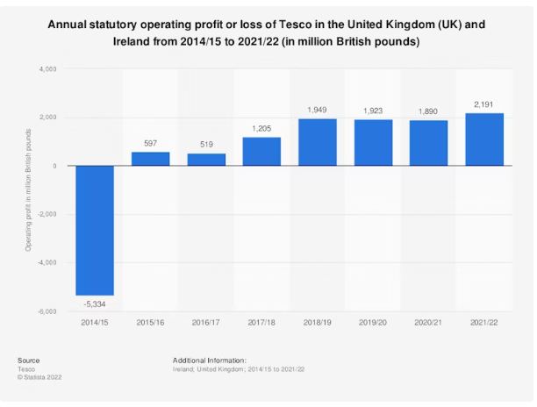
(Source: tutor2u.net, 2024)

Appendix 2: Market share Value of Tesco in UK
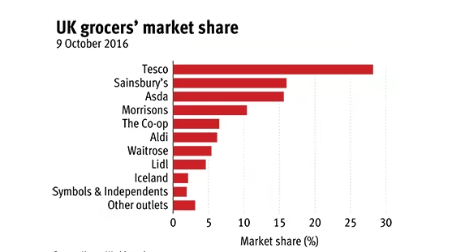
(Source: investorschronicle.co.uk, 2024)

Appendix 3: Tesco profits surge as online orders double
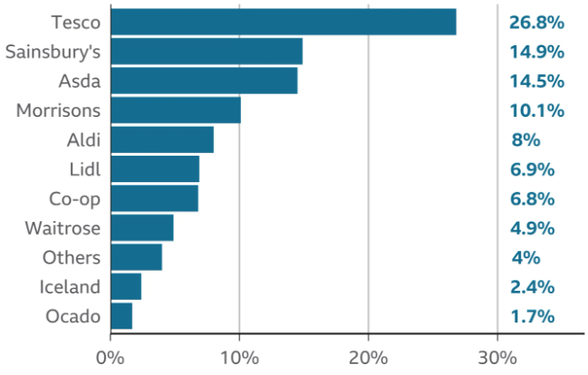
(Source: bbc.com, 2024)

