
Programme Name: Master of Business Administration
Module Code: LCMB7003
Module Name: Strategic Management
Format: Report
Title: Assessment component: Individual report on IKEA
Lecturer’s Name: Amare Desta
Student Name: SIRAJUL ISLAM
Student ID: 2422222
Word Count: 5000



Table of Content
Contents
1.0 Introduction 3
1.1 Brief background of the case organisation: IKEA 3
1.1.1 Vision, Mission and Values 3
1.1.2 Historical Timeline of IKEA 4
1.1.3 Current performance of IKEA in the global sustainable home furniture market 5
1.2 Purpose of the strategic management report 5
1.3 Structure of the report 6
2.0 Selection of Organisation and Target Market 6
2.1 Justification for choosing IKEA as the case organisation in the strategic management report 6
2.2.1 Core competencies and financial capacity of IKEA 6
2.2.2 IKEA’s commitment to sustainability 6
2.2.3 Current sustainability and regulatory problems experienced at IKEA: Fish Bone Analysis 7
2.2 Proposing a foreign target market for internationalising IKEA 8
2.2.1 Market Attractiveness of South Africa 8
2.2.2 Justifying the selection of the target market and its alignment with strategic intent of IKEA 8
3.0 Comprehensive Strategic Analysis 9
3.1 Macroenvironmental analysis of the South African Furniture market: PESTLE 9
3.2 Industry-driven Competitive Analysis of IKEA in South Africa: Porter’s Five Forces 13
3.3 Internal environmental analysis of IKEA 15
3.3.1 Porter’s Value Chain Strategies 15
3.3.2 Assessing how the core competencies of IKEA contributing to its sustainable competitive advantage: VRIO 16
3.4 Critical Analysis on the limitations and effectiveness of analytical tools used above 17
4.0 Strategic Development and Formulation 19
4.1 Discussion on Strategic organisation objectives of IKEA 19
4.2 Proposing market entry modes for IKEA, aligning with its organisational objectives 19
4.3 Ansoff Matrix to formulate a market entry strategy for IKEA: Market Development Strategy 20
4.4 Evaluating how IKEA should establish a competitive advantage in South Africa: Porter’s Diamond Model 21
4.5 Risk Mitigation Strategy aligned with CSR initiatives 23
4.6 Gantt-chart illustrations of timeline in international expansion of IKEA in South Africa 24
5.0 Performance Evaluation Framework 24
5.1 BSC Framework for identifying success metrics and KPIs 24
5.2 Sustainability metrics for IKEA in South Africa: Triple Bottom Line Theory 26
5.3 Monitoring and Control with BCG Portfolio Matrix 27
6.0 Conclusion 27
7.0 References 29

1.0 Introduction

1.1 Brief background of the case organisation: IKEA

1.1.1 Vision, Mission and Values
IKEA is a Swedish furniture retailer founded in 1943 by Ingvar Kamprad with the purpose of delivering well-designed and affordable furniture for every room. As per Forbes, IKEA operates more than 422 stores in 50 global markets (Forbes, 2024). Out of which, 70% of the stores are located in Europe. Additionally, the Swedish company ranked 5th and 33rd in Forbes’s “World Top Companies for Women in 2025” and “World’s Best Employer in 2025” (Forbes, 2024, p.1). The vision statement of the company,
“To create a better everyday life for the many people.”
Source: (IKEA, 2020, p.1)
According to Mahalaxmi et al. (2024), the mission statement of IKEA is to enable and inspire people to live more sustainably and eco-consciously. For this, IKEA invested in “People & Planet Positive”, “Forest Stewardship Council (FSC)” and “Environmental Stewardship” to become a beacon of sustainably certified business (Mahalakshmi et al., 2024). Figure 1 shows that togetherness, simplicity, lead by example, give and take responsibility, renew and improve and others are the core values at IKEA.
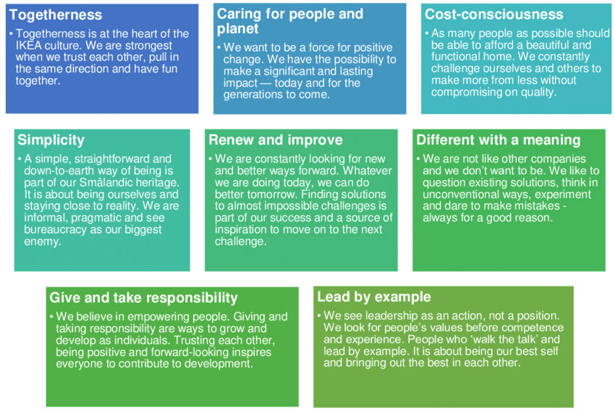
Figure 1: Common organisation values of IKEA
Source: (Al-Zghool, 2021)

1.1.2 Historical Timeline of IKEA
A 17-year-old Ingvar Kamprad founded IKEA to bridge the market gap for sustainable ready-to-assemble furniture, including home accessories and kitchen appliances. Figure 2 shows that IKEA was founded in 1930 and in a span of 10 years, the company introduced a furniture catalogue of kitchen appliances, home accessories and ready-to-assemble components. By the 1980s, the company I produced its Flat packages and expanded to England, France and the USA and Italy. In a period of 20 years, the brand grabbed its internationalisation opportunities in Japan, Russia and Turkey, Japan and Thailand. In 2024, IKEA had more than EUR 22,242 million total assets (EUR 10,918 million fixed assets, EUR 11,553 million current assets) (IKEA, 2024).
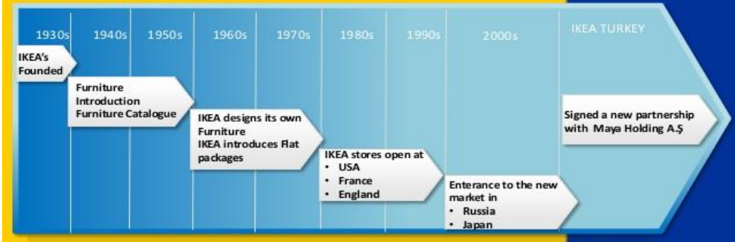
Figure 2: History of IKEA
Source: (Goel and Shraddha, 2018)

1.1.3 Current performance of IKEA in the global sustainable home furniture market
As per Mordor Intelligence, the sustainable home furniture market was valued at USD 508.59 billion and is currently growing at a 4.1% CAGR till 2030 (Mordor Intelligence, 2025). The sustainable home furniture market is perceived as fragmented with five major dominant players, for example, La-Z-Boy, IKEA, Herman Miller, Steinhoff International Holdings and Ashley Furniture Industries. The gross profit of the IKEA group increased from 9,968 million euros in 2009 to 13,860 million euros in 2024 (Statista, 2024). Flat-pack design, low price, ready-to-assemble model deeply contributed to IKEA's market positioning in the European and the Asian Pacific markets. Around 900 million customers visit and make purchases at IKEA stores and 4.6 billion people regularly visit the IKEA website.

1.2 Purpose of the strategic management report
The strategic management report aimed to propose a comprehensive “Organisation Expansion Plan” for IKEA. The overarching goal is obtained by analysing the external market trends (opportunities/threats) and internal assets/capabilities at IKEA. The purpose of the report is to present an evidence-based expansion strategy for IKEA.

1.3 Structure of the report
The report is divided into four major sections, namely, “selection of organisations and target market”, “comprehensive strategic analysis”, “strategic development and formulation” and “performance evaluation framework”.

2.0 Selection of Organisation and Target Market

2.1 Justification for choosing IKEA as the case organisation in the strategic management report

2.2.1 Core competencies and financial capacity of IKEA
Considering the findings of Goel and Garg (2018); Alzghool (2021); IKEA pioneered flat-pack design in order to make ready-to-assemble furniture more affordable. Also, the brand’s commitment to sustainability and affordability leverages new opportunities to target cost-conscious and environmentally friendly consumers across the globe. The brand also incorporates the Circular Economy processes by recycling, refurbishing and reusing its outdated furniture resources, instead of discarding them. Also, supply chain expertise and strong brand image increased IKEA's capacity to withstand market volatility and economic uncertainties. In terms of financial capacity, the 2025 Annual Report of IKEA revealed that the company generated an operating income of 26,306 million euros in FY 2025 (IKEA, 2025). However, the 2025 operating income of IKEA reduced by 232 million euros in comparison to 2024 values (26,538 million euros). The above evidence on IKEA revealed that the brand has the financial capacity to internationalise to new foreign markets in the coming years.

2.2.2 IKEA’s commitment to sustainability
The sustainability report of IKEA revealed that 98% of wood used in the production and manufacturing of home furniture is either recycled or FRC certified (“Forest Stewardship Council”). The circular assessment of more than 9,500 product portfolios collectively contributed to reducing wood resource wastage across IKEA’s value chain. The above initiatives were carried out under IKEA’s “Climate-Positive” and “People & Plant-Positive” agenda.

2.2.3 Current sustainability and regulatory problems experienced at IKEA: Fish Bone Analysis
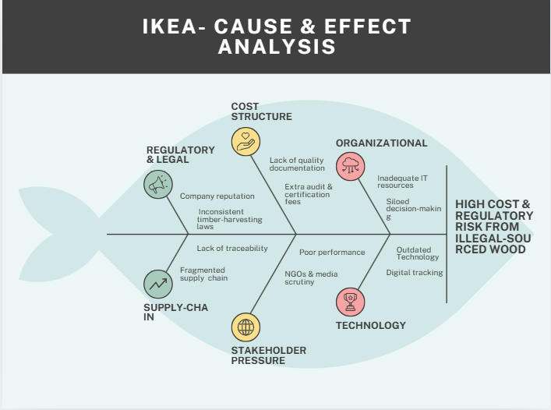
Figure 3: Cause and effect analysis on “regulatory costs and illegal wood sourcing problem” at IKEA
Source: (Self-created)
Despite these ambitious results, IKEA is struggling to cope with the expensive nature of sustainable and regulatory irregularities. For example, IKEA faced legal allegations over using illegally sourced wood in the timber supply chain. Thus, IKEA is chosen for the assignment to propose evidence-based solutions to improve governance and transparency in its supply chain activities, during its process of internationalising to new foreign markets. Figure 3 shows that inconsistent timber harvesting laws, fragmented supply chain, poor transparency, siloed decision-making and outdated digital tracking collectively contributed to the Illegal wood sourcing problem at IKEA. The report will help to suggest evidence-based solutions for improving the supply chain transparency of IKEA, while expanding to a new foreign market.

2.2 Proposing a foreign target market for internationalising IKEA

2.2.1 Market Attractiveness of South Africa
The home furniture market in South Africa generated a revenue of US$1.51 billion in 2025 (Statista, 2025). On the other hand, Fortune Business Insights found that the home furniture and decor market is currently growing at a CAGR of 5.17% in the period, “2025-2032” (Fortune Business Insights, 2025). The above statistics indicate there is a consistent demand for affordable and sustainable home furniture and decor items in South Africa.
From the economic perspective, it was found that South African GDP expanded by 0.6% in 2024, thus, rebounding from the detrimental impact of COVID-19 (Thukwana, 2025). As per CWEIC (“Commonwealth Enterprise and Investment Council”), the middle-class population in South Africa increased to 313 million in 2025 from 111 million people in 1980 (CWEIC, 2025). The South African Government enacted a “Special Economic Zones” (SEZ) program in 2014 to develop more industrial development zones and boost economic freedom in the region (Qumba, 2023).

2.2.2 Justifying the selection of the target market and its alignment with strategic intent of IKEA
Section 2.2.1 reveals that sustainability, affordability and free-pack furniture design are the strategic objectives and priorities for IKEA for internationalisation. CCPI (“Climate Change Performance Index”) found out that South Africa ranked within the top 38 countries (see Figure 4) by raising voices for equity, sustainable development, climate justice and decarbonisation in 2025 (CCPI, 2025). The market reinforced the G20 and UNFCCC principles of climate ambition and decarbonisation with its Green Transport Strategy (CCPI, 2025). However, coal still dominates in the power sector of South Africa, thus, IKEA can have a strategic edge in South Africa by producing sustainable home furniture with renewable energy and recycling technology.
The overarching goal can be fulfilled by capitalising on the market liberation and sustainability opportunities in South Africa, for example, “Renewable Energy Independent Power Producer Procurement Programme” (REIPPPP) (CCPI, 2025). Also, the consistent demand for functional furniture at an affordable price in South Africa closely fits with the strategic intent of IKEA (affordable and flat package designs). Also, the South African Government also enacted “National Forest Act 1988” for regulating illegal wood sourcing activities (Sinthumule, 2025). The regulatory and legal protection will positively contribute to improve the governance and transparency outcomes of wood sourcing at IKEA. The above evidence justified the alignment of organisational strategy and priorities and market attributes in South Africa.
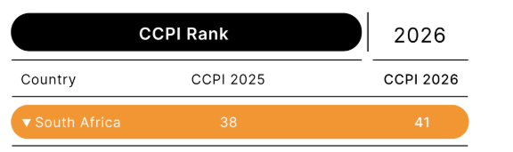
Figure 4: CCPI rank of South Africa in 2025
Source: (CCPI, 2025)

3.0 Comprehensive Strategic Analysis

3.1 Macroenvironmental analysis of the South African Furniture market: PESTLE
PESTLE dimensions | Description | Opportunity/Threats for IKEA
Political | - Around 49% of surveyed South Africans believed that the corruption level had increased in the last few years (Patel and Govindasamy, 2021).  - Protectionist measures and localisation priorities of the South African Government acted as entry barriers for foreign companies (Bernstein, Bernstein and Bernstein, 2024). | Threat
Economic | - Inflation rate in South Africa dropped from 6% in October 2023 to 2.8% in October 2024, which boosts average household expenditure on furniture items (Acharya and Gumbi, 2024).  - The net revenue generated by the South African Furniture market in 2021 was $4,822.2 and it is currently rising at a 6.5% CAGR in the period 2022 to 2030 (Grand View Research, 2025). | Opportunity
Social | - Around 65%, 59% and 50% of surveyed South Africans Indians preferred bamboo, reclaimed wood and recycled materials, respectively for their sustainable office furniture (Watson, 2025).  - Consumers in South Africa make purchase decisions considering the socio-environmental impact of home furnitures (Statista, 2025). | Opportunity
Technology | - According to Business Insider Africa, the locals spend more than 9 hours a day on social media; hence, they can be easily reached by e-commerce brands through digital marketing (Ekanem, 2025). | Opportunities
Legal | - Regulation in wood sourcing under the National Forest Act 1988.  - Copyright laws, technology patents trademarks to safeguard the originality of the businesses. | Opportunities
Environmental | - Reliance on coal and fossil fuels.  - REIPPPP, decarbonisation and climate ambition of South Africa to achieve carbon neutrality | Opportunities and Threats
Table 1: PESTLE Analysis
Source: (Self-created)
Analysis
From the PESTLE analysis, it can be inferred that the majority of the South Africans (49%) believed that corruption had increased a lot in recent times in the country (see Figure 5). As a result, IKEA might experience liability risks while operating in South Africa. Also, a high degree of corruption, localisation and protectionist stance of the South African Government might have delayed the market entry of IKEA in South Africa.
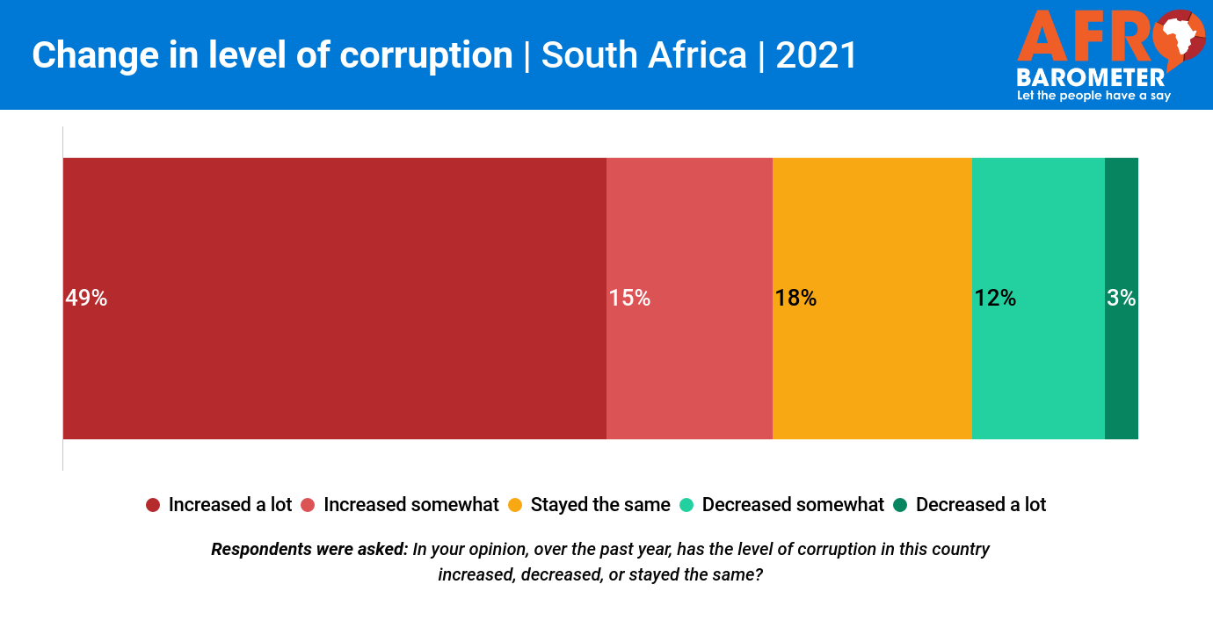
Figure 5: Corruption in South Africa in 2021
Source: (Patel and Govindasamy, 2021)
On the other hand, a low inflation rate (2.8% in October 2024) (Refer to Figure 6) and 6.5% annual growth of the Furniture market (Refer to Figure 7) will also create an opportunity for IKEA to lower its operational costs in South Africa in comparison to European markets.
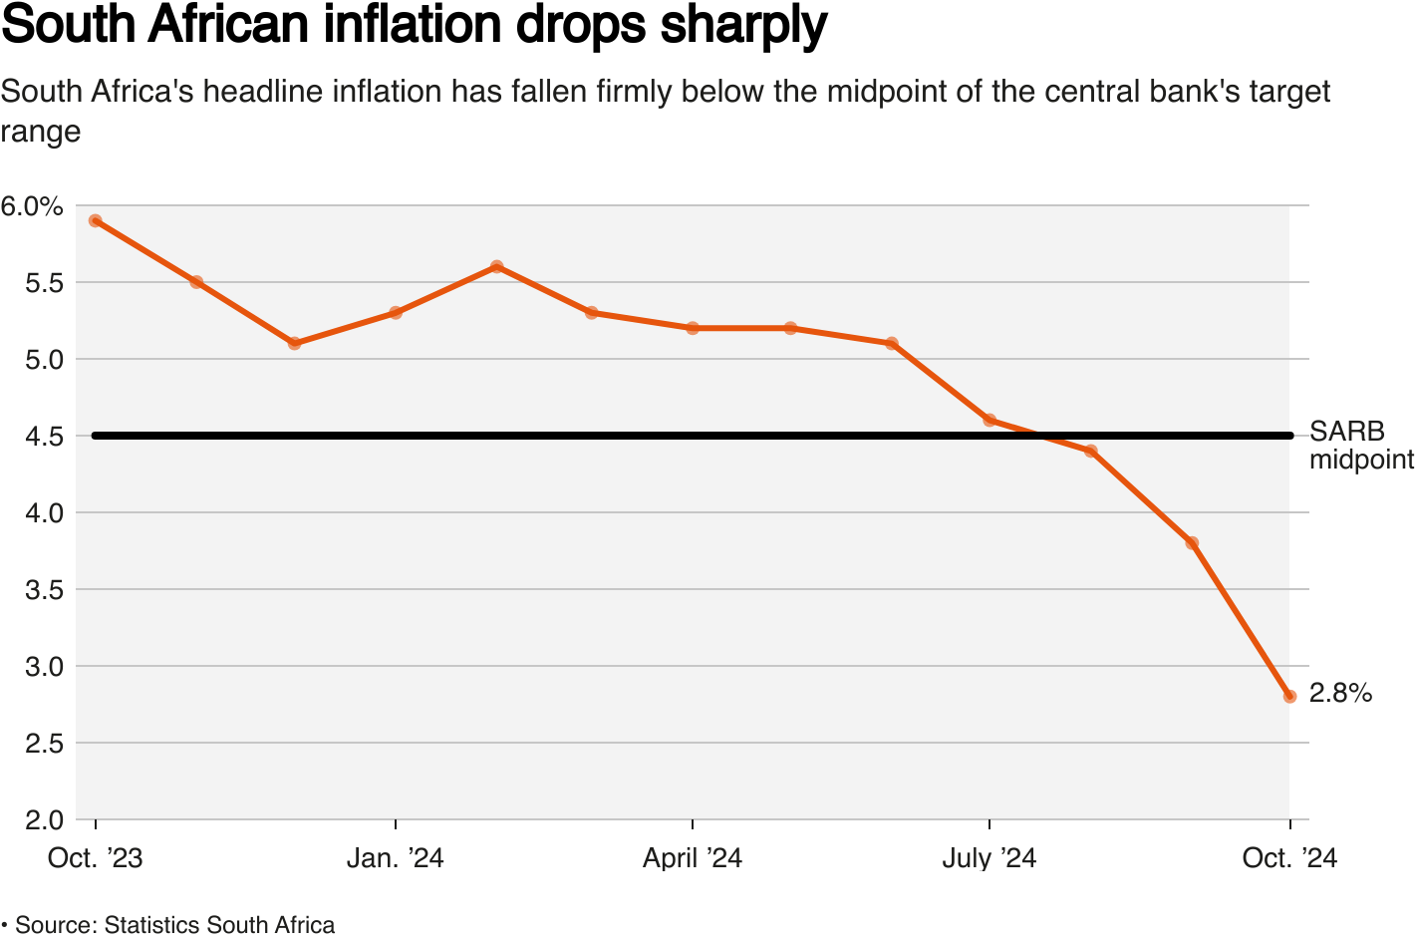
Figure 6: Inflation rate trends in South Africa
Source: (Acharya and Gumbi, 2024)
Simultaneously, the social factors revealed that continuously increasing demand for bamboo (opined by 65%), recycled materials (opined by 50%) and reclaimed wood (opined by 59%) would facilitate a competitive advantage for IKEA with its FRC-certified material sourcing. From the technology and legal perspective, it can be observed that strong social media penetration (more than 9 hours/day) and stringent regulation might reduce legal liability and false allegations (illegal sourcing) on IKEA in South Africa. Lastly, the environmental factors such as coal dependencies, climate ambition goals, decarbonisation and REIPPPP posed threats as well as opportunities for IKEA’s operations in South Africa.
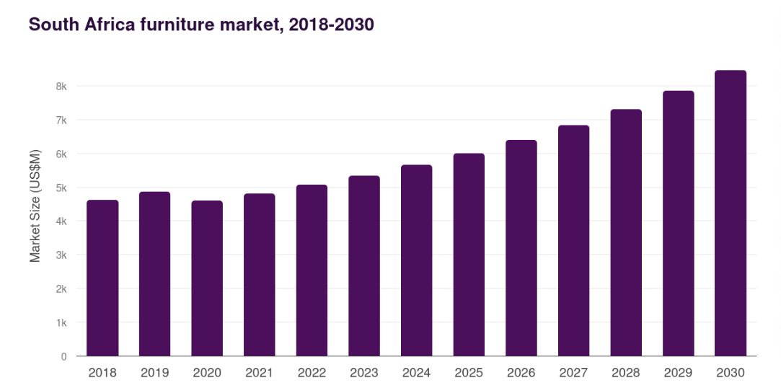
Figure 7: Economic growth of the South African furniture market
Source: (Grand View Research, 2025)

3.2 Industry-driven Competitive Analysis of IKEA in South Africa: Porter’s Five Forces
Bargaining Power of Buyers: HIGH
Relying only on FSC-certified reclaimed wood and bamboo might force IKEA to charge a higher price for its sustainable home furniture and decorations. As a result, working-class people might look for other alternatives of furniture that are available in the domestic market at a comparatively lower price. Thus, misalignment with the affordable as well as sustainable needs of local South Africans might lower their switching costs for IKEA. The findings of Ganaie and Bhat (2021); Zakiy and Haryanto (2021) mentioned that low switching cost of customers negatively influences brand loyalty and customer purchasing behaviour. Thus, the bargaining power of customers/buyers will be high for IKEA in South Africa. The threat can be taken led through customised furniture manufacturing and introducing new value-range products within the existing portfolio of IKEA.
Threat of New Entrants: LOW
The localisation and protectionist stance of the South African Government might fuel import duties and trade barriers for the new foreign businesses in South Africa. Additionally, the high capital requirements in setting up wood processing factories and the strong brand value of IKEA made it difficult for the new entrants to compete with IKEA in South Africa. Thus, the threat of new foreign furniture businesses is low for IKEA.
Bargaining Power of Suppliers: HIGH
The sustainable timber suppliers and wood processors are comparatively fewer in number in comparison to furniture manufacturing businesses. As a result, IKEA might have to negotiate better prices with the supplier for the continuous supply of flat-pack components. To mitigate the above threat, IKEA needed to establish long-term contracts with FRC-certified timber and wood suppliers based on supply volumes and price of the supplies (Morten Komdeur and Ingenbleek, 2021).
Threat of Substitutes: MODERATE
The low-end income population in South Africa are fond of purchasing second-hand furniture due to their inability to afford costly new furniture (Sydor and Kacper Stańczyk, 2025). Thus, second-hand furniture might reduce the competitive advantage of flat-pack new furniture of IKEA in South Africa. Thus, the brand needed to scale the assembly features in its flat pack design (Yu, 2019). This will engage low-income population groups to purchase second-hand high-quality substitutes of the IKEA furniture at affordable prices.
Rivalries between the existing businesses: HIGH
As per Mordor Intelligence, the market leaders of the Home Furniture industry in South Africa are La-Z-Boy, Ashley, Herman Miller, Steinhoff International and IKEA (Mordor Intelligence, 2025). The market concentration of the South African home furniture market is fragmented and highly competitive from the marketing and pricing aspects (Refer to Figure 8). To differentiate IKEA from the other rival companies, the former brand needed to strategically invest resources in digital experience, affordable pricing and design customisation (Paul et al., 2024; Meyer et al., 2023).
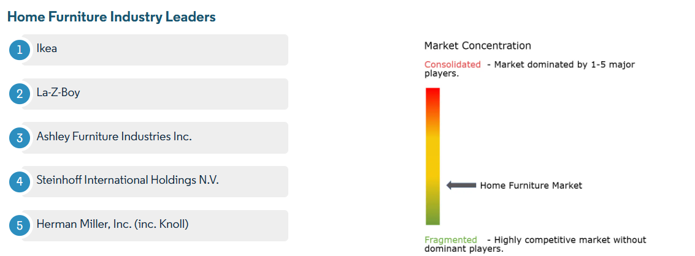
Figure 8: Market Concentration in the South African Home Furniture Industry
Source: (Mordor Intelligence, 2025)

3.3 Internal environmental analysis of IKEA

3.3.1 Porter’s Value Chain Strategies
Value chain activities | Description
Inbound logistics | The company established IKEA Supply AG, which manages 90% of the outsourced IKEA products from the global suppliers. IKEA established a long-term contract with wholesale subsidiaries, warehouse providers and transporters (IKEA, 2023).
Operations | IKEA’s operations are connected to 33 production units, including sawmills and forestry, for the continuous production of wood components and home-based furniture (IKEA, 2023). However, organisational restructuring and recruitment blocks often vary operational efficiency at IKEA.
Outbound logistics | IKEA has a distribution network of 12 franchise and company-owned traditional retail stores, small stores, and pickup points (IKEA, 2023). The robust distribution network increases customer meeting points at IKEA to over 600 (IKEA, 2023). However, high energy prices fuel the transportation costs (outbound logistics) for the company.
Service | IKEA’s customer support and technical team offer guidance to customers and solve their problems related to newly added security features at IKEA furniture (Anchor and Lock feature, Furniture tip overs) (IKEA, 2023).
Marketing and Sales | IKEA invested in storytelling-driven social media campaigns to connect with the local population. For example, the brand committed EUR 20 million in digital marketing efforts for increasing brand sales in 2024 (IKEA, 2024)
Table 2: Porter’s Value Chain Analysis
Source: (Self-created)

3.3.2 Assessing how the core competencies of IKEA contributing to its sustainable competitive advantage: VRIO
Resource/capabilities | Valueable | Rare | Costly to imitate | Exploit to organisation | Competitive advantage
Brand Value | Yes | No | Yes | Yes (can be exploited through franchising) | Temporary competitive advantage
Retail distribution network and supply chain expertise | Yes | Yes | Yes | Yes (in-house production and designing) | Sustainable Competitive Advantage
Sustainable sourcing and procurement | Yes | Yes | Yes | Yes (core to strategic intent and vision of IKEA) | Sustainable competitive advantage
Portfolio of skilled leaders and managers | Yes | No | Yes | No | Competitive Parity
Table 3: VRIO Analysis of IKEA’s Competitive Advantage
Source: (Self-created)
From the VRIO analysis, it can be inferred that the global brand value of IKEA has a temporary competitive advantage because it can be imitated by international furniture companies. Foreign furniture brands with franchising can strike a firm balance between market entry risks and long-term contract rewards. On the other hand, sustainable sourcing, supply chain expertise, and a retail distribution network will leverage a sustainable competitive advantage to IKEA. For example, Statista (2025); Watson (2025) observed that South African Indians who look for sustainable office furniture will be loyal customers of IKEA.

3.4 Critical Analysis on the limitations and effectiveness of analytical tools used above
Analytical tools | Strengths | Limitations
PESTLE | Provide a holistic view of the external environment of the South African Home Furniture Market, especially, reflecting on market opportunities and challenges for IKEA. | The PESTLE analysis provides a limited description of the cultural distance between South Africa and Sweden. Also, the application of the model is time-consuming.
Porter’s Five Forces | Helped to analyse the market concentration, switching cost of local South Africans and the threat of suppliers and existing products for IKEA. | However, the model failed to quantify the threats of existing products, the bargaining power of suppliers, and buyers in sustainable FRC-certified wood sourcing and furniture production.
Porter’s Value Chain Model | Porter's Generic model is effective in assessing the resources/competencies contribution to IKEA’s global positioning. For example, IKEA Supply AG, sourcing from forestry and sawmills and their interconnection with 33 production units. | However, the model is not suitable to associate the radical innovation opportunities for IKEA with the social, environmental and technology factors of the South African Home Furniture Market.
VRIO | Highly effective in assessing the contribution of internal resources/capabilities to the sustainable competitive advantage of IKEA. | The model provided a static view of the contribution made by internal resources/capabilities, instead of a holistic view.
Table 4: Critical Analysis of strategic tools used
Source: (Self-created)

4.0 Strategic Development and Formulation

4.1 Discussion on Strategic organisation objectives of IKEA
The global strategic objectives of IKEA is concentrated around making its functional products affordable and accessible so that it could continue to “inspire, activate and lead us in our planning, decision-making and goal setting” so that the company can expand into potential new markets. Currently, IKEA’s strategic objective lies in accessibility to a wide range of home furnishings that could be of good quality and well-designed provided at low prices. For that, expanding into emerging markets to reduce its over-dependence on European and North American markets would be important to enable inclusive growth while leveraging the benefits of strengthened global supply chain networks built over the years. As Inter IKEA Holding B.V. Annual Report FY25 finds IKEA to commit to the 'objectives and key results' ('OKR'), this methodological framework would let the management pair clear objectives with measurable outcomes to make actions more concrete while tracking progress throughout. This can be associated with the initiative of developing customer-centric innovation and leveraging the benefits of omnichannel retail to match customer needs and provide a seamless customer experience expanding into new markets.

4.2 Proposing market entry modes for IKEA, aligning with its organisational objectives
To successfully enter the South African market, IKEA would have to consider three market entry modes primarily. These include:
Wholly-Owned Subsidiaries (WOS): The market entry mode would be ideal to develop a stable and strategically important approach in the initial strategy that would allow IKEA manage flagship stores and warehouses independently. With maximum control over the subsidiaries in South Africa, IKEA can expect to manage the supply chain network and its sustainability objectives as per the specific business model requirement of the region without needing to share profits or proprietary knowledge (Bhat et al., 2022).
Franchising: According to Franchiseio (2025), 91% of franchise businesses report profitability within 2 full years of operation which shows the successful integration of franchising would be helpful because of its low investment but fast market penetration. In this entry mode, IKEA would have to rely on local franchises to offer valuable market knowledge and leverage established networks to navigate through South Africa's local customs, regulations and cultural preferences. With a diverse demographics of 81.7% black, 8.5% coloured, 2.6% Indian/Asian and 7.2% white in South African population, this market could pose a difficult challenge to take full control of brand standards and quality consistency because of wide preferences of target customers (South Africa Gateway, 2019).
Joint ventures: The third market entry mode would be joint ventures because South Africa with a complex regulatory environment because of its multi-cultural dynamics would require unique local demands. Therefore, it would be important for IKEA to mitigate the possibility of cultural misunderstandings and regulatory difficulties by building partnerships with local sourcing companies. For example, IKEA currently works with a local brand called ‘UrbanClap’ to help Indians assemble its DIY furniture IKEA shopping carts, when the management decided to expand into India (Bureau, 2018). A similar tactic can also be considered for the South African context.

4.3 Ansoff Matrix to formulate a market entry strategy for IKEA: Market Development Strategy
The Ansoff Matrix considers four primary strategies such as Market penetration, Market development, Product development and Diversification to assist businesses grow because it allows management to reflect combining two dimensions: existing versus new products and existing versus new market to evaluate. The market development strategy would be relevant in discussion here to emphasize on selling existing products to new markets because the strategy would involve entering new geographic regions to target new customer segments in South Africa based on existing lines of product. IKEA would introduce ready-to-assemble furniture, including home accessories and kitchen appliances in the South African market.
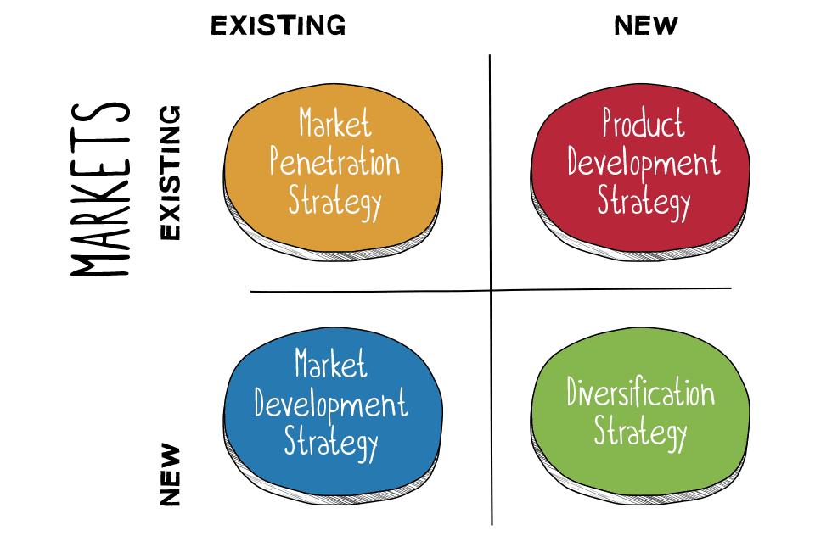
Figure 9: All four dimensions of Ansoff Matrix
Source: (Waititu, Wambui and Kamande, 2025)
Under the strategy, IKEA would have to make sure to get its products to be culturally and economically appealing for the target population because offering durable furniture that could be tailored specifically for South African climate and housing types at an affordable price rate would make it more appealing to locals. A study by NIQ (2022) backs this as it claims that South Africa has been one of the most price-sensitive nations in the world as more than 50% of South Africans buy products whatever the brand is on promotion. This shows that the market adaptation strategy has to heavily emphasize on digital marketing and building partnership with local expertise such as planning on interior design for community set-up events to make sure that the brand can be positioned as ‘affordable’ and more ‘niche-specific’ for target customers.

4.4 Evaluating how IKEA should establish a competitive advantage in South Africa: Porter’s Diamond Model
Porter's Diamond Model identifies four main points that could drive a nation's competitive advantage such as:
Factor Conditions: As per the reports of Editorial (2023), the retail industry in South Africa is the second-largest employer and the third-largest sector of the South African economy. This makes the industry filled with skilled labourers who can be trained for advanced logistical infrastructure operations and can have the capability to supply assistance in necessary local production for IKEA. For example, IKEA can consider developing local supplier programs to invest in skill development training to make sure that specialized skills can be leveraged with support of government incentives to build a strong competitive advantage entering South Africa.
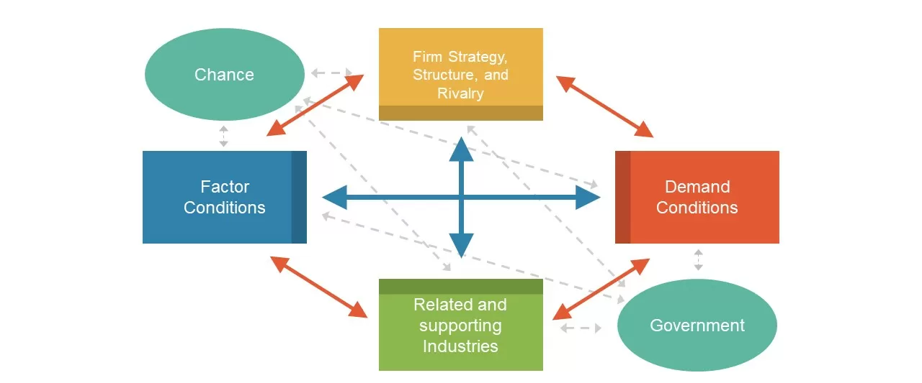
Figure 10: All four dimensions of Porter’s Diamond Model
Source: (Afshar and Shah, 2025)
Demand Conditions: According to the African Development Bank (2019), the number of middle class South Africans have tripled over the last 30 years which shows the upward trajectory of growing demand for affordable home solutions among South African consumers. With the high demand, the market can be explored by IKEA by offering affordable but sustainable products to appeal to the market more often.
Related and Supporting Industries: With the emerging capabilities in transport and logistics and the rise of the e-commerce sector, manufacturing and distribution of retail furniture could be positively impacted. For example, IKEA can depend on the local supply chain through transportation and logistic advancements that would reduce import cost dependency and can have better outcomes as a whole.
Firm Strategy, Structure, and Rivalry: IKEA may have to face local competition from South African-based companies such as Coricraft, Mr Price Group, Weylandts etc. (Khan and Sarkar, 2024). To counter such competition, IKEA should have to invest in affordability and leverage its strong international brand identity to provide superior customer experience through cost-efficient products, appealing to wider South African customers.

4.5 Risk Mitigation Strategy aligned with CSR initiatives
Risk type | Risk description | Mitigation strategy | Alignment with CSR goals
Financial | According to the World Bank collection of development indicators, stock price volatility in South Africa was reported to be at around 23.37% in 2021 (Tradingeconomics, 2025). | Increasing local sourcing to reduce import dependency and offering tiered pricing of product lines would maintain accessibility of products. | This strategy would go with the mission of affordability as initiated by IKEA that would encourage economic stability in the region through local supplier development.
Supply chain | Possibility of transportation delays and load-shedding in local factories can disrupt logistics and inventory flows. | Building a central distribution center near the capital in Cape Town could be important to enable supply diversification across the South African market. | IKEA with this strategy can generate new job roles which could boost the local economy, aligning with its positive contribution toward social goals.
Regulatory | According to Davis (2024), the Financial Sector Conduct Authority (FSCA) was reported to impose a total of approximately ZAR 943 million in administrative penalties between FY23 and FY24, showcasing that failure to adhere to evolving government regulations can lead to heavy fines. | Forming a joint venture with any significant South African local partner familiar with these regulatory environments would be the first critical step to ensure transparent compliance with necessary operating standards. | This strategy would support the CSR commitment of IKEA toward ethical governance and fair labour practices to take on social responsibility through compliance maintenance as per local regulations of employment and safety laws.

4.6 Gantt-chart illustrations of timeline in international expansion of IKEA in South Africa
Task Activities | Year 1 (Q1-Q2) | Year 1 (Q3-Q4) | Year 2 (Q1-Q2) | Year 2 (Q3-Q4) | Year 3 (Q1-Q2) | Year 3 (Q3-Q4)
Market study and assessment over local partner selection
Evaluating legal and regulatory compliance standards and scout for initial supplier
Executing store design and establishing warehouse facilities
Recruitment and staff training of local South African employees
Pilot sourcing partnership through capital investments
Evaluation and market adjustments as per the need

5.0 Performance Evaluation Framework

5.1 BSC Framework for identifying success metrics and KPIs
A balanced scorecard (BSC) goes beyond traditional financial metrics to provide a more holistic view of an organization's performance through four key dimensions (El Fallahi, Ibenrissoul and El Amri, 2023).
Financial: The return on investments should have to be 10% growth year-on-year since Year 1. Considering the initiative to support the cost reduction strategy for the energy-efficient initiative in the South Africa market, gross margin improvement for IKEA should be based on local sourcing growth.
Business processes: The efficiency of the supply chain network should be measured with KPI of lead time less than 48 hours for all major cities across South Africa. The inventory turnover ratio should also be evaluated as at least achieving a target of 25% locally-sourced materials by the end of Year 3 could be obtained as a successful venture for IKEA.
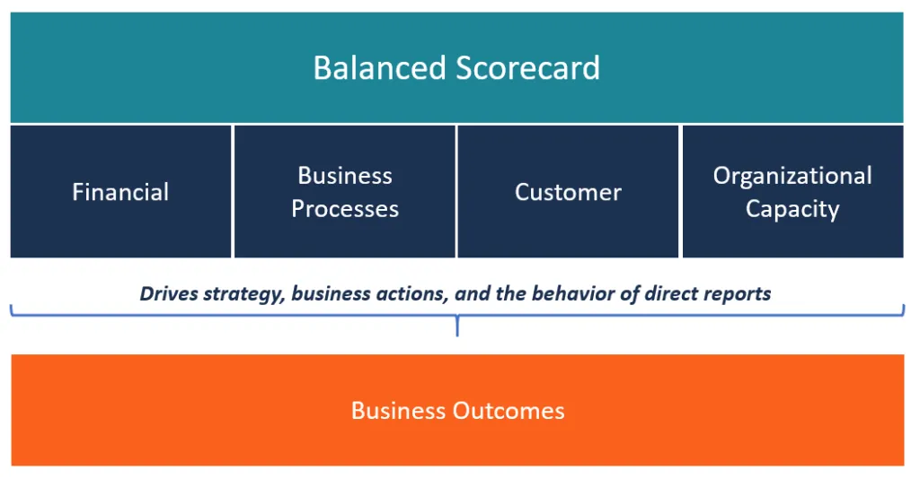
Figure 11: BSC Framework
Source: (El Fallahi, Ibenrissoul and El Amri, 2023)
Customer: IKEA should have to evaluate Customer Satisfaction Index (CSI) which is a metric that quantifies customer satisfaction with the services offered based on public survey outcomes (Khudhair, Alsadik & Jameel, 2021). A result of at least 80 to 85% of customer satisfaction and a Net Promoter Score (of over 60) would show the likelihood of a customer recommending IKEA services on the scale of 0 to 10 (Kabir and Simon, 2025).
Organisational capacity: Improved organisational capability would have to be dependent on employee training programs because positive staff retention would showcase employee satisfaction operating in IKEA units. For example, the target of staff retention rate should be above 50% to make sure that productivity can continue to uphold Year 1 onwards.

5.2 Sustainability metrics for IKEA in South Africa: Triple Bottom Line Theory
The Triple Bottom Line (TBL) theory proposes the success of any company should be measured by three interconnected bottom lines that include ‘people’ as a measurement of social responsibility, ‘planet’ as a measurement of environmental impact and ‘profit’ as a measurement of economic health (Kohli, 2025).
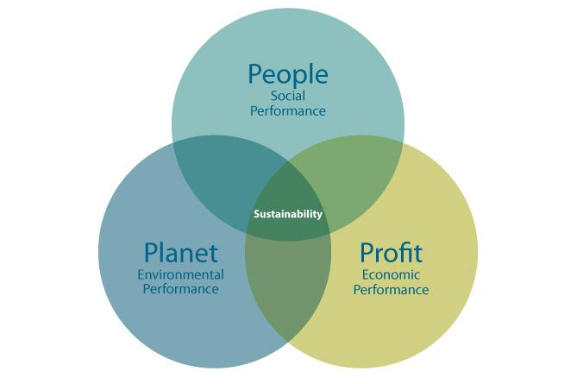
Figure 12: Triple Bottom Line (TBL) Framework
Source: (Kohli, 2025)
People: The positive contribution to the South African society would be creating direct and indirect job opportunities as IKEA should target introducing 1,500-2,000 new job positions by Year 3 aligned with safety standard compliance and training development programmes to make sure that South African youths can be offered with opportunities to work in a diversified workforce.
Planet: According to IKEA (2024), IKEA’s global climate footprint was estimated to be 21.3 million tonnes CO2 eq in absolute terms in 2024 which decreased by 5% compared to 2023. Such carbon footprint reduction goal accomplishment from local sourcing and waste reduction could also potentially align with environmental sustainability objectives in South Africa.
Profit: The profitability should be based on each subsidiary unit in South Africa as long-term contribution to the country’s overall GDP should be considered as a positive growth.

5.3 Monitoring and Control with BCG Portfolio Matrix
The BCG Portfolio Matrix offers four categories that are determined by the product services relative to market share and market growth rate (Czinkota et al., 2021).
Stars: IKEA should target its best-selling affordable furniture including tables and sofas here to look for high-growth potential and increase its market share in the South African context.
Cash Cows: Offerings such as home decor accessories or kitchenware could have stable demand and high market margins which could continue to generate steady cash flow.
Question Marks: Designs, particularly aligned with European or American market standards, could have low market share which can have potential for a selective customer segment.
Dogs: Those products that would be unsuitable for South African households would have to be completely avoided.

6.0 Conclusion
In conclusion, the report finds that the international expansion of IKEA into South Africa should have to be aligned with its organizational objectives as the proposed marketing plan for expansion should identify the core strengths of IKEA first to take advantage of. The report finds franchising could be important to understand that this method is a prudent approach to enter smaller and high-risk markets, particularly where a culturally-distant population such as South Africa’s can be found because differences in cultural preferences can make big brands difficult to meet specific goals to target customers. The report also suggests considering joint ventures because navigating local supply chains with the assistance of local expertise can reduce the possibility of market risks in initial days of operation. Particularly, the company can also consider to transition to Wholly-Owned Subsidiaries (WOS) fully once the market is established (possibly within 2-3 years of market experience in South Africa).

7.0 References
Acharya, B. and Gumbi, K. (2024) ‘South Africa inflation drops to lowest in over four years’, Reuters, 20 November. Available at: https://www.reuters.com/world/africa/south-african-consumer-inflation-falls-28-yy-october-2024-11-20/.
African Development Bank. (2019). Africa’s Middle Class Triples to more than 310m over Past 30 Years Due to Economic Growth and Rising Job Culture, Reports AfDB. [online] Banque africaine de développement - Bâtir aujourd’hui, une meilleure Afrique demain. Available at: https://www.afdb.org/fr/news-and-events/africas-middle-class-triples-to-more-than-310m-over-past-30-years-due-to-economic-growth-and-rising-job-culture-reports-afdb-7986.
Afshar, M.Z. and Shah, M.H. (2025). Leveraging Porter's Diamond Model: Public Sector Insights. The Critical Review of Social Sciences Studies, 3(2), pp.2255-2271. http://thecrsss.com/index.php/Journal/article/download/614/645
Al-Zghool, M.Z. (2021) Case study: IKEA’s organizational culture and rewards management. Available at: https://doi.org/10.13140/RG.2.2.30263.44969.
Bernstein, A., Bernstein, A. and Bernstein, A. (2024) SA must ditch Trumpian protectionism to create jobs, CDE - The Centre For Development and Enterprise. Available at: https://cde.org.za/sa-must-ditch-trumpian-protectionism-to-create-jobs/.
Bhat, M. N., Ikram, F., Rahman, M. N., and Naeem, M. H. (2022). Economic freedom of the world: wholly owned subsidiaries and joint ventures as binary response. Transnational Corporations Review, 1-18. https://www.researchgate.net/profile/Mohd-Bhat-11/publication/383610772_Economic_freedom_of_the_world_wholly_owned_subsidiaries_and_joint_ventures_as_binary_response/links/66d3fcca2390e50b2c2462ea/Economic-freedom-of-the-world-wholly-owned-subsidiaries-and-joint-ventures-as-binary-response.pdf
Bureau, E. (2018). UrbanClap is now Assembly Partner for IKEA. [online] The Economic Times. Available at: https://m.economictimes.com/small-biz/startups/newsbuzz/urbanclap-is-now-assembly-partner-for-ikea/articleshow/64299300.cms [Accessed 23 Nov. 2025].
CCPI (2025) South Africa – Climate Performance Ranking 2024 | Climate Change Performance Index. Available at: https://ccpi.org/country/zaf/.
CWEIC (2025) As Africa’s middle class grows, here’s how retailers can seize the opportunity - CWEIC, CWEIC. Available at: https://www.cweic.org/insights/as-africas-middle-class-grows-heres-how-retailers-can-seize-the-opportunity/.
Czinkota, M. R., Kotabe, M., Vrontis, D., and Shams, S. R. (2021). Product and service decisions. In Marketing Management: Past, Present and Future (pp. 341-397). Cham: Springer International Publishing. https://www.researchgate.net/profile/Demetris-Vrontis/publication/354106344_Product_and_Service_Decisions/links/6252f0404f88c3119cefe3c8/Product-and-Service-Decisions.pdf
Davis, K. (2024). Regulatory instruments for financial sector compliance in South Africa. [online] Lexology. Available at: https://www.lexology.com/library/detail.aspx?g=c6191da3-5e5e-4e76-9fe6-7c058527bea4 [Accessed 23 Nov. 2025].
Editorial. (2023). Shopping for economic growth: Retail sector continues to lead employment. [online] Top Empowerment. Available at: https://topempowerment.co.za/shopping-for-economic-growth-retail-sector-continues-to-lead-employment/.
Ekanem, S. (2025) South Africa tops 2025 global rankings for daily time using the internet, Business Insider Africa. Available at: https://africa.businessinsider.com/local/lifestyle/south-africa-tops-2025-global-rankings-for-daily-time-using-the-internet/ecqrpvm.
El Fallahi, F., Ibenrissoul, A. and El Amri, A. (2023). Defining and Measuring Overall Performance in Emerging Countries: A Comprehensive Financial Perspective Review. Financial Markets, Institutions and Risks, 7(3), pp.81-93. https://armgpublishing.com/wp-content/uploads/2023/10/FMIR_3_2023_7.pdf
Forbes (2024) ‘IKEA on the Forbes Best Employers for New Grads List’, Forbes. Available at: https://www.forbes.com/companies/ikea/.
Fortune Business Insights (2025) South Africa Furniture Market Forecast Analysis | Report [2030], www.fortunebusinessinsights.com. Available at: https://www.fortunebusinessinsights.com/south-africa-furniture-market-108569.
Franchiseio. (2025). Blocked. [online] Available at: https://franchiseio.com/franchise-success-rates-what-the-data-says-about-profitable-opportunities/ [Accessed 23 Nov. 2025].
Ganaie, T.A. and Bhat, M.A. (2021) ‘Switching Costs and Customer Loyalty: A Review of literature’, International Journal of Management and Development Studies, 10(05), pp. 7–14. Available at: https://doi.org/10.53983/ijmds.v10i05.369.
Grand View Research (2025) South Africa Furniture Market Size & Outlook, 2021-2030, Grandviewresearch.com. Available at: https://www.grandviewresearch.com/horizon/outlook/furniture-market/south-africa (Accessed: 23 November 2025).
IKEA (2020) The IKEA vision, values and business idea, IKEA. Available at: https://www.ikea.com/us/en/this-is-ikea/about-us/the-ikea-vision-and-values-pub9aa779d0/.
IKEA (2023) Inter IKEA Holding B.V. Annual Report FY23. Available at: https://www.annualreports.com/HostedData/AnnualReportArchive/i/ikea_2023.pdf.
IKEA (2024) Inter IKEA Holding B.V. Annual Report FY24. Available at: https://www.annualreports.com/HostedData/AnnualReports/PDF/ikea_2024.pdf.
IKEA (2025) Inter IKEA Holding B.V. Annual Report FY25. Available at: https://www.inter.ikea.com/-/media/interikea/igi/financial-reports/fy25-financial-reports/inter-ikea-holding-bv-annual-report-fy25-final.pdf?rev=10c81cc96c064789932e13ebf6229492&sc_lang=en.
IKEA. (2024). Climate footprint across the IKEA value chain – IKEA Global. [online] Ikea.com. Available at: https://www.ikea.com/global/en/our-business/sustainability/value-chain-climate-footprint/.
Kabir, M. M., and Simon, M. R. (2025). Assessing the impact of product customization on improving customers experience of IKEA in Finland. https://www.theseus.fi/bitstream/handle/10024/895171/Kabir_Simon.pdf?sequence=2
Khan, Md.R. and Sarkar, U. (2024). Business leadership in the digital age: IKEA’s story in the retail and consumer sector. Green Technologies and Sustainability, 2(2), pp.100081–100081. https://www.sciencedirect.com/science/article/pii/S2949736124000083
Khudhair, H. A., Alsadik, S. M., and Jameel, A. K. (2021). Estimation of transportation service quality for selected groups of users using customer satisfaction index. Periodicals of Engineering and Natural Sciences, 9(2), 325-332. https://www.academia.edu/download/84962098/1810-4438-2-PB.pdf
Kohli, N. (2025). Sustainable business practices in IKEA: a study on consumers perceptions. https://www.theseus.fi/bitstream/handle/10024/893651/Kohli_Neetu.pdf.pdf?sequence=2
Mahalakshmi, S., Nallasivam, A., Kumar, S.H., Kalavathy, K.S. and Desai, K. (2024) ‘Sustainability by Design: IKEA’s Eco-Friendly Marketing Efforts’, Advances in economics, business and management research, pp. 145–161. Available at: https://www.researchgate.net/publication/378333261_Sustainability_by_Design_IKEA's_Eco-Friendly_Marketing_Efforts.
Meyer, K.E., Li, J., Brouthers, K.D. and Jean, R.-J. ‘‘Bryan’’ (2023) ‘International business in the digital age: Global strategies in a world of national institutions’, Journal of International Business Studies, 54(4), pp. 577–598. Available at: https://doi.org/10.1057/s41267-023-00618-x.
Mordor Intelligence (2025) Home Furniture Market Size & Share Analysis - Growth Trends And Forecast (2025 - 2030) Source: https://www.mordorintelligence.com/industry-reports/global-home-furniture-market, Mordorintelligence.com. Available at: https://www.mordorintelligence.com/industry-reports/global-home-furniture-market .
Morten Komdeur, E.F. and Ingenbleek, P.T.M. (2021) ‘The potential of blockchain technology in the procurement of sustainable timber products’, International Wood Products Journal, 12(4), pp. 1–9. Available at: https://doi.org/10.1080/20426445.2021.1967624.
NIQ. (2022). South African consumers reach tipping point of affordability. [online] NielsenIQ. Available at: https://nielseniq.com/global/en/insights/education/2022/south-african-consumers-reach-tipping-point-of-affordability/.
Patel, J. and Govindasamy, P. (2021) AD476: South Africans see corruption as worsening during President Ramaphosa’s tenure, www.afrobarometer.org. Available at: https://www.afrobarometer.org/publication/ad476-south-africans-see-corruption-worsening-during-president-ramaphosas-tenure/.
Paul, J., Ueno, A., Dennis, C., Alamanos, E., Curtis, L., Foroudi, P., Kacprzak, A., Kunz, W.H., Liu, J., Marvi, R., Nair, S., Ozdemir, O., Pantano, E., Papadopoulos, T., Petit, O., Tyagi, S. and Wirtz, J. (2024) ‘Digital transformation: A multidisciplinary perspective and future research agenda’, International Journal of Consumer Studies, 48(2). Available at: https://doi.org/10.1111/ijcs.13015.
Qumba, M.F. (2023) ‘Evaluating South Africa’s Special Economic Zones’, Journal of African Law, 67(2), pp. 275–295. Available at: https://doi.org/10.1017/S0021855323000128.
Sinthumule, N.I. (2025) ‘The Role of Traditional Ecological Knowledge in Managing the Collection of Non-Timber Forest Products in Limpopo, South Africa: A Community-Based Resource Governance Approach’, Human Ecology [Preprint]. Available at: https://doi.org/10.1007/s10745-025-00641-6.
South Africa Gateway. (2019). South Africa’s population | South Africa Gateway. [online] South Africa Gateway. Available at: https://southafrica-info.com/people/south-africa-population/.
Statista (2024) Gross profit of IKEA globally 2024| Statista, Statista. Available at: https://www.statista.com/statistics/241801/gross-profit-of-ikea-worldwide/?srsltid=AfmBOorZk-6Rht52KDKUbqkaYp19WhyPPM9xG4l5byM5Cykm0Q0ogEfM (Accessed: 23 November 2025).
Statista (2025) Furniture - South Africa | Statista Market Forecast, Statista. Available at: https://www.statista.com/outlook/cmo/furniture/south-africa?srsltid=AfmBOopvyxIrgsXLG7B1RxdZQgHanNEv3U99EHw3KhcFyVOSsyWTi9LM (Accessed: 23 November 2025).
Sydor, M. and Kacper Stańczyk (2025) ‘Analyzing Joinery for Furniture Designed for Disassembly’, Journal of Manufacturing and Materials Processing, 9(5), pp. 162–162. Available at: https://doi.org/10.3390/jmmp9050162.
Thukwana, N. (2025) South Africa’s GDP Grew at Slowest Pace Since Pandemic in 2024, Bloomberg.com. Bloomberg. Available at: https://www.bloomberg.com/news/articles/2025-03-04/south-african-economy-shifted-back-to-growth-in-fourth-quarter.
Tradingeconomics. (2025). South Africa - Stock Price Volatility - 2025 Data 2026 Forecast 1996-2021 Historical. [online] Available at: https://tradingeconomics.com/south-africa/stock-price-volatility-wb-data.html.
Waititu, J., Wambui, M., and Kamande, M. (2025). Ansoff’s Growth Strategies and Financial Performance in Kenya’s Leather Industry. The Journal of Accounting and Management, 15(1), 130-140. https://dj.univ-danubius.ro/index.php/JAM/article/download/3362/3087
Watson, J. (2025) Office Furniture Trends in South Africa 2025: Sustainability & Biophilic Design for Modern Workspaces, Office Stock. Available at: https://officestock.co.za/blog/office-furniture-trends-in-south-africa-2025-sustainability-biophilic-design?srsltid=AfmBOorwD_p_-s-lbcCUH8gcGJz9PNJiuIFkJK-KXo88ZisVOdP4l6I4 (Accessed: 23 November 2025).
Yu, R. (2019) ‘Core Elements of IKEA’s Successful Product Design’, Journal of Physics: Conference Series, 1168(3), p. 032118. Available at: https://doi.org/10.1088/1742-6596/1168/3/032118.
Zakiy, M. and Haryanto, M. (2021) Linking of Service Quality and Switching Costs with Turnover Intentions: The Mediating Role of Customer Loyalty. Available at: https://www.atlantis-press.com/article/125951443.pdf (Accessed: 23 November 2025).

