I acknowledge the use of Grammarly (https://www.grammarly.com/) on 10 February 2024 to check my work using the prompt(s): 1. Please check the following text for readability, grammar, and syntax. I confirm that I have not presented any AI-generated text as my work. I confirm I have copies of my drafts, notes, and other resources I used before and after the use of AI tools, which I may be asked to provide as evidence.

Health and Fitness Evaluation Report
Patient details
- Age 21
- Gender Female
- Physical Status - sedentary individual
This report evaluates critical fitness components- cardiovascular fitness, muscular strength and endurance, body composition, and flexibility to determine current fitness levels, strengths, and areas requiring improvement (ACSM, 2018). Standardized testing methods were employed to ensure the validity and reliability of the results (Bayles, Swank, 2018). Recommendations are based on the FIIT-VP principle, providing evidence-based guidance for a structured and progressive exercise program to optimize health and performance outcomes (Ligouri, 2021).
Breakdown of Fitness Components Assessed for Exercise Prescription:

Cardiovascular fitness
The ability of the heart, lungs, and blood vessels to deliver oxygen to the muscles efficiently during prolonged periods of physical activity (Ligouri, 2021). Testing is crucial to assess the current activity levels of the individual, as lower scores increase all-cause mortality (Liguori, 2021). The test requires an individual to perform moderate to vigorous exercise for continuous periods, these exercises require the engagement of large muscle groups to work rhythmically, which relies on the respiratory, cardiovascular, and musculoskeletal systems working together (ACSM, 2018).

Muscular strength and endurance
Muscular strength is the maximum force a muscle or group of muscles can exert against resistance in a single effort, muscular endurance is the ability of muscles to sustain repeated contractions and maintain force over an extensive period (ACSM,2018). Poor muscular strength and endurance increase the risks of falls, injuries, and chronic diseases (ACSM, 2018). Testing identifies weaknesses, which enables the professional to set achievable exercise goals (ACSM, 2018). It also allows the tracking of muscular changes, which permits the professional to amend the prescription accordingly (ACSM, 2018). The exercises performed mimic natural movements and the energy used daily by the individual (ACSM,2018).

Body composition
The relative proportions of fat and fat-free mass (including muscle, bone, and water) within the human body, assessing body composition is crucial for evaluating health associated with physical activity and overall physiological status (ACSM, 2018). The body mass index (BMI) provides a straightforward method for estimating body composition (Bayles, Swank, 2018). A BMI exceeding 30 classifies an individual as obese, which is strongly associated with an elevated risk of developing chronic conditions such as hypertension, Cardiovascular disease, and type 2 diabetes (ACSM, 2018). Conversely, a BMI below 18.5 categorizes an individual as underweight, a condition linked to adverse health outcomes, including increased susceptibility to diseases and higher mortality rates (Ligouri, 2021).

Flexibility
The ability of joints to move through the full range of motion (ROM), assessing flexibility prevents injuries, improves performance, reveals imbalances or limitations, and monitors progress (Ligouri, 2021). It also serves to tailor muscle endurance and cardiovascular fitness assessments for individual capabilities (Bayles, Swank, 2018).
Method
Pre-screening
Before engaging in physical activity, the subject was required to complete the informed consent form that explained the purpose, risks, and benefits of the activity to the individual and the physical activity readiness questionnaire to identify any medical conditions or risks that could cause harm to the subject (Liguori, 2021). In addition, the International Physical Activity Questionnaire was completed to identify current activity levels and tailor the exercise prescription (Craig, et al. 2003). However, there are limitations to the self-assessment questionnaires as studies have proven that individuals tend to overcompensate the physical activity levels (Willbond, et al.2010).
Body Composition
The subject was barefoot for weighing and measuring (ACSM, 2018). Height was measured in meters using a stadiometer (Seca, 2025), and weight was measured in kilograms using a Seca weighing scale (Seca, 2025) (Ligouri,2021). These figures were then used in the following equation: weight divided by height squared (Ligouri, 2021). There are limitations to using this method as it does not distinguish between body fat, muscle mass, and bone (Ligouri, 2021). However, the equipment is easily accessible and inexpensive (Ceniccola, et al.2019).
Flexibility
The Canadian trunk forward flexion test was a standardized and accessible method for assessing flexibility (Bayles, Swank, 2018). The subject was required to sit barefoot on the floor facing a sit-and-reach box (HaB Direct, 2025), with knees fully extended, arms outstretched, and palms facing downward (Bayles, Swank,2018). The individual then reached forward along the measuring scale, maintaining the position for 2 seconds. This procedure was repeated 3 times, with the furthest distance recorded as the final result (Bayles, Swank, 2018). Despite its simplicity and practicality, the test fails to accurately measure hamstring flexibility, lower back pain, or joint angles (Ligouri, 2021).
Cardiovascular fitness
This component was measured using the Queens College Step Test (ACSM, 2018). The subject was required to warm up before testing to increase blood flow to primary muscles and reduce injuries during testing (ACSM, 2018). To monitor the heart rate during testing, the subject wore a Polar H7 heart rate chest strap (Polar, 2024). The subject was required to step on and off a platform at a cadence of 22 steps per minute for 3 minutes (ACSM, 2018). Heart rate was then recorded 5 seconds post-exercise to work out the VO2 max using the following equation: VO2 max (ml . Kg- 1. min-1) = 65.81 – 01847 x recovery heart rate in beats per minute (ACSM, 2018). This test is time-efficient, cost-effective, and simple for the participant (Bayles, Swank, 2018). However, noncompliance with the designated step cadence may compromise the accuracy and validity of the test (Bayles, Swank, 2018).
Muscular strength
The hand grip strength test was used to measure this component. Before testing, the Takei hand grip dynamometer (HaB Direct, 2025) was adjusted to ensure the second joint of the finger fitted comfortably over the handle (Ligouri, 2021). The dynamometer was set to zero, the individual stood with feet slightly apart and held the dynamometer in line with the forearm level with the thigh, away from the body (Ligouri, 2021). The subject was required to squeeze the dynamometer to maximum capacity without the object or hand touching the body or coming into contact with anything (Ligouri, 2021). The test was repeated twice for each hand, with the maximum grip strength obtained from either hand recorded to the nearest kg (Ligouri, 2021). This method is simple, accessible, and a good indicator of overall health (Vaighya, et al. 2024).
Muscular endurance
The one-minute sit-up test was chosen to assess this component (ACSM, 2014). The subject was required to lie on the floor, knees bent, feet flat, and fingers next to ears, with an aid to keep feet in place as the subject performed sit-ups, touching each elbow on the opposing knee to the maximum capability in one minute (ACSM, 2014). This method is simple, cost-effective, and suitable for many individuals (Ligouri, 2021). However, it does not replicate activities an individual would perform in daily life (Bayles, Swank, 2018).

Results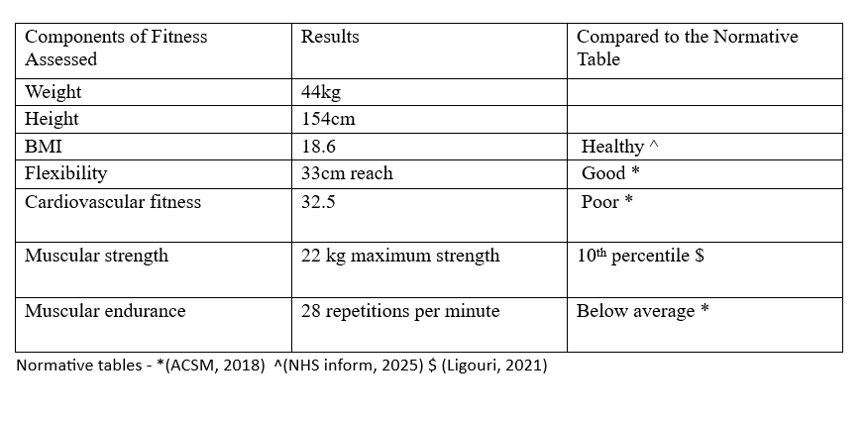

Recommendations
The results indicate significant areas for improvement in cardiovascular fitness, muscular strength, and endurance despite positive outcomes in flexibility and BMI (Ligouri, 2021). Poor cardiovascular fitness increases the risk of chronic diseases, while below-average muscular fitness could impair daily functional abilities and increase susceptibility to injuries (ACSM, 2018). However, good flexibility and a healthy BMI provide a solid foundation for creating an exercise program (ACSM, 2018). The implications for practice include prioritizing structured aerobic activities (walking, cycling) to enhance cardiovascular health and incorporating resistance training to improve muscular strength and endurance (Ligouri, 2021). An exercise session consists of three phases: warm-up, conditioning, and cool-down (Bayles, Swank, 2018). The warm-up (less than 15 minutes) uses light to moderate activities to prepare the body for exercise, with dynamic stretches improving performance and reducing injury risk (Bayles, Swank, 2018). The conditioning phase is the main workout, lasting 10-60 minutes (Ligouri, 2021). The cooldown helps the body return to resting levels and can include static stretches for relaxation and ROM (Ligouri, 2021). Flexibility exercises can be integrated into any phase or performed separately to enhance mobility and coordination (Ligouri, 2021).To optimize results, the FITT-VP principle was applied to the prescription: Frequency (how often), Intensity (effort level), Time (session duration), Type (activity mode), Volume (total amount of exercise), Progression (gradual increase in exercise demands to improve fitness overtime) (Ligouri, 2021).

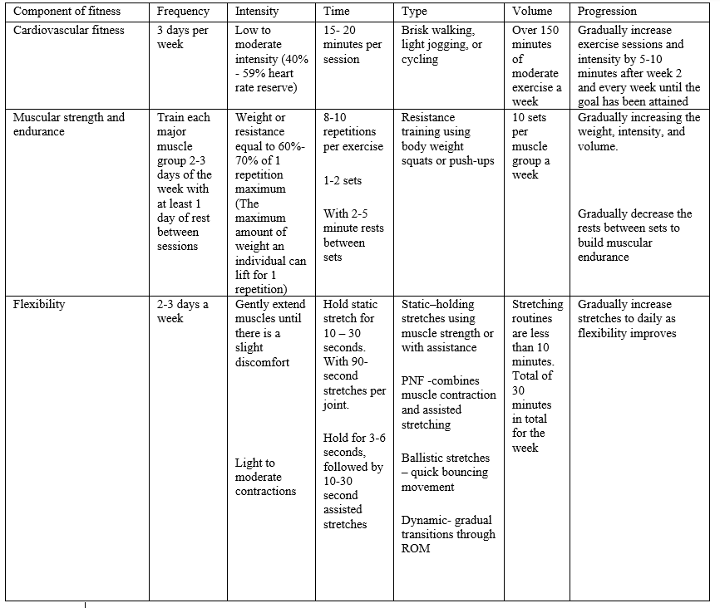
(Ligouri,2021)
This assessment has several limitations that may affect the findings. While accessible, BMI fails to differentiate between fat, muscle, and bone mass, reducing its precision (Ligouri, 2021). The flexibility test does not fully evaluate joint angles or hamstring mobility, limiting its scope (Ligouri,2021). Cardiovascular fitness results depend on strict cadence adherence, which could compromise accuracy (Bayles, Swank, 2018). The sit-up test may not represent functional daily movements, and self-reported activity questionnaires are prone to overestimation and bias (Bayles, Swank, 2018). Addressing these issues would improve the reliability and applicability of future assessments.

Total word count - 1428

References
ACSM's (2018) Guidelines for Exercise and Testing Prescription. Tenth Edition. Philadelphia: Wolters Kluwer.

American College of Sports Medicine (2014) ACSM's Guidelines for Exercise Testing and Prescription. Ninth Edition. Baltimore: Wolters Kluwer/Lippincott Williams & Wilkins.

Bayles, M.P. and Swank, A.M. (2018) Exercise Testing and Prescription. First Edition. Philadelphia: Wolters Kluwer.

Cenicola, G.D., Catro, M.G., Piovacari, S.M.F, Horie, L.M., Correa, F.G., Barrere, A.P.N., Toledo, D.O. (2019) 'Current technologies in body composition assessment: advantages and disadvantages', Nutrition, Issue 62, P 25-31. Available at: doi.org/10.1016/j.nut.2018.11.028

Craig, C.L., Marshell, A.L., Sjostrom, M., Bauman, A.E., Booth, M.L., Ainsworth, B.E., Pratt, M., Ekelund, U., Yngve, A., Sallis, J.F., Oja, P. (2003) 'International Physical Activity Questionnaire: Reliability and Validity', Medicine and Science in Sports and Exercise. Available at: 10.1249/01.MSS.0000078924.61453.FB
HaB Direct (2025) Products that perform. Available at: Home | HaB Direct (Accessed: 26/03/25).

Ligouri, G. (2021) ACSM's Guidelines for Exercise Testing and Prescription. Eleventh edition. Philadelphia: Lippincott Williams & Wilkins.

NHS inform (2025) Body Mass Index. Available at: Body mass index (BMI) | NHS inform (Accessed: 21/03/25).
Polar (2024) Polar. Available at: Heart Rate Monitors, activity trackers and bike computers | Polar UK (Accessed: 26/03/25).
Seca (2025) Seca Precision for Health. Available at: Medical measurement systems and scales · seca(Accessed: 26/03/25).

Sutkowska, E., Biernat, K., Mazurek, J., Hap, K., Kuciel, N., Sutkowska, M. and Marciniaj, D. (2024) 'Level and limitations of physical activity in patients with excess body weight or diabetes', BMJ Open Sports & Medicine, Issue 10, P 2041. Available at: doi.org/10.1136/bmjsem-2024-002041

Vaishya, R., Misra, A., Vaish, A., Urino, N., and D'Ambros, R. (2024) 'Hand grip strength as a proposed new vital sign of health: a narritive review of evidences', Journal of Health, Population and Nutrition, 43, 7. Available at: doi.org/10.1186/s41043-024-00500-y

Willbond, S.M., Laviolette, M.A., Duval, K. and Doucet, E. (2010) 'Normal weight men and women overestimate exercise energy expenditure', The Journal of Sports Medicine and Physical Fitness, Issue 50, PP 377-384. Available at: Normal weight men and women overestimate exercise energy expenditure. - Abstract - Europe PMC (Accessed: 23/03/25).

