MANAGING ENTERPRISE IN THE 21ST CENTURY

Module code: BMSK4006
Module Lecturer: Molly Jack

Student Name: Shemshat Nazarova
Student ID: 1706500

Table of Contents
Introduction 3
Research-informed Literature 4
Knowledge and Understanding of subject 5
Analysis 7
Practical Application and Deployment 8
Skills for Professional Practice 9
Conclusion 11
Reference List 12

Introduction
Many effective strategies have been evolved to manage enterprises in this 21st century. Managing enterprises refers to setting standards, measuring actual performance and taking corrective actions within and outside the organizational setting. The management of the enterprises in this 21st century involves their employees and even the consumers in the managing procedure. The enterprises in this current century have to focus on developing sustainable growth of the business and effective supply chain management.

Research-informed Literature
The whole economy is dominated by two types of enterprises, one is manufacturing enterprises and another is service enterprises. There are different types of services enterprises from those which directly support the production of goods to personal services including healthcare, education and tourism services. As opined by Welford (2016, p.17), the management of any kind of enterprise has to focus on marketing, advertising and packaging. It has been reported that in many developed market economies there has been a continual growth in case of service employment whereas; there has been a decline in employment in manufacturing company. Technological development has given more opportunities to create and deliver new services. The technical advancements have given the business organisations a great opportunity to take help of social media for advertising.
The multinational enterprises have significant potential on employment practices. There are about 82,000 MNCs in the world and they employ 77 million people. The management and the administration do not have any link with the front-line employees whereas, the management the startup companies keep a direct relationship with all the employees. The startup or small organisations have their own strategies where as the MNCs have to follow standard policies in all their subsidiaries (Bartram et al. 2015, p.140). The multinational enterprises have to alter their business strategies somewhat to handle different environments in different countries. MNCs provide the scope to their employees and their families to live in a foreign culture. These enterprises have to understand the socio-political, economic, cultural and regulatory environment of the countries they do business in.
The enterprises in the 21st century focuses on develop sustainability and supply chain management in their operations management. According to Heizer (2016, p.67), the effective operation management helps the enterprises to control the production procedures systematically and efficiently. The business management sometimes redesigns business operations over time and according to the environmental situations. Developing sustainable business is being emphasized by the government and environment ministry. The tourism and Information technology sectors are mainly targeted to adopt sustainable approaches. The supply chain management is one of the most important aspects to consider as the consumers prefer faster service. Most of the enterprises focus on having a proper supply chain so that they can make manufacturing and serving procedure faster. The key aspects in supply chain management are demand management, integration, communication and collaboration. The enterprises need to satisfy the demand of the consumers and needs to improve their products and services over time by analyzing consumers’ and market’s requirements. The enterprises also need to maintain an effective communication with all the parties involved in the supply chain so that they can work collaboratively.
In this era of 21st century the enterprises pay attention to integrated platform. According to Kesselheim and Avorn (2017, p.581), the tourism sector now does business with the integration of railways, airlines and restaurant and hotel services. The integrated or collaborative business strategy is helping all these sectors to have more number of consumers and thus more profit. The Information Technology sector and the technology support organisations are doing business in a collaborative way and thus having a great platform to meet all the technical requirements of the consumers.

Knowledge and Understanding of subject
Managing enterprises refers to controlling operational methods so that the enterprises become able to strengthen the work procedure to achieve the goal and the objectives within the established timeline (Hajli et al. 2015, p.470). There are several business management control tools that help business organization to develop effective operational procedures. Those tools include Business Management Controls framework, production operations policies manual, standardization controls, warehouse management controls, purchasing management controls and more.
- Business Management Controls Framework
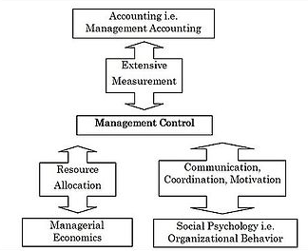
Figure 1: Business management Control Framework
(Source: Turow et al. 2015, p.470)
As per the business management control framework helps the management of the organisations to gather and use information to measure the performance of different organizational entities, for example, financial, human and organizational strategies.
Management control
The management control has the responsibility to coordinate, motivate, resource allocate and measure performance. The management control has to arrange the required infrastructure to execute the work. It is also concerned to allocate resources to each and every operational team.
Management accounting and management accounting system
The sector of the business management control framework is totally concerned with budgeting and product costing. This department of the organization has the responsibility to determine pay-scale of the employees.
According to this framework the management control and the accounting management system needs to carry out their duties properly to lead the organization to success.
- Production Operation policies manual
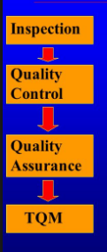
Figure 2: Quality Management
(Source: Bagley, 2015, p.89)
In manufacturing or production enterprises Quality Management model is used to evaluate the quality of the products. This model has four stages including Inspection, Quality control, Quality assurance and TQM. At the first stage the products are tested and basic quality planning is developed. Quality control stage emphasizes on developing advanced quality planning and the third stage encourages involving non-production operations and considering failure mode and effect analysis. Total Quality management (TQM) stage focuses on involving employees and the consumers in quality measurement of the products.
- Purchasing management Controls
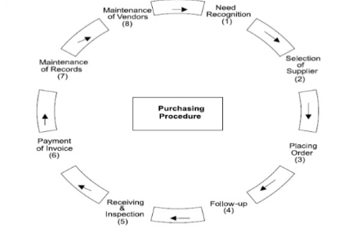
Figure 3: Purchasing management control
(Source: Kimbell, 2016, p.60)
The purchasing management control helps the management of the organisations to get guidance to carry on the purchasing procedure following the sequential stages. The organisations need to identify the needs of the materials and base ingredients that will help them in production of the finished products or provide a complete service. Selection of the suppliers is the most important stage as the quality of the products completely depends on the quality of the raw materials. After placing order and receive the materials the organisations have to inspect whether those ingredients are safe. This model helps the entrepreneurs to consider the cost of record and vendor maintenance at the time of preparing budget.

Analysis
In the era of 21st century, most of the enterprises take help of technology to run their business, for example, storing customers’ information in a database instead of paperwork, providing the shopping facility without being present at the shop and much more. As opined by Haapanen and Tapio (2016, p.3500), maintenance of information and records electronically saves cost whereas, there is a high chance of losing those records if the computers start malfunctioning if those information is not stored in a server machine or cloud. The manufacturing companies are also having a high level of profit by opting for high tech machineries or robots instead of human labor. Human labor is limited whereas machines can be more productive and generate more profit. In opposition to this, Bondar et al. (2015, p.270) stated that due to inventions of high-tech more productive machineries, the employment in manufacturing enterprises has been declined drastically. This scenario has led to lower employment contribution. But the production in manufacturing organisations is increasing more compared to service sectors.
According to Di Fabio (2014, p.110), most of the enterprises are offering the facility to make transactions online. The enterprises use the social media platform to reach to the consumers in the era of 21st century of a huge technical advancement. The forums through which the managers solve the queries are helping the enterprises in successful consumers’ retention with prompt response. With the help of information technology and web development, the enterprises are having attractive websites that attract consumers to a great extent and thus increase purchasing scope. In opposition to this, there have been some fatal incidents mainly in banking sector though hacking. The consumers are losing money to the hackers. The hackers are stealing information of the consumers from the retailers’ database and are using that sensitive information in ill purposes (Lessem and Schieffer (2016, p.67). Hence all the organisations need to ensure safety to both the employees and consumers.

Practical Application and Deployment
Reviewing the global scenario of technology innovation, it can be seen that, the interest of most of the businessman is going towards technological development of 21st century enterprises. A resounding response can be heard from most of the person. The brightness of the manufacturing as well as the software industry is developing day by day. Technology adaptation process is still in practice which was started from the 19th century. It is said that, in 21st century the business organization will face some new challenges for maintaining the enterprises, maybe it is the technical challenge may be a threat towards sustainable development. Till now the identified problem in the 21st century can be summarized such that,
- Technology has to comprises with the core business process
- Native service related to cloud computing have to be developed. XaaS will be the most fitted one.
- Catalogue has to be made for analyzing the business orchestra role. Multiple services have to be created. The consumer’s services have to be developed.
- Developing consumers’ catalogue is also essential.
No doubt that, in each of the enterprioses a different information technology wing has to be developed.
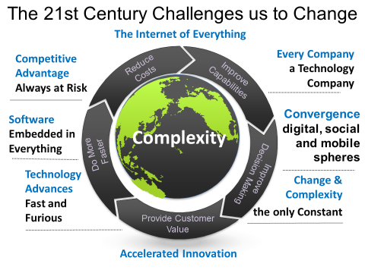
Figure 4: Complexity with 21st century enterprises
(Source: Baruah and Ward, 2015, p.812)
Mainly the enterprises have to work with three types of business role. First are service consumers. Second one is service creator and the last one is service orchestrators. Implementing these processes, it will be helpful for eradication of some challenges, described below:
- Firstly, the enterprises have to develop strategy for service creation challenge. Radical changes for service design have to be conducted. Beside of development, ‘consumption method and consumption component’ have to be reviewed for analysis. Enterprises should adopt the practice of self-healing.
- Secondly, to way up the challenges of service consumption, constant relation should have to be conveyed in between ‘self service’ and ‘customers’.
- Thirdly, the enterprises have to mitigate the challenge developed due to enterprise inertia. To mitigate the challenge the enterprise should redesign the existing services. Organization has to migrate towards the cloud based technology.

Skills for Professional Practice
It is beyond of knowledge that, to maintain the work place challenges of 21th century employee skill for professional practice is essential. Mainly, there is a requirement to clustering four types of skill.
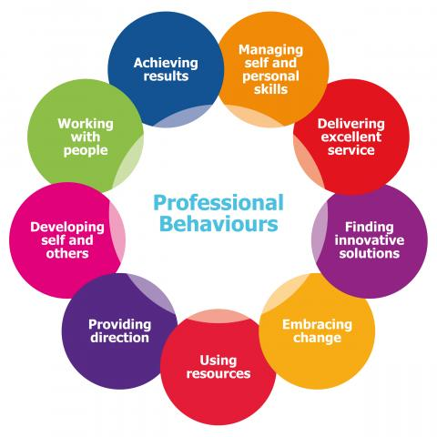
Figure 5: Skill required for sustaining in a workplace
(Source: Stamatis, 2016, p.89)
- Have to comprise with the knowledge of digital literacy so that the knowledge can be applied to manage the challenge in the workplace.
- Critical or inventing thinking skill is also another essential practice to draw out the enterprise out of the box
- Employees of enterprises have to work for developing effective communication. They have to clearly communication with the other co worker as well as the with the audience range.
- The productivity rate should have to be high. Only with the help of good productivity rate, the enterprise can develop its winning strategy and work for sustainable development. Team collaboration, interactive communication, personal responsibility are some practice that have to be adopt.

Conclusion

The number service enterprises are increasing more in this recent era compared to manufacturing organisations. The tourism and IT sector are penetrating current market more than other sectors. Due to advanced management study, the managers in these recent days are very effective in their roles and they ensure achievement of expected success by using effective business strategies. The enterprises need to adopt sustainable business strategies so that that particular business sector can last long without affecting the environment and other business sectors. The professionals in IT sectors need to develop robust algorithm so that the hackers cannot do any harm. All the business sector need to engage their employees and consumers in decision making procedure to run business as per the requirement.

Reference List
Bagley, C.E., (2015). Managers and the legal environment: Strategies for the 21st century. Boston: Cengage Learning.
Bartram, T., Boyle, B., Stanton, P., Burgess, J. and McDonnell, A., (2015). Multinational enterprises and industrial relations: A research agenda for the 21st century. Journal of Industrial Relations, 57(2), pp.127-145.
Baruah, B. and Ward, A., (2015). Metamorphosis of entrepreneurship as an effective organizational strategy. International entrepreneurship and management journal, 11(4), pp.811-822.
Bondar, S., Hsu, J.C. and Stjepandić, J., (2015). Network-centric operations during transition in global enterprise. International Journal of Agile Systems and Management, 8(3-4), pp.355-373.
Di Fabio, A., (2014). Intrapreneurial Self‐Capital: A New Construct for the 21st Century. journal of employment counseling, 51(3), pp.98-111.
Haapanen, L. and Tapio, P., (2016). Economic growth as phenomenon, institution and ideology: a qualitative content analysis of the 21st century growth critique. Journal of Cleaner Production, 112(12), pp.3492-3503.
Hajli, M., Sims, J.M. and Ibragimov, V., (2015). Information technology (IT) productivity paradox in the 21st century. International Journal of Productivity and Performance Management, 64(4), pp.457-478.
Heizer, J., (2016). Operations Management, 11/e. India: Pearson Education India.
Kesselheim, A.S. and Avorn, J., (2017). New “21st Century Cures” legislation: speed and ease vs science. Jama, 317(6), pp.581-582.
Kimbell, L., (2016). Designing for Services in Science and Technology-based Enterprises. In Designing for the 21st Century (pp. 59-70). Abingdon: Routledge.
Lessem, R. and Schieffer, A.,(2016). Transformation management: Towards the integral enterprise. Boca Raton: CRC Press.
Stamatis, D.H., (2016). 10 essentials for high performance quality in the 21st century. Productivity Press.
Turow, J., McGuigan, L. and Maris, E.R., (2015). Making data mining a natural part of life: Physical retailing, customer surveillance and the 21st century social imaginary. European Journal of Cultural Studies, 18(4-5), pp.464-478.
Welford, R., (2016). Corporate environmental management 1: Systems and strategies. Abingdon: Routledge.

