2026
Md. Juliyat Hasan
DBA, UWTSD, London
4/29/2026
Advancing to Doctoral Research Stage, LCDB7012

Table of Contents
Title: 1
1 Introduction: 1
2 Research Objective: 1
3 Background: 1
4 Literature Review: 3
4.1 Born-digital Firms: 3
4.2 Customer Relationship Management (CRM) effectiveness: 4
4.3 Business-It Strategic Alignment (BITA): 5
4.4 Related works: 6
4.5 Research Gap: 7
5 Research Problem and Phenomena: 8
6 Setting and the context of the research: 9
7 Paradigmatic stance and Assumption: 9
7.1 Ontological Assumption: 9
7.2 Epistemological Assumption: 9
7.3 Methodological Assumption: 10
8 Theoretical frameworks: 10
8.1 Strategic Alignment Model: 10
8.2 IT enabled Organisational Transformation: 10
8.3 Dynamic Capabilities Theory: 10
8.4 Digital Business Strategy: 11
9 Portfolio Items: Listing and Analysis: 11
9.1 Portfolio Item 1: Literature Review: 11
9.2 Portfolio Item 2: Setting and Context: 12
9.3 Portfolio Item 3: Paradigmatic stance and Assumptions: 12
9.4 Portfolio Item 4: Theoretical Framework: 13
10 Discussion: 13
11 Final Research Plan: 14
12 References: 14

Title: Understanding the Impact of Business–IT Strategic Alignment on CRM Effectiveness in UK Digital-Native Firms.

1 Introduction:
This research portfolio is intended to explain the evolution of the topic idea and the process to achieve it.

2 Research Objective:
- To understand how Business–IT alignment is understood and practiced in UK digital-native firms.
- To explore how different stakeholders perceive Business–IT alignment.
- To examine how Business–IT alignment influences CRM usage and effectiveness.
- To identify the factors that shape Business–IT alignment in practice.

3 Background:
Human civilisation is largely dependent on technology, which has developed into an effective instrument for day-to-day living (Sadiku et al., 2022). As a result, organisations' operational paradigms have completely changed, and technology-driven procedures and data-driven decision-making are now essential to their operations (Hafezieh and Pollock, 2023). In addition, Sadiku et al. (2022) stated that our economic and social lives revolve around digital technologies. Furthermore, all facets of our lives are becoming integrated via digitalisation: transportation, entertainment, governance, business, education, healthcare, and agriculture, among other areas (ibid). The way we conduct business is changing due to digital technologies including cloud computing, the Internet of things, robotics, big data analytics, artificial intelligence, social media, 3D printing, augmented reality, and virtual reality (ibid). According to Yoo (2010), the widespread use of digital technologies in daily life has given customers new abilities, enabled them to behave differently, and created a new generation of consumers (cited in Hafezieh and Pollock, 2023). Therefore, to fulfil the demands of these new generation consumers, business organizations are to provide more sophisticated products and services.
Jarosiński et al. (2023) argued that the emergence of new technologies like blockchain and artificial intelligence, as well as the digitalisation of the economy, are two of the most dynamic factors influencing businesses and how they compete. Although the level of digitalisation of operations varies by industry, these factors impact all businesses across all sectors (ibid). According to experts from the McKinsey Global Institute, businesses like media and finance have the highest levels of digitalisation, whereas big sectors of industrial output, such pharmaceutical manufacturing, have the lowest (ibid). However, it turns out that the industries with the greatest productivity improvements are also the ones with the highest degree of digitalisation (ibid). Additionally, Verhoef et al. (2021) claim that the adoption of new digital technologies has the potential to drastically alter conventional business practices and become the new standard (cited in Jarosiński et al., 2023). Moreover, according to Monaghan et al. (2020), born digitals are naturally more responsive and nimbler than traditional organisations (cited in Jarosiński et al., 2023).
Similarly, retaining consumers is a challenge for businesses in today's cutthroat business environment (Farhan et al., 2018). Likewise, for all businesses, regardless of size or style, managing effective and positive client relations is crucial (ibid). Customer relationship management (CRM) is regarded as one of the integrated ideas whose main goals are to establish enduring relationships between businesses and their clients (ibid). CRM systems are essential for managing and improving customer connections because they allow companies to track interactions, combine consumer data, and tailor communications, all of which strengthen relationships and boost customer loyalty (Nwabekee et al., 2024). All businesses have embraced CRM technologies to benefit from increased productivity and new prospects, as well as to keep their current clients and attract new ones (Tsou, 2022). Even though many organisations can accomplish the potential benefits and expectations of adopting such initiatives, a significant and high number of CRM programs failed or produced unsatisfactory results that fell well short of expectations (Farhan et al., 2018). CRM effectiveness, which is fuelled by customer-focused technology, must be clearly understood to benefit from CRM (Chen and Popovich 2003, cited in Tsou, 2022). It is widely acknowledged that companies' strategies and manufacturing operations must be internally consistent to achieve excellent company success (Tsou, 2022). This implies that a company's manufacturing procedures must be in line with its business plans (ibid). Nevertheless, it is still unclear how CRM effectiveness is improved by matching customisation procedures with corporate strategies, despite the possible advantages of customisation activities (ibid). According to Tsou (2022), corporate strategies are a crucial foundation for choosing customisation procedures, which ultimately enhance CRM efficacy. Furthermore, CRM systems' strategic alignment guarantees that IT expenditures promote digital innovation, enhance return on investment, and support long-term business objectives (Duarte, 2025).
An established issue in IS research is the need to comprehend the causes and effects of business-IT alignment (Coltman et al., 2015). However, achieving strategic alignment is difficult, and executives have been dealing with it as a major problem for the past forty years (Isal et al., 2016). Empirical data demonstrating the beneficial effects of alignment on corporate success continues to be supported by recent studies (Coltman et al., 2015). Organisations thrive when IT resources, including physical infrastructure, technical skills, and knowledge assets, are aligned with business strategy and managed effectively through appropriate structures (ibid). A sustainable competitive advantage and increased profitability might be produced by fostering alignment between business and IT plans; on the other hand, a lack of alignment could lead to resource waste and unsuccessful IT projects, which would have negative organisational and financial effects (Gerow et al., 2014). Chau et al. (2020) argued that even while most of the data points to a positive alignment-performance association, some evidence suggests that further research is necessary to fully understand the relationship between alignment and performance.
From this discussion, it can be realised that there have been various studies on digital-natives, CRM effectiveness, IT-Business Alignment, however, there is not enough research on the management, organisational, and strategic aspects of CRM effectiveness. These leads to a critical issue that born-digital business organizations are investing in significant amounts of capital on CRM platform (Farhan et al., 2018), nonetheless, these companies are failing to achieve expected benefits especially the start-ups (Girva et al., 2021), due to the inconsistent alignment between the business strategies and IT strategies. In addition, most of the existing literature investigated in the IT-Business alignment and CRM effectiveness mainly numerically. Since most of the born-digital firms are different from each other, it is evident that similar survey or questionnaires cannot reveal the true issues. Hence, current research is going to explore this phenomenon, the Impact of Business–IT Strategic Alignment on CRM Effectiveness in UK Digital-Native Firms.

4 Literature Review:

4.1 Born-digital Firms:
According to Hafezieh and Pollock (2023), organisations that heavily rely on digital technologies as essential components of their business models from the start are known as born digitals. It has been suggested that born digitals operate under the modern paradigm of “customer-centricity,” which calls for more creative approaches to develop new value pathways and consumer experiences (ibid). Businesses that were born digital were usually established after 1995. Using information and digital technology from the internet era to gain a competitive edge and spur rapid expansion is at the core of their operational models and capacities (AlixPartners, n.d.). Due to the widespread use of digital technologies in daily life, consumers’ expectations and practices have changed, a phenomenon known as “IT consumerization” (Gregory et al., 2018 cited in Hafezieh and Pollock, 2023). AlixPartners (n.d.) reported that the openness and capacity for experimentation are ingrained in the organisational cultures of many organisations that were born electronically as the fact that these businesses have always been at the forefront of innovative methods in some or all facets of their operations. Additionally, in the current economic environment, companies need to move fast to evaluate new business opportunities, swiftly identify acceptable partners, and integrate digital natives into the company culture (Egbon and Okolie, 2024). An organization’s culture, which is crucial to its success, affects how its employees, managers, executives, suppliers, and affiliates interact with one another (Egbon and Okolie, 2024; Sadiku et al., 2022).
The importance of born-digital firms in global economy is undeniable. 80% of newly established digital businesses have fully digitalised their customer journey, whereas only 20% of traditional businesses have fully digitalised their customer journey (AlixPartners, n.d.).
The growing significance of businesses known as “digital natives,” which are digital start-ups, is mentioned by the authors of the McKinsey Global Institute report (McKinsey, 2019 cited in Jarosiński et al., 2023). Moreover, according to McKinsey experts, digital natives can, on average, reach 12 percent of total revenues in the industries in which they are developed. This may seem insignificant in comparison to the total, but when it turns out that their total digital revenues are comparable to the “digital” portion of the revenues of businesses that have been in these industries for years, it is a significant amount (Jarosiński et al., 2023). In addition, up to 30% of businesses in high-tech industries are run by digital natives (ibid). Additionally, digital natives outperform other businesses in the sector in terms of profitability(ibid). However, digital native businesses were nimbler and daring in their investments, but they also failed more frequently (McKinsey, 2019, Jarosiński et al., 2023).

4.2 Customer Relationship Management (CRM) effectiveness:
Customer relationship management is becoming an increasingly important differentiator these days, as a result, adopting a CRM (Customer Relationship Management) approach is seen as becoming more crucial (Miguel and Crespo, 2023). Building long-lasting relationships between businesses and consumers is one of the main goals of customer relationship management, which is regarded as one of the integrated ideas in the fields of information technology and business (Farhan et al., 2018). In addition, CRM is a customer-focused company approach that focuses on increasing customer satisfaction and loyalty rates by offering clients more individualised and tailored services (ibid). These technology projects are frequently used in functional areas, such as sales, marketing, and customer services and support, to increase an organization’s profit (ibid). Furthermore, modern marketing strategies now heavily rely on Customer Relationship Management (CRM) tools, particularly in the context of digital transformation that are essential for managing customer interactions, optimising business processes, and utilising data analytics to increase marketing efficacy (Nwabekee et al., 2024). CRM tools' main objectives are to strengthen company ties, increase sales, and improve customer retention and satisfaction (ibid). For instance, Salesforce is a technology corporation that prioritises ongoing innovation to grow both its business and its industry in which customers can instantly access the newest technology thanks to its three annual releases and ongoing innovation, which enables them to stay ahead of the curve in their respective sectors (City of London Corporation, 2022). CRM tools help the companies to collect and store a substantial amount of customer data. Businesses may improve their marketing tactics and forge closer ties with their clients by utilising advanced data analytics (Nguyen et al., 2020 cited in Putri and Sianipar, 2025). Big Data integration in CRM facilitates quicker, data-driven decision-making in addition to helping businesses segment their consumer base more precisely (Zhang et al., 2022, cited in Putri and Sianipar, 2025). Only a small number of studies in the field assess this implementation from a company's point of view, and the majority do not study the effects of the cooperative and integrated execution of the many characteristics underpinning a CRM strategy (Miguel and Crespo, 2023). Therefore, it has become imperative that conducting research to investigate CRM effectiveness that can be shaped by the IT-Business strategic alignment.

4.3 Business-It Strategic Alignment (BITA):
According to Coltman et al. (2015), to give managers more useful methods for achieving alignment, models of strategic alignment and its components have been developed over time. The degree to which IT applications are suitably linked with current business procedures and routines is reflected in IT-business alignment (ITBA) (Chen et al., 2022). ITBA gives businesses access to extensive data regarding dangers and commercial possibilities, which may help with strategic decision-making (ibid). IT resources should facilitate improved organisational strategic decision-making when they facilitate efficient information consolidation and analysis because they are well-designed or orientated toward managers' expectations and requirements (Chau et al., 2020). IT is better equipped to offer suitable IT services that enhance company performance when business and IT strategy are in alignment (ibid). According to Chebrolu and Ness (2013), the process of strategic alignment ensures that organisational infrastructure and procedures, business strategy, IT strategy, and IT infrastructure and procedures are all in line. In addition, Gerow et al. (2015) claimed that IT executives continue to rank alignment as one of the top three management concerns, which is one explanation for this ongoing concern. Managing interpersonal relationships, procedures, and technological problems while sticking to the budget are the main concerns (Benkhayat et al., 2024). Unfortunately, there is frequently a lack of cooperation and communication between business and IT departments in many organisations (ibid). Furthermore, rather than being based on observable or quantifiable business needs, the alignment process frequently depends more on the prevailing organisational culture, social dynamics, and human understandings (ibid).
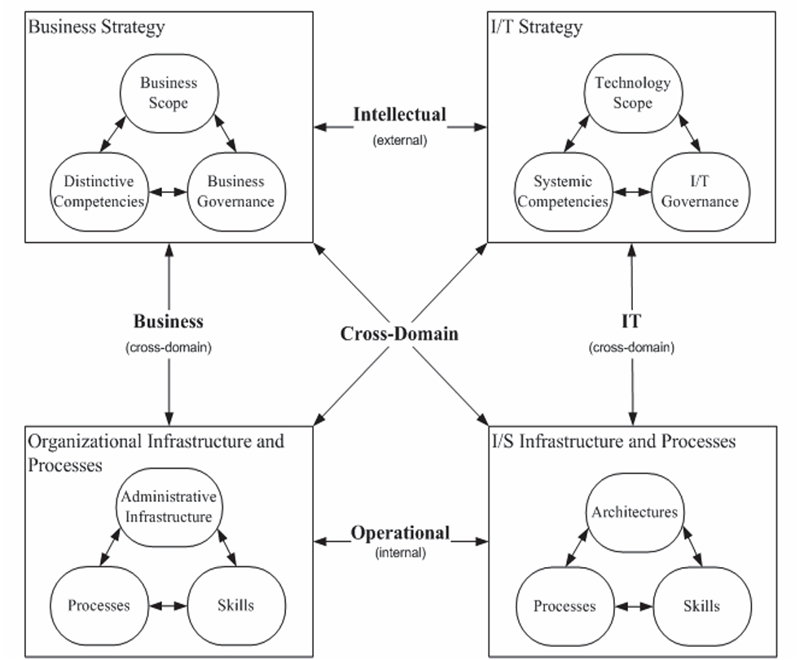
Figure 1: Henderson and Venkatraman’s Strategic Alignment Model, (Source: Gerow et al., 2014).

4.4 Related works:
There have been many studies conducted in the field of IT-Business Alignment and born-digital firms with CRM effectiveness. One study by Pierce (2002) that looked at the connections between business strategy, IT strategy, strategic alignment, return on IT investment, and corporate performance. By measuring return on IT investment and corporate performance, Pierce offered empirical support for the impact of alignment between business and IT strategies (cited in Chebrolu and Ness, 2013). Huang (2009) investigated how IT resources may be strategically employed to be an innovative organization and discovered that major companies' IT activities should be flexible in structure to promote strategic alignment while pursuing aggressive innovation (ibid). A study conducted by Chen et al. (2022) that examine the contingent roles of two significant event impact factors—event criticality and event disruption—in the context of COVID-19 and how ITBA and BDAC affect strategic decision-making. Similarly, another study by Kaggwa et al. (2023) investigated to investigate how AI has emerged and developed in the field of business strategy, looking at how technology might improve corporate agility and challenge conventional decision models. Hera et al. (2024) studied in the context of the UK FMCG business, which aims to determine how and in what ways IS affects organisational performance and decision-making. Furthermore, According to Benkhayat et al. (2024), business-IT alignment is one of the most important issues facing all organisations, and it requires cogent organisational and technology solutions. Moreover, Gerow et al. (2015) published a paper that explained the significance of distinguishing the six alignment types—which are occasionally muddled in the literature—into a single, cohesive model is emphasised.

4.5 Research Gap:
Information technology (IT) is essential for developing competitive strategies and propelling economic success since it enables companies to successfully accomplish their corporate goals (Benkhayat et al., 2024). Regretfully, not every IT investment yields business value commensurate with the investment amount (Isal et al., 2013). Henderson and Venkatraman (1993) argue that this failure is caused by a lack of alignment between business strategy and IT, often known as strategic alignment (ibid). Budgetary restrictions for IT investments and changing company objectives and tactics affect companies (Benkhayat et al., 2024).
In the previous few sections, the research has discussed several existing literatures that mainly focused on traditional firms (born-traditional) that later integrated IT infrastructures to improve their business. Up until now, with the best of research’s knowledge, there has not been any study conducted on born-digital firms that later aligned with the business strategies. In addition, a vast majority of UK population has become active users of internet and digitalized lifestyle. Therefore, the number of born-digital firms are increasing in this context. Moreover, most of these organizations are services based where customers are playing the core element, and CRM tools are responsible for trace the relationship, hence it has become imperative to explore the undiscovered phenomenon and identify how these born-digital businesses utilize BITA to shape CRM effectiveness.
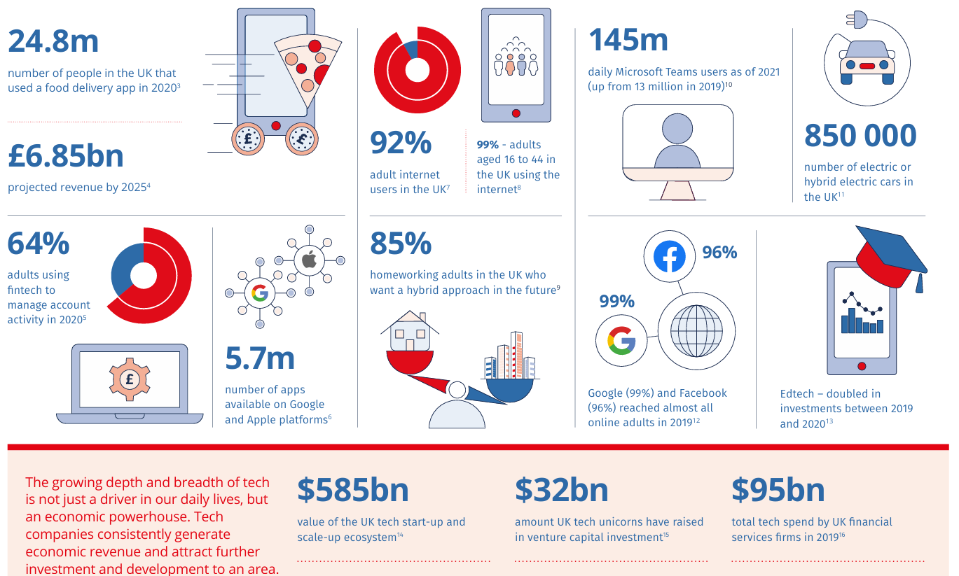
Figure 2: Tech’s influence on daily living (Source: City of London Corporation, 2022)
From the figure 2, it can be observed that technology has become the economic powerhouse.

5 Research Problem and Phenomena:
Numerous studies have been conducted on born-digital companies, CRM effectiveness, and IT-Business Alignment; nevertheless, the management, organisational, and strategic aspects of CRM effectiveness have received less attention. Due to the inconsistent alignment between business strategies and IT strategies, born-digital business organisations are investing large sums of money on CRM platforms (Farhan et al., 2018). However, these companies, particularly start-ups (Girva et al., 2021), are not reaping the anticipated benefits. Furthermore, most of the material currently in publication examined CRM efficacy and IT-business alignment primarily through numerical means. It is evident that such surveys or questionnaires cannot uncover the real problems because most digital-born businesses differ from one another. Therefore, "the Impact of Business–IT Strategic Alignment on CRM Effectiveness in UK Digital-Native Firms" is the topic of current research.

6 Setting and the context of the research:
The setting of the research is The United Kingdom (developed economy), and the context is the born-digital firms. Technology has the potential to significantly boost the UK's savings and investing culture and increase investors' chances of making profitable investments (The City of London Corporation, 2022). Additionally, technology has already significantly improved UK customers' capacity to comprehend their financial wants (shown in the figure 2), compile their financial data, comprehend their expenses and services, and effectively compare financial service providers (ibid). Similarly, with 70,086 start-ups and scale-ups with headquarters in the UK, the UK ranks third in the world for the number of tech start-ups and unicorns produced (ibid). There are more than 350 start-up incubators and accelerators in the nation for which 34% are fintech, 14% are health tech, 8% are travel tech, 5% are food tech, and 4% are gaming (ibid). Therefore, the born-digital firms in the UK playing a significant role in economy.

7 Paradigmatic stance and Assumption:
According to Chafe (2024), Some definitions of qualitative research are based on paradigms, which aid in defining what qualitative research is and how it ought to be carried out. The paradigmatic stance of this research is Interpretivism/Constructivism as the primary role of the researcher will be to understand the meaning that participants has experienced and interpret this align with the context as the result would be different in a different context.

7.1 Ontological Assumption:
Relativism- Local and specific constructed realities (Guba and Lincon, 1994). Human interaction socially constructs the reality, for instance here IT-Business alignment means different firms a differently. CRM effectiveness is experienced differently by different stakeholders. There is no single objective in this matter.

7.2 Epistemological Assumption:
Subjectivist- created findings (Guba and Lincon, 1994). Knowledge of this phenomenon would be co-created by the researcher and the participants. The findings will be created from the exploration of participants views and feelings, and the research will interpret these views in his own ways. Here the researcher is not neutral, rather has his own personal views and perceptions.

7.3 Methodological Assumption:
Hermeneutical/dialectic: Semi-structure interviews will be taken from the Born-digital firms’ managers, IT specialist and CRM experts. Multiple case studies will be conducted in the born-digital firms. Finally, the recoded interviews will be analysed through thematic analysis.

8 Theoretical frameworks:

8.1 Strategic Alignment Model:
Strategic Alignment Model is the core theory for this research as IT-Business alignment is the key indicator for the CRM effectiveness. According to Avison et al. (2004), businesses cannot compete if their information technology and business strategies are not in sync. IT effectiveness is positively impacted by strategic alignment, which increases corporate profitability. On the other hand, some contend that a company's performance and viability could be severely harmed if IT is not utilised (ibid). Alignment is thought to benefit a company in three ways: by optimising return on IT investment, by assisting in gaining a competitive edge through IS, and by offering guidance and adaptability to respond to emerging opportunities (ibid).

8.2 IT enabled Organisational Transformation:
This theory explains how IT can reshape and redesign the business strategy. Since the changes that information technology (IT) delivers to an organization and its surroundings determine its business value, IT by itself cannot generate a competitive advantage (Brocke et al., 2020). Researchers from a variety of disciplines, including IS research generally, have made IT-enabled organisational transformation a major focus (ibid). Customer relationship management (CRM) and enterprise content management (ECM) systems are well recognised for imposing their own logos on an organization's strategy, structure, function, and culture. As a result, these systems frequently bring about fundamental organisational changes (ibid).

8.3 Dynamic Capabilities Theory:
This theory focuses on how business organizations integrate, built and reconfigure the IT capabilities. This will help the researcher to identify how business organizations adopt new technologies and embed it evolving business strategies. Dynamic capabilities go one step further by acknowledging that companies frequently attempt to influence the business environment in addition to adapting to it (Teese, 2018). Furthermore, dynamic capabilities include a clear leadership and management position that enables systemic change to begin inside, which is the cause of firm-to-firm variability (ibid). A system that consists of resources and strategy also has dynamic capabilities (ibid).

8.4 Digital Business Strategy:
This Theory implies that IT strategy is inseparable from the Business strategy which introduces new concepts such as digital ecosystem and so on. An information systems (IS) strategizing process that is implemented between information technology (IT) and business in a constant, ongoing, dynamic manner is necessary to achieve the aims and objectives of a modern corporation (Brown and Brown, 2019). The integration of business and IT strategies to direct the unavoidable changes brought about by digital technology is known as digital business strategy, or DBS (ibid). Moreover, DBS is an organization-wide strategy that is developed and implemented by using digital resources to generate unique value (ibid).

9 Portfolio Items: Listing and Analysis:

9.1 Portfolio Item 1: Literature Review:
Like all other research Literature Revies is inseparable item of the current research as it is the base of the research. Knowledge have been accumulated from the exploration of existing research on topics such as Born-digital business organizations, IT-Business alignment, CRM effectiveness and the current situation of the UK digital organisations. It is important to understand the core concept of the topic for any researcher. The author of the report has acquired the relevant ideas and concepts from the literature review. It helped to identify the issues in the context of born-digital firms in the UK. How digital transformation has significantly shifted the scenario of the various businesses. The researcher of the current research has been confused by the overwhelming information; however literature review has solved the confusion.
Digital transformation is considered has positive impact of the businesses’ performances, however a through research on existing literature revealed that it also has drawbacks and causing many organizations’ failure. Due to a through literature review the research has been able to detect the research problem. Despite born digital firms have skills and relevant resource to conduct their businesses, it has been found that the failure rate is quite high due to the misalignment. In addition, conducting a literature review helped the researcher to identify the academic gap that has not been explore previously by other researchers.

9.2 Portfolio Item 2: Setting and Context:
The research will be conducted in the born digital firms in the United Kingdom. The UK is a developed economic country that has many tech companies. Only in the Square Mile (City of London) has a significant number of tech companies.
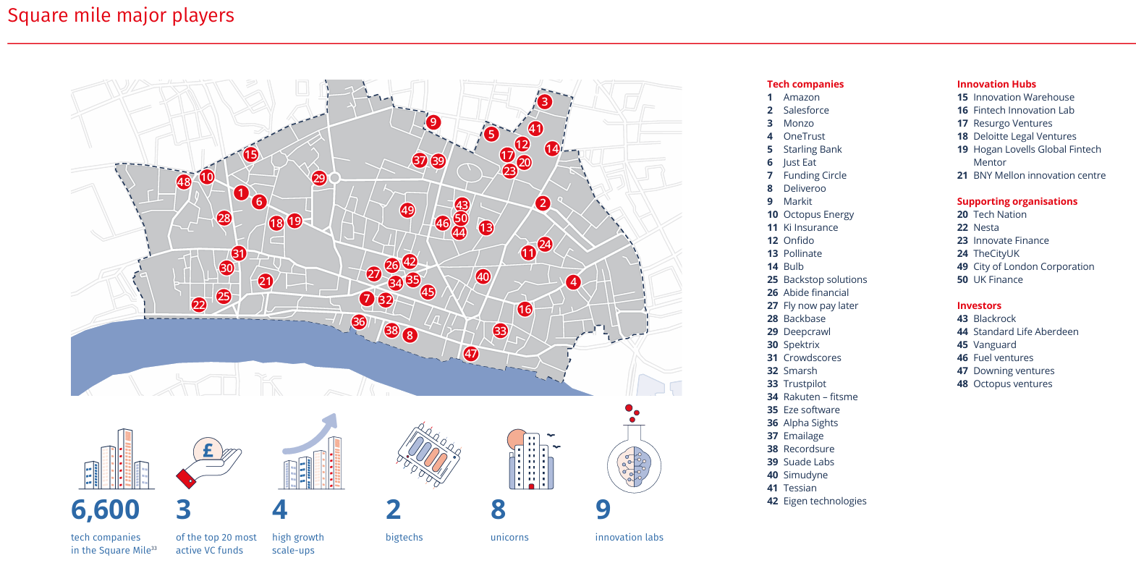Figure 3: Square Mile Major Players (Source: City of London Corporation, 2022).
In 2020, 24.8 million people in the UK utilised meal delivery apps, and 64% of adults used fintech to manage their account activity (City of London Corporation, 2022). 92% of adults in the UK use the internet, with 99% of those users being between the ages of 16 and 44 (ibid). There are 5.7 million apps on the Google and Apple platforms (ibid). From these data it is evident that the UK born-digital firms are playing a significant role in the country’s economy, therefore it will create a significant value to discover how these organisations align IT-Business strategies to shape the CRM effectiveness.

9.3 Portfolio Item 3: Paradigmatic stance and Assumptions:
Paradigmatic stance and assumption are another pivotal item for this research. Kuhn concentrates on normal science, which is defined as puzzle-solving and is carried out in accordance with a paradigm, instances of science and practice, theories, and methods of a community of scientists, which can vary in size based on the research topic (Orman, 2016). In addition, one paradigm is selected to guide regular science because it is thought to be more effective than its rivals at resolving certain issues that the scientific community considers to be vitally significant (ibid). Even if, most of the research in IT-Business alignment have employed quantitative methods, this research is focused on qualitative approaches. It is because of the research’s paradigmatic stance is interpretivism in which the reality is viewed based on subjectivity. It helps the researcher to identify how this research should be conducted. For example, different born digital firm has different organisational culture, values and strategies to run the business, that only be studied when they will share their experiences and view.

9.4 Portfolio Item 4: Theoretical Framework:
Theoretical Framework is a fundamental item from any doctoral research. Without theoretical foundation this research would not find any direction. The core theory for this research is Strategic alignment model. These theory checks four dimensions of alignment, IT strategy, Business Strategy, organizational structure and IT infrastructure of the company. Research will explore these four dimensions to see whether the alignment exist or not. Furthermore, IT enabled organizational transformation is another theory that would adopt for this research that will support the argument that only IT technologies cannot create organisational value, it needs to utilize the business strategies. Moreover, Dynamic Capabilities is one of the fundamentals for born-digital organizations. As uncertainty and fluidity are two characteristics of these organizations, managements are bound to be dynamically capable. This research will investigate how much dynamic the born-digital firms are in the UK. Finally, digital business strategy is the theory that would be directly connected to born-digital firms business strategies as this theory sees the IT strategy and Business strategy are the interrelated.

10 Discussion:
The current research is its primary stage. The researcher has been doing mostly literature reviews to find out a significant issue. There are many types of organizations in the UK. However, the number of the born-digital firms are increasing past few years. In addition, the failure rates of this type of firm are also significant. One major reason of these failures could be misalignment for IT strategies and business strategies as these companies do not follows the traditional management theories. Instead, these companies use technologies to create new market which based on customer adaptation. CRM is the pivotal tools that allows these companies to interact with and collect information of customers. Hence, it has become imperative that to investigate this issue.
This research is going to employ a qualitative methodology to conduct it. Semi-structured interviews will be conducted to gather information, and transcription will be recorded for thematic analysis. The participants will be the managers of the organizations, IT specialists and CRM experts. The sample size will be 12 to 15 and the duration of each interview will be 45 to 60 minutes. The reason for choosing this approach is that born-digital companies are different from each other, and only gathering the information from the stakeholders will be able to answer the hidden phenomenon.
To come up this plan, the researcher of the study has face lots of difficulties. First, there are various of business organizations and follow different strategies. Form the begin with, the researcher has been interested in research on business strategies. However, this interest makes the task very challenging. Secondly, finding a research gab was very difficult, as there have been much research done in the are of business strategy. Since, DBA research demands a practical issue in the business management, it has been difficult to identify a relevant issue.
The research of this study has gained a significant amount of knowledge during this period. Although the process has been very challenging and tiresome, it provided key skills and expertise to conduct doctoral research. The researcher has come across several new ideas and concept in this journey and escalated him level of understanding in research.

11 Final Research Plan:
Since this is the beginning of stage of this research, several things are needed to be done. First, the researcher needs to prepare a research proposal with required sections. When he is appointed with a supervisor, he will share his plan with the supervisor. If supervisor identifies any ideas or concept that need to be included or excluded, that would be done.
While doing the literature review, there has been some other issues appears, for instance, all the born-digital firms are dependent on digital ecosystem of third party such as AWS. This can create a drawback for the organisation as the authority is shifted to the third party.
All things considered, the finalized topic title of this research would be:
“Exploring How Business–IT Strategic Alignment Shapes CRM Effectiveness in UK Digital-Native (Born-Digital) Firms”.

12 References:
Sadiku, M.N.O., Chukwu, U.C., Ajayi-Majebi, A. and Musa, S.M., 2022. Digital natives in business. International Journal of Trend in Scientific Research and Development (IJTSRD), 6(3), pp.932–938.
Hafezieh, N. and Pollock, N., 2023. Digital consumers and the new ‘search’ practices of born digital organisations. Information and Organization, 33(1), Article 100489.
Farhan, M.S., Abed, A.H. and Abd Ellatif, M., 2018. A systematic review for the determination and classification of the CRM critical success factors supporting with their metrics. Future Computing and Informatics Journal, 3(2), pp.398–416.
Nwabekee, U.S., Abdul-Azeez, O.Y., Agu, E.E. and Ijomah, T.I., 2024. Digital transformation in marketing strategies: The role of data analytics and CRM tools. International Journal of Frontline Research in Science and Technology, 3(2), pp.055–072.
Tsou, H.-T., 2022. Linking customization capability with CRM technology adoption and strategic alignment. Service Science, 14(1), pp.60–75.
Duarte, L., 2025. Integration challenges and strategic alignment between ERP systems and CRM technologies in multinational enterprises. SCSITR – International Journal of ERP and CRM (ISCSITR-IJEC), 1(1), pp.1–7.
Coltman, T., Tallon, P., Sharma, R. and Queiroz, M., 2015. Strategic IT alignment: twenty-five years on. Journal of Information Technology, 30(2), pp.91–100.
Isal, Y.K., Pikarti, G.P., Hidayanto, A.N. and Putra, E.Y., 2016. Analysis of IT infrastructure flexibility impacts on IT-business strategic alignment. Journal of Industrial Engineering and Management, 9(3), pp.657–683.
Chau, D.C.K., Ngai, E.W.T., Gerow, J.E. and Thatcher, J.B., 2020. The effects of business–IT strategic alignment and IT governance on firm performance: A moderated polynomial regression analysis. MIS Quarterly, 44(4), pp.1679–1703.
Gerow, J.E., Grover, V., Thatcher, J.B. and Roth, P.L., 2014. Looking toward the future of IT–business strategic alignment through the past: A meta-analysis. MIS Quarterly, 38(4), pp.1159–1185.
Griva, A., Kotsopoulos, D., Karagiannaki, A. and Zamani, E.D., 2022. What do growing early-stage digital start-ups look like? A mixed-methods approach. International Journal of Information Management, 65, Article 102427.
AlixPartners, n.d. How digital natives are winning the AI race. AlixPartners Insights. Available at: https://www.alixpartners.com/media/16932/7-how-digital-natives-are-winning-the-ai-race-tl_vf.pdf. (Accessed: 02 April 2026).
City of London Corporation, 2022. Collaboration and co-creating: The changing tech landscape in the Square Mile. London: City of London Corporation. Available at: https://www.theglobalcity.uk/PositiveWebsite/media/Research-reports/Changing-Tech-Landscape-in-the-Square-Mile.pdf (Accessed: 8 April 2026).
Miguel, M.D. and Crespo, C.F., 2023. The impact of the implementation of CRM strategy on consumer behaviour. Polish Journal of Management Studies, 27(2), pp.192–206.
Chen, L., Liu, H., Zhou, Z., Chen, M. and Chen, Y., 2022. IT-business alignment, big data analytics capability, and strategic decision-making: Moderating roles of event criticality and disruption of COVID-19. Decision Support Systems, 161, Article 113745.
Chebrolu, S.B. and Ness, L., 2013. How does alignment of business and IT strategies impact aspects of IT effectiveness? International Journal of Applied Management and Technology, 12(1), pp. 1-15.
Gerow, J.E., Thatcher, J.B. and Grover, V., 2015. Six types of IT-business strategic alignment: An investigation of the constructs and their measurement. European Journal of Information Systems, 24(5), pp.465–491.
Benkhayat, A., Chiadmi, M.S. and Tkiouat, M., 2024. Strategic business-IT alignment: A multi-agent systems approach. Journal of Information Systems Engineering and Management, 9(3), Article 29392.
Chen, L., Liu, H., Zhou, Z., Chen, M. and Chen, Y. (2022) ‘IT-business alignment, big data analytics capability, and strategic decision-making: Moderating roles of event criticality and disruption of COVID-19’, Decision Support Systems, 161, article 113745.
Kaggwa, S., Eleogu, T.F., Okonkwo, F., Farayola, O.A., Uwaoma, P.U. and Akinoso, A. (2023) ‘AI in decision making: transforming business strategies’, International Journal of Research and Scientific Innovation, 10(12), pp. 423–444.
Hera, A., Al Rian, A., Faruque, M.O., Sizan, M.M.H., Khan, N.A., Rahaman, M.A. and Ali, M.J. (2024) ‘Leveraging information systems for strategic management: enhancing decision-making and organizational performance’, American Journal of Industrial and Business Management, 14, pp. 1045–1061.
Orman, T.F. (2016) ‘“Paradigm” as a central concept in Thomas Kuhn’s thought’, International Journal of Humanities and Social Science, 6(10), pp. 47–52.
Chafe, R. (2024) ‘Different paradigm conceptions and their implications for qualitative research’, International Journal of Qualitative Methods, 23, pp. 1–10
Egon G. Guba, E.G. and Yvonna S. Lincoln, Y.S. (1994) ‘Competing paradigms in qualitative research’, in Norman K. Denzin, N.K. and Yvonna S. Lincoln, Y.S. (eds.) Handbook of Qualitative Research. Thousand Oaks, CA: Sage, pp. 105–117.
Mirosław Jarosiński, M., Jurgita Sekliuckiene, J. and Miklós Kozma, M. (2023) ‘Born digitals: Understanding the sustainable competitive advantage across different markets’, in Richard Adams, R., Dietmar Grichnik, D., Asta Pundziene, A. and Christine Volkmann, C. (eds.) Artificiality and Sustainability in Entrepreneurship. Cham: Springer, pp. 41–59.
David Avison, Jill Jones, Philip Powell and David C. Wilson (2004) ‘Using and validating the strategic alignment model’, Journal of Strategic Information Systems, 13(3), pp. 223–246.
Brocke, J. V., Schmid, A.M., Simons, A. and Safrudin, N. (2021) ‘IT-enabled organizational transformation: a structured literature review’, Business Process Management Journal, 27(1), pp. 204–229.
David J. Teece (2018) ‘Dynamic capabilities as (workable) management systems theory’, Journal of Management & Organization, 24(3), pp. 359–368.
Brown, N. and Brown, I. (2019) ‘From digital business strategy to digital transformation – how? A systematic literature review’, in Proceedings of the South African Institute of Computer Scientists and Information Technologists Conference (SAICSIT ’19). Skukuza, South Africa: ACM.

