Simulation of Digital Modulation Techniques
James Howe
1910319
ACDA5008 DSP & Communications
Steve Mosey
UWTSD
Table of Contents
Table of Figures 1
Introduction 2
The Simulation 2
ASK Circuit Diagram 3
Circuit Setup 4
ASK Description 4
PSK and QPSK Differences 4
PSK Circuit Diagram 5
QPSK Circuit Diagram 6
Results 7
Discussion 9
Simulation Improvements 10
Conclusion 11
References 11
Appendix 12
ASK Table 12
PSK Table 12
QPSK Table 13
Summary Table 13

Table of Figures
Figure 1, ASK Input vs Output 2
Figure 2, Simulink ASK Circuit Diagram 3
Figure 3, PSK Inverted Wave 4
Figure 4, I/Q Modulation Techniques [1] 4
Figure 5, Simulink PSK Circuit Diagram 5
Figure 6, Simulink QPSK Circuit Diagram 6
Figure 7, ASK Signal to Noise Ratio vs Bit Error Rate 7
Figure 8, PSK Signal to Noise Ratio vs Bit Error Rate 7
Figure 9, QPSK Signal to Noise Ratio vs Bit Error Rate 8
Figure 10, SNR-BER Summary Graph of ASK, PSK and QPSK 8
Figure 11, Average Standard Deviation of the BER 9
Figure 12, Noise-Input Scope Comparison 10

Introduction
Modulation is a process that is used to convert information into a form where it is transmissible as a signal. The message signal (modulating signal) is combined with a carrier signal which is at the correct frequency for transmission. The modulating signal changes the carrier signal’s frequency or amplitude when they are combined together. This creates a new signal containing the message information and inherits the correct transmission frequency. Modulation is used in wired transmission however it is essential for wireless transmission. [1]
There are various modulation techniques that have different benefits such as a higher bit rate or being less affected by higher levels of noise. The basic techniques are ASK, PSK and QPSK which will be explored and simulated in this experiment.

The Simulation
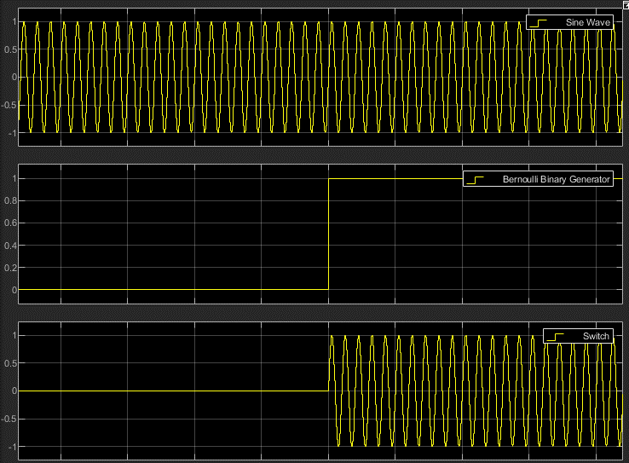
The first technique used in the simulation is ASK. The digital input signal or message signal is combined with the carrier signal and outputs a signal that has the same frequency as the carrier but the amplitude has been adjusted according to the message signal.
Figure 1, ASK Input vs Output
Line 1 represents the carrier wave containing the transmission frequency, Line 2 shows the input signal switch from a 0 to a 1 and Line 3 shows the combination of this data. When the input signal is 1 the output signal replicates the carrier wave, when it is 0 nothing is output, this is known as On-Off Keying (OOK). [1]

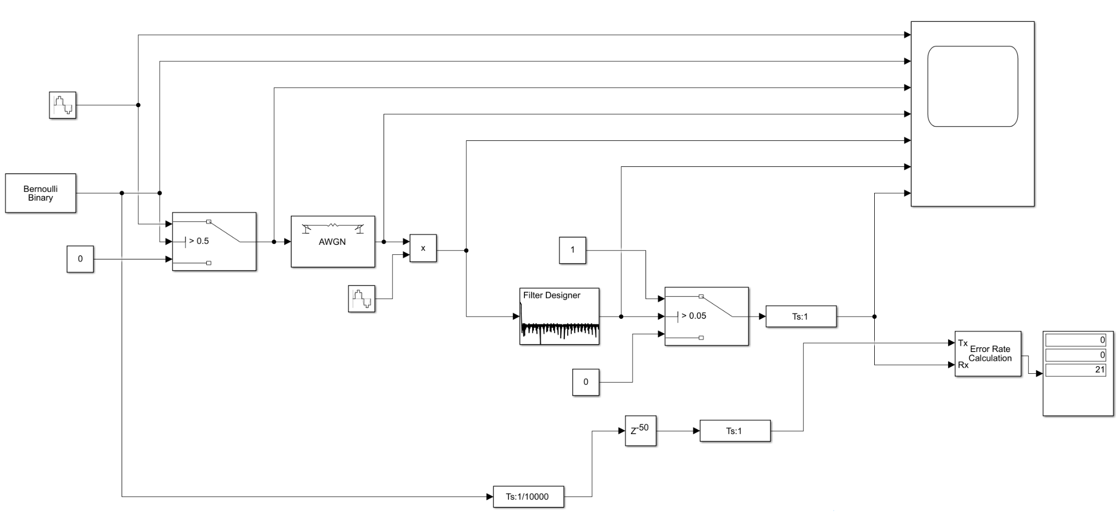
ASK Circuit Diagram
Figure 2, Simulink ASK Circuit Diagram
Delay Generator

Circuit Setup

ASK Description
Figure 2 (above) shows the setup of the Amplitude Shift-Keying Circuit created on Simulink within MATLAB. The Bernoulli Binary generator is the message signal we wish to transmit and the Sine Wave above it contains the carrier signal frequency. The switch box creates the signal shown in Figure 1 where if the message signal is currently 1, it is above the switch’s threshold and allows the sine wave through, if the message signal is 0, then the switch outputs 0.
The signal then enters the Additive White Gaussian Noise generator. This simulates real world interference that a signal might encounter. It is configurable by entering a Signal to Noise Ratio (SNR), which changes how strong the noise data is compared to the signal, this is varied in the simulation to investigate how the different modulators react to the interference. The Low Pass Filter attempts to decode the now noisy signal and the switch next to it converts it to a binary notation again. The Error Rate Calculation box allows us to count how many signals were sent from the binary generator at the beginning and then compares it to the received signal from the switch. We can calculate the Bit Error Rate (BER) from the number of erroneous bits over the total number of bits sent. The large square in the top right is a Scope that can produce the graphs shown in Figure 1.
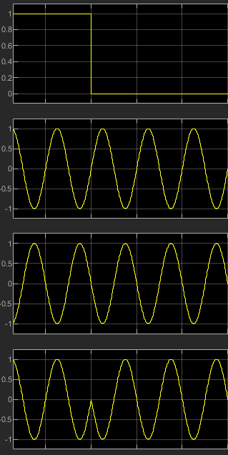
Figure 3, PSK Inverted Wave

PSK and QPSK Differences
Described in Figure 5 (below), Phase-Shift Keying (PSK) uses an extra product calculation that inverts the carrier signal, which is equivalent to shifting its phase by 180°. The switch following this outputs either the carrier wave (if the message signal is 1) or the inverse of the carrier wave (if the message signal is 0) by multiplying the amplitude of the carrier wave by -1.
The top row of Figure 3 shows the message signal switching from a 1 to a 0. Row 2 shows the carrier wave and Row 3 the inverse. Row 4 shows the modified carrier signal that uses the normal and then the inverted carrier signal.
In QPSK (Figure 6 , below) the binary message data is fed into a Demultiplexer which splits the data evenly into 2 separate lines. QPSK transmits two bits per symbol as it outputs 00, 01, 10 or 11 instead of 0 or 1. [2] The carrier signal is not limited to 2 states as in ASK (on or off) or PSK (in or out of phase) but to 4 states using more phase angles; 45°, 135°, 225° and 315°.
The first half of the QPSK diagram is setting up these 4 phases that the wave can be in that represent the symbols mentioned above.

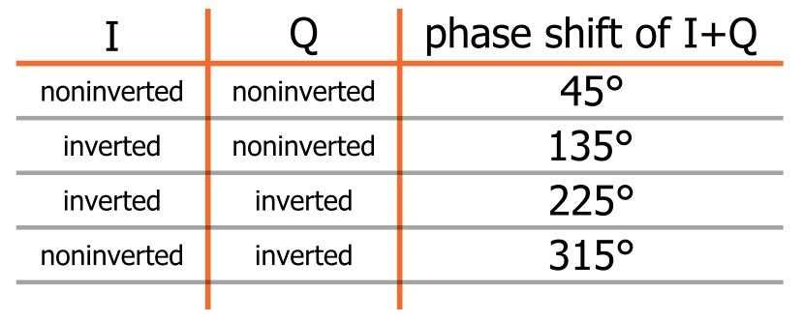
Figure 4, I/Q Modulation Techniques [1]

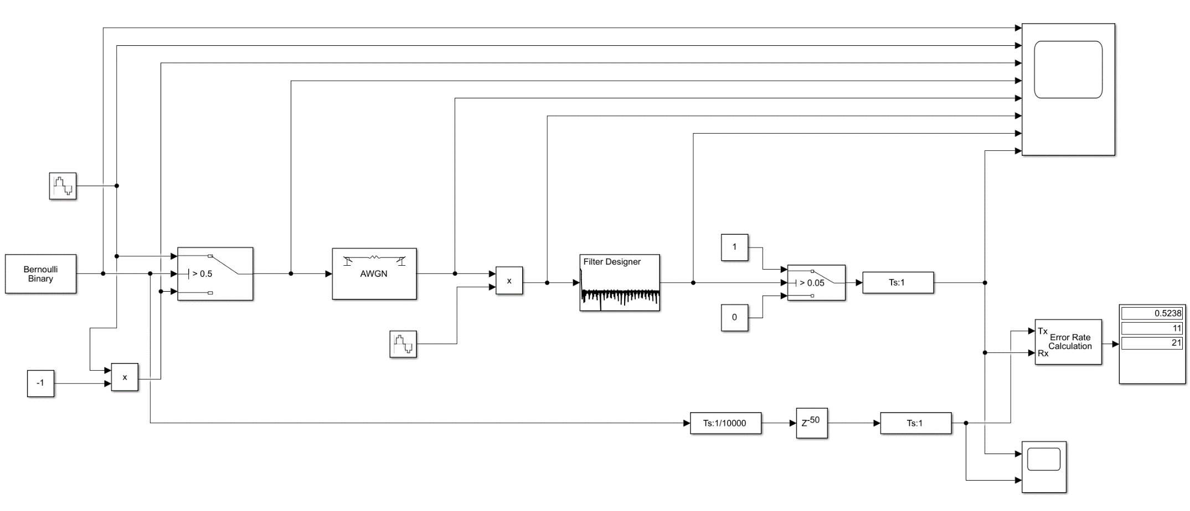
PSK Circuit Diagram
Figure 5, Simulink PSK Circuit Diagram

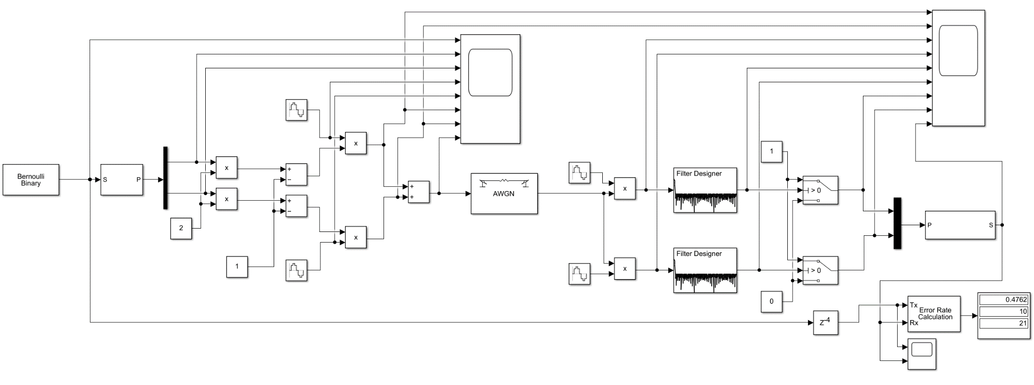
QPSK Circuit Diagram
Figure 6, Simulink QPSK Circuit Diagram

Results
Figure 7, ASK Signal to Noise Ratio vs Bit Error Rate

Figure 8, PSK Signal to Noise Ratio vs Bit Error Rate
Figure 9, QPSK Signal to Noise Ratio vs Bit Error Rate
Figure 10, SNR-BER Summary Graph of ASK, PSK and QPSK
Figures 7 to 9’s Control Variables are the number of simulations and the interval of the SNR step between tests. The independent variable is the SNR inside of the AWGN generator for each simulation. The dependent variable is the number of bits that match the original data signal, which allows the calculation of the BER.
Figure 11, Average Standard Deviation of the BER
Figure 11’s Standard Deviation graph is used to calculate the error bars for the previous BER graphs. It also gives an idea of which modulation technique produced the most closely grouped results averaged out across all SNR values.

Discussion
From the BER graphs, the relationship between the Signal to Noise Ratio and the Bit Error Rate can be determined. The lower (more negative) the ratio, the more errors are detected, up to a point around 50%.
Noise itself has an amplitude and this is why it can affect ASK so much as the key factor for deciding whether or not a symbol has changed is the wave’s amplitude. This can be seen at the beginning of Figure 7 where the BER increases quickly compared to PSK at the beginning.
It can be seen that although the circuits differ in complexity, they follow a similar trend with PSK just edging out over the other two as it continually demonstrates a lower BER until the SNR is ~-40 where the BER approaches 50%.

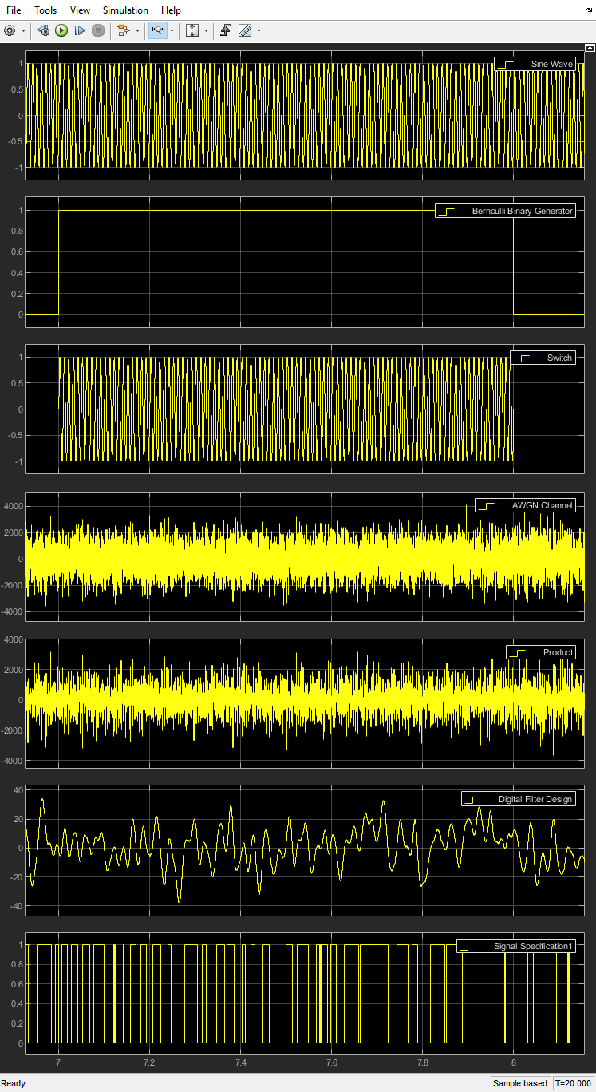
Figure 12 shows the Binary input on the 2nd row going into the ASK modulator with a -70 SNR and the output is the bottom row. The noise (amplitude above 2000) is causing the output to change a multitude of times within the 1 second that the input signal is producing a ‘1’. This could go undetected as an error as long as the signal at exactly 7 or 8 seconds matches the input which is a downside to our error detection method. A higher sampling frequency for the error rate calculation box could allow us to see more of the errors during the signal as it would compare the input and output more often and in high noise situations like this, it would show the true amount of errors. There is a fair chance that the noise randomly produces the correct signal when the error checking occurs as there are only two possible values the noise can produce. This leads to the trend that can be witnessed on the BER graphs as they all approach a maximum at around 50%. The BER cannot reliably go over 50% if given a long enough simulation time due to the aforementioned chance of the noise producing the correct signal when the error checking occurs.
Figure 12, Noise-Input Scope Comparison

Figure 7 to Figure 9 have error bars added to them using the Standard Deviation of each of the SNR increment’s results, shown in the results tables in the Appendix. The error bars represent ±σ (1 standard deviation) which provides insight on how closely grouped the BER is for that SNR value. In Figure 7 the best fit line fits through all error bars but the last, but this can be explained by the above paragraph as if the x-axis were to continue a logarithmic best fit line would be a better fit as there would be an asymptote at ~50 % BER. Figure 8 has quite wild data compared to the others. There is a large spike between -30 and -40 SNR, which could be down to the numbers obtained from the simulations by chance, but again it follows the trend and flattens out at 50%. However, all but one of the error bars includes the best fit line. Figure 9’s trend line fits within all of the error bars and contains the most tightly packed data, as evidenced by Figure 11 where QPSK has the lowest standard deviation out of the three when the standard deviation for each SNR value is averaged. QPSK could be considered a more reliable technique using this data as it produced a data set with the lowest spread of points.

Simulation Improvements
There are multiple ways that this experiment and its simulation could be improved. Firstly, each simulation run transpired for 10 seconds which allowed for 10 bits of data to be generated by the Bernoulli generator. However, the delay of the modulator circuit took up to 4 seconds which had to be accounted for in the error checking which meant that 6 bits were being checked. Increasing the simulation time to 50 or 100 would make the 4 second delay a less significant proportion of the total time, meaning more error checking could take place. More results would be averaged and a more accurate account of the BER at each SNR could be calculated. This would take more time to process however.
The simulation could be performed more than 10 times per SNR value. This would give more results in the spreadsheet that would be averaged as well, leading to more accurate results. The standard deviation graph provides good reasoning to do this as the σ is almost 10% and if there is one error in the simulation, it provides a value of 10% as there were 10 data bits to begin with. More simulations and a higher simulation time could reduce the standard deviation which would show more closely related data has been recorded.
There is a continuous error in the QPSK data at low SNR values. 1 error was detected in the time period during the delay, which means the error checking was comparing noise to 0 input. This could be an error with the program, the simulation or the circuit. It can be seen in the QPSK Table on Row 7.

Conclusion
This experiment deems QPSK to be the superior modulation technique if given no restraints in terms of circuit size and complexity. The BER graph shows consistently lower error rates until 50% where it becomes asymptotic along with the other modulation techniques. It also provides the lowest standard deviation out of the group, showing that its data is more closely packed to each other and can show its reliability over the course of the simulations.
As mentioned above this experiment could be improved significantly with more time available.
Although QPSK wins over the other two, it is also the most complex and largest circuit. Comparing Figure 6 and Figure 2, it is easy to see that a small and/or cheap device would benefit from using ASK as the results were not considerably worse but its circuit is significantly more simple. This would translate to using less components, meaning a lower cost and a reduced space required for the construction of the circuit.

References

[1] | T. O. University, “Exploring communications technology,” [Online]. Available: https://www.open.edu/openlearn/science-maths-technology/exploring-communications-technology/content-section-1.3. [Accessed 23 March 2021].
[2] | R. Keim, “Understand Quadrature Phase Sift Keying (QPSK) Modulation,” All About Circuits, 17 August 2016. [Online]. Available: https://www.allaboutcircuits.com/technical-articles/quadrature-phase-shift-keying-qpsk-modulation/. [Accessed 24 March 2021].

Appendix

ASK Table

PSK Table

QPSK Table

Summary Table

